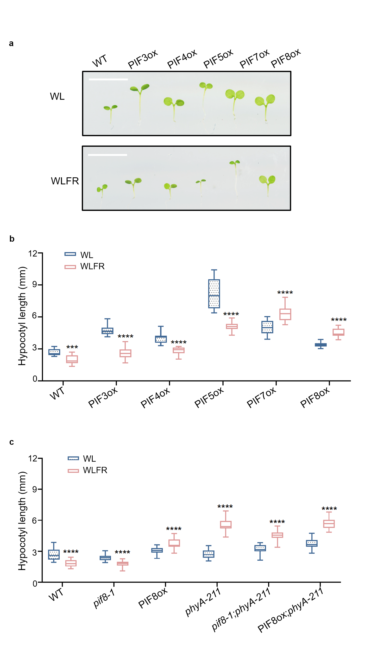
S1 Hypocotyl length of PIF lines in WL and WLFR.
a-c, Seedling images and hypocotyl length (mm) are shown. For a, scale bar =1 cm, For b, WT (Col-0), p35S::MYC-PIF8ox, PIF7ox-FLASH, p35S::PIF3-LUC, p35S::PIF5-HA and p35S::PIF4-LUC, and c, WT (Col-0), pif8-1, pif8;phyA-211 and PIF8ox;phyA-211. Lines were generated as previously described^{15,16, 40,41}.
Seedlings were grown for 6 days 8 h light (PAR = 85 ± 5 μmol m⁻² s⁻¹), 16 h dark photocycles (WL) or with supplementary FR (R:FR 0.20) (WLFR) at 22°C. Hypocotyl length was measured using ImageJ. Data are presented as mean values ± s.e.m., n=27 in b; n=28 in c (seedling numbers). A two-way ANOVA was conducted to assess statistical significance across light conditions for each genotype (α=0.05); asterisks denote significance relative to WL treatments: 0.1234 (ns), 0.0332 (*), 0.0021 (**), 0.0002 (***), P < 0.0001 (****).
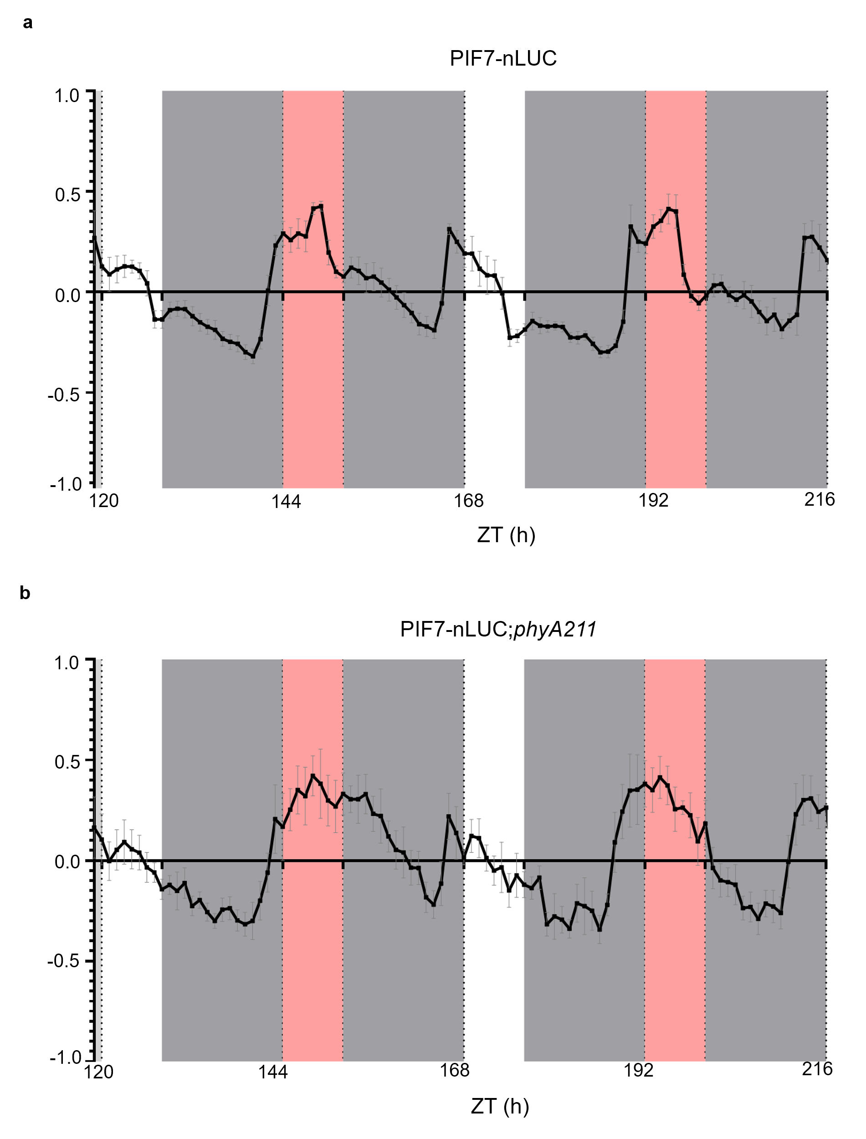
S2 PIF7 protein expression changes rhythmically.
Bioluminescence traces are shown for pPIF7::PIF7-nanoLUC (PIF7-nLUC, in the pif7-1 background) and pPIF7::PIF7-nanoLUC;phyA-211 (PIF7-nLUC;phyA-211) lines. Seedlings grown for 6d in 8hL:16hD before imaging over 3 days. Data shown are from over three consecutive days of treatment (n=5 biological replicates). White light (WL) periods are shown in while, red represents WLFR (R:FR 0.20), and grey represents darkness, PAR = 85 ± 5 μmol m⁻² s⁻¹. The raw data were analysed using BioDare2, and data are presented as mean values ± s.e.m, n=5 (seedling numbers). Representative images from three independent replicates are shown.
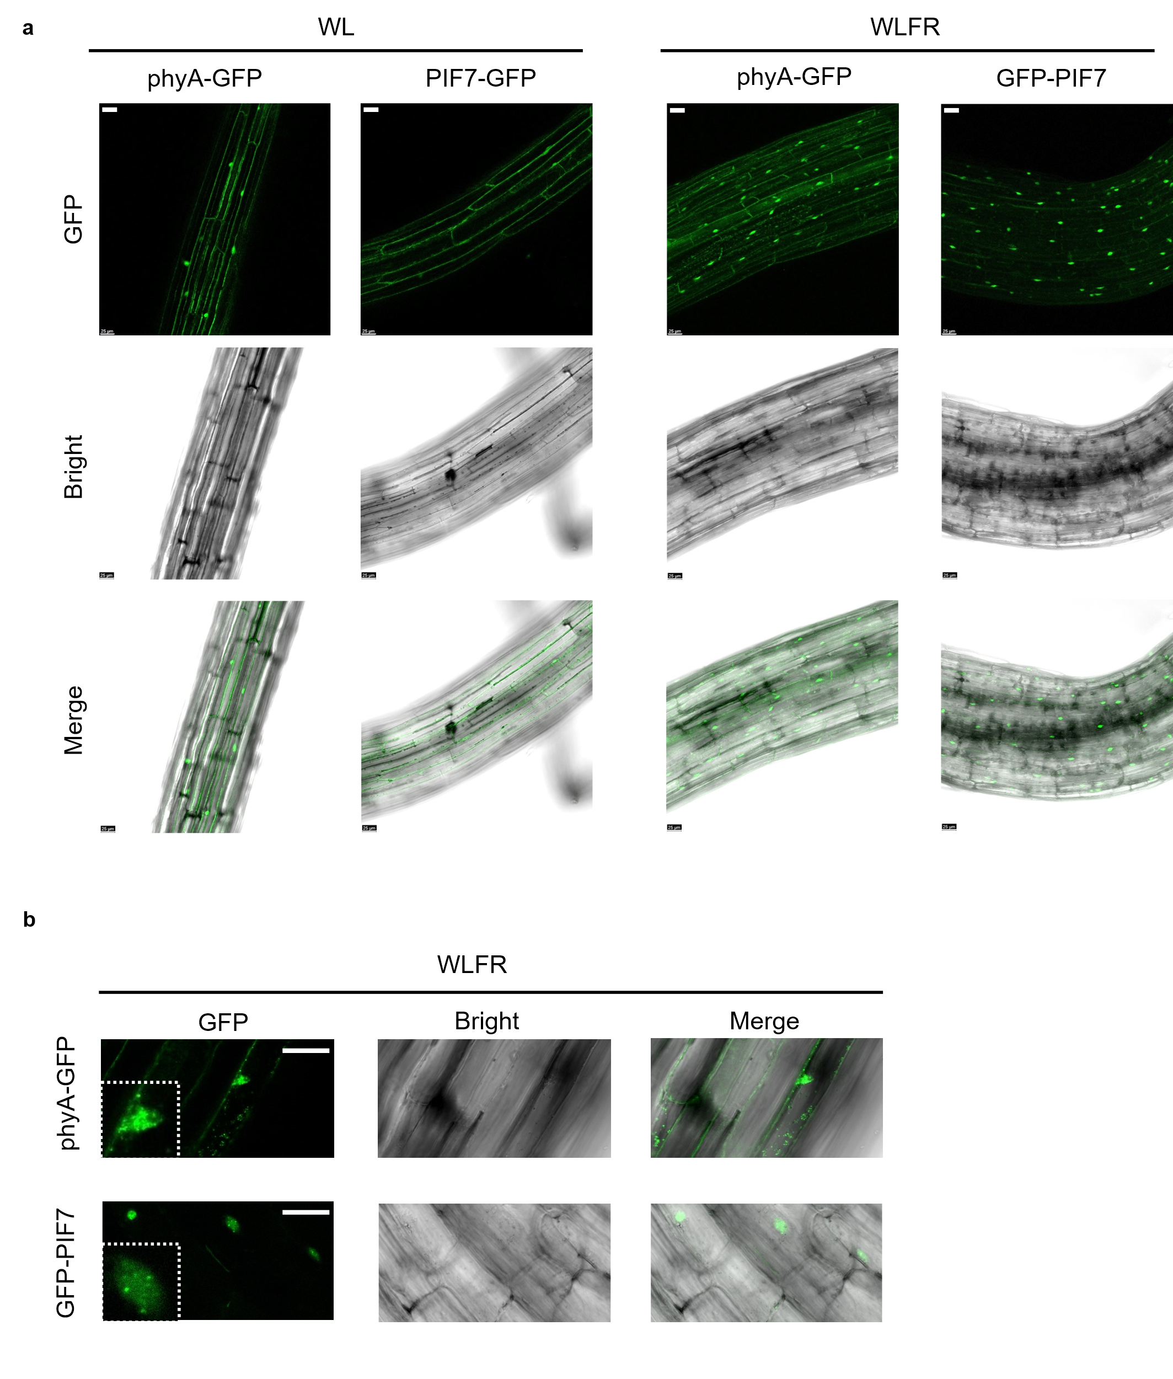
S3 Both PIF7 and phyA accumulate in nuclei under WLFR conditions.
a-b, Transgenic lines pPHYA::PHYA-sGFP and p35S::GFP-PIF7 were analysed. phyA-GFP and GFP-PIF7 accumulated in nuclear photobodies following exposure to WLFR. GFP signals were detected using a 488 nm laser. Images were captured at ZT7 after 6 days of WL/WLFR treatments. Scale bar = 25 μm. Representative images from three independent replicates are shown.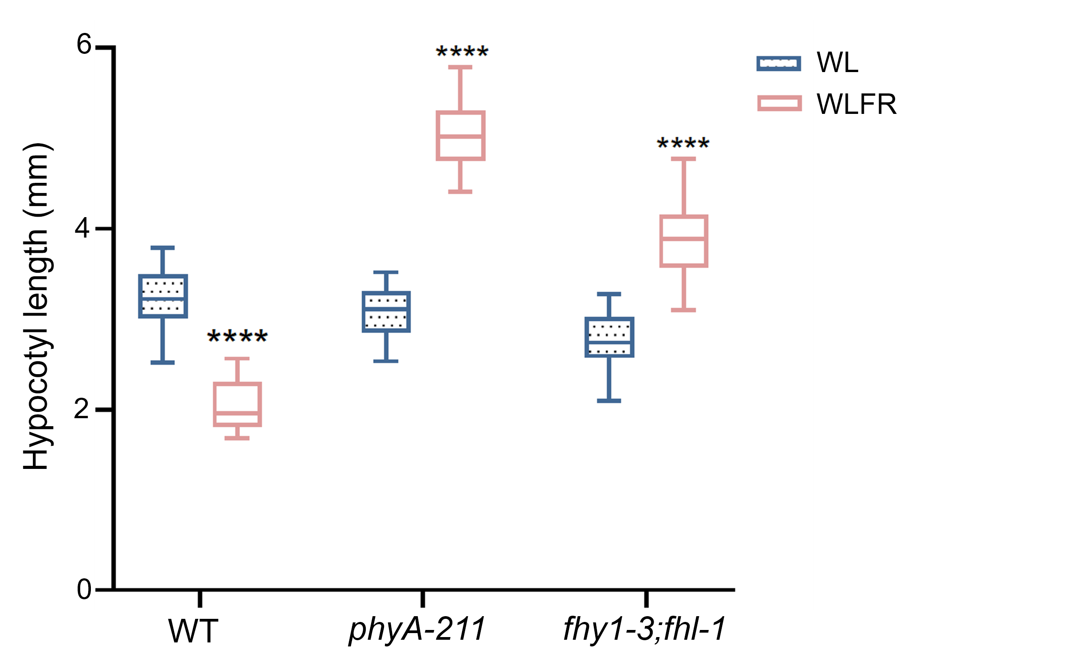
S4 The fhy1-3;fhl-1 is phenotypically similar to phyA-211 in WLFR.
Hypocotyl length (mm) of WT (Col-0), phyA-211 and fhy1-3;fhl-1 (fhl/fhy1-3)⁴⁷ double mutant under WL and WLFR. Data are presented as mean values ± s.e.m., n=25 (seedling numbers). A two-way ANOVA test assessed statistical significance (α=0.05); asterisks indicate significance compared to WL treatments in each genotype: 0.1234 (ns), 0.0332 (*), 0.0021 (**), 0.0002 (***), P < 0.0001 (****). Representative images from three independent replicates are shown.

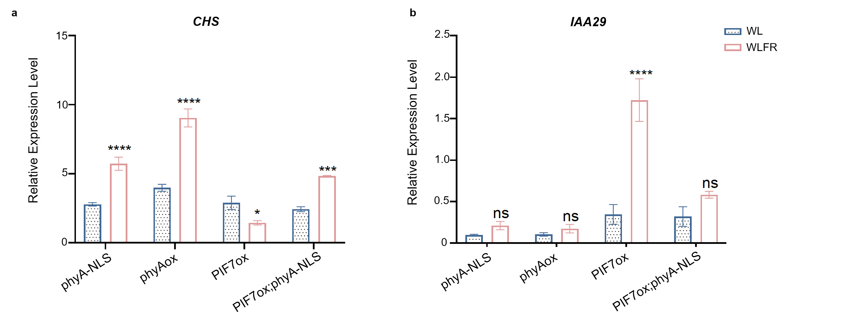
S5 phyA-NLS restores phyA control of CHS and IAA29 in PIF7ox seedlings.
Relative expression of CHS and IAA29 compared to PP2A internal control in phyA-NLS;phyA-201, phyAox, PIF7ox and PIF7ox;phyA-NLS;phyA-201. Samples were collected at ZT7 from 6d-old seedlings. Data are presented as mean values ± s.e.m., n=3 (biological repeats). A two-way ANOVA was conducted to assess statistical significance across light conditions for each genotype (α=0.05); asterisks denote significance relative to WL treatments: 0.1234 (ns), 0.0332 (*), 0.0021 (**), 0.0002 (***), P < 0.0001 (****).

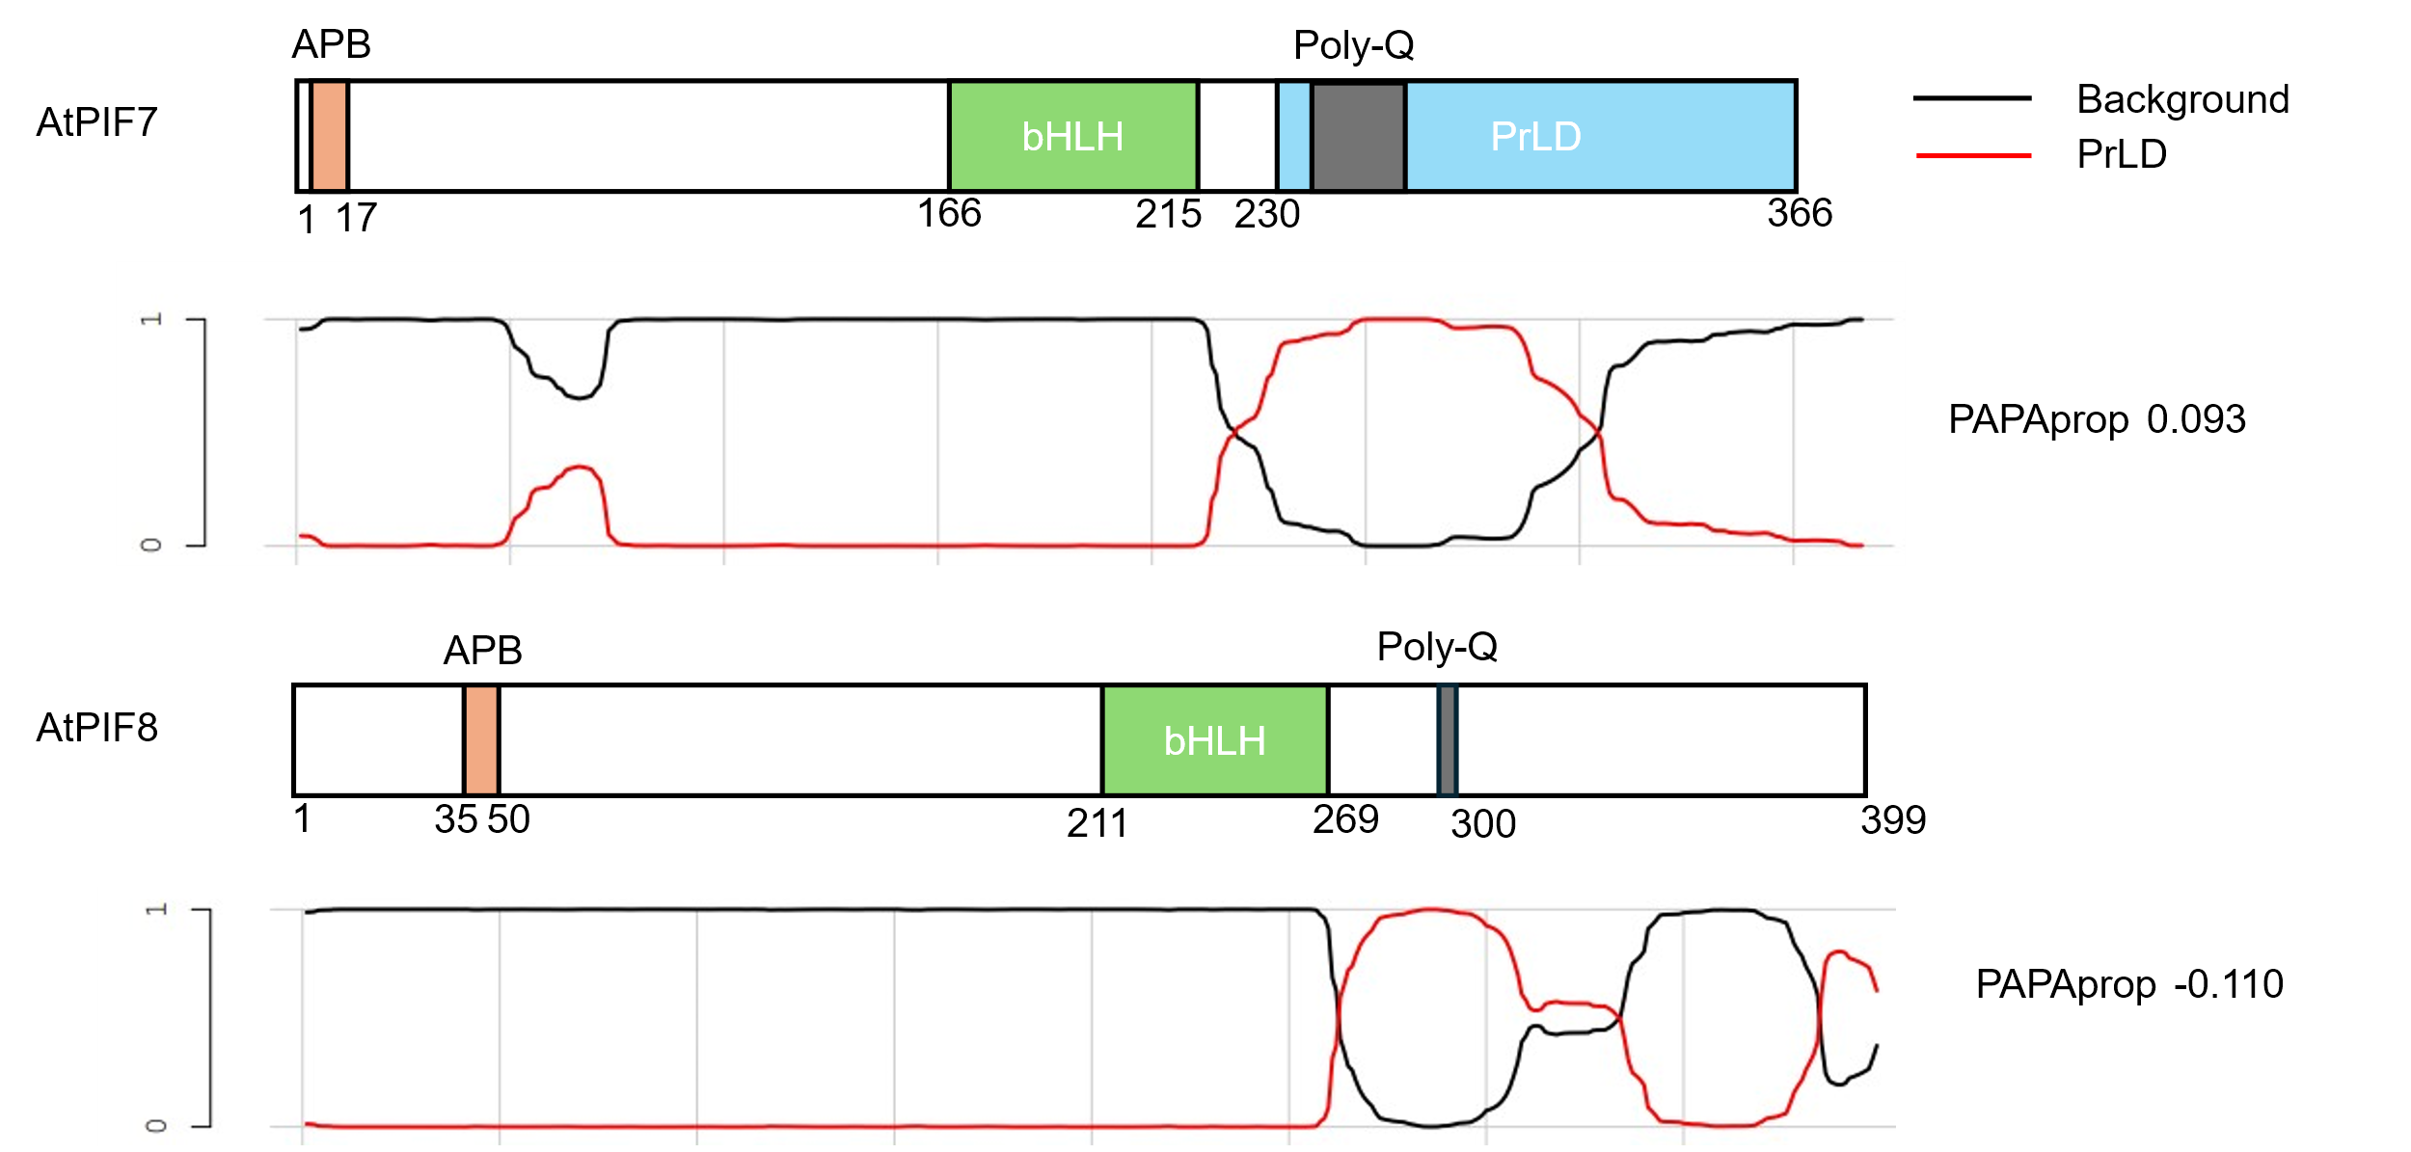
S6 Prion-Like Amino Acid Composition Prediction.
The Prion-Like Domain (PrLD) was predicted using the PLAAC tool: 'PLAAC: Finding Sequences with Prion-Like Amino Acid Composition' from MIT. PLAAC prediction (using Arabidopsis thaliana normalisation) applied to PIF7 and PIF8 protein structures; motif locations are shown in diagrams above. The red line traces indicate the PrLD prediction scores (ranging from 0 to 1), which rise in the C-terminal a regions of both genes, but most notably in PIF7. The PAPAprop score is a separate indicator of prion propensity, is higher ~0.01, again indicating the presence of PrLD.
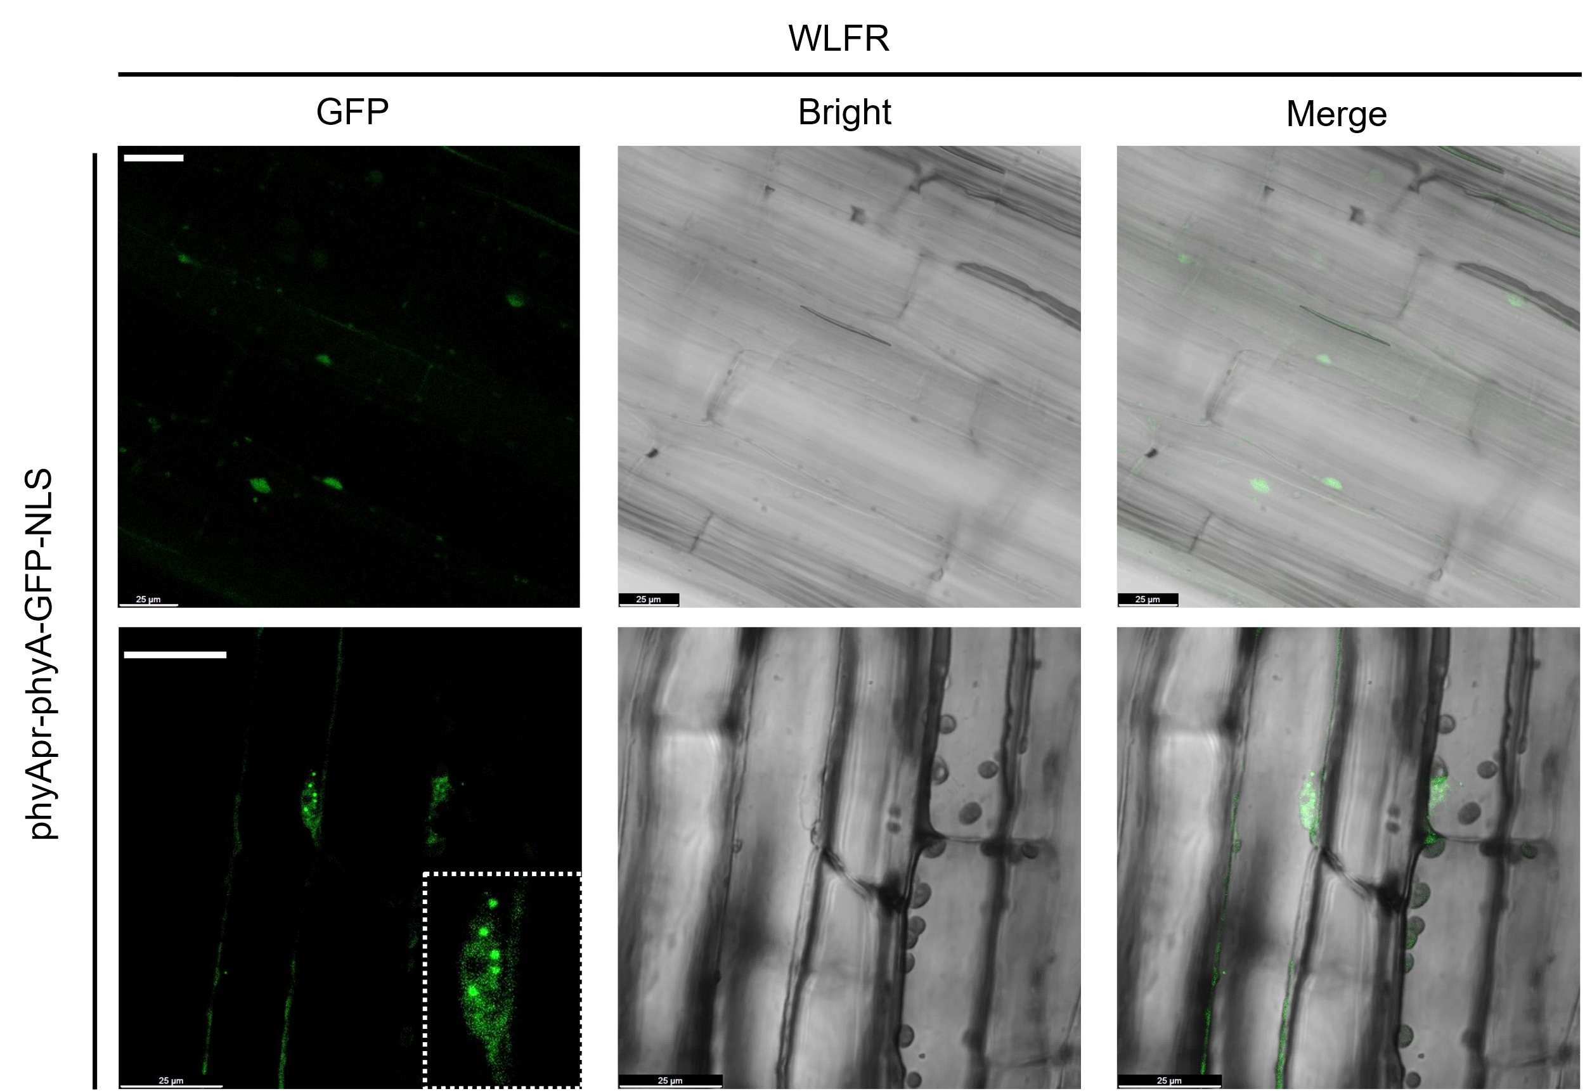
S7 phyA-GFP-NLS accumulates in nuclei and photobodies in WLFR conditions.
Images from the transgenic line pPHYA::PHYA-sGFP-NLS;phyA-201 are shown. GFP signals were observed using a 488 nm laser, and images were acquired at ZT7 following 6 days of WLFR treatment. The scale bar indicates 25 μm. Representative images from three independent replicates are shown.

