Table 1. Amide Synthesis by Carboxylic Acid Reshuffling ^{a,b}

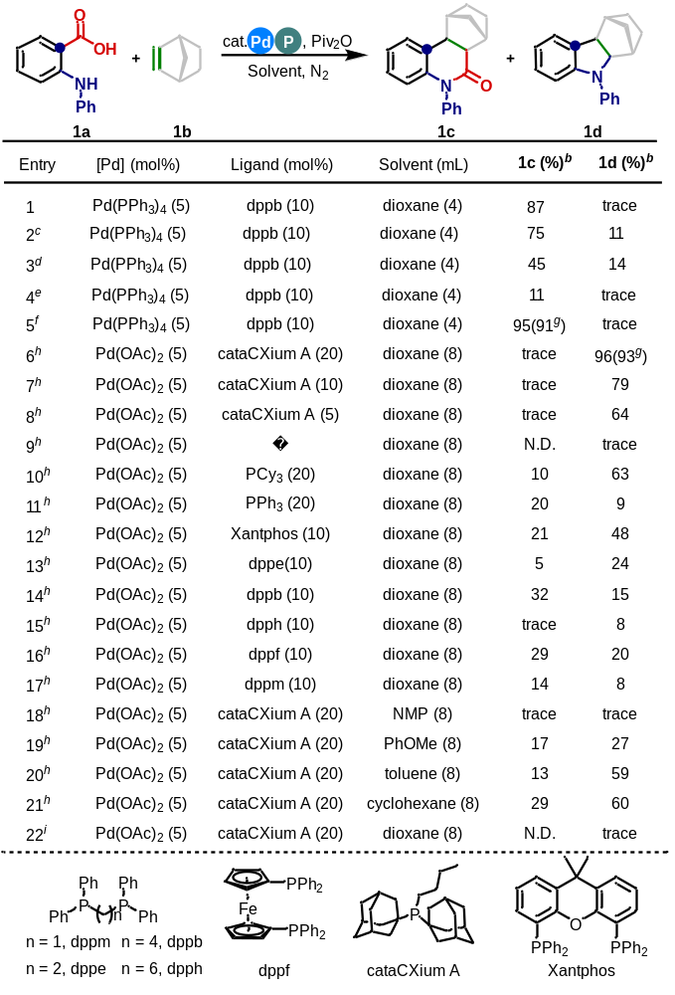

ªReaction conditions: 1a (0.2 mmol), 1b (0.8 mmol), Pd(PPh₃)₄ (5 mol%), dppb (10 mol%), Piv₂O (2 equiv), dioxane (4 mL), 110 °C, N₂, 12 h. ^{b}GC yield using tridecane as an internal standard. ^{c}130 ºC. ^{d}140 ºC. ^{e}90 °C. ^{f}24 h. ^{g}Isolated yield. ^{h}1.5 equiv Piv₂O, 2 equiv 1b, 150 °C. ^{i}Without Piv₂O, 2 equiv 1b, 150 °C.

Table 2. Substrate Scope of Amide Synthesis by Carboxylic Acid Reshuffling ^{a,b}

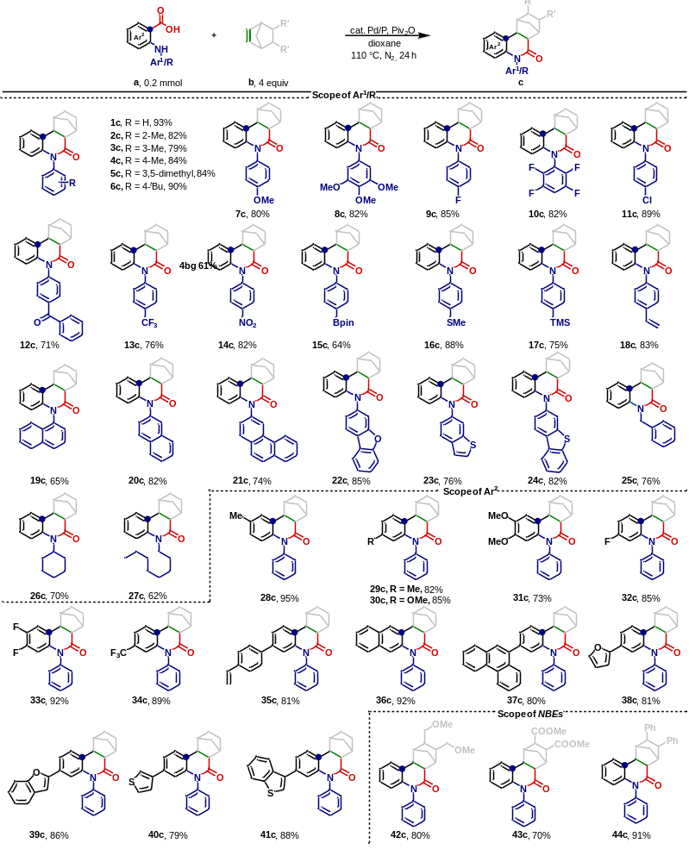

ªReaction conditions: benzoic acid a (0.2 mmol), alkene b (4 equiv), Pd(PPh₃)₄ (5 mol%), dppb (10 mol%), Piv₂O (2 equiv), dioxane (4 mL), 110 °C, N₂, 24 h. ^{b}Isolated yields.

Table 3. Substrate Scope of Decarbonylative Amination ^{a,b}

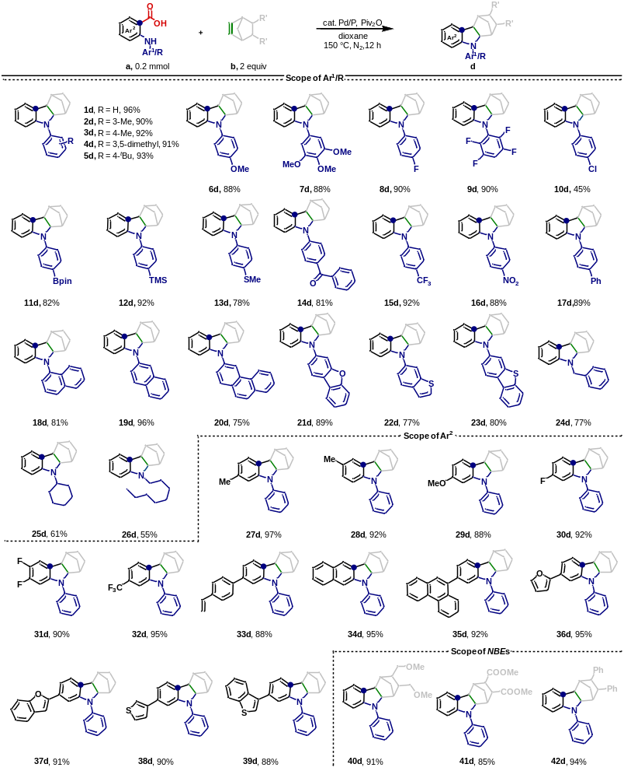

ªReaction conditions: benzoic acid a (0.2 mmol), alkene b (2 equiv), Pd(OAc)₂ (5 mol%), cataCXium A (20 mol%), Piv₂O (1.5 equiv), dioxane (8 mL), 150 °C, N₂, 12 h. ^{b}Isolated yields.

Table 4. Modification of Pharmaceuticals and Bioactive Molecules

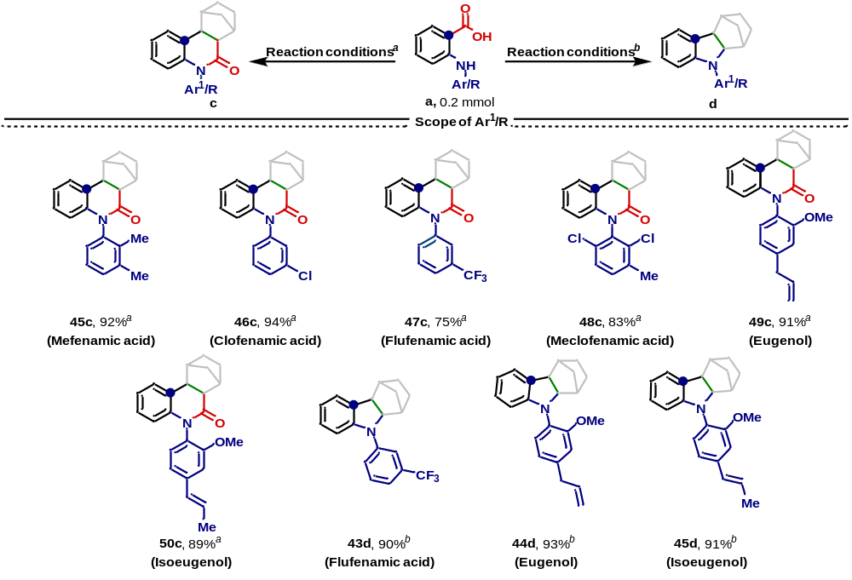

ªReaction conditions: benzoic acid a (0.2 mmol), NBE 1b (4.0 equiv), Pd(PPh₃)₄ (5 mol%), dppb (10 mol%), Piv₂O (2 equiv), dioxane (4 mL), 110 °C, N₂, 24 h; ^{b}Reaction conditions: benzoic acid a (0.2 mmol), alkene b (2.0 equiv), Pd(OAc)₂ (5 mol%), cataCXium A (20 mol%), Piv₂O (1.5 equiv), dioxane (8 mL), 150 °C, N₂, 12 h. Isolated yields.

Table 5. Substrate Scope of Linear Amide Synthesis by Carboxylic Acid Reshuffling

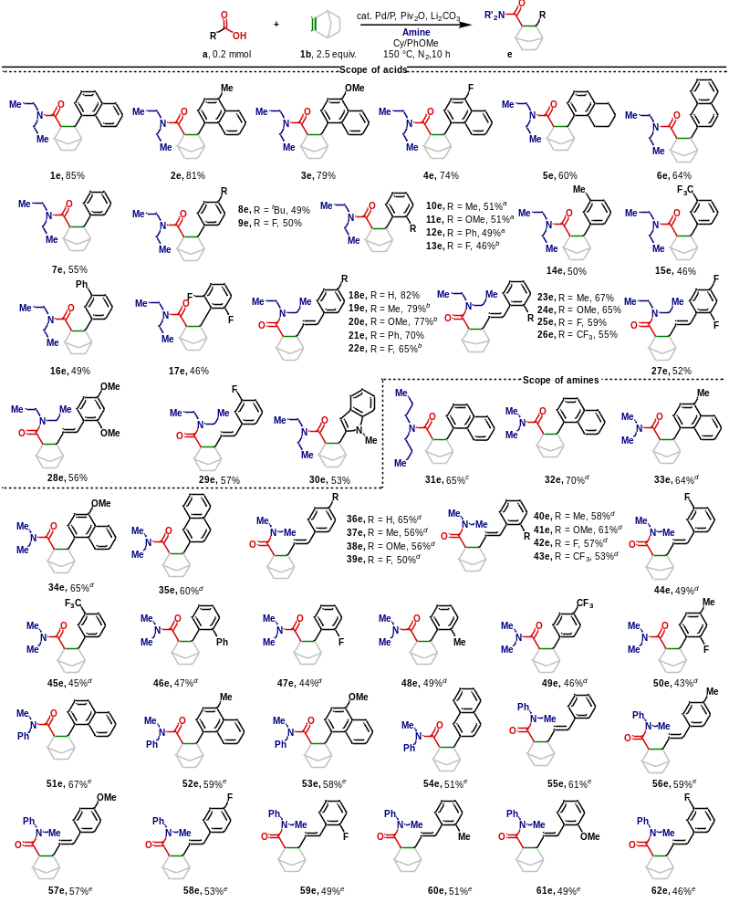

Reaction conditions: acid a (0.2 mmol), NBE 1b (2.5 equiv.), Et₃N (3 equiv.), Pd₂(dba)₃ (2.5 mol%), Xphos (10 mol%), (4-F-Ph)₃P (1 mol%), Piv₂O (1.5 equiv.), Li₂CO₃ (1 equiv.), Solvent (Cyclohexane:Anisole = 1:1, 1 mL), 150 ºC, N₂, 10 h. Isolated yields. ªPd(dba)₂ (5 mol%) instead of Pd₂(dba)₃. ^{b}Pd(acac)₂ (5 mol%) instead of Pd₂(dba)₃. ^{c}Tripropylamine instead of Et₃N. ^{d}DMF instead of Et₃N. ^{e}N-Methylformanilide instead of Et₃N.

