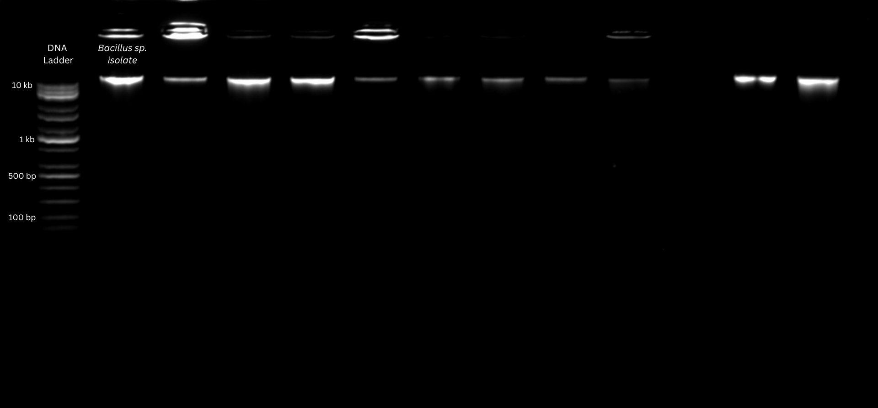
Supplementary Figure 2. Results of genomic DNA Extraction of Bacillus sp. isolate run on agarose gel electrophoresis using 1.2% VivantisTM agarose, 0.5 ul Sigma AldrichTM Ethidium bromide and 40 mL of 1X TBE Buffer. Vivantis 1kb Plus ladder was used as reference for the DNA sizes. A volume of 2 ul Vivantis Loading dye and 3 ul DNA sample was loaded on the agarose wells for 30 minutes at 100 volts using MupidOneTM gel electrophoresis system.

