Supplementary Information for
Programmable spinning of integrated circuit fibers
Fengqiang Sun¹, Fen Jiang¹, Kaige Wang¹, Weichu Chen¹, Futeng·Liu², Yida Hong¹, Xingbo Han¹, Mingbo Zhao², Yuwen Zhu¹, Hengda Sun¹*, Hongzhi Wang¹, Meifang Zhu¹, Gang Wang¹*

¹State Key Laboratory of Advanced Fiber Materials, College of Materials Science and Engineering, Donghua University, Shanghai 201620, P. R. of China.
²College of Information Science and Technology, Donghua University, Shanghai 201620, P. R. of China.

Contents
Supplementary Fig. 1 | Microfluidic spinning system. 4
Supplementary Fig. 2 | Size design of five-channel microfluidic chip. 4
Supplementary Fig. 3 | Microfluidic switching coding and fluid micrographs. 5
Supplementary Fig. 4 | Fiber spinning waveform and layered fiber photos. 5
Supplementary Fig. 5 | Single integrated fiber coding diagram. 5
Supplementary Fig. 6 | Segmented-layered fiber time gradient coding. 6
Supplementary Fig. 7 | Segmented-layered fiber spacing coding. 6
Supplementary Fig. 8 | Viscosity curves of various spinning solutions. 6
Supplementary Fig. 9 | The relationship between Ag:TPU ratios and electrical conductivity. 7
Supplementary Fig. 10 | Optical and structural characterization of EL-IC fibers. 7
Supplementary Fig. 11 | Characterization of EL-IC fibers. 8
Supplementary Fig. 12 | Optical, mechanical properties and SEM images of EL-IC fibers. 8
Supplementary Fig. 13 | The element distribution of fiber capacitor section in RC-IC fibers at different spinning flow rates. 9
Supplementary Fig. 14 | The performance curve of RC integral circuit. 9
Supplementary Fig. 15 | The performance curve of RC differential circuit. 10
Supplementary Fig. 16 | Photos of OECT-IC fibers. 10
Supplementary Fig. 17 | Transfer curves of a single device of two parallel OECTs in an OECT-IC fiber. 10
Supplementary Fig. 18 | Transfer and output curves of a single device of three parallel OECTs in an OECT-IC fiber. 11
Supplementary Fig. 19 | Capacitance and resistance performance test of EQS-IC fiber. 11
Supplementary Fig. 20 | Simulate the effect on the electrostatic field at different distances from the target to the EWM-IC fiber. 12
Supplementary Fig. 21 | Schematic diagram of the positioning calculation method. 12
Supplementary Fig. 22 | Use four EQS-IC fibers to control the movement of virtual drone. 12
Supplementary Fig. 23 | Use four EQS-IC fibers to control the movement of the robot arm. 13
Supplementary Fig. 24 | Use four EQS-IC fibers to control the drone movement. 13
Supplementary Discussion 1. Deriving system models from the equivalent circuit 13
Supplementary Discussion 2. Spatial positioning method of four EQS-IC fibers 14
References 17

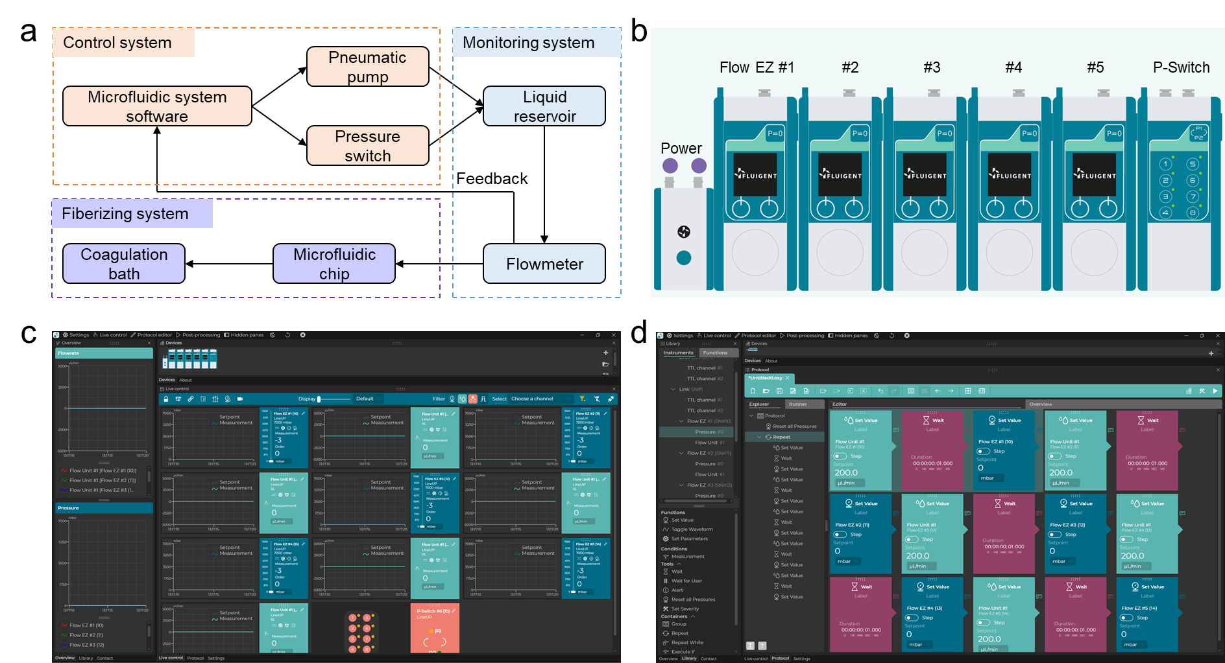
Supplementary Fig. 1 | Microfluidic spinning system. a. Flow chart of microfluidic spinning. b. Equipment diagram of high-precision pneumatic pump and the P-Switch. c. User Interface and (d) fluid coding interface of the microfluidic system software.
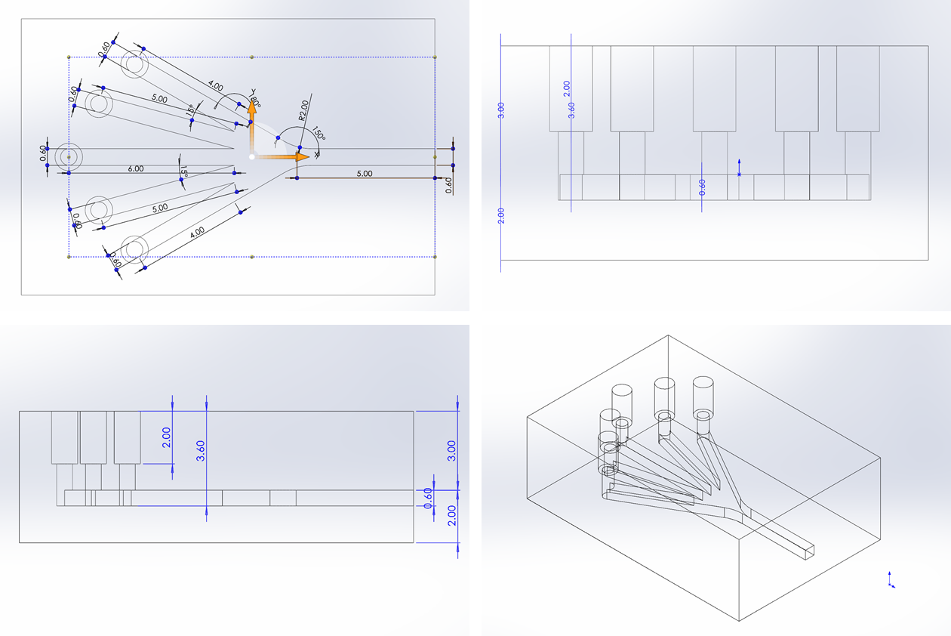

Supplementary Fig. 2 | Size design of five-channel microfluidic chip.
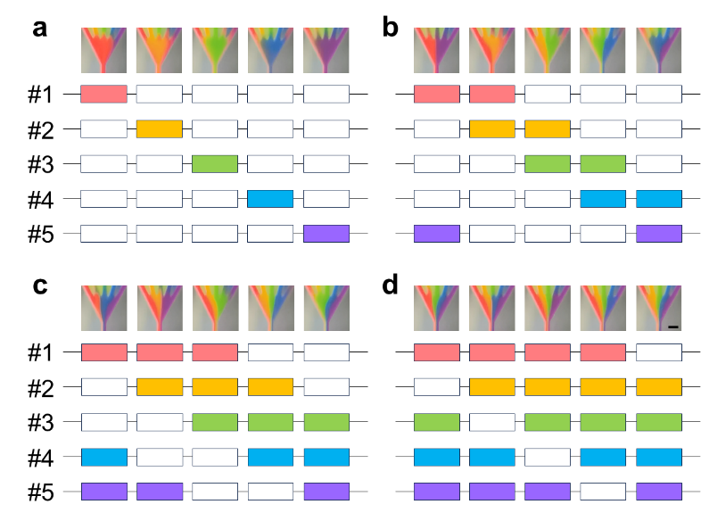
Supplementary Fig. 3 | Microfluidic switching coding and fluid micrographs. Scale bar: 1 mm.
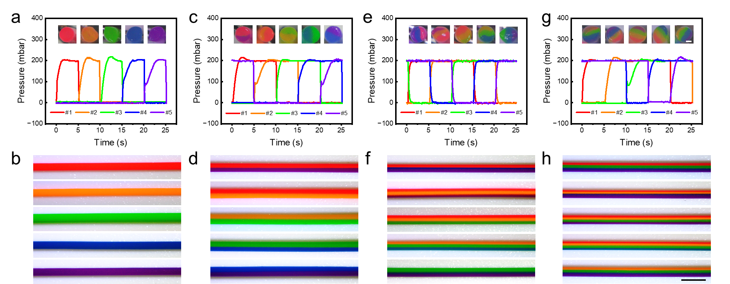
Supplementary Fig. 4 | Fiber spinning waveform and layered fiber photos. Scale bar: a, c, e, g, 0.2 mm, b, d, f, h, 1 mm.
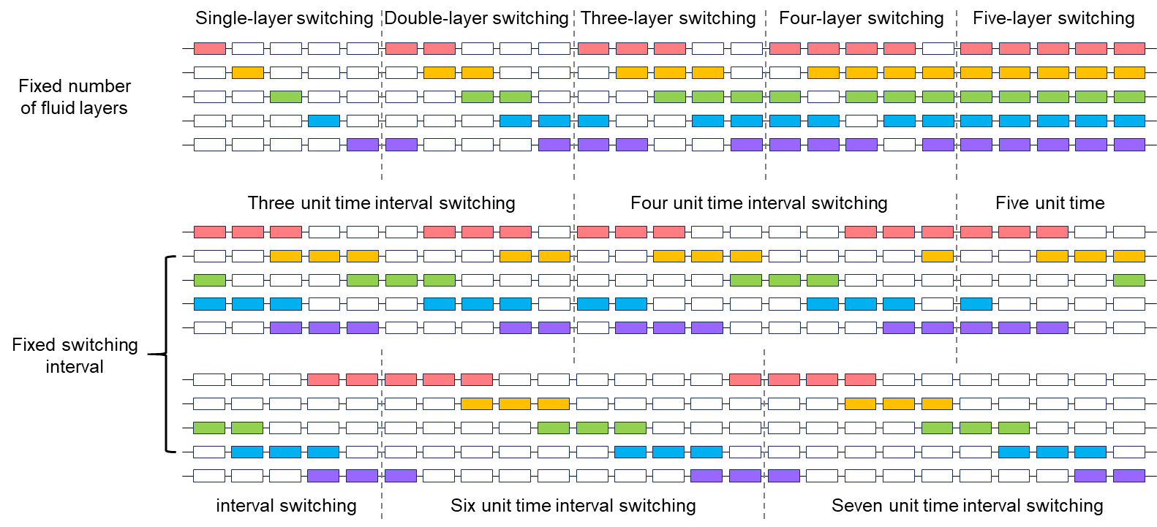

Supplementary Fig. 5 | Single integrated fiber coding diagram.
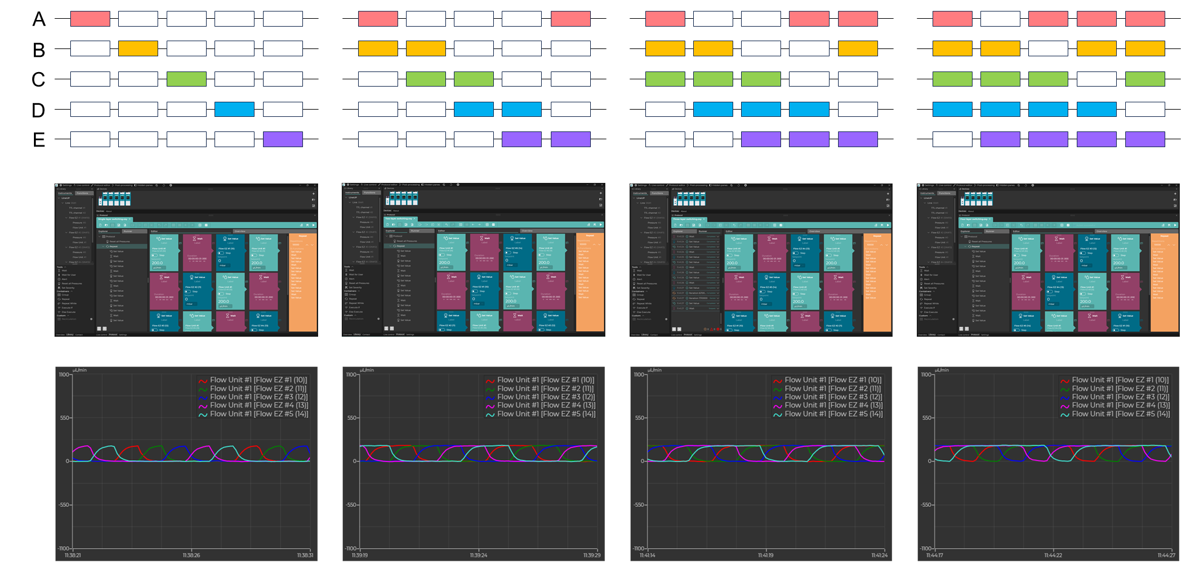

Supplementary Fig. 6 | Segmented-layered fiber time gradient coding.
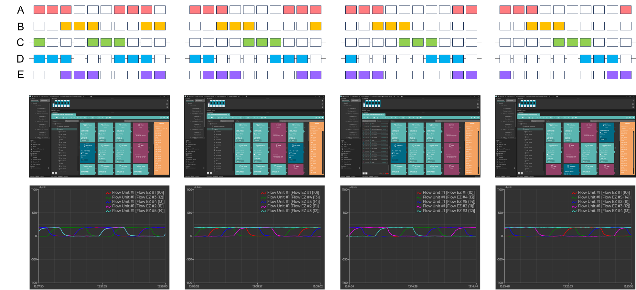

Supplementary Fig. 7 | Segmented-layered fiber spacing coding.
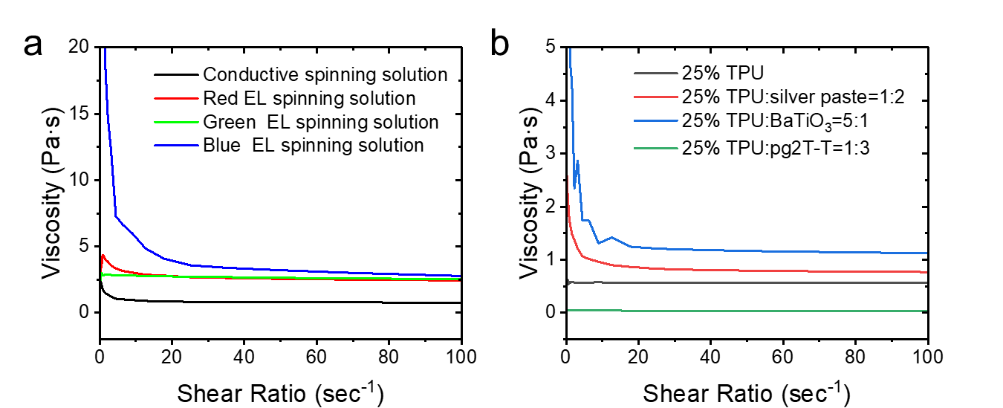

Supplementary Fig. 8. | Viscosity curves of various spinning solutions.
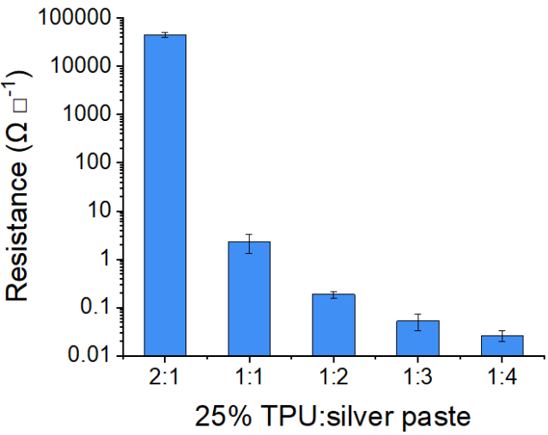

Supplementary Fig. 9 | The relationship between Ag:TPU ratios and electrical conductivity.
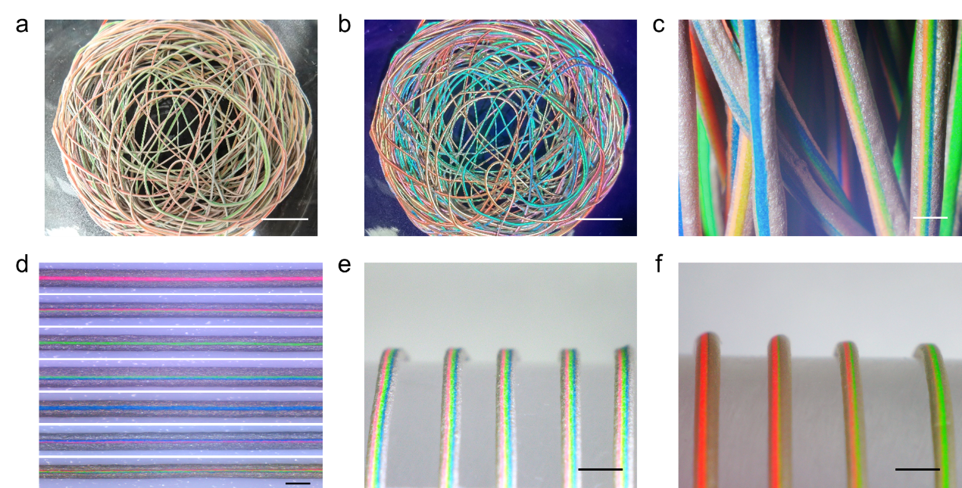
Supplementary Fig. 10 | Optical and structural characterization of EL-IC fibers. Photographs of EL-IC fibers under ambient light (a) and UV excitation (b) during spinning. c. Magnified view of dried EL-IC fibers from (a) and (b). d. EL-IC fibers with segment-specific RGB emission under UV light. e. Photograph of EL-IC fibers with continuous RGB layer stacking. f. EL-IC fibers encoded with waveform modulation. Scale bar: a, b, 1cm. c, d, 0.5 mm. e, f, 1 mm.
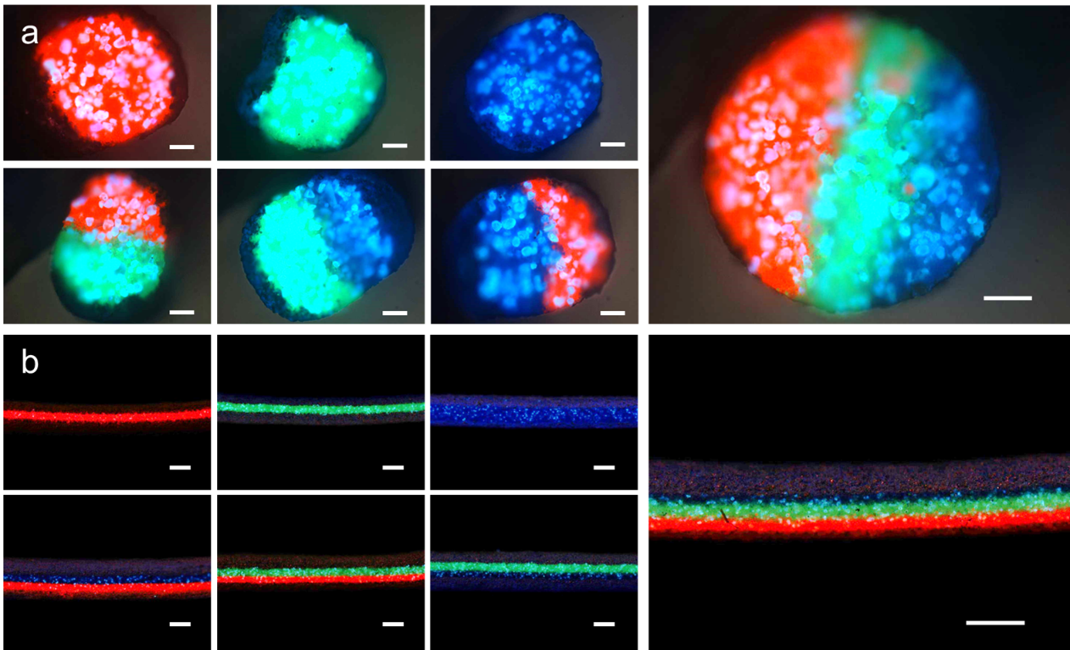
Supplementary Fig. 11. | Characterization of EL-IC fibers. a. Cross-sectional and (b) side-view fluorescence microscope of EL-IC fibers. Scale bar: a, 0.1 mm. b, 0.5 mm.
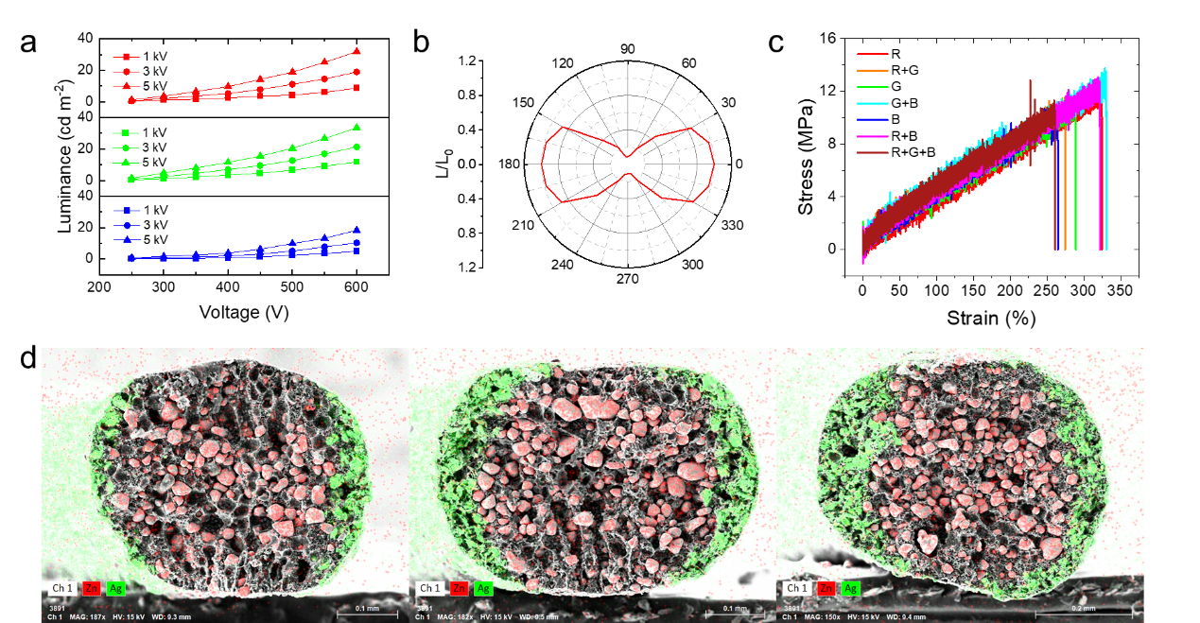
Supplementary Fig. 12 | Optical, mechanical properties and SEM images of EL-IC fibers. a. Luminance-voltage response curves of red, green, and blue EL-IC fibers. b. Luminance distribution around the EL-IC fiber. c. Mechanical properties of EL-IC fibers. d. The element distribution of EL-IC fibers at different spinning flow rates.
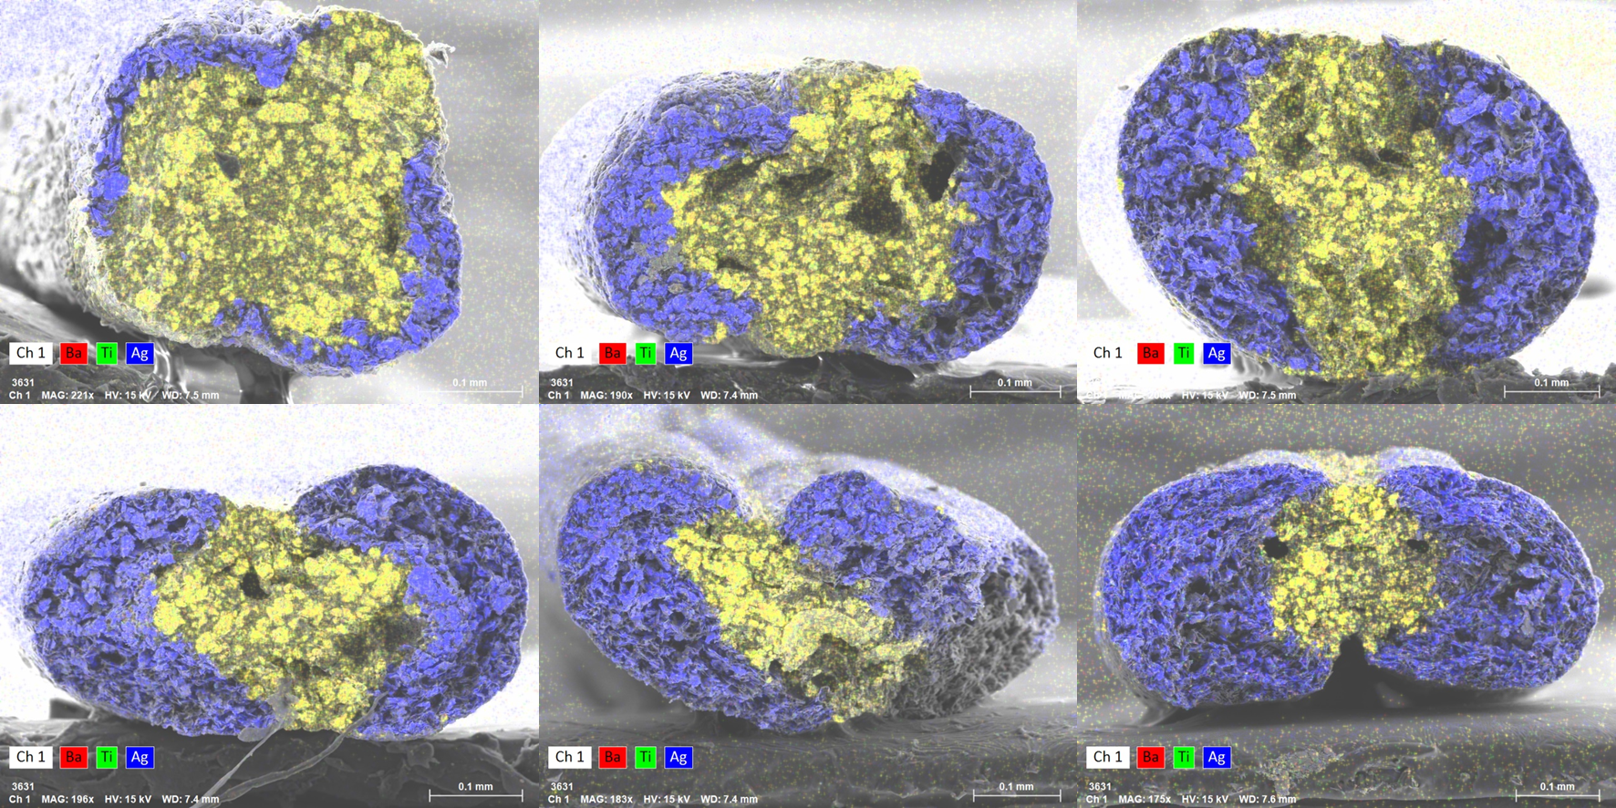

Supplementary Fig. 13 | The element distribution of fiber capacitor section in RC-IC fibers at different spinning flow rates.
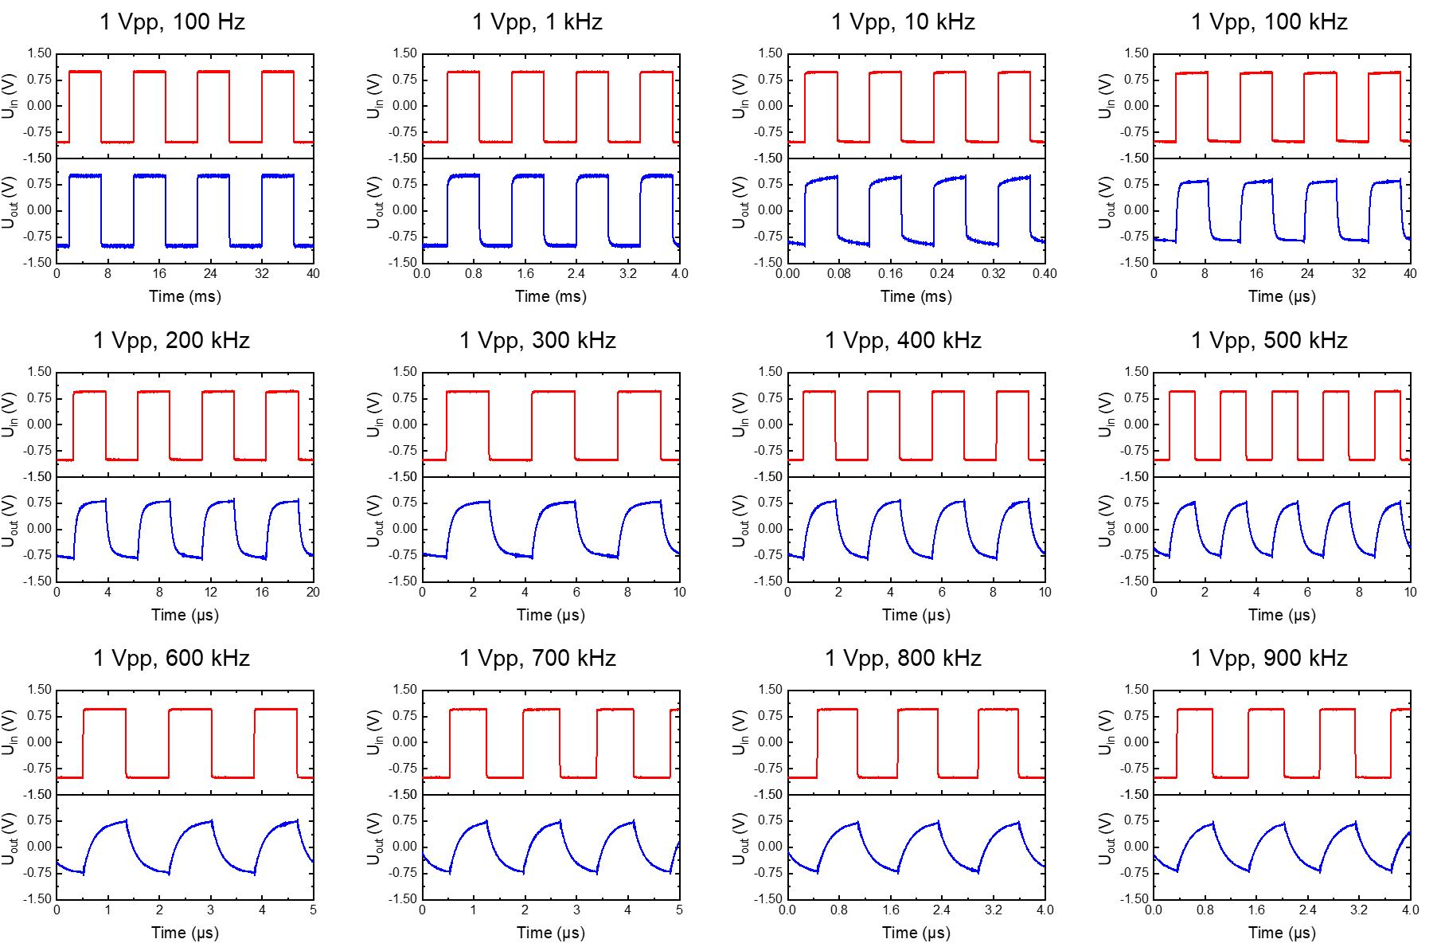

Supplementary Fig. 14 | The performance curve of RC integral circuit.

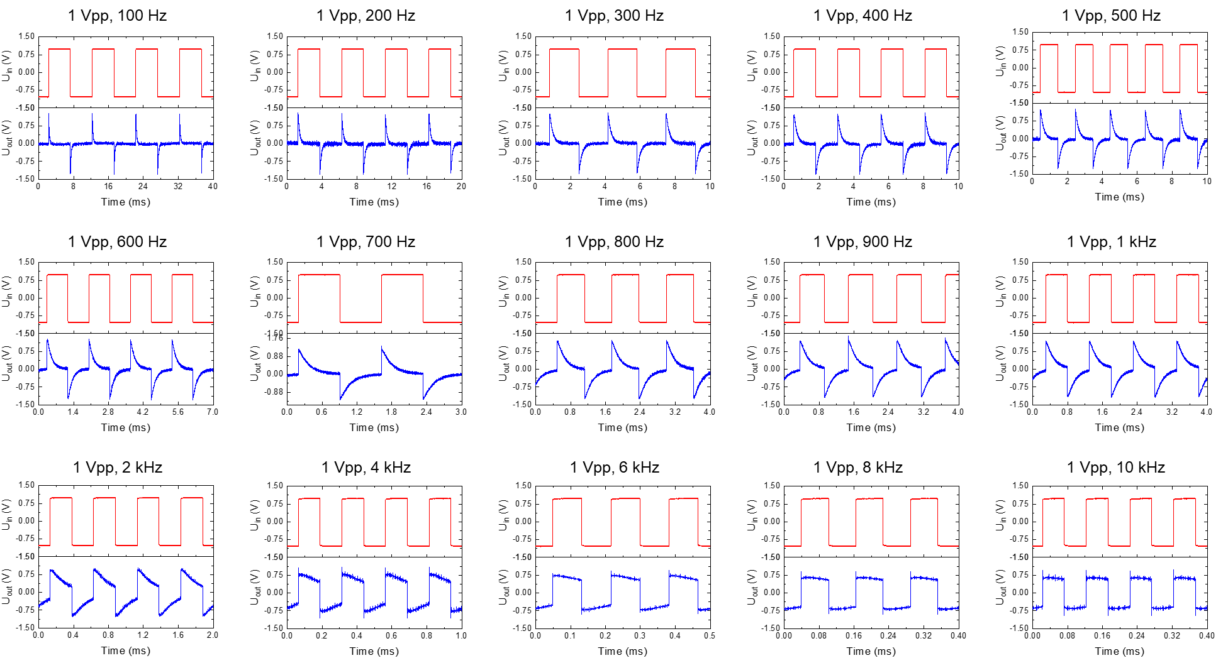

Supplementary Fig. 15 | The performance curve of RC differential circuit.
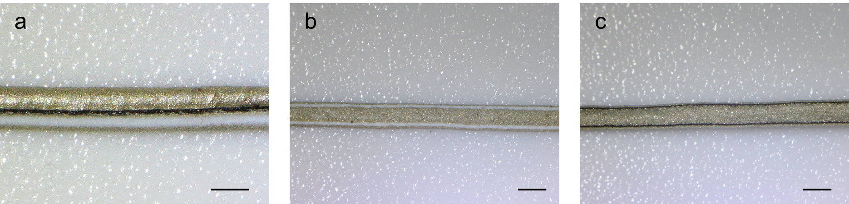
Supplementary Fig. 16 | Photos of OECT-IC fibers. Scale bar: 0.5 mm.
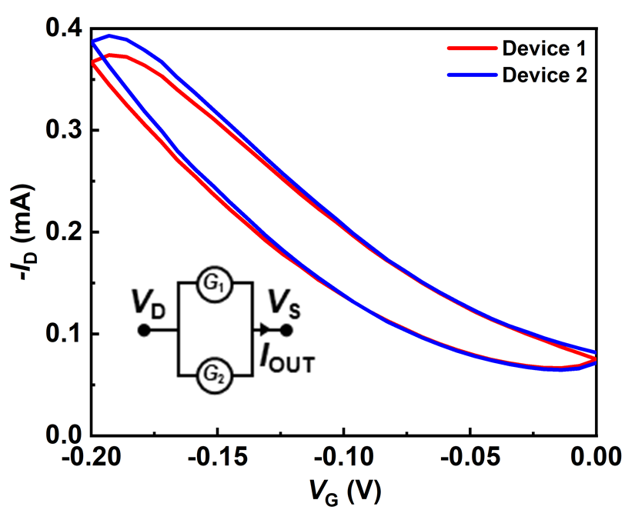

Supplementary Fig. 17 | Transfer curves of a single device of two parallel OECTs in an OECT-IC fiber.
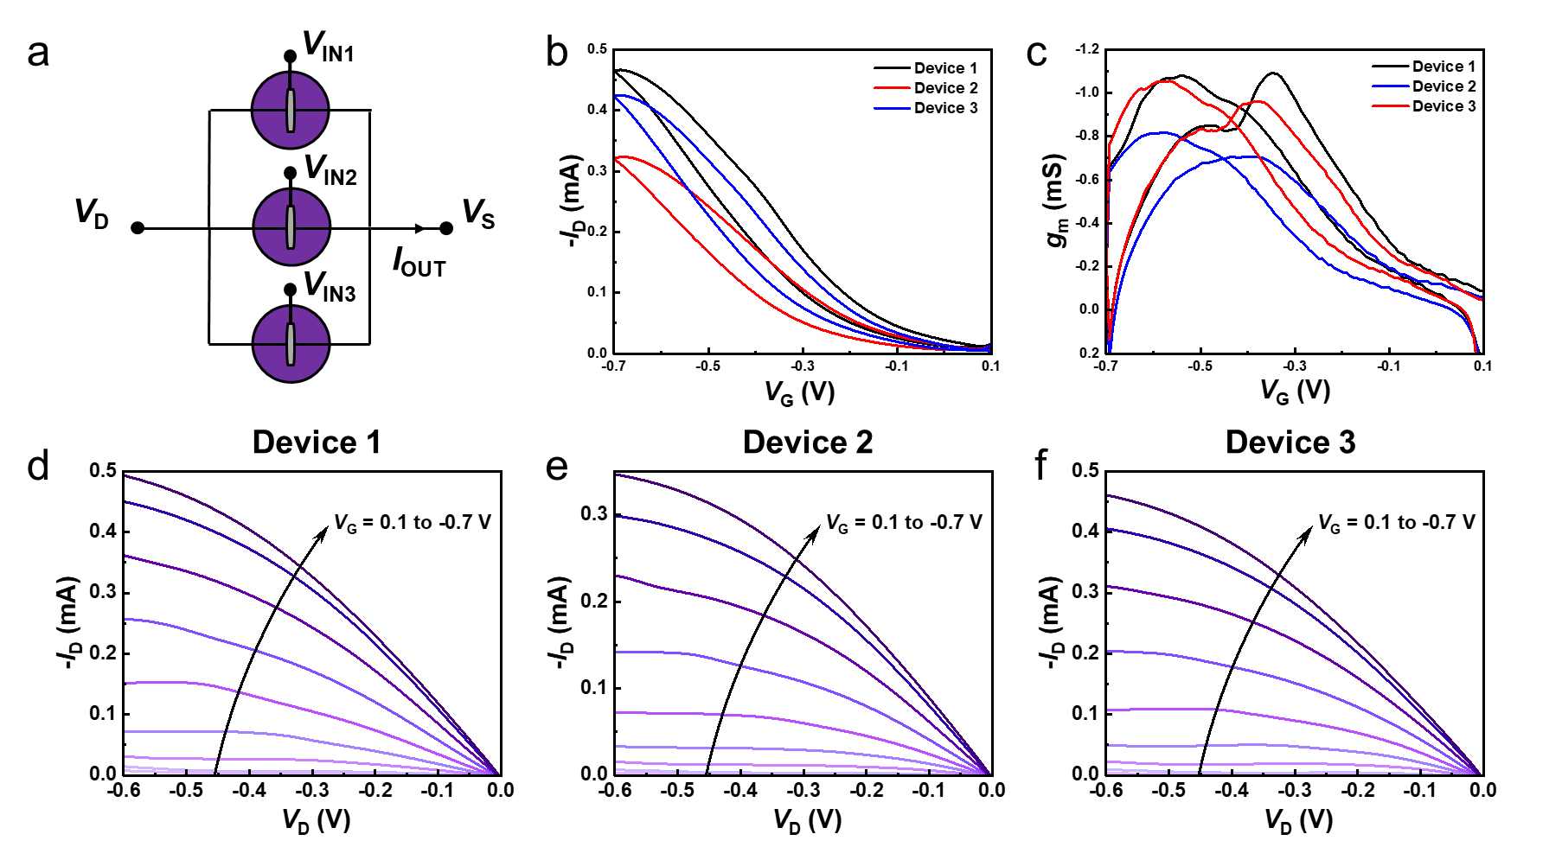

Supplementary Fig. 18 | Transfer and output curves of a single device of three parallel OECTs in an OECT-IC fiber.
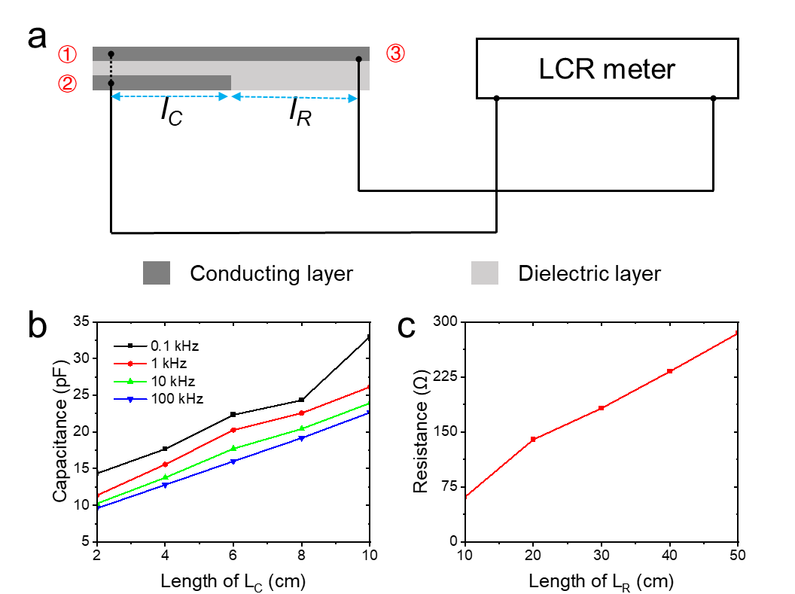
Supplementary Fig. 19 | Capacitance and resistance performance test of EQS-IC fiber. (a) Schematic diagram of capacitance and resistance test method. (b) The capacitance value changes corresponding to different capacitance segments when the fixed resistance segment length is 10 cm. (c) The resistance value changes corresponding to different resistance segments when the fixed capacitance segment length is 10 cm.
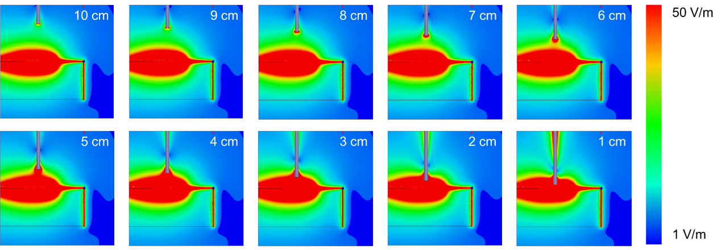

Supplementary Fig. 20 | Simulate the effect on the electrostatic field at different distances from the target to the EWM-IC fiber.
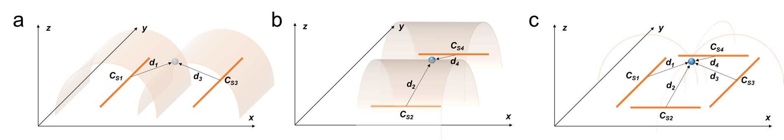
Supplementary Fig. 21 | Schematic diagram of the positioning calculation method. (a, b) Two parallel EQS-IC fibers can locate an equidistant line. (c) Four EQS-IC fibers can locate a point.¹

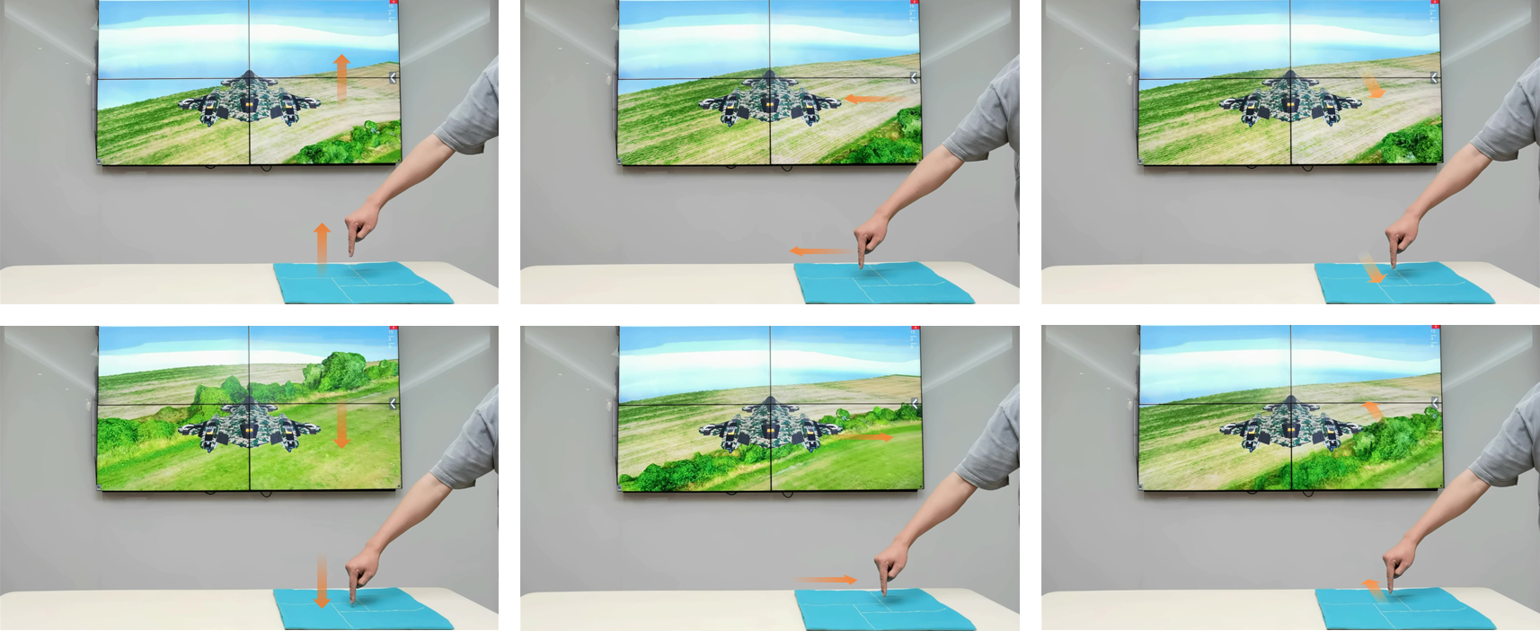

Supplementary Fig. 22 | Use four EQS-IC fibers to control the movement of virtual drone.
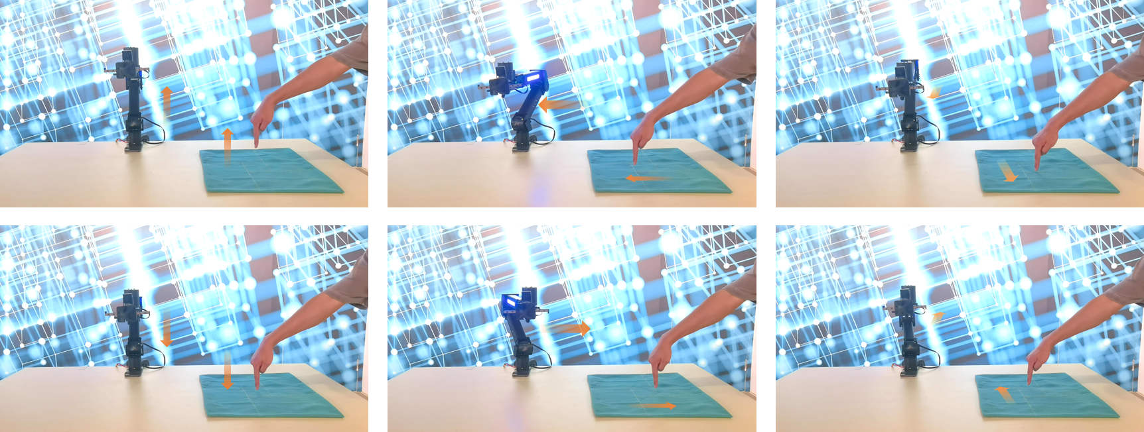

Supplementary Fig. 23 | Use four EQS-IC fibers to control the movement of the robot arm.
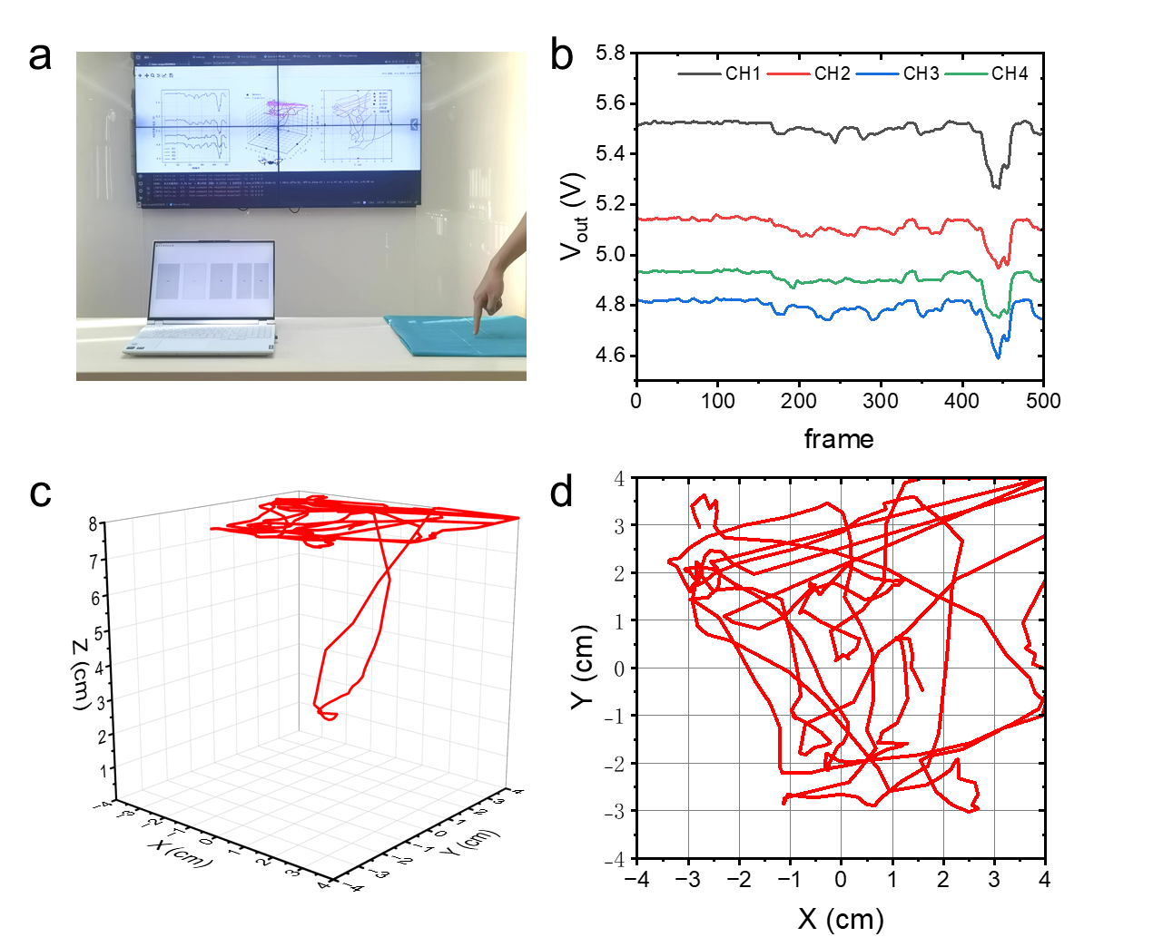

Supplementary Fig. 24 | Use four EQS-IC fibers to control the drone movement.

Supplementary Discussion 1. Deriving system models from the equivalent circuit
As illustrated in Fig. 5a, multiple capacitive couplings are established among the target object (e.g., a hand), the EQS-IC fiber, and the ground.¹ Based on the principle of capacitive voltage division, the voltage V_{Rx} received at the Rx electrode can be expressed as:
$V_{Rx}=V_{Tx}×\frac{C_{s}}{C_{s}+C_{RG}+\frac{C_{H}C_{HG}+C_{H}C_{GND}+C_{HG}C_{GND}}{C_{H}C_{HG}C_{GND}}}$ (S1)
If the system ground is directly connected to earth ground, the equivalent circuit simplifies, and the expression reduces to:
$V_{Rx}=V_{Tx}×\frac{C_{s}}{C_{s}+C_{RG}+\frac{C_{H}C_{HG}}{C_{H}+C_{HG}}}$ (S2)
where $C_{s}$ is the capacitance of the sensing segment (Tx to Rx), $C_{RG}$ is the parasitic capacitance from the Rx electrode to ground, $C_{H}$, $C_{HG}$ and $C_{GND}$ represent the capacitive paths formed between the human body, system, and ground.¹

Supplementary Discussion 2. Spatial positioning method of four EQS-IC fibers
The touchless sensing range of a single fiber forms a cylindrical detection zone, within which the signal intensity remains constant along surfaces equidistant from the fiber. When two fibers are present, their cylindrical sensing zones intersect, and the signal intensity is equal along their intersection line at the same distance from each fiber. With four fibers, the position of a target object can be uniquely determined at the point where all sensing signals converge. Increasing the number of fibers further improves localization accuracy. As shown in Supplementary Fig. 21, we employ a basic configuration of four fibers arranged to form an 8 × 8 cm square, with the touchless sensing segments of each fiber positioned along the four edges of the square to enable 3D spatial localization.
1. System Geometry Model
We define the origin O of a three-dimensional Cartesian coordinate system at the center of a square located in the XY plane (i.e., z = 0). Four EQS-IC fibers (F1–F4) are positioned along the four edges of an 8 × 8 cm square as follows:
F1: along the line y = -4 cm, with x ∈ [-4 cm, 4 cm], z = 0
F2: along the line x = 4 cm, with y ∈ [-4 cm, 4 cm], z = 0
F3: along the line y = 4 cm, with x ∈ [-4 cm, 4 cm], z = 0
F4: along the line x = -4 cm, with y ∈ [-4 cm, 4 cm], z = 0
2. Distance Measurement Model
Let the target point be T(x, y, z) with z > 0. The perpendicular distance from T to each fiber (modeled as a straight line segment) can be calculated using standard point-to-line formulas:
$\left\{\begin{aligned}d_{1}=\sqrt{{\left(y+4\right)}^{2}+z^{2}} \\ d_{2}=\sqrt{{\left(x-4\right)}^{2}+z^{2}} \\ d_{3}=\sqrt{{\left(y-4\right)}^{2}+z^{2}} \\ d_{4}=\sqrt{{\left(x+4\right)}^{2}+z^{2}}\end{aligned}\right.$ (S3)
The above distance formulas are valid under the condition that the orthogonal projection of the target point onto the fiber lies within the line segment (-4 ≤ x ≤ 4 for F1 and F3, -4 ≤ y ≤ 4 for F2 and F4). If the projection falls outside the segment, the true shortest distance should instead be computed as the Euclidean distance from the target point to the nearest endpoint. However, in practical scenarios where the target is positioned above the central region of the square (z > 0), the projection typically lies within the segment. For the sake of accuracy and completeness, we therefore adopt the general method of calculating the shortest distance from a point to a finite line segment.
3. Point-to-Line Segment Distance Calculation
For any EQS-IC fiber defined by endpoints A and B, and a target point T, the minimum distance d from T to line segment AB is computed as follows:
- Compute vectors:
$\left\{\begin{aligned}\vec{AB}=B-A \\ \vec{AT}=T-A\end{aligned}\right.$ (S4)
- Compute projection ratio:
$t=\frac{\vec{AT}∙\vec{AB}}{{\left\|\vec{AB}\right\|}^{2}}$ (S5)
- Clamp t to [0, 1]:
$t_{c}=max(0,min(1,t))$ (S6)
- Compute foot of perpendicular (P):
$\vec{P}=\vec{A}+t_{c}∙\vec{AB}$ (S7)
- Compute distance:
$d=\left\|\vec{T}-\vec{P}\right\|$ (S8)
4. Localization Principle
The localization problem can be formulated as follows: Given four measured distances $d={\left[d_{1},d_{2},d_{3},d_{4}\right]}^{T}$, the goal is to estimate the 3D coordinates of the target point $x={\left[x,y,z\right]}^{T}$, such that
$d_{i}\left(x\right)=d_{i}^{means}, i=1,2,3,4$ (S9)
where $d_{i}\left(x\right)$ is the Euclidean distance from the estimated target position to the i-th EQS-IC fiber segment, computed based on the point-to-line segment distance model described above.
This results in an overdetermined and nonlinear system of equations, as there are four equations but only three unknowns. We therefore reformulate the problem as a nonlinear least-squares optimization:
$\min_{x}{\sum_{i=1}^{4}{{(d_{i}\left(x\right)-d_{i}^{means})}^{2}}}$ (S10)
This approach allows robust estimation of the target’s position by minimizing the total squared distance error with respect to the measured values from all four EMW-IC fibers.
5. Solution Method
We solve the above nonlinear least-squares optimization problem using the Levenberg–Marquardt (LM) algorithm, which combines the advantages of gradient descent and the Gauss–Newton method. LM offers strong robustness and fast convergence, making it well-suited for nonlinear parameter estimation problems. The specific steps are as follows:
① Initialization:
An initial guess for the target position is required. Since the object is typically located above the center of the square, we initialize the estimate as (0, 0, z₀), where 𝑧₀ is estimated from the measured distances—e.g., by taking the average of the four measured values as an initial approximation.
② Iterative update:
At each iteration 𝑘, the parameters are updated based on the Jacobian of the residuals:
$x_{k+1}=x_{k}-{\left(J_{k}^{T}J_{k}+λdiag\left(J_{k}^{T}J_{k}\right)\right)}^{-1}J_{k}^{T}r_{k}$ (S11)
where:
r_{k} is the residual vector, defined as the difference between computed and measured distances:$r_{k}={\left[d_{1}\left(x_{k}\right)-d_{1}^{means},⋯,d_{4}\left(x_{k}\right)-d_{4}^{means}\right]}^{T}$.
$J_{k}$ is the Jacobian matrix of residuals with respect to the parameters $x_{k}$.
$λ$ is the damping parameter, adjusted dynamically based on a trust-region strategy.
③ Convergence check:
The iteration terminates when the change in parameters or the decrease in the cost function falls below a predefined threshold, indicating convergence.
6. Jacobian Matrix Computation
The Jacobian matrix J contains the partial derivatives of the residuals with respect to the position parameters (x,y,z). For the i-th fiber, the residual is defined as:
$r_{i}=d_{i}\left(x\right)-d_{i}^{means}$ (S12)
where $d_{i}\left(x\right)=\left\|T-P_{i}\right\|$, and $P_{i}$ is the foot of the perpendicular from the target point T=(x,y,z) to the i-th fiber segment. The derivative of $r_{i}$ with respect to x (similarly for y and z) is:
$\frac{{∂r}_{i}}{∂x}=\frac{{∂d}_{i}}{∂x}=\frac{{\left(T-P_{i}\right)}^{T}}{d_{i}}∙\frac{∂\left(T-P_{i}\right)}{∂x}$ (S13)
When $P_{i}$ lies within the segment (i.e., 0<t<1), $P_{i}$ is the orthogonal projection of T onto the line segment, and it does not vary with small changes in T. Hence,
$\frac{{∂P}_{i}}{∂x}=0$ (S14)
and the partial derivative simplifies to:
$\frac{{∂d}_{i}}{∂x}=\frac{x-P_{i,x}}{d_{i}}$, $\frac{{∂d}_{i}}{∂y}=\frac{y-P_{i,y}}{d_{i}}$, $\frac{{∂d}_{i}}{∂z}=\frac{z-P_{i,z}}{d_{i}}$ (S15)
When the foot $P_{i}$ falls outside the segment, i.e., on an endpoint, the shortest distance is from T to the nearest endpoint (Ai or Bi). In this case, we compute the derivative with respect to the corresponding endpoint: $\frac{{∂d}_{i}}{∂x}=\frac{x-A_{i,x}}{d_{i}}$ or $\frac{x-B_{i,x}}{d_{i}}$, depending on which endpoint is closer.

References
1. Zhou, J. et al. Mormyroidea-inspired electronic skin for active non-contact three-dimensional tracking and sensing. Nat. Commun. 15, 9875 (2024).

