Supporting Information for:

Phosphorus recovery by a novel electrochemical process integrating siderite and calcite: Efficacy, mechanism and optimization

Ran Mao^{b,c}, Ziyu Zhang^{b,c}, Jingwei Haoª*, Jiawei Tangª, Weiyue Dang^{b,c}, Xu Zhao^{b,c}
ªNational Institute of Low Carbon and Clean Energy, State Key Laboratory of Water Resource Protection and Utilization in Coal Mining, Beijing 102211, P.R. China
^{b}Key Laboratory of Environmental Aquatic Chemistry, State Key Laboratory of Regional Environment and Sustainability, Research Center for Eco-Environmental Sciences, Chinese Academy of Sciences, Beijing 100085, P.R. China
^{c}University of Chinese Academy of Sciences, Beijing 100049, P.R. China

*Corresponding author: Tel.: +86-10-57595677;
E-mail address: haojingweii@163.com

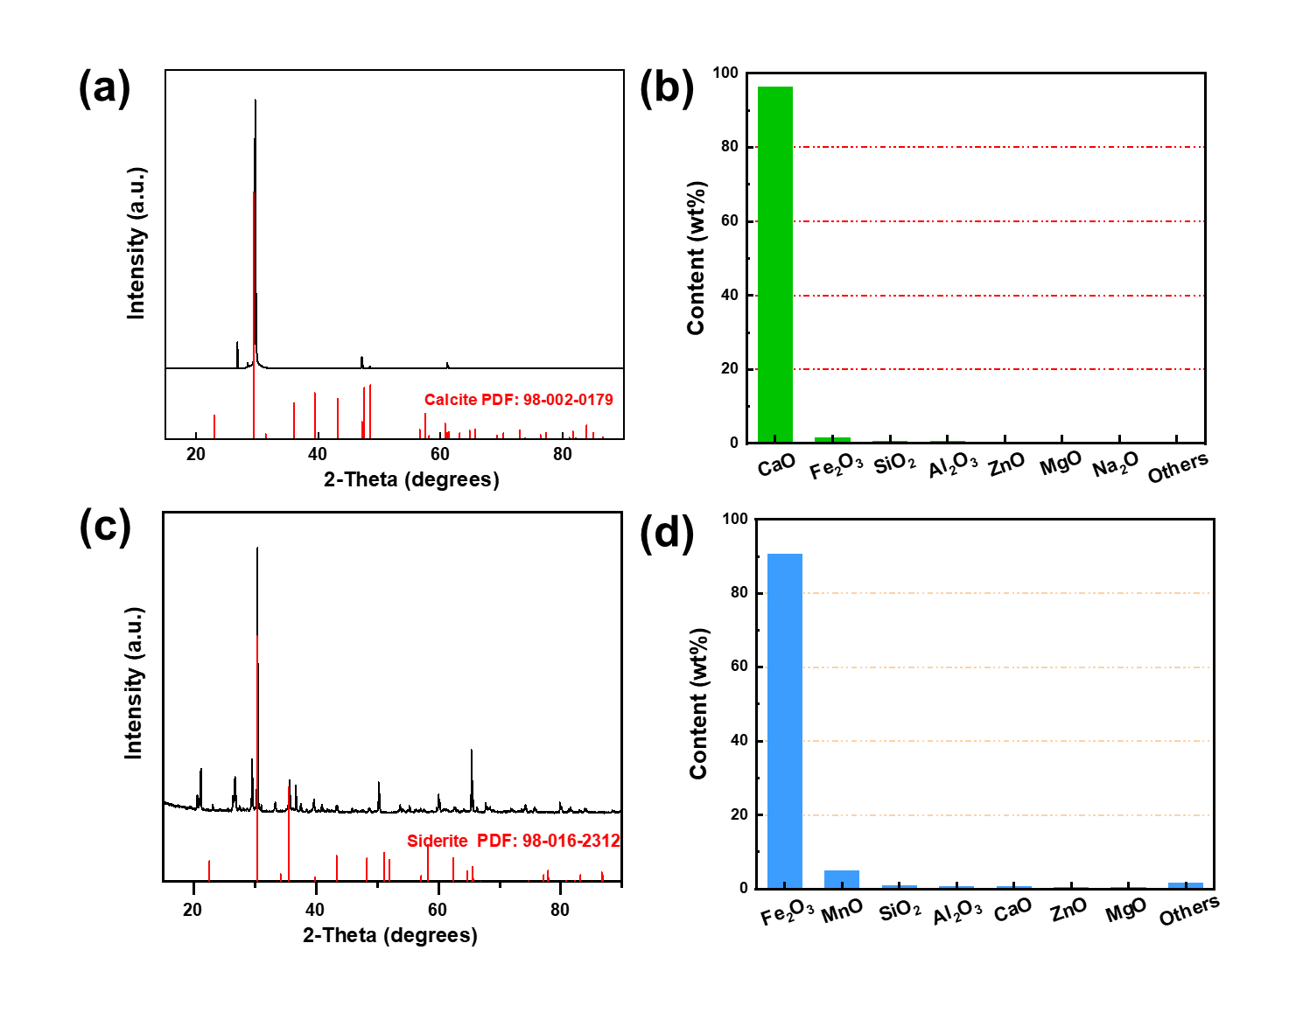
Fig. S1. (a) XRD pattern of calcite, (b) XRF pattern of calcite, (c) XRD pattern of siderite, (d) XRF pattern of siderite.

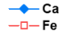
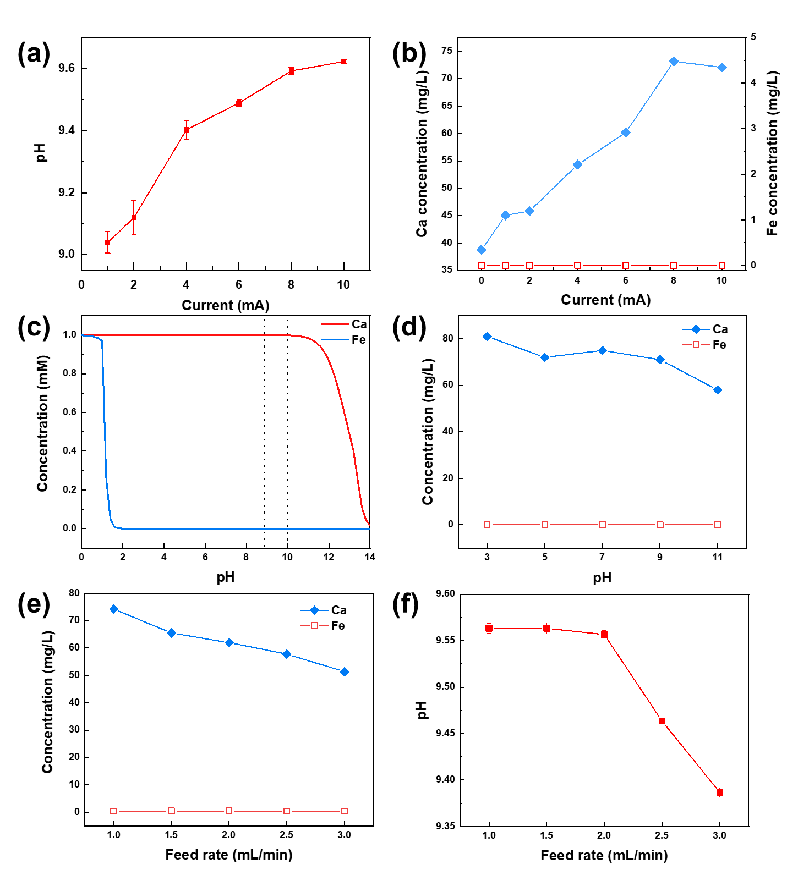
Fig. S2. (a) Effect of current on the effluent pH and (b) metal ions concentration. (c) Distribution of calcite and iron species in aqueous solution at different pH. (d) Effect of initial pH on metal ions concentration in the effluent. (e) Effect of feed rate on metal ions concentration and (f) pH in the effluent.

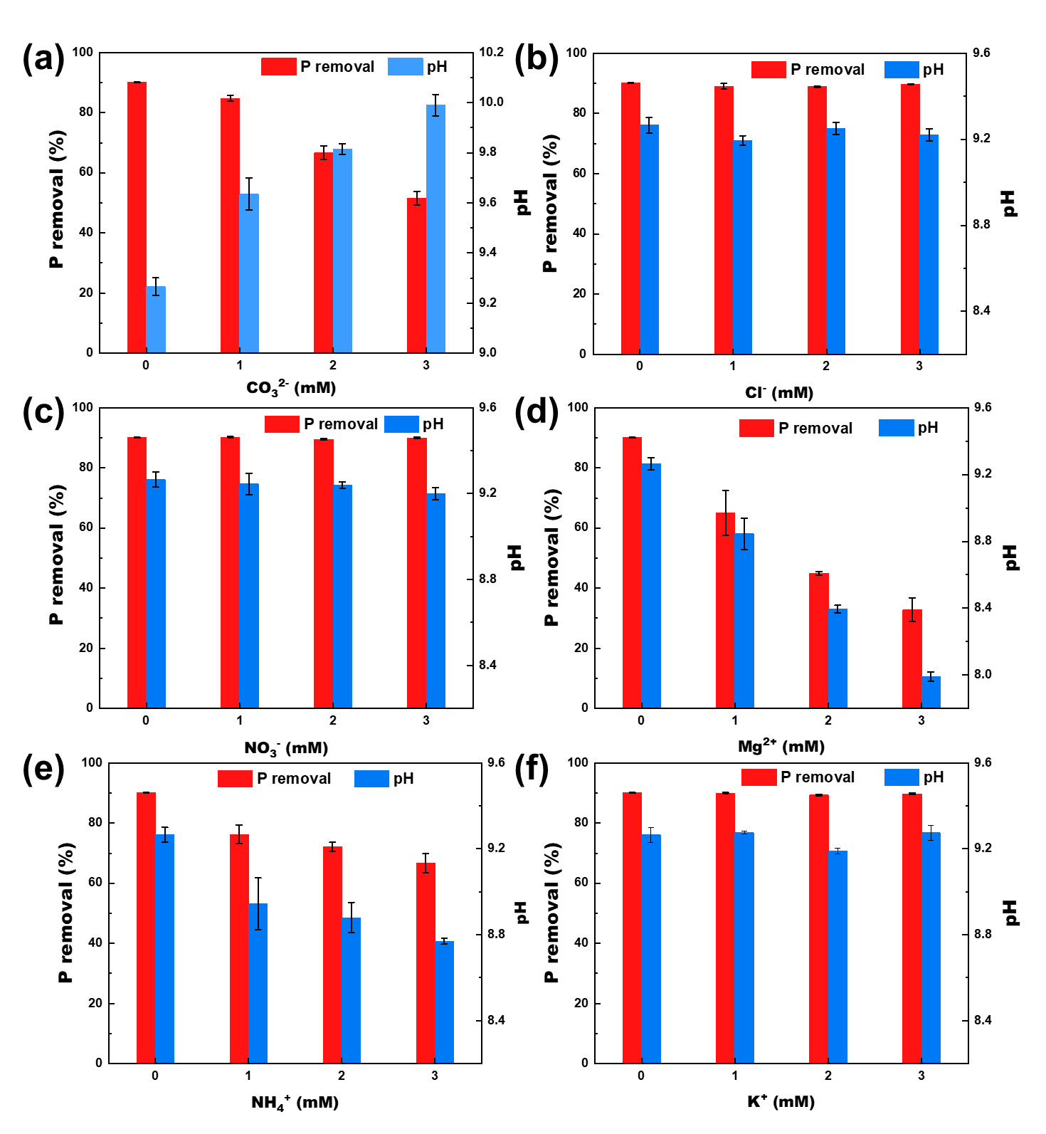
Fig. S3. Effect of competing anions (a) CO₃²⁻, (b) Cl⁻, (c) NO₃⁻, (d) Mg²⁺, (e) NH₄⁺, (f) K⁺ on removal of PO₄³⁻.
Fig. S4. P removal rate of real urine at different current densities with the feed rate of 1, 2, and 3 mL/min.

Table S1. Summary of XRD results
Sample | Compound | Chemical formula | PDF
Calcite | Calcium carbonate | CaCO₃ | 00-005-0586
Calcite adsorption | Calcite | CaCO₃ | 98-015-8258
Calcite electrochem. | Calcite | CaCO₃ | 98-004-0546
 | Tricalcium Bisphosphate | Ca₃O₈P₂ | 98-008-9320
 | Iron phosphate | FePO₄ | 98-041-2738
Siderite | siderite | FeCO₃ | 98-010-0678
Siderite adsorption | siderite | FeCO₃ | 98-010-0678
 | Iron phosphate | FePO₄ | 98-009-2199
Siderite electrochem. | siderite | FeCO₃ | 98-010-0678
 | Iron phosphate | FePO₄ | 98-016-8184
 | Anapaite | H₈Ca₂FeO₁₂P₂ | 98-002-7721
 | Cal. Pho.Oxi.Hyd. | HCa₁₀O₁₇P₄ | 98-009-7010

Table S2. Fitting parameters of Ca 2p peak of calcite and siderite.
Samples |  | Peak | FWHM (eV) | Binding energy (eV)
Calcite | Fresh | Ca2p3/2 | 1.42 | 346.74
Calcite |  | Ca2p1/2 | 1.42 | 350.23
Calcite |  | Satellite | 0.91 | 353.88
Calcite |  | Satellite | 1.11 | 358.54
Calcite | Adsorption | Ca2p3/2 | 1.54 | 347.08
Calcite |  | Ca2p1/2 | 1.54 | 350.58
Calcite |  | Satellite | 0.96 | 355.09
Calcite |  | Satellite | 1.11 | 358.73
Calcite | Electrochemical | Ca2p3/2 | 1.65 | 347.08
Calcite |  | Ca2p1/2 | 1.65 | 350.58
Calcite |  | Satellite | 1.05 | 355.06
Calcite |  | Satellite | 1.13 | 358.68
Siderite | Fresh | Ca2p3/2 | 1.61 | 347.33
Siderite |  | Ca2p1/2 | 1.61 | 231.51
Siderite |  | Satellite | - | -
Siderite | Adsorption | Ca2p3/2 | 2.48 | 347.35
Siderite |  | Ca2p1/2 | 2.48 | 350.85
Siderite |  | Satellite | 4.12 | 354.21
Siderite | Electrochemical | Ca2p3/2 | 1.79 | 347.41
Siderite |  | Ca2p1/2 | 1.79 | 350.91
Siderite |  | Satellite | - | -

Table S3. Fitting parameters of Fe 2p peak of calcite and siderite.
Samples |  | Peak | FWHM (eV) | Binding energy (eV)
Calcite | Fresh | - | - | -
Calcite | Adsorption | - | - | -
Calcite | Electrochemical | Fe-O-P | 2.92 | 712.8
Calcite |  | Fe-O | 2.43 | 711.06
Siderite | Fresh | Fe(Ⅲ) | 2.69 | 711.81
Siderite |  | Fe(Ⅱ) | 2.32 | 710.20
Siderite | Adsorption | Fe(Ⅲ) | 2.77 | 712.02
Siderite |  | Fe(Ⅱ) | 2.37 | 710.19
Siderite | Electrochemical | Fe-O-P | 2.95 | 712.79
Siderite |  | Fe-O | 2.67 | 710.50

Table S4. Fitting parameters of O 1s peak of calcite and siderite.
Samples |  | Peak | FWHM (eV) | Binding energy (eV) | Percentage (%)
Calcite | Fresh | M-O | 1.45 | 531.25 | 93.4
Calcite |  | -OH | 1.27 | 532.55 | 6.6
Calcite | Adsorption | M-O | 1.38 | 531.29 | 36.9
Calcite |  | -OH/O-P | 1.46 | 532.07 | 26.4
Calcite |  | H₂O | 1.49 | 533.2 | 36.7
Calcite | Electrochemical | M-O | 1.6 | 531.21 | 60.2
Calcite |  | M-O-P | 1.73 | 532.22 | 31.9
Calcite |  | H₂O | 1.27 | 533.49 | 7.9
Siderite | Fresh | M-O | 1.65 | 529.92 | 19.1
Siderite |  | -OH | 1.40 | 531.62 | 59.1
Siderite |  | H₂O | 1.29 | 532.81 | 21.8
Siderite | Adsorption | M-O | 1.41 | 529.89 | 15.2
Siderite |  | M-O-P | 1.51 | 531.76 | 66.4
Siderite |  | H₂O | 1.52 | 533.11 | 18.4
Siderite | Electrochemical | M-O | 1.72 | 530.17 | 21.1
Siderite |  | M-O-P | 1.52 | 531.74 | 46.8
Siderite |  | H₂O | 1.76 | 532.98 | 32.1

Table S5. Fitting parameters of P 2p peak of calcite and siderite.
Samples |  | Peak | FWHM (eV) | Binding energy (eV) | Percentage (%)
Calcite | Fresh | - | - | - | -
Calcite |  | - | - | - | -
Calcite | Adsorption | Ca-P | 1.26 | 132.90 | 53.8
Calcite |  | Fe-P | 1.27 | 133.87 | 46.2
Calcite | Electrochemical | Ca-P | 1.38 | 132.91 | 54.1
Calcite |  | Fe-P | 1.37 | 133.84 | 45.9
Siderite | Fresh | - | - |  | -
Siderite |  | - | - |  | -
Siderite | Adsorption | Ca-P | 0.5 | 132.55 | 32.1
Siderite |  | Fe-P | 0.85 | 133.56 | 67.9
Siderite | Electrochemical | Ca-P | 1.08 | 132.88 | 58.1
Siderite |  | Fe-P | 1.17 | 133.81 | 41.9

Table S6. RSM Experimental Design
Run | Pattern | Current  (mA) | Feed rate  (mL/min) | pH
1 | 000 | 5.5 | 2 | 6
2 | +0− | 10 | 2 | 3
3 | 000 | 5.5 | 2 | 6
4 | −−0 | 1 | 1 | 6
5 | 0++ | 5.5 | 3 | 9
6 | +−0 | 10 | 1 | 6
7 | −0− | 1 | 2 | 3
8 | −0+ | 1 | 2 | 9
9 | ++0 | 10 | 3 | 6
10 | 0−− | 5.5 | 1 | 3
11 | 000 | 5.5 | 2 | 6
12 | −+0 | 1 | 3 | 6
13 | +0+ | 10 | 2 | 9
14 | 0+− | 5.5 | 3 | 3
15 | 0−+ | 5.5 | 1 | 9

Table S7. ANOVA results for the Response Surface Quadratic model after variable normalization.
Item | df | Sum of squares | Mean square | F Value | p-value
P removal
Model | 8 | 12399.362 | 1549.92 | 63.228 | <.0001
current(1,10) | 1 | 3907.28 | 3907.28 | 159.395 | <.0001
feed rate(1,3) | 1 | 1158.008 | 1158.008 | 47.2402 | 0.0005
pH(3,9) | 1 | 3652.988 | 3652.988 | 149.0213 | <.0001
current*pH | 1 | 284.7656 | 284.766 | 11.6168 | 0.0143
feed rate*pH | 1 | 416.16 | 416.16 | 16.977 | 0.0062
current*current | 1 | 209.5426 | 209.543 | 8.5482 | 0.0265
feed rate*feed rate | 1 | 363.4078 | 363.408 | 14.825 | 0.0085
pH*pH | 1 | 2661.042 | 2661.042 | 108.5555 | <.0001
Error | 6 | 147.079 | 24.51 | 24.51
R-Squared | 0.9882
Adj R-Squared | 0.9726
RMSE | 4.951
Electrochemical energy consumption
Model | 7 | 119045.48 | 17006.5 | 6.8655 | 0.0105
current(1,10) | 1 | 12402.34 | 12402.34 | 5.0068 | 0.0603
feed rate(1,3) | 1 | 7928.553 | 7928.55 | 3.2007 | 0.1167
pH(3,9) | 1 | 47592.3 | 47592.3 | 19.2128 | 0.0032
feed rate*pH | 1 | 6282.94 | 6282.94 | 2.5364 | 0.1553
current*current | 1 | 8718.093 | 8718.09 | 3.5195 | 0.1028
feed rate*feed rate | 1 | 10644.83 | 10644.83 | 4.2973 | 0.0769
pH*pH | 1 | 23823.65 | 23823.65 | 9.6175 | 0.0173
Error | 7 | 17339.76 | 2477.1
R-Squared | 0.8728
Adj R-Squared | 0.7457
RMSE | 49.77

Table S8. Regression Coefficients of the Predicted Quadratic Polynomial Model
Item | Estimate | Standard error | t value | p value
P removal
Intercept | 72.06667 | 2.858507 | 25.21 | <.0001
current(1,10) | 22.1 | 1.750471 | 12.63 | <.0001
feed rate(1,3) | -12.0313 | 1.750471 | -6.87 | 0.0005
pH(3,9) | 21.36875 | 1.750471 | 12.21 | <.0001
current*pH | 8.4375 | 2.47554 | 3.41 | 0.0143
feed rate*pH | -10.2 | 2.47554 | -4.12 | 0.0062
current*current | -7.53333 | 2.576624 | -2.92 | 0.0265
feed rate*feed rate | -9.92083 | 2.576624 | -3.85 | 0.0085
pH*pH | -26.8458 | 2.576624 | -10.42 | <.0001
Electrochemical energy consumption
Intercept | 44.53333 | 28.73505 | 1.55 | 0.1651
current(1,10) | 39.37375 | 17.59655 | 2.24 | 0.0603
feed rate(1,3) | -31.4813 | 17.59655 | -1.79 | 0.1167
pH(3,9) | -77.13 | 17.59655 | -4.38 | 0.0032
feed rate*pH | 39.6325 | 24.88528 | 1.59 | 0.1553
current*current | -48.5917 | 25.90142 | -1.88 | 0.1028
feed rate*feed rate | 53.69333 | 25.90142 | 2.07 | 0.0769
pH*pH | 80.32583 | 25.90142 | 3.1 | 0.0173

