User-friendly tool for the assessment of groundwater contamination risks by long-term irrigation with reclaimed water
Mogens Thalmann^{1,2}*, Tobias L. Hohenbrink³, Sondra Klitzke⁴, Aki S. Ruhl^{2,5}, Andre Peters^{6,1}
¹ Technische Universität Braunschweig, Institute for Geoecology, Department of Soil Science, Langer Kamp 19c, 38106, Braunschweig, Germany
² German Environment Agency, Section II 3.3, Water Treatment, Schichauweg 58, 12307, Berlin, Germany
³ Deutscher Wetterdienst (DWD), Agrometeorological Research Center, Bundesallee 33, 38116, Braunschweig, Germany
⁴ German Environment Agency, Section II 3.1, Protection of Drinking Water Resources, Schichauweg 58, 12307, Berlin, Germany
⁵ Technische Universität Berlin, Water Treatment, KF4, Str. des 17. Juni 135, 10623, Berlin, Germany
⁶ Thünen Institute of Agricultural Technology, Bundesallee 50, 38116 Braunschweig, Germany
*Corresponding author Mogens Thalmann: m.thalmann@tu-braunschweig.de
ORCID ID of corresponding author: 0009-0004-1587-1244
Co-Authors ORICD ID’s:
Tobias L. Hohenbrink: 0000-0002-5227-0171
Sondra Klitzke: 0000-0001-5895-0074
Aki Sebastian Ruhl: 0000-0002-2443-4722
Andre Peters: 0000-0002-8893-8102

Supplementary Information

Additional Information for Material & Method section

S1.1 Numerical solutions of simulating the water and solute transport in H1D
H1D simulates the one-dimensional variable saturated water flow by numerically solving the modified Richards equation:
$$\frac{∂θ(h)}{∂t}=\frac{∂}{∂z}\left[K(h)\left(\frac{∂h}{∂z}+1\right)\right]-S$$ | (S1)
where,$θ$ is the water content (cm³ cm⁻³), $h$ is the pressure head (cm), $z$ is the vertical coordinate (cm), t the time (h), $S$ is a sink term representing root water uptake or another source or sink (h⁻¹), and $K(h)$ the unsaturated hydraulic conductivity function. Additional, H1D simulates the solute transport coupled to water flow by solving the advection-dispersion equation (S2) as described in detail in Šimůnek & van Genuchten (2008).
$$\frac{∂θc}{∂t}+ρ\frac{∂s}{∂t}=\frac{∂}{∂z}\left(θD\frac{∂c}{∂z}\right)-\frac{∂qc}{∂z}-φ$$ | (S2)
In equation (S2), $c$ is the solute concentration (µg L⁻¹), $s$ is the sorbed concentration (µg kg⁻¹), $D$ is the dispersion coefficient which includes molecular diffusion and hydrodynamic dispersion (cm² h⁻¹), q is the volumetric fluid flux density (cm h⁻¹) as described by the Darcy-Buckingham law, and $φ$ is a sink-source term (µg L⁻³ h⁻¹) which accounts for various zero- and first-order reactions (e.g. microbial degradation). Within the simulation scenarios, $φ$ includes the first-order decay reaction thereby considering microbial degradation.
Moreover, the transport of solutes was simulated considering equilibrium linear adsorption (S3), which describes an instantaneous equilibration between liquid solution and solid soil phase.
$$s=K_{d }c$$ | (S3)
Where $s$ is the sorbed concentration (µg kg⁻¹), $c$ is the concentration in the liquid phase (µg L⁻¹), and $K_{d }$is the linear sorption coefficient (kg L⁻¹).

S1.2 Evapotranspiration and Interception in H1D
Internally, H1D divides Evapotranspiration${ET}_{pot}$(cm day⁻¹) into Transpiration $T_{pot}$(cm day⁻¹) and Evaporation $E_{pot}$ (cm day⁻¹) according to Lambert-Beer´s law (Ritchie, 1972):
$$E_{pot}= {ET}_{pot} e^{-k LAI(t)}$$ | (S4)
$$T_{pot}= {ET}_{pot } (1-e^{-k LAI(t)})$$ | (S5)
with $k$ the canopy radiation extinction constant [-] and $LAI$, the leaf area index [-] as a function of time $t$. The extinction constant $k$ can range between 0.5 and 0.75, depending on the angle of the sun, the plant density and the arrangement of the leaves (Šimůnek et al., 2018). We adopted an extinction constant of 0.5 according to Feifel et al. (2024).
H1D is able to take interception of water by plant and soil surfaces into account under consideration of the daily inflow (cm) and the LAI according to equation (S6).
$$Iz=a LAI\left(1-\frac{1}{\frac{b In}{a LAI}}\right)$$ | (S6)
Where$Iz$ is the interception rate (cm day⁻¹), $In$ is the daily Inflow (cm day⁻¹), $b$ is an empirical constant (-), and $a$ is the interception constant (cm day⁻¹), which was set to 0.025 as usual value for an ordinary agricultural crop (Braden, 1985). For the constant $b$, the dimensionless soil cover fraction ($SCF)$ can be used:
$$SCF(t)=1-e^{-k∙LAI(t)}$$ | (S7)

S1.3 Control and automatize Hydrus-1D simulations and data processing
A base simulation was first set up with predefined geometric parameters (rooting depth, profile depth), root water uptake models, temporal and spatial discretization, and initial and boundary conditions. This base simulation served as a template for all subsequent simulations. The corresponding project files were then duplicated, and scenario-specific input files were automatically modified or replaced. This process was automated using R (R Core Team, 2022) within the RStudio environment (Posit Team, 2023).
The MATER.IN input file, which defines the hydraulic functions of the PDI model for each differentiated soil texture class, and the ATMOSPH.IN file, which specifies atmospheric boundary conditions, were replaced with scenario-specific tables generated in R. Additionally, key soil hydraulic and reaction parameters—including saturated water content (%), saturated hydraulic conductivity (Ksat, cm day⁻¹), bulk density (g cm⁻³), sorption parameters (K_{d}, L kg⁻¹), and degradation rate constants (day⁻¹)—were modified in the SELECTOR.IN file by replacing predefined dummy values from the base simulation using the “stringr” package (Wickham et al., 2023a).
Once all Hydrus-1D project folders were generated with the customized input files, the simulations were executed sequentially using the call.H1D command from the “hydrusR” package (Acharya, 2020).
For post-processing, the “kwb.hydrus1D” package (Ruster, 2025) was used to iteratively extract data from the T_Level.OUT and solute.OUT files, containing results for water and solute transport, respectively. All visualizations were created using the “ggplot2” package (Wickham et al., 2023b).

S1.4 Irrigation and atmospheric boundary conditions
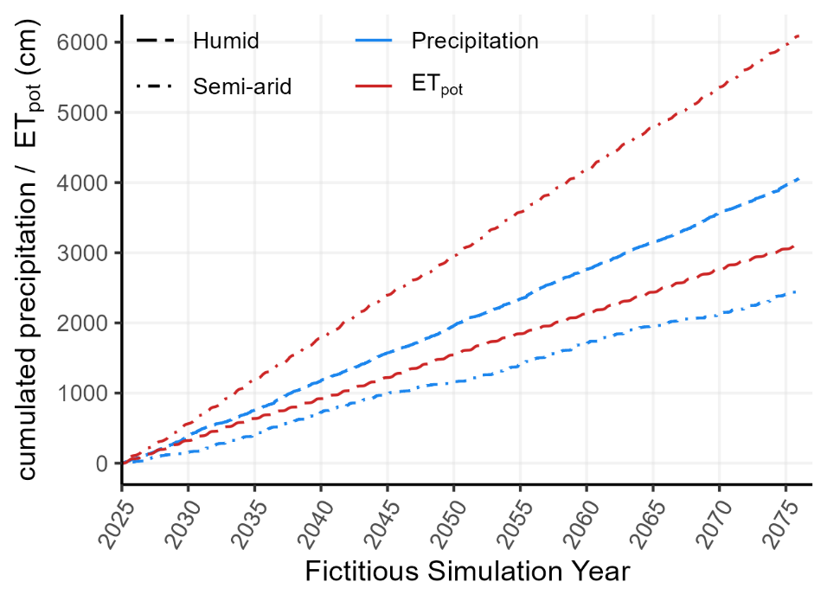
Figure S1: Cumulative precipitation and ${ET}_{pot}$for the humid and semi-arid climate of the total 51 years simulation period.

Table S1: Information on irrigation height in scenario combinations differing in the irrigation (soil type, climate, irrigation).
Soil type | Climate | Irrigation | Mean yearly Irrigation | Standard Deviation (n = 50) | Cumulated irrigation (50 years)
 |  |  | cm
clay | humid | all-season | 62.7 | 4.32 | 3135
clay | humid | demand-based | 22.3 | 4.32 | 1115
clay | semi-arid | all-season | 132.8 | 4.30 | 6639
clay | semi-arid | demand-based | 47.5 | 4.55 | 2376
clay loam | humid | all-season | 60.9 | 4.32 | 3045
clay loam | humid | demand-based | 21.7 | 4.32 | 1083
clay loam | semi-arid | all-season | 130.9 | 4.30 | 6543
clay loam | semi-arid | demand-based | 46.8 | 4.48 | 2340
loam | humid | all-season | 63.7 | 4.32 | 3186
loam | humid | demand-based | 22.7 | 4.32 | 1133
loam | semi-arid | all-season | 133.8 | 4.30 | 6692
loam | semi-arid | demand-based | 47.9 | 4.58 | 2395
loamy sand | humid | all-season | 53.8 | 4.34 | 2690
loamy sand | humid | demand-based | 19.1 | 4.34 | 956
loamy sand | semi-arid | all-season | 122.3 | 4.25 | 6114
loamy sand | semi-arid | demand-based | 43.5 | 4.25 | 2177
sandy loam | humid | all-season | 60.1 | 4.32 | 3007
sandy loam | humid | demand-based | 21.4 | 4.32 | 1069
sandy loam | semi-arid | all-season | 130.1 | 4.31 | 6504
sandy loam | semi-arid | demand-based | 46.5 | 4.45 | 2325

Process-based leaching simulations

S2.1 Comparison of the simulated and fitted leaching
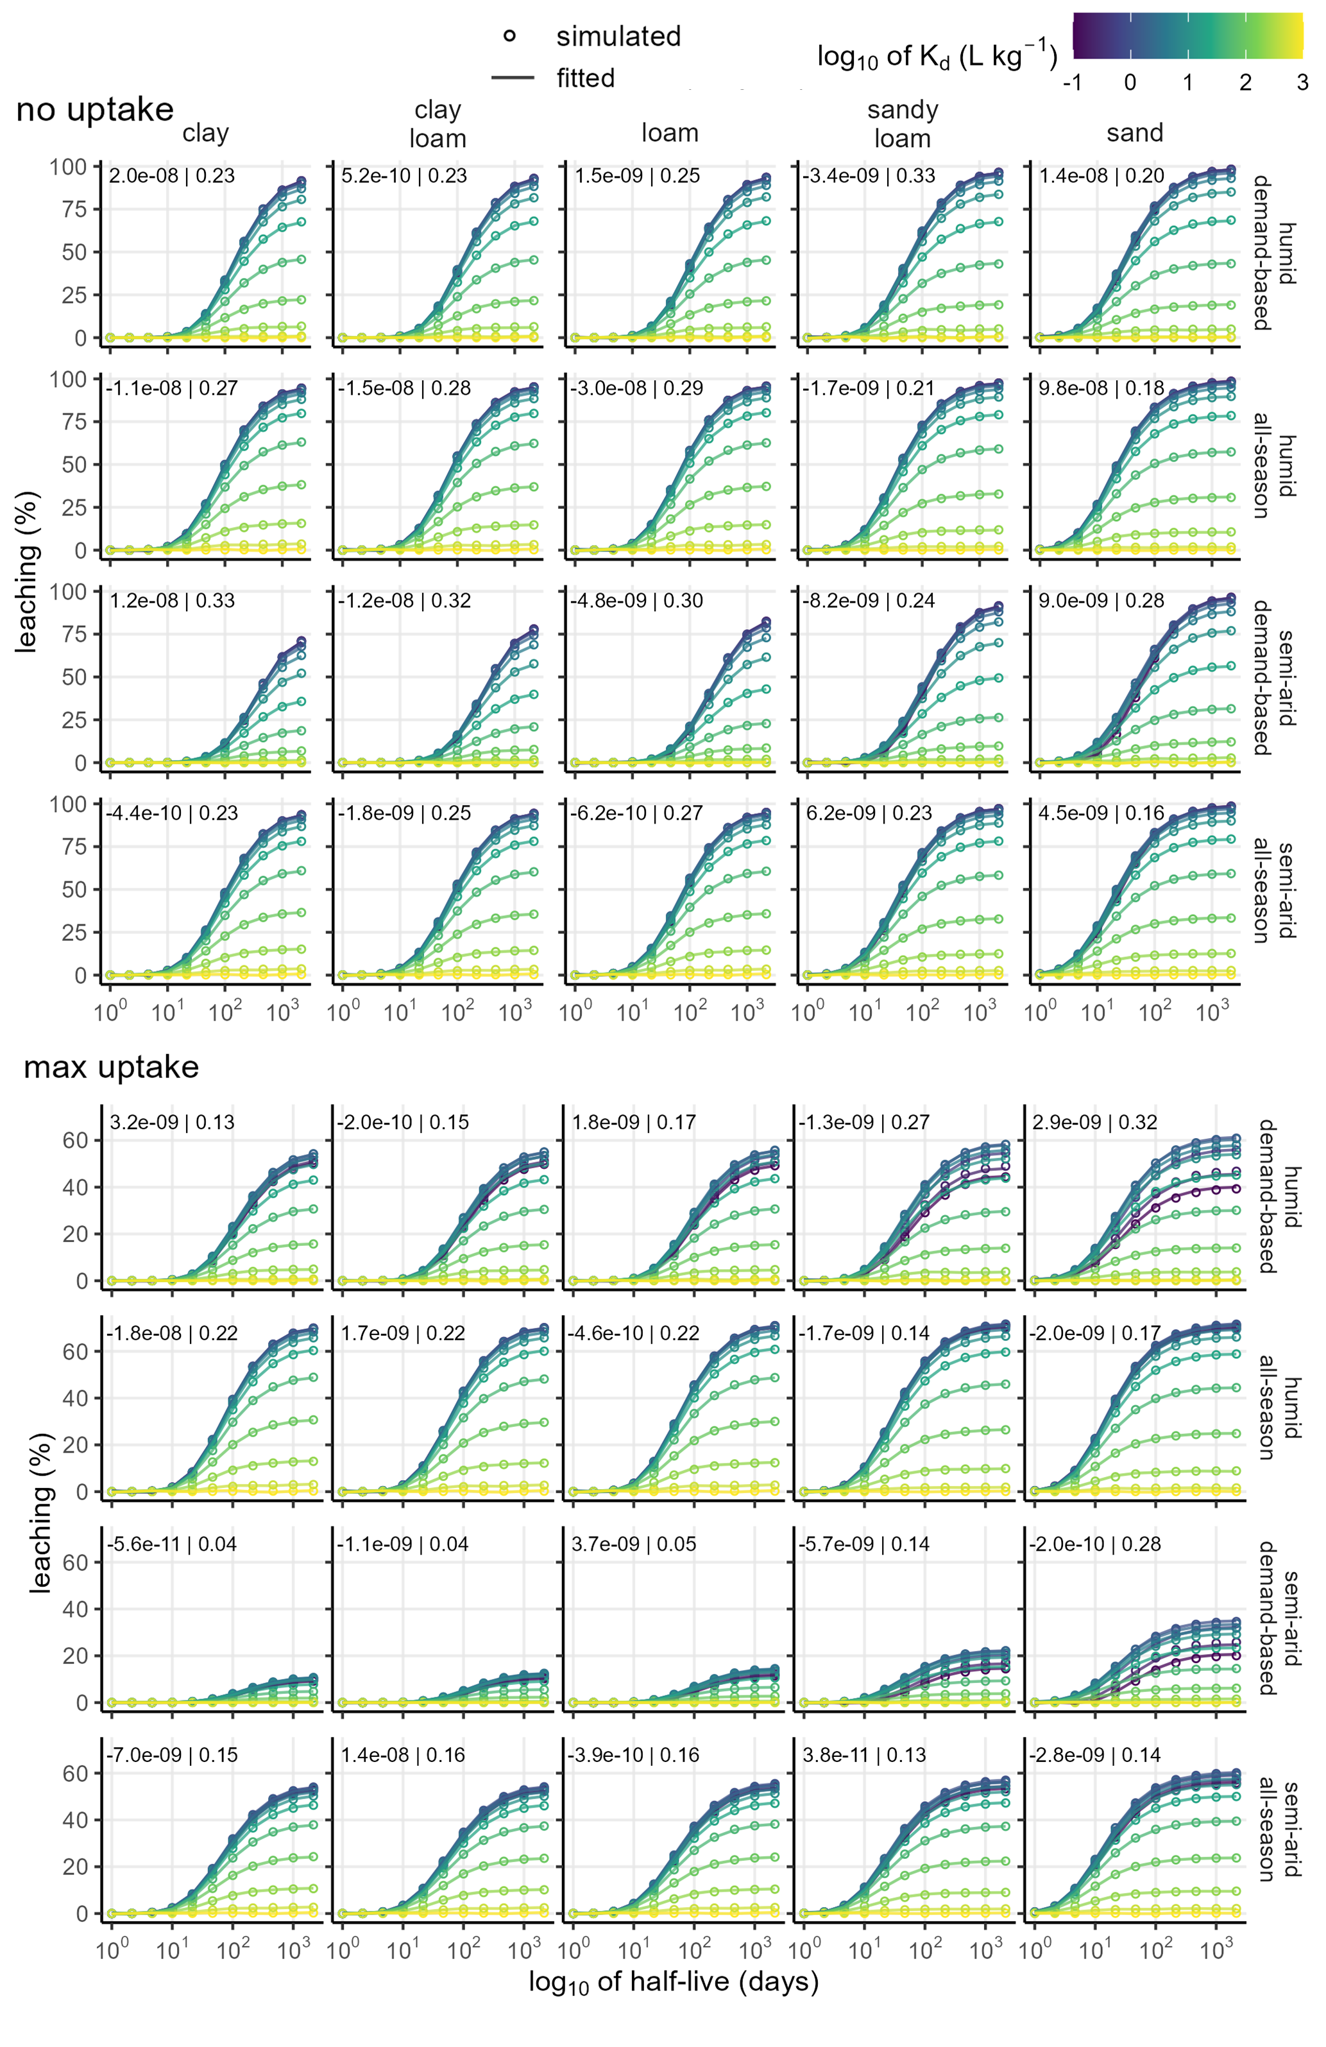
Figure S2: Comparison between simulated (H1D outputs) and fitted (Fourier cosine series of 7th order) solute leaching (%) at lower system´s boundary (2 m) as function of log₁₀ half-live values (days). Each subplot represents a discrete site-specific condition as combination of soil type, irrigation scenario and climate, and solute uptake mode. The continuous color grade shows the log10 values of the varied sorption parameters. The first value in upper left corner of each subplot indicate the mean error (ME), the second the RMSE indicating the goodness of the prediction fit.
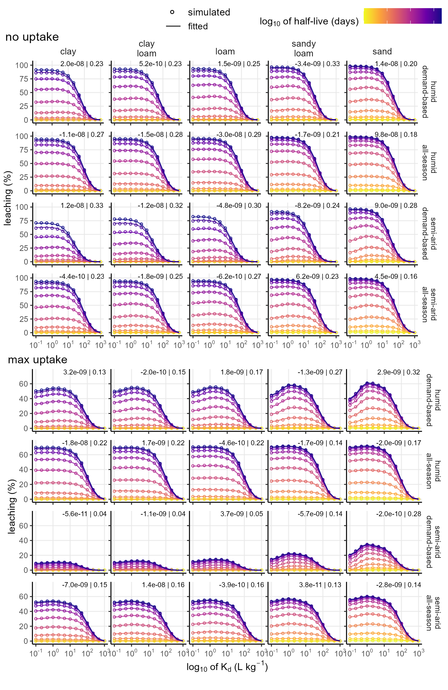
Figure S3: Comparison between simulated (H1D outputs) and predicted (fitted by a Fourier cosine series of 7th order) solute leaching (%) at lower system´s boundary (2 m) as function of log10 K_{d} values (L kg⁻¹). Each subplot represents a discrete site-specific condition as combination of soil type, irrigation scenario and climate, and solute uptake mode. The continuous color grade shows the log10 values of the varied sorption parameters. The first value in upper left corner of each subplot indicate the mean error (ME) in %, the second the RMSE (unit %) indicating the goodness of the prediction fit.

S2.2 Description of the model equation
To fit a bivariate Fourier cosine series of 7th order to the data, the log₁₀ transformed values of the predictor variables (K_{d} and half-live) needed to be rescaled on values between 0 and $π$ first, so that the smallest value in the range equals 0 and the highest value equals $π$. Subsequently, the fitted equation is formulated as:
$$z=a+b\cos\left(x"\text{)+ c cos(}y"\right)+d\cos\left(2x"\text{)+ e cos(}x"\right)\cos\left(y"\text{)+ f cos(2}y"\right)+g\cos\left(3x"\text{)+ h cos(2}x"\right)\cos\left(y"\text{)+ i cos(}x"\right)\cos\left(2y"\text{)+ j cos(3}y"\right)+k\cos\left(4x"\text{)+ l cos(3}x"\right)\cos\left(y"\text{)+ m cos(2}x"\right)\cos\left(2y"\text{)+ n cos(}x"\right)\cos\left(3y"\text{)+ o cos(4}y"\right)+p cos(5x")+q cos(4x" ) cos⁡(y")+r cos(3x" ) cos⁡(2y")+s cos(2x" ) cos⁡(3y")+t cos(x" ) cos⁡(4y")+u cos(5y" )+v cos⁡(6x")+aa cos(5x" ) cos⁡(y")+ab cos(4x" ) cos⁡(2y")+ac cos(3x" ) cos⁡(3y")+ad cos(2x" ) cos⁡(4y")+aec os(x" ) cos⁡(5y")+af cos(6y" )+ag cos(7x")+ah cos(6x" ) cos⁡(y")+ai cos(5x" ) cos⁡(2y")+aj cos(4x" ) cos⁡(3y")+ak cos(3x" ) cos⁡(4y")+al cos(2x" ) cos⁡(5y")+ am cos(x" ) cos⁡(6y")+an cos(7y" )$$ | (S8)
where z is the leaching (%) in 2 m depth, $x"$ is the K_{d} values log₁₀ transformed and scaled between 0 and $π$, and $y"$ is the half-live values log₁₀ transformed and scaled between 0 and $π$.

S2.3 Non-monotonicity of leaching as function of K_{d}
Several non-monotonic patterns were observed, where leaching initially increases, reaching a maximum at approximately 3 L kg⁻¹, before subsequently decreasing in a sigmoidal manner (Figure S3). This effect is particularly pronounced in coarse-textured soils, suggesting that solute residence time plays a key role in this phenomenon. However, as K_{d} continues to increase beyond 3 L kg⁻¹, leaching generally declines until it reaches 0 % at K_{d} of 1000 L kg⁻¹, irrespective of degradation rates or site-specific conditions. This complete reduction in leaching occurs due to strong sorption within the 30 cm plough horizon, effectively immobilizing the solutes.
Figure S5 presents cumulative degradation, bottom flux, and the cumulative water balance (total infiltration from precipitation and irrigation minus actual evapotranspiration) for a representative scenario exhibiting a distinct non-monotonic trend (sand soil, semi-arid climate, demand-based irrigation, no solute uptake by plants, and a half-live of 46 days). As shown, cumulative degradation is highest at K_{d} of 0.1 L kg⁻¹, while bottom flux remains lower than at K_{d} of 1 L kg⁻¹. During periods of negative water balance (April to October), solutes accumulate in the root zone when no plant uptake occurs. These solutes are then transported to deeper layers during periods of positive water balance in winter (October to April).
These findings suggest that the initial increase in leaching at low sorption values (K_{d} < 3 L kg⁻¹) results from reduced bioavailability for microbial degradation and plant uptake, as both processes require solutes to be present in the liquid phase. This interpretation aligns with previous studies reporting that sorption limits solute bioavailability, thereby reducing degradation and plant uptake (Ghafoor et al., 2011; Ren et al., 2018).
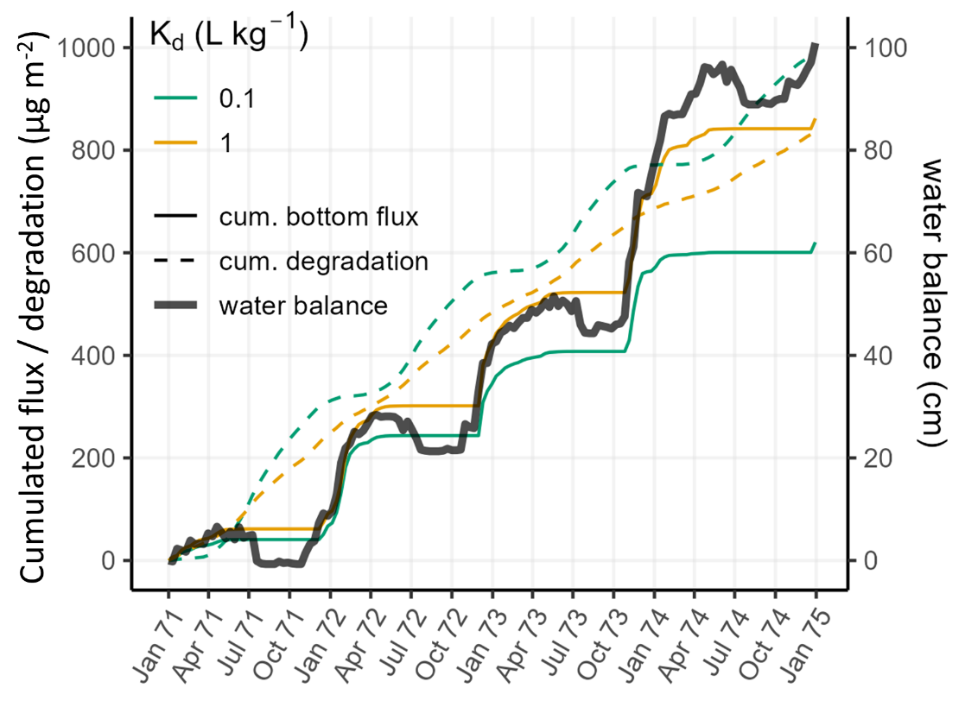
Figure S5: Cumulated fluxes (degradation and bottom outflux) and cumulative water balance in sand soil under semi-arid climate, demand-based irrigation, and no solute uptake by plants at a half-live of 46 days for K_{d} values 0.1 and 1 L kg⁻¹ in the final 4 years simulation period (2071 – 2074). Water balance is calculated as cumulated infiltration (precipitation + irrigation) subtracted by the actual cumulated evapotranspiration.

Notes for tool users

S3.1 Use of the prediction tool and obtaining the needed reaction parameters
To obtain a leaching prediction from the Excel-based tool (available in the ZENODO repository at DOI: https://doi.org/10.5281/zenodo.17287510; Thalmann et al., 2025), the user must first select the most appropriate site-specific conditions from the 40 discrete scenario options, which include soil type, climate, irrigation mode, and solute plant uptake mode. Additionally, the desired prediction timespan (5, 10, 20, 30, or 50 years after the start of irrigation) must be specified.
Next, the user must enter sorption (K_{d}) and degradation (half-live/DT₅₀) values for the substance of interest. Ideally, these parameters should be determined experimentally for the specific soil and environmental conditions under investigation or obtained from reliable literature sources where conditions closely match those of the site. However, in many cases, such reaction parameters are unavailable or unsuitable for the site-specific conditions. Conducting laboratory experiments to determine these values is often labor-intensive, time-consuming, and requires well-established analytical methods.
When experimental data are lacking, model-based approaches can provide alternative estimates for sorption and degradation parameters (Mamy et al., 2014). Numerous sorption models exist for predicting K_{d} and K_{OC} (the K_{d} normalized to the organic carbon content of the soil) values of contaminants in soils, based on molecular properties and soil characteristics (e.g., Franco & Trapp, 2008; Barron et al., 2009; Limmer & Burken, 2014; Li et al., 2020; Sigmund et al., 2020; Zhang et al., 2024). A comprehensive review by Mamy et al. (2014) summarizes various prediction models for the fate of organic compounds in environmental compartments, including quantitative structure-activity relationships (QSARs) that estimate sorption (K_{d}, K_{OC}) in soils based on molecular properties.
In contrast, predictive models for biodegradation in soils remain scarce. A recent study by Rietra et al. (2024) developed a multiple linear regression model to predict K_{d} and half-live values for eight antibiotics, utilizing soil properties (i.e., pedotransfer functions). Such approaches may help improve degradation estimates where experimental data are unavailable.

S3.2 Correcting the degradation parameters by soil depth, temperature and moisture
A reduction of the microbial degradation with increasing soil depth (Ghafoor et al., 2011; Rietra et al., 2024; Veeh et al., 1996) is associated with decreased microbial activity in deeper soil layers (Naylor et al., 2022), which in turn is correlated with the organic matter distribution (Veeh et al., 1996). A depth-dependent correction for the degradation is considered in the conducted H1D simulations adopted by the FOCUS groundwater scenarios (FOCUS, 2021), which considers a reduction of the degradation rate with increasing soil depth derived from empirical observations found in literature. The according depth correction factors are 1, 0.5, 0.3, and 0 for 0 - 30, 30 - 60, 60 – 100, and > 100 cm, respectively. Using this approach, it is possible to parametrize degradation for the entire soil profile by use of the topsoil degradation parameter, as commonly degradation is tested solely for the topsoil layer.
Moreover, microbial degradation in soils may depend strongly on environmental factors such as soil temperature and moisture (Campan et al., 2023; FOCUS, 2021). In the pesticides leaching model “FOCUS PELMO” (FOCUS, 2021) these impacts are considered by an internal coupling to soil temperature and moisture dynamics. With reference to FOCUS (2021) we want to briefly explain how experimentally driven degradation rate constants can roughly be corrected by the tool user regarding temperature and moisture conditions to be more suitable to the conditions of the site of interest.
Firstly, regarding a temperature correction, FOCUS (2021) uses the Arrhenius-based Q10-rule, which describes the temperature dependency of chemical and biological reactions. Accordingly, a correction factor can be calculated by:
$$f_{Temp}=Q^{\frac{T-T_{0}}{10}}$$ | (S9)
where, $f_{Temp}$ is the temperature correction factor (-), $Q$ is the factor for rate increase given a temperature rise of 10 °C, $T_{0}$ is the reference temperature of the experimental condition (°C), and $T$ is the actual soil temperature (°C). The recommended default value for the $Q$ values is 2.58 (FOCUS, 2021). As a rough external correction of the half-live or degradation rate constant, the tool user can estimate a mean yearly soil temperature (e.g. in 20 cm depth) of the site of interest (if information is available), and correct the parameter by multiplying with the estimated $f_{Temp}$ value. However, in a recent study by Campan et al. (2023) three common Arrhenius-based temperature correction models for degradation of pesticides were compared. As a result, the authors reported that a constant $Q$ factor (equaling to a constant activation energy) is not valid to describe the temperature dependency of biodegradation for the whole temperature range (especially for higher temperatures such as in tropical soils). Nonetheless, in a temperature range between 5 to 20 °C the above described correction approach is robust.
Secondly, again with reference to FOCUS (2021), the effect of soil moisture can be con considered using a model proposed by Walker (Walker, 1978; Walker & Barned, 1981):
$$f_{moist}= {\left(\frac{θ}{θ_{0}}\right)}^{f_{w}}$$ | (S10)
where, $f_{moist}$ is the soil moisture correction factor for the biodegradation, $θ$ is the current volumetric soil moisture in the respective soil layer (%), $θ_{0}$ is the moisture during the degradation experiment (%), and $f_{w}$ is the empirical exponent describing the moisture dependency (-), for which the default value is 0.7 (FOCUS, 2021). Accordingly, the tool user may calculate a mean moisture content of the topsoil layer for the site of interest (if such data is available), to use this as $θ$ in equation S3 to obtain a moisture correction factor.

References
Acharya, S. (2020). hydrusR: Interface for preprocessing, execution and visualization of HYDRUS-1D simulations. R package version 1.0.0. https://CRAN.R-project.org/package=hydrusR
Barron, L., Havel, J., Purcell, M., Szpak, M., Kelleher, B., & Paull, B. (2009). Predicting sorption of pharmaceuticals and personal care products onto soil and digested sludge using artificial neural networks. The Analyst, 134, 663. doi:10.1039/b817822d
Braden, H. (1985). Ein Energiehaushalts-und Verdunstungsmodell für Wasser- und Stoffhaushaltsuntersuchungen landwirtschaftlich genutzter Einzugsgebiete. Mitteilungen Dtsch. Bodenkundliche Gesellschaft 42, 294–299.
Campan, P., Samouelian, A., & Voltz, M. (2023). Evaluation of temperature corrections for pesticide half-lives in tropical and temperate soils. Environmental Science and Pollution Research, 30, 21468–21480. doi:10.1007/s11356-022-23566-9
Feifel, M., Durner, W., Hohenbrink, T. L., & Peters, A. (2024). Effects of improved water retention by increased soil organic matter on the water balance of arable soils: A numerical analysis. Vadose Zone Journal, 23. doi:10.1002/vzj2.20302
FOCUS. (2021). Generic Guidance for Tier 1 FOCUS Ground Water Assessments. Version 2.3. Generic Guidance for Tier 1 FOCUS Ground Water Assessments. Version 2.3. Retrieved from https://esdac.jrc.ec.europa.eu/public_path/projects_data/focus/gw/docs/Generic_guidance_FOCUS_GW_V2-3final.pdf
Franco, A., & Trapp, S. (2008). Estimation of the soil–water partition coefficient normalized to organic carbon for ionizable organic chemicals. Environmental Toxicology and Chemistry, 27, 1995–2004. doi:10.1897/07-583.1
Ghafoor, A., Moeys, J., Stenström, J., Tranter, G., & Jarvis, N. J. (2011). Modeling Spatial Variation in Microbial Degradation of Pesticides in Soil. Environmental Science & Technology, 45, 6411–6419. doi:10.1021/es2012353
Grossberger, A., Hadar, Y., Borch, T., & Chefetz, B. (2014). Biodegradability of pharmaceutical compounds in agricultural soils irrigated with treated wastewater. Environmental Pollution, 185, 168–177. doi:10.1016/j.envpol.2013.10.038
Limmer, M. A., & Burken, J. G. (2014). Plant Translocation of Organic Compounds: Molecular and Physicochemical Predictors. Environmental Science & Technology Letters, 1, 156–161. doi:10.1021/ez400214q
Mamy, L., Patureau, D., Barriuso, E., Bedos, C., Bessac, F., Louchart, X., . . . Benoit, P. (2014). Prediction of the Fate of Organic Compounds in the Environment From Their Molecular Properties: A Review. Critical Reviews in Environmental Science & Technology, 45, 1277–1377. doi:10.1080/10643389.2014.955627
Naylor, D., McClure, R., & Jansson, J. (2022). Trends in Microbial Community Composition and Function by Soil Depth. Microorganisms, 10, 540. doi:10.3390/microorganisms10030540
Posit Team. (2023). RStudio: Integrated development environment for R. (version: 2023.06.2+561.pro5). Posit Software, PBC [software]. https://www.posit.co
R Core Team. (2022). R: A language and environment for statistical computing. Vienna, Austria. R Foundation for Statistical Computing [software]. https://www.R-project.org/
Ren, X., Zeng, G., Tang, L., Wang, J., Wan, J., Liu, Y., . . . Deng, R. (2018). Sorption, transport and biodegradation – An insight into bioavailability of persistent organic pollutants in soil. Science of The Total Environment, 610-611, 1154–1163. doi:10.1016/j.scitotenv.2017.08.089
Rietra, R. P., Berendsen, B. J., Mi-Gegotek, Y., Römkens, P. F., & Pustjens, A. M. (2024). Prediction of the mobility and persistence of eight antibiotics based on soil characteristics. Heliyon, 10, e23718. doi:10.1016/j.heliyon.2023.e23718
Ritchie, J. T. (1972). Model for predicting evaporation from a row crop with incomplete cover. Water Resources Research, 8, 1204–1213. doi:10.1029/wr008i005p01204
Rustler, M. (2025). kwb.hydrus1d: R Interface for the Last Official Release of Hydrus1D (V4.17.0140) for Windows. R package version 0.1.0, https://github.com/KWB-R/kwb.hydrus1d.
Sigmund, G., Gharasoo, M., Hüffer, T., & Hofmann, T. (2020). Deep Learning Neural Network Approach for Predicting the Sorption of Ionizable and Polar Organic Pollutants to a Wide Range of Carbonaceous Materials. Environmental Science & Technology, 54, 4583–4591. doi:10.1021/acs.est.9b06287
Šimůnek, J., & van Genuchten, M. T. (2008). Modeling Nonequilibrium Flow and Transport Processes Using HYDRUS. Vadose Zone Journal, 7, 782–797. doi:10.2136/vzj2007.0074
Thalmann, M., Hohenbrink, T. L., Klitzke, S., Ruhl, A. S., & Peters, A. (2025). Prediction tool for assessing groundwater contamination risk under irrigation with reclaimed water (Version 1.0.1) [Software]. Zenodo. https://doi.org/10.5281/zenodo.17287510
Veeh, R. H., Inskeep, W. P., & Camper, A. K. (1996). Soil Depth and Temperature Effects on Microbial Degradation of 2,4‐D. Journal of Environmental Quality, 25, 5–12. doi:10.2134/jeq1996.00472425002500010002x
Walker, A. (1978). Simulation of the persistence of eight soil‐applied herhicides. Weed Research, 18, 305–313. doi:10.1111/j.1365-3180.1978.tb01165.x
Walker, A., & Barnes, A. (1981). Simulation of herbicide persistence in soil; a revised computer model. Pesticide Science, 12, 123–132. doi:10.1002/ps.2780120204
Wickham, H. (2023a). stringr: Simple, consistent wrappers for common string operations. R package version 1.5.1. Available at: https://CRAN.R-project.org/package=stringr (accessed June 10, 2024).
Wickham, H. (2023b). ggplot2: Create elegant data visualisations using the grammar of graphics. R package version 3.5.0. Available at: https://CRAN.R-project.org/package=ggplot2 (accessed July 24, 2025).
Zhang, Z., Wang, S., Brown, T. N., Sangion, A., Arnot, J. A., & Li, L. (2024). Modeling sorption of environmental organic chemicals from water to soils. Water Research X, 22, 100219. doi:10.1016/j.wroa.2024.100219

