Supplementary information
Unraveling the Corrosion Mechanism of Boro-Alumino-Phospho-Silicate Glass: Advanced Insights from Solid-State NMR Spectroscopy
Muhammad Amer Khan^{a, b}, Lili Huª, Shubin Chenª, Yongchun Xuª, Jinjun Ren^{a, b} *
a. Advanced Laser and Optoelectronic Functional Materials Department, Special Glasses and Fibers Research Center, Shanghai Institute of Optics and Fine Mechanics, Chinese Academy of Sciences, Shanghai 201800, P. R. China.
b. Center of Materials Science and Optoelectronics Engineering, University of Chinese Academy of Sciences, Beijing 100049, P. R. China
* Corresponding author.
E-mail: jinjunren@siom.ac.cn

Experimental details
i. REDOR/REAPDOR experiments: Atomic spatial distribution and dipolar interaction strength were studied using rotational echo Double resonance (REDOR) studies. Applying π pulses on the influenced nuclei allows REDOR to restore dipolar interactions, averaged by MAS. A normalized REDOR (ΔS/S₀) REDOR curve was obtained as a function of dipole evolution time (NTr). All experiments used a 4 mm MAS probe at 12 kHz, with a saturation comb added before relaxation. The typical pulse sequence of Gullion and Schaefer, as modified by Chan and Eckert, was used in the ²⁷Al{³¹P} REDOR experiments [1, 2]. For both the ²⁷Al and ³¹P nuclei, the 180° pulse lengths were 8.5 µs. Moreover, the relaxation time was 1s. A short evolution time $(\text{0≤ΔS/}{\text{S}}_{\text{0}}\text{≤0.2})$ was used to obtain the second dipolar moment, or $M_{2}^{SI}$ (S=²⁷Al, I=³¹P), from the REDOR parabolic curve by using the following equation:
$\frac{∆S}{S_{0}}=\frac{1}{I(I+1)π^{2}}{(NT_{r})}^{2}{\text{M}}_{\text{2}}^{ \text{SI}}$
ΔS/S₀ = (S₀ - S)/S₀, where S₀ and S are the signal intensities measured with and without dipolar recoupling effects. This ratio was calculated as a function of dipolar evolution time, denoted as NTr, where N indicates the number of rotor cycles and Tr denotes the length of the evolution period. The ³¹P{²⁷Al} REAPDOR experiments were carried out using a pulse sequence developed by Garbow and Gullion [3]. In ³¹P{²⁷Al} REAPDOR pulse sequence, for the ³¹P nuclei, a pulse length of 8.5 µs (180°) and a relaxation delay of 40 s were set. For ²⁷Al, the recoupling pulse was 27.8 µs, corresponding to one-third of the rotor period, and the nutation frequency was set to 22.1 kHz, determined using a liquid sample of Al(NO₃)₃. Furthermore, the ²⁷Al{¹H} REDOR experiments employed the Gullion and Schaefer pulse sequence [3]. The relaxation time for ²⁷Al{¹H} REDOR was 1.0 s, and 180° pulse duration was 7.0 µs.
ii. ²⁷Al{¹H} 1D J-HMQC and ²⁷Al{³¹P} J-HMQC: The ²⁷Al{¹H} 1D heteronuclear double quantum coherence (HMQC) experiment was performed utilizing a 4 mm magic angle spinning (MAS) probe operating at a rotation frequency of 12 kHz and a relaxation interval of 1.0 s, accompanied by saturation comb before the experiment. To detect heteronuclear J-coupling, the heteronuclear double quantum coherence was excited by two 90° pulses across the ²⁷Al and ¹H nuclei, each with a pulse length of 4 µs. This method directly detects bonding connectivity between Al and H nuclei, providing direct evidence of their chemical bonds [4]. WURST-enhanced ³¹P {²⁷Al} J-HMQC tests were conducted to probe direct P-O-Al connectivity, utilizing a 4 mm MAS probe rotating at 12 kHz. The WURST-80 excitation pulse was utilized on the Al channel to enhance the sensitivity of the ³¹P{²⁷Al} J-HMQC. The scan rate of the WURST-80 excitation pulse was synchronized with the spinning speed of 12 kHz. The pulse duration was fine-tuned to 250 µs, while the deviation from the central frequency was fine-tuned to ±350 kHz. The mixing period, denoted as 𝜏, for generating J-coupled double quantum coherence was optimized to 4.75 ֋s, during which the magnetization underwent evolution. The duration of the 90° pulses for ³¹P and ²⁷Al nuclei was 4.25 µs and 10 µs, respectively. To ensure stable signal acquisition, a saturation comb pulse was added to the P channel before a relaxation period of 60 s.
iii. ²⁷Al{²⁷Al} 2D WURST 2Q-1Q (Double Quantum-One Quantum) correlation: The ²⁷Al{²⁷Al} 2D WURST 2Q-1Q correlation experiment was conducted to investigate the proximity between Al species [5]. In this experiment, the BR221 pulse technique developed by Wang et al. [6], was employed with WURST to increase signal intensity. Furthermore, this experiment was performed using a 4 mm MAS probe with a spinning rate of 12 kHz. Excitation and reconversion periods were set to 1666.7 µs. The ²⁷Al pulse lengths at 90° and 180° were 14.5 µs and 29.0 µs, respectively. A saturation comb was used before a 1.0 s relaxation interval. Following the double transformation, the correlated signals in the F1 dimension are positioned half the total of their chemical shifts in the F2 dimension.
iv. ²⁹Si{¹H} CP MAS: This experiment examined the interaction between Si and H atoms. The experiment used the TPPM15 pulse scheme with a 160° pulse length of 4.44 µs on the H channel for decoupling during data acquisition. A relaxation delay of 1.0 s was applied and the nutation frequencies of ¹H and ²⁹Si were 90.9 and 32.2 kHz, respectively. The contact time was 3.0 ms, and the H power level underwent a linear ramp down from 90.9 kHz to a nutation frequency of 45.5 kHz.

Supplement Results
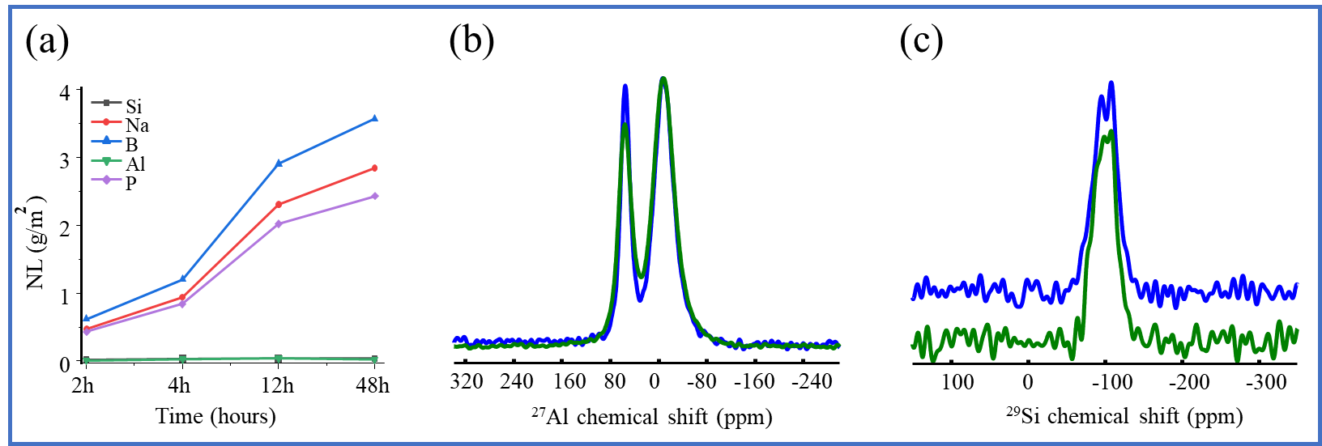
Figure S1(a) shows normalized leaching at different immersion times. (b) Static ²⁷Al NMR spectra of wet (green) and dry (blue) P-48h sample. (c) Static ²⁹Si spectra of wet (green) and dry (blue) P-48h sample.

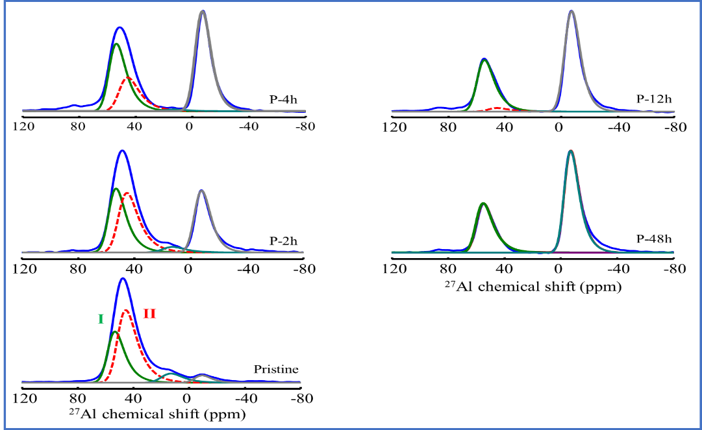
Figure S2 presents the deconvoluted ²⁷Al NMR spectra of pristine and corroded glass samples.

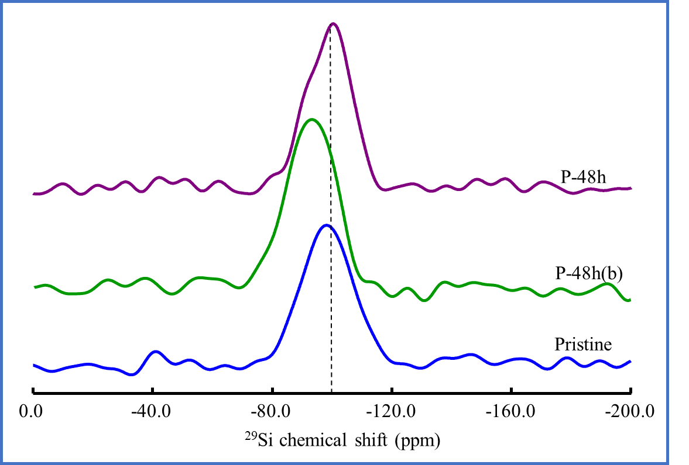
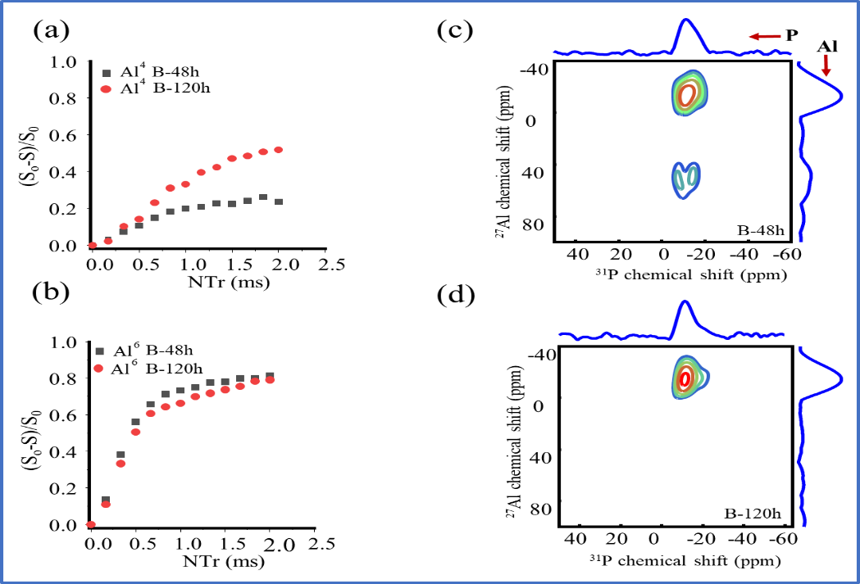
Figure S4 compares the ²⁹Si NMR spectra of pristine, P-48h(b) at SA/V=38 m⁻¹ and P-48h at SA/V=2018 m⁻¹ of glass powder samples.
Figure S3(a, b) show the ²⁷Al{¹H} REDOR curves for the Al⁴ and Al⁶ units, while (c, d) present the corresponding ²⁷Al{³¹P} 2D-HMQC spectra of samples B-48h and B-120h.

Table S1 presents nominal wt. % and with corresponding ICP-AES measurements in parenthesis.
Glass | Al₂O₃ wt. %  (±2%) | P₂O₅ wt. %  (±2%) | Na₂O wt. %  (±2%)
BAPS (pristine) | 4.61(4.72) | 15.12(14.49) | 18.51(18.95)

Table S2 normalized mass loss for elements present in BAPS glass.
Time (hours) | NL (g/m⁻²)
 | B (± 0.9) | Na (± 1.2) | P (± 0.7) | Al (± 0.1) | Si (± 0.1)
2 h | 6.1 | 4.6 | 4.4 | 0.1 | 0.2
4 h | 12.0 | 9.1 | 8.8 | 0.3 | 0.3
12 h | 29.0 | 22.6 | 21.1 | 0.3 | 0.4
48 h | 35.6 | 27.8 | 25.3 | 0.2 | 0.4

Note: Errors in parenthesis represent the maximum standard deviation from duplicate experiments.

Table S3 includes the ³¹P fitting parameters of pristine glass and altered glass (P-48h, values in parenthesis).
Peaks | $δ_{iso}^{cs}$ [ppm(±0.3)] | FWHM [ppm (±0.3)] | Area [% (±3)]
$$I$$ | 3.0 (3.0) | 5.4 (5.4) | 5.3 (3.1)
$$II$$ | -3.1 (-2.7) | 7.4 (7.0) | 31.5 (27.9)
$$III$$ | -8.0 (-8.5) | 8.5 (7.7) | 42.3 (53.5)
$$IV$$ | -14.9 (-14.9) | 9.1 (9.1) | 21.2 (15.5)

Table S4 includes the fitting parameters of ¹¹B units for pristine and corroded BAPS glass samples.
Name | unit | $δ_{iso}^{cs}$[ppm (±0.3)] | Area [% (±2)]
Pristine | $$B^{3}ring$$ | 17.5 | 36.3
Pristine | $$B^{3} non ring$$ | 13.0 | 5.0
Pristine | $$B^{4}(1B^{3},3{Si}^{4})$$ | 0.25 | 5.3
Pristine | B⁴(1P) | -0.4 | 42.2
Pristine | B⁴(2P) | -2.4 | 11.1
P-2h | $$B^{3}ring$$ | 17.5 | 37.0
P-2h | $$B^{3} non ring$$ | 13.4 | 7.5
P-2h | $$B^{4}(1B^{3},3{Si}^{4})$$ | 0.3 | 9.8
P-2h | B⁴(1P) | -0.4 | 36.0
P-2h | B⁴(2P) | -2.4 | 10.0
P-48h | $$B^{3}ring$$ | 18.5 | 39.92
P-48h | $$B^{3} non ring$$ | 14 | 4.71
P-48h | $$B^{4}(1B^{3},3{Si}^{4})$$ | 0.4 | 15.4
P-48h | B⁴(1P) | -0.35 | 40.0
P-48h | B⁴(2P) | -2.4 | 4.9

Table S5 shows the isotropic chemical shift (δ_{iso}), quadrupolar coupling constant (C_{Q}), the fraction of ²⁷Al species (%), and the dipolar second moment M₂ (Al-P) obtained from the ²⁷Al {³¹P} REDOR spectra for both glass (pristine + corroded) and crystalline glass reference.
Samples | Units | δ_{iso}  [ppm(±0.3)] | C_{Q}  (MHz) | Fraction  [%(±2)] | M₂ ^{Al-P a}  ×10⁶rad²/s² | M₂ ^{Al-P b}  ×10⁶rad²/s²
Pristine | Al(IV)^{I} | 58.0 | 4.3 | 33.3 | 3.4 | -
Pristine | Al(IV)^{II} | 51.0 | 4.7 | 54.7 | 3.4 | -
Pristine | Al(V) | 19.0 | 4.7 | 7.5 | 3.4 | -
Pristine | Al(VI) | -5.0 | 3.9 | 4.5 | 3.4 | -
P-2h | Al(IV)^{I} | 58.0 | 4.3 | 32.5 | 2.7 | 3.8
P-2h | Al(IV)^{II} | 51.0 | 4.7 | 35.0 | 2.7 | 3.8
P-2h | Al(V) | 19.0 | 4.7 | 3.42 | 2.7 | 3.8
P-2h | Al(VI) | -3.4 | 3.9 | 29.0 | 2.7 | 3.8
P-4h | Al(IV)^{I} | 58.5 | 4.3 | 34.2 | nm | nm
P-4h | Al(IV)^{II} | 51.3 | 4.7 | 19.9 | nm | nm
P-4h | Al(V) | 19.0 | 4.7 | 1.0 | nm | nm
P-4h | Al(VI) | -3.2 | 3.7 | 44.8 | nm | nm
P-12h | Al(IV)^{I} | 59.3 | 4.3 | 35.5 | 2 | 3.5
P-12h | Al(IV)^{II} | 51.2 | 4.7 | 3.0 | 2 | 3.5
P-12h | Al(V) | 19.0 | 4.7 | 0.5 | 2 | 3.5
P-12h | Al(VI) | -3.2 | 3.7 | 61.0 | 2 | 3.5
P-48h | Al(IV)^{I} | 59.6 | 4.3 | 35.5 | 1.2 | 4.1
P-48h | Al(IV)^{II} | - | - | - | 1.2 | 4.1
P-48h | Al(V) | 19.0 | 4.7 | 0.4 | 1.2 | 4.1
P-48h | Al(VI) | -2.9 | 3.9 | 64.1 | 1.2 | 4.1
P-48h |  |  |  |  | AlPO₄(5.0) | Al(PO₃)₃(4.7)

^{‘a’} and ^{‘b’} denote M₂ for Al⁴-O-P and Al⁶-O-P units, respectively. While ‘nm’ denotes not measured.

Table S6 presents the normalized mass loss for the BAPS glass corroded for 48 hours at different SA/V values.
SA/V (m⁻¹) | Normalize loss NL(g/m²)
 | B (± 0.8) | Na (± 0.9) | P (± 1.0) | Al (± 0.1) | Si (± 0.1)
2108 | 35.6 | 28.5 | 24.3 | 0.3 | 0.4
175 | 38.4 | 31.6 | 27.9 | 0.2 | 1.5
38 | 38.0 | 31.4 | 28.9 | 0.2 | 3.7

References
[1] T. Gullion and J. J. J. o. M. R. Schaefer, "Rotational-echo double-resonance NMR," vol. 81, no. 1, pp. 196-200, 1989.
[2] J. C. Chan and H. J. J. o. M. R. Eckert, "Dipolar coupling information in multispin systems: application of a compensated REDOR NMR approach to inorganic phosphates," vol. 147, no. 2, pp. 170-178, 2000.
[3] J. R. Garbow and T. J. C. p. l. Gullion, "The importance of precise timing in pulsed, rotor-synchronous MAS NMR," vol. 192, no. 1, pp. 71-76, 1992.
[4] A. Lesage, D. Sakellariou, S. Steuernagel, and L. J. J. o. t. A. C. S. Emsley, "Carbon− proton chemical shift correlation in solid-state NMR by through-bond multiple-quantum spectroscopy," vol. 120, no. 50, pp. 13194-13201, 1998.
[5] J. Ren, L. Zhang, and H. J. T. J. o. P. C. C. Eckert, "Medium-range order in sol–gel prepared Al2O3–SiO2 glasses: new results from solid-state NMR," vol. 118, no. 9, pp. 4906-4917, 2014.
[6] Q. Wang, B. Hu, O. Lafon, J. Trébosc, F. Deng, and J.-P. J. J. o. m. r. Amoureux, "Double-quantum homonuclear NMR correlation spectroscopy of quadrupolar nuclei subjected to magic-angle spinning and high magnetic field," vol. 200, no. 2, pp. 251-260, 2009.

