Appendix B
Scatter Plots of Students’ Online Credibility Evaluation Skills

Figure B1
Scatter Plot of Students’ Online Credibility Evaluation Skills for a Popular Science Text.

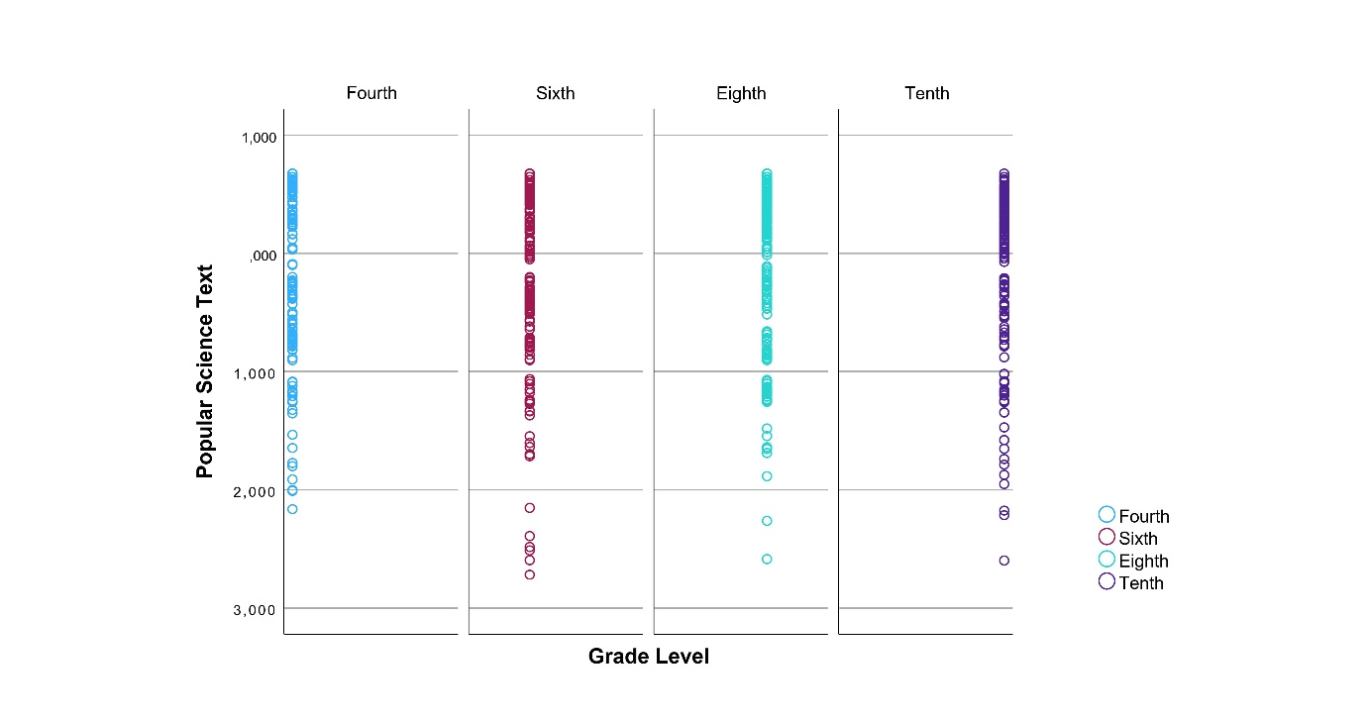
Figure B2
Scatter Plot of Students’ Online Credibility Evaluation Skills for a Science Newspaper Article. 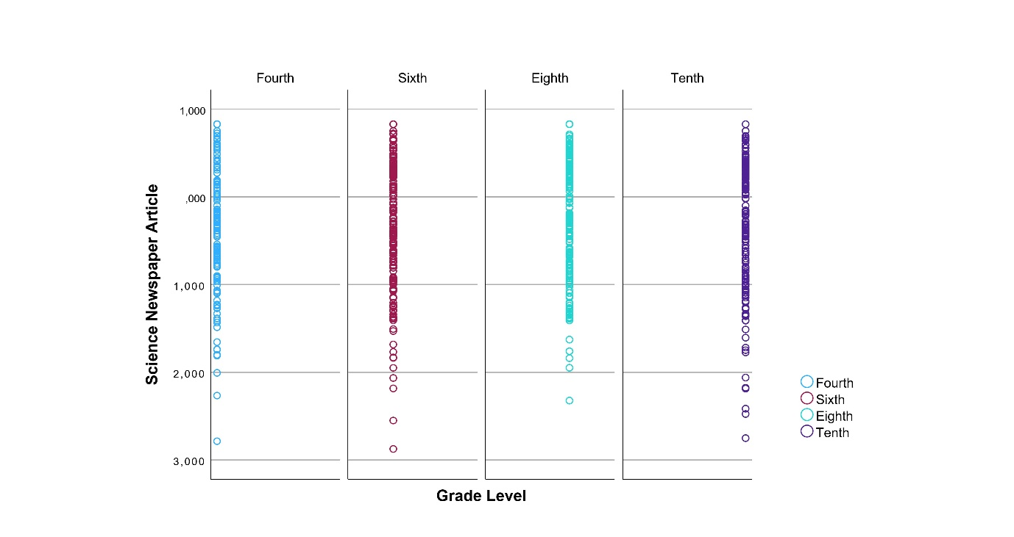

Figure B3
Scatter Plot of Students’ Online Credibility Evaluation Skills for a Layperson’s Blog Text.
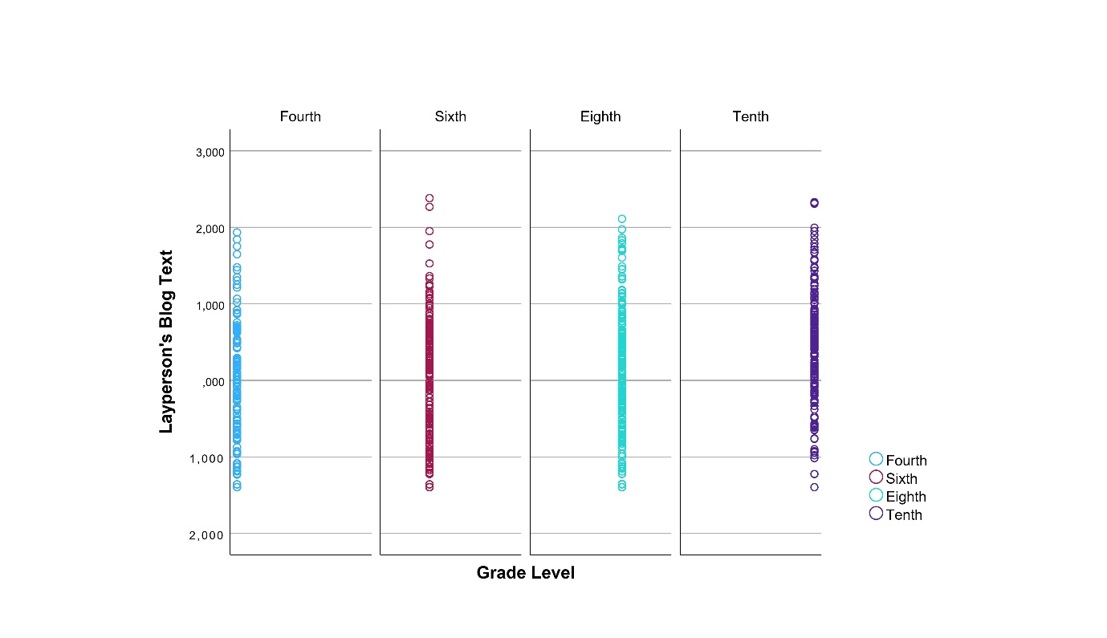
Figure B4
Scatter Plot of Students’ Online Credibility Evaluation Skills for a Commercial Text.
