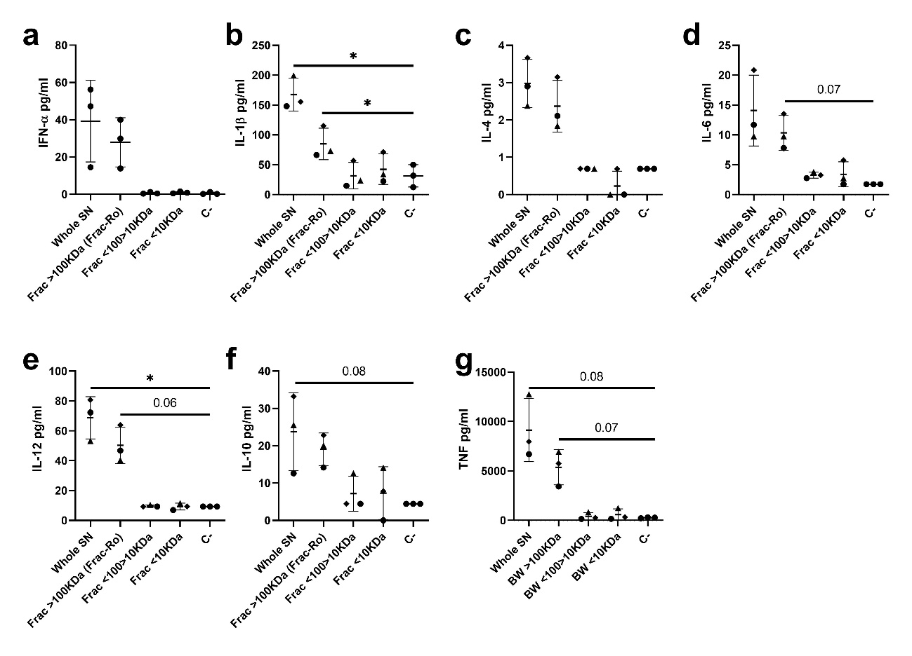
Supplementary Figure 1. PAMs were stimulated for 24 hours with the different supernatant fractions separated by molecular weights. Levels of IFN-α (a), IL-1β (b), IL-4 (c), IL-6 (d), IL-12 (e), IL-10 (f), and TNF (g) from PAMs supernatant were measured by Luminex-based multiplex assay. Non-stimulated cells were used as control. Significant differences were determined using a one-way ANOVA (* p-value ≤ 0.05).

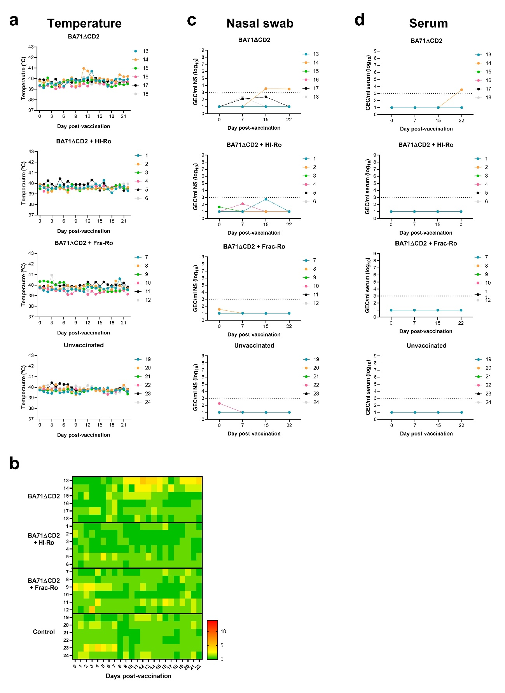
Supplementary Figure 2. Daily rectal temperature charts (a) and clinical scores (b) of individual pigs from day 0 to day 22 post-vaccination (p.v.). The severity of the clinical signs (score value) is represented by a coloured gradient: green (absence), yellow (mild), and orange/red (severe). (c-d) Virus loads measured by qPCR in nasal swabs (c) and serum (d) at days 0, 7, 15, and 22 p.v. Genomic equivalent copies (GEC) of ASFV were quantified by the detection of the ASFV gene PK.

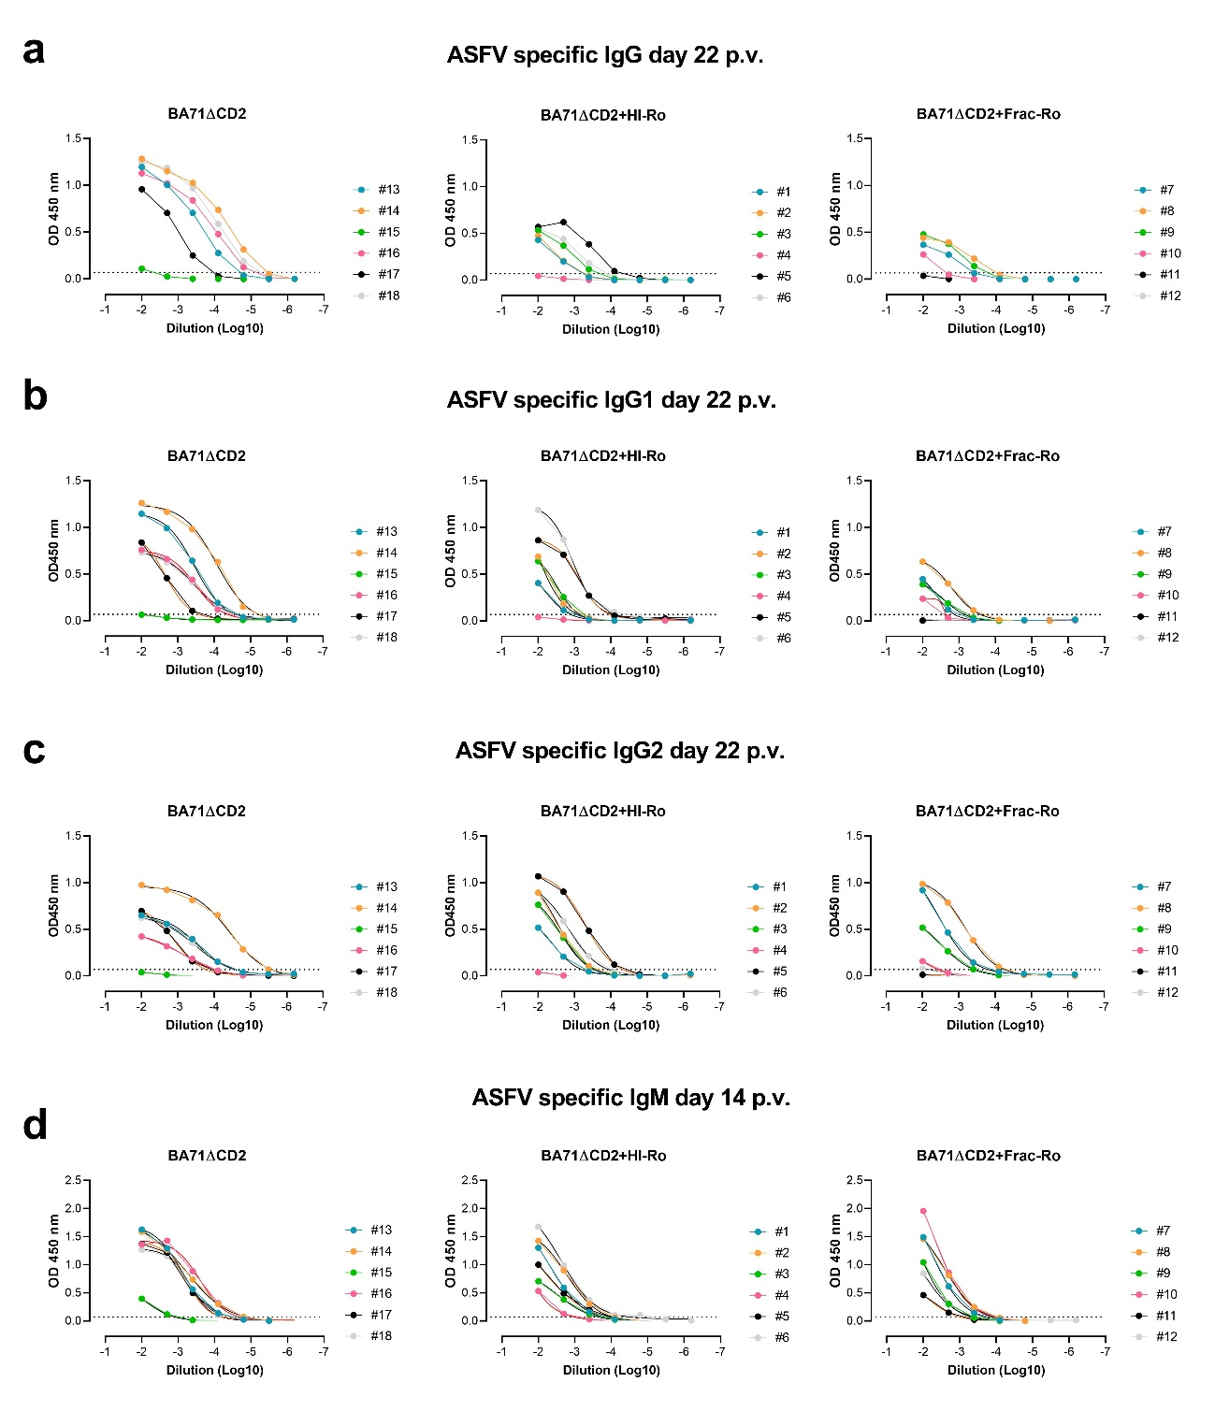
Supplementary Figure 3. ASFV-specific IgG (a), IgG1 (b), IgG2 (c), and IgM (d) antibodies measured by ELISA at 22 (a-c) or 14 (d) days p.v. for each animal.

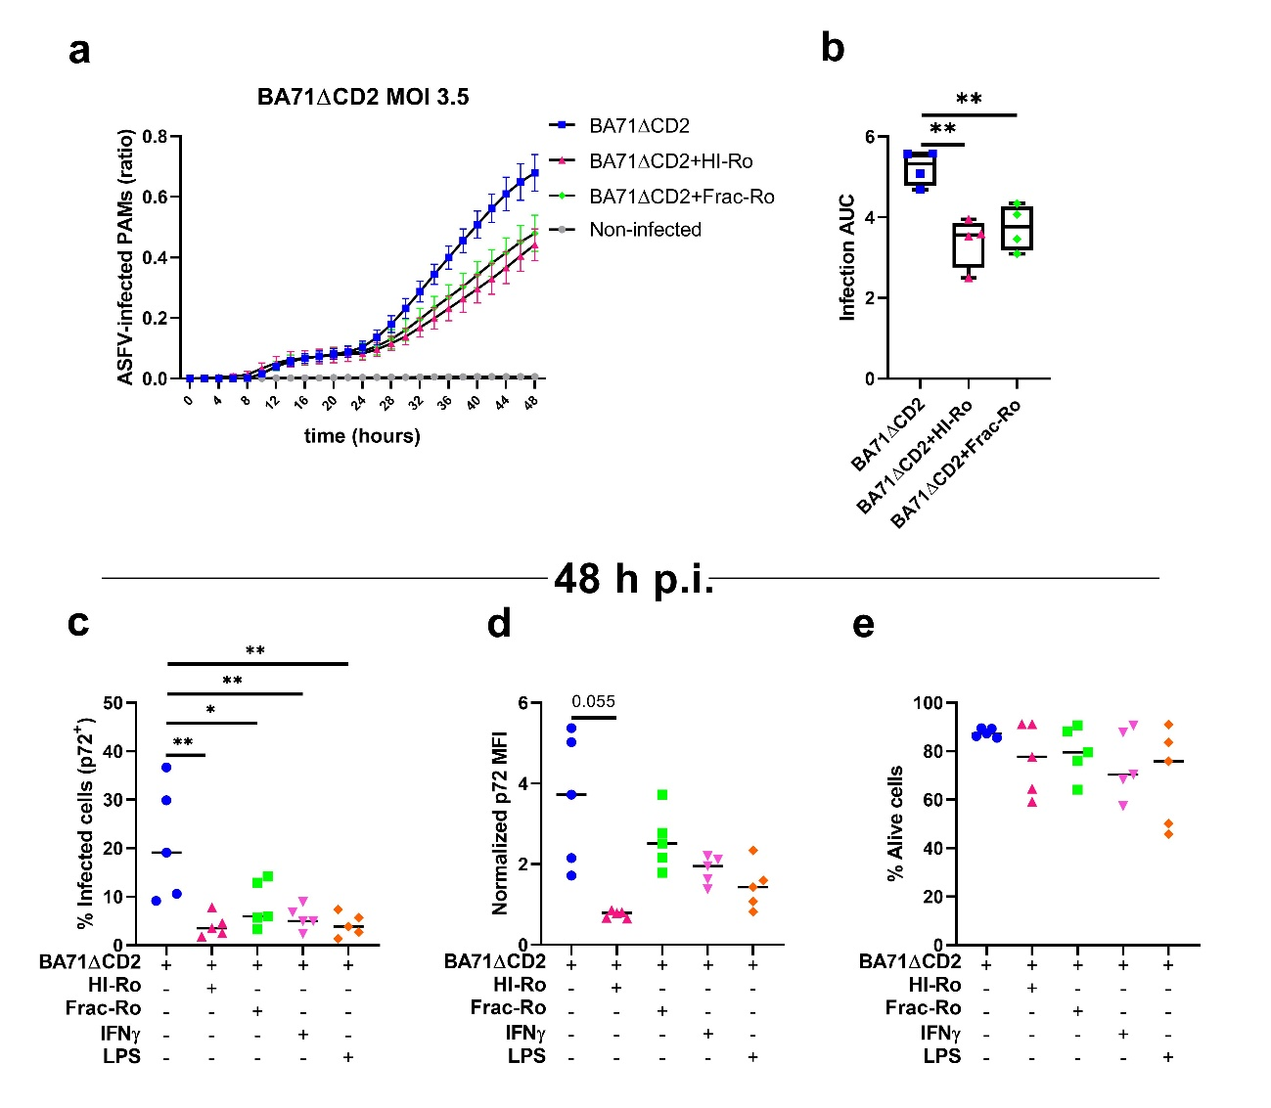
Supplementary Figure 4. (a-b) PAMs were infected with the fluorescently-labelled BA71ΔCD2-mWasabi at MOI 3.5. Two hours post-infection, cells were treated with HI-Ro (MOI 50), Frac-Ro or left untreated. (a) The percentages of p72-positive infected cells were analyzed every 2 hours using time-lapse Incucyte analysis. (b) Area under the curve (AUC) for each condition obtained from the kinetics of percentages of infected cells. (c-e) BA71ΔCD2-infected PAMs (MOI 3.5) treated with HI-Ro (MOI 50), Frac-Ro, IFN-γ (0.1 μg/mL), LPS (10 μg/mL) or left untreated were analyzed at 48 hours post-infection by flow cytometry. The percentages of BA71ΔCD2-infected cells (c), the mean fluorescence intensity (MFI) of the p72 ASFV protein (d), and the percentage of alive cells (e) are shown. Non-infected cells were used as control. Significant differences were determined using a one-way ANOVA (* p-values ≤ 0.05, ** ≤ 0.01, *** ≤ 0.001).

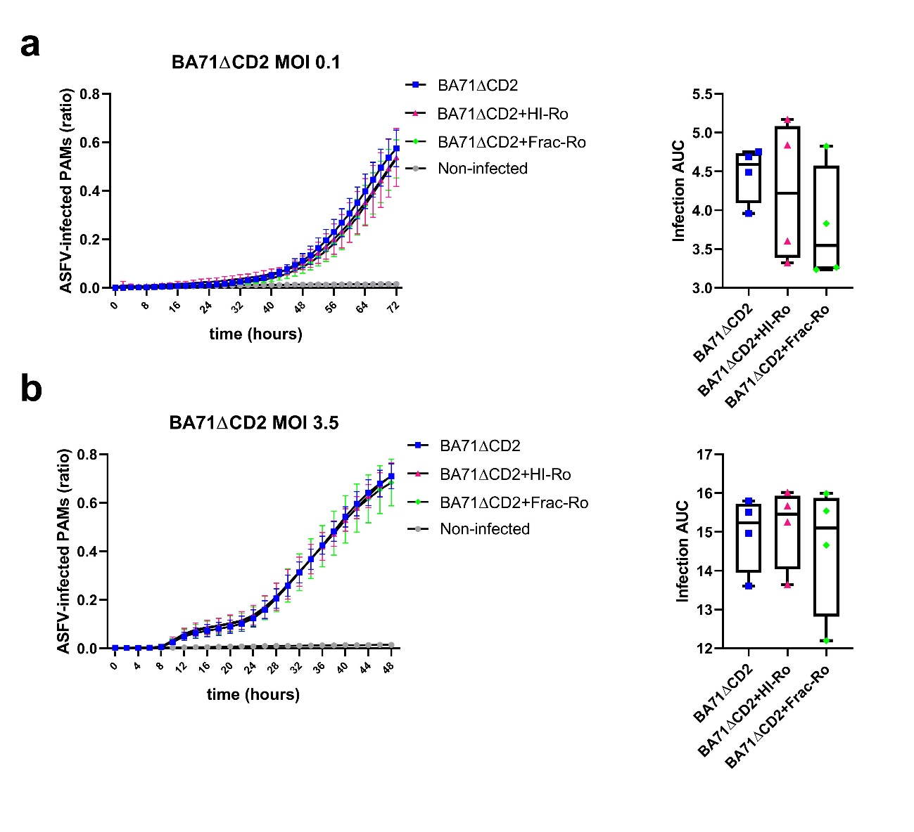
Supplementary Figure 5. Short HI-Ro or Frac-Ro stimulation do not impair BA71ΔCD2 replication. PAMs were stimulated with HI-Ro (MOI 50), Frac-Ro or left untreated for 2 hours (a-b). Subsequently, cells were infected with the fluorescent-labelled BA71ΔCD2-mWasabi at MOI 0.1 (a) or 3.5 (b). The percentages of ASFV-infected cells quantified every 2 hours using time-lapse Incucyte analysis, and the area under the curve (AUC) of the virus kinetics expansion was calculated.

