Supplementary materials
Table S1. Models parameters, thermal limits of the species studied (T_{opt}: optimal temperature ; CT_{min}: critical threshold minimum, CT_{max}: critical threshold maximum).
Habitat | Species | Best model | Topt | CTmin | CTmax
Freshwater | Salmo salar | Ratkowsky | 18.98 | 4.23 | 26.69
Freshwater | Salvelinus alpinus | Gaussian | 14.6 | 1.47 | 27.74
Freshwater | Salvelinus confluentus | Gaussian | 13.28 | 2.16 | 24.4
Marine | Carcinus maenas | Rezende | 16.68 | 2.5 | 18.67
Marine | Cardium lamarcki | Modifiedgaussian | 21.99 | 12.5 | 31.48
Marine | Cerastoderma edule | Gaussian | 15.54 | -8.42 | 39.51
Marine | Chionoecetes opilio | Boatman | 5.29 | -4.9 | 14.12
Marine | Ciona intestinalis | Ratkowsky | 20.76 | -1.31 | 22.84
Marine | Crassostrea virginica | Gaussian | 28.31 | -0.58 | 57.21
Marine | Halichondria panicea | Lactin2 | 14.7 | 3.34 | 15.04
Marine | Haliotis midae | Rezende | 20.89 | -5.97 | 24.84
Marine | Hiatella arctica | Pawar | 15.97 | -2.25 | 21.17
Marine | Littorina littorea | Flinn | 24.9 | -38.12 | Inf
Marine | Mytilus edulis | Quadratic | 15.46 | -0.35 | 31.27
Marine | Nereis diversicolor | Ratkowsky | 18.39 | -2.6 | 26.03
Marine | Nucella lapillus | Sharpeschoolfull | 21.57 | 2.76 | 24.56
Marine | Ostrea edulis | Modifiedgaussian | 21.06 | 14.39 | 27.74
Marine | Temora longicornis | Quadratic | 15.46 | -0.35 | 31.27
Marine | Urosalpinx cinerea | Gaussian | 25.51 | 8.26 | 42.76
Terrestrial | Brachycentrus americanus | Johnson_lewin | 22.84 | Inf | 32.37
Terrestrial | Cicindela hybrida | Gaussian | 39.06 | 13.74 | 64.37
Terrestrial | Formica schaufussi | Beta | 27.85 | 15.59 | 39.07
Terrestrial | Hyles lineata | Quadratic | 24.25 | 7.42 | 41.08
Terrestrial | Manduca sexta | Quadratic | 23.58 | 5.93 | 41.23
Terrestrial | Messor pergandei | Lactin2 | 35.21 | 7.13 | 39.59
Terrestrial | Ocymyrmex barbiger | Gaussian | 57.69 | 19.32 | 96.05
Terrestrial | Pogonomyrmex maricopa | Gaussian | 40.56 | 14.18 | 66.94
Terrestrial | Pogonomyrmex rugosus | Rezende | 44.27 | 6.14 | 51.65

Supplementary Figure 1. Thermal performance curves obtained for the 3 Freshwater species studied.
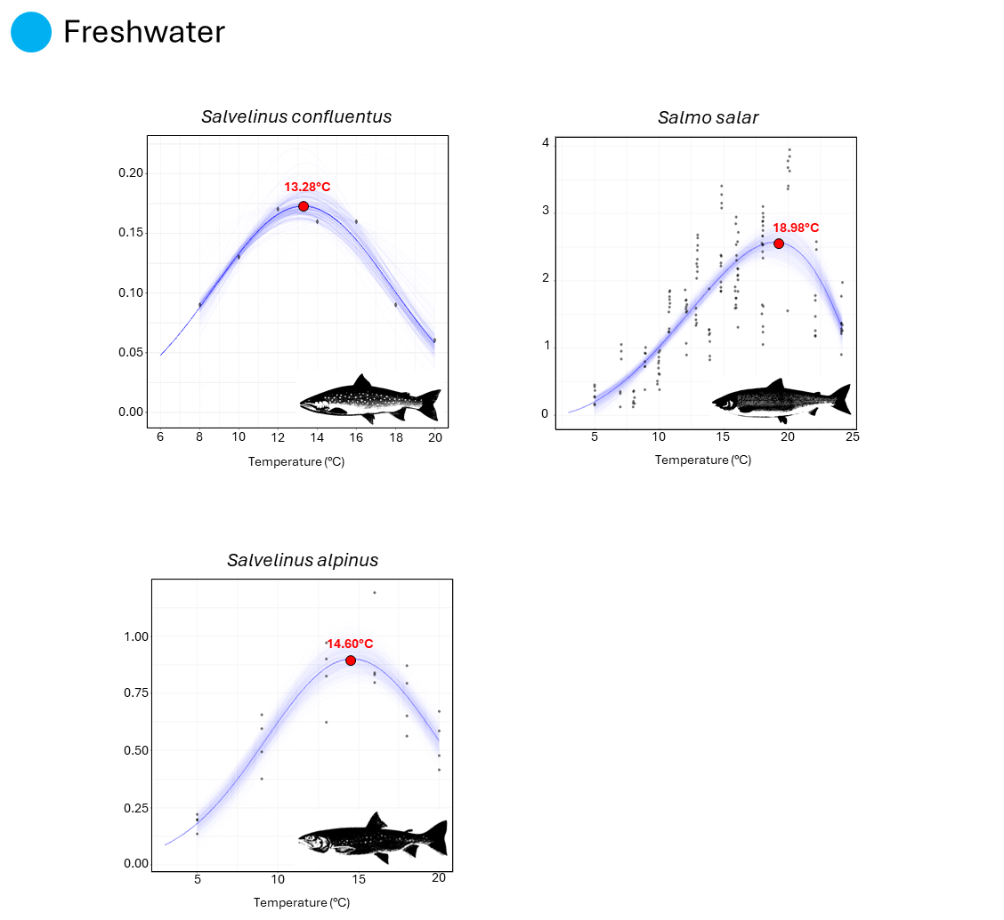

Supplementary Figure 2. Thermal performance curves obtained for the 16 Marine species studied.
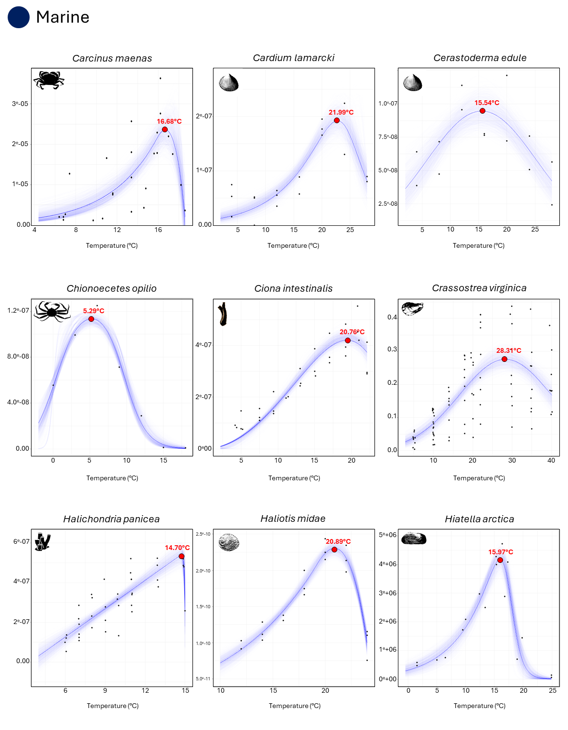

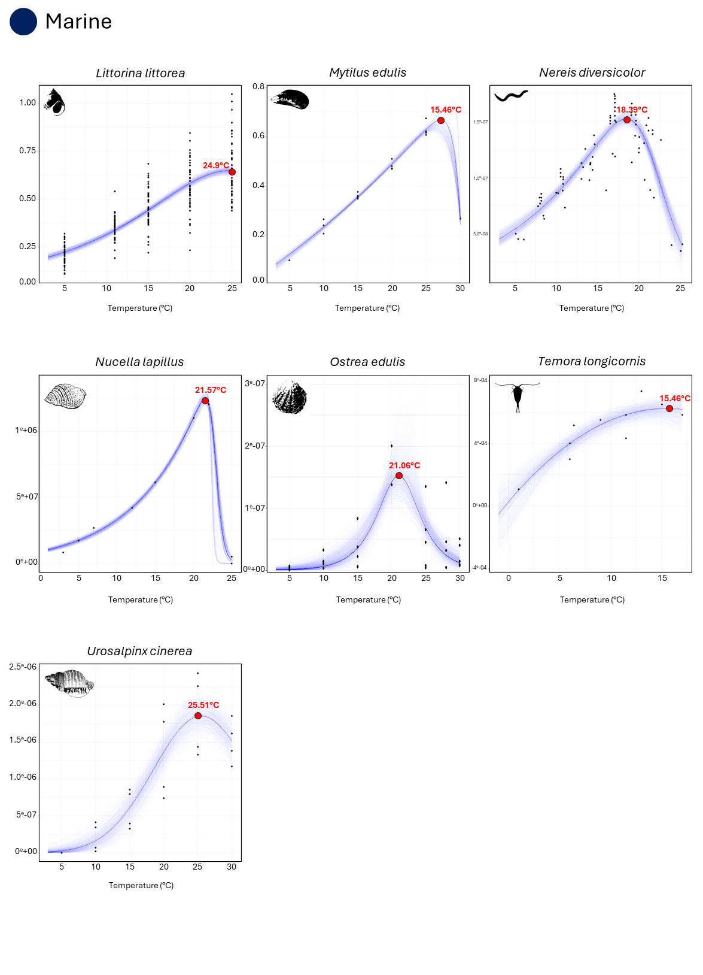

Supplementary Figure 3. Thermal performance curves obtained for the 9 Terrestrial species studied.
