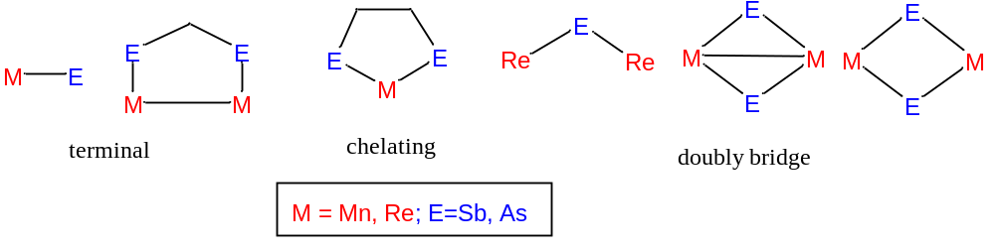
Chart 1. Diversity of bonding modes of manganese/rhenium-arsenic/antimony complexes

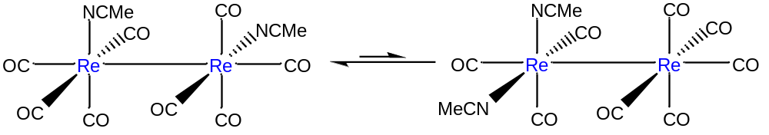
Chart 2. 2,6- and 2,3-isomers of [Re₂(CO)₈(NCMe)₂].

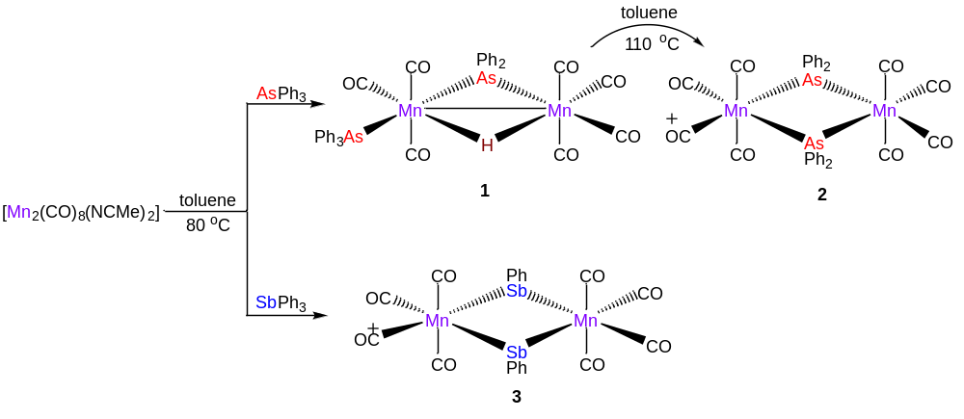
Scheme 1. Reactions of [M₂(CO)₈(NCMe)₂] (M = Mn, Re) with AsPh₃ and SbPh₃
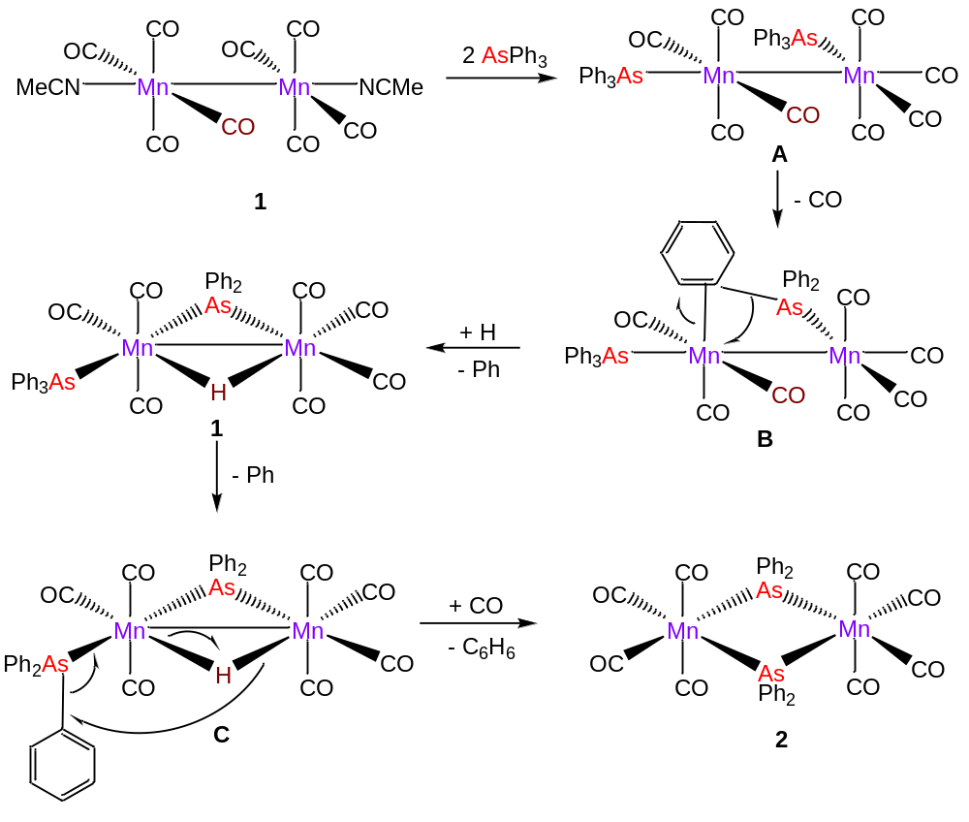
Scheme 2. Schematic representation of the probable mechanism of formation of 1 and 2
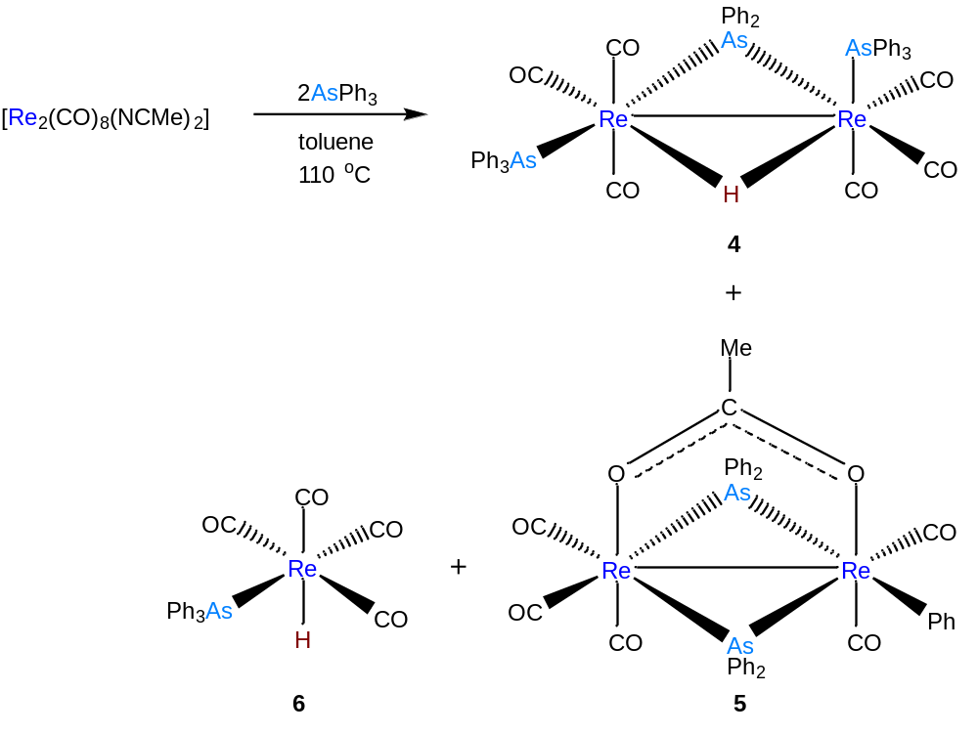
Scheme 3. Products of the reaction of [Re₂(CO)₈₍NCMe)₂] with AsPh₃

