It is stated that, in order to better understand the factors, it is necessary to analyze the differences and similarities among them (Lee, 2017). Statements that are placed similarly across all factors are defined as consensus (agreement) statements, while those placed significantly differently are defined as distinguishing statements. Consensus statements provide an in-depth understanding of the nature of the factor, whereas distinguishing statements offer insight into how the factors differ from one another (Thomas, 2017). In this context, the distinguishing and consensus statements related to the factors were examined. The distinguishing statements for the factors are presented in Table A.

Table A. Distinguishing statements for the factors
 | Factor 1 |  | Factor 2
Q Statements | Q | Z | Q |  | Z
8. I express my emotions in the school environment without hesitation. | 1 | 0,14 | -4 |  | -1,658
2. I serve as a role model for school stakeholders through my behaviors that align with soft skills. | 3 | 1,24 | -1 |  | -0,537
3. I take advantage of professional development opportunities related to soft skills. | 1 | 0,72 | -3 |  | -1,502
4. I make effective interventions during crises at my school. | 3 | 1,56 | 1 |  | 0,843
7. I monitor the academic, social, emotional, and vocational development of students at my school. | 1 | 0,4 | -1 |  | -0,665
13. I create opportunities to improve relationships among school staff. | 0 | -0,04 | -2 |  | -0,802
19. I encourage students at my school to participate in activities and projects that will improve their academic skills. | 0 | -0,32 | -2 |  | -0,949
1. I make an effort to ensure that no one in my school is subjected to bullying. | 4 | 2,22 | 3 | 1,176
5. I provide opportunities to enhance collaboration among teachers at my school. | 2 | 1,15 | 1 | 0,301
6. I adopt a participatory management approach that takes into account the opinions of stakeholders in my school. | 2 | 1,08 | 1 | 0,535
15. I follow our students’ achievements in extracurricular activities. | -1 | -0,48 | -2 | -1,412
22. I take concrete steps to resolve conflicts at my school. | -1 | -0,71 | 0 | 0,012
20. I do not make hasty decisions when experiencing intense emotions such as anger and stress. | -3 | -1,38 | -1 | -0,277
14. I implement a fair management approach in my school. | 1 | 0,33 | 4 | 2,426
18. I encourage respect for individual differences (physical, economic, cognitive, social, etc.) at my school. | -1 | -0,4 | 2 | 0,854
23. I plan the future goals of our school together with school stakeholders. | -3 | -1,38 | 0 | 0,001
17. I make an effort to solve the problems of stakeholders at my school. | -2 | -0,77 | 2 | 0,901
21. I concretely (verbally or in writing) acknowledge the efforts of teachers at my school. | -2 | -0,9 | 3 | 1,168
24. I approach the suggestions of stakeholders at my school without prejudice | -4 | -1,73 | 1 | 0,382
Significant at p<.01

Distinguishing statements for the factors are presented in Table A. Accordingly, 19 statements were identified as significant within the "p<.05" significance level.

Statements indicating inter-factor consensus (agreement) are presented in Table B.

Table B. Inter-factor consensus
 | Factor 1 |  | Factor 2
Q Statements | Q | Z | Q | Z
9. I uphold honesty as a shared value in my school. | 2 | 0,791 | 2 | 0,869
10. I establish open communication with stakeholders at my school. | 0 | 0,1 | 0 | 0,108
11. I support the academic development of teachers at my school. | 0 | 0,069 | -1 | -0,295
12. I approach all stakeholders in my school with an empathetic perspective. | 0 | 0,021 | 0 | 0,185
16. I support stakeholders in my school in expressing their emotions. | -1 | -0,364 | 0 | -0,132
25. I monitor the behaviors of teachers at my school in terms of their alignment with soft skills. | -2 | -1,351 | -3 | -1,53
Non-Significant at p>.01

An examination of Table B reveals that, within the "p > .05" significance level, there is consensus on six statements across all factors.

Factor I
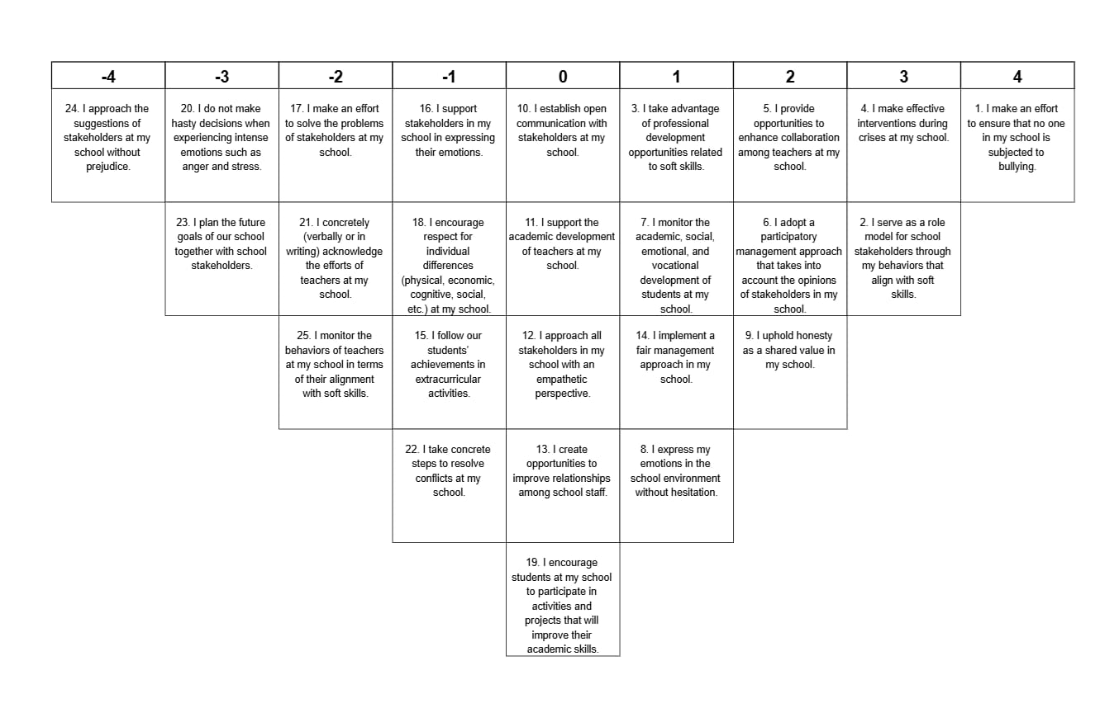

Factor II
