Supplementary material information: Supplementary material consist of additional results and supplementary tables and figures which supporting the main message presented in the manuscript. We planned to add also Methods section in the Supplementary information but we placed after figure captions as required in submission guidelines.

Supplementary material
Supplementary results
Experiment 1
Juveniles choosers spent a significantly more time in the proximity of familiar individuals (mother and siblings together) than in the proximity of unfamiliar ones (Z = 1.964, P = 0.044; Suppl. Fig. 3). Although the average time juveniles spent in different target zones was not significantly different between the targets (Suppl. Fig. 4; Friedman ANOVA, Chi-Square 5.7, p=0.128), the number of juvenile choices shown by spending more time (t>150s, = 25% of total time) in one or two of the target zones indicated significant preferences (Chi-Square Test, Likelihood ratio = 11.9, df=3, p=0.008). Juveniles chose the arm with their mothers more frequently (N=13) than the arm with unfamiliar mothers (N=3) or unfamiliar juveniles (N=4) (Chi-Square test, p<0.05). The juvenile’s choice of siblings (N=7) did not differ from the number of choices of any of the other arms (p>0.05).
Mothers as choosers did not exhibit any significant preferences between target areas (Suppl. Fig. 5).

Experiment 2
The behavioural patterns observed were very similar in all ten studied pairs. Generally, after release into the experimental arena, the juveniles of both mothers dispersed from their mothers and spread throughout the aquarium. Subsequently, mothers started interacting with their opponent by touching with their second antennae or their claws, locking claws or by visual signals (meral spread, high-on-legs). Fights never exceeded 10 min and consisted of several bouts of aggressive interactions. Each bout ended with avoidance behaviour by one of the mothers suggesting the establishment of dominance. In total, contestants displayed an average of 84.8 ± 37.6 sec of aggressive behaviour (including claw locking, claw or antenna touching, visual displays). The number of individual bouts in a fight was on average 25.6 ± 9.8 sec per pair. Dominant mothers won significantly more bouts than subordinate mothers (Suppl. Fig. 6). Subordinate females displayed avoidance behaviour significantly more often (Suppl. Fig. 7). After dominance was established, the dominant mother moved through the arena with an extended and slightly raised abdomen (probably to enable juveniles to re-attach), while the subordinate mother stayed in a corner with her tail flexed under her body or tried to climb up the walls of the arena. This resulted in the significantly greater locomotory activity of dominant mothers (Suppl. Fig. 8). After dominance was established, juveniles showed more affinity to the dominant mother than to the subordinate and gathered below the dominant’s raised abdomen. In 8 out of 10 pairings, all offspring re-attached to just one (the dominant) female on average 2,399 ± 845 sec (range 1,095–2,760 sec.) after the start of the experiment. In two pairings, 96.5 ± 2.1% of juveniles were attached after one hour to the dominant mother while the rest were moving freely in the arena. No juveniles returned to the subordinate mother. The strength of the fight may have had an influence on the re-attachment of juveniles to the dominant mother. However, we found no significant relationships between the time taken for all the offspring to re-attach and the number of bouts, the number of contacts, or the percentage of bouts won. Two additional trials were conducted under the same conditions but using instead a pair of dominant mothers each carrying two juvenile clutches from previous fights. The outcome was consistent with the results of the interactions between pairs of mothers with single clutches. In both cases one mother ended up carrying all juveniles (i.e. four clutches: her own and three unfamiliar clutches; see Fig. 1 in the manuscript) and the other was deprived of all juveniles.
SUPPLEMENTARY TABLES
Supplementary Table 1. The carapace length (CL) and number of juveniles (N_{juv}) of the marbled crayfish (Procambarus virginalis) mothers used in the juvenile’s choice experiment.
Trial no. | CL (mm) | N_{juv} | CL (mm) | N_{juv}
1 | 20.1 | 69 | 20.2 | 71
2 | 24.1 | 112 | 23.1 | 81
3 | 22.0 | 83 | 23.1 | 88
4 | 23.5 | 78 | 22.4 | 95
5 | 22.7 | 88 | 23.1 | 92
6 | 23.9 | 108 | 23.0 | 102
7 | 19.3 | 85 | 20.2 | 111
8 | 21.5 | 104 | 22.3 | 79
9 | 21.3 | 99 | 22.4 | 71
10 | 22.7 | 87 | 23.5 | 101
11 | 27.7 | 113 | 26.7 | 91

Supplementary Table 2. The carapace length (CL) and number of juveniles (N_{juv}) of the marbled crayfish (Procambarus virginalis) mothers used in the mother’s choice experiment in each set-up.
Trial no. | M1: CL (mm) | N_{juv} | M2: CL (mm) | N_{juv}
1 | 26.7 | 127 | 27.7 | 141
2 | 22.7 | 84 | 22.3 | 77
3 | 21.5 | 96 | 22.4 | 71
4 | 23.5 | 123 | 22.6 | 84
5 | 23.9 | 107 | 24.2 | 100
6 | 23.8 | 87 | 24.1 | 116
7 | 22.0 | 96 | 22.7 | 84
8 | 20.2 | 92 | 20.1 | 72
9 | 25.4 | 126 | 24.5 | 136
10 | 24.3 | 111 | 24.0 | 103

Supplementary Table 3. The carapace length (CL) and number of juveniles (N_{juv}) in the marbled crayfish (Procambarus virginalis) mothers used in the mother’s interaction experiment. M1 – first mother, M2 – second mother.
Set-up no. | M1 CL (mm) | N_{juv} | M2 CL (mm) | N_{juv}
1 | 24.7 | 113 | 24.1 | 167
2 | 23.9 | 134 | 24.5 | 129
3 | 24.4 | 141 | 25.0 | 108
4 | 22.2 | 56 | 21.6 | 52
5 | 21.9 | 63 | 21.7 | 58
6 | 20.8 | 71 | 21.3 | 83
7 | 23.2 | 84 | 23.7 | 56
8 | 24.4 | 47 | 24.5 | 35
9 | 25.3 | 87 | 25.9 | 69
10 | 23.4 | 63 | 23.0 | 72

SUPPLEMENTARY FIGURES AND FIGURE CAPTIONS

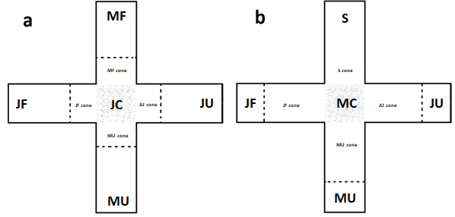
30 cm
Supplementary Figure 1. a: Experimental plus-maze arena for the juvenile choice experiment (MF – familiar mother, JU – unfamiliar juveniles, MU – unfamiliar mother, JF – familiar juveniles, JC – choosing juvenile). b: Experimental plus-maze arena for mother’s choice experiment (S – shelter, JU – unfamiliar juveniles, MU – unfamiliar mother, JF – familiar juveniles, MC – choosing mother). Dashed lines: plastic mesh wall.

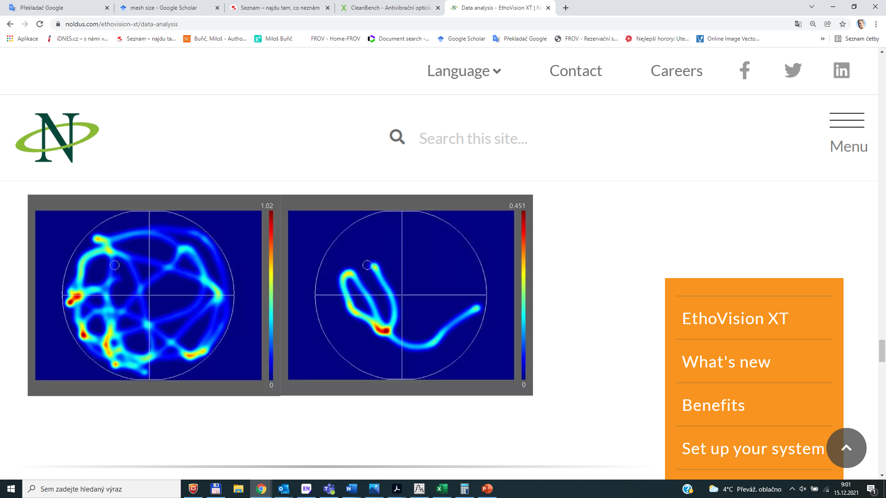
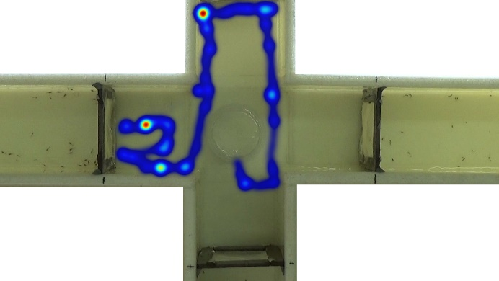
min max
Supplementary Figure 2. An example of the colour visualisation (heatmap) of the time spent in specific zones by the juvenile marbled crayfish (Procambarus virginalis) chooser in Experiment 1. The colour range of the time spent is indicated by the scale from blue (less time) to red (more time).
Supplementary Figure 3. The time spent by juvenile marbled crayfish (Procambarus virginalis) choosers in the proximity of familiar individuals (mother and siblings) and unfamiliar individuals (different mothers and their offspring) in Experiment 1. The asterisk highlights the significant difference (Wilcoxon test, P < 0.05). Data are presented as a mean and standard error of the mean.

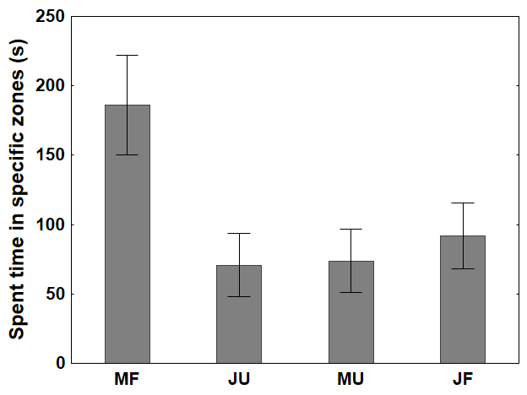
Supplementary Figure 4. The time spent by juvenile marbled crayfish (Procambarus virginalis) choosers in the proximity of a particular choice zone in Experiment 1: MF – familiar mother, JU – unfamiliar offspring, MU – unfamiliar mother, JF – siblings. Data are presented as a mean and standard error of the mean.
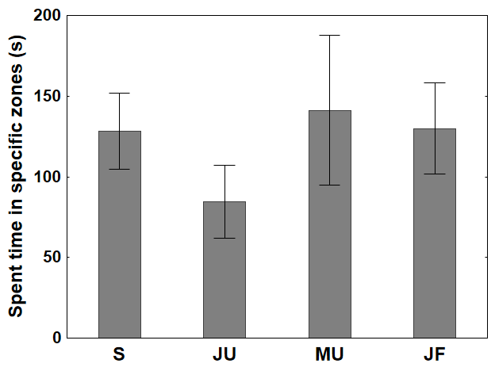
Supplementary Figure 5. The time spent by mother marbled crayfish Procambarus virginalis chooser in the proximity of particular choice zones in Experiment 1: S – shelter, JU – unfamiliar offspring, MU – opponent mother, JF – own offspring. Data are presented as a mean and standard error.
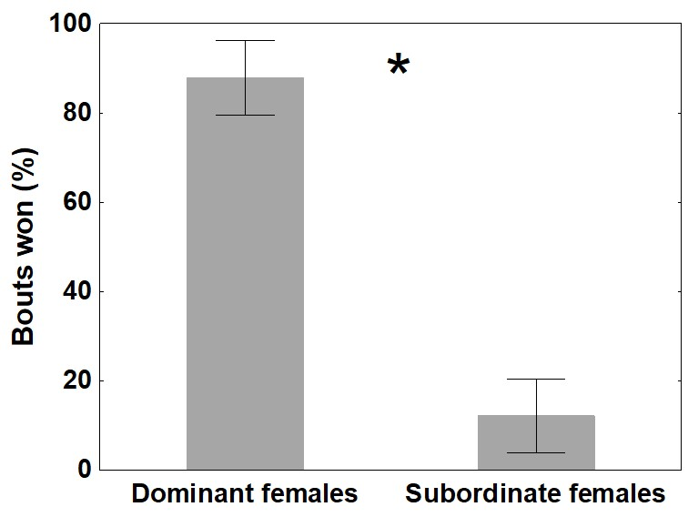
Supplementary Figure 6. The number of wins as a percentage of the total number of bouts fought during interactions of marbled crayfish (Procambarus virginalis) mothers in Experiment 2. The asterisk highlights the significant difference (Paired t-test, P < 0.05). Data are presented as a mean and standard error.
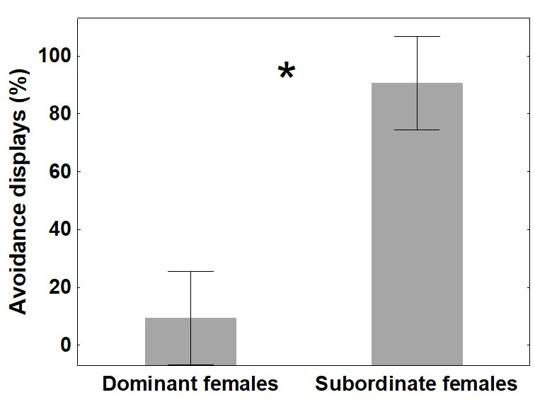
Supplementary Figure 7. The number of avoidance displays as a percentage of the total number of displays during interactions of marbled crayfish (Procambarus virginalis) mothers in Experiment 2. The asterisk highlights the significant difference (Paired t-test, P < 0.05). Data are presented as a mean and standard deviation.

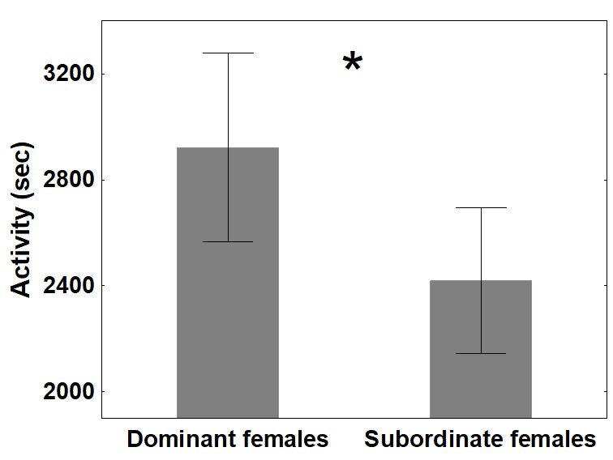
Supplementary Figure 8. The time spent in locomotory activity (activity) in two similarly sized marbled crayfish (Procambarus virginalis) mothers during Experiment 2. The asterisk highlights the significant difference (Paired t-test, P < 0.05).

