Supplementary materials

Optimization of microwave-assisted extraction of polyphenols and antioxidant activity in Reichardia tingitana and Atriplex halimus via response surface methodology
Shoukat Zaman ª, Muhammad Hassan ª, Mohammed Alissa ^{b}, Muhammad Adnan ª, Abdullah Alghamdi ^{b}, Suad A. Alghamdi ^{b}, Abdulkarim S. Binshaya ^{b}, Ghada M. Alnafesah ^{c}, Adil Abalkhail ^{c}, Dilfaraz Khan ª*
ª Institute of Chemical Sciences, Gomal University, D.I.Khan, 29050, KPK, Pakistan
^{b} Department of Medical Laboratory, College of Applied Medical Sciences, Prince Sattam bin Abdulaziz University, Al-Kharj 11942, Saudi Arabia
^{c} Department of Medical Laboratories, College of Applied Medical Sciences, Shaqra University, Shaqra, 11961, Saudi Arabia
^{d} Department of Public Health, College of Applied Medical Sciences, Qassim University, Buraydah 52571, Saudi Arabia
Authors information:
Corresponding author: Dilfaraz Khan
Email: dilfarazkhan@gu.edu.pk

Table S2: Regression coefficients estimated for polyphenol content extracted from selected plants
Factor | Coefficient estimate
 | TPC-1 | TPC-2
Intercept | 129.15 (β₀) | 91.59 (β₀)
A-MW power (X₁) | 2.77 (β₁) | 2.85 (β₁)
B-Temp (X₂) | 1.60 (β₂) | 1.56 (β₂)
C-Time (X₃) | 1.52 (β₃) | 1.51 (β₃)
D-ethanol conc. (X₄) | -0.425 (β₄) | -0.458 (β₄)
AB (X₁₂) | -2.11 (β₁₂) | -2.12 (β₁₂)
AC (X₁₃) | -1.63 (β₁₃) | -1.64 (β₁₃)
AD (X₁₄) | 0.06 (β₁₄) | 0.085 (β₁₄)
BC (X₂₃) | -2.26 (β₂₃) | -2.31 (β₂₃)
BD (X₂₄) | 0.11 (β₂₄) | 0.125 (β₂₄)
CD (X₃₄) | -0.325 (β₃₄) | -0.35 (β₃₄)
A² (X₁²) | -4.39 (β₁₁) | -4.52 (β₁₁)
B² (X₂²) | -1.91 (β₂₂) | -2.00 (β₂₂)
C² (X₃²) | -1.46 (β₃₃) | -1.52 (β₃₃)
D² (X₄²) | -5.43 (β₄₄) | -5.59 (β₄₄)
TPC-1 = Reichardia tingitana, TPC-2 = Atriplex halimus

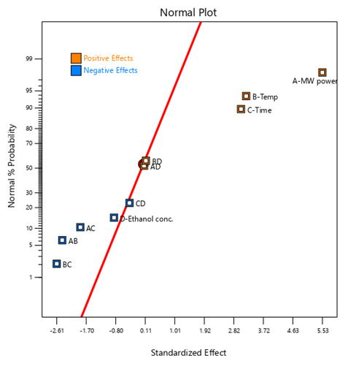
Figure S1: Pareto and normal charts for TPC contents in R. tingitana, showing the relative and statistical significance of different factors and their interaction impacting the TPC yield
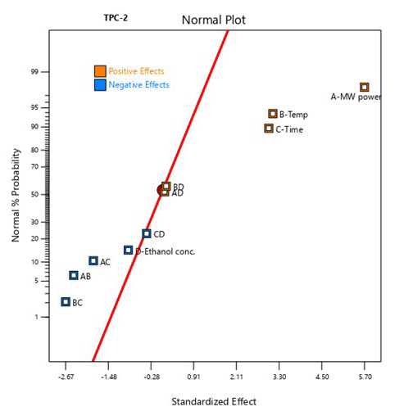
Figure S2: Pareto and normal probability plots for TPC contents in A. halimus highlight the relative contribution and impact of different factors and their interactions on the extraction of polyphenols

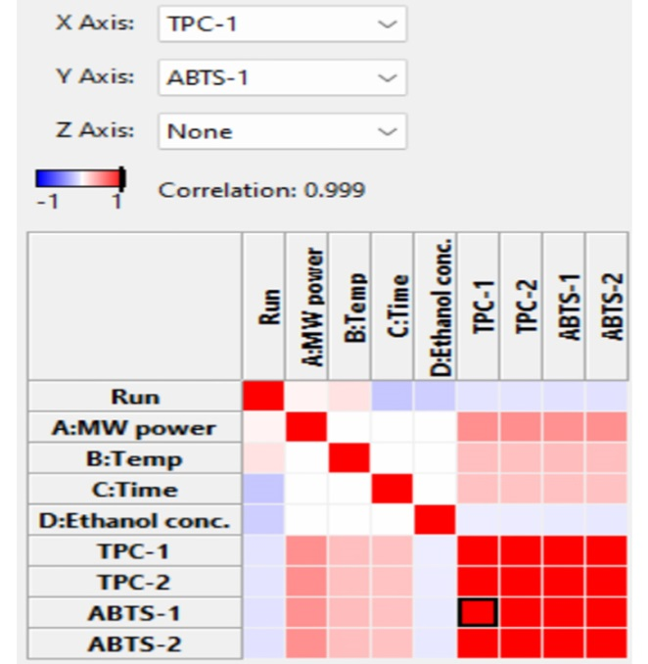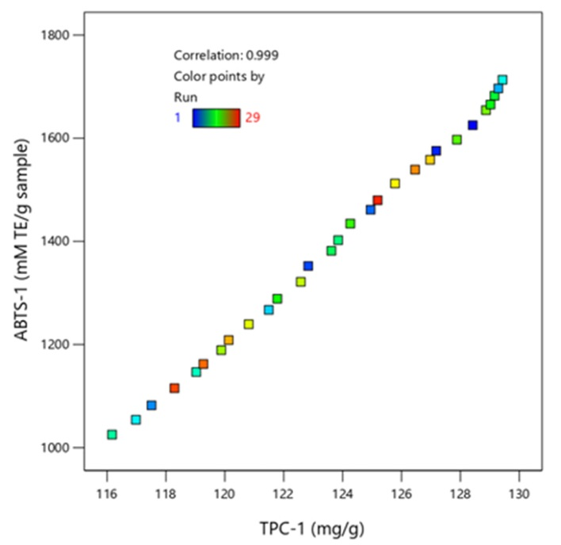
(A)
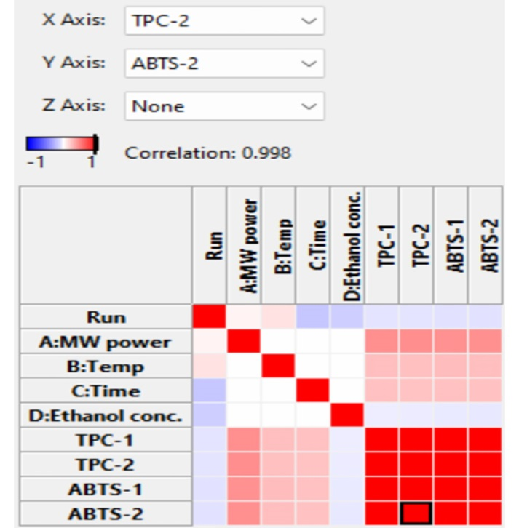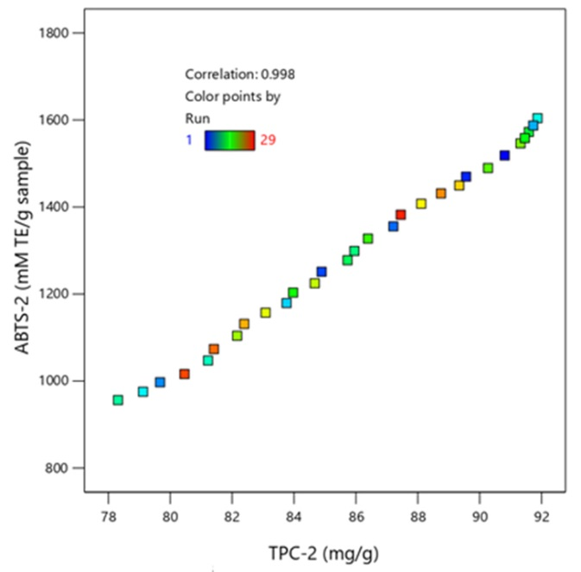
(B)
Figure S3: Correlation of ABTS radical scavenging activity with the Polyphenol contents: (A) TPC-1 and ABTS-1; (B) TPC-2 and ABTS-2
TPC-1 = Reichardia tingitana; TPC-2 = Atriplex halimus; ABTS-1 = R. tingitana; ABTS-2 = A. halimus

