Supplementary material

Table S1: Assessment of reproducibility and quantification for the MaxQuant analysis with “match between runs”. For each protocol the number of consistently identified unique peptides, PGs and quantified PGs was established and divided by the corresponding total number. The calculated ratio is given in percentage. The CV for each quantified PG was determined. The given CV is the median percentage for all shared quantified PGs for each protocol.
Protocol | Consistently identified unique peptides /Total number | Consistently identified PGs /Total number | Consistently quantified PGs /Total number | Median CV
1 | 76.3% | 88.3% | 56.7% | 18.3%
2 | 50.4% | 75.5% | 42.5% | 19.3%
3 | 79.5% | 84.7% | 61.0% | 16.6%
4 | 80.1% | 92.5% | 62.8% | 14.1%
5 | 55.6% | 63.8% | 47.0% | 17.5%
6 | 78.1% | 91.4% | 63.7% | 8.8%

Table S2: Assessment of analytical variability. Three Internal Standards (HeLa) were added to the batch. Based on the numbers of unique peptides, identified and quantified protein groups (PGs) the CV was computed.
 | Internal Standard 1 | Internal Standard 2 | Internal Standard 3 | Mean Value | Standard Deviation | CV
PSMs | 19006 | 18465 | 18254 | 18575 | 223 | 1.7%
Unique peptides | 12917 | 12941 | 12951 | 12936 | 14 | 0.1%
Identified PGs | 2757 | 2788 | 2738 | 2761 | 21 | 0.7%
Quantified PGs | 1965 | 2084 | 2315 | 2121 | 145 | 6.8%

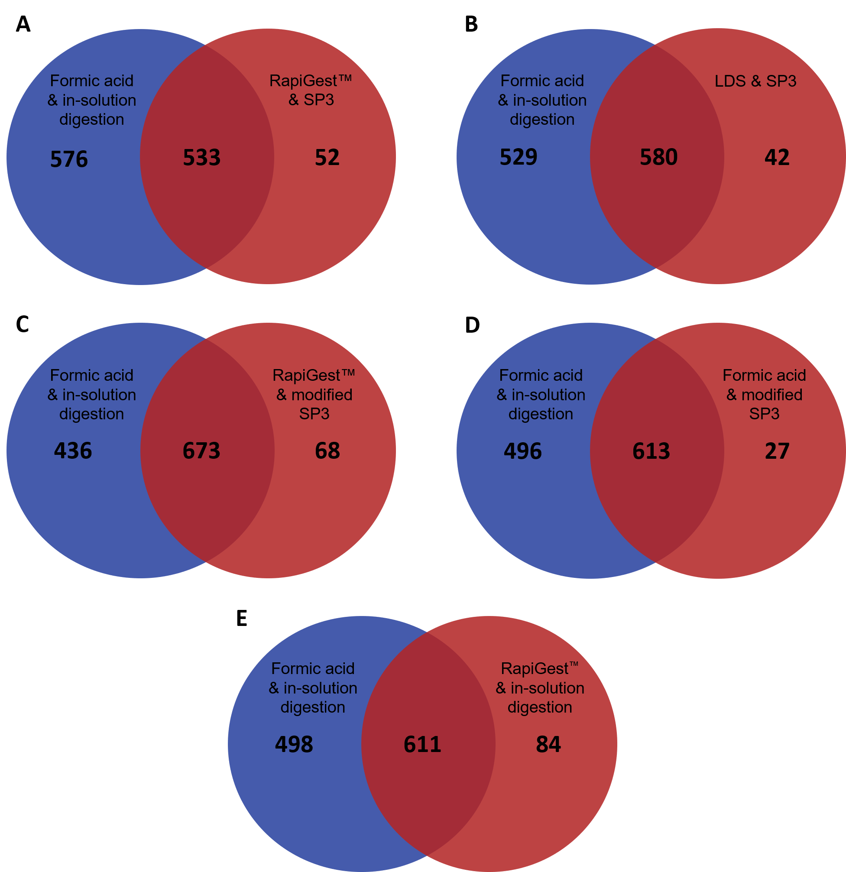
Figure S1: Venn-Diagrams of quantified Protein Groups between the different protocols. For each protocol, all Protein Groups were used that were quantified in all three replicates. Based on the UniProt accession number the list of quantified Protein Groups from formic acid & in-solution digestion protocol was compared to all other protocols (A: RapiGest™ & SP3; B: LDS & SP3; C: RapiGest™ & modified SP3; D: Formic acid & modified SP3; E: RapiGest™ & in-solution digestion).

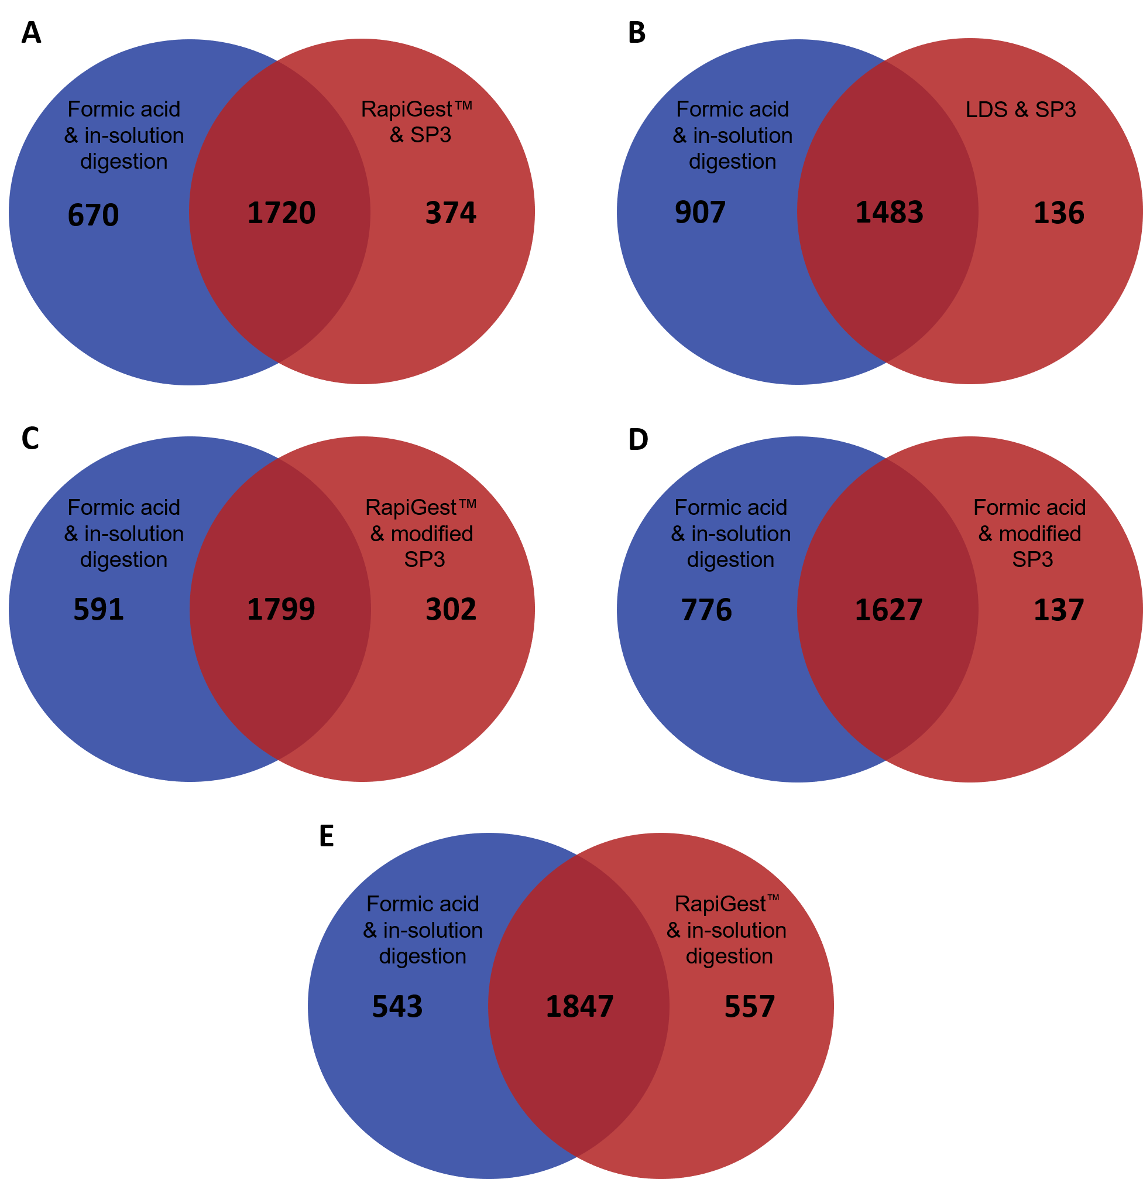
Figure S2: Venn-Diagrams of identified Protein Groups between the different protocols. For each protocol, all Protein Groups were used that were identified in at least one replicate. Based on the UniProt accession number the list of identified Protein Groups from formic acid & in-solution digestion protocol was compared to all other protocols (A: RapiGest™ & SP3; B: LDS & SP3; C: RapiGest™ & modified SP3; D: Formic acid & modified SP3; E: RapiGest™ & in-solution digestion).

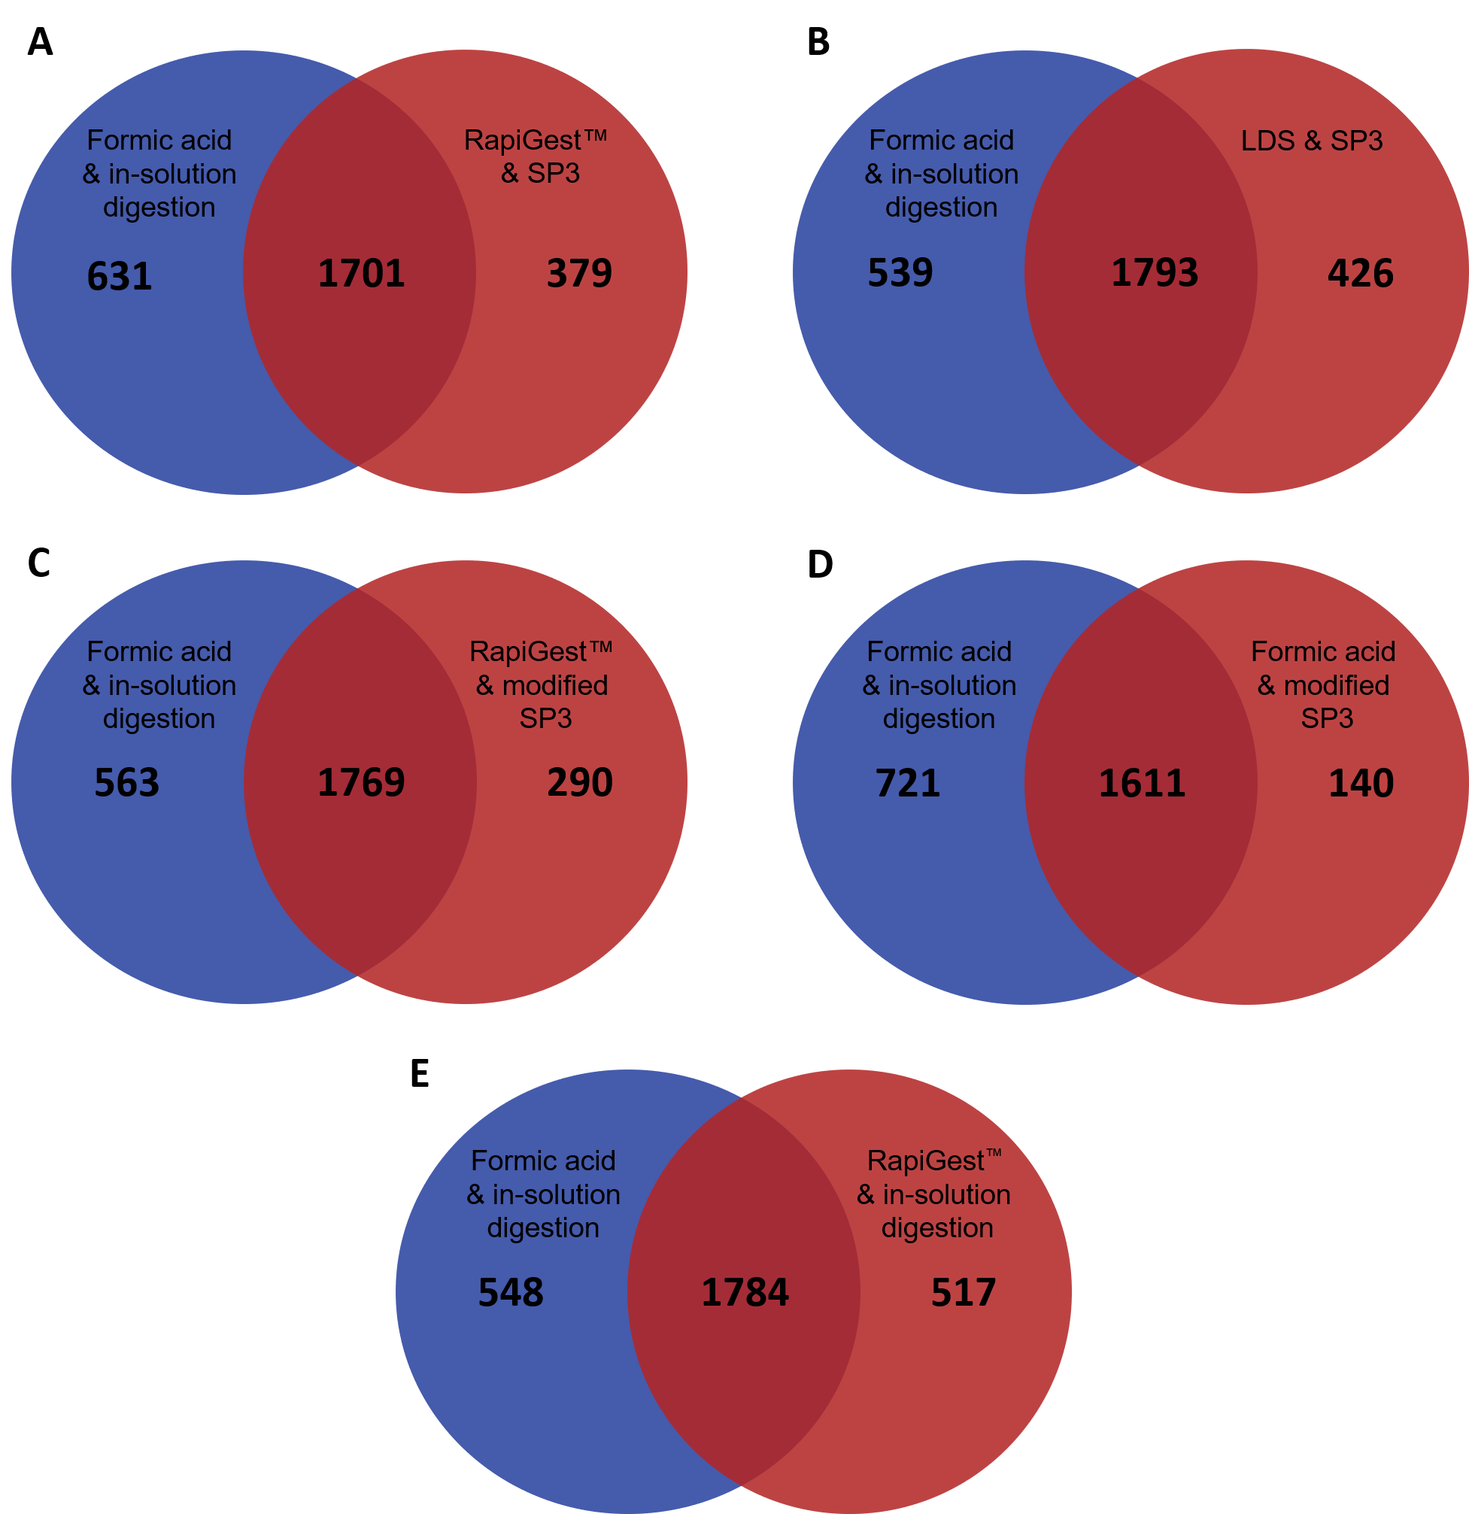
Figure S3: Venn-Diagrams of quantified Protein Groups between the different protocols. For each protocol, all Protein Groups were used that were quantified in at least one replicate. Based on the UniProt accession number the list of identified Protein Groups from formic acid & in-solution digestion protocol was compared to all other protocols (A: RapiGest™ & SP3; B: LDS & SP3; C: RapiGest™ & modified SP3; D: Formic acid & modified SP3; E: RapiGest™ & in-solution digestion).

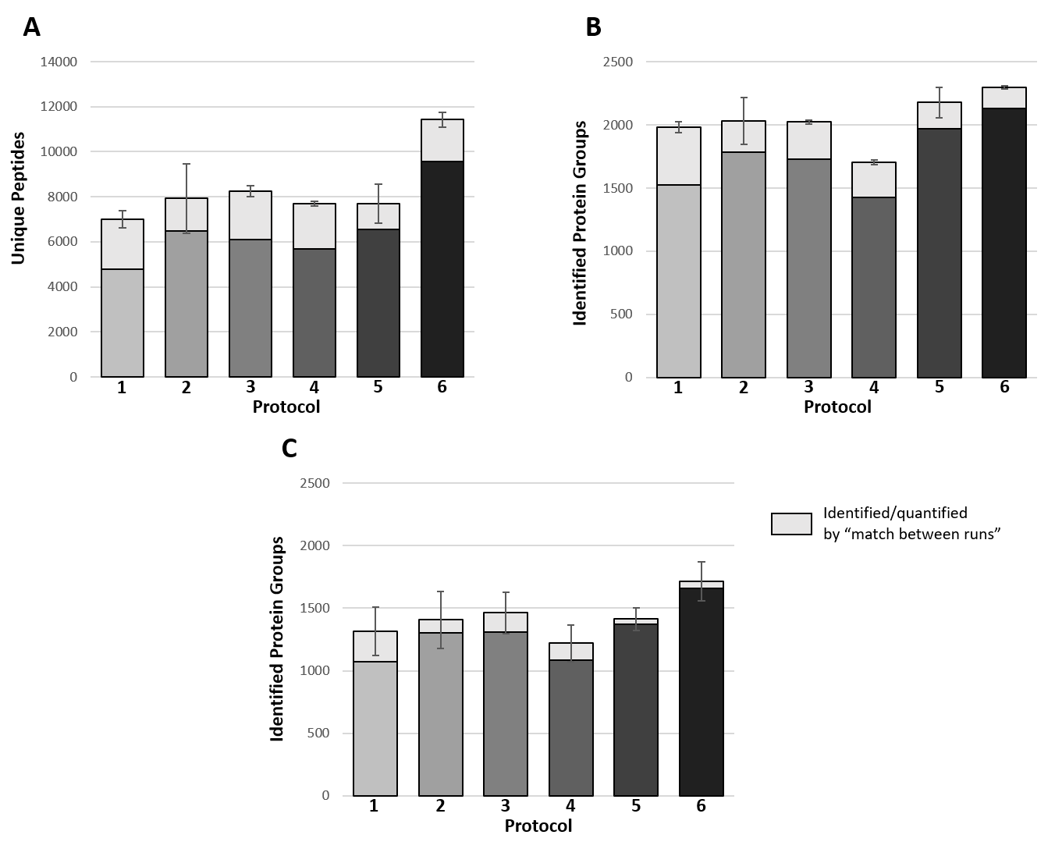
Figure S4: Mean unique peptides (A), identified PGs (B) and quantified PGs (C) for the MaxQuant analysis with “match between runs”. The error bars provide information about the SD between the three replicates. Protocol 1: RapiGest™ & SP3; Protocol 2: LDS & SP3; Protocol 3: RapiGest™ & modified SP3, Protocol 4: Formic acid & modified SP3; Protocol 5: RapiGest™ & in-solution digestion; Protocol 6: Formic acid & in-solution digestion.

