Impact of a two-year trial of nutritional ketosis on indices of cardiovascular disease risk in patients with type 2 diabetes
Running title: Nutritional ketosis and CVD risk indices in T2D
Shaminie J. Athinarayanan PhD^{1*}, Sarah J. Hallberg DO^{1,2,3*}, Amy L. McKenzie PhD¹, Katharina Lechner MD ^{4,5}, Sarah M. King PhD ⁶ James P. McCarter MD, PhD ^{7,8} Jeff S. Volek PhD^{1,9}, Stephen D. Phinney MD, PhD¹, Ronald M. Krauss MD ⁶
*SJA and SJH contributed equally to the study
¹ Virta Health, 501 Folsom Street, San Francisco, CA 94105, USA
² Indiana University Health Arnett, Lafayette, IN, USA
³ Indiana University, School of Medicine, Indianapolis, IN, USA
⁴ Department of Cardiology, German Heart Centre Munich, Technical University Munich, Munich, Germany
⁵ DZHK (German Centre for Cardiovascular Research), Partner site Munich, Munich Heart Alliance, Munich, Germany
⁶ School of Medicine, University of California, San Francisco, CA 94143, USA
⁷ Abbott Diabetes Care, Alameda, CA 94502, USA
⁸ Department of Genetics, Washington University School of Medicine, St. Louis, MO, USA
⁹ Department of Human Sciences, The Ohio State University, Columbus, OH, USA
Supplementary Tables: 7
Supplementary Figures: 1

Supplementary Figure 1. Change in lipids and lipoprotein subclasses in CCI at baseline, one and two years
- LDL cholesterol,
- HDL cholesterol
- Triglycerides
- Small/very small LDL subclasses
- Large/medium LDL subclasses
- Large/medium HDL subclasses
- IDL subclasses
- VLDL subclasses
*** p<0.0015; ** p<0.005

Supplementary Figure 1.
A. B.
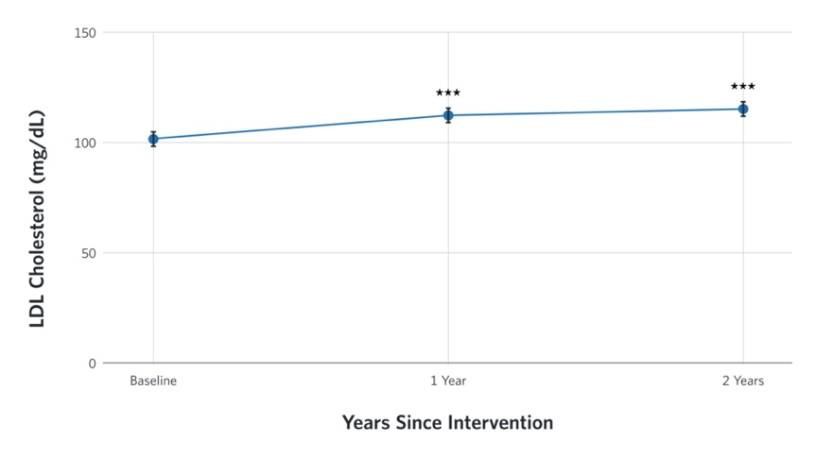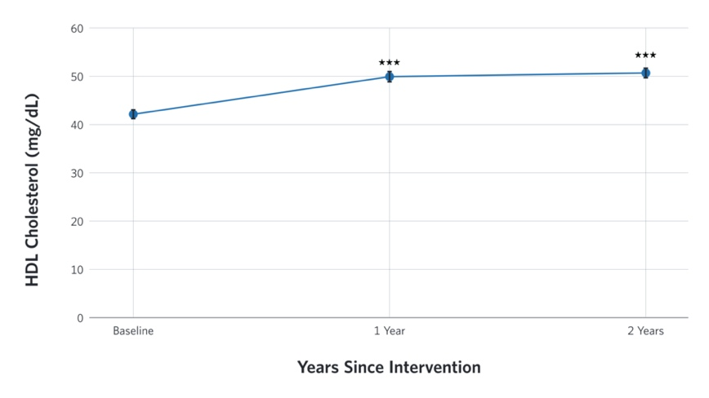

C. D.
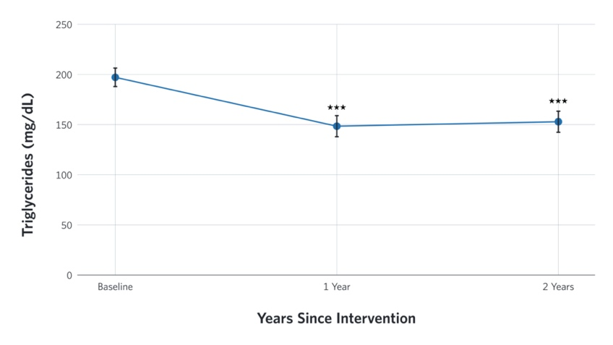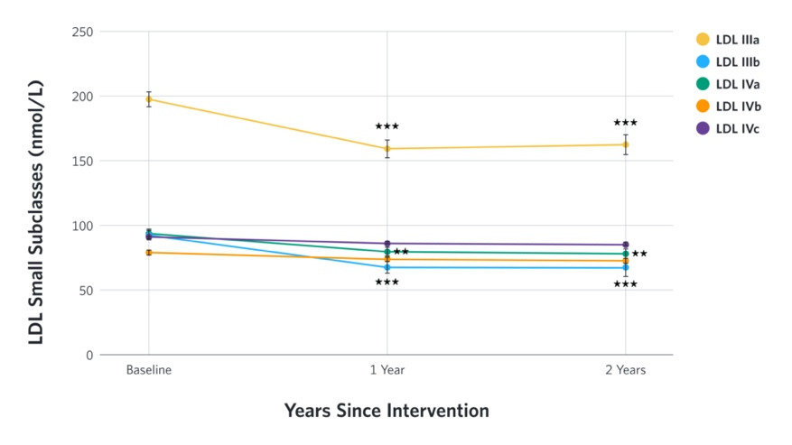

E. F.
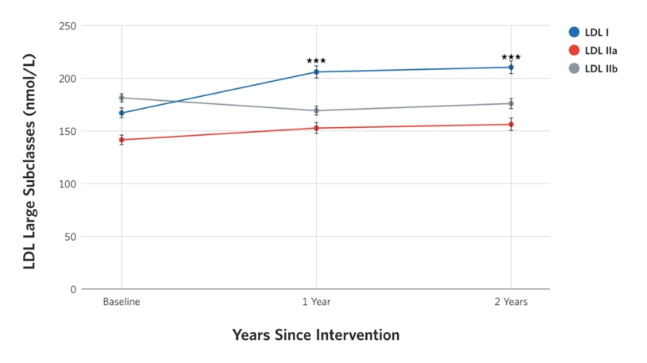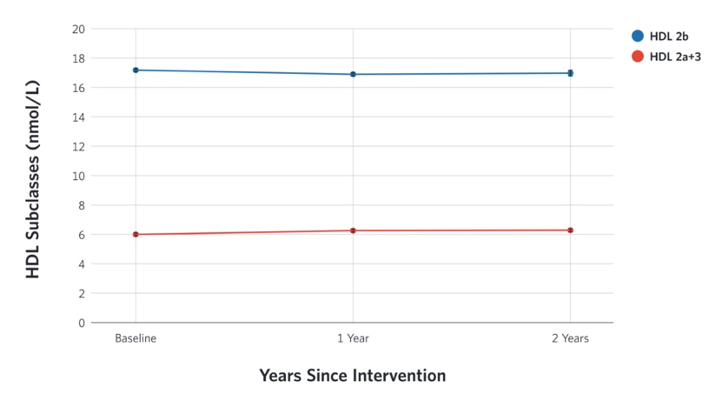
G. H.
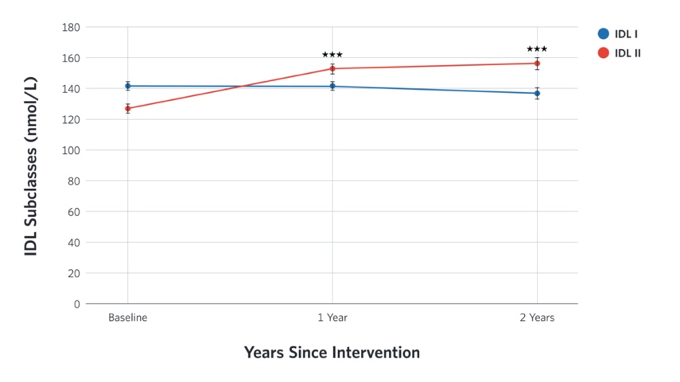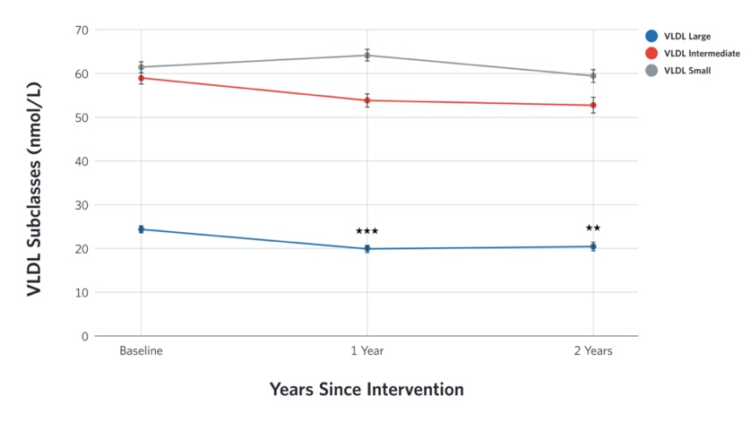

Supplementary Table 1. Lipid lowering and anti-hypertensive medication use over time among completers

Medications | Visit | Continuous Care Intervention (CCI)  n=194 |  |  | Usual Care (UC)  n=58
 |  | Mean (%) | SE | P-value | Mean (%) | SE | P-value
Statin | Baseline | 52.6 | 3.1 | 0.25 | 53.4 | 5.3 | 0.12
 | 2 yrs | 49.0 | 3.6 | 0.25 | 65.5 | 6.3 | 0.12
Other lipid lowering medications | Baseline | 9.3 | 1.9 | 8.0x10⁻³ | 15.5 | 4.3 | 1.0
 | 2 yrs | 5.2 | 1.6 | 8.0x10⁻³ | 17.2 | 5.0 | 1.0
Any antihypertensive medications | Baseline | 76.8 | 2.6 | 1.0x10⁻³ | 63.8 | 5.1 | 0.34
 | 2 yrs | 66.5 | 3.4 | 1.0x10⁻³ | 70.7 | 6.0 | 0.34
ACE & ARB | Baseline | 61.9 | 3.0 | 0.07 | 53.4 | 5.4 | 0.75
 | 2 yrs | 56.2 | 3.6 | 0.07 | 56.9 | 6.6 | 0.75
Diuretics | Baseline | 40.7 | 3.0 | 7.0x10⁻³ | 25.9 | 4.9 | 0.23
 | 2 yrs | 31.4 | 3.3 | 7.0x10⁻³ | 34.5 | 6.3 | 0.23
Abbreviations. SE, standard error, ACE, angiotensin converting enzyme inhibitors; ARB, angiotensin receptor blocker.
Note. Other lipid lowering medications include bile acid sequestrants, fibrates, niacin, and omega-3 fatty acid ethyl esters. Changes in estimated mean proportion of medication use were analyzed using McNemar’s test.

Supplementary Table 2. Adjusted means and changes in lipids, lipoproteins, apoproteins, blood pressure, and CIMT over time by treatment group (intent-to-treat analysis)

Variables | Visit | Continuous Care Intervention (n=262) |  | Usual Care (n=87) |  | Between Group Effect
 |  | Mean ± SE | Change from baseline (Mean, CI) | Mean ± SE | Change from baseline (Mean, CI) | Mean  Difference | 95% CI
Lipids, blood pressure, and CIMT
Total Cholesterol (mg/dL) | Baseline | 186.0±2.8 |  | 172.3±5.5 |  | 13.7 | 1.3 to 26.0
Total Cholesterol (mg/dL) | 1 yr | 194.0±3.2 | 8.0, -0.2 to 16.2 | 172.9±5.9 | 0.6, -14.5 to 15.7 | 21.1^{Ï} | 7.8 to 34.4
Total Cholesterol (mg/dL) | 2 yrs | 196.0±3.4 | 10.0, 1.4 to 18.5 | 172.0±6.2 | -0.3, -16.1 to 15.4 | 24.0 * | 9.8 to 38.1*
LDL-C(mg/dL) | Baseline | 102.4 ±2.2 |  | 98.0 ±4.5 |  | 4.4 | -5.6 to 14.4
LDL-C(mg/dL) | 1 yr | 113.1 ±2.5 | 10.8, 4.2 to 17.3 * | 88.0 ±5.0 | -10.0, -22.8 to 2.8 | 25.2 * | 14.1 to 36.3 *
LDL-C(mg/dL) | 2 yrs | 115.0 ±2.7 | 12.7, 5.8 to 19.5 * | 90.8 ±5.1 | -7.2, -20.1 to 5.8 | 24.3 * | 12.8 to 35.8 *
HDL-C(mg/dL) | Baseline | 42.2±0.8 |  | 37.2±1.7 |  | 5.0 | 1.3 to 8.8
HDL-C(mg/dL) | 1 yr | 49.9±1.0 | 7.7, 5.2 to 10.2 * | 35.2±1.8 | -2.0, -6.6 to 2.6 | 14.7 * | 10.7 to 18.8
HDL-C(mg/dL) | 2 yrs | 50.7±1.0 | 8.5, 5.9 to 11.1 * | 41.0±1.9 | 3.8, -1.0 to 8.5 | 9.7 * | 5.4 to 14.0
Triglycerides (mg/dL)^{b} | Baseline | 197.2±9.1 |  | 282.9±45.1 |  | -85.7 | -177.2 to 5.9
Triglycerides (mg/dL)^{b} | 1 yr | 148.9±10.1 | -48.3, -24.9 to –73.1 * | 314.5±61.4 | 31.6, -48.3 to 108.4 | -165.5 | -289.9 to –41.2 *
Triglycerides (mg/dL)^{b} | 2 yrs | 153.3±10.4 | -43.9, -14.7 to –67.7 * | 209.5±18.5 | -73.4, -99.3 to 67.9 | -56.2 | -97.5 to –14.8 *
Systolic Blood Pressure (mmHg) | Baseline | 132.2±0.9 |  | 128.5±1.7 |  | 3.7 | -0.2 to 7.6
Systolic Blood Pressure (mmHg) | 1 yr | 126.0±1.0 | -6.2, -8.8 to –3.6 * | 128.0±1.7 | -0.6, -5.1 to 4.0 | -1.9 | -5.9 to 2.0
Systolic Blood Pressure (mmHg) | 2 yrs | 125.8±1.1 | -6.4, -9.2 to –3.6 * | 129.4±2.0 | 0.8, -4.2 to 5.9 | -3.6 | -8.2 to 1.0
Diastolic Blood Pressure (mmHg) | Baseline | 82.0±0.5 |  | 79.8±1.0 |  | 2.2 | -0.1 to 4.6
Diastolic Blood Pressure (mmHg) | 1 yr | 78.2±0.6 | -3.8, -5.4 to –2.3 * | 79.6±1.0 | -0.1, -2.9 to 2.6 | -1.4 | -3.8 to 0.9
Diastolic Blood Pressure (mmHg) | 2 yrs | 78.5±0.7 | -3.5, -5.1 to –1.9 * | 81.0±1.2 | 1.2, -1.8 to 4.2 | -2.5 | -5.2 to 0.3
non-HDL (mg/dL) | Baseline | 143.7±2.8 |  | 135.1±5.5 |  | 8.7 | -3.6 to 20.9
non-HDL (mg/dL) | 1 yr | 144.1±3.2 | 0.3, -7.8 to 8.5 | 137.7±5.8 | 2.6, -12.5 to 17.6 | 6.4 | -6.8 to 19.6
non-HDL (mg/dL) | 2 yrs | 145.3±3.4 | 1.6, -6.9 to 10.1 | 131.0±6.2 | -4.1, -11.5 to 19.7 | 14.4 | 0.3 to 28.4
Remnant Cholesterol (mg/dL) | Baseline | 34.8±0.9 |  | 33.2±1.8 |  | 1.6 | -2.5 to 5.7
Remnant Cholesterol (mg/dL) | 1 yr | 26.2±1.0 | -8.7, -11.3 to –6.0 * | 34.6±2.0 | 1.4, -3.9 to 6.6 | -8.4 * | -13.0 to –3.9 *
Remnant Cholesterol (mg/dL) | 2 yrs | 26.9±1.1 | -8.0, -10.8 to –5.2 * | 31.0±2.1 | -2.3, -7.6 to 3.0 | -4.1 | -8.8 to 0.6
CIMT | Baseline | 0.68±0.01 |  | 0.69±0.02 |  | -0.01 | -0.05 to 0.03
CIMT | 1 yr | 0.68±0.01 | 0.00, -0.03 to 0.03 | 0.69±0.02 | 0.00, -0.04 to 0.05 | -0.01 | -0.05 to 0.03
CIMT | 2 yrs | 0.67±0.01 | -0.01, -0.04 to 0.02 | 0.70±0.02 | 0.01, -0.04 to 0.06 | -0.03 | -0.07 to 0.01
Apoproteins
Total ApoB | Baseline | 106.3±1.8 |  | 100.7±3.6 |  | 5.6 | -2.6 to 13.8
Total ApoB | 1 yr | 104.8±2.1 | -1.5, -6.8 to 3.9 | 102.2±3.9 | 1.5, -8.5 to 11.5 | 2.6 | -6.2 to 11.4
Total ApoB | 2 yrs | 101.7±2.3 | -4.6, -10.2 to 1.1 | 98.7±4.1 | -2.0, -12.4 to 8.4 | 3.0 | -6.3 to 12.4
Total ApoA1 | Baseline | 146.9±1.7 |  | 144.0±3.4 |  | 3.0 | -4.7 to 10.6
Total ApoA1 | 1 yr | 161.3±2.0 | 14.4, 9.3 to 19.5 * | 141.2±3.6 | -2.8, -12.2 to 6.7 | 20.1 * | 11.8 to 28.4 *
Total ApoA1 | 2 yrs | 163.2±2.7 | 16.3, 11.0 to 21.6 * | 137.4±3.9 | -6.6, -16.4 to 3.2 | 25.9 * | 17.1 to 34.6 *
ApoB: ApoA1 ratio | Baseline | 0.7±0.0 |  | 0.7±0.0 |  | 0.0 | -0.0 to 0.1
ApoB: ApoA1 ratio | 1 yr | 0.7±0.0 | -0.1, -0.1 to –0.0 Ï | 0.7±0.0 | 0.0, -0.1 to 0.1 | -0.1 | -0.1 to 0.0
ApoB: ApoA1 ratio | 2 yrs | 0.7±0.0 | -0.1, -0.1 to –0.1 * | 0.7±0.0 | 0.0, -0.1 to 0.1 | -0.1 | -0.2 to –0.0
Lipoproteins
Total VLDL (nmol/L) | Baseline | 144.8±3.0 |  | 131.6±6.0 |  | 13.2 | -0.3 to 26.6
Total VLDL (nmol/L) | 1 yr | 137.9±3.4 | -6.9, -15.8 to 2.0 | 133.6±6.2 | 2.0, -14.3 to 18.4 | 4.2 | -10.0 to 18.4
Total VLDL (nmol/L) | 2 yrs | 132.6±4.0 | -12.2, -22.0 to –2.5 | 132.2±6.8 | 0.6, -16.7 to 17.8 | 0.4 | -15.3 to 16.0
VLDL Large (nmol/L) | Baseline | 24.4±0.8 |  | 22.2±1.5 |  | 2.3 | -1.2 to 5.7
VLDL Large (nmol/L) | 1 yr | 19.9±0.9 | -4.5, -6.8 to –2.2 * | 23.6±1.6 | 1.4, -2.7 to 5.6 | -3.6 | -7.3 to –0.0
VLDL Large (nmol/L) | 2 yrs | 20.4±1.0 | -4.0, -6.5 to –1.5 Ï | 22.2±1.7 | 0.0, -4.4 to 4.4 | -1.7 | -5.7 to 2.2
VLDL Medium (nmol/L) | Baseline | 58.9±1.4 |  | 54.6±2.7 |  | 4.3 | -1.7 to 10.4
VLDL Medium (nmol/L) | 1 yr | 53.7±1.6 | -5.2, -9.2 to –1.2 | 55.6±2.8 | 1.0, -6.4 to 8.4 | -1.8 | -8.3 to 4.6
VLDL Medium (nmol/L) | 2 yrs | 52.8±1.8 | -6.1, -10.5 to –1.7 | 55.0±3.1 | 0.5, -7.3 to 8.2 | -2.2 | -9.3 to 4.8
VLDL small (nmol/L) | Baseline | 61.4±1.2 |  | 54.9±2.3 |  | 6.6 | 1.4 to 11.7
VLDL small (nmol/L) | 1 yr | 64.2±1.3 | 2.8, -0.6 to 6.2 | 54.5±2.4 | -0.4, -6.7 to 5.9 | 9.7 * | 4.3 to 15.2 *
VLDL small (nmol/L) | 2 yrs | 59.4±1.5 | -2.0, -5.8 to 1.6 | 55.0±2.6 | 0.1, -6.5 to 6.7 | 4.4 | -1.6 to 10.4
Total IDL (nmol/L) | Baseline | 268.4±4.7 |  | 238.3±9.2 |  | 30.1 | 9.4 to 50.8
Total IDL (nmol/L) | 1 yr | 294.2±5.3 | 25.8, 12.1 to 39.5 * | 238.4±9.6 | 0.1, -25.0 to 25.2 | 55.8 * | 34.0 to 77.6
Total IDL (nmol/L) | 2 yrs | 293.0±6.1 | 24.7, 9.7 to 39.6 * | 242.1±10.4 | 3.8, -22.6 to 30.2 | 51.0 * | 27.0 to 75.0
IDL 1 (nmol/L) | Baseline | 141.4±2.5 |  | 127.3±5.0 |  | 14.1 | 3.0 to 25.2
IDL 1 (nmol/L) | 1 yr | 141.7±2.8 | 0.3, -7.1 to 7.6 | 127.1±5.2 | -0.1, -13.6 to 13.4 | 14.5 | 2.8 to 26.3
IDL 1 (nmol/L) | 2 yrs | 136.9±3.3 | -4.5, -12.5 to 3.6 | 127.6±5.6 | 0.3, -13.9 to 14.6 | 9.3 | -3.6 to 22.2
IDL 2 (nmol/L) | Baseline | 127.0±2.9 |  | 111.0±5.7 |  | 16.0 | 3.3 to 28.7
IDL 2 (nmol/L) | 1 yr | 152.5±3.2 | 25.5, 17.1 to 33.9 * | 111.2±5.9 | 0.2, -15.2 to 15.6 | 41.3 * | 27.9 to 54.7 *
IDL 2 (nmol/L) | 2 yrs | 156.1±3.7 | 29.1, 19.9 to 38.3 * | 114.4±6.4 | 3.4, -12.8 to 19.7 | 41.7 * | 26.9 to 56.4 *
Total LDL (nmol/L) | Baseline | 1038.4±16.5 |  | 1014.0±33.9 |  | 24.4 | -50.8 to 99.6
Total LDL (nmol/L) | 1 yr | 994.0±18.8 | -44.4, -93.0 to 4.2 | 993.7±34.9 | -20.3, -112.8 to 92.2 | 0.3 | -78.5 to 79.1
Total LDL (nmol/L) | 2 yrs | 1010.3±21.5 | -28.1, -81.0 to 24.7 | 974.3±37.9 | -39.7, -136.9 to 57.4 | 36.0 | -50.6 to 122.5
LDL I (nmol/L) | Baseline | 167.7±4.6 |  | 150.0±9.1 |  | 17.6 | -2.7 to 37.9
LDL I (nmol/L) | 1 yr | 206.5±5.2 | 38.9, 25.4 to 52.3 * | 142.2±9.4 | -7.9, -32.5 to 16.8 | 64.3 * | 42.9 to 85.8 *
LDL I (nmol/L) | 2 yrs | 211.3±6.0 | 43.6, 28.9 to 58.3 * | 152.0±10.3 | 1.9, -24.1 to 27.9 | 59.3 * | 35.7 to 83.0 *
LDL IIa (nmol/L) | Baseline | 142.2±3.7 |  | 132.6±7.3 |  | 9.6 | -6.8 to 25.9
LDL IIa (nmol/L) | 1 yr | 153.0±4.2 | 10.9, 0.1 to 21.7 | 122.5±7.6 | -10.1, -30.0 to 9.7 | 30.6 * | 13.3 to 47.8 *
LDL IIa (nmol/L) | 2 yrs | 156.9±4.8 | 14.7, 2.9 to 26.5 | 127.4±8.2 | -5.2, -26.1 to 15.6 | 29.5 Ï | 10.5 to 48.5 Ï
LDL IIb (nmol/L) | Baseline | 182.3±4.4 |  | 174.4±8.7 |  | 7.9 | -11.7 to 27.5
LDL IIb (nmol/L) | 1 yr | 169.8±5.0 | -12.4, -25.4 to 0.5 | 163.8±9.1 | -10.6, -34.4 to 13.2 | 6.1 | -14.6 to 26.8
LDL IIb (nmol/L) | 2 yrs | 176.4±5.8 | -5.9, -20.1 to 8.3 | 168.6±9.9 | -5.7, -30.8 to 19.4 | 7.7 | -15.1 to 30.5
LDL IIIa (nmol/L) | Baseline | 198.0±5.8 |  | 177.7±11.5 |  | 20.3 | -5.4 to 46.0
LDL IIIa (nmol/L) | 1 yr | 159.3±6.6 | -38.8, -55.8 to 21.8 * | 188.3±11.9 | 10.6, -20.6 to 41.8 | -29.0 | -56.1 to –1.9
LDL IIIa (nmol/L) | 2 yrs | 162.7±7.6 | -35.4, -53.9 to –16.8 * | 191.8±13.0 | 14.1, -18.8 to 47.0 | -29.1 | -59.0 to 0.8
LDL IIIb (nmol/L) | Baseline | 91.2±3.5 |  | 83.5±7.0 |  | 7.7 | -7.9 to 23.3
LDL IIIb (nmol/L) | 1 yr | 69.2±4.0 | -22.0, -32.3 to –11.7 * | 98.0±7.2 | 14.5, -4.4 to 33.4 | -28.8 * | -45.3 to –12.3 *
LDL IIIb (nmol/L) | 2 yrs | 68.0±4.6 | -23.1, -34.4 to –11.8 * | 96.2±7.9 | 12.7, -7.2 to 32.7 | -28.1 Ï | -46.3 to –10.0 Ï
LDL IVa (nmol/L)ª | Baseline | 92.6±2.7 |  | 93.8±5.5 |  | -1.2 | -13.4 to 11.0
LDL IVa (nmol/L)ª | 1 yr | 80.0±3.1 | -12.6, -20.6 to –4.7 Ï | 104.2±5.7 | 10.4, -4.5 to 25.2 | -24.2 * | -37.0 to –11.4*
LDL IVa (nmol/L)ª | 2 yrs | 78.6±3.5 | -14.0, -22.7 to –5.3 Ï | 91.5±6.3 | -2.3, -18.0 to 13.4 | -12.9 | -27.1 to 1.2
LDL IVb (nmol/L)ª | Baseline | 79.5±1.5 |  | 82.5±3.0 |  | -3.1 | -9.6 to 3.5
LDL IVb (nmol/L)ª | 1 yr | 74.6±1.7 | -4.9, -9.2 to –0.6 | 83.8±3.0 | 1.3, -6.8 to 9.3 | -9.2 | -16.1 to –2.3
LDL IVb (nmol/L)ª | 2 yrs | 74.0±1.9 | -5.5, -10.1 to –0.8 | 83.9±3.3 | 1.3, -7.0 to 9.7 | -9.9 | -17.4 to –2.3
LDL IVc (nmol/L)ª | Baseline | 89.6±1.0 |  | 90.1±2.0 |  | -0.5 | -5.0 to 3.9
LDL IVc (nmol/L)ª | 1 yr | 85.9±1.1 | -3.7, -6.6 to –0.8 | 89.0±2.1 | -1.1, -6.6 to 4.3 | -3.1 | -7.8 to 1.6
LDL IVc (nmol/L)ª | 2 yrs | 84.5±1.3 | -5.1, -8.2 to –1.9 Ï | 86.7±2.2 | -3.5, -9.1 to 2.2 | -2.2 | -7.3 to 3.0
Mid-zone (nmol/L) | Baseline | 880.7±6.2 |  | 898.7±12.3 |  | -18.0 | -45.6 to 9.6
Mid-zone (nmol/L) | 1 yr | 839.2±7.1 | -41.5, -59.8 to –23.2 * | 889.1±12.8 | -9.6, -43.1 to 24.0 | -49.9 * | -79.1 to –20.7 *
Mid-zone (nmol/L) | 2 yrs | 820.5±8.2 | -60.2, -80.2 to –40.3 * | 878.7±14.0 | -20.0, -55.4 to 15.3 | -58.2 * | -90.3 to –26.1 *
Total HDL (µmol/L) | Baseline | 23.2±0.2 |  | 24.0±0.3 |  | -0.7 | -1.4 to 0.0
Total HDL (µmol/L) | 1 yr | 23.1±0.2 | -0.1, -0.5 to 0.4 | 23.5±0.3 | -0.4, -1.3 to 0.4 | -0.4 | -1.1 to 0.3
Total HDL (µmol/L) | 2 yrs | 23.2±0.2 | 0.0, -0.5 to 0.5 | 23.9±0.4 | -0.1, -0.9 to 0.8 | -0.7 | -1.5 to 0.1
HDL 2b (µmol/L) | Baseline | 6.0±0.1 |  | 6.0±0.1 |  | 0.0 | -0.3 to 0.2
HDL 2b (µmol/L) | 1 yr | 6.3±0.1 | 0.3, 0.1 to 0.5 Ï | 6.0±0.1 | 0.0, -0.4 to 0.3 | 0.3 | 0.0 to 0.6
HDL 2b (µmol/L) | 2 yrs | 6.3±0.1 | 0.3, 0.1 to 0.5 | 6.2±0.1 | 0.1, -0.2 to 0.5 | -0.1 | -0.3 to 0.4
HDL 2a+3 (µmol/L) | Baseline | 17.2±0.1 |  | 17.9±0.2 |  | -0.7 | -1.2 to –0.2
HDL 2a+3 (µmol/L) | 1 yr | 16.9±0.1 | -0.4, -0.7 to –0.0 | 17.5±0.2 | -0.4, -1.0 to 0.2 | -0.7 | -1.2 to –0.1
HDL 2a+3 (µmol/L) | 2 yrs | 17.0±0.2 | -0.3, -0.7 to 0.1 | 17.7±0.3 | -0.2, -0.9 to 0.5 | -0.8 | -1.4 to –0.2
LDL Peak Diameters (Å) | Baseline | 215.3±0.4 |  | 214.7±0.7 |  | 0.7 | -1.0 to 2.3
LDL Peak Diameters (Å) | 1 yr | 219.2±0.4 | 3.9, 2.8 to 5.0 * | 214.7±0.8 | 0.0, -2.0 to 2.0 | 4.6 * | 2.8 to 6.3 *
LDL Peak Diameters (Å) | 2 yrs | 219.3±0.5 | 4.0, 2.8 to 5.2 * | 215.9±0.8 | 1.2, -0.9 to 3.4 | 3.4 * | 1.5 to 5.4 *
Abbreviations. SE, standard error; CI, 95% confidence interval; LDL, low density lipoprotein; HDL, high-density lipoprotein; IDL, intermediate density lipoprotein; VLDL, very low-density lipoprotein; CIMT, carotid intima-media thickness.
Note.
Adjusted means and mean changes were obtained from an intent-to-treat analysis using linear mixed-effects model (LMM) controlling for baseline age, sex, race, body mass index, HDL 2+3a, mid-zone, insulin use and statin use. A maximum likelihood-based approach was used to estimate missing data.
ª Variables normalized by removing the top 1% of values. Analyses were conducted excluding the top 1% values, although all cases were included using the maximum likelihood approach.
^{b} Variables normalized by natural log transformation. Non-transformed and unadjusted means, mean changes, CI and standard errors were provided in the table, but the significance level is calculated from the transformed analysis
* P<0.0015 Bonferroni corrected significance value over 33 variables with an overall simultaneous significance of P<0.05
Ï P<0.005

Supplementary Table 3. Estimated mean proportions and standard errors in the change of LDL phenotype patterns from baseline to two years

Treatment Groups | Visit | LDL Pattern A |  | LDL Pattern I |  | LDL Pattern B |  | P-value  (Baseline versus follow up)
 |  | Mean (%) | SE | Mean (%) | SE | Mean (%) | SE
CCI | Baseline | 35.5 | 3.1 | 15.8 | 2.4 | 48.7 * | 3.3
 | 1 year | 63.3 | 3.6 | 15.0 Ï | 2.7 | 21.7 * | 3.1 | 1.1x10⁻¹⁶
 | 2 years | 60.7 | 4.2 | 17.0 Ï | 3.2 | 22.2 * | 3.6 | 4.2x10⁻¹¹
UC | Baseline | 22.2 | 5.2 | 20.6 | 5.1 | 57.1 * | 6.2
 | 1 year | 25.9 | 5.8 | 13.8 | 4.5 | 60.3 * | 6.4 | 0.82
 | 2 years | 29.2 | 6.6 | 25.0 | 6.3 | 45.8 * | 7.2 | 0.21

Abbreviations. SE, standard error; CCI, continuous care intervention; UC, usual care; LDL, low density lipoprotein.
Note.
Estimated mean proportions and standard error were obtained from the generalized estimating equation (GEE) models controlling for baseline age, sex, race, body mass index, HDL 2+3a, mid-zone, insulin use, and statin use. Only participants with available data at baseline, 1 year, and 2 years were included in the analysis.
* P<0.05 Significant difference in the proportion of LDL Pattern B versus LDL Pattern A
Ï P<0.05 Significant difference in the proportion of LDL Pattern I versus LDL Pattern A

Supplementary Table 4. Multivariate analysis of variance (MANOVA) of lipoprotein subclasses in ApoB hypo- versus hyper-responders
One-way MANOVA analysis result
Statistics | Value | F | Significance | 𝜔²
Pillai’s Trace | 0.372 | 1.75 | 0.07 | 0.372
Univariate analysis results
Variables | Hypo-responder (n=36)  Mean (SD) | Hyper-responder (n=32) Mean (SD) | F, p-value | 𝜔²
VLDL Large (nmol/L) a | 18.8 (10.2) | 21.9 (13.3) | 0.63, 0.43 | 0.009
VLDL Medium (nmol/L) a | 48.8 (19.0) | 56.9 (21.6) | 2.37, 0.13 | 0.035
VLDL Small (nmol/L) ª | 53.9 (17.6) | 66.5 (16.7) | 10.81, 2.0x10⁻³ | 0.141
IDL 1 (nmol/L) ª | 123.8 (37.3) | 152.5 (33.7) | 13.60, 4.6x10⁻⁴ | 0.171
IDL 2 (nmol/L) ª | 139.2 (58.3) | 182.4 (73.8) | 8.75, 4.0x10⁻³ | 0.117
LDL I (nmol/L) ª | 185.6 (82.5) | 253.0 (107.2) | 7.99, 6.0x10⁻³ | 0.108
LDL IIa (nmol/L) ª | 137.6 (54.0) | 186.3 (64.2) | 10.23, 2.0x10⁻³ | 0.134
LDL IIb (nmol/L) ª | 159.1 (73.5) | 205.4 (72.7) | 8.46, 5.0x10⁻³ | 0.114
LDL IIIa (nmol/L) ª | 150.3 (86.3) | 180.4 (86.8) | 3.09, 0.08 | 0.045
LDL IIIb (nmol/L) ª | 63.6 (37.9) | 69.3 (32.3) | 1.04, 0.31 | 0.015
LDL IVa(nmol/L) a | 79.3 (36.5) | 80.6 (35.1) | 0.07, 0.79 | 0.001
LDL IVb(nmol/L) ª | 76.7 (22.1) | 79.0 (28.5) | 0.07, 0.79 | 0.001
LDL IVc (nmol/L) a | 84.3 (16.0) | 88.1 (22.3) | 0.51, 0.48 | 0.008
Mid-zone (nmol/L) | 824.6 (147.2) | 823.1 (135.8) | 0.00, 0.96 | 0.000
HDL 2b (µmol/L) ª | 6.2 (1.4) | 6.2 (1.2) | 0.00, 0.98 | 0.000
HDL 2a+3 (µmol/L) | 16.1 (2.4) | 17.0 (2.1) | 2.66, 0.11 | 0.039
LDL Peak Diameter (Å) | 219.4 (6.4) | 219.7 (7.3) | 0.03, 0.87 | 0.000
Abbreviations. M, mean; SD, standard deviation; LDL, low density lipoprotein; HDL, high-density lipoprotein; IDL, intermediate density lipoprotein; VLDL, very low-density lipoprotein
ª Variables normalized by natural log transformation. Non-transformed and unadjusted means, and standard deviations were provided in the table, but the significance level is calculated from the transformed analysis
P<0.003 Bonferroni corrected significance value over 17 variables with an overall simultaneous significance of P<0.05

Supplementary Table 5. Relationships between change in BMI and central abdominal fat with lipids and lipoproteins
 | Δ BMI |  |  |  |  |  | Δ Central Abdominal Fat
 | Linear  Regression Analysis |  | Multiple Regression Analysis |  |  |  | Linear  Regression Analysis |  | Multiple Regression Analysis
Dependent Variables | r² | P-value | r² | β | t | P-value | r² | P-value | r² | β | t | P-value
Triglycerides | 0.37 | 1.4x10⁻⁴ | 0.39 | 0.35 | 7.60 | 1.0x10⁻⁵ | 0.38 | 1.7x10⁻⁵ | 0.39 | -0.18 | -0.95 | 0.35
HDL-C | 0.52 | 6.0x10⁻⁶ | 0.55 | -0.15 | -0.96 | 0.34 | 0.56 | 1.8x10⁻⁸ | 0.55 | -0.34 | -5.29 | 6.3x10⁻⁷
VLDL-Large | 0.28 | 0.02 | 0.26 | 0.19 | 2.12 | 0.04 | 0.27 | 0.03 | 0.26 | -0.19 | -0.90 | 0.37
IDL-2 | 0.34 | 0.01 | 0.34 | 0.22 | 1.07 | 0.29 | 0.36 | 4.9x10⁻¹¹ | 0.34 | -0.25 | -2.95 | 4.0x10⁻³
Mid-zone | 0.46 | 0.09 | 0.44 | 0.13 | 1.68 | 0.10 | 0.46 | 0.03 | 0.44 | 0.12 | 1.61 | 0.11
LDL IVa | 0.19 | 0.30 | 0.19 | 0.15 | 1.60 | 0.11 | 0.21 | 0.04 | 0.19 | 0.11 | 1.22 | 0.23
LDL IIIa | 0.31 | 9.0x10⁻³ | 0.32 | 0.26 | 3.09 | 3.0x10⁻³ | 0.33 | 6.0x10⁻³ | 0.32 | -0.00 | -0.01 | 1.0
LDL IIIb | 0.18 | 0.06 | 0.21 | 0.22 | 2.39 | 0.02 | 0.24 | 0.01 | 0.21 | -0.10 | -0.45 | 0.66
LDL IIb | 0.25 | 0.01 | 0.23 | 0.23 | 2.52 | 0.01 | 0.24 | 0.04 | 0.23 | -0.01 | -0.02 | 0.98
LDL I | 0.24 | 0.18 | 0.20 | -0.10 | -1.13 | 0.26 | 0.28 | 0.04 | 0.20 | -0.16 | -1.74 | 0.08
HDL 2b | 0.29 | 2.0x10⁻³ | 0.29 | 0.05 | 0.24 | 0.81 | 0.34 | 4.1x10⁻⁴ | 0.29 | -0.30 | -3.54 | 1.0x10⁻³
Abbreviations. BMI, body mass index; Δ, delta; LDL, low density lipoprotein; HDL, high-density lipoprotein; IDL, intermediate density lipoprotein; VLDL, very low-density lipoprotein
Note. All regression analyses were adjusted with baseline value of each analyzed dependent variable.

Supplementary Table 6. Association between frequency of participants reporting BHB ≥ 0.5mM with change in lipids and lipoproteins from baseline to 2 years

Variables
Variables | Beta | SE | P-value | Incidence Rate Ratio (IRR)
Δ Triglycerides | -0.001 | 0.001 | 0.01 | 0.999
Δ HDL-cholesterol | 0.021 | 0.007 | 3.0x10⁻³ | 1.021
Δ IDL-2 | 0.004 | 0.002 | 8.0x10⁻³ | 1.004
Δ Mid-zone | -0.002 | 0.001 | 2.0x10⁻³ | 0.998
Δ LDL I | 0.002 | 0.001 | 0.01 | 1.002

Abbreviations. SE, standard error; Δ, delta; LDL, low density lipoprotein; HDL, high-density lipoprotein; IDL, intermediate density lipoprotein

Supplementary Table 7. LDL phenotype conversions and their associations with frequency of participants reporting BHB ≥ 0.5mM from baseline to 2 years
Among those classified as “A” and “B” at baseline and 2 years
Baseline | 2 Years | CCI | UC | Beta | Incidence Rate Ratio (IRR) | P-value
A | A | 44 (93.6%) | 8 (78.7%) | -0.37 | 0.69 | 0.55
 | B | 3 (6.4%) | 3 (27.3%) | -0.37 | 0.69 | 0.55
B | A | 25 (48.1%) | 4 (18.2%) | -0.98 | 0.37 | 4.2x10⁻⁴
 | B | 27 (51.9%) | 18 (81.8%) | -0.98 | 0.37 | 4.2x10⁻⁴
Among those classified as “A” and “Both B and I included as B” at baseline and 2 years
A | A | 44 (86.3%) | 8 (50.0%) | -0.22 | 0.80 | 0.59
 | B | 7 (13.7%) | 8 (50.0%) | -0.22 | 0.80 | 0.59
B | A | 40 (45.5%) | 8 (22.2%) | -0.60 | 0.55 | 0.005
 | B | 48 (54.5%) | 28 (77.8%) | -0.60 | 0.55 | 0.005
Abbreviations. CCI, continuous care intervention; UC, usual care
Note:
Among those classified as “B” at baseline, the log count of the number of times participants reported a BHB value ≥ 0.5mM decreases by 0.98 in those remained as phenotype B versus to those who shifted their phenotype from B to A at 2 years. The incidence rate for those remaining as phenotype B is 0.37 times those shifting from phenotype B to A when the number of times the participants reported a BHB of ≥ 0.5mmol/L increases.
Among those classified as “Both B and I included as B” at baseline, the log count of the number of times participants reported a BHB value ≥ 0.5mM decreases by 0.60 in those remained as phenotype B versus to those who shifted their phenotype from B to A at 2 years. The incidence rate for those remaining as phenotype B is 0.55 times those shifting from phenotype B to A when the number of times the participants reported a BHB of ≥ 0.5mmol/L increases.

