Supplementary Information For

Revisiting the Hydrogen Evolution Kinetics of Magnesium Corrosion: a First-principles Study with Constant Potential Method

Author
Xinchen Xu ª, Gaoning Shi ^{b}, Yuyang Chen ª, Jingya Wang ^{a,c}, Leyun Wang ^{a,c,*}, Hong Zhu ^{a,b,*}, Xiaoqin Zeng ^{a,c,*}

Affiliations
ª National Engineering Research Center of Light Alloy Net Forming, School of Materials Science and Engineering, Shanghai Jiao Tong University, Shanghai, 200240, P.R. China
^{b} Global College, Shanghai Jiao Tong University, Shanghai 200240, P.R. China
^{c} State Key Laboratory of Metal Matrix Composites, Shanghai Jiao Tong University, Shanghai, 200240, P.R. China
*Corresponding authors.
E-mail address: hong.zhu@sjtu.edu.cn (H. Zhu), leyunwang@sjtu.edu.cn (L.Y. Wang), xqzeng@sjtu.edu.cn (X.Q. Zeng).

Supplementary Information Text

Calculation method for the hydrogen adsorption energy
Hydrogen adsorption energy is an important descriptor for HER. In accordance with the electrochemical framework proposed by Noskov [1, 2], the hydrogen adsorption energy $∆G_{H}$ can be calculated using the following formula:
$$\begin{aligned}∆G_{H}\left(U\right)=G_{*H}\left(U\right)-G_{*}\left(U\right)-μ_{H},\#\left( AUTONUM \backslash * Arabic \right)\end{aligned}$$
where $G_{*H}\left(U\right)$ and $G_{*}\left(U\right)$ represent the potential-dependent Gibbs free energy of the adsorption site with and without an H atom, respectively, corresponding to the initial states of the Heyrovsky and Volmer steps. $μ_{H}$ is the chemical potential of H atom, defined as:
$$\begin{aligned}μ_{H}=\frac{1}{2}G_{H_{2}}-0.0591pH- eU,\#\left( AUTONUM \backslash * Arabic \right)\end{aligned}$$
where $G_{H_{2}}$ denotes the Gibbs free energy of the $H_{2}$ molecular, e is the elementary charge, U indicates the applied potential.
In previous corrosion studies and early electrocatalysis research, the constant charge method was commonly employed for calculations. Equation (13) can be rewritten as:
$\begin{aligned}∆G_{H}^{PZC}=G_{*H}^{PZC}-G_{*}^{PZC}-μ_{H}\#\left( AUTONUM \backslash * Arabic \right)\end{aligned}$
Here, $G_{*H}^{PZC}$and $G_{*}^{PZC}$ represent the free energy of the adsorption site model with and without the H atom at neutral charge, respectively.

2. Calculation method for the anodic polarization curve
In previous work[3], Meta dynamics simulations were used to compute the free energy surface for Mg atom dissolution from the Mg(0001) surface, allowing for the estimation of the activation energy in the anodic dissolution process. Based on these parameters, the anodic polarization curve were constructed, The corrosion rate was characterized using polarization curves and could be described using the following equations:
- Anodic current density:
$$\begin{aligned}I=I_{0}\left[\exp\left(\frac{αnF\left(E-E_{e}\right)}{RT}\right)-\exp\left(-\frac{\left(1-α\right)nF\left(E-E_{e}\right)}{RT}\right)\right]\#\left( AUTONUM \backslash * Arabic \right)\end{aligned}$$
- Exchange current density:
$$\begin{aligned}I_{0}=\frac{nFc_{A}KT}{h}\exp\left(-\frac{ΔG_{\text{Mg}→{\text{Mg}}^{n+}}+αnFΦ_{e}}{RT}\right)\#\left( AUTONUM \backslash * Arabic \right)\end{aligned}$$
Here, $I_{0}$ represents the exchange current density, n is the number of electrons involved in Mg atom dissolution, $α$ is the transfer coefficient, $E_{e}$ is the equilibrium potential, $Φ_{e}$​ is the absolute electrode potential, and $ΔG_{\text{Mg}→{\text{Mg}}^{n+}}$ is the free energy barrier of the dissolution reaction. Constants F, R, T, K, h, and $c_{A}$​ are the Faraday constant, gas constant, temperature, Boltzmann constant, Planck constant, and concentration of the reductant, respectively.
The anodic polarization curve obtained by this method showed some discrepancies compared to experimental values, which were attributed to the neglect of chloride ion effects.
In this work, AIMD equilibrium calculations were re-performed using a solution model that includes chloride ions, although the effect of chloride ions on the activation energy was still not considered.
Considering the effect of Cl- ions, the equilibrium potential $E_{e}​$ decreased from -2.17V to -2.24V, and the potential Φ difference increased from 2.27V to 2.20V, resulting in an anodic exchange current density increasing from ${1.14×10}^{-10}A·cm^{-2}$ to ${3.04×10}^{-10}A·cm^{-2}$.

Derivation of the Expression for the Potential-Dependent Activation Energy
The activation Gibbs free energy, $ΔG^{‡}(U)$, as a function of the potential U, is defined as the difference between the Gibbs free energies of the transition state (TS) and the initial state (IS):
$$\begin{aligned}ΔG^{‡}\left(U\right)=G_{TS}\left(U\right)-G_{IS}\left(U\right)\#\left( AUTONUM \backslash * Arabic \right)\end{aligned}$$
The expressions for $G_{TS}\left(U\right)$ and $G_{IS}\left(U\right)$ are given by following equations:
$$G_{TS}\left(U\right)=-\frac{1}{2}C{\left(U-U_{TS}^{PZC}\right)}^{2}+E_{TS}^{PZC}+ZPE-T×S \\ \begin{aligned}=-\frac{1}{2}C{\left(U-U_{TS}^{PZC}\right)}^{2}+G_{TS}^{PZC}\#\left( AUTONUM \backslash * Arabic \right)\end{aligned}$$
$$G_{IS}\left(U\right)=-\frac{1}{2}C{\left(U-U_{IS}^{PZC}\right)}^{2}+E_{IS}^{PZC}+ZPE-T×S \\ \begin{aligned}=-\frac{1}{2}C{\left(U-U_{IS}^{PZC}\right)}^{2}+G_{IS}^{PZC}\#\left( AUTONUM \backslash * Arabic \right)\end{aligned}$$
In above equations, $U_{TS}^{PZC}$ and $U_{IS}^{PZC}$ are the potentials of zero charge for the transition and initial states, respectively, and $E_{TS}^{PZC}$​ and $E_{IS}^{PZC}$ represent the DFT energies at potentials of zero charge, $G_{TS}^{PZC}$ and $G_{IS}^{PZC}$ represent the Gibbs free energies at potentials of zero charge , C is the surface capacitance and is considered the same for IS and TS, ZPE represents the zero-point energy, T is the ambient temperature, and S is the entropy, which is calculated based on the vibrational frequencies of the adsorbate. The ZPE − T*S term is calculated based on the vibrational frequencies of the adsorbate. The difference in this term between the initial and transition states is typically assumed to be constant. Substituting these expressions into the definition of $ΔG^{‡}(U)$, we obtain:
$$\begin{aligned}ΔG^{‡}\left(U\right)=\left[-\frac{1}{2}C{\left(U-U_{TS}^{PZC}\right)}^{2}+G_{TS}^{PZC}\right]-\left[-\frac{1}{2}C{\left(U-U_{IS}^{PZC}\right)}^{2}+G_{IS}^{PZC}\right]\#\left( AUTONUM \backslash * Arabic \right)\end{aligned}$$
Simplifying this, we have:
$$\begin{aligned}ΔG^{‡}\left(U\right)=\frac{1}{2}C\left({\left(U-U_{IS}^{PZC}\right)}^{2}-{\left(U-U_{TS}^{PZC}\right)}^{2}\right)+G_{TS}^{PZC}-G_{IS}^{PZC}\#\left( AUTONUM \backslash * Arabic \right)\end{aligned}$$
The quadratic terms ${\left(U-U_{IS}^{PZC}\right)}^{2}-{\left(U-U_{TS}^{PZC}\right)}^{2}$ can be rewrite as:
$$\begin{aligned}ΔG^{‡}\left(U\right)=\frac{1}{2}C\left(\left(U_{TS}^{PZC}-U_{IS}^{PZC}\right)\left(2U-U_{IS}^{PZC}-U_{TS}^{PZC}\right)\right)+G_{TS}^{PZC}-G_{IS}^{PZC}\#\left( AUTONUM \backslash * Arabic \right)\end{aligned}$$
Then, to express the energy difference $G_{TS}^{PZC}-G_{IS}^{PZC}$​, we apply the Brønsted–Evans–Polanyi (BEP) relation. Additionally, we define the potential difference $ΔU_{IS→TS}=U_{TS}^{PZC}-U_{IS}^{PZC}$. Substituting these into the expression for $ΔG^{‡}(U)$, we obtain the following equation:
$$\begin{aligned}ΔG^{‡}\left(U\right)=CΔU_{IS→TS}\left(U-U_{IS}^{PZC}-\frac{ΔU_{IS→TS}}{2}\right)+ΔG^{‡,0}\#\left( AUTONUM \backslash * Arabic \right)\end{aligned}$$
In this equation, $U_{IS}^{PZC}$ and $ΔG_{H}$ can be obtained through calculations of hydrogen adsorption energy the constant charge method, $ΔG^{‡,0}$ is the activation energy at neutral charge. As for the surface capacitance C and the potential difference $ΔU_{IS→TS}$, we use the average values for the all solid solutions.

Table S1
Relative energy of alloy at different dope site (Units: eV)
The stability of alloying elements at different sites (Shown in Fig S2) is listed in the table below, with the relative energy calculated using the following formula:
$$E_{reletive}=E_{i}-E_{1}$$
Site | 1 | 2 | 3 | 4 | 5
Sc | 0.00 | -0.06 | 0.62 | 0.53 | 0.46
Al | 0.00 | -0.18 | -0.44 | -0.40 | -0.34
Y | 0.00 | -0.11 | 0.00 | 0.58 | 0.44
Mn | 0.00 | 0.03 | -0.22 | -0.24 | -0.21
Zn | 0.00 | -0.20 | -0.44 | -0.40 | -0.36
Zr | 0.00 | -0.07 | 0.54 | 0.42 | 0.38

Table S2
Comparison of hydrogen adsorption energies at PZC in different alloy elements with previous works (Unit: eV)
Alloy element | This work | Previous Works
UHP-Mg | 0.172 | 0.17[4];0.18[5];0.28[6]
Al | 0.334 | 0.32[5]
Y | 0.213 | 0.277[6]
Sc | 0.222 | 0.266[6]
Mn | -0.115 | -0.14[7]
Zn | 0.148 | 0.03[4]
Zr | 0.224

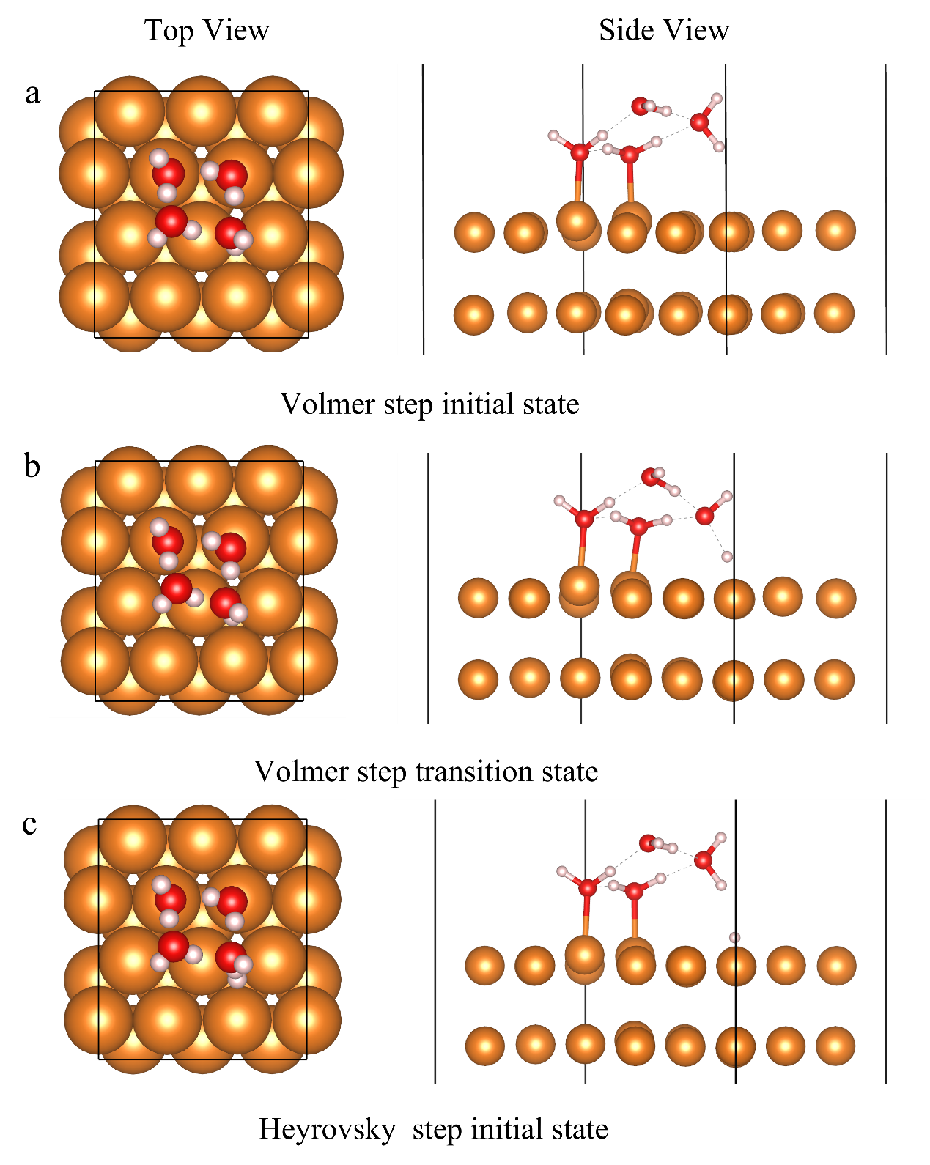

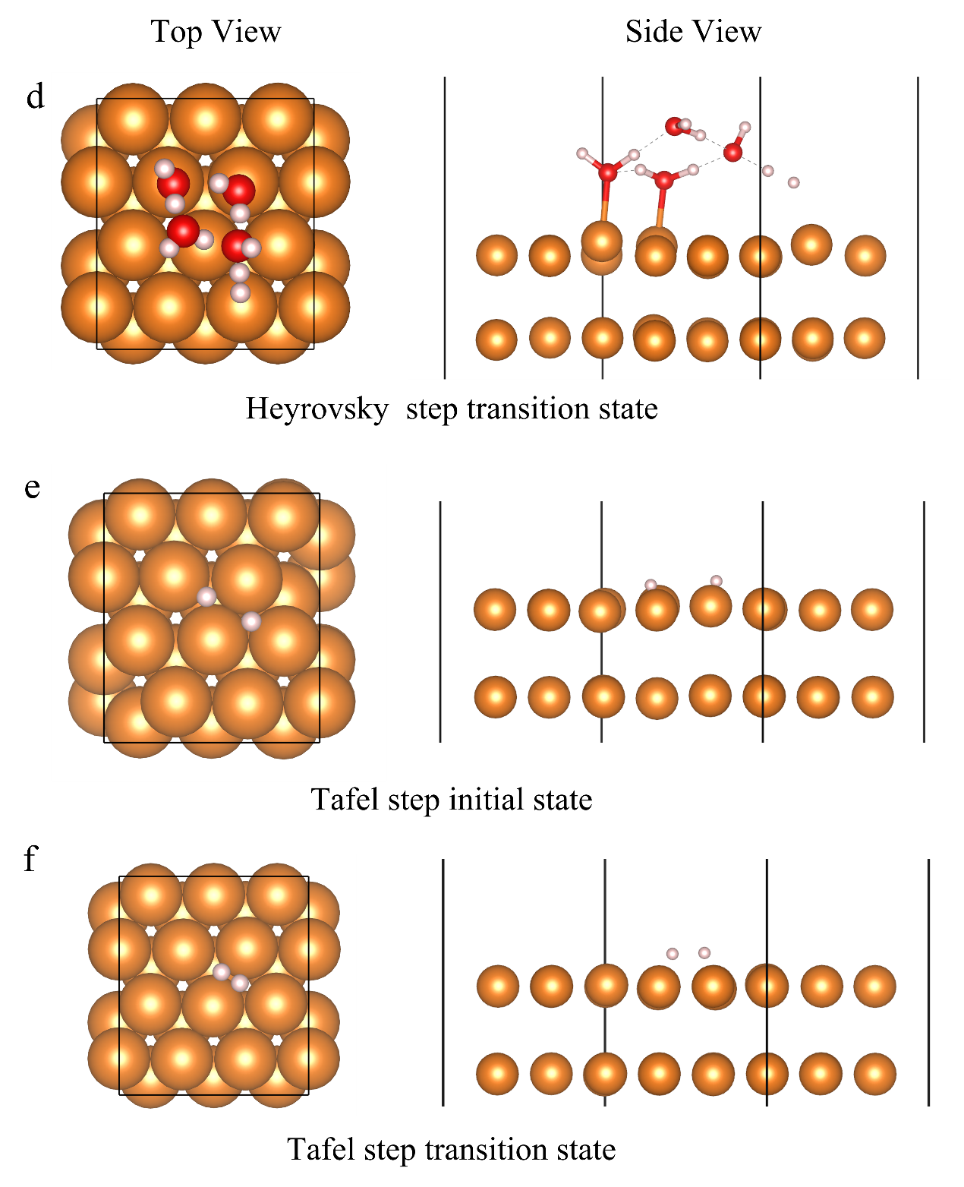Figure S1 Schematic of initial and transition states for different elementary steps of the HER, where orange, red, and white spheres represent magnesium, oxygen, and hydrogen atoms, respectively.

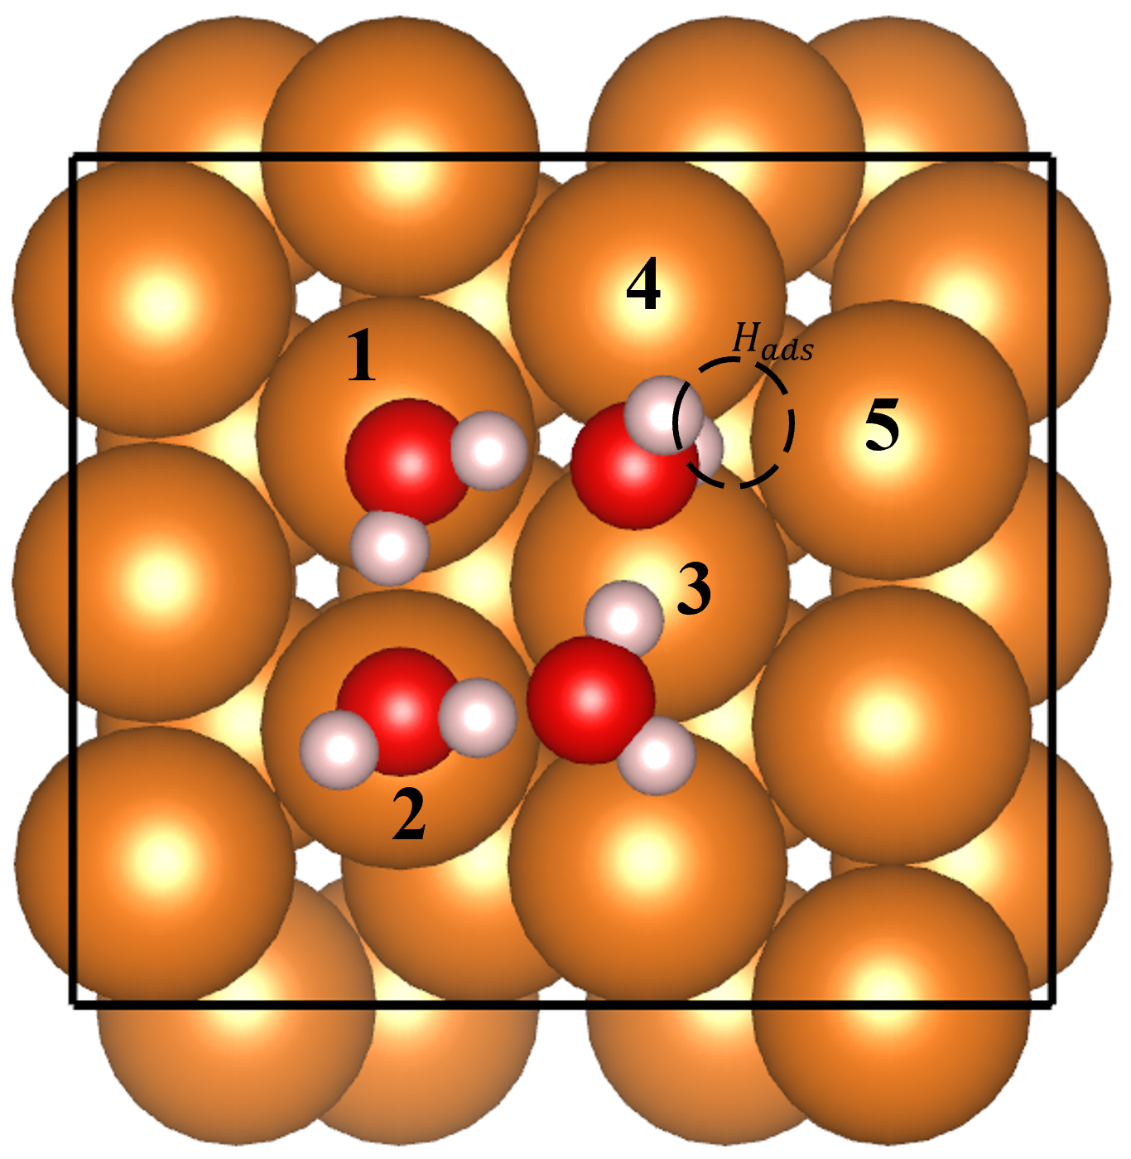 Figure S2 Schematic of different doping sites for alloying elements
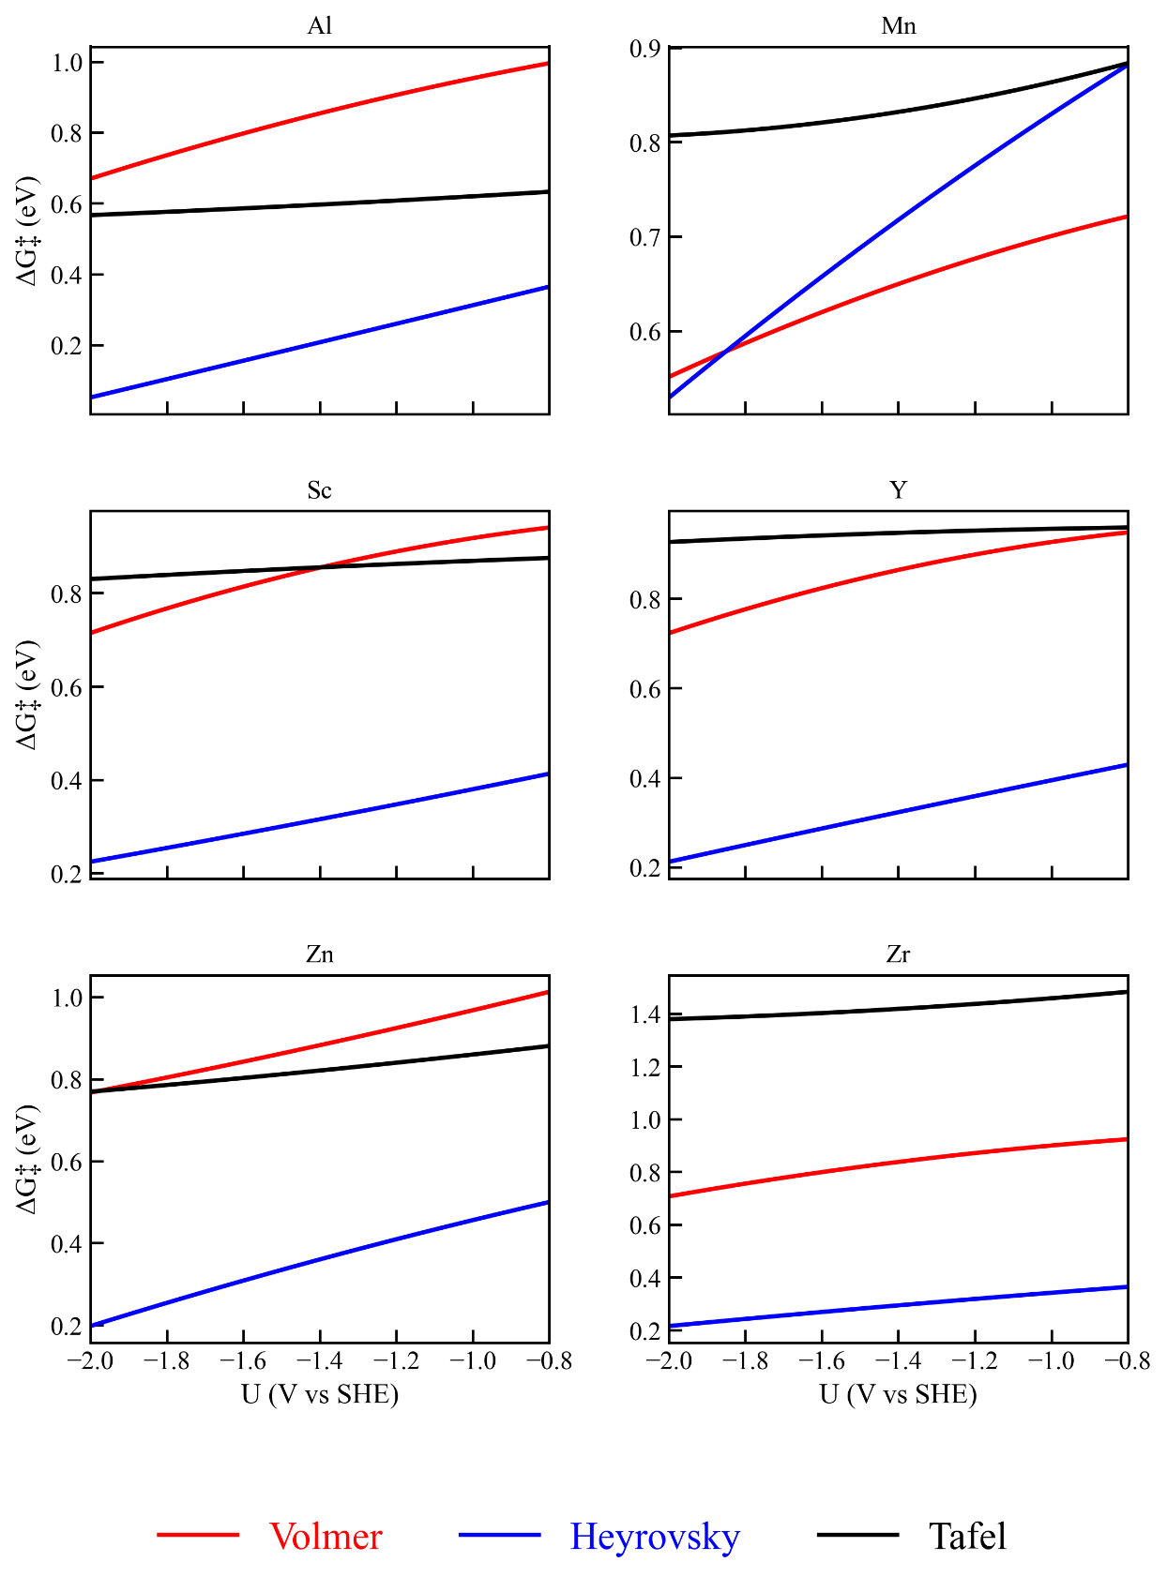 Figure S3 Potential-dependent activation energies of Volmer and Heyrovsky step for Mg(0001) solid solutions with alloying elements

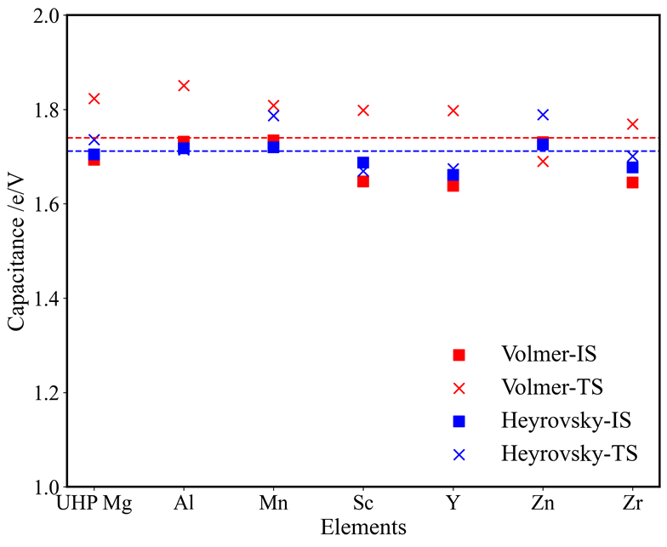
Figure S4 Surface capacitance of magnesium-based alloys with different alloying elements (Al, Mn, Sc, Y, Zn, Zr).

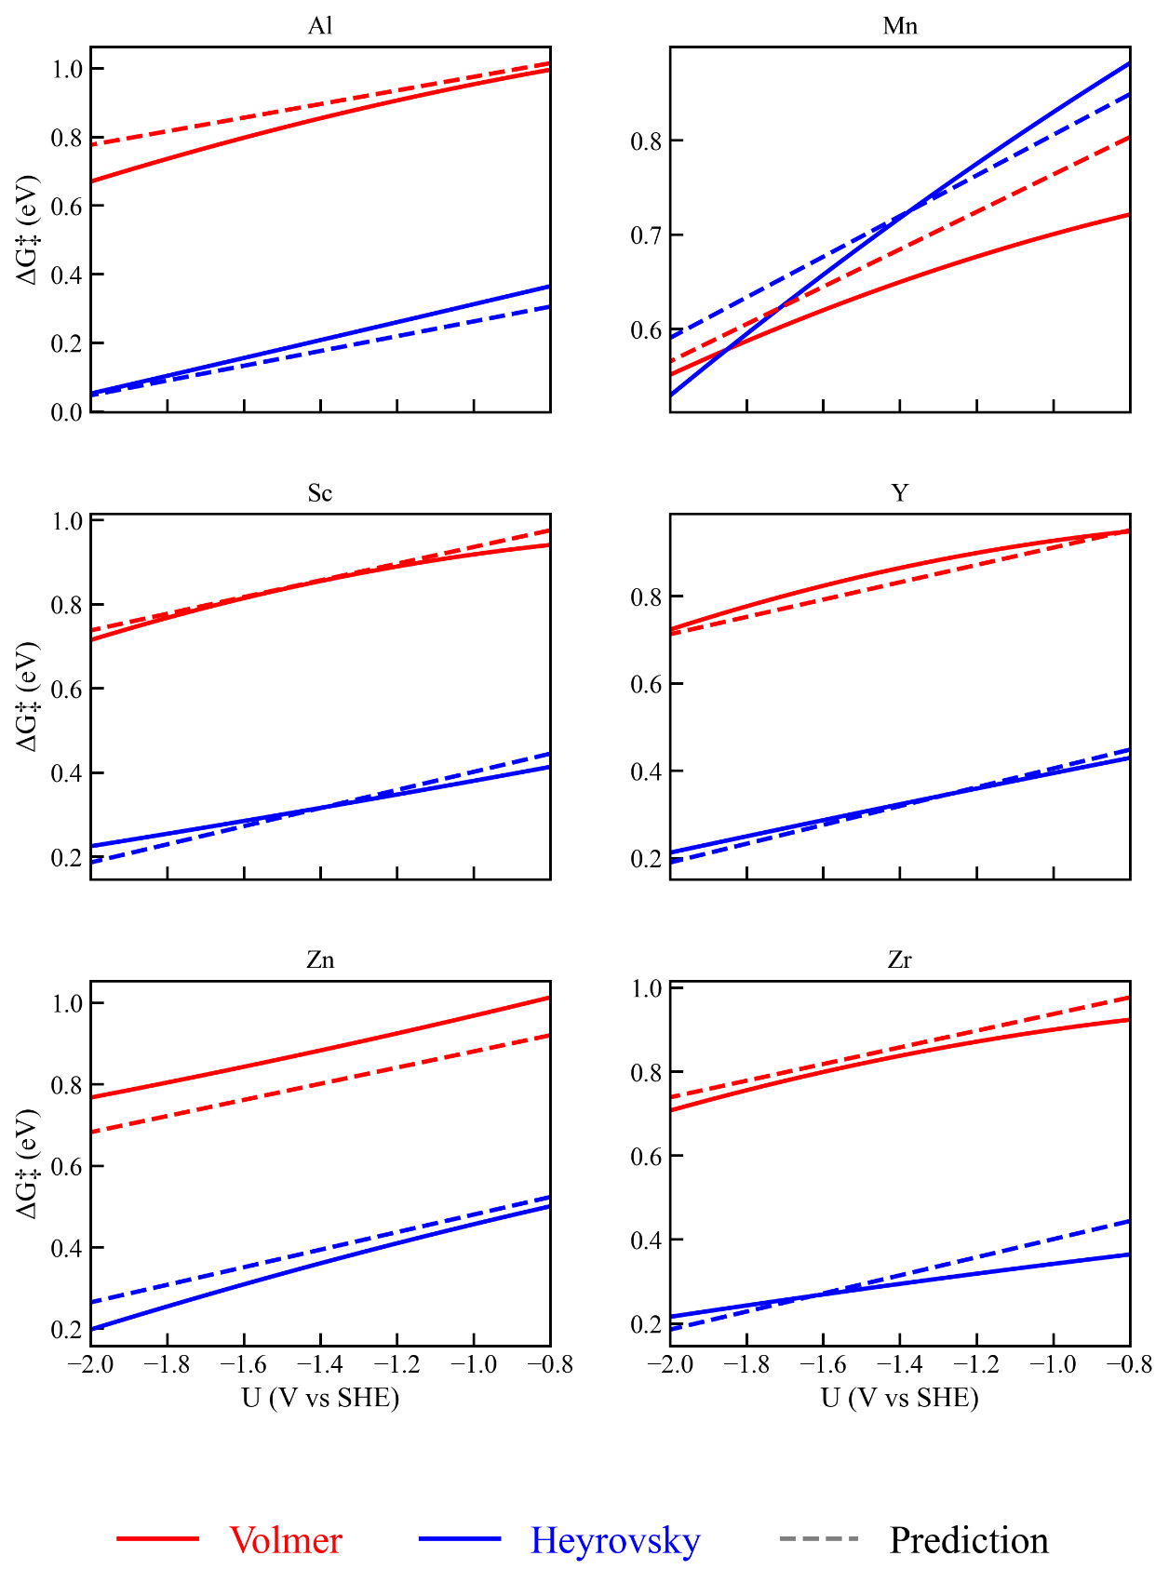
Figure S5 Potential-dependent activation energies of Volmer and Heyrovsky step for Mg(0001) solid solutions with alloying elements from BEP relationship

Reference
[1] Energy Trends in Catalysis, Fundamental Concepts in Heterogeneous Catalysis2014, pp. 85-96.
[2] J.K. Nørskov, F. Studt, F. Abild-Pedersen, T. Bligaard, Fundamental concepts in heterogeneous catalysis, John Wiley & Sons2014.
[3] J. Yan, X. Xu, G. Shi, Y. Wang, C. Guan, Y. Chen, Y. Yang, T. Ying, H. Zhu, Q. Tang, X. Zeng, The anodic dissolution kinetics of Mg alloys in water based on ab initio molecular dynamics simulations, Mater. Genome Eng. Adv. 2(2) (2024) e47.
[4] H. Ma, L. Wu, C. Liu, M. Liu, C. Wang, D. Li, X. Chen, J. Dong, W. Ke, First-principles modeling of the hydrogen evolution reaction and its application in electrochemical corrosion of Mg, Acta Mater. 183 (2020) 377–389.
[5] C. Zhang, J. Wang, X. Li, S. Wang, S. Zhu, S. Guan, Rapid screening alloying elements for improved corrosion resistance on the Mg(0001) surface using first principles calculations, Phys. Chem. Chem. Phys. 23(47) (2021) 26887–26901.
[6] Y. Huang, X. Zhang, J. Wang, Y. Zeng, X. Zhang, L. Luo, Y. Liu, First-principles modeling of corrosion potential/current and its application in AZ and AZ-RE magnesium alloys, Mater. Today Commun. 39 (2024) 108771.
[7] M.-F. Ng, D.J. Blackwood, H. Jin, T.L. Tan, First-Principles Investigation into the Contributions of ORR and HER in Magnesium Corrosion, J. Electrochem. Soc. 170(7) (2023) 071501.

