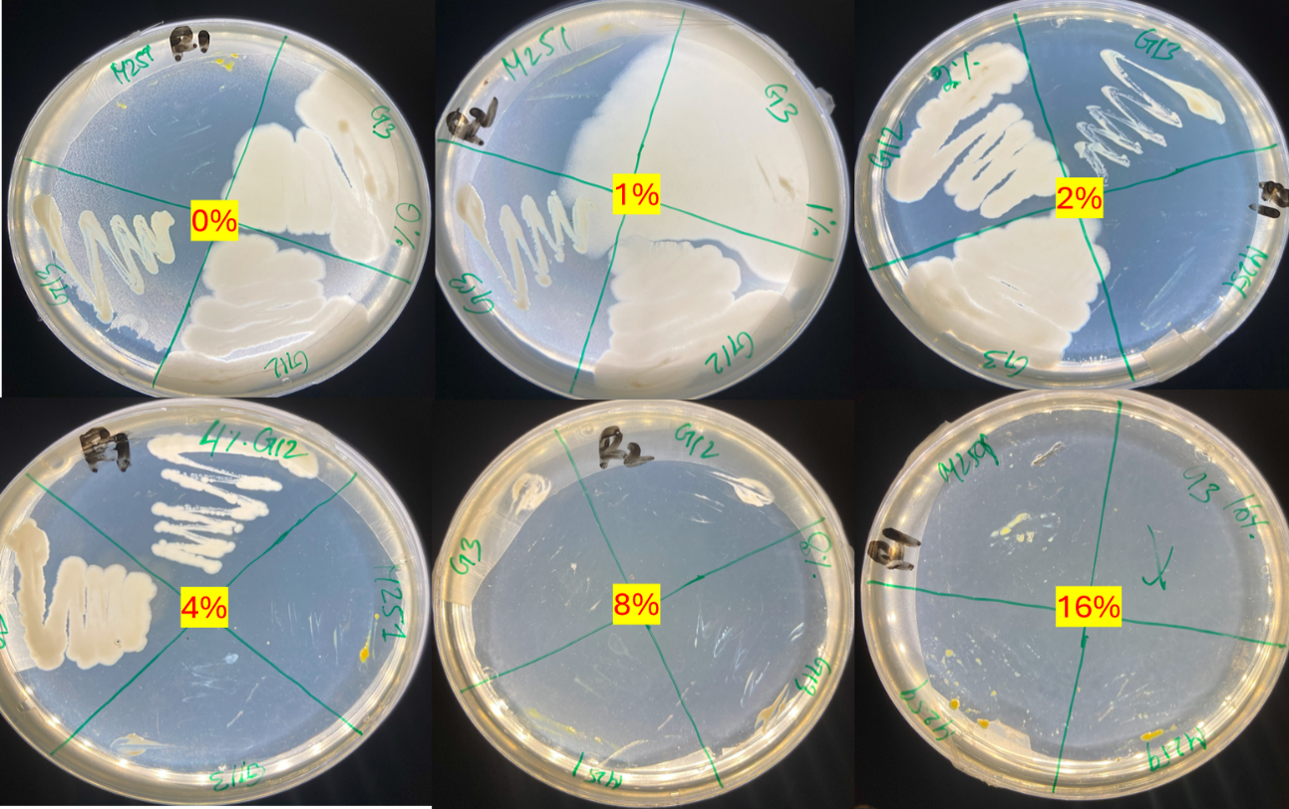Supplementary Figure S1. The Salinity tolerance assay of the five selected plant associate bacteria. The LB agar plates is presented according to the growing salinity concentration (0% to 16%).

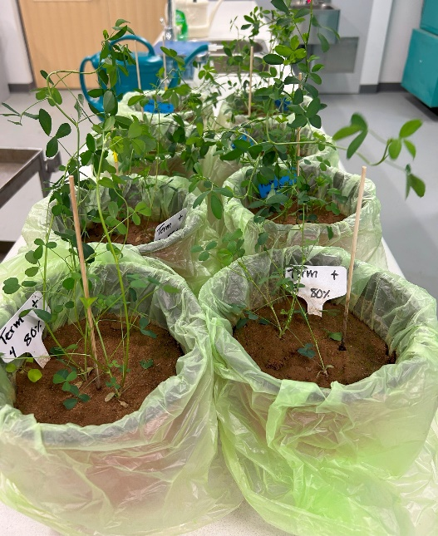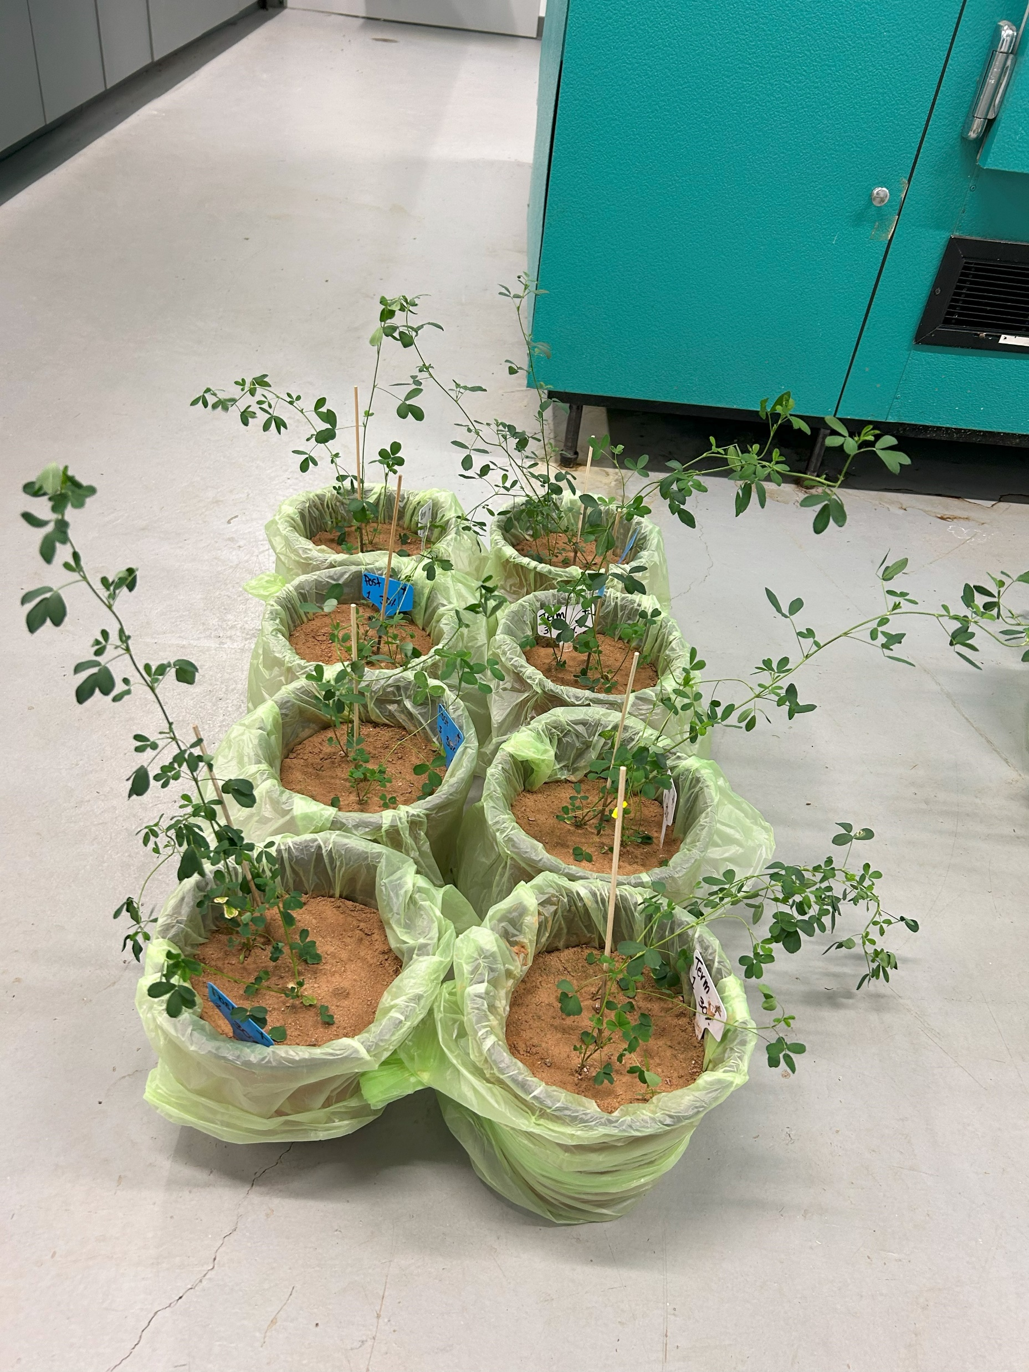
A
B
Supplementary Figure S2. Visual Comparison of Plant Response to Drought and Well-Watered Conditions After Two Weeks of Treatment. The photographs illustrate the effects of two distinct soil moisture regimes on plant growth: (A) 30% field capacity (FC), representing drought-stressed conditions, and (B) 80% FC, denoting well-watered conditions. These images were taken just prior to irrigation, clearly showing the markedly drier soil in the 30% FC treatment. The plants exhibit significantly greater vigour and growth under the 80% FC treatment, highlighting the detrimental impact of drought stress on plant health at 30% FC.

SynCom Negative
SynCom Positive
A
B
Supplementary Figure S3. Pearson correlation among the above ground traits, (A) SynCom Positive group, (B) SynCom Negative group.
Supplementary Table S1. Optical density (OD₆₀₀) values of bacterial strains cultured in LB medium supplemented with 0%, 5%, and 10% polyethylene glycol (PEG 6000) to simulate drought stress. Measurements were taken at 24 and 48 hours. Data are expressed as mean ± standard deviation (n = 3). Superscript letters denote statistically significant differences among strains within each treatment and time point, as determined by one-way ANOVA followed by Tukey’s Honest Significant Difference (HSD) post hoc test at p < 0.05.
Drought Tolerance Test
 | LB+ 0% PEG |  | LB + 5% PEG |  | LB + 10% PEG
Strains | 24 hr | 48hr | 24 Hr | 48hr | 24 Hr | 48hr
G3 | 0.245 ± 0.005ᵇᶜ | 0.449 ± 0.039ᵇ | 0.174 ± 0.011ᶜ | 0.285 ± 0.01ᵈ | 0.134 ± 0.008ᶜ | 0.262 ± 0.021ᶜ
G12 | 0.201 ± 0.01ᶜ | 0.375 ± 0.02ᶜ | 0.142 ± 0.004ᵈ | 0.211 ± 0.011ᵉ | 0.118 ± 0.004ᶜ | 0.169 ± 0.008ᵈ
G13 | 0.317 ± 0.021ᵃ | 0.536 ± 0.013ᵃ | 0.218 ± 0.005ᵇ | 0.332 ± 0.027ᶜ | 0.191 ± 0.006ᵇ | 0.256 ± 0.03ᶜ
M251 | 0.28 ± 0.026ᵃᵇ | 0.555 ± 0.027ᵃ | 0.255 ± 0.009ᵃ | 0.513 ± 0.013ᵃ | 0.259 ± 0.017ᵃ | 0.465 ± 0.026ᵃ
M259 | 0.314 ± 0.017ᵃ | 0.574 ± 0.011ᵃ | 0.212 ± 0.012ᵇ | 0.423 ± 0.002ᵇ | 0.187 ± 0.005ᵇ | 0.329 ± 0.01ᵇ

Supplementary Table S2. Salinity tolerance of five bacterial isolates (G3, G12, G13, M251, M259) assessed across increasing NaCl concentrations (0–32%). Growth responses are indicated as Y (growth >100 colonies), Y– (reduced growth, 10–30 colonies), and N (no growth). At 0% NaCl, all isolates showed robust growth. Tolerance decreased progressively with higher salinity, with no growth observed at 32% NaCl. The PVK test for phosphate solubilization showed a positive halo zone only for isolate G13, indicating its potential for phosphate mobilization.
Salinity Tolerance Test
NaCl (%) | G3 | G12 | G13 | M251 |  | M259 | Code (Colony Number)
0% | Y | Y | Y | Y |  | Y | (Y) >100
2% | Y | Y | Y | Y- |  | Y- | (Y-) 10-30
4% | Y | Y | Y- | N | N |  | N-No Growth
8% | Y- | Y- | Y- | N | N
16% | Y- | Y- | N | N | N
32% | N | N | N | N | N
PVK Test | N | N | Y | N | N |  | Halo Zone: Y

Supplementary Table S3. A two-way ANOVA was performed for normally distributed variables, with drought and SynCom as fixed factors. For variables not meeting parametric assumptions (Shoot Biomass, Root Nodule, Nematode), the Scheirer–Ray–Hare test—a non-parametric equivalent of two-way ANOVA—was applied. *p-values from statistical analyses evaluating the effects of drought, SynCom inoculation, and their interaction on plant physiological and root traits under stress and recovery conditions. Significant effects are denoted by asterisks: ***p ≤ 0.001, **p ≤ 0.01, p ≤ 0.05, p ≤ 0.1. Traits analyzed include photosynthetic efficiency (FvFm), shoot and root biomass, root architecture parameters, chlorophyll content (SPAD), and nematode number.
 | Drought Stress |  |  | Recovery Stage
Variable | Drought | SynCom | Interaction | Drought | SynCom | Interaction
Fv/Fm | 0.0003 *** | 0.0001 *** | 0.0000 *** | 0.195 | 1.00 | 0.741
Root Surface Area | 0.1160 | 0.779 | 0.2346 | 0.278 | 0.183 | 0.271
Root Dry Biomass | 0.0430 * | 0.0410 * | 0.0729 | 0.634 | 0.732 | 0.669
Root Diameter | 0.2113 | 0.1482 | 0.0610 | 0.623 | 0.078 | 0.536
Root Length | 0.2528 | 0.2293 | 0.1851 | 0.845 | 0.118 | 0.522
Root Volume | 0.0957. | 0.4740 | 0.0750 | 0.264 | 0.106 | 0.269
SPAD | 0.6645 | 0.1790 | 0.7189 | 0.014 * | 0.020 * | 0.464
Shoot Dry Biomass | 0.0001 *** | 0.0606 | 0.3945 | 0.160 | 0.083 | 0.349
Shoot Length | 0.0080 ** | 0.5735 | 0.5842 | 0.214 | 0.129 | 0.566
Nematode | 0.3700 | 0.3560 | 0.7360 | 0.857 | 0.814 | 0.681
Root Nodule | — | — | — | 0.033 * | 0.001 *** | 0.288

Supplementary Table S4. Shoot trait, soil nematode and root nodulation responses under stress and recovery conditions across three drought levels (MD: moderate drought, SD: severe drought, WW: well-watered) and SynCom treatments (neg: uninoculated, pos: inoculated). Values represent mean ± standard deviation for shoot length, biomass, SPAD, FvFm, nematode population and root nodule.
Drought | Time | SynCom | Shoot Length | Shoot Biomass | SPAD | FvFm | Nematode (per g soil) | Root nodule
MD | Stress | neg | 46.23 ± 10.62 | 1.66 ± 0.56 | 61.95 ± 9.01 | 0.75 ± 0.03 | 1.67 ± 0.35
MD | Stress | pos | 44.02 ± 2.87 | 1.69 ± 0.37 | 64.4 ± 4.68 | 0.68 ± 0.07 | 2.15 ± 1.07
MD | Recovery | neg | 55.1 ± 21.74 | 4.9 ± 0.79 | 57.79 ± 10.23 | 0.77 ± 0.03 | 1.17 ± 0.42 | 32.33 ± 9.93
MD | Recovery | pos | 68.4 ± 17.64 | 7.59 ± 3.43 | 68.39 ± 9.14 | 0.76 ± 0.02 | 1.32 ± 0.45 | 63.12 ± 19.2
SD | Stress | neg | 35.2 ± 4.27 | 0.78 ± 0.21 | 56.67 ± 11.06 | 0.56 ± 0.05 | 1.29 ± 0.12
SD | Stress | pos | 41.52 ± 5.81 | 1.15 ± 0.1 | 64.84 ± 7.8 | 0.76 ± 0.01 | 1.67 ± 0.58
SD | Recovery | neg | 49.5 ± 7.85 | 5.81 ± 2.44 | 40.51 ± 12.64 | 0.74 ± 0.02 | 1.53 ± 0.23 | 14.17 ± 5.25
SD | Recovery | pos | 49.83 ± 4.94 | 5.25 ± 0.36 | 57.75 ± 10.2 | 0.75 ± 0.05 | 1.22 ± 0.88 | 41.25 ± 11.46
WW | Stress | neg | 52.08 ± 7.78 | 2.22 ± 1.06 | 62.86 ± 5.12 | 0.70 ± 0.03 | 2.46 ± 1.89
WW | Stress | pos | 53.65 ± 12.72 | 3.33 ± 1.17 | 65.64 ± 7.45 | 0.84 ± 0.05 | 1.68 ± 0.26
WW | Recovery | neg | 52.2 ± 11.15 | 5.57 ± 0.49 | 62.39 ± 6.75 | 0.73 ± 0.02 | 1.36 ± 0.34 | 36 ± 10.12
WW | Recovery | pos | 65.35 ± 11.75 | 6.04 ± 0.62 | 66.62 ± 11.64 | 0.73 ± 0.06 | 1.37 ± 0.59 | 45.33 ± 14.75

Supplementary Table S5. Root trait responses under stress and recovery conditions across three drought levels (MD: moderate drought, SD: severe drought, WW: well-watered) and SynCom treatments (neg: uninoculated, pos: inoculated). Values represent mean ± standard deviation for root biomass (RootBIo), root length (RootLen), root area, root diameter (RootDia), and root volume.
Drought | Time | SynCom | Root  Biomass (g) | Root  Length (cm) | Root  Surface Area | Root  Diameter | Root  Volume
SD | Stress | neg | 0.76 ± 0.37 | 22.00 ± 2.86 | 150.04 ± 47.20 | 0.65 ± 0.10 | 2.37 ± 0.64
SD | Stress | pos | 1.26 ± 0.13 | 24.81 ± 3.82 | 180.14 ± 16.98 | 0.78 ± 0.05 | 3.63 ± 0.60
SD | Recovery | neg | 0.65 ± 0.23 | 23.62 ± 4.87 | 108.68 ± 57.65 | 0.64 ± 0.07 | 1.85 ± 1.16
SD | Recovery | pos | 0.88 ± 0.46 | 27.08 ± 4.97 | 109.94 ± 23.61 | 0.70 ± 0.11 | 1.96 ± 0.59
MD | Stress | neg | 1.56 ± 0.38 | 27.23 ± 3.13 | 210.64 ± 56.19 | 0.73 ± 0.06 | 3.96 ± 1.36
MD | Stress | pos | 1.39 ± 0.18 | 25.30 ± 3.30 | 170.51 ± 43.15 | 0.68 ± 0.06 | 2.99 ± 0.92
MD | Recovery | neg | 0.90 ± 0.54 | 24.23 ± 3.80 | 99.37 ± 57.33 | 0.64 ± 0.16 | 1.76 ± 1.07
MD | Recovery | pos | 1.05 ± 0.35 | 24.42 ± 1.72 | 165.87 ± 42.59 | 0.78 ± 0.11 | 3.32 ± 1.29
WW | Stress | neg | 0.99 ± 0.25 | 22.50 ± 3.46 | 129.06 ± 50.71 | 0.62 ± 0.09 | 2.13 ± 1.13
WW | Stress | pos | 1.57 ± 0.54 | 26.69 ± 3.33 | 154.48 ± 40.63 | 0.68 ± 0.06 | 2.68 ± 0.68
WW | Recovery | neg | 1.03 ± 0.45 | 21.50 ± 1.80 | 141.81 ± 34.48 | 0.70 ± 0.03 | 2.50 ± 0.48
WW | Recovery | pos | 0.85 ± 0.66 | 26.80 ± 7.04 | 147.75 ± 33.96 | 0.73 ± 0.05 | 2.78 ± 0.75

Supplementary Table S6. Relative percentage change of above ground and below ground traits of SynCom-positive plants compared to SynCom-negative controls under different drought conditions during Stress and Recovery time points, along with the effect on nematode population and root nodule formation during recovery. Positive values indicate improvement due to SynCom inoculation, while negative values indicate reduction.
Time Point |  | Stress |  |  | Recovery
Drought | Severe | Moderate | Well-watered | Severe | Moderate | Well-watered
Shoot Biomass | 47.44 | 1.81 | 50 | −9.64 | 54.9 | 8.44
Root Biomass | 65.79 | −10.90 | 58.59 | 35.38 | 16.67 | −17.48
SPAD | 14.42 | 3.95 | 4.42 | 42.56 | 18.34 | 6.78
Shoot Length | 17.95 | −4.78 | 3.01 | 0.67 | 24.14 | 25.19
Root Length | 12.77 | −7.09 | 18.62 | 14.65 | 0.78 | 24.65
Nematode | 29.46 | 28.74 | −31.71 | −20.26 | 12.82 | 0.74
Root Surface Area | 20.06 | −19.05 | 19.7 | 1.16 | 66.92 | 4.19
Root Diameter | 20 | −6.85 | 9.68 | 9.37 | 21.88 | 4.29
Root Volume | 53.16 | −24.49 | 25.82 | 5.95 | 88.64 | 11.2
FvFm | 35.71 | −9.33 | 20 | 1.35 | −1.30 | 0
Root Nodule | - | - | - | 191.26 | 95.17 | 25.92

