Supporting Information

High performance and recyclable Au-Ag/TiO₂/PS substrate for the detection of organic pollutants

Lingling Yan¹, Junhui Yi¹, Hongxin Cai^{1∗}, Yixin Shao¹, Liang Chen^{1∗}, Qiang Hu¹, and Lingli Wang²

¹ School of Physics and Electronic Information Engineering, Henan Polytechnic University, Jiaozuo, 454000, PR China
² School of Electronics and Information, Zhengzhou University of Light Industry, Zhengzhou, 450002, PR China

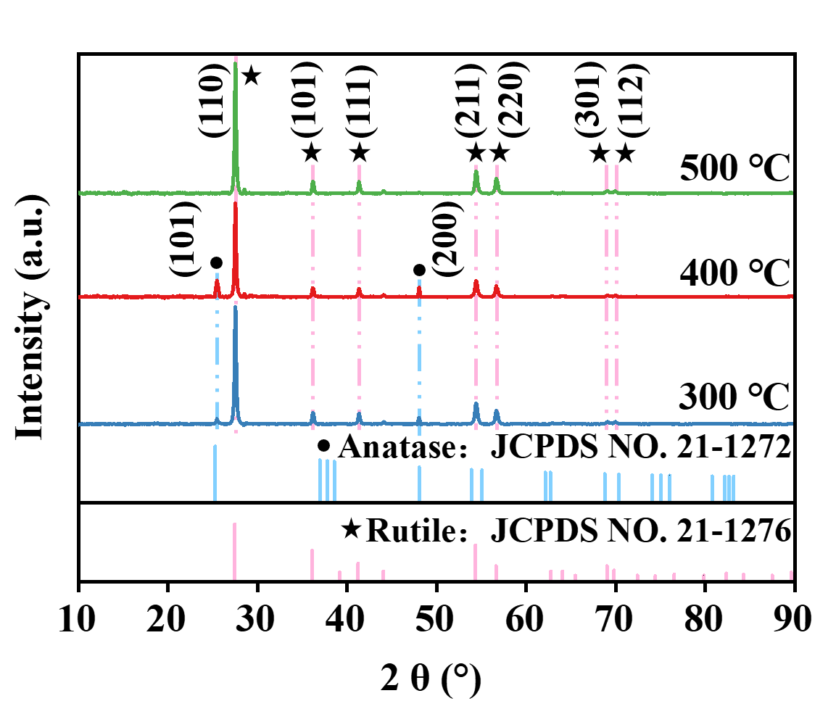
Fig. S1. XRD patterns of the samples obtained at different annealing temperatures.

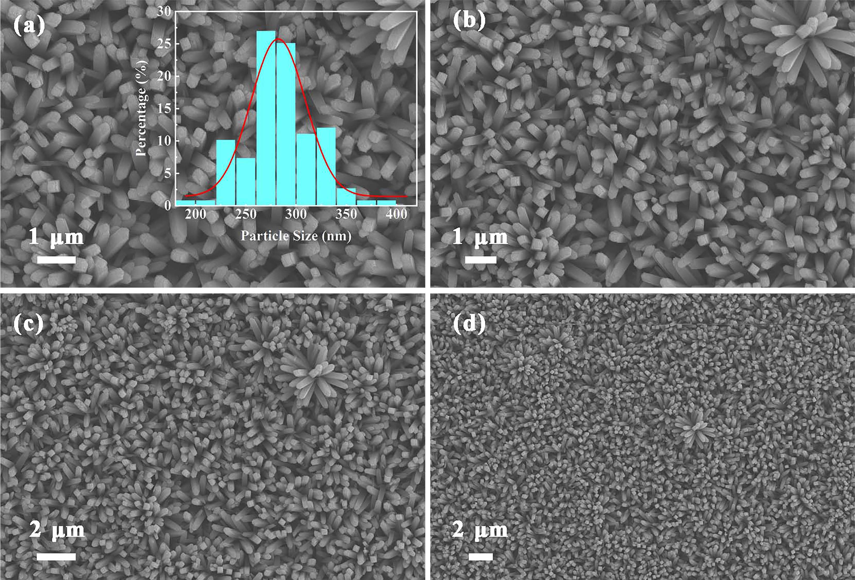
Fig. S2. SEM images of TiO₂/PS. (Inset: the frequency distribution histogram of TiO₂/PS)

Fig. S3. Raman spectrum of CV with a concentration of 10⁻² M after immersion in the PS substrate.

Fig. S4. Comparison of SERS spectra on TiO₂/PS substrates modified with different noble metals.

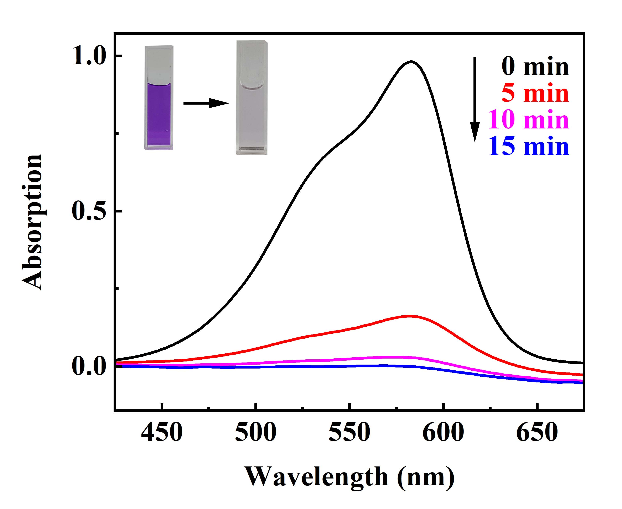
Fig. S5. UV-Vis absorption spectra of the CV solution after different photocatalysis times (Inset: Optical images of the CV solution before and after irradiation).

∗ Corresponding author: E-mail address: me2001@hpu.edu.cn.
∗ Corresponding author: E-mail address: Cl721@hpu.edu.cn.

