Supplementary Information

Semimetal-enabled Rectenna for Sub-THz Wireless Energy Harvesting and Wave-mixing
Zhaowen Bao^{1,2†}, Xiaokai Pan^{1,6†}, Yinghui Liu^{3,4}, Yiming Wang⁵, Yingdong Wei^{1,2}, Zhen Hu^{1,6}, Yichong Zhang^{1,7}, Xiaoyun Wang^{1,6}, Huichuan Fan^{1,6}, Hongfei Wu^{1,2}, Zhiyuan Zhou^{1,7}, Lei Yang^{1,8}, Xiaoshuang Chen^{1,2, 6}, Hailong Qiu³*, and Lin Wang^{1, 6}*
¹State Key Laboratory of Infrared Physics, Shanghai Institute of Technical Physics, Chinese Academy of Sciences, 500 Yu-tian Road, Shanghai 200083, China.
²School of Physical Science and Technology, ShanghaiTech University, Shanghai 201210, China
- ³State Key Laboratory of Crystal Materials, Tianjin Key Laboratory of Functional Crystal Materials, Institute of Functional Crystals, Tianjin University of Technology Tianjin 300384, China.
- ⁴Tianjin Key Lab for Rare Earth Materials and Applications, Center for Rare Earth and Inorganic Functional Materials, School of Materials Science and Engineering, Nankai University, Tianjin, 300350, China.
- ⁵College of Future Information Technology & Institute of Optoelectronics, Fudan University, Shanghai 200433, China
⁶University of Chinese Academy of Sciences, No. 19A Yuquan Road, Beijing 100049, China.
⁷School of physics, Donghua University, Shanghai, 201620, China.
⁸School of Microelectronics, Shanghai University, Shanghai, 200072, China.

†These authors contributed equally to this work.
⁎Corresponding authors: wanglin@mail.sitp.ac.cn; qiu@tjut.edu.cn

Supplementary note 1: Material preparation process
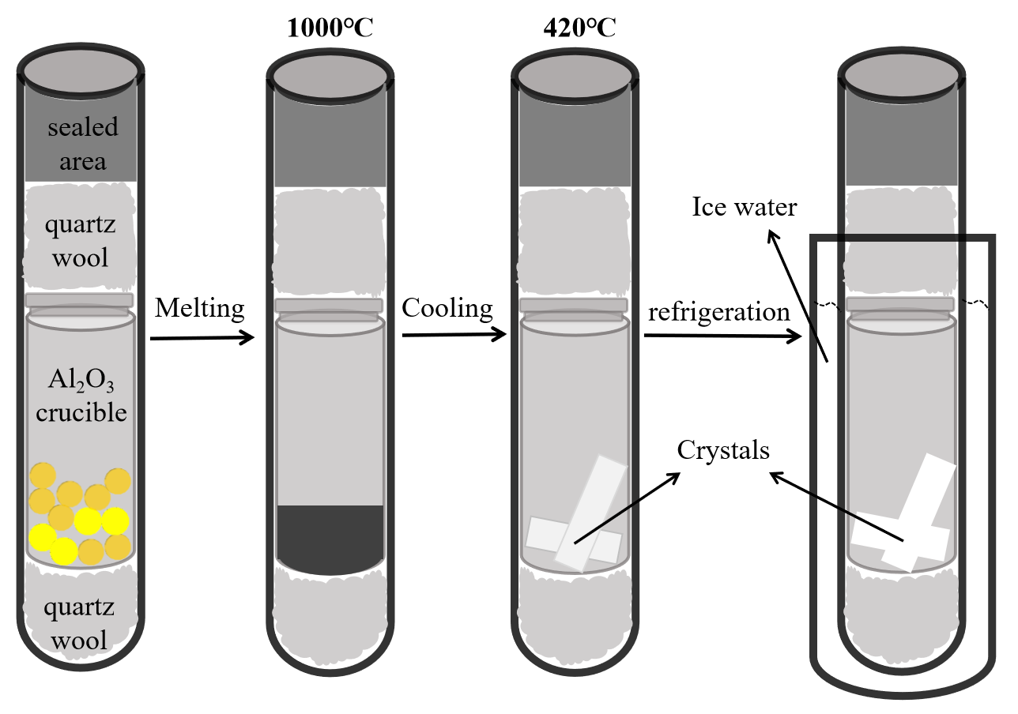
Fig. S1. Flowchart for the preparation of topological semimetal β-PdBi₂ using the melt-growth method.

Supplementary note 2: Scanning Electron Microscope (SEM) image
To verify the successful formation of the anticipated heterojunction, we employed scanning electron microscopy (SEM) for detailed analysis. The high-resolution SEM image presented in Fig. S2(a) confirms the successful construction of the heterojunction. Additionally, the energy-dispersive spectroscopy (EDS) spectrum depicted in Fig. S2(b) reveals an atomic ratio of Palladium to Bismuth (Pd:Bi) in the PdBi₂ crystals of approximately 1:2, consistent within the error margin. The elemental distribution analysis, illustrated in Fig. S2(c-d) further supports our findings, indicating that the PdBi₂ crystals predominantly exhibit a well-distributed Pd to Bi atomic ratio. Notably, the Pd and Bi elements are uniformly dispersed throughout the PdBi₂ crystals.
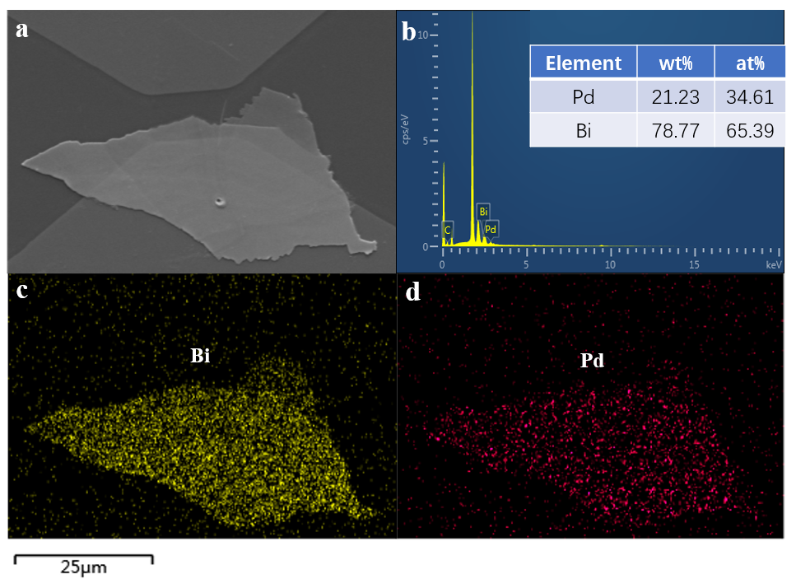
Fig. S2. SEM characterization of the heterojunction on a high-resistivity silicon substrate. (a) SEM images of PdBi₂. (b) EDX spectra of the Pd, Bi elements, and the quantification. (c-d) Elemental analysis showing the distribution of Bi and Pd elements.

Supplementary note 3: Thickness measurement using Atomic Force Microscopy (AFM)
The thickness of the heterojunction we fabricated was accurately assessed using Atomic Force Microscopy (AFM). The data obtained revealed that the thickness of the PdBi2 crystal we exfoliated and subsequently transferred was measured at 114.4 nm. In addition, the graphene layer utilized in our construction was determined to be 13.1 nm thick. Consequently, the total thickness of the resultant heterojunction was found to be 127.5 nm, which aligns perfectly with the sum of the PdBi2 crystal and graphene thicknesses. This finding indicates that the heterojunction is tightly integrated without any discernible gaps. Such structural integrity provides a solid foundation for the experiments planned for the subsequent phase of our research.
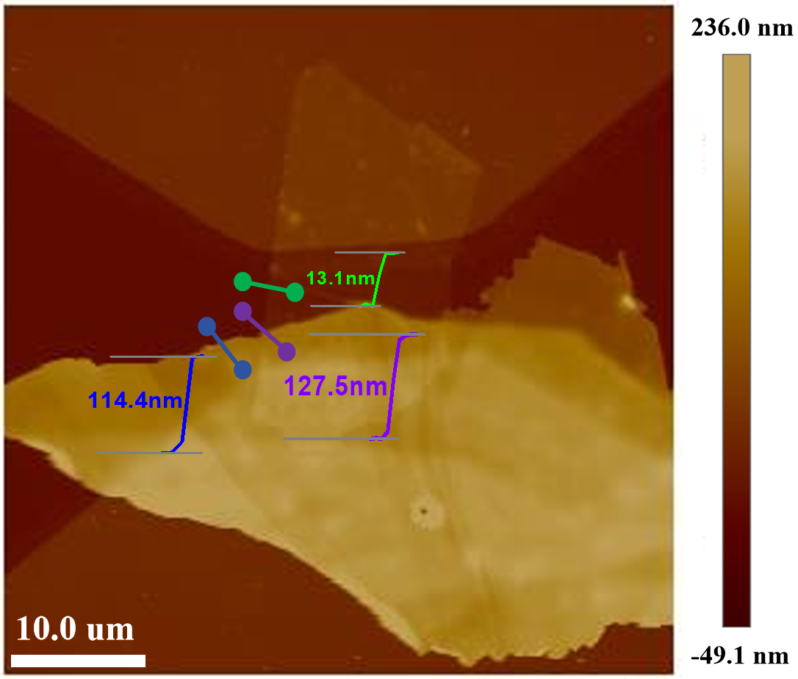
Fig. S3. Atomic force microscopy (AFM) image of the heterojunction on a high-resistivity silicon substrate with metal-plated electrodes.

Supplementary note 4: Band diagram of PdBi₂
First-principles calculations were performed using Quantum ESPRESSO within the density functional theory (DFT) framework. The Perdew-Burke-Ernzerhof (PBE) generalized gradient approximation was employed for the exchange-correlation functional. Ultrasoft pseudopotentials were used to describe the electron-ion interactions for Pd and Bi. A kinetic energy cutoff of 80 Ry was set for the plane-wave basis set. The β-PdBi₂ crystal structure was optimized using a 10×10×3 Monkhorst-Pack k-point mesh until forces on each atom were below 10-3 Ry/Bohr. Spin-orbit coupling (SOC), essential for heavy elements like Bi, was included in all calculations using fully relativistic pseudopotentials to accurately capture the electronic band topology. Band structures were calculated along high-symmetry paths in the Brillouin zone to investigate the potential Weyl semimetal characteristics of β-PdBi₂. Supplementary Fig. S4 presents the electronic band structures of β-PdBi₂ slab model along two distinct k-paths, illustrating a comparison between the scenarios with spin-orbit coupling (indicated by purple solid lines) and without spin-orbit coupling (represented by green dashed lines). Blue squares mark four candidate Dirac points with energies at D₁(0.26 eV), D₂(-0.55 eV), D₃(-0.65 eV), and D₄(0.37 eV). Comparative analysis suggests that D₁ likely corresponds to D₄, while D₂ corresponds to D₃, representing projections of the same Dirac points along different k-paths. The small energy differences (~0.10 eV) can be attributed to different cutting angles through the Dirac cones by the tilted k-paths, which is a typical feature of Dirac points in three-dimensional momentum space projected onto two dimensions. These results indicate that β-PdBi₂ likely hosts two distinct Dirac points: one located approximately 0.6 eV below the Fermi level and another approximately 0.3 eV above the Fermi level.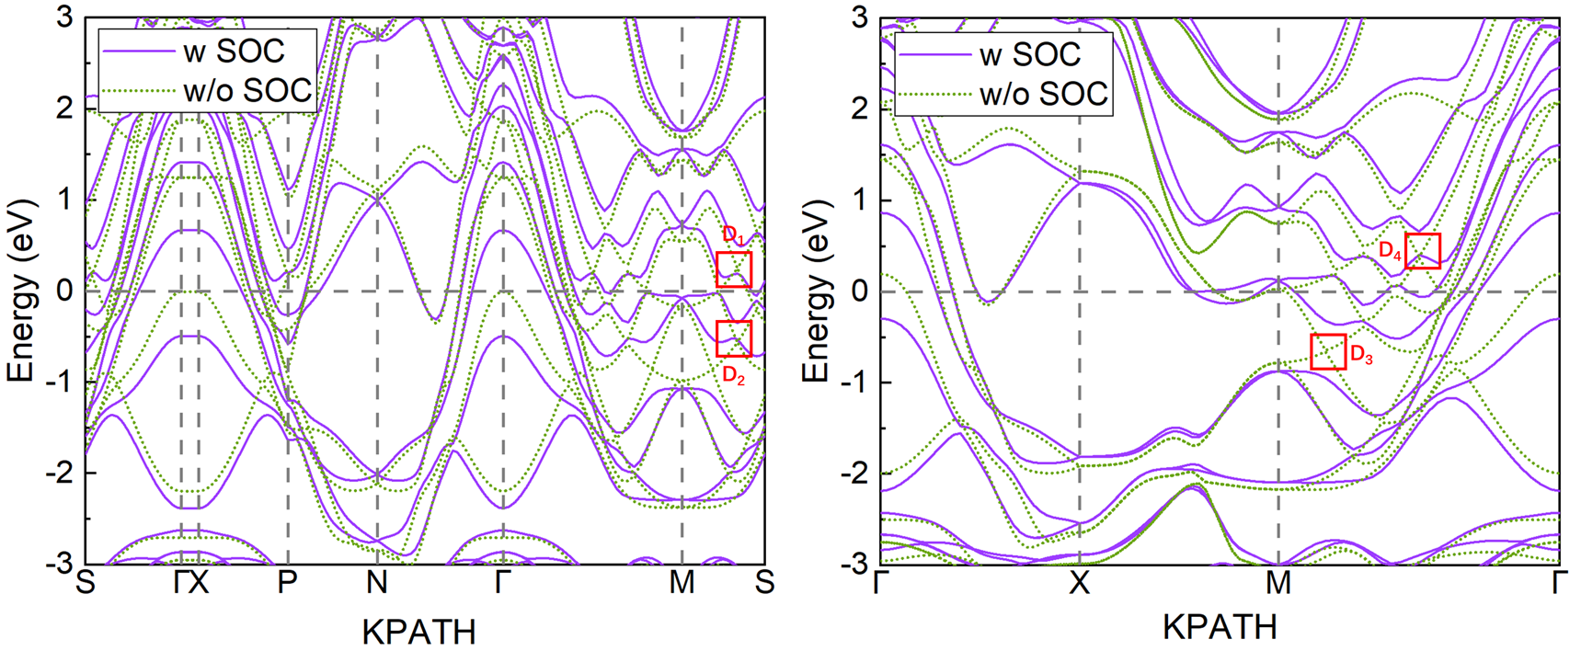
Fig. S4. Electronic band structures of β-PdBi2 slab model along two different k-paths, showing comparison between cases with spin-orbit coupling (solid purple lines) and without spin-orbit coupling (dotted green lines).

Supplementary note 5: The current-voltage (I-V) characteristic
Fig. S5a displays the current-voltage (I-V) characteristic curve of the PdBi₂-graphene detector. It is evident from the figure that the measured I-V characteristic curve exhibits a highly ideal linear relationship, which is a typical characteristic of ohmic contact. Through further data processing and analysis, the resistance of this detector under the test conditions is calculated to be approximately 926 Ω. Fig. S5b depicts the current-voltage (I-V) characteristic of a detector fabricated from pure PdBi₂ material. Due to the semi-metallic nature of PdBi₂ material, its electronic structure enables relatively free electron transmission within the material, facilitating the formation of a better ohmic contact when in contact with electrodes. As can be seen from the I-V characteristic curve, it also exhibits a perfect linear relationship, and the calculated resistance is only 106 Ω.
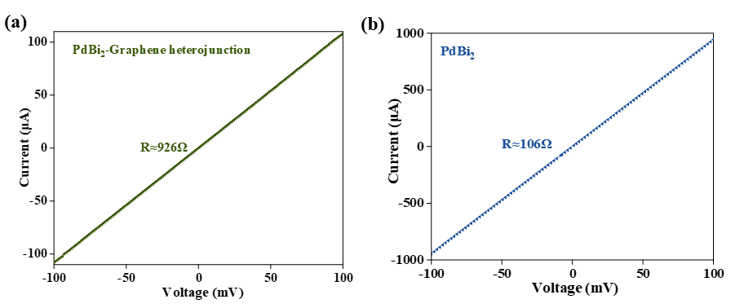
Fig. S5. (a) The current-voltage (I-V) characteristic curve of the PdBi₂-graphene detector. (b) The current-voltage (I-V) characteristic curve of the PdBi₂ detector.

Supplementary note 6: Device Waveform Diagram
Fig. S6 illustrates the performance of the terahertz detector constructed based on the PdBi₂-graphene heterojunction structure under room temperature conditions, specifically demonstrating the time-resolved photocurrent response curve of the detector under 0.03 Hz incident light excitation. During the expe`riment, a pulsed terahertz source with an electrical modulation frequency of 1 kHz was employed as the excitation source, and a lock-in amplifier was utilized for synchronous acquisition of the photocurrent signal to ensure data accuracy and reliability. The experimental results revealed that under three distinct bias voltages of 0 mV, -75 mV, and -150 mV, the detector consistently maintained high-fidelity waveform characteristics in the output pulse signals, which fully demonstrated the stable and reliable operational performance of the terahertz detector across varying bias voltage conditions.

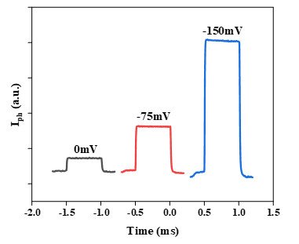
Fig. S6. Waveform diagrams of the device at 0.03 THz under bias voltages of 0 mV, -75 mV, and -150 mV.

Supplementary note 7: NEP under different bias voltages
Through the noise-equivalent power (NEP) testing of 0.3 THz incident light under varying bias voltage conditions, it has been revealed that the device maintains outstanding dark-current noise suppression capability throughout its entire operating range, which fully demonstrates its stability advantage.

Fig. S7. Noise-Equivalent Power (NEP) at 0.3 THz under Different Bias Voltages.

Supplementary note 8: Variation of frequency components generated from mixing with respect to radio frequency (RF) input power
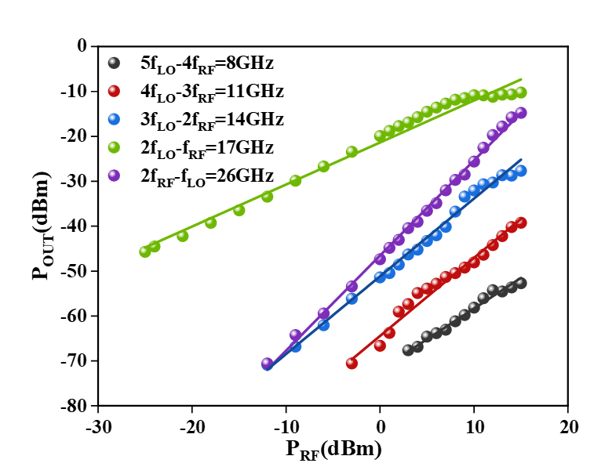
Fig. S8. The variation of frequency components generated by mixing in the heterodyne mixing test of the PdBi₂-graphene rectifying antenna with respect to the radio frequency (RF) input power.

