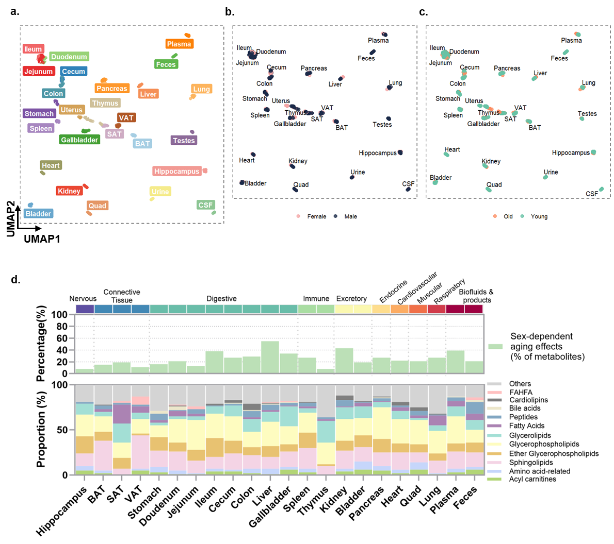
Extended Data Fig. 1. UMAP analysis of metabolic profiles labeled for (a) multiple organs, (b) sexes, and (c) age groups. Only metabolites detected in > 70% of samples were included. (d) Sex-dependent aging effects across tissues and metabolite classes. Upper panel: Percentage of significantly age-related metabolites showing sex-dependent effects, determined by two-way ANOVA (age × sex interaction, FDR < 0.05). Lower panel: Chemical class composition of these sex-dependent aging metabolites across tissues.

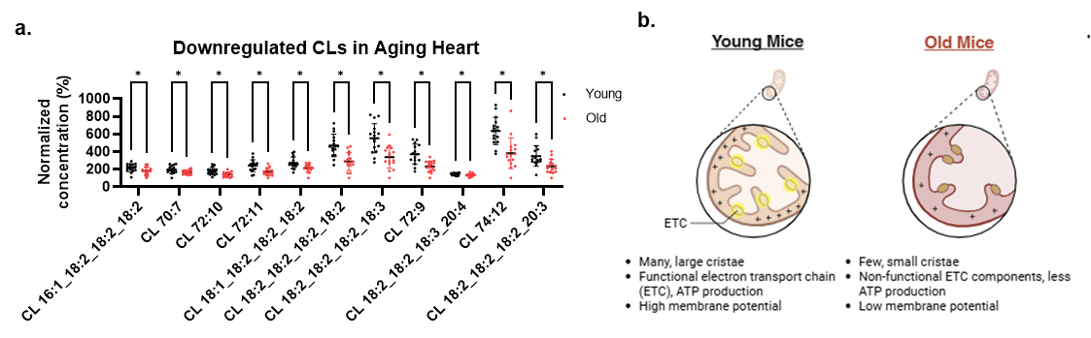
Extended Data Fig. 2. (a) Downregulated linoleate-rich mature cardiolipin (CL) species in heart for young (black) and old (red) mice (n = 16 per age, sex-balanced). (b) Schematic of mitochondrial ultrastructure in organ exhibiting CL depletion (e.g., BAT).

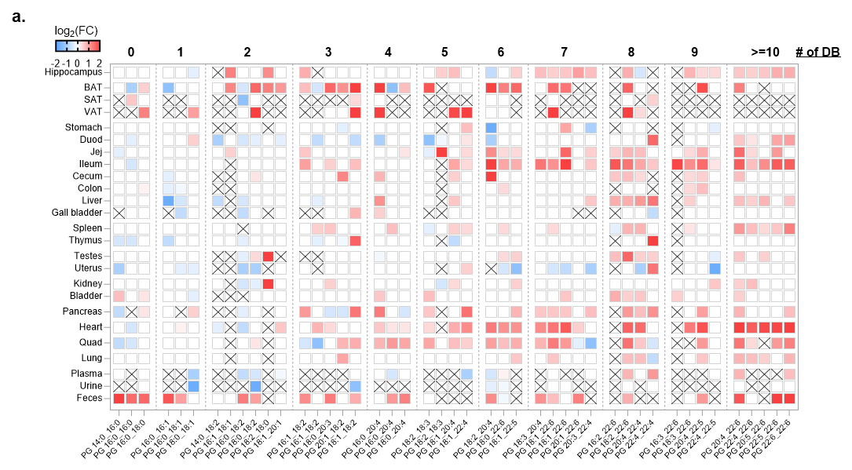
Extended Data Fig. 3. Heat map of log₂-fold changes (FC) between old and young mice for phosphatidylglycerols (PGs) stratified by the number of double bonds (DB). × denotes not detected. Color scale (−2 to +2; blue, decrease; red, increase; white, not significant).

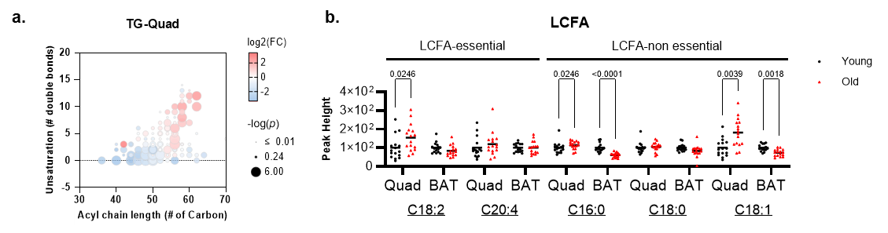
Extended Data Fig. 4. (a) TG species remodeling quadricep muscle. Bubble plots position individual TG species by total acyl carbons (x-axis) and number of double bonds (y-axis). Bubble color denotes log₂ fold change (old vs. young); bubble size denotes −log₁₀(p). Diverging color scale: blue, decrease; red, increase; white, not significant). (b) Peak heights of selected long-chain fatty acids (LCFA) in quadriceps and brown fat (BAT) for young (black) and old (red) mice (n=16 per age, sex-balanced). Dots represent individual animals, horizontal bars, medians. Statistics: two-sided Mann–Whitney U tests; FDR-adjusted q values reported.

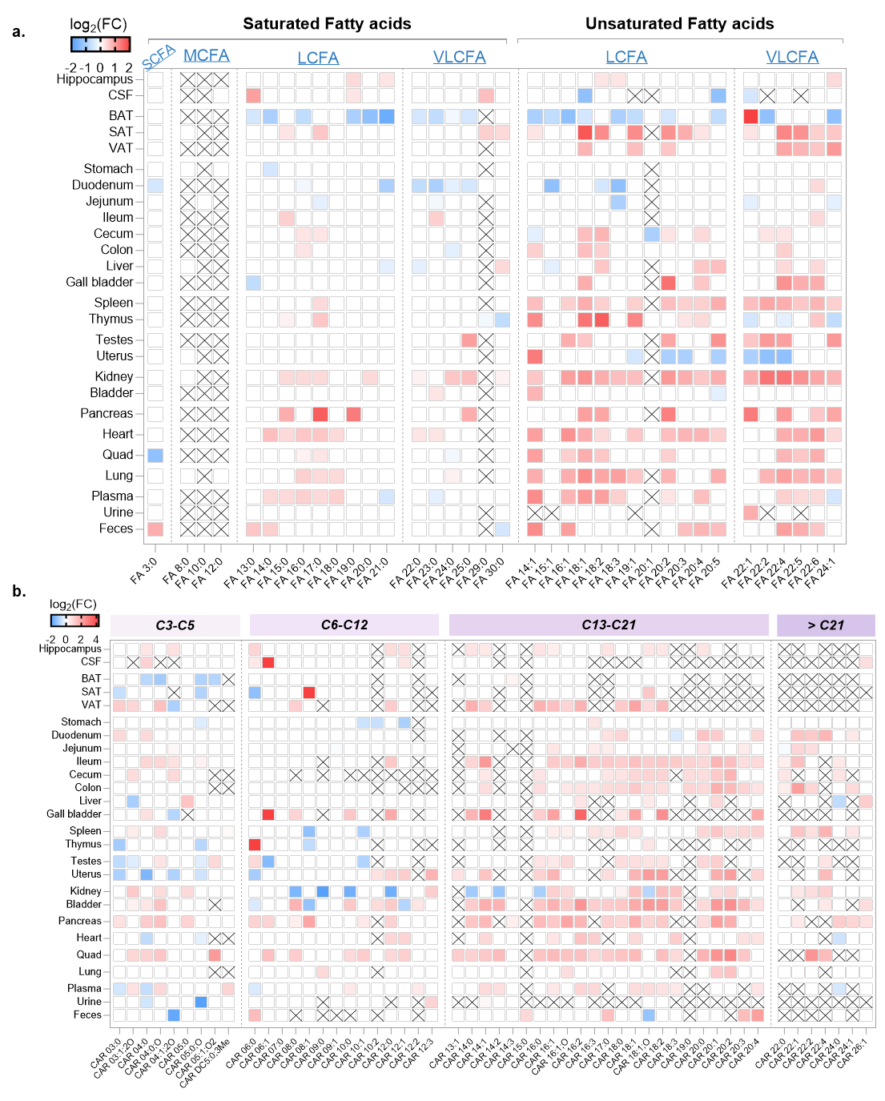
Extended Data Fig. 5. (a) Heat map of log₂-fold changes (FC) between old and young mice for saturated and unsaturated fatty acids in tissues. (b) Heat map of log₂-fold changes (FC) between old and young mice for different chain length of acyl carnitines. × denotes not detected. Color scale (−2 to +2; blue, decrease; red, increase; white, not significant).

