Table S1 UGT1A1 variants and allele type, all patients
Subject No. | UGT1A1 deficient allele | UGT1A1 gene variant report | Identified variants | UGT1A1 allele
1 | 0 | Not detected |  | *1/*1
2* | 0 | Not detected |  | *1/*1
3 | 1 | Detected | c, -3279T>G,  c, -3156G>A, (VUS)  -41_-40dupA | *1/*28
4 | 1 | Detected | c, -3279T>G,  c, -64G>C, (VUS)  c, 211G>A | *1/*6
5* | 0 | Detected | c, -3279T>G | *1/*1
6 | 0 | Not detected |  | *1/*1
7* | 1 | Detected | c, -3279T>G,  c, -3156G>A, (VUS)  -41_-40dupTA | *1/*28
8 | 0 | Not detected |  | *1/*1
9 | 0 | Not detected |  | *1/*1
10 | 0 | Not detected |  | *1/*1
11 | 0 | Not detected |  | *1/*1
12 | 1 | Detected | c, 211G>A | *1/*6
13* | 2 | Detected | c, -3279T>G,  c, -3156G>A, (VUS)  -41_-40dupTA  c, 211G>A  c, 335C>G (VUS) | *6/*28
14 | 1 | Detected | c, 211G>A  c, 783G>A | *1/*6
15 | 1 | Detected | c, -3279T>G  c, 211G>A | *1/*6
16* | 2 | Detected | c, -3279T>G,  c, -3156G>A, (VUS)  -41_-40dupTA  c, 211G>A | *6/*28
17* | 1 | Detected | c, -3279T>G,  c, 211G>A | *1/*6
18 | 0 | Detected | c, -3279T>G | *1/*1
19 | 1 | Detected | c, 211G>A  c,996+15T>C (VUS) | *1/*6
20 | 0 | Detected | c, -3279T>G | *1/*1
21 | 1 | Detected | c, -3279T>G,  c, -3156G>A, (VUS)  -41_-40dupTA  c,996+15T>C (VUS) | *1/*28
22 | 1 | Detected | c, -3279T>G,  c, -3156G>A, (VUS)  -41_-40dupTA  c,996+15T>C (VUS) | *1/*28
23 | 0 | Detected | c, -3279T>G,  c, -3177C>G, (VUS)  c, -3175A>G (VUS)  c, -64G>C | *1/*1
24 | 0 | Not detected | c, -3345delC (VUS) | *1/*1
25* | 0 | Not detected |  | *1/*1
26 | 1 | Detected | c, -3279T>G,  c, -3156G>A (VUS)  c, -3177C>G, (VUS)  c, -3175A>G (VUS)  c, -64G>C  -41_-40dupTA | *1/*28
27 | 0 | Detected | c, -3279T>G, | *1/*1
28 | 1 | Detected | c, -3279T>G,  c, 211G>A | *1/*6
29 | 0 | Not detected | c, 996+15T>C (VUS) | *1/*1
30 | 0 | Not detected |  | *1/*1
31 | 0 | Detected | c, -3279T>G,  c, -3345delC (VUS)  c, 64G>C | *1/*1
32 | 1 | Detected | c, 211G>A | *1/*6
33 | 0 | Detected | c, -3279T>G,  c, 996+15T>C (VUS) | *1/*1
34 | 0 | Not detected |  | *1/*1
35 | 0 | Not detected | c, -3345delC (VUS) | *1/*1
36* | 1 | Detected | c, -3279T>G,  c, -3156G>A (VUS)  -41_-40dupTA | *1/*28
37* | 2 | Detected | c, -3279T>G,  c, -3156G>A (VUS)  -41_-40duaTA  c, 211G>A | *6/*28
38 | 1 | Detected | c, -3279T>G,  c, -3156G>A (VUS)  -41_-40dupTA  c, 686C>A | *1/*28
39 | 0 | Detected | c, -3279T>G | *1/*1
40 | 1 | Detected | c, -3279T>G,  c, -3156G>A (VUS)  -41_-40dupTA | *1/*28
41 | 1 | Detected | c, 211G>A  c, 996+15T>C (VUS) | *1/*6
*: Screening-failed patients

Table S2 Subgroup analyses for factors predicting PFS
Factor |  | Univariate analysis |  | Multivariate analysis
 |  | HR (95% CI) | p value | HR (95% CI) | p value
Sex
 | Male | 1
 | Female | 0.852 (0.410-1.768) | 0.667
Age
 | <60 | 1
 | ≥60 | 0.747 (0.369-1.515) | 0.419
ECOG PS
 | 0 | 1
 | 1 | 1.409 (0.571-3.478) | 0.457
Location of primary tumor
 | Non-rectum | 1
 | Rectum | 0.831 (0.412-1.679) | 0.606
KRAS
 | Wild type | 1
 | Mutant | 0.649 (0.314-1.340) | 0.243
UGT1A1 deficient allele
 | 0 | 1
 | 1 | 1.579 (0.768-3.245) | 0.214
Metastatic site, lung
 | No | 1
 | Yes | 0.974 (0.417-2.277) | 0.952
Metastatic site, liver
 | No | 1
 | Yes | 1.215 (0.571-2.587) | 0.613
Metastatic site, peritoneum
 | No | 1
 | Yes | 0.948 (0.380-2.363) | 0.909
Number of metastatic sites
 | <3 | 1
 | ≥3 | 0.764 (0.308-1.895) | 0.561
Irinotecan free interval
 | <12months | 1
 | ≥12 months | 0.625 (0.308-1.269) | 0.194
PFS, progression-free survival; HR, hazard ratio; ECOG PS, Eastern Cooperative Oncology Group Performance Status; KRAS Kirsten rat sarcoma
Table S3 Subgroup analyses for factors predicting OS
Factor |  | Univariate analysis |  | Multivariate analysis
 |  | HR (95% CI) | p value | HR (95% CI) | p value
Sex
 | Male | 1
 | Female | 0.843 (0.397-1.789) | 0.656
Age
 | <60 | 1
 | ≥60 | 0.721 (0.351-1.482) | 0.373
ECOG PS
 | 0 | 1
 | 1 | 2.699 (0.910-8.002) | 0.073
Location of primary tumor
 | Non-rectum | 1
 | Rectum | 1.140 (0.551-2.358) | 0.723
KRAS
 | Wild type | 1
 | Mutant | 1.420 (0.674-2.990) | 0.356
UGT1A1 deficient allele
 | 0 | 1
 | 1 | 1.211 (0.572-2.562) | 0.617
Metastatic site, lung
 | No | 1
 | Yes | 1.448 (0.582-3.630) | 0.426
Metastatic site, liver
 | No | 1
 | Yes | 1.429 (0.627-3.256) | 0.396
Metastatic site, peritoneum
 | No | 1
 | Yes | 1.470 (0.593-3.647) | 0.406
Number of metastatic sites
 | <3 | 1
 | ≥3 | 1.162 (0.466-2.901) | 0.747
Irinotecan free interval
 | <12months | 1
 | ≥12 months | 0.776 (0.375-1.605) | 0.494
PFS, progression-free survival; HR, hazard ratio; ECOG PS, Eastern Cooperative Oncology Group Performance Status; KRAS Kirsten rat sarcoma
Table S4 Subgroup analyses for factors predicting response rate
Factor |  | Univariate analysis |  | Multivariate analysis
 |  | HR (95% CI) | p value | HR (95% CI) | p value
Sex
 | Male | 1
 | Female | 0.364 (0.036-3.707) | 0.396
Age
 | <60 | 1
 | ≥60 | 3.714 (0.366-37.708) | 0.267
ECOG PS
 | 0 | 1
 | 1 | 0.261 (0.033-2.089) | 0.206
Location of primary tumor
 | Non-rectum | 1
 | Rectum | 4.308 (0.424-43.733) | 0.217
KRAS
 | Wild type | 1
 | Mutant | 1.393 (0.200-9.711) | 0.738
UGT1A1 deficient allele
 | 0 | 1
 | 1 | 0.269 (0.027-2.733) | 0.267
Metastatic site, lung
 | No | 1
 | Yes | 403868717.2 | 0.999
Metastatic site, liver
 | No | 1
 | Yes | 2.000 (0.194-20.614) | 0.560
Metastatic site, peritoneum
 | No | 1
 | Yes | 1.100 (0.100-12.087) | 0.938
Number of metastatic sites
 | <3 | 1
 | ≥3 | 3.833 (0.479-30.700) | 0.206
Irinotecan free interval
 | <12months | 1
 | ≥12 months | 0.776 (0.375-1.605) | 0.494
PFS, progression-free survival; HR, hazard ratio; ECOG PS, Eastern Cooperative Oncology Group Performance Status; KRAS Kirsten rat sarcoma
Fig. S1 Overall survival by UGT21A1 allele type

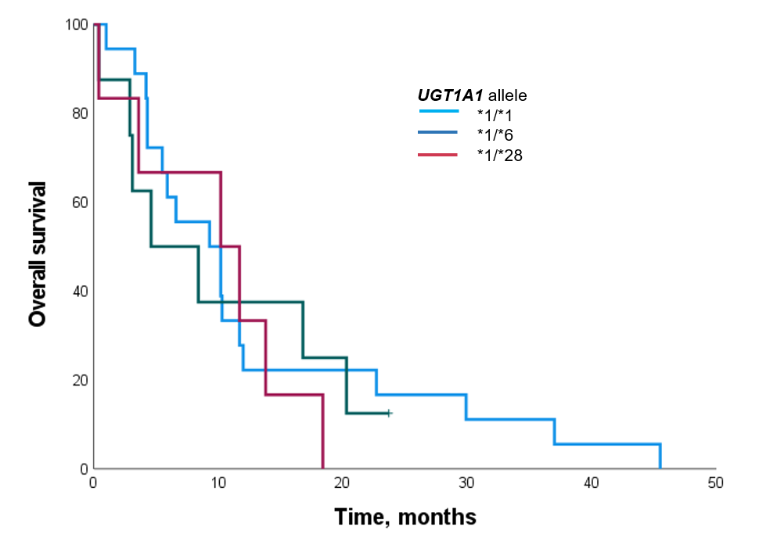

Figure S2. Progression-free survival by UGT21A1 allele type
