Supplementary Figures
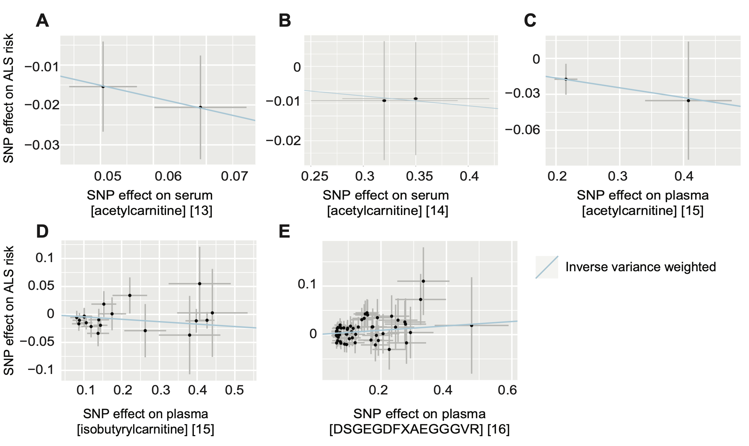
Supplementary Figure 1: Metabolites causally associated with ALS are confirmed with MR in an independent dataset. Scatter plots demonstrate a significant association of circulating serum/plasma metabolite concentrations with ALS risk via the inverse-variance weighted test for acetylcarnitine (A, B, and C represent three different tests), isobutyrylcarnitine (D), and DSGEGDFXAEGGGVR (E). Each point represents the effect size (β) and standard errors for each SNP–outcome relationship.

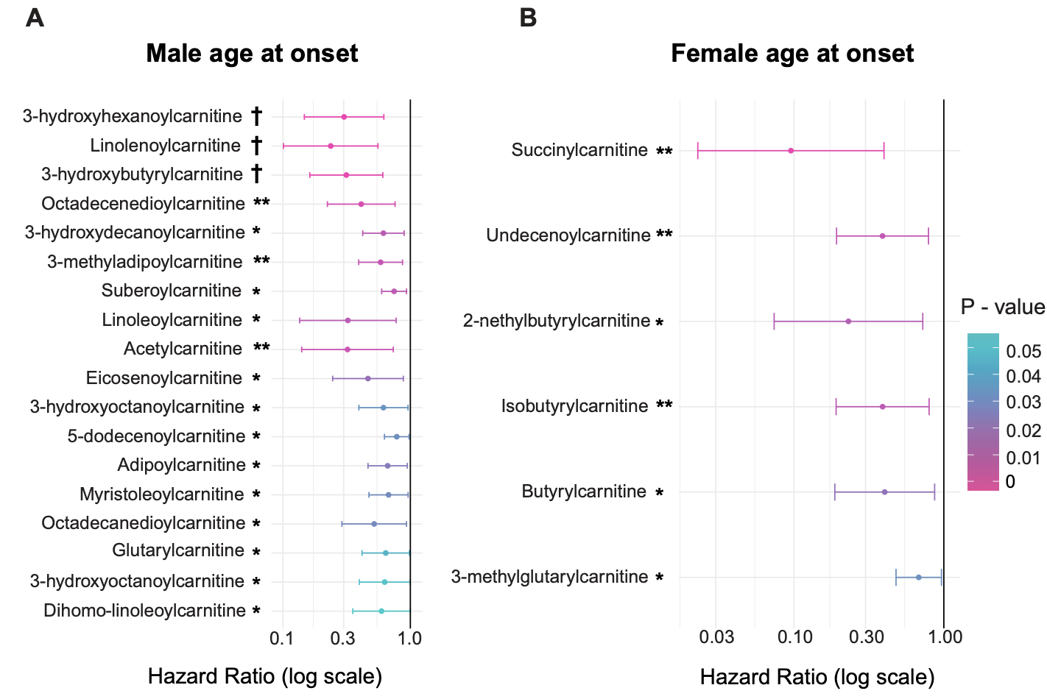
Supplementary Figure 2: Sex-stratified Cox regression for the association of circulating carnitine concentration on age of ALS symptom onset. (A) Hazard ratios in males for carnitines with P < 0.05. (B) Hazard ratios in females for carnitines with P < 0.05. Hazard ratios are plotted on a log scale. *P < 0.05; *P < 0.01; †FDR < 0.05.

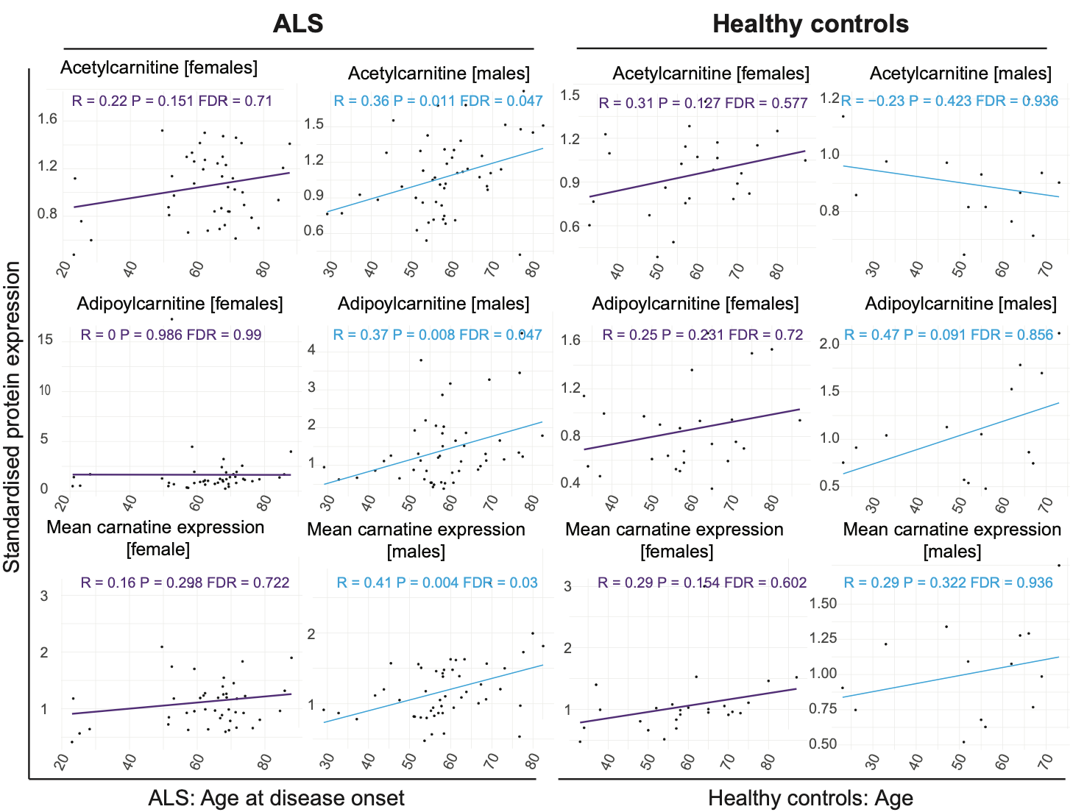
Supplementary Figure 3: Sex-stratified Pearson correlations between circulating carnitine concentration and age of ALS symptom onset. Data for females in purple and males in blue. Shown are data for acetylcarnitine (top panels) and adipoylcarnitine (middle panels), and also shown is the mean expression value of all measured carnitine metabolites (bottom panels). Additional carnitines with a significant male-only correlation (data not shown): docosapentaenoylcarnitine, eicosenoylcarnitine, laurylcarnitine, linolenoylcarnitine, myristoleoylcarnitine, myristoylcarnitine, octadecanedioylcarnitine, octadecenedioylcarnitine, pimeloylcarnitine, 3-methyladipoylcarnitine , suberoylcarnitine, undecenoylcarnitine, 3-hydroxybutyrylcarnitine, 3-hydroxydecanoylcarnitine, 3-hydroxyhexanoylcarnitine, 3-hydroxyoctanoylcarnitine, and 5-dodecenoylcarnitine.

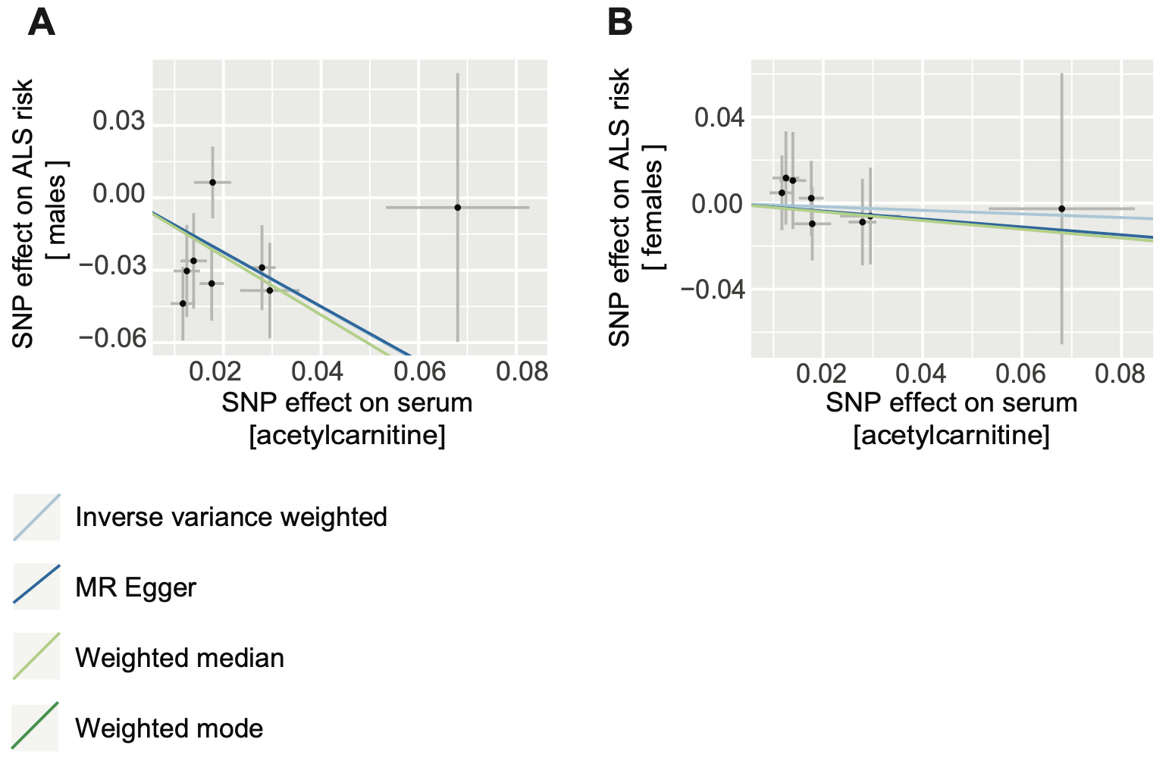
Supplementary Figure 4: Sex-specific two-sample MR to determine whether there is a causal relationship between circulating concentration of acetylcarnitine and risk of ALS. Scatter plots for (A) males and (B) females. Each point represents the effect size (β) and standard errors for each SNP–outcome relationship.
Supplementary Table 1: Metabolome-wide two-sample Mendelian randomization (MR) screen for circulating metabolites causally linked to ALS risk. N = number of genetic instruments; SE = standard error; Q = Cochran’s Q-test; LOO = Leave-one-out test.
Supplementary Table 2: Comparison of directly measured concentration of carnitines in plasma from ALS patients and controls.
Supplementary Table 3: Comparison of directly measured concentration of selected simple carbohydrates in plasma from ALS patients and controls.
Supplementary Table 4: Cox regression for the relationship between plasma concentration of selected simple carbohydrates and ALS survival time.
Supplementary Table 5: Cox regression for the relationship between plasma concentration of selected simple carbohydrates and ALS age of onset.
Supplementary Table 6: NADH production by mouse cortical neurons with and without an ALS-associated C9orf72 G4C2-repeat expansion in different energy substrates. P-value for repeated measures ANOVA shown for each energy substrate.
Supplementary Data 1: Raw data for measurements of NADH production by mouse cortical neurons with and without an ALS-associated C9orf72 G4C2-repeat expansion in different energy substrates. (relates to Figure 5 and Supplementary Table 6)

