Supporting Information for:
Carrying capacity as constraint for maximum efficient CDR in agricultural soils

K. Ulrich Mayer*^{,1}, Sergio A. Bea¹, Danyang Su¹, Jennifer Soong¹, Jenny Mills¹, and Shawn G. Benner¹

¹Terradot Soil Inc., San Francisco, CA, USA

S.1. Supporting Tables and Figures
Table S.1a: Calculated pore water composition (pH, [Ca], [DIC], alkalinity and SIs of major Mg-carbonate phases) for the simulation cases with pCO2 = 5,000ppm, model input shaded in green, model output shaded in orange, calcite SI ranges form 0.0 to 1.0, Mg ranges from 0 – 5 mM (24 – 122 mg L⁻¹).
# | pCO₂ | calcite SI | Mg | pH | Ca | DIC | Total alkalinity | hydro-magnesite SI | magnesite SI | nesquehonite SI
# | [ppm] | [-] | [mg L⁻¹] [mM] | [-] | [mg L⁻¹] | [mg CO₂ L⁻¹] | [mg HCO₃⁻ L⁻¹] | [-] | [-] | [-]
1 | 5,000 | 0 | 0 (0) | 7.5 | 52 | 120 | 157 | N/A | N/A | N/A
2 | 5,000 | 0 | 24(1) | 7.6 | 30 | 161 | 214 | -12.5 | -0.3 | -2.73
3 | 5,000 | 0 | 49 (2) | 7.8 | 17 | 220 | 297 | -9.8 | 0.2 | -2.19
4 | 5,000 | 0 | 73 (3) | 7.9 | 11 | 292 | 399 | -7.9 | 0.6 | -1.8
5 | 5,000 | 0 | 97 (4) | 8.0 | 7 | 370 | 510 | -6.4 | 0.9 | -1.5
6 | 5,000 | 0 | 122 (5) | 8.0 | 5 | 450 | 626 | -5.3 | 1.1 | -1.27
7 | 5,000 | 0.5 | 0 (0) | 7.7 | 79 | 179 | 239 | N/A | N/A | N/A
8 | 5,000 | 0.5 | 24(1) | 7.7 | 56 | 217 | 293 | -11.4 | -0.1 | -2.5
9 | 5,000 | 0.5 | 49 (2) | 7.8 | 39 | 267 | 363 | -9.1 | 0.4 | -2.04
10 | 5,000 | 0.5 | 73 (3) | 7.9 | 28 | 328 | 451 | -7.5 | 0.7 | -1.71
11 | 5,000 | 0.5 | 97 (4) | 8.0 | 20 | 398 | 550 | -6.2 | 1.0 | -1.45
12 | 5,000 | 0.5 | 122 (5) | 8.1 | 16 | 472 | 658 | -5.1 | 1.2 | -1.24
13 | 5,000 | 1.0 | 0 (0) | 7.8 | 122 | 271 | 370 | N/A | N/A | N/A
14 | 5,000 | 1.0 | 24(1) | 7.9 | 98 | 307 | 422 | -10.1 | 0.2 | -2.24
15 | 5,000 | 1.0 | 49 (2) | 7.9 | 79 | 351 | 485 | -8.1 | 0.6 | -1.84
16 | 5,000 | 1.0 | 73 (3) | 8.0 | 64 | 403 | 560 | -6.7 | 0.8 | -1.57
17 | 5,000 | 1.0 | 97 (4) | 8.1 | 51 | 462 | 645 | -5.7 | 1.1 | -1.35
18 | 5,000 | 1.0 | 122 (5) | 8.1 | 42 | 527 | 739 | -4.7 | 1.2 | -1.17

Table S.1b: Calculated pore water composition (pH, [Ca], [DIC], alkalinity and SIs of major Mg-carbonate phases) for the simulation cases with pCO2 = 10,000ppm, model input shaded in green, model output shaded in orange, calcite SI ranges form 0.0 to 1.0, Mg ranges from 0 – 5 mM (24 – 122 mg L⁻¹).
# | pCO₂ | calcite SI | Mg | pH | Ca | DIC | Total alkalinity | hydro-magnesite SI | magnesite SI | nesquehonite SI
# | [ppm] | [-] | [mg L⁻¹] [mM] | [-] | [mg L⁻¹] | [mg CO₂ L⁻¹] | [mg HCO₃⁻ L⁻¹] | [-] | [-] | [-]
19 | 10,000 | 0 | 0 (0) | 7.3 | 66 | 159 | 201 | N/A | N/A | N/A
20 | 10,000 | 0 | 24(1) | 7.4 | 44 | 198 | 255 | -13.7 | -0.5 | -2.89
21 | 10,000 | 0 | 49 (2) | 7.5 | 28 | 252 | 330 | -11.2 | 0.0 | -2.4
22 | 10,000 | 0 | 73 (3) | 7.6 | 19 | 318 | 423 | -9.4 | 0.4 | -2.05
23 | 10,000 | 0 | 97 (4) | 7.7 | 13 | 393 | 528 | -8.0 | 0.6 | -1.76
24 | 10,000 | 0 | 122 (5) | 7.8 | 10 | 471 | 640 | -6.9 | 0.9 | -1.54
25 | 10,000 | 0.5 | 0 (0) | 7.5 | 101 | 235 | 308 | N/A | N/A | N/A
26 | 10,000 | 0.5 | 24(1) | 7.5 | 78 | 272 | 359 | -12.4 | -0.2 | -2.64
27 | 10,000 | 0.5 | 49 (2) | 7.6 | 59 | 319 | 424 | -10.3 | 0.2 | -2.22
28 | 10,000 | 0.5 | 73 (3) | 7.7 | 45 | 375 | 503 | -8.8 | 0.5 | -1.92
29 | 10,000 | 0.5 | 97 (4) | 7.7 | 35 | 439 | 594 | -7.6 | 0.7 | -1.69
30 | 10,000 | 0.5 | 122 (5) | 7.8 | 27 | 509 | 694 | -6.6 | 0.9 | -1.48
31 | 10,000 | 1.0 | 0 (0) | 7.6 | 157 | 355 | 477 | N/A | N/A | N/A
32 | 10,000 | 1.0 | 24(1) | 7.7 | 133 | 391 | 527 | -11.1 | 0.0 | -2.37
33 | 10,000 | 1.0 | 49 (2) | 7.7 | 113 | 433 | 587 | -9.2 | 0.4 | -2
34 | 10,000 | 1.0 | 73 (3) | 7.8 | 95 | 481 | 655 | -7.9 | 0.7 | -1.75
35 | 10,000 | 1.0 | 97 (4) | 7.8 | 80 | 536 | 732 | -6.9 | 0.9 | -1.55
36 | 10,000 | 1.0 | 122 (5) | 7.9 | 68 | 595 | 817 | -6.1 | 1.0 | -1.38

Table S.1c: Calculated pore water composition (pH, [Ca], [DIC], alkalinity and SIs of major Mg-carbonate phases) for the simulation cases with pCO2 = 20,000ppm, model input shaded in green, model output shaded in orange, calcite SI ranges form 0.0 to 1.0, Mg ranges from 0 – 5 mM (24 – 122 mg L⁻¹).
# | pCO₂ | calcite SI | Mg | pH | Ca | DIC | Total alkalinity | hydro-magnesite SI | magnesite SI | nesquehonite SI
# | [ppm] | [-] | [mg L⁻¹] [mM] | [-] | [mg L⁻¹] | [mg CO₂ L⁻¹] | [mg HCO₃⁻ L⁻¹] | [-] | [-] | [-]
37 | 20,000 | 0 | 0 (0) | 7.1 | 85 | 216 | 258 | N/A | N/A | N/A
38 | 20,000 | 0 | 24(1) | 7.2 | 62 | 253 | 310 | -14.7 | -0.6 | -3.04
39 | 20,000 | 0 | 49 (2) | 7.3 | 44 | 302 | 379 | -12.5 | -0.2 | -2.6
40 | 20,000 | 0 | 73 (3) | 7.3 | 32 | 362 | 463 | -10.9 | 0.1 | -2.27
41 | 20,000 | 0 | 97 (4) | 7.4 | 23 | 431 | 559 | -9.6 | 0.4 | -2.02
42 | 20,000 | 0 | 122 (5) | 7.5 | 18 | 506 | 664 | -8.5 | 0.6 | -1.8
43 | 20,000 | 0.5 | 0 (0) | 7.3 | 130 | 315 | 396 | N/A | N/A | N/A
44 | 20,000 | 0.5 | 24(1) | 7.3 | 107 | 351 | 447 | -13.4 | -0.4 | -2.78
45 | 20,000 | 0.5 | 49 (2) | 7.4 | 87 | 394 | 508 | -11.4 | 0.0 | -2.39
46 | 20,000 | 0.5 | 73 (3) | 7.4 | 70 | 445 | 580 | -10.1 | 0.3 | -2.12
47 | 20,000 | 0.5 | 97 (4) | 7.5 | 57 | 504 | 661 | -9.0 | 0.5 | -1.9
48 | 20,000 | 0.5 | 122 (5) | 7.5 | 47 | 568 | 752 | -8.1 | 0.7 | -1.72
49 | 20,000 | 1.0 | 0 (0) | 7.5 | 202 | 471 | 617 | N/A | N/A | N/A
50 | 20,000 | 1.0 | 24(1) | 7.5 | 179 | 507 | 667 | -12.0 | -0.1 | -2.5
51 | 20,000 | 1.0 | 49 (2) | 7.5 | 157 | 547 | 724 | -10.2 | 0.3 | -2.14
52 | 20,000 | 1.0 | 73 (3) | 7.5 | 138 | 593 | 787 | -9.0 | 0.5 | -1.91
53 | 20,000 | 1.0 | 97 (4) | 7.6 | 121 | 643 | 858 | -8.1 | 0.7 | -1.73
54 | 20,000 | 1.0 | 122 (5) | 7.6 | 107 | 697 | 935 | -7.4 | 0.8 | -1.57

Table S.2a: Maximum effective CDR [tn CO₂ ha⁻¹ yr⁻¹] calculated as the product of groundwater recharge $q_{r}$ and dissolved inorganic carbon $[DIC]$ as a function of a range of groundwater recharge rates [mm yr⁻¹] for the simulation cases with pCO₂ = 5,000ppm at T = 25°C. Color shading indicates the range of maximum efficient CDR. white: < 0.5 tn CO₂ ha⁻¹ yr⁻¹, green: 0.5 – < 1 tn CO₂ ha⁻¹ yr⁻¹, blue: 1-2 tn CO₂ ha⁻¹ yr⁻¹, orange: > 2 tn CO₂ ha⁻¹ yr⁻¹.
#/q_{r} | Code | 50 | 100 | 150 | 200 | 250 | 300 | 350 | 400 | 500 | 600 | 700 | 800 | 900 | 1000
1 | 5-0-0 | 0.06 | 0.12 | 0.18 | 0.24 | 0.30 | 0.36 | 0.42 | 0.48 | 0.60 | 0.72 | 0.84 | 0.96 | 1.08 | 1.20
2 | 5-0-1 | 0.08 | 0.16 | 0.24 | 0.32 | 0.40 | 0.48 | 0.56 | 0.64 | 0.81 | 0.97 | 1.13 | 1.29 | 1.45 | 1.61
3 | 5-0-2 | 0.11 | 0.22 | 0.33 | 0.44 | 0.55 | 0.66 | 0.77 | 0.88 | 1.10 | 1.32 | 1.54 | 1.76 | 1.98 | 2.20
4 | 5-0-3 | 0.15 | 0.29 | 0.44 | 0.58 | 0.73 | 0.88 | 1.02 | 1.17 | 1.46 | 1.75 | 2.04 | 2.34 | 2.63 | 2.92
5 | 5-0-4 | 0.19 | 0.37 | 0.56 | 0.74 | 0.93 | 1.11 | 1.30 | 1.48 | 1.85 | 2.22 | 2.59 | 2.96 | 3.33 | 3.70
6 | 5-0-5 | 0.23 | 0.45 | 0.68 | 0.90 | 1.13 | 1.35 | 1.58 | 1.80 | 2.25 | 2.70 | 3.15 | 3.60 | 4.05 | 4.50
7 | 5-5-0 | 0.09 | 0.18 | 0.27 | 0.36 | 0.45 | 0.54 | 0.63 | 0.72 | 0.90 | 1.07 | 1.25 | 1.43 | 1.61 | 1.79
8 | 5-5-1 | 0.11 | 0.22 | 0.33 | 0.43 | 0.54 | 0.65 | 0.76 | 0.87 | 1.09 | 1.30 | 1.52 | 1.74 | 1.95 | 2.17
9 | 5-5-2 | 0.13 | 0.27 | 0.40 | 0.53 | 0.67 | 0.80 | 0.93 | 1.07 | 1.34 | 1.60 | 1.87 | 2.14 | 2.40 | 2.67
10 | 5-5-3 | 0.16 | 0.33 | 0.49 | 0.66 | 0.82 | 0.98 | 1.15 | 1.31 | 1.64 | 1.97 | 2.30 | 2.62 | 2.95 | 3.28
11 | 5-5-4 | 0.20 | 0.40 | 0.60 | 0.80 | 1.00 | 1.19 | 1.39 | 1.59 | 1.99 | 2.39 | 2.79 | 3.18 | 3.58 | 3.98
12 | 5-5-5 | 0.24 | 0.47 | 0.71 | 0.94 | 1.18 | 1.42 | 1.65 | 1.89 | 2.36 | 2.83 | 3.30 | 3.78 | 4.25 | 4.72
13 | 5-10-0 | 0.14 | 0.27 | 0.41 | 0.54 | 0.68 | 0.81 | 0.95 | 1.08 | 1.36 | 1.63 | 1.90 | 2.17 | 2.44 | 2.71
14 | 5-10-1 | 0.15 | 0.31 | 0.46 | 0.61 | 0.77 | 0.92 | 1.07 | 1.23 | 1.54 | 1.84 | 2.15 | 2.46 | 2.76 | 3.07
15 | 5-10-2 | 0.18 | 0.35 | 0.53 | 0.70 | 0.88 | 1.05 | 1.23 | 1.40 | 1.76 | 2.11 | 2.46 | 2.81 | 3.16 | 3.51
16 | 5-10-3 | 0.20 | 0.40 | 0.60 | 0.81 | 1.01 | 1.21 | 1.41 | 1.61 | 2.02 | 2.42 | 2.82 | 3.22 | 3.63 | 4.03
17 | 5-10-4 | 0.23 | 0.46 | 0.69 | 0.92 | 1.16 | 1.39 | 1.62 | 1.85 | 2.31 | 2.77 | 3.23 | 3.70 | 4.16 | 4.62
18 | 5-10-5 | 0.26 | 0.53 | 0.79 | 1.05 | 1.32 | 1.58 | 1.84 | 2.11 | 2.64 | 3.16 | 3.69 | 4.22 | 4.74 | 5.27

Table S.2b: Maximum effective CDR [tn CO₂ ha⁻¹ yr⁻¹] calculated as the product of groundwater recharge $q_{r}$ and dissolved inorganic carbon $[DIC]$ as a function of a range of groundwater recharge rates [mm yr⁻¹] for the simulation cases with pCO₂ = 10,000ppm at T = 25°C. Color shading indicates the range of maximum efficient CDR. white: < 0.5 tn CO₂ ha⁻¹ yr⁻¹, green: 0.5 – < 1 tn CO₂ ha⁻¹ yr⁻¹, blue: 1-2 tn CO₂ ha⁻¹ yr⁻¹, orange: > 2 tn CO₂ ha⁻¹ yr⁻¹.
#/q_{r} | Code | 50 | 100 | 150 | 200 | 250 | 300 | 350 | 400 | 500 | 600 | 700 | 800 | 900 | 1000
19 | 10-0-0 | 0.08 | 0.16 | 0.24 | 0.32 | 0.40 | 0.48 | 0.56 | 0.64 | 0.80 | 0.96 | 1.12 | 1.27 | 1.43 | 1.59
20 | 10-0-1 | 0.10 | 0.20 | 0.30 | 0.40 | 0.50 | 0.59 | 0.69 | 0.79 | 0.99 | 1.19 | 1.39 | 1.59 | 1.78 | 1.98
21 | 10-0-2 | 0.13 | 0.25 | 0.38 | 0.50 | 0.63 | 0.76 | 0.88 | 1.01 | 1.26 | 1.51 | 1.76 | 2.01 | 2.27 | 2.52
22 | 10-0-3 | 0.16 | 0.32 | 0.48 | 0.64 | 0.80 | 0.95 | 1.11 | 1.27 | 1.59 | 1.91 | 2.23 | 2.55 | 2.86 | 3.18
23 | 10-0-4 | 0.20 | 0.39 | 0.59 | 0.79 | 0.98 | 1.18 | 1.37 | 1.57 | 1.96 | 2.36 | 2.75 | 3.14 | 3.53 | 3.93
24 | 10-0-5 | 0.24 | 0.47 | 0.71 | 0.94 | 1.18 | 1.41 | 1.65 | 1.88 | 2.36 | 2.83 | 3.30 | 3.77 | 4.24 | 4.71
25 | 10-5-0 | 0.12 | 0.24 | 0.35 | 0.47 | 0.59 | 0.71 | 0.82 | 0.94 | 1.18 | 1.41 | 1.65 | 1.88 | 2.12 | 2.35
26 | 10-5-1 | 0.14 | 0.27 | 0.41 | 0.54 | 0.68 | 0.82 | 0.95 | 1.09 | 1.36 | 1.63 | 1.91 | 2.18 | 2.45 | 2.72
27 | 10-5-2 | 0.16 | 0.32 | 0.48 | 0.64 | 0.80 | 0.96 | 1.12 | 1.27 | 1.59 | 1.91 | 2.23 | 2.55 | 2.87 | 3.19
28 | 10-5-3 | 0.19 | 0.37 | 0.56 | 0.75 | 0.94 | 1.12 | 1.31 | 1.50 | 1.87 | 2.25 | 2.62 | 3.00 | 3.37 | 3.75
29 | 10-5-4 | 0.22 | 0.44 | 0.66 | 0.88 | 1.10 | 1.32 | 1.54 | 1.76 | 2.19 | 2.63 | 3.07 | 3.51 | 3.95 | 4.39
30 | 10-5-5 | 0.25 | 0.51 | 0.76 | 1.02 | 1.27 | 1.53 | 1.78 | 2.04 | 2.55 | 3.05 | 3.56 | 4.07 | 4.58 | 5.09
31 | 10-10-0 | 0.18 | 0.36 | 0.53 | 0.71 | 0.89 | 1.07 | 1.24 | 1.42 | 1.78 | 2.13 | 2.49 | 2.84 | 3.20 | 3.55
32 | 10-10-1 | 0.20 | 0.39 | 0.59 | 0.78 | 0.98 | 1.17 | 1.37 | 1.56 | 1.96 | 2.35 | 2.74 | 3.13 | 3.52 | 3.91
33 | 10-10-2 | 0.22 | 0.43 | 0.65 | 0.87 | 1.08 | 1.30 | 1.52 | 1.73 | 2.17 | 2.60 | 3.03 | 3.46 | 3.90 | 4.33
34 | 10-10-3 | 0.24 | 0.48 | 0.72 | 0.96 | 1.20 | 1.44 | 1.68 | 1.92 | 2.41 | 2.89 | 3.37 | 3.85 | 4.33 | 4.81
35 | 10-10-4 | 0.27 | 0.54 | 0.80 | 1.07 | 1.34 | 1.61 | 1.88 | 2.14 | 2.68 | 3.22 | 3.75 | 4.29 | 4.82 | 5.36
36 | 10-10-5 | 0.30 | 0.60 | 0.89 | 1.19 | 1.49 | 1.79 | 2.08 | 2.38 | 2.98 | 3.57 | 4.17 | 4.76 | 5.36 | 5.95

Table S.2c: Maximum effective CDR [tn CO₂ ha⁻¹ yr⁻¹] calculated as the product of groundwater recharge $q_{r}$ and dissolved inorganic carbon $[DIC]$ as a function of a range of groundwater recharge rates [mm yr⁻¹] for the simulation cases with pCO₂ = 20,,000ppm at T = 25°C. Color shading indicates the range of maximum efficient CDR. white: < 0.5 tn CO₂ ha⁻¹ yr⁻¹, green: 0.5 – < 1 tn CO₂ ha⁻¹ yr⁻¹, blue: 1-2 tn CO₂ ha⁻¹ yr⁻¹, orange: > 2 tn CO₂ ha⁻¹ yr⁻¹.
#/q_{r} | Code | 50 | 100 | 150 | 200 | 250 | 300 | 350 | 400 | 500 | 600 | 700 | 800 | 900 | 1000
37 | 20-0-0 | 0.11 | 0.22 | 0.32 | 0.43 | 0.54 | 0.65 | 0.75 | 0.86 | 1.08 | 1.29 | 1.51 | 1.72 | 1.94 | 2.16
38 | 20-0-1 | 0.13 | 0.25 | 0.38 | 0.51 | 0.63 | 0.76 | 0.89 | 1.01 | 1.27 | 1.52 | 1.77 | 2.02 | 2.28 | 2.53
39 | 20-0-2 | 0.15 | 0.30 | 0.45 | 0.60 | 0.76 | 0.91 | 1.06 | 1.21 | 1.51 | 1.81 | 2.11 | 2.42 | 2.72 | 3.02
40 | 20-0-3 | 0.18 | 0.36 | 0.54 | 0.72 | 0.91 | 1.09 | 1.27 | 1.45 | 1.81 | 2.17 | 2.54 | 2.90 | 3.26 | 3.62
41 | 20-0-4 | 0.22 | 0.43 | 0.65 | 0.86 | 1.08 | 1.29 | 1.51 | 1.73 | 2.16 | 2.59 | 3.02 | 3.45 | 3.88 | 4.31
42 | 20-0-5 | 0.25 | 0.51 | 0.76 | 1.01 | 1.27 | 1.52 | 1.77 | 2.02 | 2.53 | 3.04 | 3.54 | 4.05 | 4.55 | 5.06
43 | 20-5-0 | 0.16 | 0.31 | 0.47 | 0.63 | 0.79 | 0.94 | 1.10 | 1.26 | 1.57 | 1.89 | 2.20 | 2.52 | 2.83 | 3.15
44 | 20-5-1 | 0.18 | 0.35 | 0.53 | 0.70 | 0.88 | 1.05 | 1.23 | 1.40 | 1.75 | 2.10 | 2.46 | 2.81 | 3.16 | 3.51
45 | 20-5-2 | 0.20 | 0.39 | 0.59 | 0.79 | 0.99 | 1.18 | 1.38 | 1.58 | 1.97 | 2.37 | 2.76 | 3.15 | 3.55 | 3.94
46 | 20-5-3 | 0.22 | 0.45 | 0.67 | 0.89 | 1.11 | 1.34 | 1.56 | 1.78 | 2.23 | 2.67 | 3.12 | 3.56 | 4.01 | 4.45
47 | 20-5-4 | 0.25 | 0.50 | 0.76 | 1.01 | 1.26 | 1.51 | 1.76 | 2.02 | 2.52 | 3.02 | 3.53 | 4.03 | 4.53 | 5.04
48 | 20-5-5 | 0.28 | 0.57 | 0.85 | 1.14 | 1.42 | 1.71 | 1.99 | 2.27 | 2.84 | 3.41 | 3.98 | 4.55 | 5.12 | 5.68
49 | 20-10-0 | 0.24 | 0.47 | 0.71 | 0.94 | 1.18 | 1.41 | 1.65 | 1.88 | 2.36 | 2.83 | 3.30 | 3.77 | 4.24 | 4.71
50 | 20-10-1 | 0.25 | 0.51 | 0.76 | 1.01 | 1.27 | 1.52 | 1.77 | 2.03 | 2.54 | 3.04 | 3.55 | 4.06 | 4.56 | 5.07
51 | 20-10-2 | 0.27 | 0.55 | 0.82 | 1.09 | 1.37 | 1.64 | 1.91 | 2.19 | 2.74 | 3.28 | 3.83 | 4.38 | 4.92 | 5.47
52 | 20-10-3 | 0.30 | 0.59 | 0.89 | 1.19 | 1.48 | 1.78 | 2.08 | 2.37 | 2.97 | 3.56 | 4.15 | 4.74 | 5.34 | 5.93
53 | 20-10-4 | 0.32 | 0.64 | 0.96 | 1.29 | 1.61 | 1.93 | 2.25 | 2.57 | 3.22 | 3.86 | 4.50 | 5.14 | 5.79 | 6.43
54 | 20-10-5 | 0.35 | 0.70 | 1.05 | 1.39 | 1.74 | 2.09 | 2.44 | 2.79 | 3.49 | 4.18 | 4.88 | 5.58 | 6.27 | 6.97

Table S.3a: Global annual maximum efficient CDR [gt CO₂ yr⁻¹] for simulations cases with pCO₂ = 5,000 ppm for terrestrial surface covered by cropland based on 2024 data from Dynamic World¹ (2024-01-01 to 2024-12-31). In addition, cropland area [ha] and percentage of total cropland [%] with maximum efficient CDR [tn CO₂ ha⁻¹ yr⁻¹] exceeding 0.5, 1, and 2 tn CO₂ ha⁻¹ yr⁻¹ are provided. The simulation code refers to pCO₂, calcite SI, and Mg concentrations, e.g. 5_5_1: pCO₂ = 5,000 ppm, calcite SI = 0.5, [Mg] = 1 mM.
 |  | Global annual maximum achievable CDR  [gt CO₂ yr⁻¹] | Land area [ha] with maximum achievable CDR [tn CO₂ ha⁻¹ yr⁻¹] greater than |  |  | Percentage of cropland [%] with maximum achievable CDR [tn CO₂ ha⁻¹ yr⁻¹] greater than
Simulation | Code | Global annual maximum achievable CDR  [gt CO₂ yr⁻¹] | 0.5 | 1.0 | 2.0 | 0.5 | 1.0 | 2.0
1 | 5_0_0 | 0.15 | 1.8E+07 | 9.1E+05 | 0.0E+00 | 1.3 | 0.1 | 0.0
2 | 5_0_1 | 0.20 | 5.4E+07 | 4.4E+06 | 0.0E+00 | 4.1 | 0.3 | 0.0
3 | 5_0_2 | 0.26 | 1.2E+08 | 1.1E+07 | 7.0E+05 | 9.2 | 0.8 | 0.1
4 | 5_0_3 | 0.34 | 1.7E+08 | 4.1E+07 | 3.0E+06 | 13.1 | 3.1 | 0.2
5 | 5_0_4 | 0.43 | 2.4E+08 | 7.9E+07 | 7.0E+06 | 18.2 | 5.9 | 0.5
6 | 5_0_5 | 0.52 | 3.1E+08 | 1.3E+08 | 1.4E+07 | 23.6 | 9.9 | 1.1
7 | 5_5_0 | 0.23 | 7.7E+07 | 5.5E+06 | 0.0E+00 | 5.7 | 0.4 | 0.0
8 | 5_5_1 | 0.27 | 1.3E+08 | 1.2E+07 | 4.6E+05 | 9.6 | 0.9 | 0.0
9 | 5_5_2 | 0.32 | 1.7E+08 | 3.1E+07 | 2.3E+06 | 12.5 | 2.4 | 0.2
10 | 5_5_3 | 0.39 | 2.2E+08 | 5.6E+07 | 4.9E+06 | 16.8 | 4.2 | 0.4
11 | 5_5_4 | 0.47 | 3.0E+08 | 9.3E+07 | 8.9E+06 | 22.6 | 7.0 | 0.7
12 | 5_5_5 | 0.55 | 3.5E+08 | 1.4E+08 | 1.7E+07 | 25.8 | 10.2 | 1.3
13 | 5_10_0 | 0.34 | 1.8E+08 | 3.4E+07 | 2.5E+06 | 13.8 | 2.6 | 0.2
14 | 5_10_1 | 0.38 | 2.2E+08 | 4.8E+07 | 3.2E+06 | 16.5 | 3.6 | 0.2
15 | 5_10_2 | 0.43 | 2.7E+08 | 7.1E+07 | 5.3E+06 | 20.2 | 5.3 | 0.4
16 | 5_10_3 | 0.49 | 3.2E+08 | 1.0E+08 | 9.0E+06 | 23.7 | 7.8 | 0.7
17 | 5_10_4 | 0.55 | 3.7E+08 | 1.4E+08 | 1.5E+07 | 27.7 | 10.5 | 1.1
18 | 5_10_5 | 0.62 | 4.2E+08 | 1.6E+08 | 3.0E+07 | 31.1 | 12.0 | 2.2

Table S.3b: Global annual maximum efficient CDR [gt CO₂ yr⁻¹] for simulations cases with pCO₂ = 10,000 ppm for terrestrial surface covered by cropland based on 2024 data from Dynamic World¹ (2024-01-01 to 2024-12-31). In addition, cropland area [ha] and percentage of total cropland [%] with maximum efficient CDR [tn CO₂ ha⁻¹ yr⁻¹] exceeding 0.5, 1, and 2 tn CO₂ ha⁻¹ yr⁻¹ are provided. The simulation code refers to pCO₂, calcite SI, and Mg concentrations, e.g. 10_5_1: pCO₂ = 10,000 ppm, calcite SI = 0.5, [Mg] = 1 mM.
 |  | Global annual maximum achievable CDR  [gt CO₂ yr⁻¹] | Land area [ha] with maximum achievable CDR [tn CO₂ ha⁻¹ yr⁻¹] greater than |  |  | Percentage of cropland [%] with maximum achievable CDR [tn CO₂ ha⁻¹ yr⁻¹] greater than
Simulation | Code | Global annual maximum achievable CDR  [gt CO₂ yr⁻¹] | 0.5 | 1.0 | 2.0 | 0.5 | 1.0 | 2.0
19 | 10_0_0 | 0.20 | 5.5E+07 | 3.4E+06 | 0.0E+00 | 4.1 | 0.3 | 0.0
20 | 10_0_1 | 0.25 | 1.0E+08 | 7.9E+06 | 0.0E+00 | 7.5 | 0.6 | 0.0
21 | 10_0_2 | 0.30 | 1.5E+08 | 2.5E+07 | 1.9E+06 | 11.3 | 1.9 | 0.1
22 | 10_0_3 | 0.38 | 2.1E+08 | 5.3E+07 | 4.0E+06 | 15.5 | 3.9 | 0.3
23 | 10_0_4 | 0.46 | 3.0E+08 | 8.8E+07 | 8.9E+06 | 22.4 | 6.6 | 0.7
24 | 10_0_5 | 0.55 | 3.4E+08 | 1.3E+08 | 1.6E+07 | 25.1 | 10.0 | 1.2
25 | 10_5_0 | 0.30 | 1.5E+08 | 1.6E+07 | 9.1E+05 | 11.2 | 1.2 | 0.1
26 | 10_5_1 | 0.34 | 1.8E+08 | 3.5E+07 | 2.5E+06 | 13.6 | 2.6 | 0.2
27 | 10_5_2 | 0.39 | 2.3E+08 | 5.3E+07 | 4.2E+06 | 17.2 | 4.0 | 0.3
28 | 10_5_3 | 0.45 | 2.9E+08 | 8.7E+07 | 5.8E+06 | 21.9 | 6.5 | 0.4
29 | 10_5_4 | 0.52 | 3.3E+08 | 1.2E+08 | 1.1E+07 | 24.9 | 9.2 | 0.8
30 | 10_5_5 | 0.60 | 4.0E+08 | 1.5E+08 | 2.5E+07 | 29.9 | 11.4 | 1.9
31 | 10_10_0 | 0.45 | 2.9E+08 | 7.5E+07 | 5.5E+06 | 22.0 | 5.6 | 0.4
32 | 10_10_1 | 0.49 | 3.2E+08 | 9.9E+07 | 6.4E+06 | 24.1 | 7.4 | 0.5
33 | 10_10_2 | 0.54 | 3.7E+08 | 1.3E+08 | 1.2E+07 | 27.5 | 9.6 | 0.9
34 | 10_10_3 | 0.59 | 4.0E+08 | 1.5E+08 | 1.8E+07 | 30.0 | 10.9 | 1.4
35 | 10_10_4 | 0.65 | 4.4E+08 | 1.7E+08 | 3.2E+07 | 32.9 | 12.5 | 2.4
36 | 10_10_5 | 0.71 | 4.8E+08 | 1.9E+08 | 4.4E+07 | 35.6 | 14.1 | 3.3

Table S.3c: Global annual maximum efficient CDR [gt CO₂ yr⁻¹] for simulations cases with pCO₂ = 20,000 ppm for terrestrial surface covered by cropland based on 2024 data from Dynamic World¹ (2024-01-01 to 2024-12-31). In addition, cropland area [ha] and percentage of total cropland [%] with maximum efficient CDR [tn CO₂ ha⁻¹ yr⁻¹] exceeding 0.5, 1, and 2 tn CO₂ ha⁻¹ yr⁻¹ are provided. The simulation code refers to pCO₂, calcite SI, and Mg concentrations, e.g. 20_5_1: pCO₂ = 20,000 ppm, calcite SI = 0.5, [Mg] = 1 mM.
 |  | Global annual maximum achievable CDR  [gt CO₂ yr⁻¹] | Land area [ha] with maximum achievable CDR [tn CO₂ ha⁻¹ yr⁻¹] greater than |  |  | Percentage of cropland [%] with maximum achievable CDR [tn CO₂ ha⁻¹ yr⁻¹] greater than
Simulation | Code | Global annual maximum achievable CDR  [gt CO₂ yr⁻¹] | 0.5 | 1.0 | 2.0 | 0.5 | 1.0 | 2.0
37 | 20_0_0 | 0.28 | 1.3E+08 | 1.2E+07 | 2.3E+05 | 9.7 | 0.9 | 0.0
38 | 20_0_1 | 0.32 | 1.6E+08 | 2.4E+07 | 1.6E+06 | 11.8 | 1.8 | 0.1
39 | 20_0_2 | 0.37 | 2.1E+08 | 4.5E+07 | 3.2E+06 | 15.3 | 3.4 | 0.2
40 | 20_0_3 | 0.44 | 2.8E+08 | 7.5E+07 | 5.6E+06 | 20.7 | 5.6 | 0.4
41 | 20_0_4 | 0.51 | 3.3E+08 | 1.2E+08 | 1.1E+07 | 24.5 | 9.0 | 0.8
42 | 20_0_5 | 0.59 | 4.0E+08 | 1.5E+08 | 2.4E+07 | 29.6 | 11.2 | 1.8
43 | 20_5_0 | 0.40 | 2.4E+08 | 5.4E+07 | 3.2E+06 | 18.2 | 4.0 | 0.2
44 | 20_5_1 | 0.44 | 2.9E+08 | 7.2E+07 | 5.5E+06 | 21.4 | 5.4 | 0.4
45 | 20_5_2 | 0.49 | 3.2E+08 | 9.9E+07 | 6.9E+06 | 23.9 | 7.4 | 0.5
46 | 20_5_3 | 0.55 | 3.7E+08 | 1.3E+08 | 1.2E+07 | 27.7 | 9.8 | 0.9
47 | 20_5_4 | 0.61 | 4.1E+08 | 1.5E+08 | 2.5E+07 | 30.4 | 11.3 | 1.9
48 | 20_5_5 | 0.68 | 4.6E+08 | 1.7E+08 | 3.9E+07 | 34.4 | 12.9 | 2.9
49 | 20_10_0 | 0.60 | 4.1E+08 | 1.5E+08 | 1.6E+07 | 30.8 | 11.2 | 1.2
50 | 20_10_1 | 0.64 | 4.4E+08 | 1.6E+08 | 2.5E+07 | 32.7 | 11.9 | 1.8
51 | 20_10_2 | 0.68 | 4.8E+08 | 1.8E+08 | 3.5E+07 | 35.9 | 13.7 | 2.6
52 | 20_10_3 | 0.73 | 5.0E+08 | 2.0E+08 | 4.3E+07 | 37.4 | 15.2 | 3.2
53 | 20_10_4 | 0.79 | 5.3E+08 | 2.3E+08 | 5.4E+07 | 39.6 | 17.3 | 4.0
54 | 20_10_5 | 0.85 | 5.7E+08 | 2.6E+08 | 7.0E+07 | 42.8 | 19.5 | 5.2

Table S.4a: Global annual maximum efficient CDR [gt CO₂ yr⁻¹] for simulations cases with pCO₂ = 5,000 ppm for terrestrial surface covered by cropland and grassland based on 2024 data from Dynamic World¹ (2024-01-01 to 2024-12-31). In addition, combined cropland and grassland area [ha] and percentage of total cropland and grassland [%] with maximum efficient CDR [tn CO₂ ha⁻¹ yr⁻¹] exceeding 0.5, 1, and 2 tn CO₂ ha⁻¹ yr⁻¹ are provided. The simulation code refers to pCO₂, calcite SI, and Mg concentrations, e.g. 5_5_1: pCO₂ = 5,000 ppm, calcite SI = 0.5, [Mg] = 1 mM.
 |  | Global annual maximum achievable CDR  [gt CO₂ yr⁻¹] | Land area [ha] with maximum achievable CDR [tn CO₂ ha⁻¹ yr⁻¹] greater than |  |  | Percentage of crop- and grasslands [%] with maximum achievable CDR [tn CO₂ ha⁻¹ yr⁻¹] greater than
Simulation | Code | Global annual maximum achievable CDR  [gt CO₂ yr⁻¹] | 0.5 | 1.0 | 2.0 | 0.5 | 1.0 | 2.0
1 | 5_0_0 | 0.24 | 5.2E+07 | 2.3E+06 | 0.0E+00 | 2.9 | 0.1 | 0.0
2 | 5_0_1 | 0.32 | 1.2E+08 | 1.3E+07 | 0.0E+00 | 6.6 | 0.7 | 0.0
3 | 5_0_2 | 0.42 | 2.3E+08 | 3.7E+07 | 2.1E+06 | 13.1 | 2.1 | 0.1
4 | 5_0_3 | 0.55 | 3.2E+08 | 9.3E+07 | 9.1E+06 | 18.2 | 5.2 | 0.5
5 | 5_0_4 | 0.69 | 4.3E+08 | 1.6E+08 | 2.0E+07 | 23.9 | 9.1 | 1.1
6 | 5_0_5 | 0.84 | 5.3E+08 | 2.5E+08 | 4.2E+07 | 29.6 | 14.0 | 2.4
7 | 5_5_0 | 0.36 | 1.5E+08 | 1.9E+07 | 1.4E+05 | 8.6 | 1.1 | 0.0
8 | 5_5_1 | 0.43 | 2.4E+08 | 3.5E+07 | 8.4E+05 | 13.4 | 2.0 | 0.0
9 | 5_5_2 | 0.52 | 3.1E+08 | 7.5E+07 | 5.2E+06 | 17.5 | 4.2 | 0.3
10 | 5_5_3 | 0.63 | 4.0E+08 | 1.2E+08 | 1.5E+07 | 22.3 | 6.8 | 0.8
11 | 5_5_4 | 0.75 | 5.1E+08 | 1.8E+08 | 2.5E+07 | 28.6 | 10.3 | 1.4
12 | 5_5_5 | 0.89 | 5.7E+08 | 2.5E+08 | 4.8E+07 | 31.9 | 14.3 | 2.7
13 | 5_10_0 | 0.54 | 3.4E+08 | 7.7E+07 | 5.2E+06 | 19.0 | 4.3 | 0.3
14 | 5_10_1 | 0.61 | 3.9E+08 | 1.0E+08 | 9.2E+06 | 22.1 | 5.8 | 0.5
15 | 5_10_2 | 0.69 | 4.6E+08 | 1.4E+08 | 1.7E+07 | 26.0 | 8.1 | 1.0
16 | 5_10_3 | 0.78 | 5.3E+08 | 2.0E+08 | 2.6E+07 | 29.7 | 11.1 | 1.5
17 | 5_10_4 | 0.89 | 6.0E+08 | 2.6E+08 | 4.6E+07 | 33.4 | 14.5 | 2.6
18 | 5_10_5 | 1.00 | 6.6E+08 | 3.0E+08 | 7.1E+07 | 37.0 | 16.6 | 4.0

Table S.4b: Global annual maximum efficient CDR [gt CO₂ yr⁻¹] for simulations cases with pCO₂ = 10,000 ppm for terrestrial surface covered by cropland and grassland based on 2024 data from Dynamic World¹ (2024-01-01 to 2024-12-31). In addition, combined cropland and grassland area [ha] and percentage of total cropland and grassland [%] with maximum efficient CDR [tn CO₂ ha⁻¹ yr⁻¹] exceeding 0.5, 1, and 2 tn CO₂ ha⁻¹ yr⁻¹ are provided. The simulation code refers to pCO₂, calcite SI, and Mg concentrations, e.g. 10_5_1: pCO₂ = 10,000 ppm, calcite SI = 0.5, [Mg] = 1 mM.
 |  | Global annual maximum achievable CDR  [gt CO₂ yr⁻¹] | Land area [ha] with maximum achievable CDR [tn CO₂ ha⁻¹ yr⁻¹] greater than |  |  | Percentage of crop- and grasslands [%] with maximum achievable CDR [tn CO₂ ha⁻¹ yr⁻¹] greater than
Simulation | Code | Global annual maximum achievable CDR  [gt CO₂ yr⁻¹] | 0.5 | 1.0 | 2.0 | 0.5 | 1.0 | 2.0
19 | 10_0_0 | 0.32 | 1.2E+08 | 1.1E+07 | 1.4E+05 | 6.5 | 0.6 | 0.0
20 | 10_0_1 | 0.39 | 1.9E+08 | 2.4E+07 | 1.4E+05 | 10.8 | 1.4 | 0.0
21 | 10_0_2 | 0.49 | 2.8E+08 | 6.3E+07 | 4.0E+06 | 15.8 | 3.5 | 0.2
22 | 10_0_3 | 0.61 | 3.7E+08 | 1.2E+08 | 1.4E+07 | 20.9 | 6.5 | 0.8
23 | 10_0_4 | 0.74 | 5.0E+08 | 1.7E+08 | 2.5E+07 | 28.2 | 9.8 | 1.4
24 | 10_0_5 | 0.88 | 5.6E+08 | 2.5E+08 | 4.7E+07 | 31.2 | 14.1 | 2.6
25 | 10_5_0 | 0.47 | 2.8E+08 | 4.7E+07 | 2.0E+06 | 15.6 | 2.6 | 0.1
26 | 10_5_1 | 0.54 | 3.3E+08 | 7.8E+07 | 5.2E+06 | 18.7 | 4.4 | 0.3
27 | 10_5_2 | 0.63 | 4.1E+08 | 1.1E+08 | 1.2E+07 | 22.8 | 6.4 | 0.7
28 | 10_5_3 | 0.73 | 5.0E+08 | 1.7E+08 | 1.9E+07 | 27.8 | 9.5 | 1.1
29 | 10_5_4 | 0.84 | 5.5E+08 | 2.3E+08 | 3.7E+07 | 31.0 | 13.1 | 2.1
30 | 10_5_5 | 0.97 | 6.4E+08 | 2.8E+08 | 6.3E+07 | 35.6 | 15.8 | 3.5
31 | 10_10_0 | 0.71 | 5.0E+08 | 1.5E+08 | 1.9E+07 | 28.0 | 8.4 | 1.1
32 | 10_10_1 | 0.78 | 5.4E+08 | 1.9E+08 | 2.3E+07 | 30.1 | 10.6 | 1.3
33 | 10_10_2 | 0.86 | 6.0E+08 | 2.4E+08 | 3.5E+07 | 33.4 | 13.4 | 2.0
34 | 10_10_3 | 0.94 | 6.4E+08 | 2.7E+08 | 5.3E+07 | 35.8 | 15.4 | 2.9
35 | 10_10_4 | 1.04 | 6.9E+08 | 3.1E+08 | 7.5E+07 | 38.6 | 17.5 | 4.2
36 | 10_10_5 | 1.15 | 7.3E+08 | 3.4E+08 | 9.6E+07 | 41.2 | 19.3 | 5.4

Table S.4c: Global annual maximum efficient CDR [gt CO₂ yr⁻¹] for simulations cases with pCO₂ = 20,000 ppm for terrestrial surface covered by cropland and grassland based on 2024 data from Dynamic World¹ (2024-01-01 to 2024-12-31). In addition, combined cropland and grassland area [ha] and percentage of total cropland and grassland [%] with maximum efficient CDR [tn CO₂ ha⁻¹ yr⁻¹] exceeding 0.5, 1, and 2 tn CO₂ ha⁻¹ yr⁻¹ are provided. The simulation code refers to pCO₂, calcite SI, and Mg concentrations, e.g. 20_5_1: pCO₂ = 20,000 ppm, calcite SI = 0.5, [Mg] = 1 mM.
 |  | Global annual maximum achievable CDR  [gt CO₂ yr⁻¹] | Land area [ha] with maximum achievable CDR [tn CO₂ ha⁻¹ yr⁻¹] greater than |  |  | Percentage of crop- and grasslands [%] with maximum achievable CDR [tn CO₂ ha⁻¹ yr⁻¹] greater than
Simulation | Code | Global annual maximum achievable CDR  [gt CO₂ yr⁻¹] | 0.5 | 1.0 | 2.0 | 0.5 | 1.0 | 2.0
37 | 20_0_0 | 0.44 | 2.4E+08 | 3.3E+07 | 3.6E+05 | 13.6 | 1.9 | 0.0
38 | 20_0_1 | 0.51 | 3.0E+08 | 6.2E+07 | 3.7E+06 | 16.6 | 3.5 | 0.2
39 | 20_0_2 | 0.59 | 3.7E+08 | 9.8E+07 | 9.2E+06 | 20.9 | 5.5 | 0.5
40 | 20_0_3 | 0.70 | 4.7E+08 | 1.5E+08 | 1.8E+07 | 26.4 | 8.5 | 1.0
41 | 20_0_4 | 0.82 | 5.5E+08 | 2.3E+08 | 3.4E+07 | 30.6 | 12.8 | 1.9
42 | 20_0_5 | 0.96 | 6.3E+08 | 2.8E+08 | 6.2E+07 | 35.3 | 15.6 | 3.5
43 | 20_5_0 | 0.64 | 4.2E+08 | 1.1E+08 | 9.9E+06 | 23.7 | 6.3 | 0.6
44 | 20_5_1 | 0.70 | 4.9E+08 | 1.5E+08 | 1.8E+07 | 27.3 | 8.2 | 1.0
45 | 20_5_2 | 0.78 | 5.3E+08 | 1.9E+08 | 2.3E+07 | 29.9 | 10.7 | 1.3
46 | 20_5_3 | 0.87 | 6.0E+08 | 2.5E+08 | 4.0E+07 | 33.6 | 13.8 | 2.2
47 | 20_5_4 | 0.98 | 6.5E+08 | 2.8E+08 | 6.3E+07 | 36.3 | 15.8 | 3.5
48 | 20_5_5 | 1.09 | 7.1E+08 | 3.2E+08 | 8.8E+07 | 39.8 | 18.0 | 4.9
49 | 20_10_0 | 0.95 | 6.5E+08 | 2.8E+08 | 4.7E+07 | 36.7 | 15.6 | 2.6
50 | 20_10_1 | 1.02 | 6.9E+08 | 3.0E+08 | 6.3E+07 | 38.5 | 16.7 | 3.5
51 | 20_10_2 | 1.09 | 7.4E+08 | 3.3E+08 | 7.9E+07 | 41.8 | 18.8 | 4.4
52 | 20_10_3 | 1.17 | 7.7E+08 | 3.7E+08 | 9.3E+07 | 43.4 | 20.6 | 5.2
53 | 20_10_4 | 1.26 | 8.1E+08 | 4.1E+08 | 1.2E+08 | 45.3 | 22.9 | 6.5
54 | 20_10_5 | 1.36 | 8.6E+08 | 4.5E+08 | 1.4E+08 | 48.1 | 25.2 | 7.8

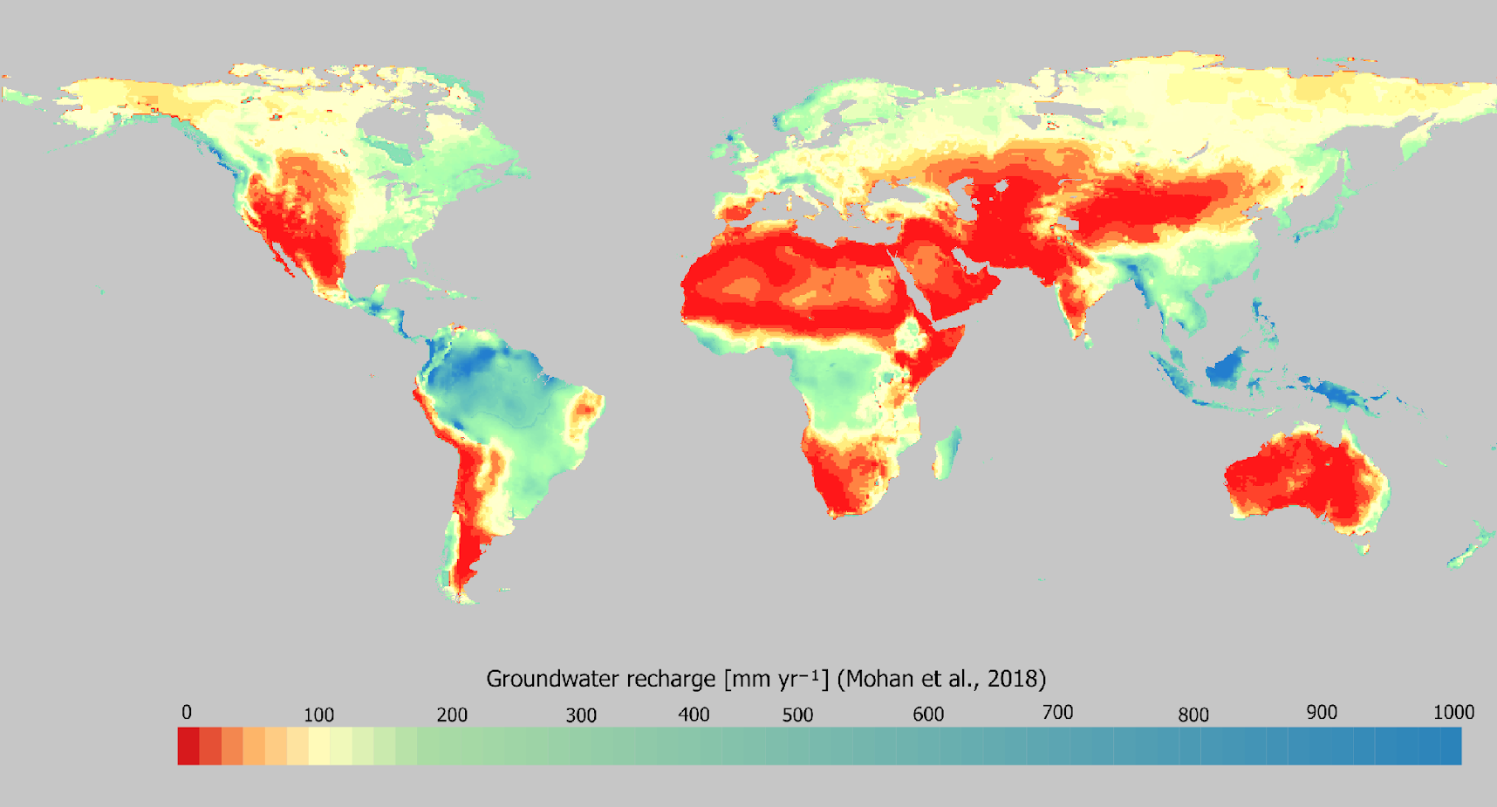
Figure S.1: Long-term (1981–2014) average annual groundwater recharge [mm yr⁻¹], reproduced from Mohan et al².

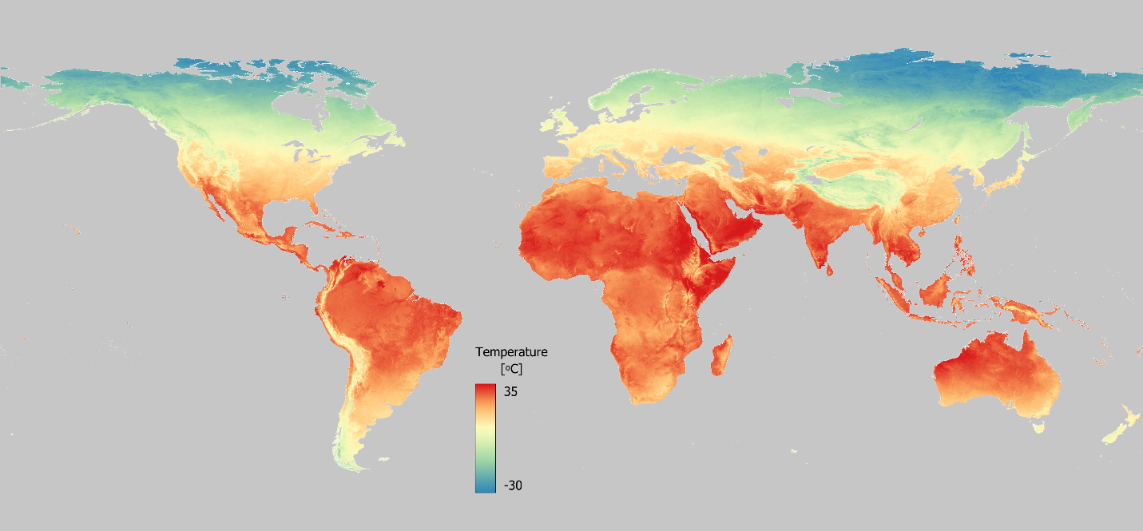
Figure S.2: Global distribution of average annual surface temperatures [°C] in 2024. Temperature data is based on the average of daytime and nighttime temperatures from the MOD21C2 dataset from 2024-01-01 to 2024-12-31³.

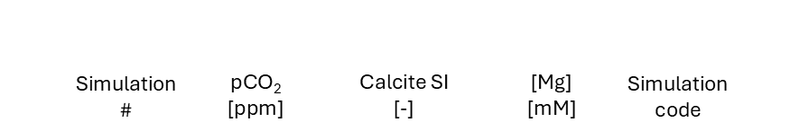
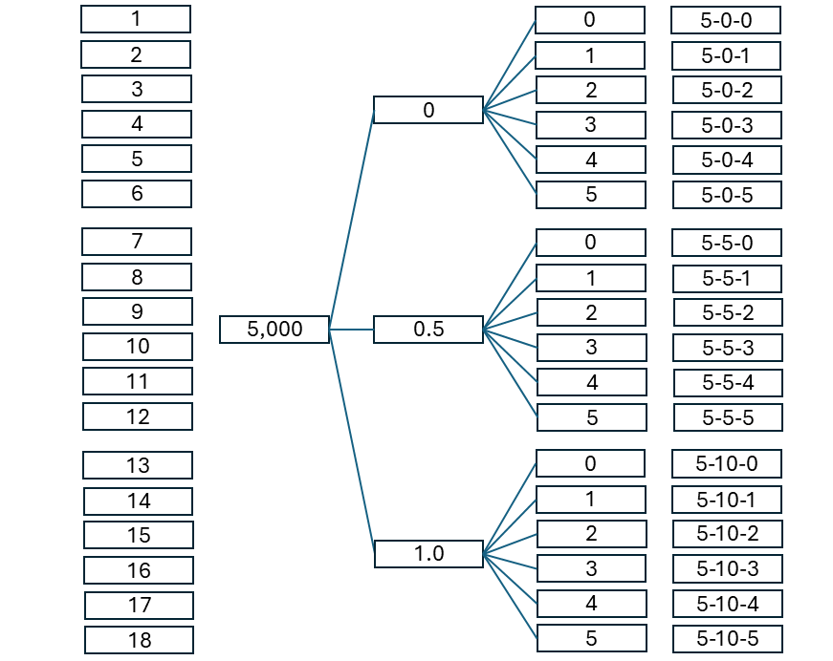
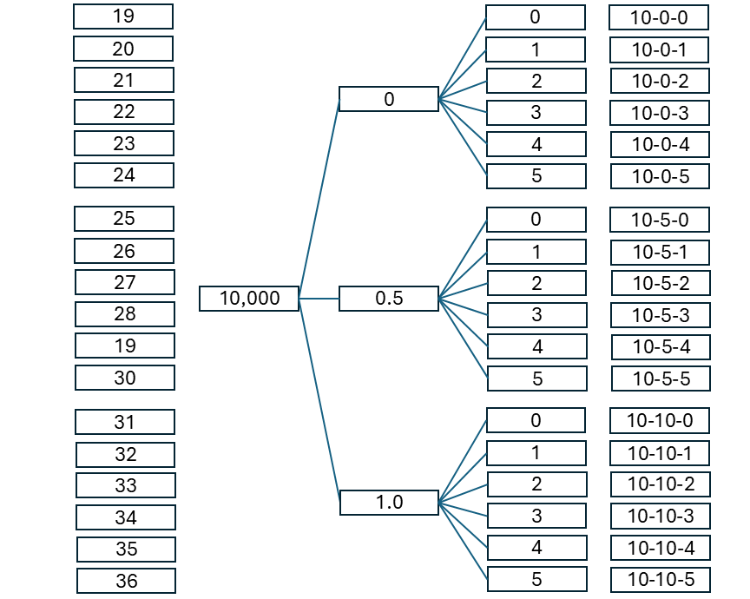
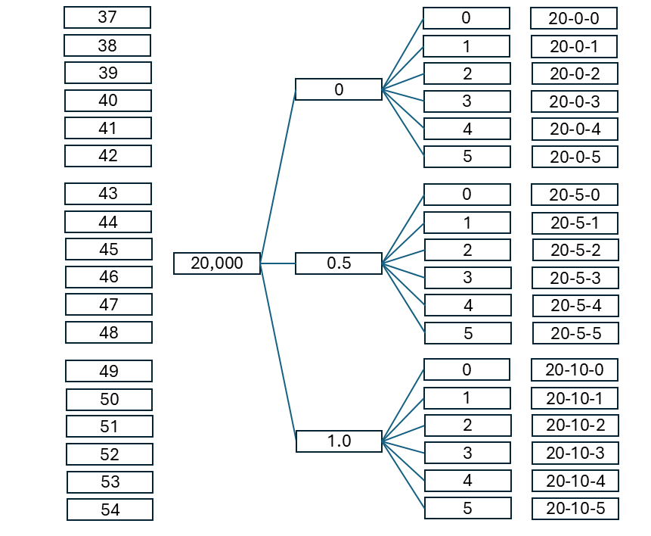
Figure S.3: Simulation grid for a range of pCO₂ values (5,000, 10,000 and 20,000ppm), calcite saturation indices (SI = 0.0, 0.5 and 1.0) and Mg-concentrations (0-5 mM, 24-122 mg L⁻¹).
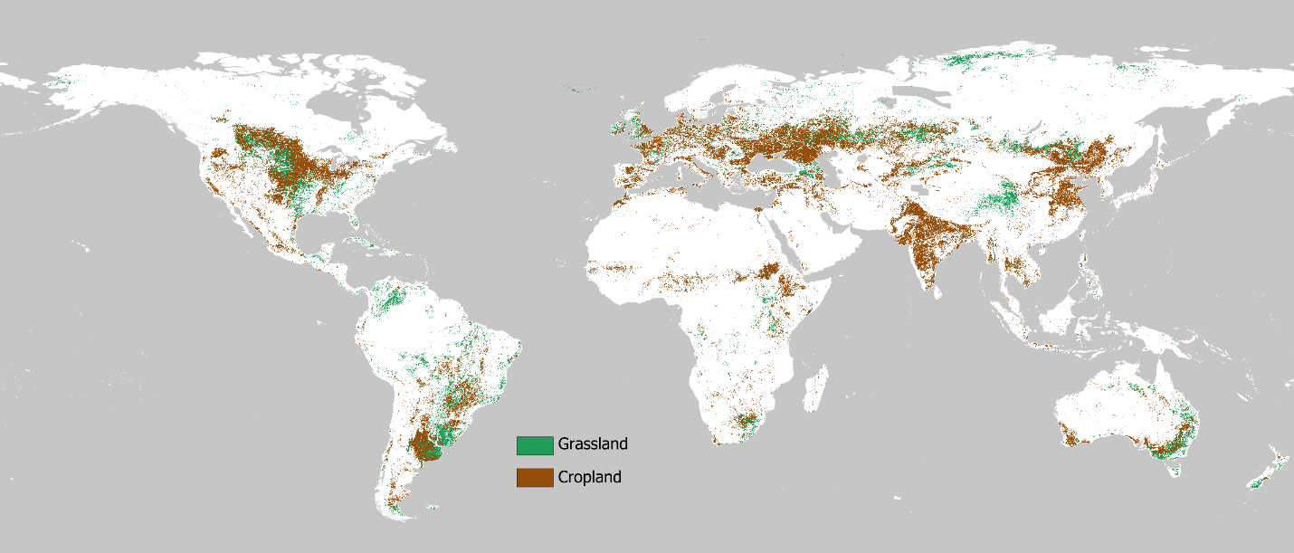
Figure S.4: Global map of cropland and grassland coverage, data from Dynamic World¹ (2024-01-01 to 2024-12-31).

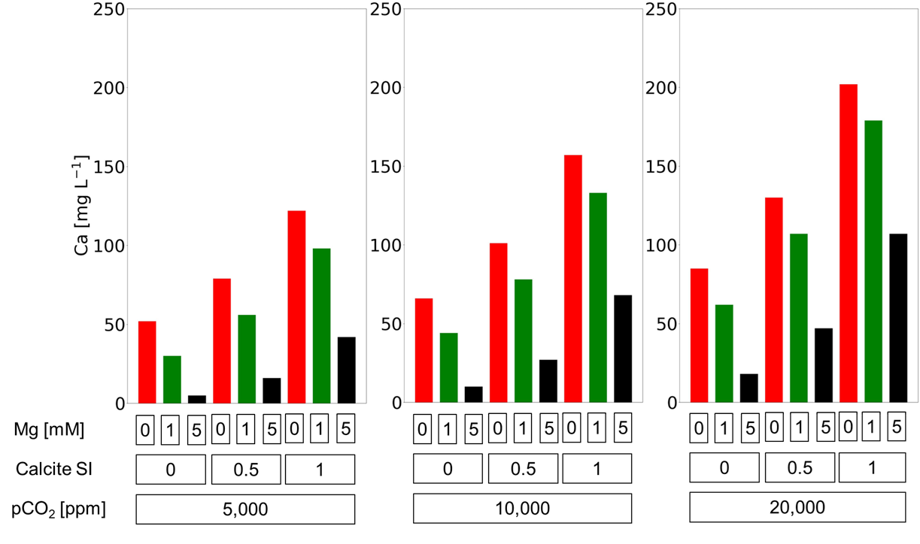
Figure S.5: Calculated Ca-concentrations for selected simulation cases at T = 25°C. Full water chemistry (pCO₂, pH, Ca, Mg, DIC, alkalinity) for all simulation cases is provided in tabular form in Table S.1.

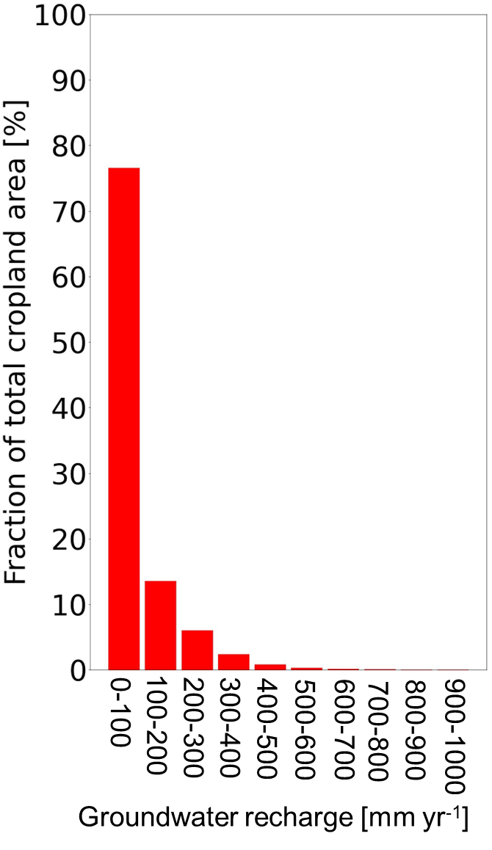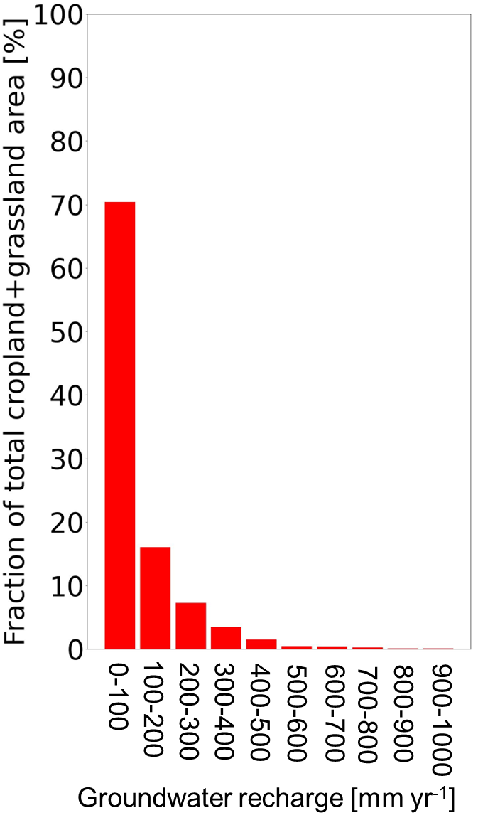
Figure S.6. Areal frequency distributions of recharge rates for cropland (left) and cropland+grassland (right) covering the range of recharge rates inferred by Mohan et al.².
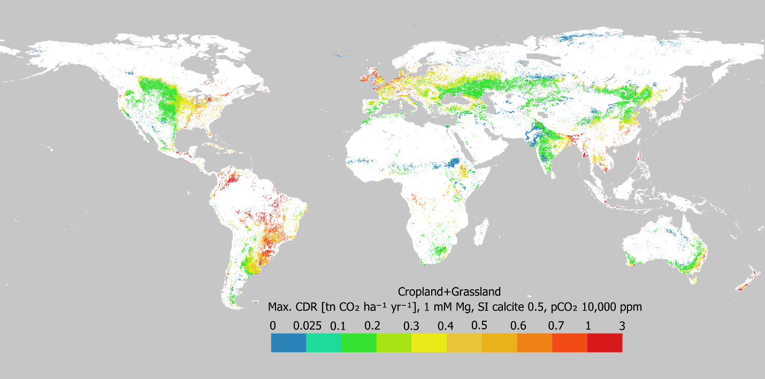
Figure S.7: Global map of maximum efficient CDR on cropland and grassland as a function of effective groundwater recharge and average annual surface temperature determined based on simulation 26 (pCO₂ = 10,000ppm, calcite SI = 0.5, Mg concentration 1 mmol L⁻¹ (24 mg L⁻¹)).
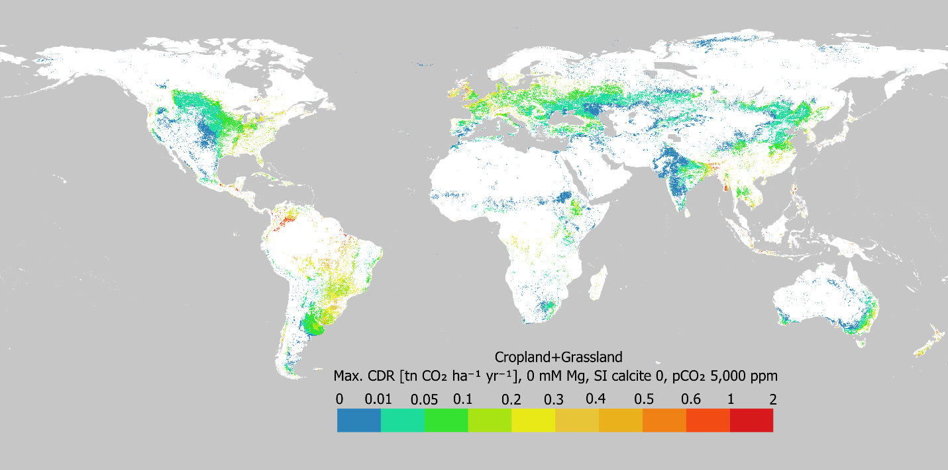
Figure S.8: Global map of maximum efficient CDR on cropland as a function of effective groundwater recharge and average annual surface temperature determined based on simulation 1 (pCO₂ = 5,000ppm, calcite SI = 0, Mg concentration 0 mmol L⁻¹ (0 mg L⁻¹)). This simulation represents the lower limit for maximum efficient CDR considered in the present study when considering cropland only.
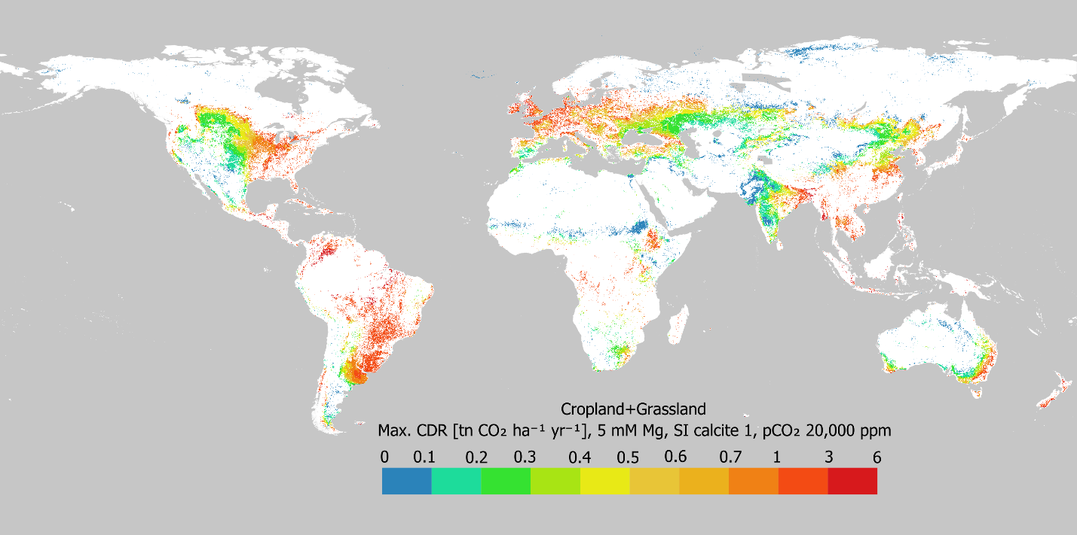
Figure S.9: Global map of maximum efficient CDR on cropland as a function of effective groundwater recharge and average annual surface temperature determined based on simulation 54 (pCO₂ = 20,000ppm, calcite SI = 1.0, Mg concentration 5 mmol L⁻¹ (122 mg L⁻¹)). This simulation represents the upper limit for maximum efficient CDR considered in the present study when considering cropland only.

References
1. Brown, C. F. et al. Dynamic World, Near real-time global 10 m land use land cover mapping. Scientific Data 9, 251 (2022).
2. Mohan, C., Western, A. W., Wei, Y. & Saft, M. Predicting groundwater recharge for varying land cover and climate conditions – a global meta-study. Hydrology and Earth System Sciences 22, 2689–2703 (2018).
3. Hulley, G., Freepartner, R., Malakar, N. & Sarkar, S. Moderate Resolution Imaging Spectroradiometer (MODIS), Land Surface Temperature and Emissivity Product (MxD21), User Guide,Collection 6.1. (2022).

