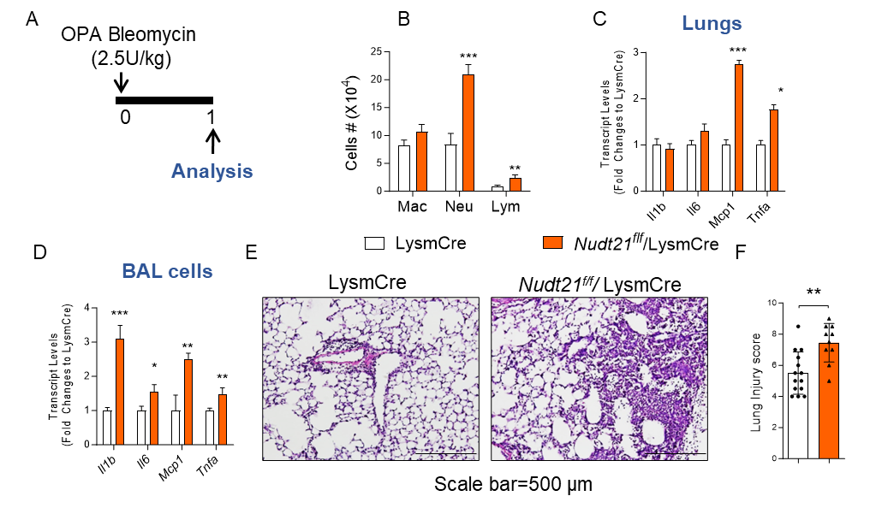Supplementary Figure 1. Bleomycin-induced ARDS in mice with myeloid specific NUDT21 knockout. Nudt21^{f/f} LysmCre and their age- and gender-matched control LysmCre mice were injected with 2.5 U/kg bleomycin via OPA to induce ARDS. The lungs were analyzed one day after. (A) Treatment timeline. (B)The immune cell numbers in the BAL. (C and D) The cytokine transcript levels in (C) the whole lung and (D) BAL cells were determined using RT-qPCR. (E) Representative H&E stained lungs. (F) The lung injury scores were blindly determined. Scale bar =500 μm. N≥9. * P<0.05, ** P<0.01 and *** P<0.001 based on a two-tailed student t-test.

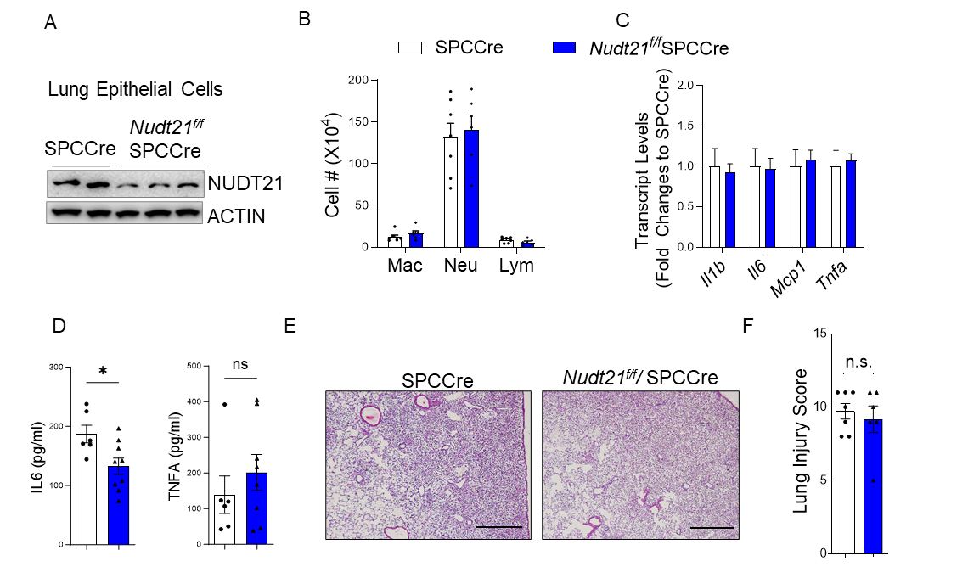
Supplementary Figure 2. LPS-induced ARDS in mice with epithelial specific NUDT21 knockout. Nudt21f/f SPCCreER and their age- and gender-matched control SPCCreER mice were i.p. injected with tamoxifen (37.5 mg/kg daily) for 3 days. One week after the first tamoxifen injection, mice were injected with 2.5 mg/kg LPS via OPA to induce ARDS. The lungs were analyzed on day 3 after LPS. NUDT21 protein levels were examined in (A) primary isolated alveolar epithelial cells from mice without LPS injection. (B)The immune cell number in the BAL. (C) The cytokine levels in the BAL cells were determined using RT-qPCR. (D) The protein levels of IL6 and TNFA in the BAL fluid were measured using ELISA. (E) Representative H&E stained lungs. (F) The lung injury scores were blindly determined. Scale bar =1000 μm.

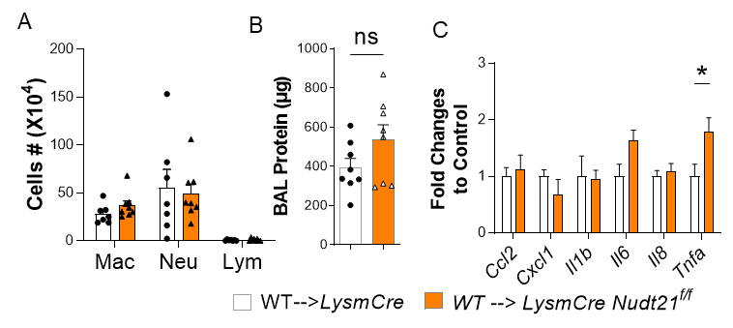
Supplementary Figure 3. NUDT21 restoration in bone marrow attenuates lung injury in KO mice. Bone marrow from CD45.1-bearing mice was transplanted into lethally irradiated Nudt21^{f/f} LysmCre and control mice recipients. Bleomycin (2.5U/kg) was injected via OPA 12 weeks later to induce ARDS, and the lungs were assessed one day after. (A) The number of immune cells in BAL. (B) Total BAL protein levels were determined using a BCA analysis. (C) RT qPCR measured transcript levels of Ccl2, Cxcl1, Il1b, Il6, Il8, and Tnfa in BAL cells. *p<0.05 vs control mice based on a two-tailed Student's t-test.

