Supplementary Information

European Journal of Forest Research

Challenges and solutions for reducing bias in Forest inventory-based estimates of aboveground biomass in arid zones

Luis A. Hernández-Martínez ^{a, b}, José Luis Hernández-Stefanoni ^{a, c}, Alfonso Medel-Narváez ^{d}, Carlos Portillo-Quintero ^{e}, Carlos A. Cabada-Tavares ^{b}, Carlos Lim-Vega ^{f}, Juan Manuel Dupuy-Rada ^{a, c, *}

ª Centro de Investigación Científica de Yucatán A.C. Unidad de Recursos Naturales, Calle 43 # 130 entre 32 y 34. Chuburná de Hidalgo. C.P. 97205, Mérida, Yucatán. México
^{b} Campo Experimental Todos Santos del Instituto Nacional de Investigaciones Forestales, Agrícolas y Pecuarias (INIFAP), Calle Agricultura No. 1555 entre Calle México y Durango, La Paz 23070, Baja California Sur, México
^{c} Laboratorio Nacional CONAHCyT de Biología del Cambio Climático, SECIHTI
^{d} Centro de Investigaciones Biológicas del Noroeste (CIBNOR), Av. Instituto Politécnico Nacional 195, Playa Palo de Santa Rita Sur; La Paz, 23096, Baja California Sur, México
^{e} Department of Natural Resources Management, College of Agricultural Sciences and Natural Resources Management, Texas Tech University, Lubbock, TX 79401, USA
^{f} Rancho Cacachilas, Revolución de 1910 #590, Col. Centro, La Paz, 23000, Baja California Sur, México
* Corresponding author, e-mail: jmdupuy@cicy.mx

Table S1 Allometric equations used to estimate AGB
Allometric equations | Reference | Applied to
exp(-2.76) * (DBH ^ 2.37) | Acosta, 2003 | Prunus sp.
(0.0342) * ( DBH ^ 2.7590) | Aguilar et al., 2012 | Quercus sp.
(0.3764 * ( DBH ^ 2)) - (2.3146 * DBH) - 1.9106 | Aguilar-Hernández et al., 2016 | Arbutus xalapensis
(340.308)*(((3.1416)*RC1*RC2*H)^1.115)/1000 | Búrquez et al., 2010 | Different species of shrubs of arid vegetation
(896.501)*(((3.1416)*RC1*RC2*H)^1.66)/1000 | Búrquez et al., 2010 | Different species of shrubs of arid vegetation
(356.983)*(((3.1416)*RC1*RC2* H)^1.416)/1000 | Búrquez et al., 2010 | Different species of shrubs of arid vegetation
(-40.102 + (1.787 * DBH) + (10.182 * H)) | Castañuela-Ramos, 2013 | Yucca sp.
0.7 * exp(-0.667+1.784 * log(DBH) + 0.207 * log((DBH ^2))-0.0281*log((DBH ^3))) | Chave et al., 2005 | Trees
exp(-2.281 + 1.525*log(DB) + 0.831*log(DC) + 0.523*log(H)) | Conti et al., 2019 | Shrubs
(exp(-2.0074)*( DBH ^1.7761)*(H^0.3650)) + (exp(-5.1933)*( DBH ^2.3694)*(H^1.1154))+(exp(-2.0728)*( DBH ^2.4631)*(H^-1.1749)) | Cuevas y Aquino, 2020 | Pinus lagunae
-4.51 + (7.7*H) | Frangi and Lugo, 1985 | Palmas
(exp(-1.1131+0.7843*log(DB*DC)+1.2691*log(H)))*1.058 | Hernández-Martínez et al., 2022 | Prosopis sp.
(exp( -9.69613 + 1.297437 *log((DC*100)*(H*100))) + exp( -10.1966 + 1.380835 *log((DC*100)*(H*100))))*0.5 | López-Serrato et al., 2021 | Agave sp.
((0.1498) - (0.0609*DB) + (0.004448*(DB^2 * H)))+(-3.72131 + (0.24869*DB)+ (5.1932*H) - (10.4555*(log(H)))) + (-3.72131 + (0.248698*DB) + (5.1932*H)-(10.455*(log(H)))) | Návar et al., 2004 | Bernardia sp.
(0.0433)*( DBH ^2.3929) | Návar et al., 2009 | Lysiloma sp.
(0.3700)*( DBH ^1.9600) | Navar, 2009b | Erythrina sp.
(0.027059)*( DBH ^2.86357) | Rodríguez et al., 2006 | Ficus sp.
(0.010702)*( DBH ^3.05082) | Rodríguez et al., 2009 | Quercus devia
((((3.1416*(( DBH)/2)^2))*(H*100))*0.4)/1000 | Using wood density reported by: Romero et al., 2020 | Pachycereus with a single stem
DB = basal diameter; DBH = diameter at breast height; H = total height; RC1 y RC2 = crown radii; DC = crown diameter.
Acosta M., 2003. Diseño y aplicación de un método para medir los almacenes de carbono en sistemas con vegetación forestal y agrícolas de ladera de México. Thesis, Colegio de Postgraduados.
Aguilar R., Ghilardi A., Vega E., Skutsch M., Oyama K., 2012. Sprouting productivity and allometric relationships of two oak species man- aged for traditional charcoal making in central Mexico. Biomass Bioenergy 36:192–207.
Aguilar-Hernández, L., García-Martínez, R., Gómez-Miraflor, A., Martínez-Gómez, O., 2016. Estimación de biomasa mediante la generación de una ecuación alométrica para madroño (Arbutus xalapensis). IV Congreso Internacional y XVIII Congreso Nacional de Ciencias Agronómicas. Universidad Autónoma Chapingo.
Búrquez, A., Martínez-Yrízar, A., Núñez, S., Quintero, T., Aparicio, A., 2010. Aboveground biomass in three Sonoran Desert communities: Variability within and among sites using replicated plot harvesting. Journal of Arid Environments 74(10), 1240–1247. https://doi.org/10.1016/j.jaridenv.2010.04.004
Castañuela-Ramos Y.I, 2013. Estimación de la Biomasa Aérea y Captura de Carbono en Yucca filifera (Chaubad) y Atriplex canescens (Pursh) Nutt. Usando Ecuaciones Alométricas, en Mazapíl, Zacatecas. Universidad Autónoma Agraria Antonio Narro, División de Agronomía. Tesis de licenciatura.
Chave, J., Andalo, C., Brown, S., Cairns, M.A., Chambers, J.Q., Eamus, D., Fölster, H., Fromard, F., Higuchi, N., Kira, T., Lescure, J.P., Nelson, B.W., Ogawa, H., Puig, H., Riéra, B., Yamakura, T., 2005. Tree allometry and improved estimation of carbon stocks and balance in tropical forests. Oecologia 145(1), 87–99. https://doi.org/10.1007/s00442-005-0100-x
Conti, G., Gorné, L. D., Zeballos, S. R., Lipoma, M. L., Gatica, G., Kowaljow, E., Whitworth-Hulse, J. I., Cuchietti, A., Poca, M., Pestoni, S., & Fernandes, P. M. (2019). Developing allometric models to predict the individual aboveground biomass of shrubs worldwide. Global Ecology and Biogeography, 28(7), 961–975. https://doi.org/10.1111/geb.12907
Cuevas C., J. C., Aquino R., M. (2020). Ecuaciones de aditividad para la estimación de biomasa aérea de Pinus cembroides Zucc. Madera y Bosques, 26(1), e2611821. doi: 10.21829/myb.2020.2611821
Delgado-Fernandez, M., Garcillán, P. P., & Ezcurra, E. (2017). The giant columnar cactus Pachycereus pringlei adaptively modifies its stem shape from the dry tropics into the arid mid-latitude deserts. Journal of Arid Environments, 146, 10–17. https://doi.org/10.1016/j.jaridenv.2017.07.004
Frangi, J.L., Lugo, A.E., 1985. Ecosystem Dynamics of a Subtropical Floodplain Forest Published by : Ecological Society of America ECOSYSTEM DYNAMICS OF A SUBTROPICAL. Ecol. Monogr. 55, 351–369.
Hernández-Martínez L.A. y J.L. González-Barrios (Coord.). 2022. Estudios biométricos y de captura de carbono en mezquitales del noroeste de México. Instituto Nacional de Investigaciones Forestales, Agrícolas y Pecuarias. Centro de Investigación Regional Noroeste. Campo Experimental Todos Santos. Ciudad de México, México. Libro Científico No. 1. 111 p
López-Serrano, P.M., Hernández-Ramos, A., Méndez-González, J., MartínezSalvador, M., Aguirre-Calderón, O., Vargas-Larreta, B., Corral-Rivas J.J. 2021. Mejores prácticas de manejo y ecuaciones alométricas de biomasa de Agave angustifolia Haw., en los estados de Sonora y Guerrero.
https://www.gob.mx/cms/uploads/attachment/file/707137/Mejores_practicas_de_Agave_angustifolia.pdf
Návar J, Méndez E, Nájera A, Graciano J, Dale V, Parresol B., 2004. Biomass equations for shrub species of Tamaulipas thornscrub of northeastern Mexico. J Arid Environ 59:657–674
Návar, J. 2009. Allometric equations and expansion factors for tropical dry forest trees of eastern Sinaloa, Mexico. Trop Subtrop Agroecosyt 10:45–52
Návar J., 2009b. Allometric equations for tree species and carbon stocks for forests ofnorthwestern Mexico. For Ecol Manag 257:427–434
Rodríguez R, Jiménez J, Aguirre O, Treviño E (2006) Estimación de carbono almacenado en un bosque de niebla en Tamaulipas, México. Ciencia-UANL 9: 179–187
Rodríguez R, Jiménez J, Aguirre O, Treviño E, Razo R (2009) Estimación de carbono almacenado en el bosque de pino-encino en la Reserva de la Biosfera el Cielo, Tamaulipas, México. Ra Ximhai 5:317–327
Romero, E., Dávalos-Sotelo, R., Meave, J. A., & Terrazas, T. (2020). Wood density, deposits and mineral inclusions of successional tropical dry forest species. European Journal of Forest Research, 139(3), 369–381. https://doi.org/10.1007/s10342-019-01236-9

Table S2 Descriptive statistics of dendrometric measurements of Pachycereus pringlei individuals used for the development of the allometric equations to estimate AGB
Variable | mean (min - max)
BD (cm) | 25.97 (18.7 - 39)
DBH (cm) | 27.44 (19 – 43.07)
H (m) | 5.18 (3.45 - 8)
CD (m) | 1.28 (0.55 – 2.45)

Table S3 Correction factors estimated from the percentage of AGBD contributed by shrubs and small trees in our sampled plots across AGBD quartiles in four vegetation types of the Cape Region
Vegetation type | Quartile | AGBD range  (Mg ha⁻¹) | % AGBD of small individuals | Correction factor
Xeric shrubland | 0 - 25 | ≤ 26.1 | 15.9 | 1.159
Xeric shrubland | 25 - 50 | > 26.1 - ≤ 30.6 | 36.1 | 1.361
Xeric shrubland | 50 - 75 | > 30.6 - ≤ 45.1 | 16.2 | 1.162
Xeric shrubland | 75 - 100 | > 45.1 | 37.7 | 1.377
Tropical deciduous forest | 0 - 25 | ≤ 23.0 | 80.6 | 1.806
Tropical deciduous forest | 25 - 50 | > 23.0 - ≤ 29.4 | 65.4 | 1.654
Tropical deciduous forest | 50 - 75 | > 29.4 - ≤ 40.3 | 29.2 | 1.292
Tropical deciduous forest | 75 - 100 | > 40.3 | 41.9 | 1.419
Broad-leaved forest | 0 - 25 | ≤ 30.2 | 3.2 | 1.032
Broad-leaved forest | 25 - 50 | > 30.2 - ≤ 49.0 | 1.5 | 1.015
Broad-leaved forest | 50 - 75 | > 49.0 - ≤ 58.4 | 3.2 | 1.032
Broad-leaved forest | 75 - 100 | > 58.4 | 0 | 1.000
Coniferous-broad-leaved forest | 0 - 25 | ≤ 123.8 | 0.4 | 1.004
Coniferous-broad-leaved forest | 25 - 50 | > 123.8 - ≤ 152.1 | 0.7 | 1.007
Coniferous-broad-leaved forest | 50 - 75 | > 152.1 - ≤ 162.3 | 0 | 1.000
Coniferous-broad-leaved forest | 75 - 100 | > 162.3 | 0.3 | 1.003

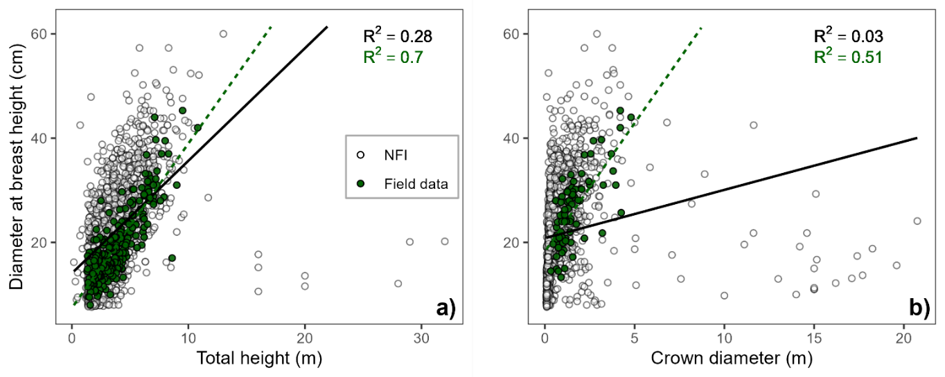
Fig. S1 Scatter plots and coefficients of determination from linear regressions between diameter at breast height (DBH) and height (H) a), and between DBH and crown diameter (CD) b), for Pachycereus spp. individuals measured in the NFI (unfilled circles and black line) and in the field plots from this study (green circles and dashed line). Note the scatter of NFI values compared to field-sampled plots

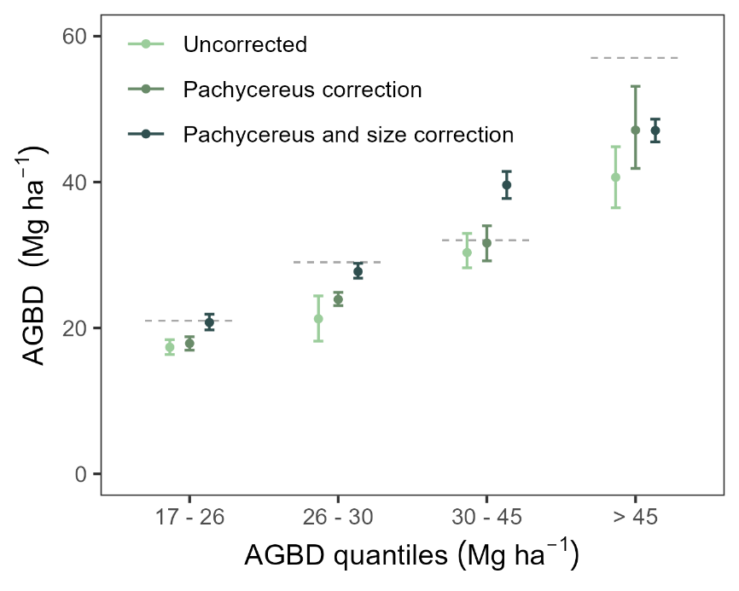
Fig. S2 Comparison of the mean AGBD estimated from NFI data at the state level (Baja California Sur) without correction, with the correction for Pachycereus, and with the correction for Pachycereus and size in xeric shrubland. The mean and 95% confidence interval of the quartiles are compared with the reference value obtained from our sampled plots in the Cape Region (dotted line)

