APPENDIX
Table 5: Injury Rates
Greenway | Accident Count | Injury Count | Injury Rate
Cumberland River Greenway | 43 | 39 | 0.906977
Cumberland River Greenway | 39 | 34 | 0.871795
Gulch Greenway | 31 | 31 | 1
Cumberland River Greenway | 13 | 14 | 1.076923
Seven Mile Creek Greenway | 9 | 8 | 0.888889
Cumberland River Greenway | 5 | 5 | 1
Gulch Greenway | 5 | 5 | 1
Seven Mile Creek Greenway | 5 | 6 | 1.2
Mill Creek Greenway | 4 | 4 | 1
Cumberland River Greenway | 3 | 3 | 1
Cumberland River Greenway | 3 | 3 | 1
440 Greenway | 3 | 3 | 1
Cumberland River Greenway | 3 | 3 | 1
Gulch Greenway | 2 | 2 | 1
Cumberland River Greenway | 2 | 3 | 1.5
Stones River Greenway | 2 | 2 | 1
Cumberland River Greenway | 1 | 4 | 4
Richland Creek Greenway | 1 | 1 | 1
Browns Creek Greenway | 1 | 1 | 1
Mill Creek Greenway | 1 | 0 | 0
Seven Mile Creek Greenway | 1 | 1 | 1
Mill Creek Greenway | 1 | 1 | 1
Mill Creek Greenway | 1 | 1 | 1
Richland Creek Greenway | 1 | 1 | 1
Richland Creek Greenway | 1 | 1 | 1
Cumberland River Greenway | 1 | 1 | 1
Gulch Greenway | 1 | 1 | 1
Mill Creek Greenway | 1 | 1 | 1
Cumberland River Greenway | 1 | 4 | 4
Mill Creek Greenway | 1 | 0 | 0
Richland Creek Greenway | 1 | 1 | 1
 | 187 | 184 | 0.983957
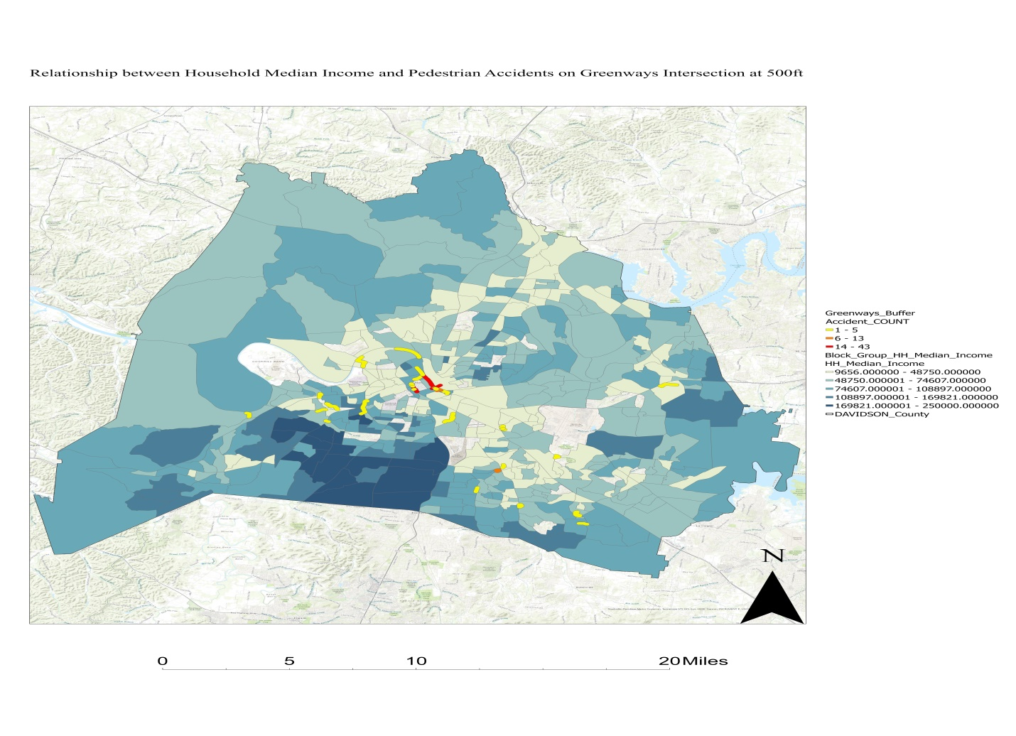
Figure 9: Accident count Income Overlay Analysis

Table 6: Accident Count, injury, fatality and time of the day
Time | Accident Count | Injury | Fatality
0:00-0:59 | 10 | 8 | 0
1:00-1:59 | 21 | 15 | 2
2:00-2:59 | 13 | 11 | 0
3:00-3:59 | 20 | 18 | 2
4:00-4:59 | 4 | 5 | 0
5:00-5:59 | 14 | 18 | 2
6:00-6:59 | 9 | 9 | 0
7:00-7:59 | 7 | 7 | 0
8:00-8:59 | 4 | 4 | 0
9:00-9:59 | 2 | 2 | 0
10:00-10:59 | 3 | 3 | 0
11:00-11:59 | 3 | 3 | 0
12:00-12:59 | 0 | 0 | 0
13:00-13:59 | 4 | 4 | 0
14:00-14:59 | 4 | 5 | 0
15:00-15:59 | 13 | 14 | 0
16:00-16:59 | 1 | 1 | 0
17:00-17:59 | 3 | 3 | 0
18:00-18:59 | 5 | 6 | 0
19:00-19:59 | 7 | 7 | 0
20:00-20:59 | 8 | 8 | 0
21:00-21:59 | 12 | 10 | 0
22:00-22:59 | 11 | 11 | 0
23:00-23:59 | 9 | 9 | 0

Table 7: Research Data Base
Greenway | YearBuilt | HH_Median_Income_Max | Log_HH_Median_Income_Max | SUM_AADT | Greenway_Length_Category
Mill Creek Greenway | 2013 | 48750 | 10.79446 | 156482 | Other
Gulch Greenway | 2015 | 94620 | 11.45762 | 33622 | Short
Cumberland River Greenway | 2008 | 87616 | 11.38072 | 217752 | Short
Gulch Greenway | 2019 | 98621 | 11.49904 | 120895 | Short
Cumberland River Greenway | 2015 | 93019 | 11.44056 | 68217 | Short
Richland Creek Greenway | 2006 | 68681 | 11.13723 | 53572 | Short
Seven Mile Creek Greenway | 2013 | 58333 | 10.97392 | 74584 | Short
Gulch Greenway | 2019 | 34444 | 10.44709 | 42506 | Short
Seven Mile Creek Greenway | 2008 | 52750 | 10.87332 | 108525 | Short
Mill Creek Greenway | 2002 | 83568 | 11.33342 | 24976 | Short
Mill Creek Greenway | 2001 | 47734 | 10.7734 | 95871 | Medium
Richland Creek Greenway | 2014 | 86914 | 11.37267 | 130554 | Medium
Seven Mile Creek Greenway | 2008 | 57039 | 10.95149 | 43014 | Medium
Mill Creek Greenway | 2013 | 48750 | 10.79446 | 469446 | Medium
Mill Creek Greenway | 0 | 94289 | 11.45412 | 120895 | Medium
Cumberland River Greenway | 2005 | 80313 | 11.29369 | 120895 | Medium
Cumberland River Greenway | 2015 | 93019 | 11.44056 | 168938 | Medium
Richland Creek Greenway | 2010 | 57039 | 10.95149 | 120895 | Medium
Cumberland River Greenway | 2001 | 93019 | 11.44056 | 150340 | Medium
Mill Creek Greenway | 2015 | 89781 | 11.40513 | 120895 | Medium
Gulch Greenway | 2010 | 98621 | 11.49904 | 105914 | Medium
Cumberland River Greenway | 2013 | 93019 | 11.44056 | 51798 | Medium
Cumberland River Greenway | 2001 | 98621 | 11.49904 | 82027 | Medium
Cumberland River Greenway | 2008 | 98621 | 11.49904 | 93768 | Medium
Richland Creek Greenway | 2008 | 85981 | 11.36188 | 18169 | Medium
Stones River Greenway | 2000 | 87222 | 11.37621 | 161567 | Long
Browns Creek Greenway | 2019 | 68125 | 11.1291 | 68544 | Long
Cumberland River Greenway | 2012 | 46875 | 10.75524 | 78423 | Long
440 Greenway | 2018 | 94500 | 11.45636 | 278978 | Long
Cumberland River Greenway | 2001 | 98621 | 11.49904 | 256806 | Long
Cumberland River Greenway | 2004 | 87616 | 11.38072 | 108876 | Other

SUM_AADT | Mean_AADT_31_6_26 | Log_AADT | MIN_SPD_LMT | MAX_SPD_LMT | MEAN_SPD_LMT
156482 | 120895 | 11.9607 | 0 | 55 | 6.875
33622 | 120895 | 10.42294 | 0 | 35 | 20
217752 | 120895 | 12.29111 | 30 | 55 | 45
120895 | 120895 | 11.70268 | 0 | 30 | 6
68217 | 120895 | 11.13045 | 0 | 30 | 26.66667
53572 | 120895 | 10.88878 | 0 | 40 | 26.66667
74584 | 120895 | 11.21968 | 0 | 40 | 30
42506 | 120895 | 10.6574 | 0 | 30 | 8.571429
108525 | 120895 | 11.59474 | 0 | 40 | 18
24976 | 120895 | 10.12567 | 0 | 45 | 21.66667
95871 | 120895 | 11.47076 | 0 | 45 | 28.75
130554 | 120895 | 11.77954 | 0 | 55 | 23.4
43014 | 120895 | 10.66928 | 0 | 40 | 29
469446 | 120895 | 13.05931 | 0 | 55 | 11.95652
120895 | 120895 | 11.70268 | 0 | 40 | 11.66667
120895 | 120895 | 11.70268 | 45 | 45 | 45
168938 | 120895 | 12.03729 | 0 | 40 | 26.33333
120895 | 120895 | 11.70268 | 0 | 30 | 15
150340 | 120895 | 11.92065 | 0 | 40 | 20.35714
120895 | 120895 | 11.70268 | 0 | 30 | 8
105914 | 120895 | 11.57038 | 0 | 35 | 14.81482
51798 | 120895 | 10.85511 | 0 | 40 | 23
82027 | 120895 | 11.3148 | 0 | 35 | 13.06452
93768 | 120895 | 11.44858 | 0 | 35 | 19.44444
18169 | 120895 | 9.807472 | 0 | 35 | 16.45833
161567 | 120895 | 11.99267 | 0 | 70 | 47.14286
68544 | 120895 | 11.13523 | 0 | 40 | 25.66667
78423 | 120895 | 11.26987 | 0 | 40 | 18.46154
278978 | 120895 | 12.53889 | 0 | 55 | 18.29268
256806 | 120895 | 12.45608 | 0 | 40 | 14.41667
108876 | 120895 | 11.59797 | 30 | 55 | 42.5

MEDIAN_SPD_LMT | SUM_Total_Popu | GW_Buffer_Length(mi) | GW_Bu_Area (SqMi) | Pedes_Proxy_Volume | Accident_COUNT
0 | 11999 | 0.661091 | 181.7522 | 66 | 1
30 | 2915 | 0.679511 | 190.9536 | 15 | 2
55 | 10470 | 0.692294 | 199.8688 | 52 | 1
0 | 6957 | 0.699044 | 200.761 | 35 | 1
30 | 21404 | 0.78647 | 254.5576 | 84 | 5
40 | 3496 | 0.867689 | 287.1027 | 12 | 1
35 | 7422 | 0.9505 | 373.7585 | 20 | 9
0 | 10342 | 0.969939 | 345.9712 | 30 | 5
15 | 6754 | 1.050473 | 382.2924 | 18 | 5
20 | 7378 | 1.063614 | 448.9828 | 16 | 4
40 | 10248 | 1.102849 | 427.4637 | 24 | 1
30 | 9286 | 1.188996 | 469.5548 | 20 | 1
35 | 10790 | 1.18931 | 446.2572 | 24 | 1
0 | 23710 | 1.250927 | 529.8138 | 45 | 1
0 | 26766 | 1.274458 | 490.2071 | 55 | 1
45 | 3759 | 1.302753 | 509.1072 | 7 | 1
30 | 27553 | 1.338662 | 559.6638 | 49 | 13
15 | 18015 | 1.346576 | 527.6103 | 34 | 1
30 | 25150 | 1.408735 | 555.5989 | 45 | 39
0 | 12321 | 1.432034 | 681.6318 | 18 | 1
0 | 12385 | 1.499755 | 615.1661 | 20 | 31
35 | 12187 | 1.550124 | 642.3686 | 19 | 2
15 | 11929 | 1.556691 | 640.7233 | 19 | 3
30 | 13647 | 1.752386 | 728.3338 | 19 | 3
30 | 16207 | 1.958184 | 884.4751 | 18 | 1
40 | 5906 | 2.052209 | 897.4948 | 7 | 2
35 | 2438 | 2.288596 | 1065.068 | 2 | 1
0 | 14949 | 2.438187 | 1111.626 | 13 | 3
0 | 12774 | 2.799309 | 1279.882 | 10 | 3
0 | 25076 | 2.84127 | 1294.947 | 19 | 43
42.5 | 14013 | 2.933558 | 1327.483 | 11 | 1

Log_Acciddent_Count | SUM_Number_of_Injuries | SUM_Number_of_Fatalities | Log_Mean_SPD_Limit | Log_Proxy_Ped_Volume | Log_GW_Length
0 | 0 | 2 | 1.927892 | 4.189655 | -0.413865
0.693147 | 2 | 0 | 2.995732 | 2.70805 | -0.386382
0 | 4 | 1 | 3.806663 | 3.951244 | -0.367744
0 | 1 | 0 | 1.791759 | 3.555348 | -0.358041
1.609438 | 5 | 0 | 3.283414 | 4.430817 | -0.240201
0 | 1 | 0 | 3.283414 | 2.484907 | -0.141922
2.197225 | 8 | 1 | 3.401197 | 2.995732 | -0.050767
1.609438 | 5 | 0 | 2.148434 | 3.401197 | -0.030522
1.609438 | 6 | 0 | 2.890372 | 2.890372 | 0.04924
1.386294 | 4 | 0 | 3.075775 | 2.772589 | 0.061673
0 | 1 | 0 | 3.358638 | 3.178054 | 0.097897
0 | 1 | 0 | 3.152736 | 2.995732 | 0.173109
0 | 1 | 0 | 3.367296 | 3.178054 | 0.173373
0 | 0 | 2 | 2.481277 | 3.806663 | 0.223885
0 | 1 | 0 | 2.456736 | 4.007333 | 0.242521
0 | 1 | 0 | 3.806663 | 1.94591 | 0.264479
2.564949 | 14 | 0 | 3.270836 | 3.89182 | 0.291671
0 | 1 | 0 | 2.70805 | 3.526361 | 0.297565
3.663562 | 34 | 0 | 3.013432 | 3.806663 | 0.342692
0 | 1 | 0 | 2.079442 | 2.890372 | 0.359096
3.433987 | 31 | 2 | 2.695628 | 2.995732 | 0.405301
0.693147 | 3 | 0 | 3.135494 | 2.944439 | 0.438335
1.098612 | 3 | 0 | 2.5699 | 2.944439 | 0.442562
1.098612 | 3 | 0 | 2.967561 | 2.944439 | 0.560978
0 | 1 | 0 | 2.800832 | 2.890372 | 0.672017
0.693147 | 2 | 0 | 3.853183 | 1.94591 | 0.718917
0 | 1 | 0 | 3.245193 | 0.693147 | 0.827939
1.098612 | 3 | 0 | 2.915689 | 2.564949 | 0.891255
1.098612 | 3 | 0 | 2.906501 | 2.302585 | 1.029373
3.7612 | 39 | 0 | 2.668385 | 2.944439 | 1.044251
0 | 4 | 1 | 3.749504 | 2.397895 | 1.076216

