BGC-Argo float reveals regime shifts in nitrogen-carbon cycling in an oxygen-deficient zone

Mariana Bif¹, Colette Kelly², Mark Altabet³, Annie Bourbonnais⁴, Claire Elbon⁵, Edgart Flores⁶, Alanna Mnich³, Josh Plant⁷, Kenneth S. Johnson⁷

¹University of Miami, Rosenstiel School of Marine, Atmospheric and Earth Sciences (RSMAES), Miami FL
²Woods Hole Oceanographic Institution, Woods Hole, MA
³University of Massachusetts Dartmouth School for Marine Science and Technology, New Bedford, MA
⁴School of the Earth, Ocean and Environment, University of South Carolina, Columbia, SC
⁵School of Earth and Atmospheric Sciences, Georgia Institute of Technology, Atlanta, GA
⁶Department of Geological Sciences and Institute of Arctic and Alpine Research (INSTAAR) at the UC Boulder
⁷Monterey Bay Aquarium Research Institute (MBARI), Moss Landing CA

Extended Data

Figure S1. Oxygen anomalies in suboxic waters of the ETNP. Time series of oxygen anomalies relative to the mean O₂ concentration where O₂ < 1 µmol kg⁻¹. The apparent temporal pattern in the anoxic layer reflects a known optode offset drift artifact at very low O₂.
Figure S2. Snapshots of monthly sea surface chlorophyll-a levels for the year 2022. The black circle symbolizes the approximate location of the BGC-Argo float in that month. Notice that July was the month when we started observing the most productive period of the time series, spanning from 07/30/2022 to 10/11/2022.

Figure S3. Snapshots of monthly sea surface chlorophyll-a levels for the year 2023. The black circle symbolizes the approximate location of the BGC-Argo float that month.

Figure S4. Snapshots of monthly sea surface chlorophyll-a levels for the year 2024. The black circle symbolizes the approximate location of the BGC-Argo float that month.
Figure S5. TS diagrams for the Eastern Tropical North Pacific. Water masses are shown for the upper 2000 m depth during (a) low-nitrite (stations 30-97, between 11/11/2022 and 01/10/2024) and (b) high-nitrite (stations 1-29, between 01/15/2022 and 11/01/2022) conditions. Z-axes are colored by NO₂⁻ concentrations (µmol kg⁻¹).

Figure S6. Modeled nitrogen transformation rates under three different conditions in the ETNP ODZ. Different shades of blue denote the fractional contributions of DNRN, anammox, denitrification, nitrite oxidation, and CaCO₃ dissolution to changes in DIC during the high-nitrite regime (January-November 2022, light blue), high POC episode (July 2022 and October 2022, medium blue) and low nitrite regime (November 2022-October 2024, dark blue). Black stars indicate one standard deviation from Monte Carlo uncertainty propagation. The dashed vertical line denotes the approximate boundary depth of the upper ODZ, when O₂ < 1 µmol kg⁻¹.

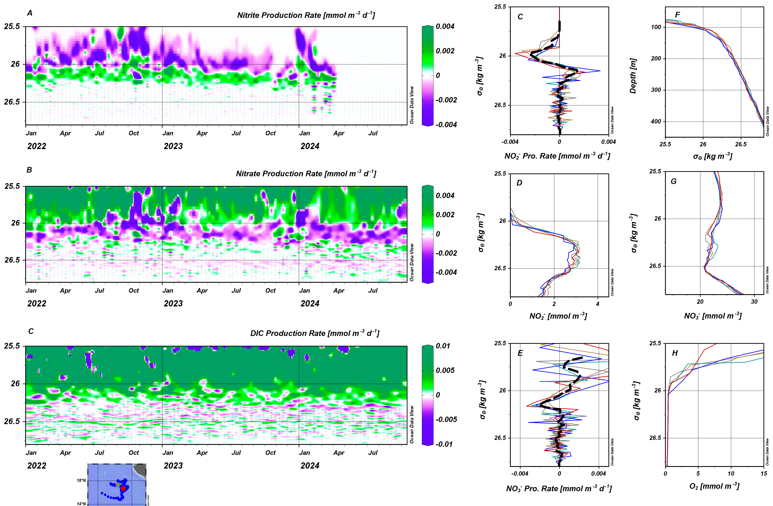
Figure S7. Modeled production rates. (a) Rate of nitrite production, (b) rate of nitrate production, (c) rate of DIC production determined from equation 5 versus density anomaly sigma theta and time. (c) Nitrite production rates on 5 individual profiles (48 to 52) in May and June of 2023 versus density anomaly. (d) The 5 nitrite profiles shown in (c) versus density anomaly. (e) Nitrate production rates as in panel (c). (f) Density aomaly profiles in panel (c) versus depth. (g) Nitrate profiles as in panel (d). (h) Oxygen profiles as in panel (d).

Table S1: Stoichiometries for each of the five key reactions included in the model, based on an organic matter stoichiometry of C_{113.1}H_{a}O_{b}N_{11.23}P. We solve for the stoichiometry of each reaction based on the stoichiometry of the organic matter being respired, following Cinay et al. (2022).
Process | Reaction
DNRN | $$OM+182.66{NO}_{3}^{-}+11.23H^{+}→113.1{CO}_{2}+11.23{NH}_{4}^{+}+H_{3}{PO}_{4}+182.66{NO}_{2}^{-}+yH_{2}O$$
Denitrification | $$OM+121.77{NO}_{2}^{-}+133.0H^{+}→113.1{CO}_{2}+11.23{NH}_{4}^{+}+H_{3}{PO}_{4}+60.89N_{2}+wH_{2}O$$
Anammox | $${NH}_{4}^{+}+1.32{NO}_{2}^{-}+0.11{CO}_{2}+0.02H^{+}→N_{2}+0.11{OM}^{amx}+1.90H_{2}O+0.3{NO}_{3}^{-}$$
NO₂⁻ Oxidation | $${NO}_{2}^{-}+oxidant→{NO}_{3}^{-}+reductant$$
CaCO₃ Dissolution | $$Ca{CO}_{3}→{Ca}^{2+}+{CO}_{3}^{2-}$$

Table S2: Cycling regimes and associated stations and dates. The data are broken down into three key biogeochemical regimes and eight density layers (see Figure S5), within which the importance of different nitrogen cycle reactions is assumed to be constant.
Cycling Regime | Stations | Dates
Low POC, high NO₂⁻ | 1-19, 28-29 | 1/15/22-7/20/22, 10/21/22-11/1/22
High POC | 20-27 | 7/30/22-10/11/22
Low POC, low NO₂⁻ | 30-71 | 11/11/22-1/10/24

Table S3: Theoretical Δtracer/ΔDIC for each of the five key reactions included in the model.
Tracer | DNRN | Denitrification | Anammox | NO₂⁻ Oxidation | CaCO₃ Dissolution
ΔNO₃⁻/ΔDIC | -1.62 | 0.00 | 2.91 | 46.30 | 0.00
ΔNO₂⁻/ΔDIC | 1.62 | -1.08 | -1.20 | -46.30 | 0.00
ΔN*/ΔDIC | 0.10 | 0.10 | -9.09 | 0.00 | 0.00
ΔTA/ΔDIC | 0.09 | 1.17 | 0.18 | 0.00 | 2.00
ΔDIC/ΔDIC | 1.00 | 1.00 | -1.00 | -1.00 | 1.00

