Supplementary Information
Table S1 List of the reference sequences from GenBank used in insect and symbiont analyses. GenBank accession numbers for mitochondrial host (partial 16S rRNA and COI-tRNA-COII region) and symbiont (16s rRNA) gene sequences and corresponding references.

Taxon  Insect |  | GenBank accession no |  | Reference
Taxon  Insect | haplotype | COI-tRNA-COII | 16S rRNA | Reference
Trupanea denotata |  | KM079225 | KM079202 | Viale et al., 2015
Trupanea swezey | a  b | KM079236  KM079235 | KM079215  KM079214 | Viale et al., 2015
Phaeogramma sp. |  | KM079217 | KM079194 | Viale et al., 2015
Phaeogramma vittipennis |  | KM079218 | KM079195 | Viale et al., 2015
Trupanea crassipes | a  b | KM079222  KM079223 | KM079199  KM079200 | Viale et al., 2015
Trupanea artemisiae |  | KM079221 | KM079197 | Viale et al., 2015
Trupanea arboreae |  | KM079219 | KM079196 | Viale et al., 2015
Trupanea cratericola |  | KM079224 | KM079201 | Viale et al., 2015
Trupanea beardsleyi |  | KM079238 | KM079198 | Viale et al., 2015
Trupanea dubautiae | a  b  c | KM079226  KM079227  KM079228 | KM079204  KM079205  KM079206 | Viale et al., 2015
Trupanea joycey | a  b  c | KM079229  KM079230  KM079231 | KM079207  KM079208  KM079209 | Viale et al., 2015
Trupanea sp. waikamoi |  | KM079237 | KM079216 | Viale et al., 2015
Trupanea perkinsi |  | KM079233 | KM079212 | Viale et al., 2015
Trupanea pantosticta |  | KM079232 | KM079210 | Viale et al., 2015
Trupanea sp. pohakuloa |  | KM079234 | KM079213 | Viale et al., 2015
Trupanea stellata |  | GQ175797 | GQ175862 | Mazzon et al., 2010
Tephritis arnicae |  | GQ175793 | GQ175830 | Mazzon et al., 2010
Trupanea amoena |  | GQ175796 | GQ175833 | Mazzon et al., 2010
Achanthiophilus helianthi |  | GQ175795 | GQ175832 | Mazzon et al., 2010
Capitites ramulosa |  | GQ175803 | GQ175840 | Mazzon et al., 2010
Tephritis divisa |  | GQ175790 | GQ175827 | Mazzon et al., 2010
Tephritis matricariae |  | GQ175791 | GQ175828 | Mazzon et al., 2010
Tephritis cometa |  | GQ175792 | GQ175829 | Mazzon et al., 2010
Tephritis bardaneae |  | GQ175794 | GQ175831 | Mazzon et al., 2010
Oxyna flavipennis |  | GQ175798 | GQ175835 | Mazzon et al., 2010
Campiglossa guttella |  | GQ175801 | GQ175838 | Mazzon et al., 2010
Campiglossa doronici |  | GQ175802 | GQ175839 | Mazzon et al., 2010
Campiglossa (=Dioxyna) bidentis |  | GQ175800 | GQ175837 | Mazzon et al., 2010
Sphenella marginata |  | GQ175799 | GQ175836 | Mazzon et al., 2010
Bactrocera oleae |  | GQ175825 | GQ175862 | Mazzon et al., 2010
Symbiotic bacteria |  | 16S rRNA
Stammerula sp. of T. artemisiae |  | KM079242 |  | Viale et al., 2015
Stammerula sp. of T. perkinsi |  | KM079255 |  | Viale et al., 2015
Stammerula sp. of T. joycey |  | KM079251; KM079252; KM079250 |  | Viale et al., 2015
Stammerula sp. of T. pantosticta |  | KM079253; KM079254 |  | Viale et al., 2015
Stammerula sp. of T. pohakuloa |  | KM079256 |  | Viale et al., 2015
Stammerula sp. of T. waikamoi |  | KM079259 |  | Viale et al., 2015
Stammerula sp. of Phaenogramma “sp. nov.” |  | KM079239 |  | Viale et al., 2015
Stammerula sp. of P. vittipennis |  | KM079240 |  | Viale et al., 2015
Stammerula sp. of T. dubautiae |  | KM079248; KM079247; KM079249 |  | Viale et al., 2015
Stammerula sp. of T. arboreae |  | KM079241 |  | Viale et al., 2015
Stammerula sp. of T. cratericola |  | KM079245 |  | Viale et al., 2015
Stammerula sp. of T. beardsleyi |  | KM079243 |  | Viale et al., 2015
Stammerula sp. of T. crassipes |  | KM079244 |  | Viale et al., 2015
Stammerula sp. of T. denotata |  | KM079246 |  | Viale et al., 2015
Stammerula sp. of T. swezeyi |  | KM079257; KM079258 |  | Viale et al., 2015
Stammerula sp. of T. amoena |  | EF469626 |  | Mazzon et al., 2008
Stammerula sp. of T. stellata |  | EF469627 |  | Mazzon et al., 2008
Stammerula sp. of C. ramulosa |  | EF469628 |  | Mazzon et al., 2008
Stammerula sp. of A. helianthi |  | EF469625 |  | Mazzon et al., 2008
Stammerula sp. of S. marginata |  | EF469629 |  | Mazzon et al., 2008
Stammerula tephritidis of T. bardanae |  | EF469617 |  | Mazzon et al., 2008
Stammerula tephritidis of T. arnicae |  | EF469616 |  | Mazzon et al., 2008
Stammerula tephritidis of T. cometa |  | EF469615 |  | Mazzon et al., 2008
Stammerula tephritidis of T. divisa |  | EF469619 |  | Mazzon et al., 2008
Stammerula tephritidis of T. matricariae |  | EF469623 |  | Mazzon et al., 2008
Stammerula sp. of Oxyna flavipennis |  | EF469630 |  | Mazzon et al., 2008
Stammerula sp. of Campiglossa doronici |  | EF469636 |  | Mazzon et al., 2008
Erwinia persicina |  | AM184098 |  | Randazzo et al., 2009
Symb. of Campiglossa guttella |  | EF469637 |  | Mazzon et al., 2008
Erwinia dacicola of Bactrocera oleae |  | AJ586620 |  | Capuzzo et al., 2005
Symb. of Dioxyna bidentis |  | EF469631 |  | Mazzon et al., 2008
Symb. of Noeeta pupillata | A  C | EF469633  EF469635 |  | Mazzon et al., 2008
Symb. of Noeeta bisetosa |  | EF469632 |  | Mazzon et al., 2008
Klebsiella oxytocina |  | DQ444288 |  | Hao et al., 2008

Fig. S1 Phylogenetic placement of Tephritini (in bold) from Australia and several Tephritini species from Europe and Hawaii obtained by Maximum Likelihood (ML) analyses of the concatenated mitochondrial data set (partial 16S rRNA gene and COI-tRNA-COII region).

Fig. S2 A plot showing that the total cost of events is significantly different compared with the distribution of costs in hosts-associated symbionts (Setting 2).

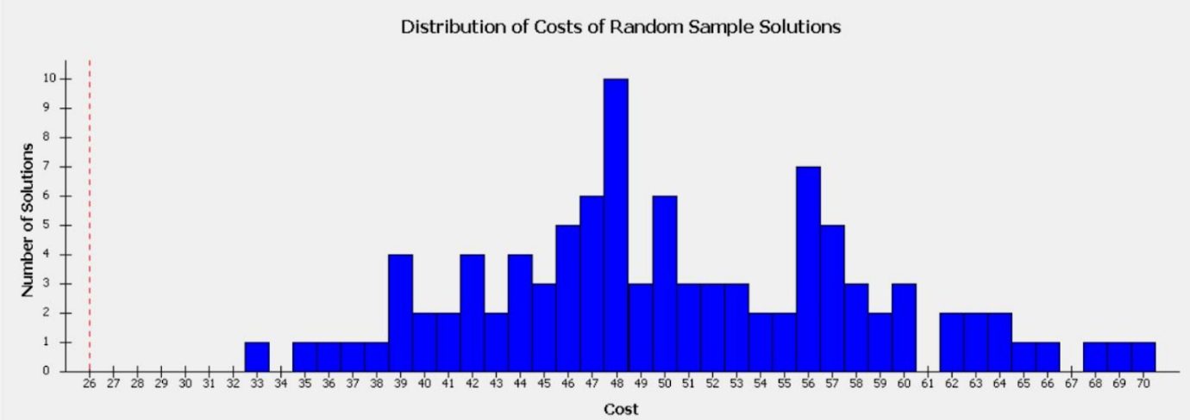

Fig. S3 Cophylogeny of tephritini and bacterial symbionts from Jane at the species level. Blue and black lines indicate the phylogenies of symbionts and host flies, respectively. Arrows indicate host switch events; hollow red circles indicate cospeciation events; solid yellow circles indicate duplications. A) Settings 1; B) Settings 2.

A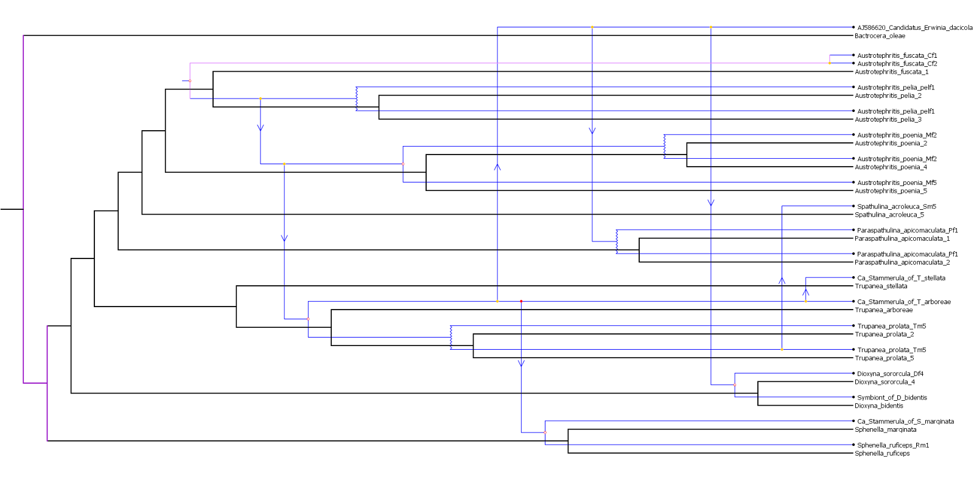
B