Supplementary Materials for
Long term nitrogen burial exceeds denitrification in global fjords
Henry L.S. Cheung¹, Lubrina S. Levin², Craig Smeaton³, Tobia Politi¹, Bo Thamdrup², Isaac R. Santos¹, Stefano Bonaglia¹
Corresponding author: lok.shan.cheung@gu.se
The document includes:
- Methods.
- Figure S1 Spatial distributions of nitrogen accumulation rates (N_{AR}).
- Figure S2 Rates of nitrogen cycling processes in global fjords.
- Figure S3 Potential changes in fjord N₂ production as a function of oxygen concentrations.
- Figure S4 Sediment nitrate reduction rates measured in the centre of Gullmar Fjord during oxic and hypoxic season.
- Figure S5 Location of sampling sites in Sweden and Iceland.
- Figure S6 Result of spatial weighting of each measurement in the database.
- Figure S7 Summary of empirical observations and spatial weighting bootstrapped means.
- Table S1 Summary of global fjord nitrogen burial estimates.
- Table S2 Summary of sampling site in Sweden and Iceland.
- Supplementary References.

Methods
Studied sites
New datasets of fjord nitrogen (N) loss via sediment burial and microbial N₂ production were collected in five fjords in Sweden and Iceland (Fig. S5). Gullmar, Hake, and By Fjords are temperate systems (57–59˚N) located at west coast of Sweden, with length of 28, 22, and 4 km, respectively. Bottom water of By, Gullmar, and Hake Fjords are long-term anoxic, seasonally hypoxic, and oxic conditions, respectively. Bottom waters of Gullmar Fjord are renewed annually, yet low oxygen (O₂) concentrations can be developed when deep-water exchanges is absent or only partially occur ¹. Water column below sill depth (~20 m) in By Fjord is characterised by long-term euxinic condition. The water column is mixed vertically every 3–5 years, while O₂ depleted within weeks to months by significant biological consumptions ². Gullmar Fjord has been designated as a conservation area with temperate forests, where minimal anthropogenic inputs have been influencing the fjord since past decades ³. In contrast, catchment of By and Hake Fjord are covered by agriculture and developed areas. Reyðarfjörður and Berufjörður, are sub-polar systems located at the east coast of Iceland (64–65˚N). These fjords are 20–30 km long with 60–170 m water depth. Small river inputs from the heads of both fjords regarding the drainage basins <160 km². Vegetation cover is sparse (25–45%) and is dominated by shrubs, grasses, and mosses ⁴. Aquaculture has been established in both fjords, where higher organic matter contents and labilities were found in waters adjacent to sea cages ⁵. Water columns were well-mixed and oxygenated in these fjords during our sampling, while hypoxic conditions (O₂ concentration < 60 µM) have been recorded near the head of Berufjörður in summer ⁶.
Sampling procedures
In Swedish fjords, samples for mass accumulation rates and sediment nitrogen analyses were collected from nine locations within the three fjords in September–October 2021. Measured rates and details of the sampling were described in previous publication ⁷. To determine N₂ production in the three Swedish fjords, incubation experiments were conducted during sampling campaigns in 2023 and 2024. Prior to sediment sampling, CTD casts with a Sea-Bird SBE 911 were made to record bottom water column temperature, dissolved O₂, and salinity. Approximately 70 L of bottom waters were also collected for later incubation experiments. In Gullmar and Hake Fjord, sediments were collected from the seafloor using a box corer. Intact cores (inner diameter = 4.6 cm; length = 30 cm) were sub-sampled from undisturbed sediment in the corer, and were immediately submerged in situ bottom water at ambient temperature for later incubation experiments. In By Fjord, N₂ production rates were determine using water samples at oxic-anoxic interface at the centre station were collected in 2023 (see details below), given that bottom water was anoxic and highly sulfidic ⁸. For N₂ production at the head and mouth in By Fjord, benthic rates were obtained from a previous publication ⁹.
For Icelandic fjords, samples for mass accumulation rates, sediment stoichiometric analysis, and N₂ production measurements were collected in June 2023. Sediment cores and bottom waters were collected by the same sampling approached as in Swedish fjords. Larger intact cores (inner diameter = 5.6 cm; length = 44 cm) and smaller ones (inner diameter = 4.6 cm; length = 30 cm) were sub-sampled from the box corer for sediment analyses and incubation experiments, respectively. Larger cores were sliced at 1 cm intervals from 0-6 cm, 2 cm intervals from 6-20 cm, then a 5 cm interval from 20 – 25 cm immediately after sampling. Samples were stored in sealed LDPE containers at -20°C for later sediment analyses. Measured rates and sediment stoichiometric data were described in previous publication ¹⁰. Smaller cores were immediately submerged in situ bottom water at ambient temperature for later incubation experiments.
Sediment N₂ production processes rate measurement and calculation
Sediment N₂ production rates (denitrification and anammox) as well as dissimilatory nitrate reduction to ammonium rates (DNRA) were determined by intact sediment incubation using revised-isotope pairing technique ¹¹. Collected sediment cores in each station of Swedish and Icelandic fjords were transferred to incubation tanks situated in a temperature-controlled room at in situ bottom water temperature (Table S4). In situ bottom water in each incubation tanks were air-aerated (oxic stations) and well‐stirred. For hypoxic stations (i.e., Gullmar Fjord in October, 2024), O₂ concentrations of the water in the incubation tanks were maintained at in situ concentration by aerating N₂/Air mixture that adjusted with flowmeters. O₂ concentrations in the tanks were monitored by an optode probe (OXROB10, PyroScience). A temperature sensor (TDIP15, PyroScience) was placed into a water bath for real-time temperature compensation of optode measurements. Each core was supplied with a magnetic stirring bar (60 rpm) to maintain the water phase of each core well mixed.
After an overnight preincubation, sediment denitrification, anammox, and DNRA rates were measured by ¹⁵N-nitrate (¹⁵NO₃–) amendments. Briefly, sediment cores (n = 12) were spiked with ¹⁵NO₃⁻ tracer to obtain triplicate cores with mean final concentrations of 11, 24, 56, and 120 µM ¹⁵N. To calculate actual ¹⁵N enrichment in each core, water samples for the NO₃– concentration analysis were collected before and after the tracer addition, and analysed by spectrophotometric method ¹². Incubation started after a lag time of 1‒4 hrs to allow the spiked ¹⁵NO₃– to homogeneously mix with the endogenous ¹⁴NO₃– and diffused to the sediment nitrate reduction zone. Each core was then capped with airtight lids, and O₂ concentrations were recorded immediately via optode spots (OXSP5, PyroScience). Incubations were terminated by uncapping the core when O₂ had decreased by 20 – 25% of the initial concentrations, in order to ensure linear uptake of O₂ and solute exchange over incubation time (oxic: 12 – 24 hrs; hypoxic: 6 hrs). Top 6 cm of sediment of each core were gently mixed with overlying water to obtain a slurry. A 20 mL slurry aliquot was immediately transferred into a 12 mL exetainer (Labco) and fixed with 200 µL of 50% w/v ZnCl₂ for later ²⁹N₂ and ³⁰N₂ analyses. To determine the rate of DNRA, a sub-sample was collected from the slurry samples for ²⁹N₂ and ³⁰N₂ analyses for later ¹⁵NH₄⁺ analysis. Abundance of ²⁹N₂ and ³⁰N₂ of N₂ is determined directly through headspace analysis by gas chromatography-isotope ratio mass spectrometry (GC-IRMS), while ¹⁵NH₄⁺ can be first treated with hypobromite-iodine solution that oxidize NH₄⁺ to N₂ form, and the result content of ²⁹N₂ and ³⁰N₂ measured in GC-IRMS represent which originally from the ¹⁵NH₄⁺ in the sample.
Total N₂ production (p₁₄) was expressed as a function of r₁₄, the ratio between ¹⁴NO₃⁻ and ¹⁵NO₃⁻ in the sediment nitrate reduction zone:
$$p_{14}=2×r_{14}\left(p^{29}N_{2}+p^{30}N_{2}\left(1-r_{14}\right)\right)$$ | (1)
where p²⁹N₂ and p³⁰N₂ are the production rate of ²⁹N₂ and ³⁰N₂ from the incubation, which are calculated as the slopes of the significant (p < 0.05) linear regression of ²⁹N₂ and ³⁰N₂ concentration as a function of time. The value of r₁₄ is calculated from the p²⁹N₂ and p³⁰N₂ measured in two incubations with different ¹⁵NO₃– concentrations:
$${r_{14}}^{(a)}=\frac{{p^{29}N_{2}}^{(a)}-V×{p^{29}N_{2}}^{(b)}}{2×({p^{30}N_{2}}^{\left(a\right)}-V^{2}×{p^{30}N_{2}}^{(b)})}$$ | (2)
where p²⁹N₂^{(a)} and p³⁰N₂^{(a)} refer to the production rates of ²⁹N₂ and ³⁰N₂ in the incubation at lower ¹⁵NO₃– concentration, whereas p²⁹N₂^{(b)} and p³⁰N₂^{(b)} refer to the production rates of ²⁹N₂ and ³⁰N₂ in the incubation at higher ¹⁵NO₃– concentration. The parameter V, the ratio between concentrations of ¹⁵NO₃– in the water phase from two incubations with different ¹⁵NO₃– concentrations, is calculated by:
$$V=\frac{{p^{29}N_{2}}^{(a)}+2×{p^{30}N_{2}}^{(a)}}{{p^{29}N_{2}}^{(b)}+2×{p^{30}N_{2}}^{(b)}}$$ | (3)
Values of V and r₁₄ are calculated by matrix of values from 4 different ¹⁵NO₃⁻ amendments using Eqs. 2 and 3.
Anammox rate (A₁₄) was calculated according to the formula:
$$A_{14}=2×r_{14}(p^{29}N_{2}-2×r_{14}×p^{30}N_{2})$$ | (4)
while the ambient denitrification rate (D₁₄) is calculated by subtracting the anammox rate from p₁₄:
$$D_{14}=p_{14}-{aao}_{14}$$ | (5)
Rates of DNRA are calculated by multiplying the production rate of ¹⁵NH₄⁺ (p¹⁵NH₄⁺, i.e., the increase in ¹⁵NH₄⁺ concentrations versus time) by r₁₄.
Water column N₂ production rate measurement
Rates of water column total N₂ production were determined using ¹⁵N-labelled substrates. Experiments were conducted with water sampled near the oxic-anoxic interface (21, 22.5 and 24 m below surface) at the centre station of By Fjord following the procedures described previously ^{13, 14}. For a rate profile, a 2 L screw top bottle was filled directly from the Niskin bottle at each of three depths, overflowed at least three times the total volume, and immediately sealed bubble-free with a butyl rubber stopper. Collected samples were stored for 6 hours in the dark at in situ temperature (8 °C) until processed. To set up the experiment, water was removed from the bottle to allow He purging for 45 min. After purging, 1.6 mL of 100 mM He-purged NaS was added to the bottle to mimic the ambient sulphidic condition (38 µM final concentration) and transferred into 12 mL exetainers (LabCo) and capped with He-degassed caps, and headspaced with He to minimise O₂ contamination ^{15, 16}. To determine potential denitrification rates as accumulation of ³⁰N₂, samples received a 2 mL He headspace and amended to a finial concentration of 20.0 µM ¹⁵NO₃– in duplicate samples per time point (0, 3, 6, 9, and 12 hrs). To determine N loss kinetics, samples received a 2mL He headspace and amended to a finial concentration of 0.3, 0.7, 1.4, 3.6, 8.1, and 11.0 µM ¹⁵NO₃– in duplicate samples per time point (0.5, 2, 5, and 10 hrs). and left to incubate in the dark at in situ temperature. At each time point, incubation was terminated by adding 100 μL of 50% w/v ZnCl₂ solution to each exetainer. Final total NO₃– concentrations were analysed on an ion chromatograph on samples from the first time point of each treatment.
Water column microbial N loss rates were quantified from the combined production of ¹⁵N labelled N₂ and N₂O as determined by GC-IRMS (Dalsgaard et al. 2012). With the lower ¹⁵NO₃⁻ amendments used for determination of N loss kinetics, the NO₃⁻ pool was depleted by ≥ 50% during the incubation, and rates of N₂ + N₂O production decreased over time due to increasing substrate limitation. As limitation may even have affected the first time interval of the incubation at the lowest amendments, leading to an underestimation of initial rates, kinetic parameters were determined by fitting the incubation time, t, by which N₂ + N₂O had accumulated to a certain observed concentration, N_{loss}, to the time by which this N loss would occur assuming that the depletion of the substrate (NO₃⁻) from an initial concentration, N_{init}, was subject to Michaelis-Menten kinetics ¹⁷:
$$t= \left[N_{loss}+ K_{m}×ln\left(\frac{N_{init}}{N_{init}-N_{loss}}\right)\right]×{V_{max}}^{-1}$$ | (6)
where K_{m} and V_{max} are the parameters of the Michaelis-Menten equation:
$$Rate=\frac{V_{max}×[{{NO}_{3}}^{-}]}{K_{m}+[{{NO}_{3}}^{-}]}$$ | (7)
Thus, K_{m} and V_{max} were estimated by a single least-squares fit of Equation 6 across the whole range of ¹⁵NO₃⁻ amendments, yielding values of 0.58 µM h⁻¹ and 0.33 µM, respectively. Ambient microbial N loss rates were estimated using the Michaelis-Menten equation (7) with derived values K_{m} and in situ NO₃– concentrations, where potential denitrification rates were applied as V_{max} ¹⁸. The resulting volumetric rates were then converted into areal rates by multiplying with the depth of the denitrification zone, which was defined as the thickness of the anoxic NO₃– containing layers at the oxic-anoxic interface ¹⁴. The depth was identified when the O₂ sensor was pulled slowly upwards from the anoxic bottom waters to the oxygenated surface waters. Before the upcast, the O₂ sensor stayed at the anoxic bottom water for a period of 5 min to obtain signal for zero O₂. Water column profiles of NO₃– concentrations were measured on 6 discrete samples from the Niskin bottles at 1 m intervals near the oxic-anoxic interface. NO₃⁻ concentrations were analysed as described above.

Supplementary Figures
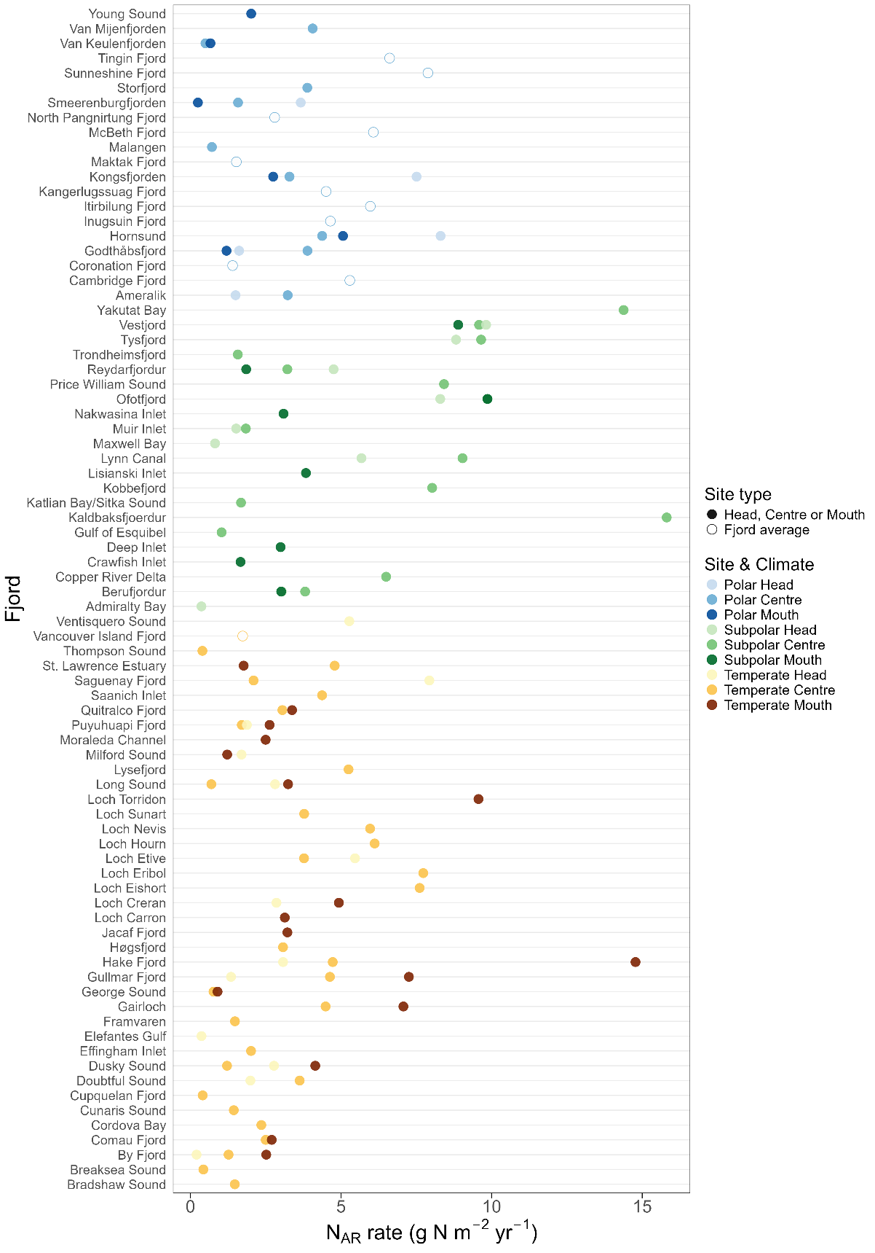
Figure S1 Spatial distributions of nitrogen accumulation rates (N_{AR}). Rates were determined from cores collected at the head, centre, and mouth of the corresponding fjords across climate regions (colour-coded). Solid dots indicate rates at head, centre, and mouth of the fjord, whilst circles indicate fjord average rates.
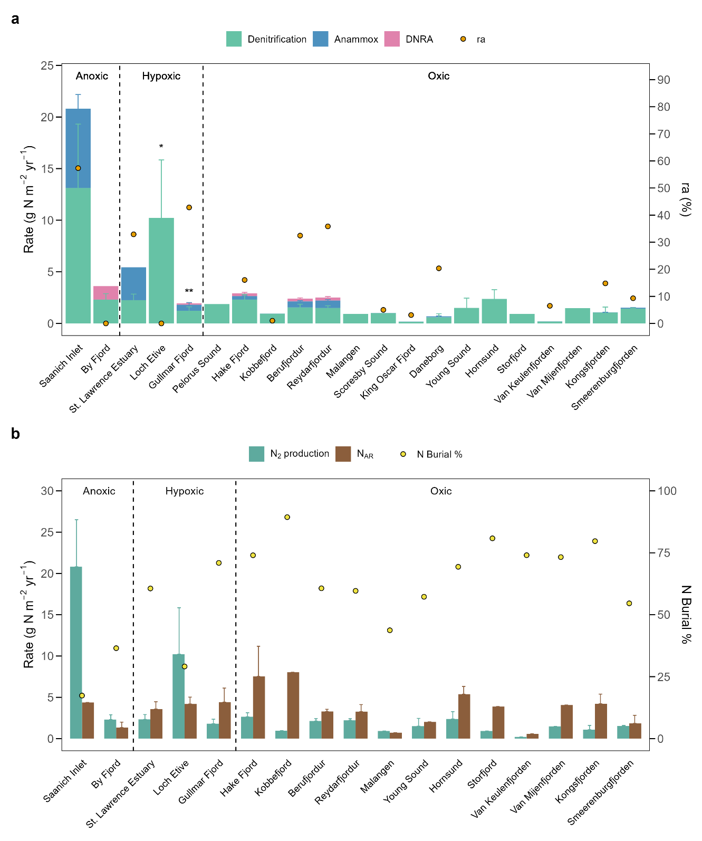
Figure S2 Rates of nitrogen cycling processes in global fjords. (a) Mean total N₂ production rates (denitrification and anammox) and dissimilatory nitrate reduction to ammonium rates (DNRA) measured by ¹⁵N-labelled experiments. Anammox contribution to total N₂ production (ra) were defined as the anammox rates relative to the total microbial N₂ production rate (denitrification + anammox). Rates in oxic and hypoxic fjords were determined from the sediments, while rates in anoxic fjords were determined from the nitrate-reduction zone along the water column. * denotes N₂ production rate measured under oxic condition in seasonal hypoxic Loch Etive, and ** denotes rates measured under both oxic and hypoxic condition in Gullmar Fjord. (b) Mean total N₂ production rate and sediment nitrogen accumulation rate (N_{AR}) in fjords where both processes were measured. Dots denote relative contribution of sediment to total N loss (N₂ production + N_{AR}). Vertical line divided fjords with anoxic (O₂ < 10 µM), hypoxic (O₂ 10 – 100 µM), and oxic (O₂ > 100 µM) fjords. Fjords are ranks with increasing latitude (from left to right) within each redox condition group. Error bars denote standard errors.
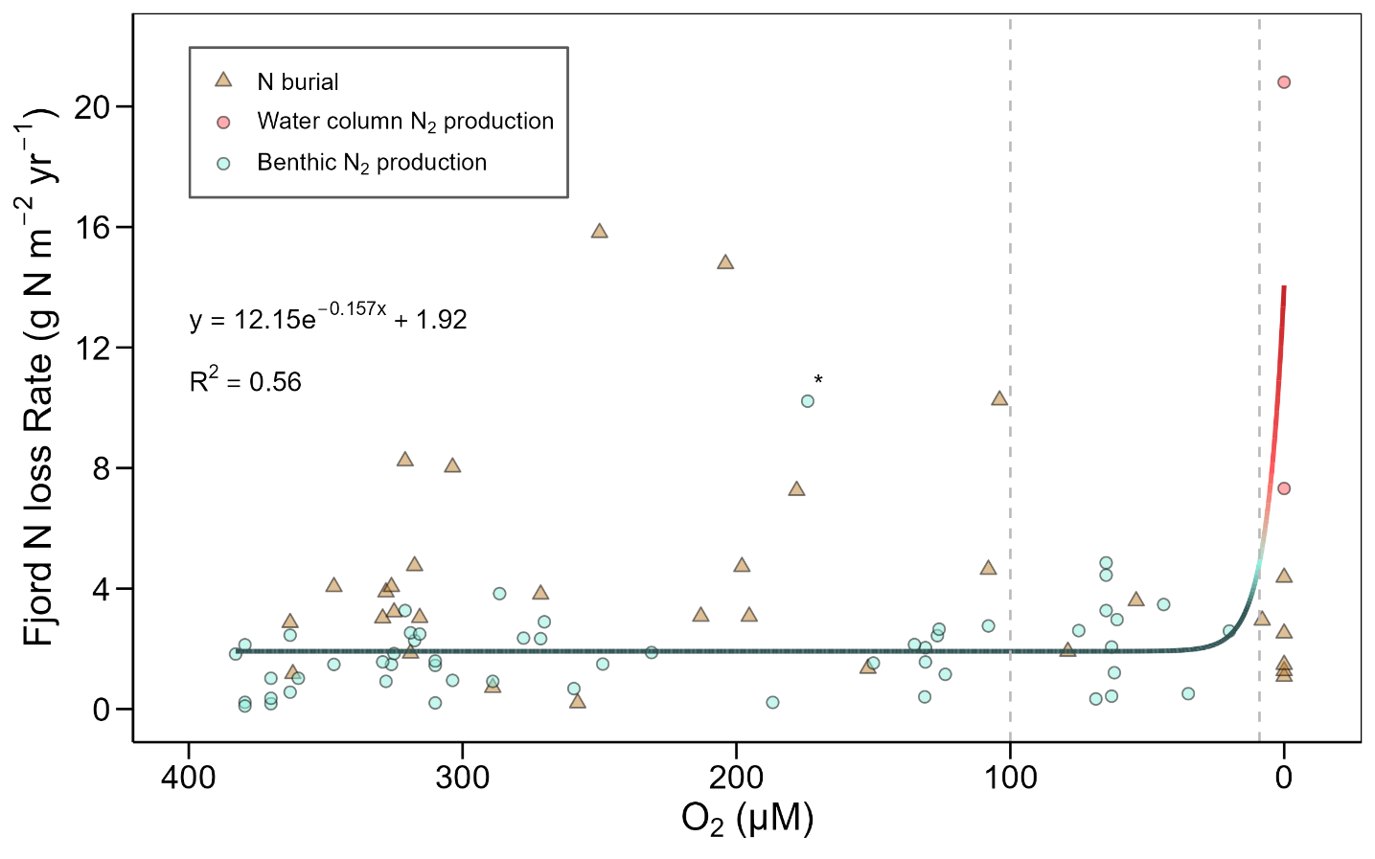
Figure S3 Potential changes in fjord N₂ production as a function of oxygen concentrations. Sediment and water column total N₂ production rates (denitrification + anammox) and N burial rates in global fjord are based on a compilation of measurements from the literatures and new data from Sweden and Iceland. An exponential model was fitted to develop a predive equation of N₂ production (N₂ production rate = 12.15 · e^{-0.157[O2]} + 1.92; R² = 0.56). Note that x-axis is in reverse scale. No significant trend was observed between N burial and O₂ concentrations. Asterisks denote a higher benthic N₂ production rate reported in Loch Etive under oxygenated condition, yet where known to experience periodic hypoxia ¹⁹.
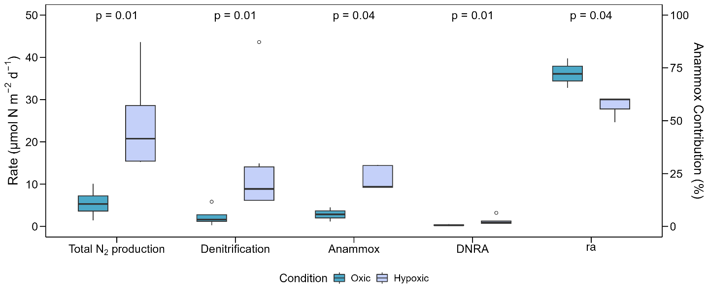
Figure S4 Sediment nitrate reduction rates measured in the centre of Gullmar Fjord during oxic and hypoxic season. Mean N₂ production rates (denitrification and anammox) and dissimilatory nitrate reduction to ammonium rates (DNRA) were measured by sediment core ¹⁵N-labelled experiments. Sediments were collected during oxic (April 2023) and hypoxic (October 2024) conditions that oxygen concentrations were 260 and 61 µM, respectively. Anammox contribution to total N₂ production (ra) were defined as the anammox rates relative to the sum of denitrification and anammox rates. Error bars denote standard errors. Denoted p values were resulted from Mann-Whitney-Wilcoxon test between oxic and hypoxic rates of the corresponding process.
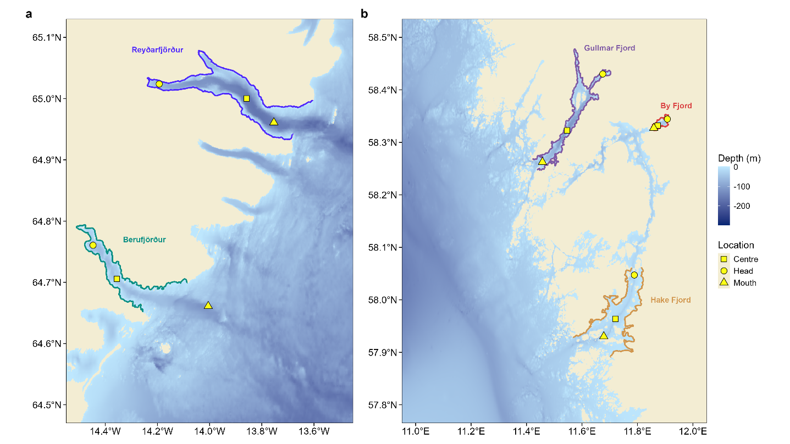
Figure S5 Location of sampling sites in Sweden and Iceland. Samples for fjord nitrogen burial and microbial N₂ production measurements were collected in five fjords in Sweden and Iceland during sampling campaigns in 2023 and 2024. Symbol shapes denote sampling site of head, centre, and mouth of the fjord.
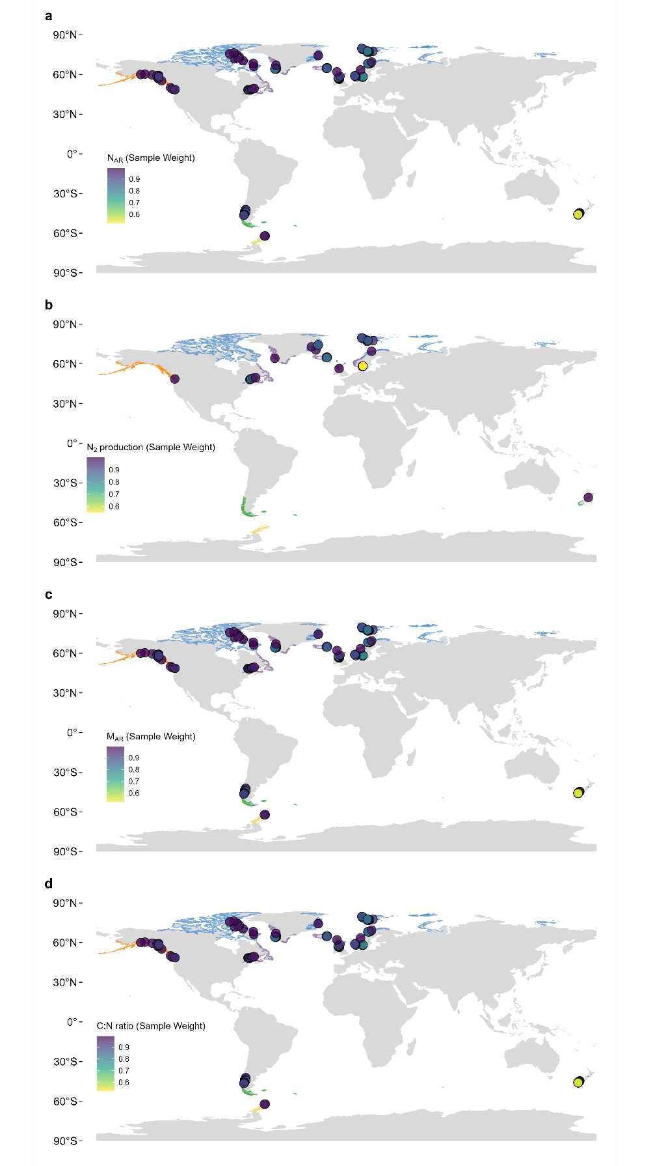
Figure S6 Result of spatial weighting of each measurement in the database. Each observation of (a) nitrogen accumulation rate and (b) microbial N₂ production rate is assigned with weights based on their spatial proximity to other samples with spatial scale of approximately 55 km (0.5 degree).
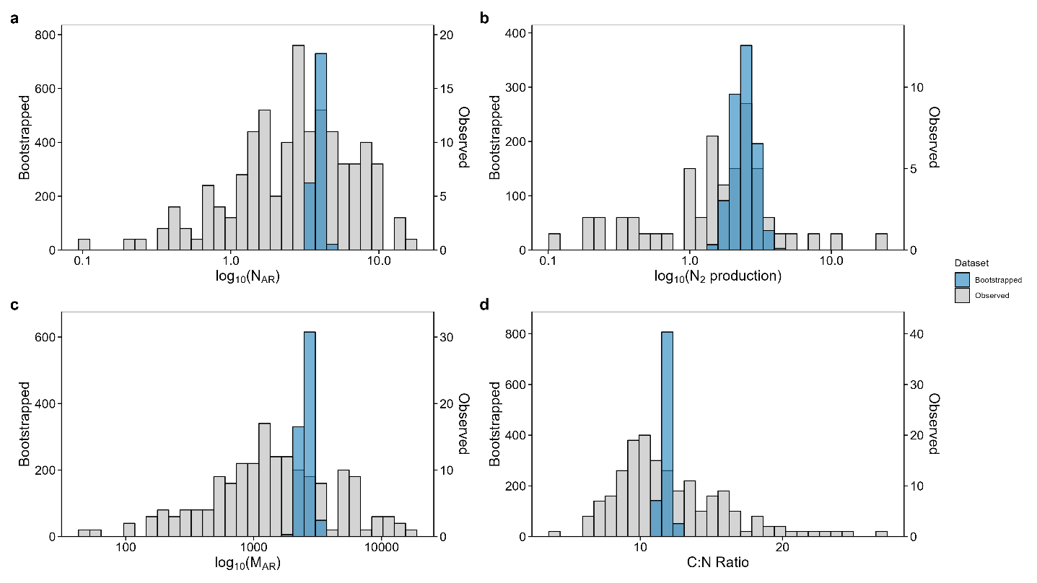
Figure S7 Summary of empirical observations and spatial weighting bootstrapped means. Bootstrap analysis was performed to the dataset of spatial weighted nitrogen accumulation rate (N_{AR}) and N₂ production rate (N₂) to generate distributions of 1,000 weighted bootstrapped means. Distribution of observed raw data (grey) and bootstrapped data (blue) used in the analyses were illustrated.

Supplementary Table
Table S1 Summary of global fjord nitrogen burial estimates.
 | Min | Q1 | Median | Q3 | Max
Marine N burial (Tg N yr⁻¹) ²⁰ | 10.0 | 17.0 | 22.5 | 25.0 | 58.0
Fjord area 1 (259,899 km²) ²¹
Fjord N burial (Tg N yr⁻¹) | 0.8 | 1.0 | 1.0 | 1.1 | 1.2
Fjord % of total | 1.7 | 4.0 | 4.5 | 5.9 | 10.1
Fjord area 2 (455,535 km²) ²²
Fjord N burial (Tg N yr⁻¹) | 1.4 | 1.7 | 1.8 | 1.8 | 2.1
Fjord % of total | 3.0 | 7.1 | 7.8 | 10.4 | 17.6

Table S2 Summary of sampling site in Sweden and Iceland.
Region | Fjord | Location | Depth  (m) | Redox condition | Temperature  (°C) | O₂  (µM) | NH₄⁺  (µM) | NO_{x}–  (µM)
Sweden West Coast | Gullmar Fjord | Head | 26 | Oxic | 14.0 | 124 | 0.4 | 12.0
Sweden West Coast |  | Centre | 118 | Seasonally hypoxic | 6.3 – 6.9 | 61 – 259 | 0.5 – 2.4 | 6.4 – 14.2
Sweden West Coast |  | Mouth | 57 | Seasonally hypoxic | 9.1 | 127 | 0.4 | 13.0
Sweden West Coast | Hake Fjord | Head | 21 | Oxic | 6.7 | 287 | 2.9 | 13.5
Sweden West Coast |  | Centre | 32 | Oxic | 7.0 | 265 | 1.9 | 7.8
Sweden West Coast |  | Mouth | 41 | Oxic | 6.8 | 270 | 2.5 | 15.0
Sweden West Coast | By Fjord | Head | 11 | Oxic | 7.0 | 258 | <d.l. | <d.l.
Sweden West Coast |  | Centre | 47 | Anoxic | 7.9 | <d.l. | <d.l. | <d.l.
Sweden West Coast |  | Mouth | 23 | Anoxic | 8.3 | <d.l. | 14.9 | 3.4
Iceland East Coast | Reyðarfjörður | Head | 70 | Oxic | 3.6 | 318 | 3.3 | 7.9
Iceland East Coast |  | Centre | 160 | Oxic | 3.6 | 325 | 3.0 | 5.0
Iceland East Coast |  | Mouth | 157 | Oxic | 3.4 | 319 | 2.2 | 6.0
Iceland East Coast | Berufjörður | Head | 49 | Oxic | 4.1 | 316 | 4.6 | 13.2
Iceland East Coast |  | Centre | 52 | Oxic | 4.9 | 272 | 4.2 | 10.2
Iceland East Coast |  | Mouth | 114 | Oxic | 4.4 | 329 | 1.9 | 8.9
Note. Site water depth, bottom water temperature, dissolved O₂ concentration (O₂), ammonium (NH₄⁺), and nitrate + nitrate (NO_{x}–) are shown. Ranges of measured values are reported for centre station of Gullmar Fjord, where samples were collected from two campaigns in oxic and hypoxic seasons. <d.l. denotes below detection limits.
Burial data23, 24, 25, 26, 27, 28, 29, 30, 31, 32, 33, 34, 35, 36, 37, 38, 39, 40, 41, 42, 43, 44, 45, 46, 47, 48, 49, 50 N₂ data^{51, 52, 53, 54, 55}

Supplementary References [Including global fjord dataset references which are not cited in the main text]
1. Filipsson H. A 200-year environmental record of a low-oxygen fjord, sweden, elucidated by benthic foraminifera, sediment characteristics and hydrographic data. Journal of Foraminiferal Research - J FORAMIN RES 2004, 34: 277-293.

2. Viktorsson L, Kononets M, Roos P, Hall P. Recycling and burial of phosphorus in sediments of an anoxic fjord—The By Fjord, western Sweden. Journal of Marine Research 2013, 71.

3. Nordberg K, Gustafsson M, Krantz A-L. Decreasing oxygen concentrations in the Gullmar Fjord, Sweden, as confirmed by benthic foraminifera, and the possible association with NAO. Journal of Marine Systems 2000, 23(4): 303-316.

4. Denk T, Grímsson F, Zetter R, Símonarson L. Late Cainozoic Floras of Iceland: 15 Million Years of Vegetation and Climate History in the Northern Atlantic, vol. 35, 2011.

5. Eiriksson T, Moodley L, Helgason G, Lilliendahl K, Halldorsson H, Bamber S, et al. Estimate of organic load from aquaculture – a way to increased sustainability, 2017.

6. Árnadóttir AL. Seasonal variability of dissolved oxygen in Berufjörður: University of Iceland, 2024.

7. Watts EG, Hylén A, Hall POJ, Eriksson M, Robertson EK, Kenney WF, et al. Burial of Organic Carbon in Swedish Fjord Sediments: Highlighting the Importance of Sediment Accumulation Rate in Relation to Fjord Redox Conditions. Journal of Geophysical Research: Biogeosciences 2024, 129(4): e2023JG007978.

8. Deutsch B, Forster S, Wilhelm M, Dippner JW, Voss M. Denitrification in sediments as a major nitrogen sink in the Baltic Sea: an extrapolation using sediment characteristics. Biogeosciences 2010, 7(10): 3259-3271.

9. De Brabandere L, Bonaglia S, Kononets M, Viktorsson L, Stigebrandt A, Thamdrup B, et al. Oxygenation of an anoxic fjord basin strongly stimulates benthic denitrification and DNRA. Biogeochemistry 2015, 126(1-2): 131-152.

10. Watts EG, Zautcke K, Santos I, Smeaton C, Ljungberg W, Cheung HLS, et al. Efficient Burial of Labile Organic Carbon in Sediments of Oxygenated Icelandic Fjords. Estuaries and Coasts 2025, 48(6): 167.

11. Risgaard-Petersen N, Nielsen LP, Rysgaard S, Dalsgaard T, Meyer RL. Application of the isotope pairing technique in sediments where anammox and denitrification coexist. Limnology and Oceanography: Methods 2003, 1(1): 63-73.

12. García-Robledo E, Corzo A, Papaspyrou S. A fast and direct spectrophotometric method for the sequential determination of nitrate and nitrite at low concentrations in small volumes. Marine Chemistry 2014, 162: 30-36.

13. Bonaglia S, Klawonn I, De Brabandere L, Deutsch B, Thamdrup B, Brüchert V. Denitrification and DNRA at the Baltic Sea oxic–anoxic interface: Substrate spectrum and kinetics. Limnology and Oceanography 2016, 61(5): 1900-1915.

14. Dalsgaard T, De Brabandere L, Hall POJ. Denitrification in the water column of the central Baltic Sea. Geochimica et Cosmochimica Acta 2013, 106: 247-260.

15. De Brabandere L, Canfield DE, Dalsgaard T, Friederich GE, Revsbech NP, Ulloa O, et al. Vertical partitioning of nitrogen-loss processes across the oxic-anoxic interface of an oceanic oxygen minimum zone. Environmental Microbiology 2014, 16(10): 3041-3054.

16. Steinsdóttir HGR, Schauberger C, Mhatre S, Thamdrup B, Bristow LA. Aerobic and anaerobic methane oxidation in a seasonally anoxic basin. Limnology and Oceanography 2022, 67(6): 1257-1273.

17. Dalsgaard T, Bak F. Nitrate Reduction in a Sulfate-Reducing Bacterium, Desulfovibrio desulfuricans, Isolated from Rice Paddy Soil: Sulfide Inhibition, Kinetics, and Regulation. Applied and Environmental Microbiology 1994, 60(1): 291-297.

18. Michiels CC, Huggins JA, Giesbrecht KE, Spence JS, Simister RL, Varela DE, et al. Rates and Pathways of N2 Production in a Persistently Anoxic Fjord: Saanich Inlet, British Columbia. Frontiers in Marine Science 2019, 6.

19. Black KD, Gontarek S, Gillibrand P. Identifying the Risk of Deoxygenation in Scottish Sea Lochs with Isolated Deep Water. Scottish Association for… 2006.

20. Zhang X, Ward BB, Sigman DM. Global Nitrogen Cycle: Critical Enzymes, Organisms, and Processes for Nitrogen Budgets and Dynamics. Chemical Reviews 2020, 120(12): 5308-5351.

21. Laruelle GG, Rosentreter JA, Regnier P. Extrapolation-Based Regionalized Re-evaluation of the Global Estuarine Surface Area. Estuaries and Coasts 2024, 48(2): 34.

22. Dürr HH, Laruelle GG, van Kempen CM, Slomp CP, Meybeck M, Middelkoop H. Worldwide Typology of Nearshore Coastal Systems: Defining the Estuarine Filter of River Inputs to the Oceans. Estuaries and Coasts 2011, 34(3): 441-458.

23. á Norði G, Glud RN, Simonsen K, Gaard E. Deposition and benthic mineralization of organic carbon: A seasonal study from Faroe Islands. Journal of Marine Systems 2018, 177: 53-61.

24. Buydens M, De Borger E, Meire L, Bodé S, Schirone A, Soetaert K, et al. Carbon Burial in two Greenland Fjords: Exploring the Influence of Glacier Type on Organic Carbon Dynamics. EGUsphere 2025, 2025: 1-29.

25. Duffield C, Alve E, Andersen N, Andersen T, Hess S, Strohmeier T. Spatial and temporal organic carbon burial along a fjord to coast transect: A case study from Western Norway. The Holocene 2017, 27(9): 1325-1339.

26. Faust JC, Knies J. Organic Matter Sources in North Atlantic Fjord Sediments. Geochemistry, Geophysics, Geosystems 2019, 20(6): 2872-2885.

27. Faust JC, Knies J, Slagstad T, Vogt C, Milzer G, Giraudeau J. Geochemical composition of Trondheimsfjord surface sediments: Sources and spatial variability of marine and terrigenous components. Continental Shelf Research 2014, 88: 61-71.

28. Ingall E, Kolowith L, Lyons T, Hurtgen M. Sediment carbon, nitrogen and phosphorus cycling in an anoxic fjord, Effingham Inlet, British Columbia. American Journal of Science 2005, 305: 240-258.

29. Knudson KP, Hendy IL, Neil HL. Re-examining Southern Hemisphere westerly wind behavior: insights from a late Holocene precipitation reconstruction using New Zealand fjord sediments. Quaternary Science Reviews 2011, 30(21): 3124-3138.

30. Koziorowska K, Kuliński K, Pempkowiak J. Deposition, return flux, and burial rates of nitrogen and phosphorus in the sediments of two high-Arctic fjords. Oceanologia 2018, 60(4): 431-445.

31. Mayr C, Rebolledo L, Schulte K, Schuster A, Zolitschka B, Försterra G, et al. Responses of nitrogen and carbon deposition rates in Comau Fjord (42°S, southern Chile) to natural and anthropogenic impacts during the last century. Continental Shelf Research 2014, 78: 29-38.

32. McQuoid MR, Whiticar MJ, Calvert SE, Pedersen TF. A post-glacial isotope record of primary production and accumulation in the organic sediments of Saanich Inlet, ODP Leg 169S. Marine Geology 2001, 174(1): 273-286.

33. Ramirez MT, Allison MA, Bianchi TS, Cui X, Savage C, Schüller SE, et al. Modern deposition rates and patterns of organic carbon burial in Fiordland, New Zealand. Geophysical Research Letters 2016, 43(22): 11,768-711,776.

34. Schüller SE, Bianchi TS, Li X, Allison MA, Savage C. Historical Reconstruction of Phytoplankton Composition in Estuaries of Fiordland, New Zealand: the Application of Plant Pigment Biomarkers. Estuaries and Coasts 2015, 38(1): 56-71.

35. Schüller SE, Savage C. Spatial distribution of diatom and pigment sedimentary records in surface sediments in Doubtful Sound, Fiordland, New Zealand. New Zealand Journal of Marine and Freshwater Research 2011, 45(4): 591-608.

36. Sepúlveda J, Pantoja S, Hughen KA. Sources and distribution of organic matter in northern Patagonia fjords, Chile (∼44–47°S): A multi-tracer approach for carbon cycling assessment. Continental Shelf Research 2011, 31(3): 315-329.

37. Skei J. Geochemical and sedimentological considerations of a permanently anoxic fjord — Framvaren, south Norway. Sedimentary Geology 1983, 36(2): 131-145.

38. Smeaton C, Yang H, Austin WEN. Carbon burial in the mid-latitude fjords of Scotland. Marine Geology 2021, 441: 106618.

39. Smittenberg RH, Hopmans EC, Schouten S, Hayes JM, Eglinton TI, Sinninghe Damsté JS. Compound-specific radiocarbon dating of the varved Holocene sedimentary record of Saanich Inlet, Canada. Paleoceanography 2004, 19(2).

40. Sørensen HL, Meire L, Juul-Pedersen T, de Stigter HC, Meysman FJR, Rysgaard S, et al. Seasonal carbon cycling in a Greenlandic fjord: an integrated pelagic and benthic study. Marine Ecology Progress Series 2015, 539: 1-17.

41. St-Onge G, Hillaire-Marcel C. Isotopic constraints of sedimentary inputs and organic carbon burial rates in the Saguenay Fjord, Quebec. Marine Geology 2001, 176(1): 1-22.

42. Syvitski JPM, LeBlanc KWG, Cranston RE. The flux and preservation of organic carbon in Baffin Island fjords. Geological Society, London, Special Publications 1990, 53(1): 177-199.

43. Thamdrup B, Fleischer S. Temperature dependence of oxygen respiration, nitrogen mineralization, and nitrification in Arctic sediments. Aquatic Microbial Ecology 1998, 15: 191-199.

44. Velinsky DJ, Fogel ML. Cycling of dissolved and particulate nitrogen and carbon in the Framvaren Fjord, Norway: stable isotopic variations. Marine Chemistry 1999, 67(3): 161-180.

45. Walinsky SE, Prahl FG, Mix AC, Finney BP, Jaeger JM, Rosen GP. Distribution and composition of organic matter in surface sediments of coastal Southeast Alaska. Continental Shelf Research 2009, 29(13): 1565-1579.

46. Walsh EM, Ingalls AE, Keil RG. Sources and transport of terrestrial organic matter in Vancouver Island fjords and the Vancouver-Washington Margin: A multiproxy approach using d13Corg, lignin phenols, and the ether lipid BIT index. Limnology and Oceanography 2008, 53(3): 1054-1063.

47. Wang Y, Ahad JME, Mucci AO, Gélinas Y, Douglas PMJ. Large burial flux of modern organic carbon in the St. Lawrence estuarine system indicates a substantial atmospheric carbon sink. Earth and Planetary Science Letters 2025, 652: 119204.

48. Wehrmann LM, Riedinger N, Brunner B, Kamyshny A, Hubert CRJ, Herbert LC, et al. Iron-controlled oxidative sulfur cycling recorded in the distribution and isotopic composition of sulfur species in glacially influenced fjord sediments of west Svalbard. Chemical Geology 2017, 466: 678-695.

49. Wehrmann LM, Formolo MJ, Owens JD, Raiswell R, Ferdelman TG, Riedinger N, et al. Iron and manganese speciation and cycling in glacially influenced high-latitude fjord sediments (West Spitsbergen, Svalbard): Evidence for a benthic recycling-transport mechanism. Geochimica et Cosmochimica Acta 2014, 141: 628-655.

50. Yoon HI, Park BK, Kim Y, Kim D. Glaciomarine sedimentation and its paleoceanographic implications along the fjord margins in the South Shetland Islands, Antarctica during the last 6000 years. Palaeogeography, Palaeoclimatology, Palaeoecology 2000, 157(3): 189-211.

51. Anschutz P, Sundby B, Lefrançois L, Luther GW, Mucci A. Interactions between metal oxides and species of nitrogen and iodine in bioturbated marine sediments. Geochimica et Cosmochimica Acta 2000, 64(16): 2751-2763.

52. Christensen PB, Glud RN, Dalsgaard T, Gillespie P. Impacts of longline mussel farming on oxygen and nitrogen dynamics and biological communities of coastal sediments. Aquaculture 2003, 218(1): 567-588.

53. Katsev S, Chaillou G, Sundby B, Mucci A. Effects of progressive oxygen depletion on sediment diagenesis and fluxes: A model for the lower St. Lawrence River Estuary. Limnology and Oceanography 2007, 52(6): 2555-2568.

54. Politi T, Olenin S, Deja K, Oleszczuk B, Zilius M, Bonaglia S, et al. Benthic metabolism and macrofauna bioturbation along a glacier-driven gradient in Kongsfjorden. Estuarine, Coastal and Shelf Science 2025, 320: 109304.

55. Wang F, Juniper SK, Pelegrı́ SlP, Macko SA. Denitrification in sediments of the Laurentian Trough, St. Lawrence Estuary, Québec, Canada. Estuarine, Coastal and Shelf Science 2003, 57(3): 515-522.

