Appendix 1: List of Abbreviations
AIDS | Acquired Immuno-deficiency syndrome
ANC | Antenatal care
CHW | Community Health Worker
DM | Diabetes Mellitus
EN | Enrolled nurse
HAST | HIV, AIDS, STI, TB
HH | Households
HIV | Human Immunodeficiency Virus
HPT | Hypertension
MCH | Mother and Child Health
NCD | Non-communicable diseases
NGO | Non-governmental organisation
NHI | National Health Insurance
OPD | Outpatients Department
OTL | Outreach Team Leader
PHC | Primary Health Care
PN | Professional nurse
SA | South Africa
STI | Sexually transmitted Infections
TB | Tuberculosis
WBPHCOT | Ward based PHC Outreach team
WHO | World Health Organisation

Appendix 2: Map of South African health districts and Ekurhuleni specifically
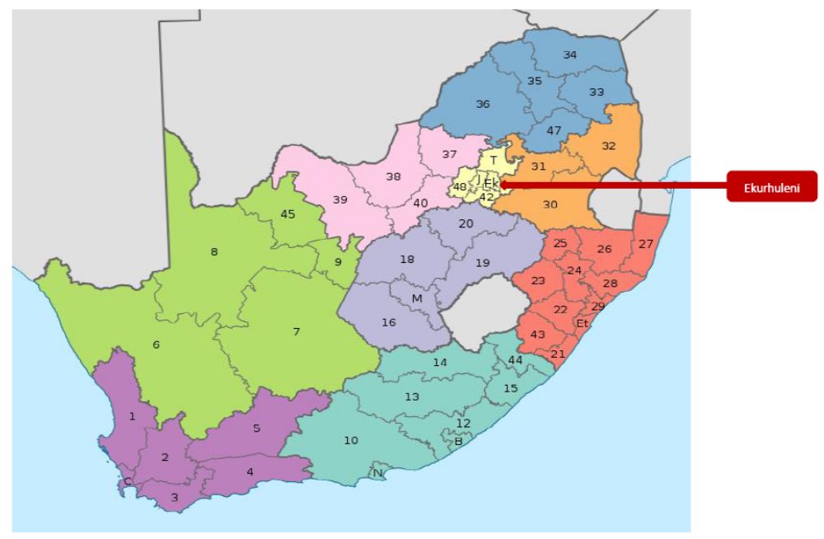

Appendix 3: Template of monthly team reports
Month:
Number of Teams:
No of OTLs:
Number of CHWs:
1. Key Priorities
Number of male condoms distributed:
Number of female condoms distributed:
*Number of clients with chronic medications for home delivery:
*Number of malnourished children identified:
* Submit separate list with names and addresses, and condition
2. In-service training of CHWs
Date | Topic

3. Courses attended by OTLs
Date | Course attended

4. Campaigns Participated
Date | Campaign | Activities | Referral to clinic | Reasons for referral

5. Support Groups Facilitated:
Date | Group Name | Topic | No. of Clients | Facilitator

6. Screening done
Activities | No. screened | No. Referred | No. Reported at the Facility | Link to care/Outcome
TB
HIV
STI
Pregnancy
Family Planning
Immunisation
Vit A & Deworming
Malnutrition
Diabetes
Hypertension
Pap Smear
MMC
Social support services
Cataract

7. Defaulters Traced/Lost to follow up
No. of Defaulters to trace | No. successfully traced | Reported to clinic | Total Linked to care
TB =
ART=
Pap smear=
Mental Health=
Chronic=
Bloods =

9. Pregnant Women:
 | < 20 weeks | >20 weeks
No. Tested for Pregnancy
No. Tested positive for Pregnancy
Confirmed test at the Facility
No. Started ANC

ACHIEVEMENTS

CHALLENGES

COMPILED BY:

Date:

