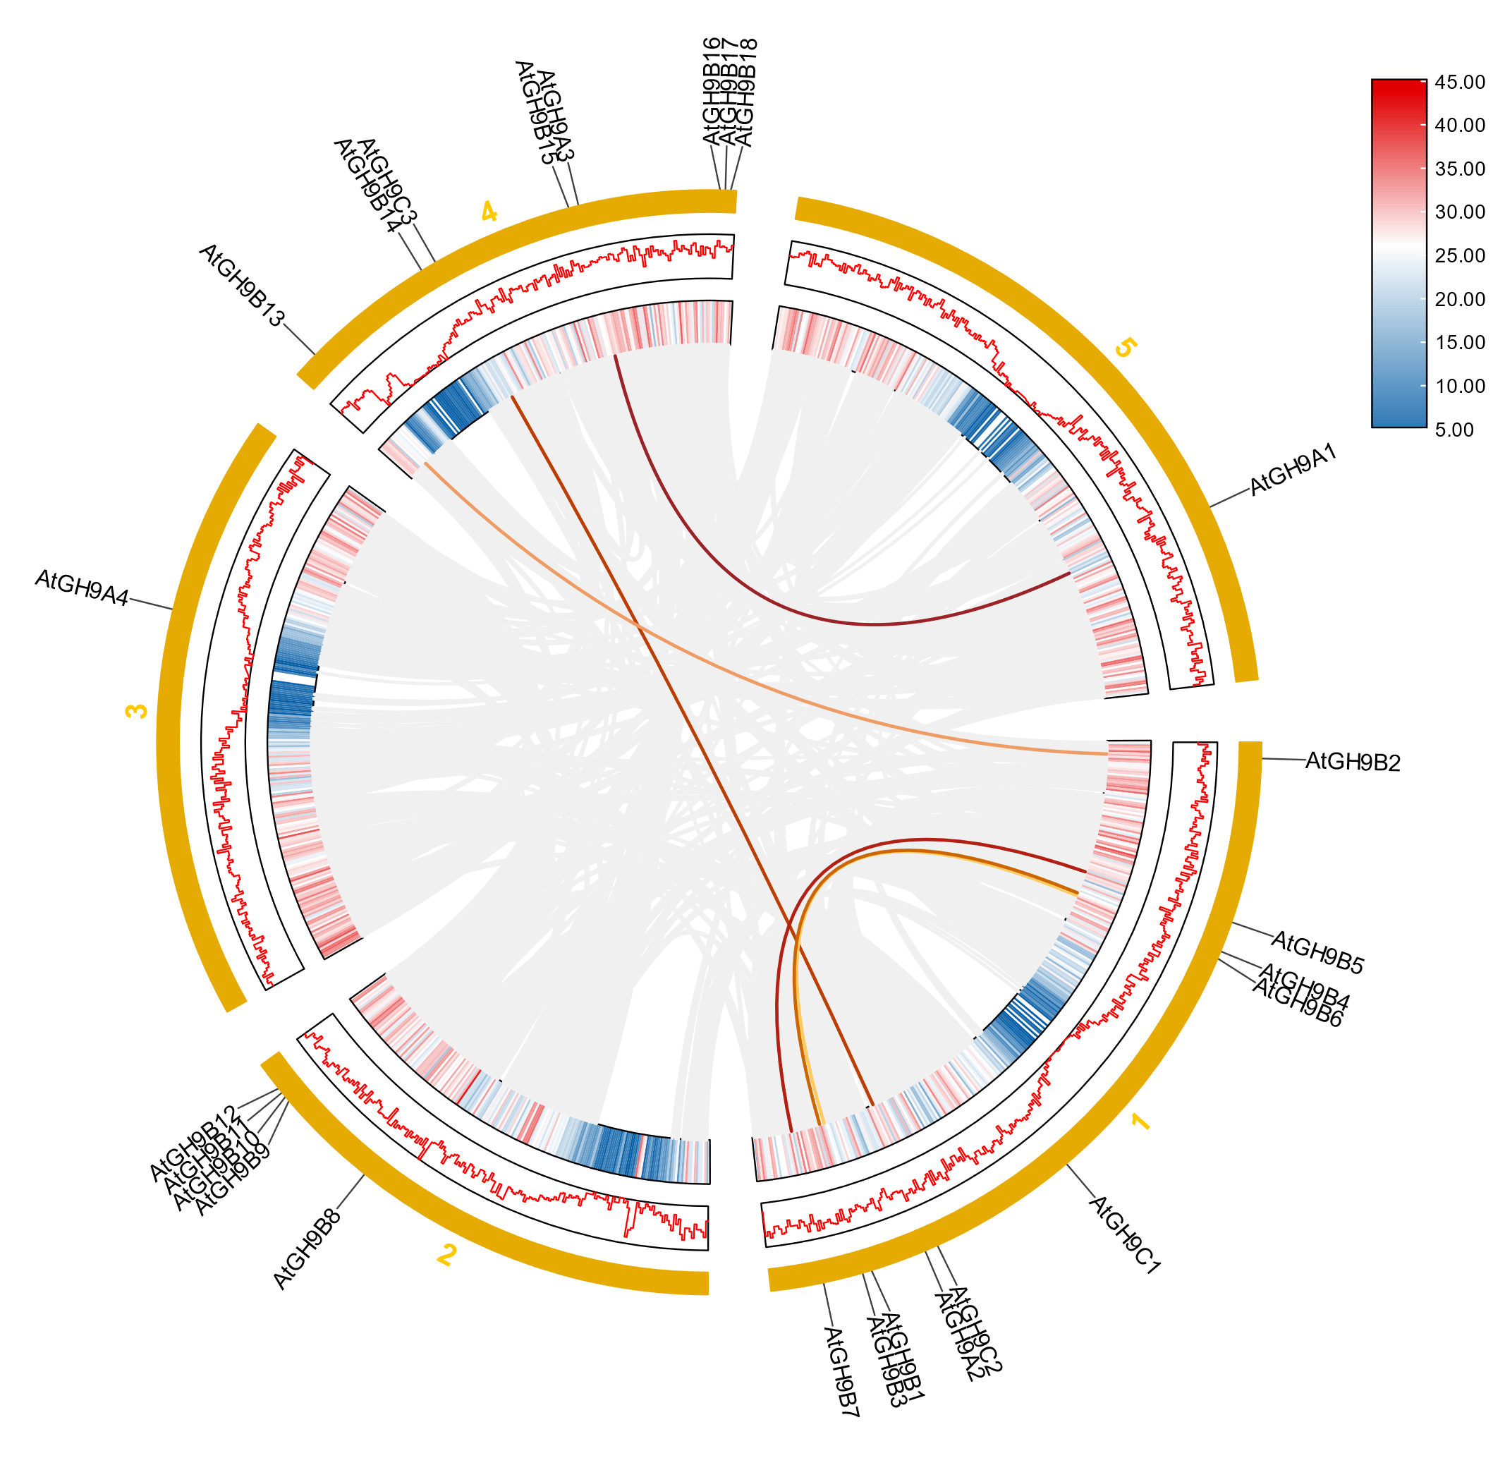
Figure S1 Distribution and collinearity of GH9 family genes in the Arabidopsis genome. The colored lines represent duplicate GH9 gene pairs.

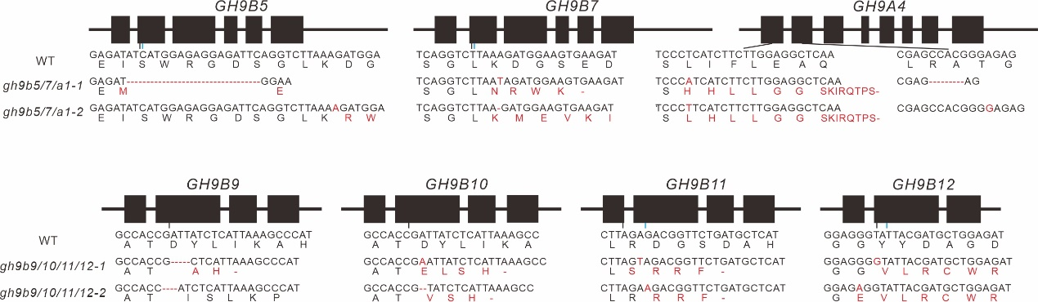
Figure S2 Generation of gh9b5/7/a4 and gh9b9/10/11/12 mutants. Four distinct single guide RNAs (sgRNAs) were employed for CRISPR/Cas9-mediated genome editing. Edited sites are marked in black, while unedited sites are indicated in blue. Red denotes the resulting downstream nucleotide or protein sequences that differ from the original ones due to genome editing.

