Effects of internal migration on the life satisfaction of apprentices: Online Appendix

Sample description
Table A1 shows means, standard deviations, minima, and maxima in the main analysis sample for all time-invariant variables. The distributions generally conform with our expectations, with only a few outliers regarding the occupational status of the occupations respondents stated to train. These outliers are 1 case with an ISEI-08 larger than 80, 61 cases with an ISEI larger than 70, 1 case with a SIOPS-08 larger than 70, and 23 cases with a SIOPS larger than 60. These outliers did not influence the results of our main regression analyses.
Table A2 shows the corresponding information for all time-varying variables. Here, the values are provided for the baseline and each training year separately. There are a 10 individuals observed at an age below 14 (minimum age of 12). While these observations seem unlikely to occur, it is not impossible for students at such a young age to attend grade 9 in the German school system. We therefore chose to not exclude them from the sample.
VET cancellation and panel dropout are coded as binary variables with a value of zero for participation and one for the last observation prior to cancellation/dropout. Both could only occur in our sample after a first observation in VET, therefore, the variables can only take a value of zero during the baseline measurement.

Table A1: Descriptive statistics of time-invariant variables (analysis sample with listwise deletion)
 |  |  |  | N | Mean / % | SD | Min. | Max.
VET-related migration |  | RLM 141 | Yes | 508 | 18.16
VET-related migration |  |  | No | 2,289 | 81.84
 |  |  | Total | 2,797 | 100.00
Poor regional  VET opportunity structureª | VET positions | Segments | RLM 141 | 2,797 | -0.01 | 0.01 | -0.13 | 0.00
Occupational status | ISEI |  |  | 2,797 | 40.05 | 13.52 | 11.56 | 85.85
Destination area | BBSR | City |  | 522 | 18.66
 |  | Urbanised district |  | 1,227 | 43.87
 |  | Rural |  | 1,048 | 37.47
 |  | Total |  | 2,797 | 100.00
Notes: NEPS SC4; N: individuals; (a) lower numbers indicate better VET opportunity structures.

Table A2: Descriptive statistics of time-variant variables (analysis sample with listwise deletion)
 | Time | N | Mean | SD | Min. | Max.
Life satisfaction | Baseline | 9,034 | 7.56 | 1.95 | 0.00 | 10.00
 | 1st year | 2,829 | 8.28 | 1.14 | 1.00 | 10.00
 | 2nd year | 1,826 | 8.23 | 1.13 | 0.00 | 10.00
 | 3rd year | 1,529 | 8.11 | 1.14 | 2.00 | 10.00
Age | Baseline | 9,034 | 16.24 | 1.41 | 12.92 | 24.67
 | 1st year | 2,826 | 18.60 | 1.70 | 16.00 | 26.58
 | 2nd year | 1,826 | 19.47 | 1.79 | 16.89 | 26.58
 | 3rd year | 1,529 | 20.37 | 1.65 | 17.92 | 27.00
VET cancellation | Baseline | 9,034 | 0.00 |  | 0 | 0
 | 1st year | 2,464 | 0.06 |  | 0 | 1
 | 2nd year | 1,554 | 0.03 |  | 0 | 1
 | 3rd year | 1,290 | 0.02 |  | 0 | 1
Panel dropout | Baseline | 9,034 | 0.00 |  | 0 | 0
 | 1st year | 2,688 | 0.14 |  | 0 | 1
 | 2nd year | 1,785 | 0.15 |  | 0 | 1
 | 3rd year | 1,502 | 0.16 |  | 0 | 1
Waves | Baseline | 9,034 | 3.05 | 2.31 | 1 | 12
 | 1st year | 2,829 | 6.94 | 1.96 | 5 | 14
 | 2nd year | 1,826 | 8.30 | 1.49 | 7 | 14
 | 3rd year | 1,529 | 9.09 | 1.35 | 8 | 14
Notes: NEPS SC4; N: observations.

Regression tables
Table A3: Fixed-effects regressions of apprentices’ life satisfaction
 | (1) |  | (2) |  | (3) |  | (4) |  | (5)
 | Coefficient |  | Coefficient |  | Coefficient |  | Coefficient |  | Coefficient
Training years (ref. baseline)
1st year | 0.414 | *** | 0.416 | *** | 0.415 | *** | 0.418 | *** | 0.521 | ***
2nd year | 0.365 | *** | 0.346 | *** | 0.346 | *** | 0.347 | *** | 0.395 | ***
3rd year | 0.271 | *** | 0.265 | ** | 0.265 | ** | 0.267 | *** | 0.286 | **
Years # migration (ref. no migration)
1st year |  |  | -0.011 |  | -0.001 |  | -0.041 |  | -0.326 | **
2nd year |  |  | 0.106 |  | 0.119 |  | 0.101 |  | -0.014
3rd year |  |  | 0.036 |  | 0.039 |  | 0.027 |  | -0.106
Years # poor VET opportunity structures
1st year |  |  |  |  | 0.009
2nd year |  |  |  |  | -0.045
3rd year |  |  |  |  | 0.008
Years # migration # poor VET opportunity structures
1st year |  |  |  |  | 0.054
2nd year |  |  |  |  | 0.153 | **
3rd year |  |  |  |  | 0.024
Years # ISEI
1st year |  |  |  |  |  |  | -0.025
2nd year |  |  |  |  |  |  | -0.059
3rd year |  |  |  |  |  |  | -0.038
Years # migration # ISEI
1st year |  |  |  |  |  |  | 0.182 | *
2nd year |  |  |  |  |  |  | 0.063
3rd year |  |  |  |  |  |  | 0.049
Years # urban destination region (ref. rural)
1st year |  |  |  |  |  |  |  |  | -0.160 | *
2nd year |  |  |  |  |  |  |  |  | -0.072
3rd year |  |  |  |  |  |  |  |  | -0.027
Years # migration # urban destination region
1st year |  |  |  |  |  |  |  |  | 0.556 | ***
2nd year |  |  |  |  |  |  |  |  | 0.199
3rd year |  |  |  |  |  |  |  |  | 0.258
VET cancellation | Yes |  | Yes |  | Yes |  | Yes |  | Yes
Panel dropout | Yes |  | Yes |  | Yes |  | Yes |  | Yes
Age | Yes |  | Yes |  | Yes |  | Yes |  | Yes
Wave groups | Yes |  | Yes |  | Yes |  | Yes |  | Yes
Survey months | Yes |  | Yes |  | Yes |  | Yes |  | Yes
N (individuals) | 2,797 |  | 2,797 |  | 2,797 |  | 2,797 |  | 2,797
N (observations) | 17,788 |  | 17,788 |  | 17,788 |  | 17,788 |  | 17,788
Notes: NEPS SC4, significance levels: ⁺ p < 0.1, * p < 0.05, ** p < 0.01, *** p < 0.001.

Sensitivity analyses

Alternative specifications of the multiverse analysis
This section describes the alternative specifications we used to test our hypotheses. We used multiverse analysis (also known as specification curve analysis) in an exploratory manner to find patterns of sensitivity to researcher decisions in our analyses (Simonsohn et al., 2020; Steegen et al., 2016). Table A4 lists our preferred analytical choices used in the main analyses as well as plausible alternatives. The multiverse consists of all possible analyses based on valid combinations of all alternatives. The total number of plausible models is the product of the numbers of preferred and alternative specifications. It amounts to 1,944 plausible models. Of these models, we randomly selected and estimated 100 models to reduce the computational burden of our multiverse analysis.
Table A4: Decision points forming the multiverse of analyses
Analytical Dimension | Preference | Alternatives
Sample | Students at regular schools from all tracks | Students in the Gymnasium track only
 | Students at regular schools from all tracks | Students in low/mid school tracks only
Intermittent phases after school completion | Included | Excluded
Regional Labour Markets | Kosfeld & Werner (2012)  (141 RLMs) | Kropp & Schwengler (2011)  (105 RLMs / 50 RLMs)
Opportunity structure of departure region | VET opportunity structure captured by VET vacancies | Share of employees in aspired occupation
Opportunity structure of departure region | VET opportunity structure captured by VET vacancies | Commuter balance
Granularity of occupations | Segments | Sectors
Occupational status | ISEI-08 | SIOPS-08
Type of destination region | Dichotomisation of BBSR settlement structure type | Dichotomisation of BBSR settlement structure type without type “urbanised district”
 |  | Dichotomisation of classification by the Thünen Institute
Missing value handling | Complete case analysis | Multiple imputation without imputed values for VET-related migration
 |  | Multiple imputation without imputed values for VET-related migration and life satisfaction

In our preferred model, we included students who were sampled from a random sample of all regular schools in Germany. However, to explore whether the results depend on the educational track, we also used a sample consisting of Gymnasium schools only (the school type leading to the highest school degree). We additionally used a sample only including students from lower and middle secondary school tracks. Attendance of these different school types is not only linked to individual ability but also to social stratification (Hillmert & Jacob, 2010), both of which potentially affect the experience of internal migration, which might produce different results for students from different educational tracks.
To assess the sensitivity of the estimation of life satisfaction changes to gaps between leaving school and entering VET (e.g., due to prevocational training), we estimated alternative models in which observations falling between leaving school and entering VET are excluded. These observations may be associated with uncertainty about the future or frustration due to a long duration of the search for VET (Jongbloed & Giret, 2022), which might be associated with lower life satisfaction biasing the baseline downwards, thereby biasing the estimates of life satisfaction change after entering VET upwards.
Furthermore, we explored two alternative measures for regional labour markets (RLMs) proposed by Kropp and Schwengler (2011). This is warranted by the modifiable area unit problem, which states that results based on spatial units are sensitive to the choice of units (Authors, 2019). Kropp and Schwengler’s delineations lead to fewer and, therefore, larger RLMs than the delineations by Kosfeld and Werner (2012), which affects our definitions of internal migration and the VET opportunity structure. Regarding the VET opportunity structure, we also used occupational sectors as an alternative to occupational segments in the operationalisation, thereby accounting for the unknown granularity at which occupational aspirations influence decisions regarding VET. Additionally, we explored two measures of the labour market structure as alternative measures of the VET opportunity structure: The share of employees in the aspired occupation (segments or sectors) and the commuter balance. Because the registration of vacant VET positions is optional for employers in Germany, it may lead to underestimation of the VET opportunities school leavers experience. The labour market indicators, on the other hand, depend on administrative data and may, therefore, be more reliable in this regard. Because they refer to the labour market, they may, however, be less valid indicators of the VET opportunity structure.
We assessed the sensitivity of the results to different operationalisations of occupational status by using the Standard International Occupational Prestige Score (SIOPS-08; Ganzeboom & Treiman, 2003; Züll, 2016) alternatively to the ISEI-08. While the ISEI can be seen as an objective measure of the socio-economic position an occupation yields, the SIOPS is a measure of occupational prestige and thus highlights a potentially important subjective and cultural dimension of the occupational choice.
The dichotomous distinction between urban and rural regions necessarily reduces complex regional nuances to two categories. Therefore, we used two alternatives to check the sensitivity of the rural-urban indicator. As a first alternative, we only considered “large cities” to be urban regions, using the BBSR settlement structure types (BBSR, 2024), thereby excluding “urbanised districts” from the analysis. This provides a clearer distinction between urban and rural regions. As a second alternative, we used a dichotomised version of a classification by the Federal Research Institute for Rural Areas, Forestry and Fisheries (Küpper, 2016; Thünen-Institut, 2016). Here, we grouped all types of rural regions into one group, while using “non-rural” regions as the reference category.
Another part of the sensitivity analysis considered different missing value (MV) handling techniques. For simplicity, we chose complete case analysis as our preferred technique, with samples held constant across all models. However, this implies the untestable assumption of a missing-at-random mechanism (Enders, 2022). To see whether missing value handling and missingness mechanisms have an impact on our results, we carried out multiple imputations in two different configurations: First, we estimated models in which all variables were imputed and in which cases were then excluded for which the main treatment variable (VET-related migration) was imputed. Second, we estimated models in which all variables were imputed and in which cases were excluded for which either VET-related migration or life satisfaction was imputed, or both. We decided to not use imputed data for VET-related migration in any of our models because of potential selection into migration, which is unlikely to be adequately modelled in the imputation. Biased imputation of the treatment variable may severely affect the resulting analyses. Similar concerns can be raised regarding the imputation of the outcome variable (life satisfaction). With fewer missing values (see below), however, the potential bias would be much smaller. The results of the multiverse analysis (Figure A4 to Figure A15) lend support to the assumption that the imputation of life satisfaction is inconsequential in our analyses.
The imputation models were the same for each model of the multiverse, with only the analysis variables being substituted depending on the specification of each model. All imputation models used 100 iterations across 5 imputed datasets. We imputed all variables using classification and regression trees (Burgette & Reiter, 2010). We imputed interaction terms indirectly based on the product of the imputed values of the interacted variables. To impute time-variant variables, we used all available information, whereas for time-constant variables, we only used time-constant variables. To improve the reliability and precision of the imputation, we used gender, school GPA, educational level before VET entrance (CASMIN), and interests (RIASEC) as auxiliary variables. For distributions and missingness of all time-constant variables before imputation in the full sample see Table A5. The only time-variant variable on which we observed missingness was the outcome variable life satisfaction: 6.66% of observations (grouped into baseline, first, second, and third training year) were missing (N = 1330) and for 0.01% of individuals (N = 43) we observed life satisfaction less than two times (therefore preventing the use of these individuals in the panel regression models entirely). Age, VET cancellation, panel dropout, and waves were fully observed. Exemplary imputation diagnostics for the first imputation model of the multiverse show no concerning bias and are reported in section A3.2.
Table A5: Descriptive statistics of time-invariant variables (full sample)
 |  |  |  | N | % MV | Mean / % | SD | Min. | Max.
VET-related migration |  | RLM 141^{b} | Yes | 650 |  | 9.79
VET-related migration |  |  | No | 3,229 |  | 48.62
 |  |  | Missing | 2,762 | 41.59
 |  |  | Total | 6,641 |  | 100.00
 |  | RLM 105 | Yes | 615 |  | 9.26
 |  |  | No | 3,229 |  | 48.62
 |  |  | Missing | 2,797 | 42.12
 |  |  | Total | 6,641 |  | 100.00
 |  | RLM 50 | Yes | 495 |  | 7.45
 |  |  | No | 3,229 |  | 48.62
 |  |  | Missing | 2,917 | 43.92
 |  |  | Total | 6,641 |  | 100.00
Poor regional  VET opportunity structureª | VET positions | Sectors | RLM 141 | 6,641 | 27.63 | -0.02 | 0.02 | -0.53 | 0.00
Poor regional  VET opportunity structureª | VET positions |  | RLM 105 | 6,641 | 27.63 | -0.04 | 0.09 | -1.18 | 0.00
Poor regional  VET opportunity structureª |  |  | RLM 50 | 6,641 | 27.63 | -0.10 | 0.14 | -1.49 | 0.00
Poor regional  VET opportunity structureª |  | Segments | RLM 141^{b} | 6,641 | 27.63 | -0.01 | 0.01 | -0.14 | 0.00
 |  |  | RLM 105 | 6,641 | 27.63 | -0.01 | 0.03 | -0.49 | 0.00
 |  |  | RLM 50 | 6,641 | 27.63 | -0.03 | 0.05 | -0.52 | 0.00
 | Employee share | Sectors | RLM 141 | 6,641 | 19.20 | 24.20 | 8.16 | 0.96 | 44.37
 | Employee share |  | RLM 105 | 6,641 | 19.20 | 24.18 | 8.05 | 1.12 | 44.37
 |  |  | RLM 50 | 6,641 | 19.20 | 24.12 | 7.70 | 1.12 | 44.37
 |  | Segments | RLM 141 | 6,641 | 23.17 | 8.49 | 3.73 | 0.42 | 22.63
 |  |  | RLM 105 | 6,641 | 23.17 | 8.49 | 3.67 | 0.44 | 22.63
 |  |  | RLM 50 | 6,641 | 23.17 | 8.45 | 3.50 | 0.46 | 19.21
 | Commuter balance |  | NUTS-3 | 6,318 | 6,641 | -11.52 | 28.10 | -147.32 | 66.22
Occupational status | ISEI^{b} |  |  | 6,641 | 1.72 | 38.88 | 13.76 | 11.56 | 85.85
Occupational status | SIOPS |  |  | 6,641 | 1.72 | 42.78 | 8.24 | 13.00 | 75.68
Destination area | BBSR^{b} | City |  | 1,032 |  | 15.54
 |  | Urbanised district |  | 2,623 |  | 39.50
 |  | Rural |  | 2,365 |  | 35.61
 |  | Missing |  | 621 | 9.35
 |  | Total |  | 6,641 |  | 100.00
 | Thünen | Urban |  | 1,828 |  | 27.53
 |  | Rural |  | 4,192 |  | 63.12
 |  | Missing |  | 621 | 9.35
 |  | Total |  | 6,641 |  | 100.00
Parents | ISEI |  |  | 6,641 | 39.77 | 47.95 | 19.02 | 11.56 | 88.96
 | Education (years) |  |  | 6,641 | 42.01 | 13.46 | 2.07 | 9.00 | 18.00
 | Net household monthly income |  |  | 6,641 | 49.31 | 3,202 | 1,875 | 0.00 | 46,000
Auxiliary variables | Gender | Female |  | 3,094 |  | 46.59
Auxiliary variables |  | Male |  | 3,542 |  | 53.34
 |  | Missing |  | 5 | 0.08
 |  | Total |  | 6,641 |  | 100.00
 | Prior education | CASMIN | No degree (1a) | 252 |  | 3.79
 | Prior education |  | Low (1b) | 1,522 |  | 22.92
 |  |  | Medium (2b) | 2,839 |  | 42.75
 |  |  | High (2c_gen) | 1,714 |  | 25.81
 |  |  | Missing | 314 | 4.73
 |  |  | Total | 6,641 |  | 100.00
 | School grade |  |  | 6,641 | 13.01 | 2.67 | 0.52 | 1.00 | 5.80
 | Interests | Realistic |  | 6,641 | 13.90 | 2.93 | 1.07 | 1.00 | 5.00
 |  | Investigative |  | 6,641 | 13.91 | 2.59 | 0.93 | 1.00 | 5.00
 |  | Artistic |  | 6,641 | 14.40 | 2.43 | 0.96 | 1.00 | 5.00
 |  | Social |  | 6,641 | 14.35 | 3.07 | 0.98 | 1.00 | 5.00
 |  | Enterprising |  | 6,641 | 14.47 | 3.00 | 0.81 | 1.00 | 5.00
 |  | Conventional |  | 6,641 | 14.53 | 2.56 | 0.83 | 1.00 | 5.00
Notes: NEPS SC4; (a) lower numbers indicate better VET opportunity structures; (b) preferred specification used in main analysis.

Multiple imputation diagnosis
Figure A1 shows plots of potential scale reduction (PSR) factors (blue) and serial correlations (red) for all variables over iterations. Empty plots correspond to non-imputed variables, i.e., variables that were included in the imputation to provide information but were fully observed. Plots labelled “timeX…” correspond to variables that signify interactions between internal migration and VET opportunity structure, VET status, and destination regions. These variables were indirectly imputed and depend on the original variables in their imputation behaviour. Ideally, PSR factors should converge on a value of 1 and serial correlations should converge on a value of 0. These convergence patterns can be observed for all variables except for entrepreneurial interests (riasec_e), which, however, is only of minor interest being an auxiliary variable. The convergence of means and standard deviations of all variables and the replication of univariate distributions also revealed no patterns indicating biases.
Additionally, we investigated whether the bivariate correlations between all variables of substantive interest (i.e., variables which were used in the analysis or as auxiliary variables in the imputation) were preserved in the imputed data. We found no difference between correlations in the observed data and in the completed data (i.e., observed plus imputed) that exceeded ±0.05.
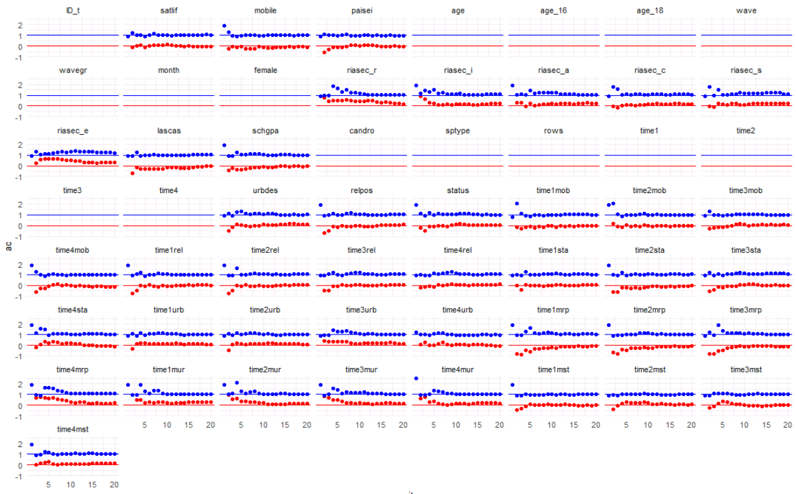Figure A1: Potential scale reduction (PSR) factor (blue) and serial correlation (red) for all variables over iterations

Additional results of the multiverse analysis
Figure A2 shows a summary graph of the regression coefficients for the effect of VET-related migration on life satisfaction by training years across all models included in the multiverse. The boxes show the 25th and 75th percentiles and the lines inside the boxes show the median estimate. Whiskers correspond to 1.5 times the interquartile range and outliers are shown as dots. Figure A2 shows that the regression coefficients tend to fall within a relatively narrow range of +/-0.125 points on the life satisfaction scale. While the estimates cluster around zero for the first training year, the estimated effects tend to be more positive for the second and third years. Overall, the alternative models lead to similar conclusions as the main analysis.
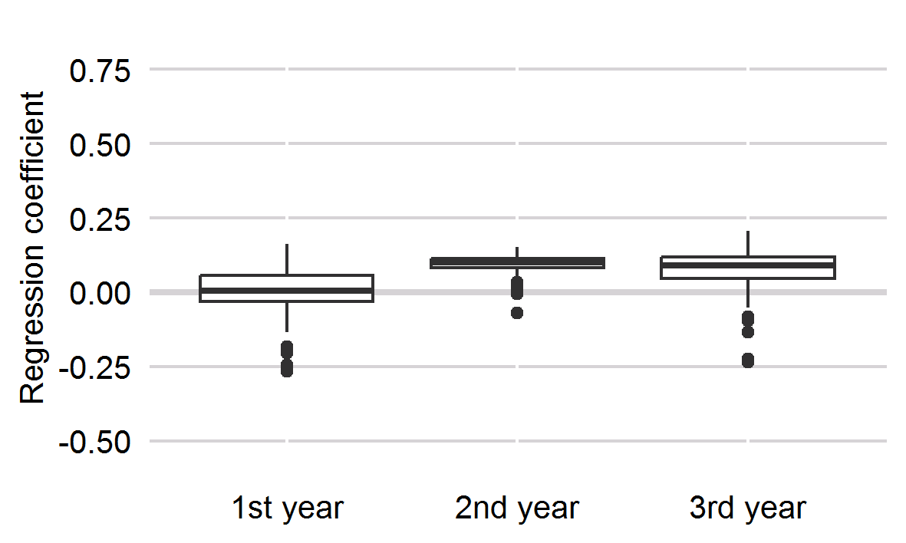
Figure A2: Boxplots of the multiverse of point estimates of the effects of VET-related migration on apprentices’ life satisfaction over training years: Results of fixed-effects regressions.
Data source: NEPS SC4, N (models) = 100.

Figure A4 to Figure A6 show the individual regression coefficients summarized in Figure A2 as well as additional details. In each figure, the uppermost panel contains the point estimates and 95%-confidence intervals, while the panels below contain information about the characteristics of each model. They only show information on decision points that are relevant to the respective hypothesis. Decisions that are only relevant for one hypothesis are not shown for the multiverse plots referring to models testing other hypotheses.
Irrespective of the modelling decisions, almost no model gives a significant estimate of the general effect of VET-related migration on life satisfaction for any year. Only for the first training year there are three models that yield a barely significant negative effect. These models indicate limited sensitivity of the results to modelling decisions. As can be seen in the model characteristics, these models all rely on complete case analysis and include the Gymnasium sample, either exclusively or as part of the total sample. However, given that other models including the Gymnasium sample or relying on complete case analysis lead to the substantial interpretation that there is no significant effect in most models, we disregard these three models as being particularly sensitive to the idiosyncrasies of the respective samples. Thus, we still favour the interpretation based on the preferred model that there is no substantial effect of internal migration on life satisfaction beyond entering VET. Inspecting the patterns of model characteristics, we found a tendency of the Gymnasium sample to produce more negative regression coefficients in the first training year and more positive coefficients in the third training year (vice versa for the sample without Gymnasium students). This could indicate a miniscule difference in the timing of when VET-related migration has its strongest effects on life satisfaction. Given the small size of these effects and their statistical insignificance, however, we do not regard this variation as substantial.
Figure A3 shows boxplots for the multiverse estimation of the hypothesised moderating effects. Again, the results of the preferred models are largely insensitive to alternative modelling decisions. Most models yield positive effects for VET-related migration from poor VET opportunity structures and for migration towards urban regions in the first training year. All models find positive effects of migration linked to higher-status occupations in the first training year. The effects of all models tend to diminish over time. The effect sizes also correspond to those in our preferred models: We observe by far the largest effects of VET-related migration to urban destination regions and smaller moderating effects of the VET opportunity structures and the status of the attained VET position.
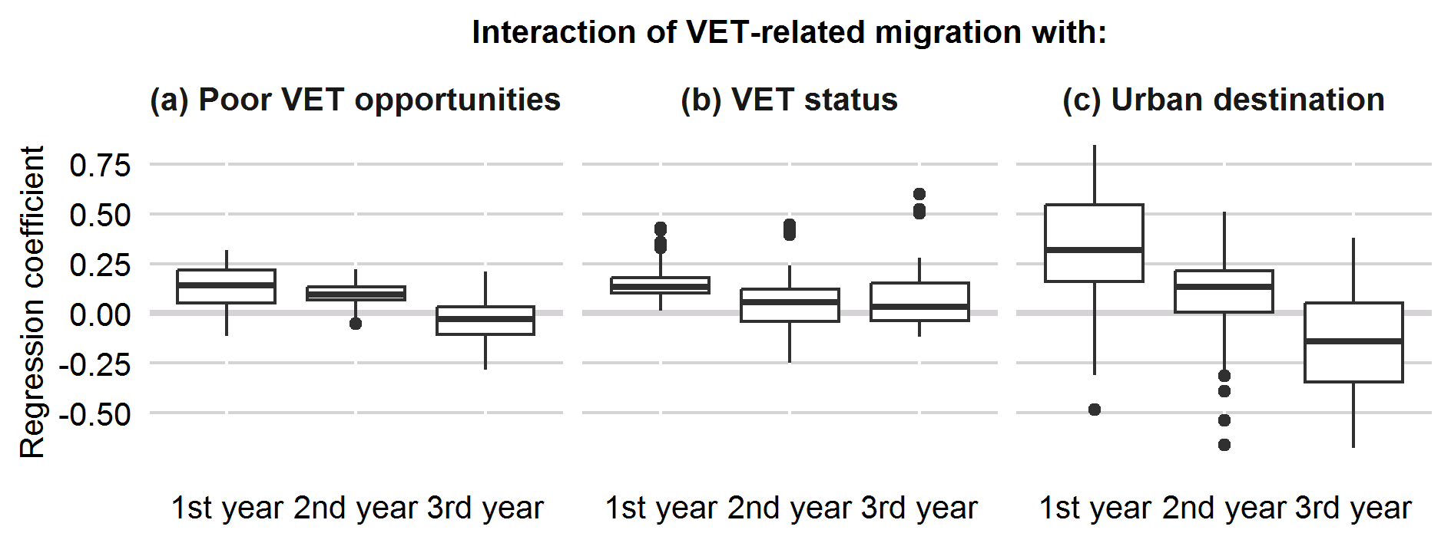
Figure A3: Boxplots of the multiverse of point estimates of moderators of migrating apprentices’ life satisfaction over training years: Results of fixed-effects regressions.
Data source: NEPS SC4, N (models) = 100.

Figure A7 to Figure A9 show the detailed multiverse plots for the moderation effects of poor regional opportunity structures on the effect of VET-related migration. Only a few exceptional models show significant positive effects in the first and second training years. Interestingly, they highlight a pattern depending on the school types that respondents first attended: The samples for which we found significant results all include Gymnasium students. For the first training year, the Gymnasium-only sample shows a tendency towards more positive results, while the sample without Gymnasium students tends towards more negative results. This may indicate that Gymnasium students are more able to offset regional disadvantages by migrating than students from other tracks. This difference, nonetheless, is rather small.
Figure A10 to Figure A12 show the detailed plots for the moderation effects of the occupational status of the trained occupation. There is no discernible pattern of effect sizes or direction between ISEI and SIOPS scores as indicators of occupational status. There is, however, a vague pattern of influence for missing value handling. Complete case analyses tend to yield positive and significant results. Because our preferred model also relies on complete case analysis it may, therefore, overestimate the effect of occupational status. On the other hand, none of the models produce negative estimates. This could indicate inflated standard errors in the models using multiple imputation. On balance, we conclude that reaching a higher occupational status is slightly beneficial for apprentices’ life satisfaction on average. However, there seem to be large differences in its utility across individuals and we cannot be certain about the extent to which our results depend on potential missingness mechanisms.
Finally, Figure A13 to Figure A15 show the regression coefficients and model characteristics of urban destination regions in reference to rural destination regions. The multiverse yields significant strong positive effects for about a third of the models: Only our preferred indicator (“BBSR both”) reliably produces positives estimates, while both the BBSR-based indicator excluding urbanised districts (“BBSR city”) and the Thünen-based indicator produce smaller and often insignificant point estimates. This indicates that the positive effect of urban regions is partially driven by those districts identified as “urbanised” by the BBSR, i.e., districts which do not only consist of one city but include multiple municipalities of which at least half are “large” or “middle” cities or have a population density of 150 inhabitants per square kilometre or more (BBSR, 2024). These regions may offer a good balance between amenities and costs for many apprentices. Furthermore, we found the strongest effects in the Gymnasium sample in the first training year. This may indicate that students from the Gymnasium track are either more interested in urban amenities or better able to reap their benefits – a hypothesis that could also be considered in future research.
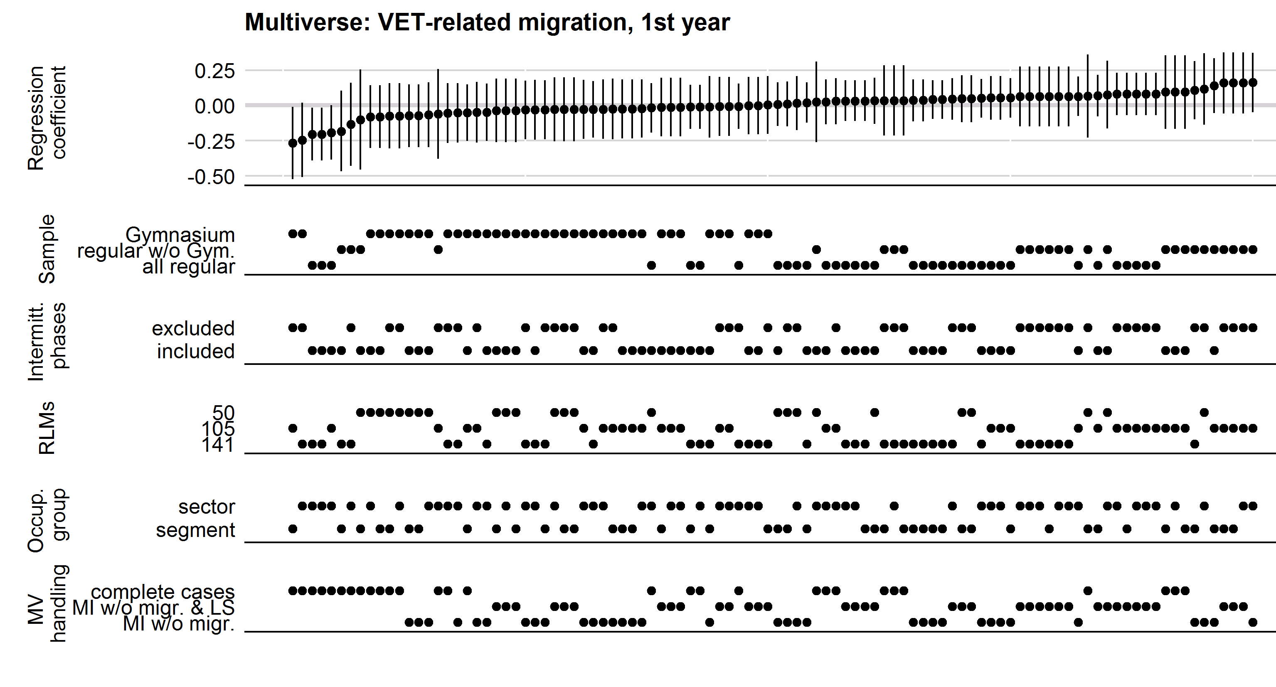
Figure A4: Multiverse plot for VET-related migration (1st training year): Results of fixed-effects regressions (regression coefficients and 95%-confidence intervals)
Data source: NEPS SC4, N (models) = 100.
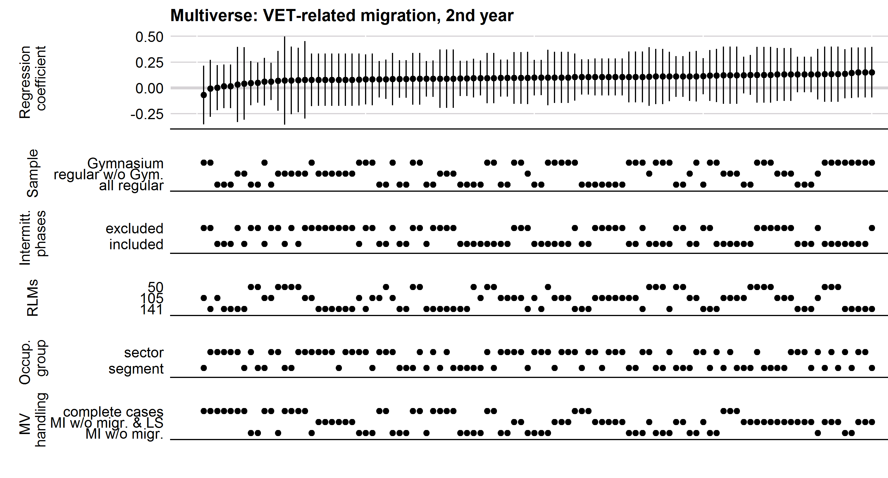
Figure A5: Multiverse plot for VET-related migration (2nd training year): Results of fixed-effects regressions (regression coefficients and 95%-confidence intervals)
Data source: NEPS SC4, N (models) = 100.
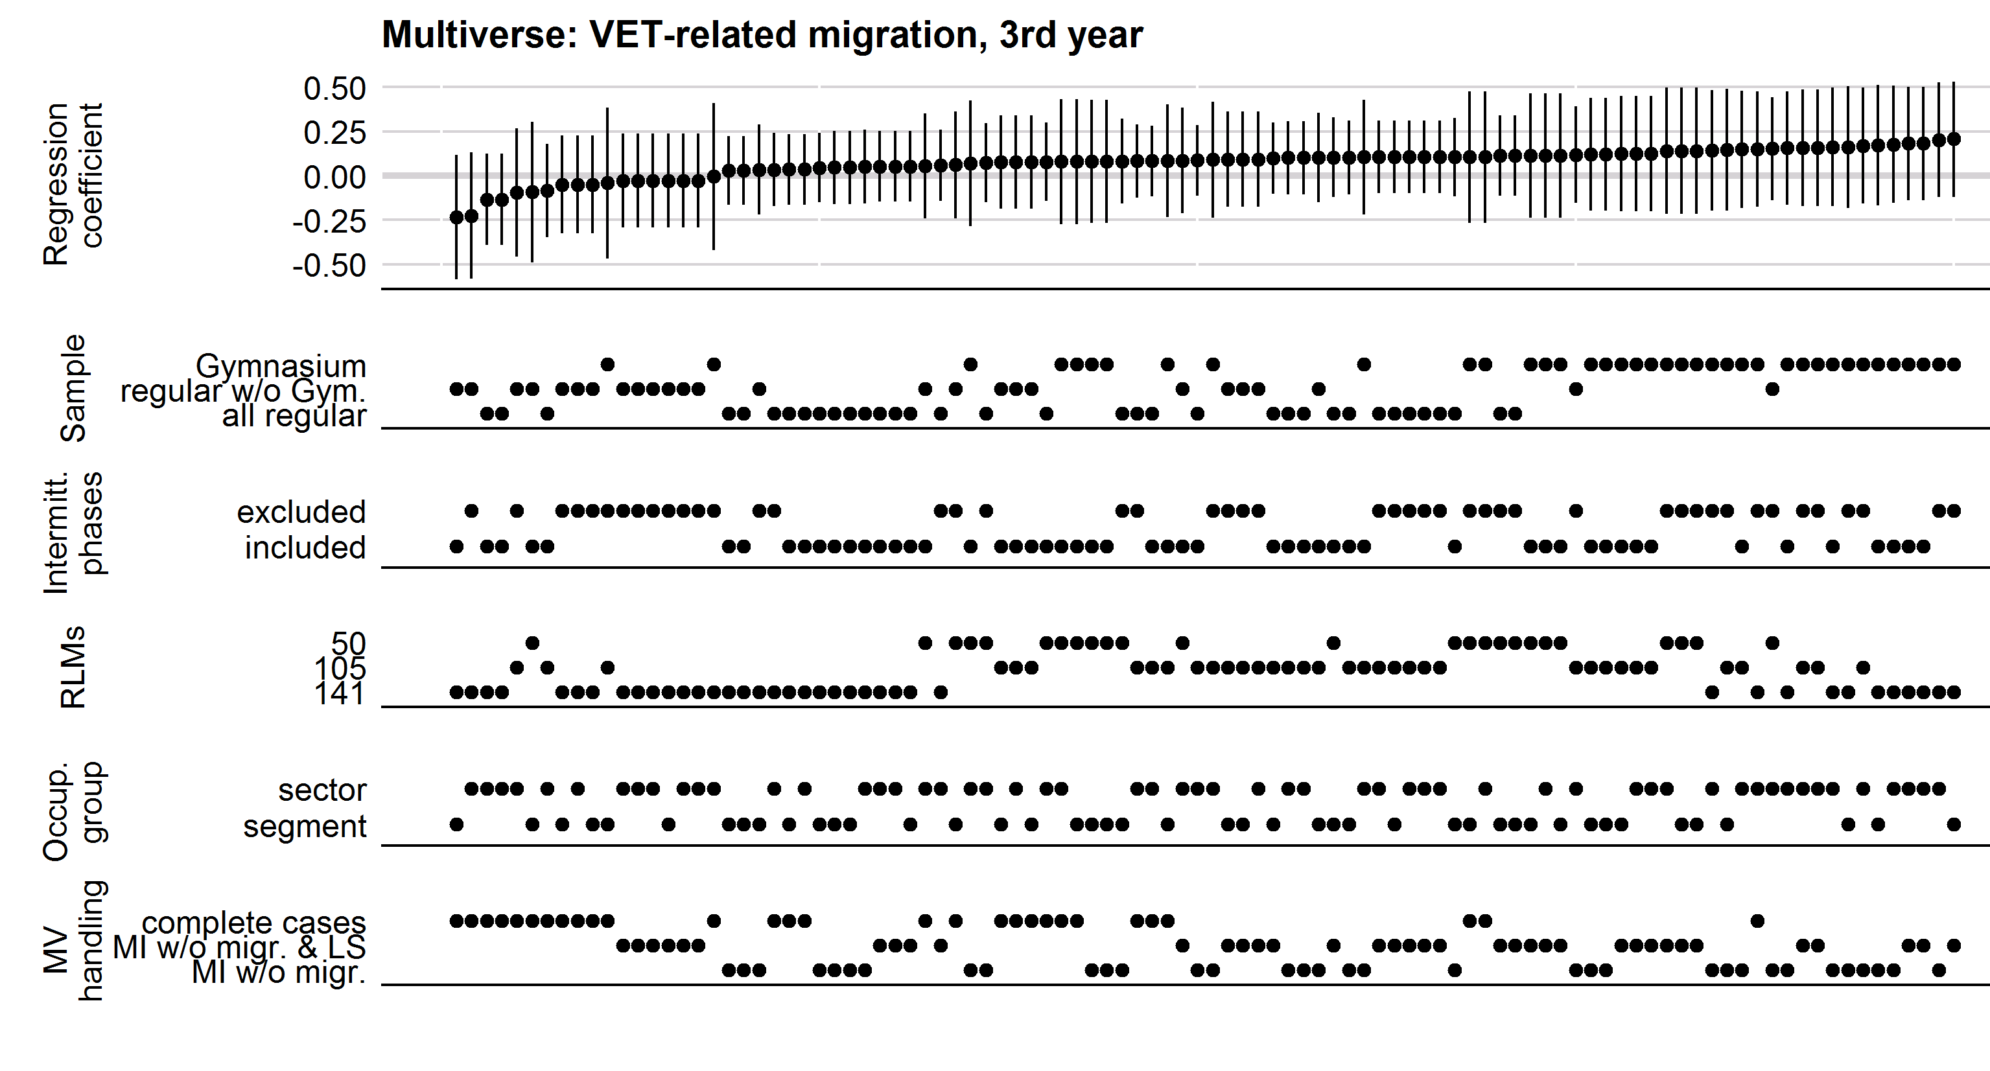
Figure A6: Multiverse plot for VET-related migration (3rd training year): Results of fixed-effects regressions (regression coefficients and 95%-confidence intervals)
Data source: NEPS SC4, N (models) = 100.
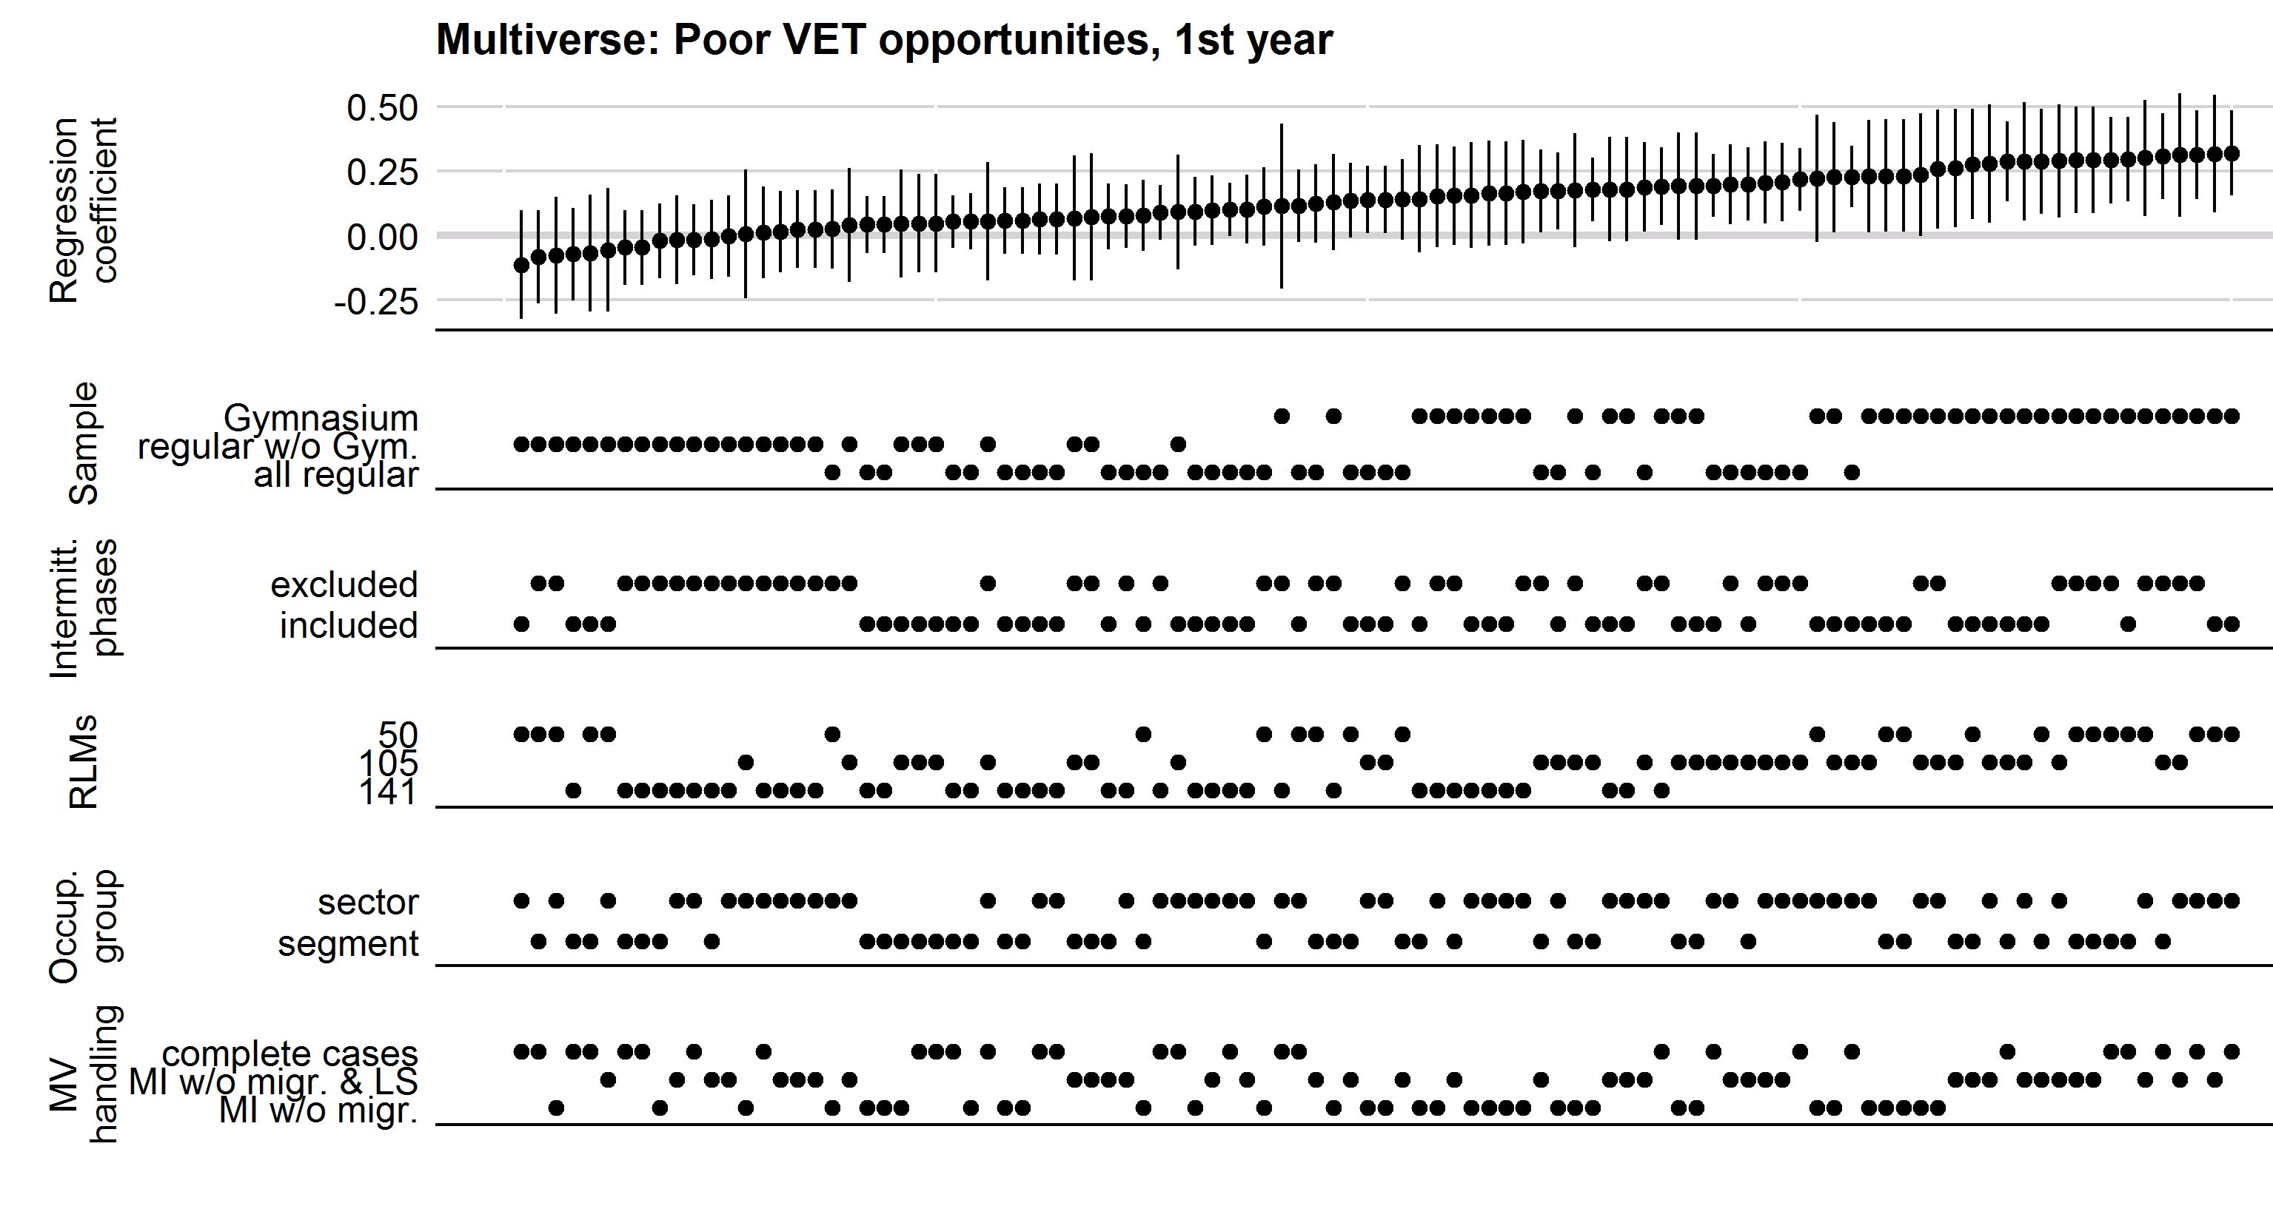
Figure A7: Multiverse plot for the moderation of the effects of VET-related migration by a poor VET opportunity structure (1st training year): Results of fixed-effects regressions (regression coefficients and 95%-confidence intervals)
Data source: NEPS SC4, N (models) = 100.
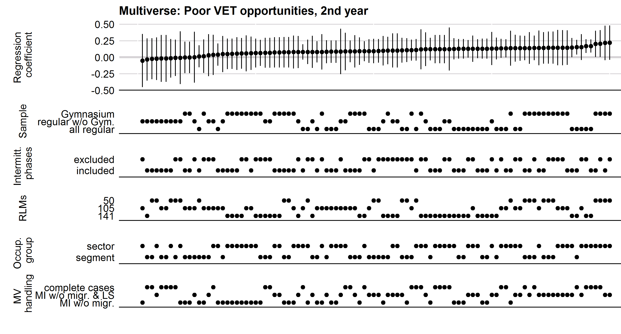
Figure A8: Multiverse plot for the moderation of the effects of VET-related migration by a poor VET opportunity structure (2nd training year): Results of fixed-effects regressions (regression coefficients and 95%-confidence intervals)
Data source: NEPS SC4, N (models) = 100.
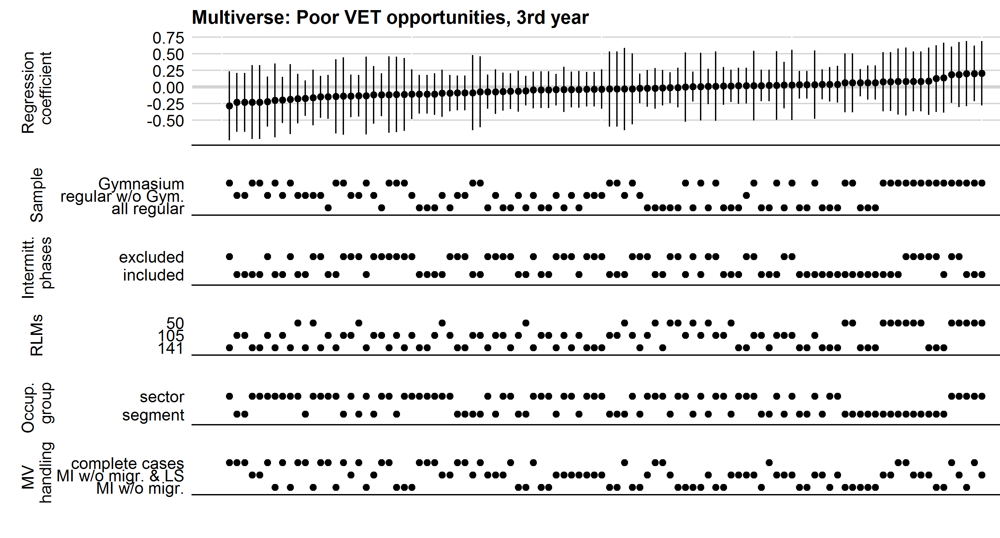
Figure A9: Multiverse plot for the moderation of the effects of VET-related migration by a poor VET opportunity structure (3rd training year): Results of fixed-effects regressions (regression coefficients and 95%-confidence intervals)
Data source: NEPS SC4, N (models) = 100.
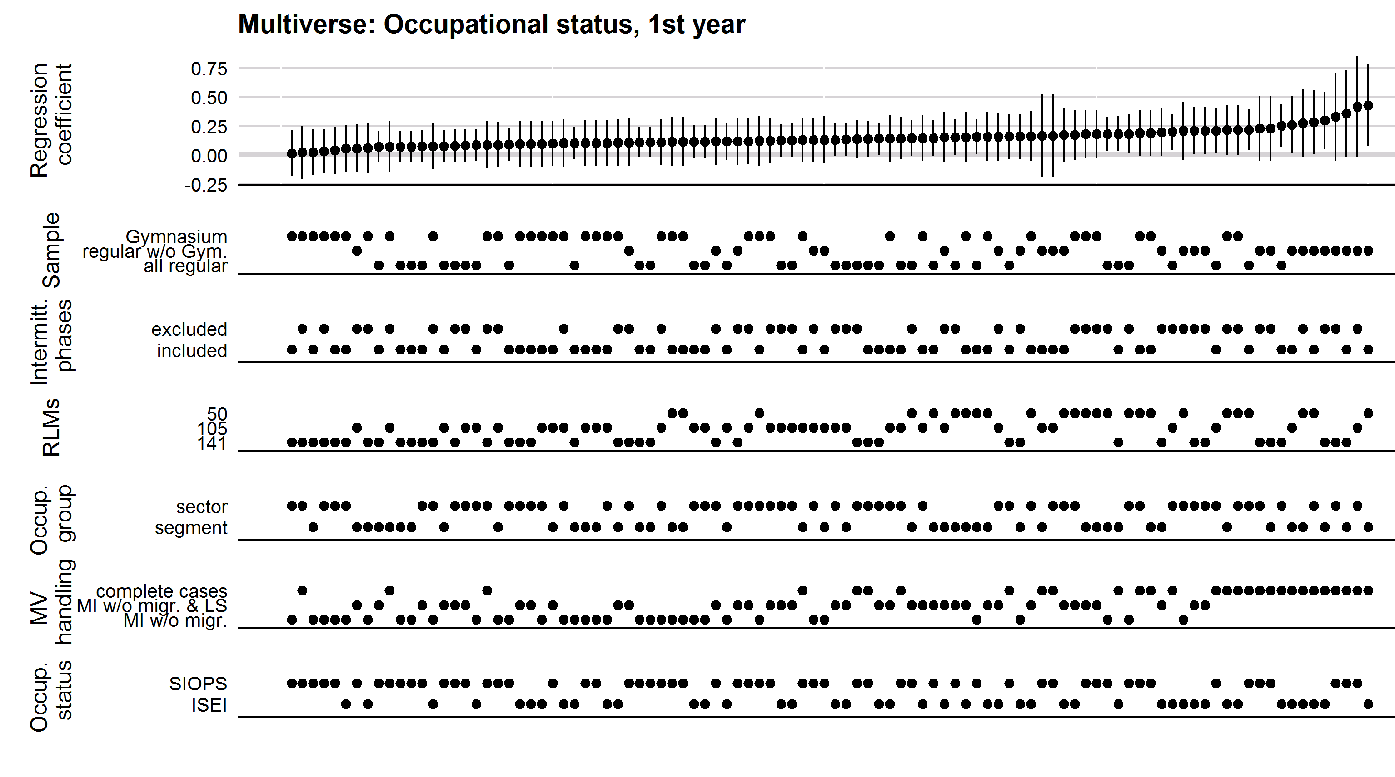
Figure A10: Multiverse plot for the moderation of the effects of VET-related migration by occupational status (1st training year): Results of fixed-effects regressions (regression coefficients and 95%-confidence intervals)
Data source: NEPS SC4, N (models) = 100.
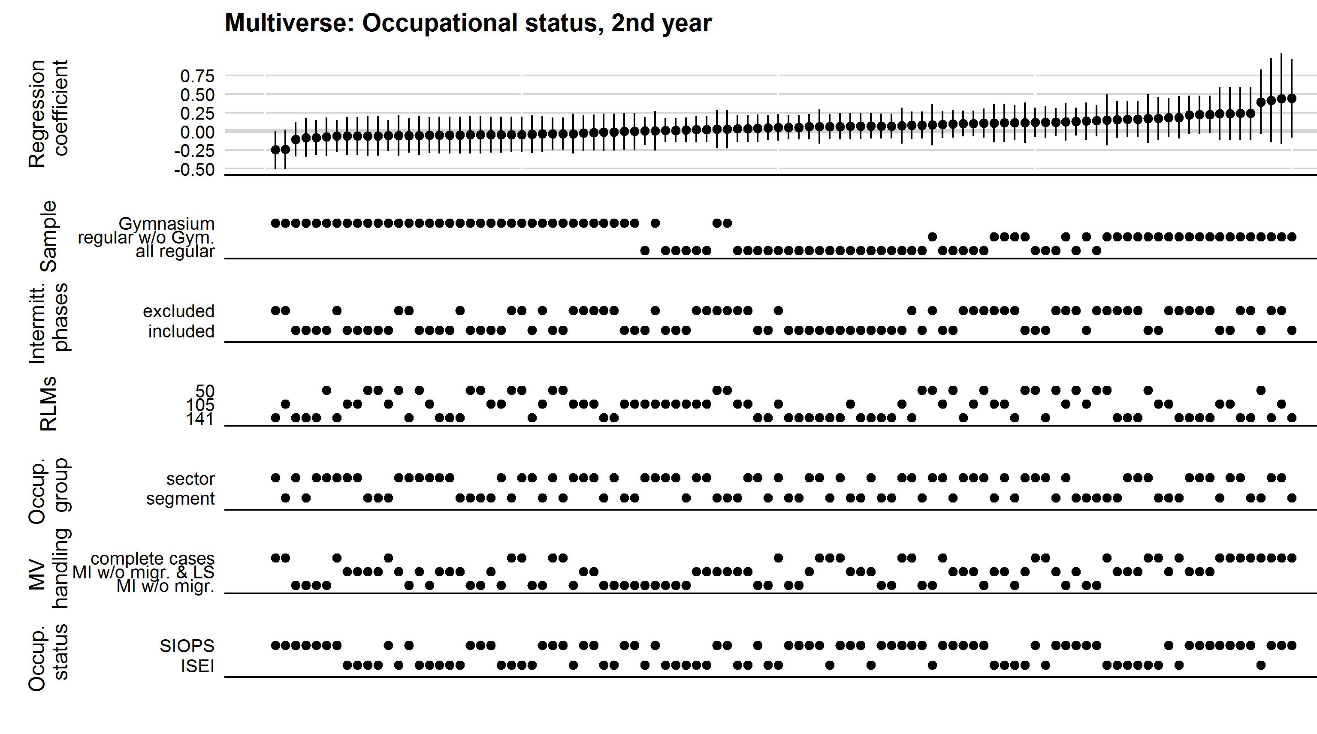
Figure A11: Multiverse plot for the moderation of the effects of VET-related migration by occupational status (2nd training year): Results of fixed-effects regressions (regression coefficients and 95%-confidence intervals)
Data source: NEPS SC4, N (models) = 100.
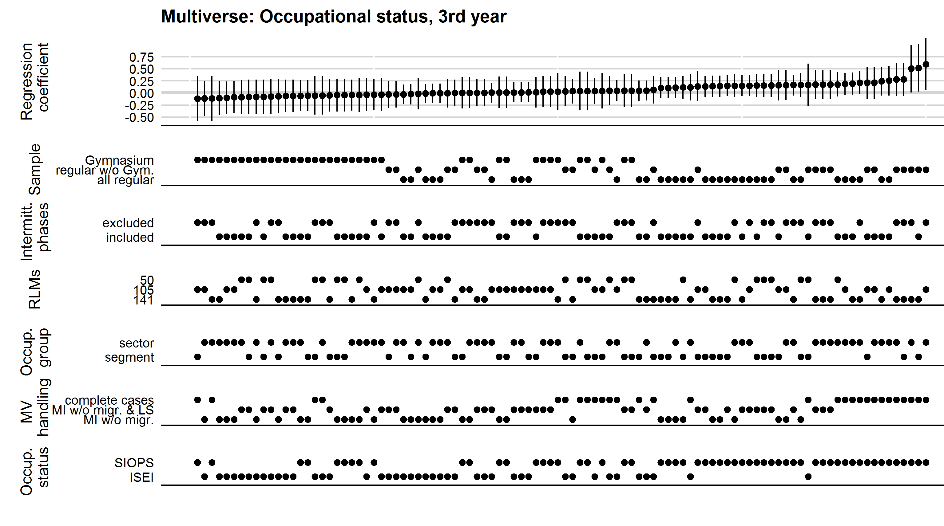
Figure A12: Multiverse plot for the moderation of the effects of VET-related migration by occupational status (3rd training year): Results of fixed-effects regressions (regression coefficients and 95%-confidence intervals)
Data source: NEPS SC4, N (models) = 100.
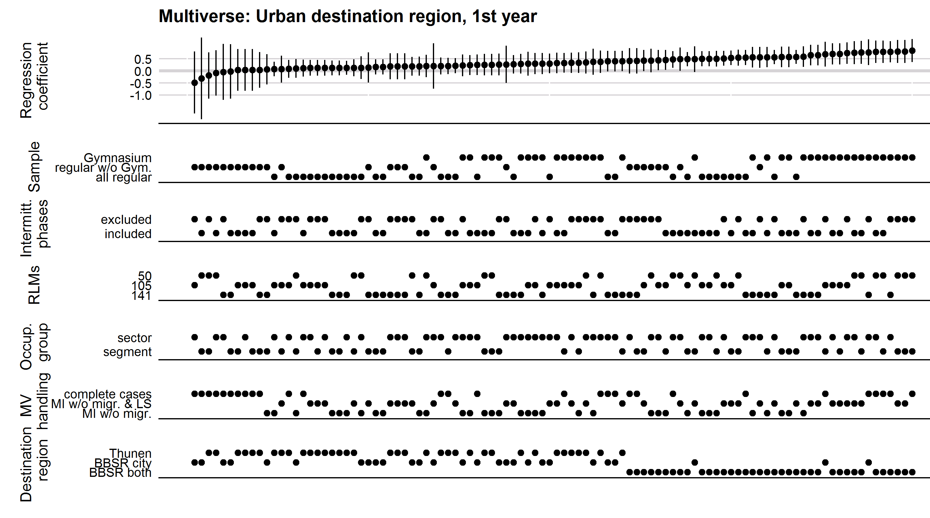
Figure A13: Multiverse plot for the moderation of the effects VET-related migration by type of destination region (1st training year): Results of fixed-effects regressions (regression coefficients and 95%-confidence intervals)
Data source: NEPS SC4, N (models) = 100.
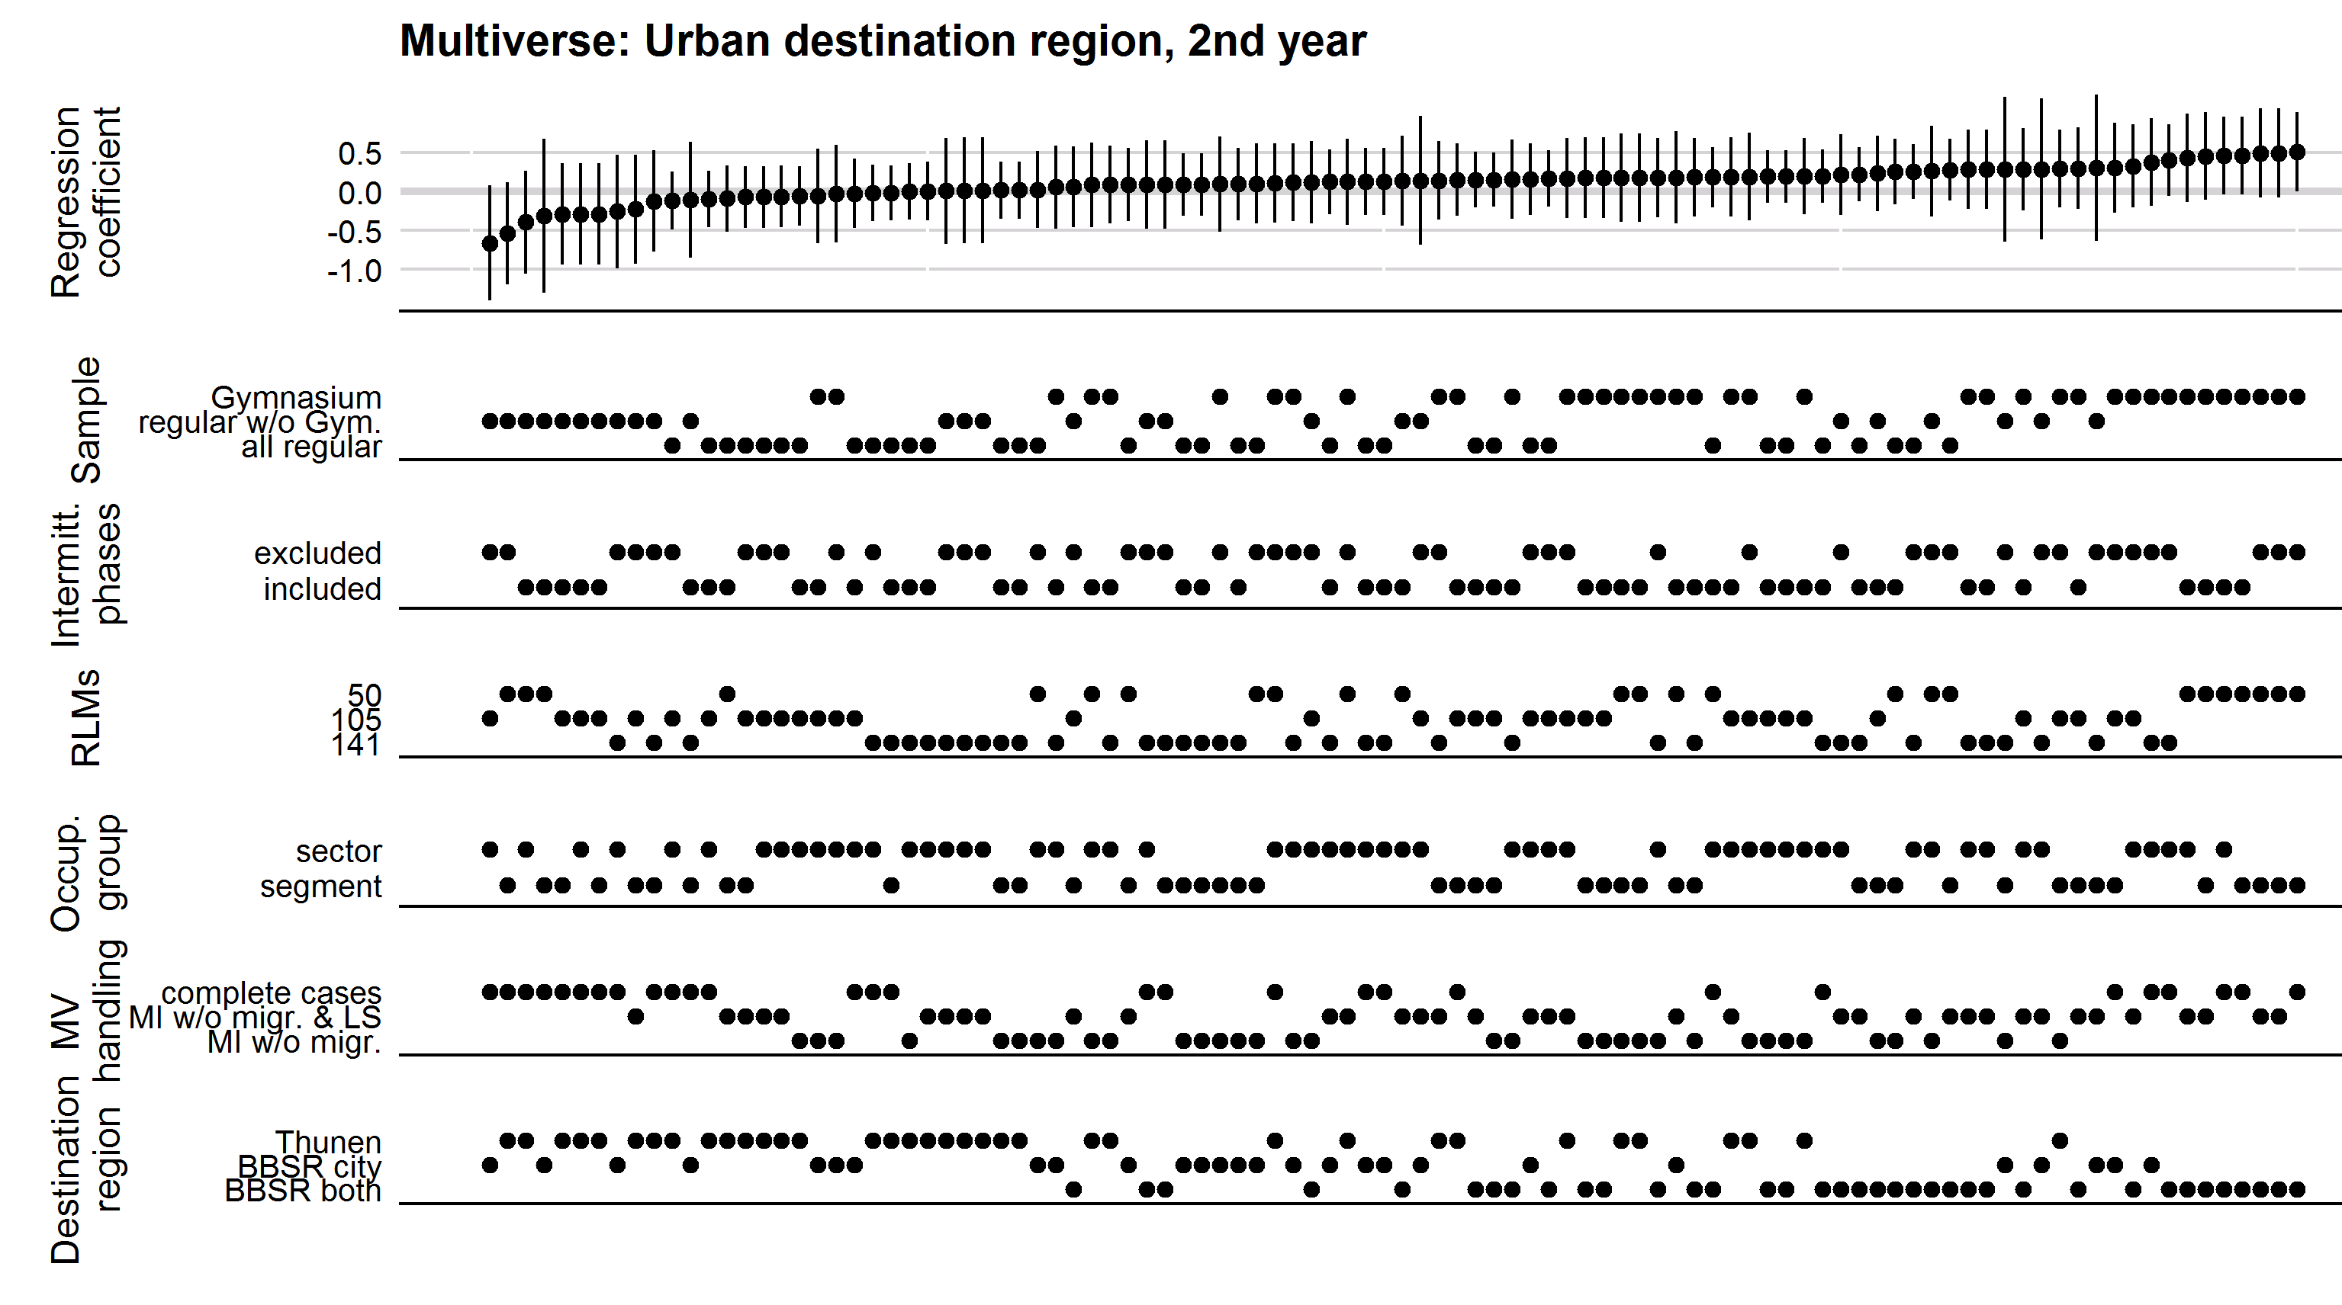
Figure A14: Multiverse plot for the moderation of the effects VET-related migration by type of destination region (2nd training year): Results of fixed-effects regressions (regression coefficients and 95%-confidence intervals)
Data source: NEPS SC4, N (models) = 100.
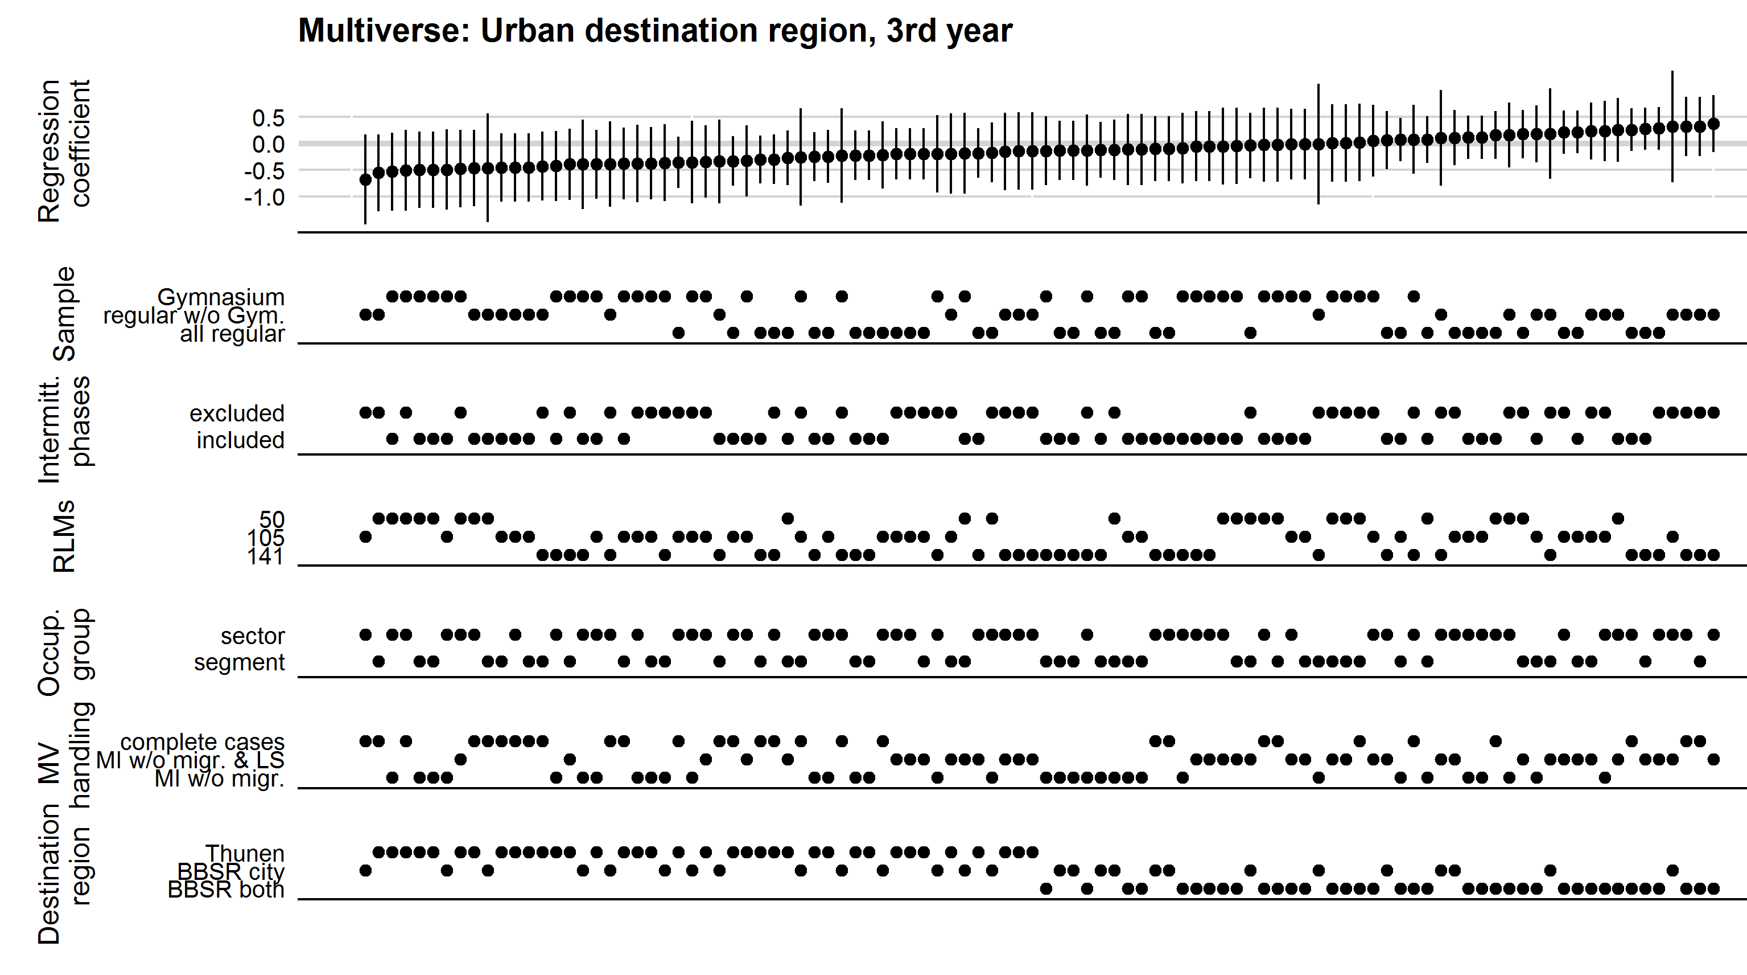
Figure A15: Multiverse plot for the moderation of the effects of VET-related migration by type of destination region (3rd training year): Results of fixed-effects regressions (regression coefficients and 95%-confidence intervals)
Data source: NEPS SC4, N (models) = 100.

Results of the split sample analyses
In our preferred models, we found a very strong effect of VET-related migration in the first training year for apprentices who migrated to urban regions. We concluded that internal migration is a means to achieve higher life satisfaction for apprentices in that it grants access to urban amenities. However, urban regions not only offer amenities which are relevant for young individuals’ lifestyles (Adam & Pütz, 2023; Authors, 2020; Benson & Furstenberg, 2006; Gans, 2017; Günthner, 2012; Mouratidis, 2021; Schäfer & Just, 2018). They can also offer better labour market opportunities (Ahlin et al., 2014; Günthner, 2012). Therefore, the effect of migration to urban regions might be confounded with the effects of leaving a poor VET opportunity structure and entering high-status VET occupations. We investigate this possibility using two approaches: First, we performed split-sample analyses for the moderation of the effects of VET-related migration by a poor VET opportunity structure in the home region and for the moderation of the effect of VET-related migration by the VET occupational status. We split the samples between individuals living in urban and rural regions during their apprenticeship. The results of the split-sample analyses are presented in Figure A16 and Figure A17. Second, we formally tested whether there were significant four-way interactions between time, VET-related migration, the type of destination region, and either poor VET opportunity structures or VET occupational status using two additional FE regressions. The results of the formal test are presented in Table A6.
Figure A16 shows the interactions between VET-related migration and poor VET opportunity structures as well as the VET status for rural destination regions, while Figure A17 does the same for urban destination regions. A comparison of the graphs shows that the moderation by poor VET opportunity structures follows the same pattern as in the main analysis in both the rural and the urban sample, with no significant difference found, but a small increase of the effect in the second training year. There is, however, a difference between rural and urban destination regions concerning the moderation by VET status: Only in rural destination regions did we find a significant moderation in the first training year and ongoing positive (insignificant) effects. The complete absence of a significant effect and overall lower level of the effects in urban destination regions indicates that apprentices do not often migrate towards urban regions to attain training in higher-status occupations. Instead, it seems that apprentices who are interested in high-status occupations and achieve a life satisfaction increase by attaining such occupations are willing to forego the amenities of urban regions to find a training position in rural regions. This may be due to stronger competition for training positions in urban regions.
The formal tests of the four-way interactions, however, do not yield any significant results (Table A6). Therefore, we conclude that urban destination regions offer unique benefits to apprentices that cannot be explained by potentially advantageous VET opportunities.
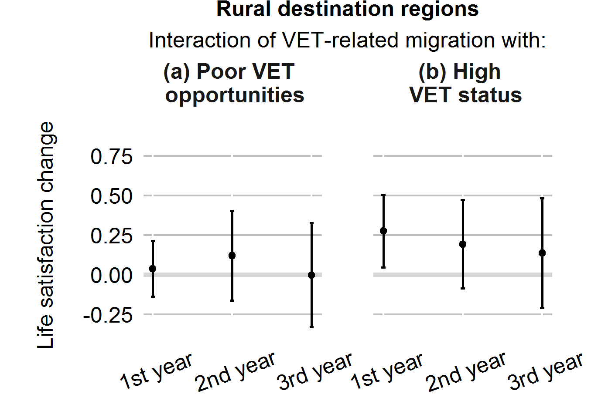
Figure A16: Split-sample analysis - Rural destination regions (average marginal effects and 95%-confidence intervals)
Data source: NEPS SC4, N (individuals) = 1,048, N (observations) = 6,498.

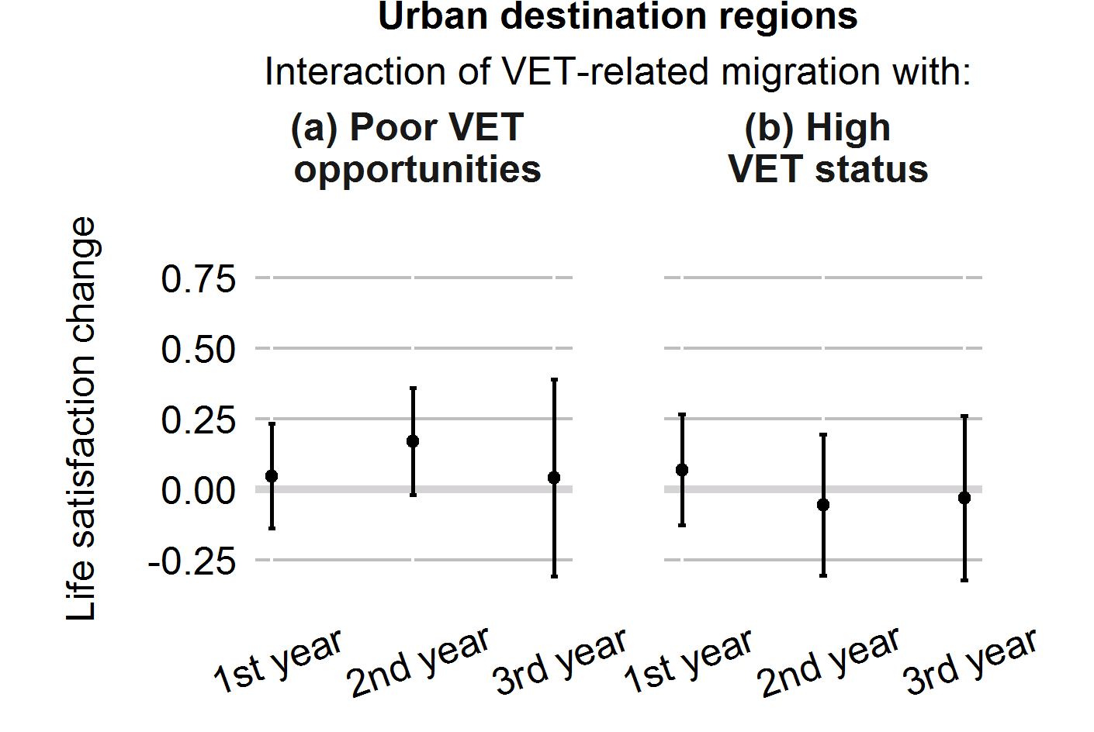
Figure A17: Split-sample analysis - Urban destination regions (average marginal effects and 95%-confidence intervals)
Data source: NEPS SC4, N (individuals) = 1,749, N (observations) = 11,290.

Table A6: Interaction of type of destination region with VET opportunity structure and VET occupational status: Results of fixed-effects regressions
 | 1st year |  | 2nd year |  | 3rd year |  | 1st year |  | 2nd year |  | 3rd year
 | Coef. |  | Coef. |  | Coef. |  | Coef. |  | Coef. |  | Coef.
Training year (ref. baseline) | 0.521 | *** | 0.393 | *** | 0.287 | ** | 0.522 | *** | 0.390 | *** | 0.285 | **
Years # migration (ref. no migration) | -0.314 | ** | 0.010 |  | -0.104 |  | -0.340 | ** | -0.021 |  | -0.119
Years # urban destination region (ref. rural) | -0.162 | * | -0.069 |  | -0.030 |  | -0.158 | * | -0.064 |  | -0.022
Years # migration # urban destination region | 0.543 | *** | 0.175 |  | 0.249 |  | 0.552 | *** | 0.236 |  | 0.287
Years # poor VET opportunity structures | 0.012 |  | -0.045 |  | 0.008
Years # migration # poor VET opportunity structures | 0.021 |  | 0.153 |  | -0.014
Years # migration # poor VET opportunity structures # urban destination region | 0.040 |  | -0.001 |  | 0.068
Years # ISEI |  |  |  |  |  |  | -0.021 |  | -0.056 |  | -0.037
Years # migration # ISEI |  |  |  |  |  |  | 0.247 | * | 0.142 |  | 0.108
Years # migration # ISEI # urban destination region |  |  |  |  |  |  | -0.161 | ⁺ | -0.163 |  | -0.130
VET cancellation | Yes |  | Yes |  | Yes |  | Yes |  | Yes |  | Yes
Panel dropout | Yes |  | Yes |  | Yes |  | Yes |  | Yes |  | Yes
Age | Yes |  | Yes |  | Yes |  | Yes |  | Yes |  | Yes
Wave groups | Yes |  | Yes |  | Yes |  | Yes |  | Yes |  | Yes
Survey months | Yes |  | Yes |  | Yes |  | Yes |  | Yes |  | Yes
N (individuals) | 2,797 |  | 2,797 |  | 2,797 |  | 2,797 |  | 2,797 |  | 2,797
N (observations) | 17,788 |  | 17,788 |  | 17,788 |  | 17,788 |  | 17,788 |  | 17,788
Notes: NEPS SC4. Significance levels: ⁺ p < 0.1, * p < 0.05, ** p < 0.01, *** p < 0.001.

References
Adam, B., & Pütz, T. (2023). Post-Corona: Wo liegen neue Sehnsuchtsorte? BBSR-Analysen Kompakt, 06/2023. https://www.bbsr.bund.de/BBSR/DE/veroeffentlichungen/analysen-kompakt/2023/ak-06-2023-dl.pdf
Ahlin, L., Andersson, M., & Thulin, P. (2014). Market thickness and the early labour market career of university graduates: An urban advantage? Spatial Economic Analysis, 9(4), 396–419. https://doi.org/10.1080/17421772.2014.961534
BBSR. (2024). Siedlungsstruktureller Kreistyp. Bundesinstitut für Bau-, Stadt- und Raumforschung. https://www.bbsr.bund.de/BBSR/DE/forschung/raumbeobachtung/Raumabgrenzungen/deutschland/kreise/siedlungsstrukturelle-kreistypen/kreistypen.html
Benson, J., & Furstenberg, F. (2006). Entry into adulthood: Are adult role transitions meaningful markers of adult identity? Advances in Life Course Research, 11, 199–224. https://doi.org/10.1016/S1040-2608(06)11008-4
Burgette, L., & Reiter, J. (2010). Multiple imputation for missing data via sequential regression trees. American Journal of Epidemiology, 172(9), 1070–1076. https://doi.org/10.1093/aje/kwq260
Enders, C. (2022). Applied missing data analysis (Second Edition). Guilford Press.
Gans, P. (2017). Urban population development in Germany (2000-2014): The contribution of migration by age and citizenship to reurbanisation. Comparative Population Studies, 42, 319–352. https://doi.org/10.12765/CPoS-2018-01en
Ganzeboom, H., & Treiman, D. (2003). Three internationally standardised measures for comparative research on occupational status. In J. Hoffmeyer-Zlotnik & C. Wolf (Eds.), Advances in Cross-National Comparison (pp. 159–193). Springer.
Günthner, S. (2012). ÖPNV und wohnungsnahe Versorgung—Attraktivitätsfaktoren großer Städte. In BBSR - Bundesinstitut für Bau-, Stadt- und Raumforschung (Ed.), Die Attraktivität großer Städte: Ökonomisch, demografisch, kulturell. Ergebnisse eines Ressortforschungsprojekts des Bundes (pp. 73–79).
Hillmert, S., & Jacob, M. (2010). Selections and social selectivity on the academic track: A life-course analysis of educational attainment in Germany. Research in Social Stratification and Mobility, 28(1), 59–76. https://doi.org/10.1016/j.rssm.2009.12.006
Jongbloed, J., & Giret, J.-F. (2022). Quality of life of NEET youth in comparative perspective: Subjective well-being during the transition to adulthood. Journal of Youth Studies, 25(3), 321–343. https://doi.org/10.1080/13676261.2020.1869196
Kosfeld, R., & Werner, A. (2012). Deutsche Arbeitsmarktregionen – Neuabgrenzung nach den Kreisgebietsreformen 2007–2011. Raumforschung Und Raumordnung, 70(1), 49–64. https://doi.org/10.1007/s13147-011-0137-8
Kropp, P., & Schwengler, B. (2011). Probleme der kreisscharfen Abgrenzung von Arbeitsmarktregionen und ein Vergleich von funktionalen Arbeitsmarktabgrenzungen. In C. Dreger, R. Kosfeld, & M. Türck (Eds.), Empirische Regionalforschung heute (pp. 195–211). Springer Fachmedien.
Küpper, P. (2016). Abgrenzung und Typisierung ländlicher Räume. Thünen Working Paper, 68. https://literatur.thuenen.de/digbib_extern/dn057783.pdf
Mouratidis, K. (2021). Urban planning and quality of life: A review of pathways linking the built environment to subjective well-being. Cities, 115, 103229. https://doi.org/10.1016/j.cities.2021.103229
Schäfer, P., & Just, T. (2018). Does urban tourism attractiveness affect young adult migration in Germany? Journal of Property Investment & Finance, 36(1), 68–90. https://doi.org/10.1108/JPIF-01-2017-0008
Simonsohn, U., Simmons, J., & Nelson, L. (2020). Specification curve analysis. Nature Human Behaviour, 4(11), 1208–1214. https://doi.org/10.1038/s41562-020-0912-z
Steegen, S., Tuerlinckx, F., Gelman, A., & Vanpaemel, W. (2016). Increasing transparency through a multiverse analysis. Perspectives on Psychological Science, 11(5), 702–712. https://doi.org/10.1177/1745691616658637
Thünen-Institut. (2016). Thünen-Landatlas. landatlas.de
Züll, C. (2016). The coding of occupations. GESIS Survey Guidelines. https://doi.org/10.15465/GESIS-SG_EN_019

Both indicators were made available to us by the German Federal Employment Agency.

