Hydrogen sulfide and polysulfide levels in cerebrospinal fluid and plasma of patients with schizophrenia, Alzheimer’s disease, Parkinson’s disease, and in relation to cigarette smoking

Supplementary information

Yuka Kimura ¹, Kotaro Hattori ², Yoshie Omachi ³, Tadashi Tsukamoto ³, Chinatsu Fujimaki ³, Yuji Takahashi ³, Makoto Takada ⁴, Daisuke Imahori ⁵, Toshiharu Nagatsu ⁶, Hideo Kimura ¹*

- Faculty of Engineering, Sanyo-Onoda City University, Yamaguchi, Japan.
- Medical Genome Center, National Center for Neurology and Psychiatry, Tokyo, Japan
- National Center of Neurology and Psychiatry Hospital, Tokyo, Japan
- Faculty of Pharmaceutical Science, Fukuoka University, Fukuoka, Japan
- Faculty of Pharmaceutical Science, Sanyo-Onoda City University, Yamaguchi, Japan
- School of Medicine, Fujita Health University, Toyoake, Japan

*Correspondence and material requests should be addressed to Hideo Kimura,
e-mail:kimura@rs.socu.ac.jp
ORCID ID: https://orcid.org/0000-0002-6069-0475

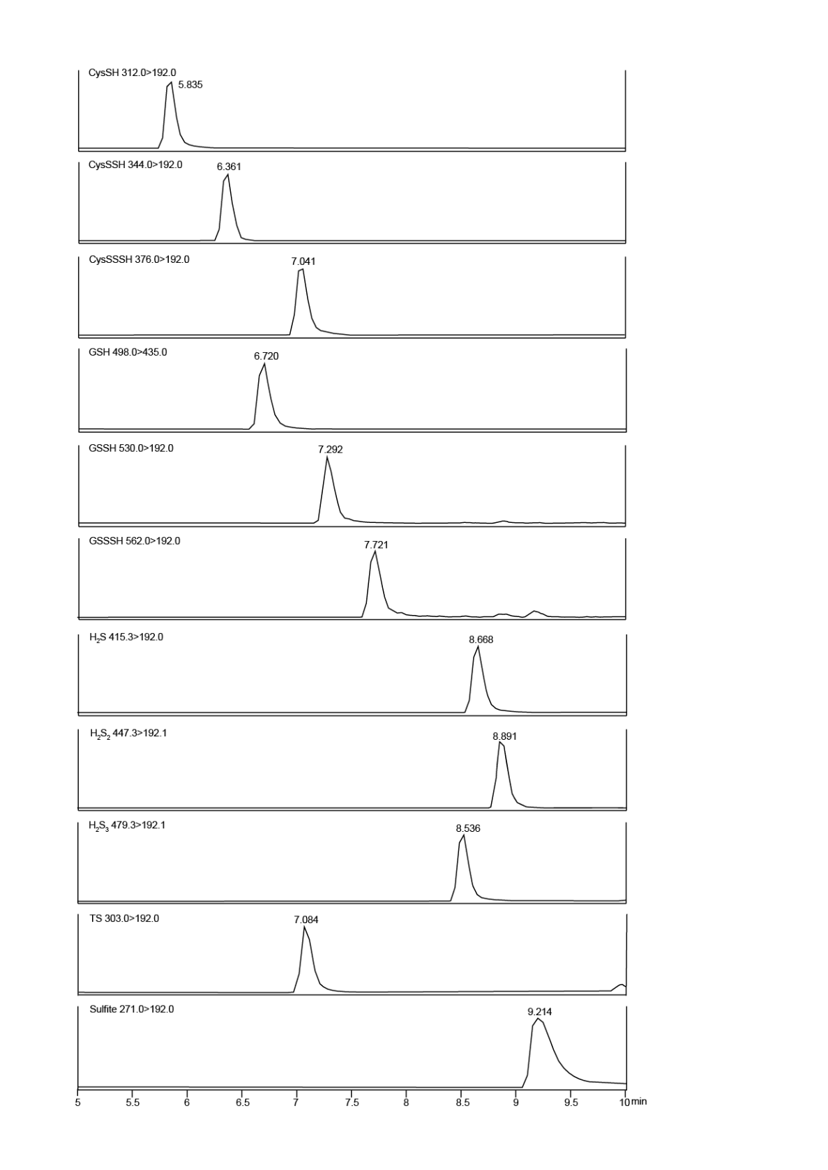
Supplementary Fig. S1 | A representative chromatogram of LC-tandem mass spectrometry (LC-MS/MS). LC-MS/MS chromatograms are shown for monobromobimane adducts of S1 (H₂S), S2 (H₂S₂), S3 (H₂S₃), Cys-SH, Cys-SSH, GSH, GSSH, GSSSH, thiosulfate (TS), and sulfite. Note: S1, S2 and S3 are detected as di-bimane adducts, while others are mono-bimane adducts.

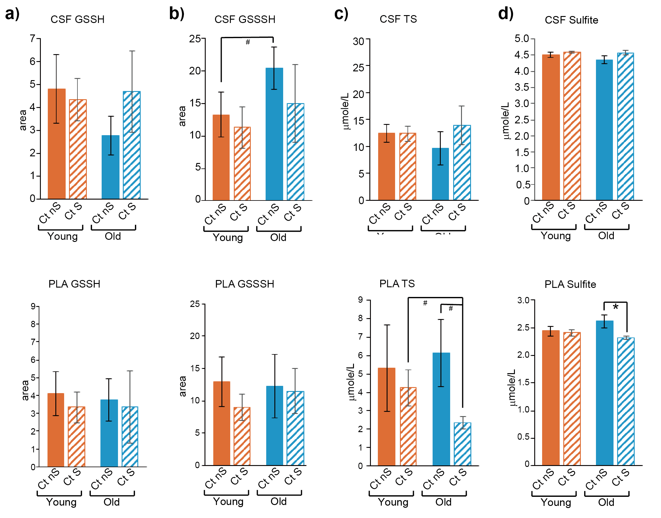
Supplementary Fig. S2 | Endogenous levels of GSSH, GSSSH, thiosulfate, and sulfite in the CSF and PLA of control young and old smokers and non-smokers. a-d, Endogenous levels of GSSH (a), GSSSH (b), thiosulfate (TS) (c), and sulfite (d) in the CSF (upper row) and PLA (lower row) obtained from control (Ct) young (37–56 years old) smokers (S) (n = 7) and non-smokers (nS) (n = 5) and control old (57-71 years old) smokers (n = 3) and non-smokers (n = 5). Both CSF and PLA were obtained from the same individuals. *p<0.05, **p<0.01 indicate significantly different, and #p<0.1 indicate tendency, Student t-test. All data are presented as mean ± SEM.

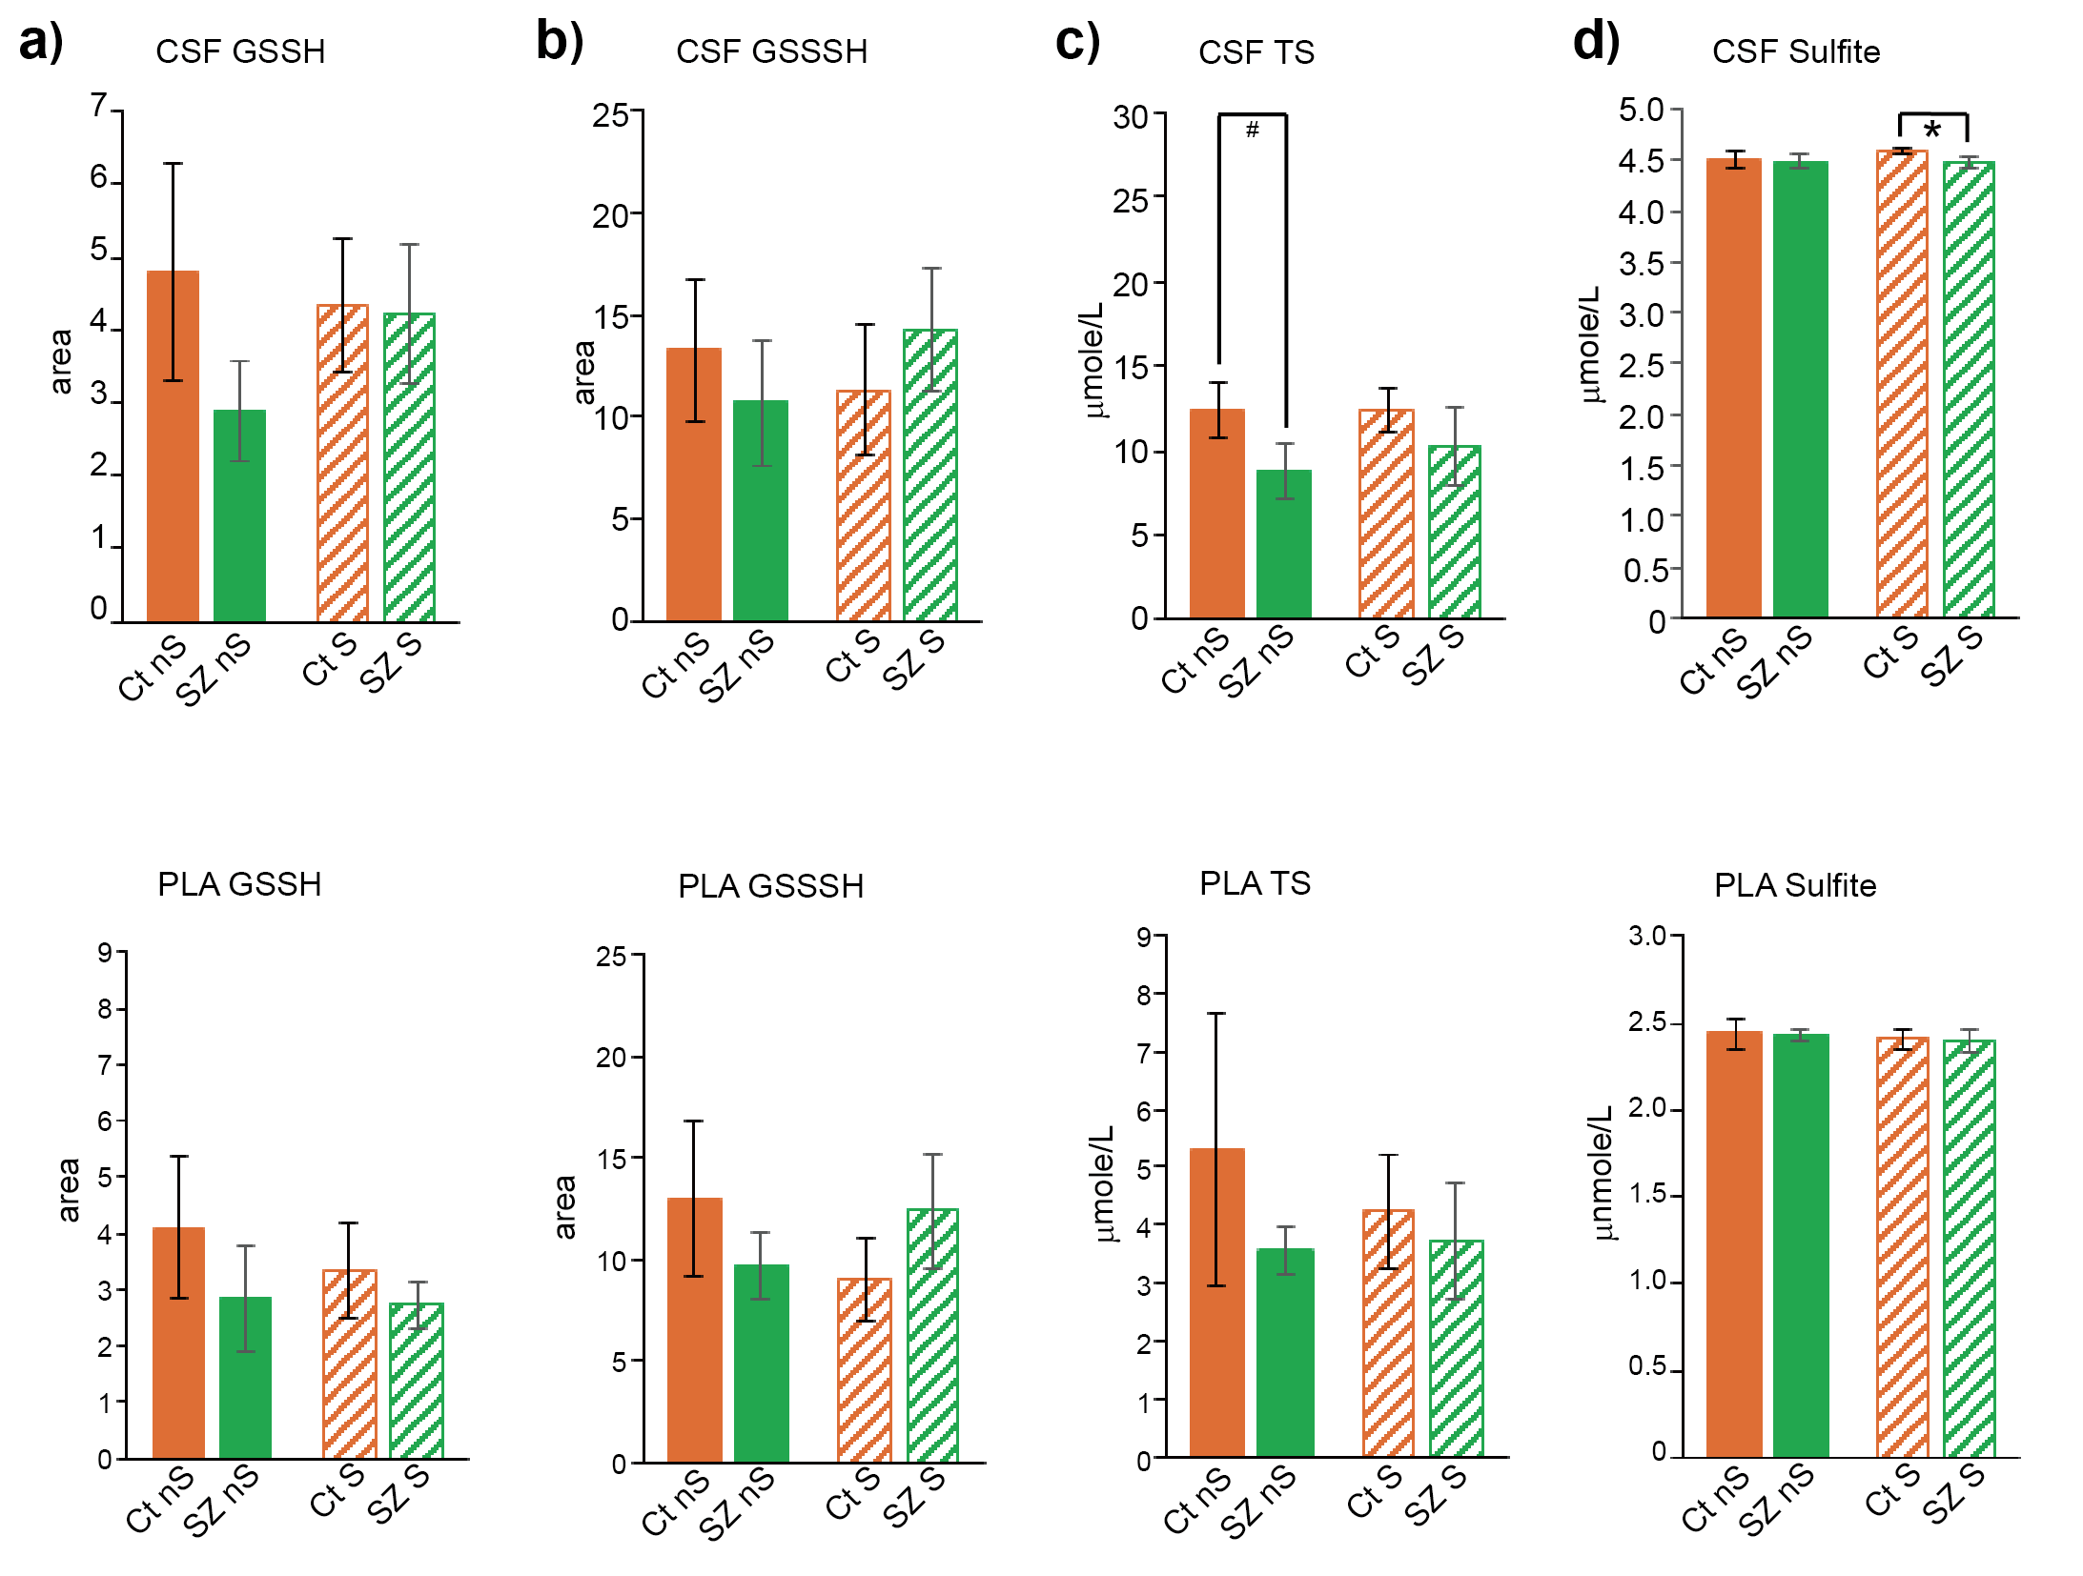

Supplementary Fig. S3 | Endogenous levels of GSSH, GSSSH, thiosulfate, and sulfite in the CSF and PLA of SZ smokers and non-smokers compared with control young smokers and non-smokers. a-h, Endogenous levels of GSSH (a), GSSSH (b), thiosulfate (TS) (c), and sulfite (d) in the CSF (upper row) and PLA (lower row) obtained from SZ (36–56 years old) smokers (S) (n = 10) and non-smokers (nS) (n = 10) and control (Ct) young (37–56 years old) smokers (n = 7) and non-smokers (n = 5) were compared. Both CSF and PLA were obtained from the same individuals. *p<0.05, **p<0.01 indicate significantly different, and #p<0.1 indicate tendency, Student t-test. All data are presented as mean ± SEM.

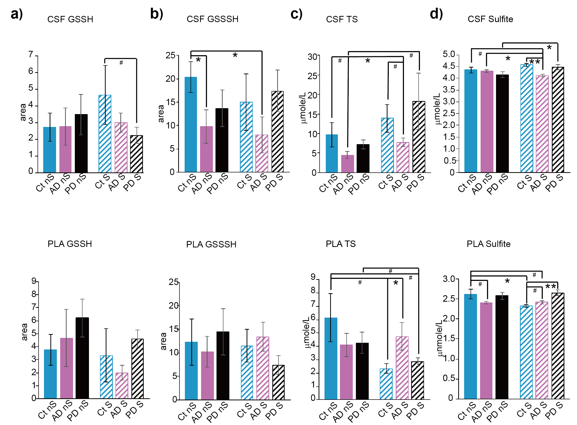
Supplementary Fig. S4 | Endogenous levels of GSSH, GSSSH, thiosulfate, and sulfite in the CSF and PLA of AD and PD smokers and non-smokers compared with control old smokers and non-smokers. a-h, Endogenous levels of GSSH (a), GSSSH (b), thiosulfate (TS) (c), and sulfite (d) in the CSF (upper row) and PLA (lower row) obtained from AD (57–81 years old) smokers (S) (n = 5) and non-smokers (nS) (n = 5), PD (57–74 years old) smokers (n = 6) and non-smokers (n = 6), and control (Ct) old (57–73 years old) smokers (n = 3) and non-smokers (n = 5) were compared. Both CSF and PLA samples were obtained from the same individuals. *p<0.05, **p<0.01 indicate significantly different, and #p<0.1 indicate tendency, Student t-test. All data are presented as mean ± SEM.

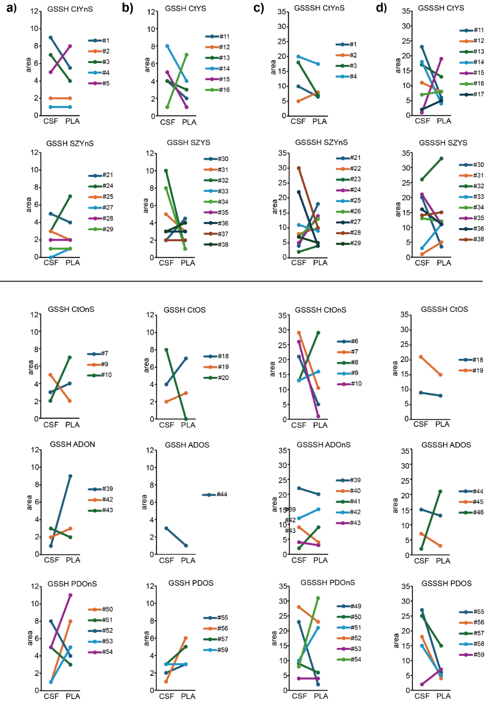
Supplementary Fig. S5 | Changes in localization of GSSH and GSSSH between CSF and PLA of patients with SZ, AD, and PD compared with those of control individuals, and the effects of smoking habits. a-d, Endogenous levels of GSSH (a, b), and GSSSH (c, d) in the CSF and PLA obtained from the same control (Ct) young (Y) (first row), SZ (second row), control old (O) (third row), AD (forth row), and PD (fifth row) non-smokers (nS) (a, c) and smokers (S) (b, d) were compared. The number of samples is indicated on the right side of each figure as a line corresponding to each color. Note: Data for GSSH levels in patients with AD from the same individuals could not be obtained.

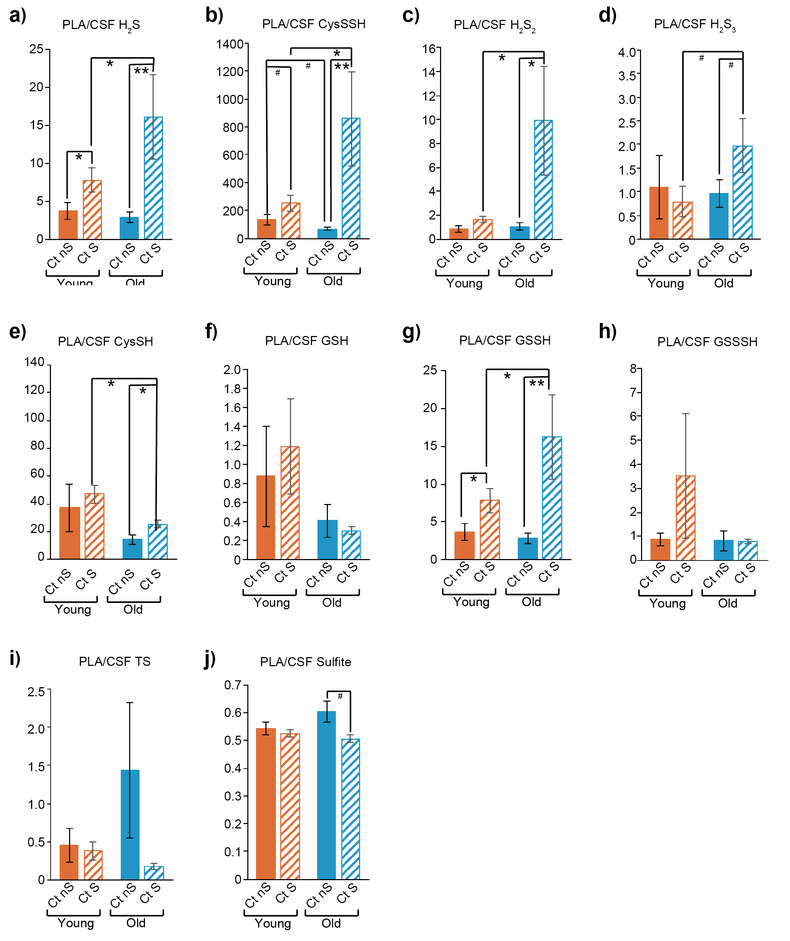
Supplementary Fig. S6 | PLA/CSF ratio of H₂S, polysulfides, and related molecules in control young and old smokers and non-smokers. a–j. PLA/CSF ratio of H₂S (a), CysSSH (b), H₂S₂ (c), H₂S₃ (d), CysSH (e), GSH (f), GSSH (g), GSSSH (h), thiosulfate (TS) (i), and sulfite (j) compared between control (Ct) young individuals (37–56 years old) (smokers (S): n = 7, non-smokers (nS): n = 5) and the old counterparts (57–73 years old) (smokers: n = 3, non-smokers: n = 5). Both CSF and PLA samples were obtained from the same individuals. *p<0.05, **p<0.01 indicate significantly different, and #p<0.1 indicate tendency, Student t-test. All data are presented as mean ± SEM.

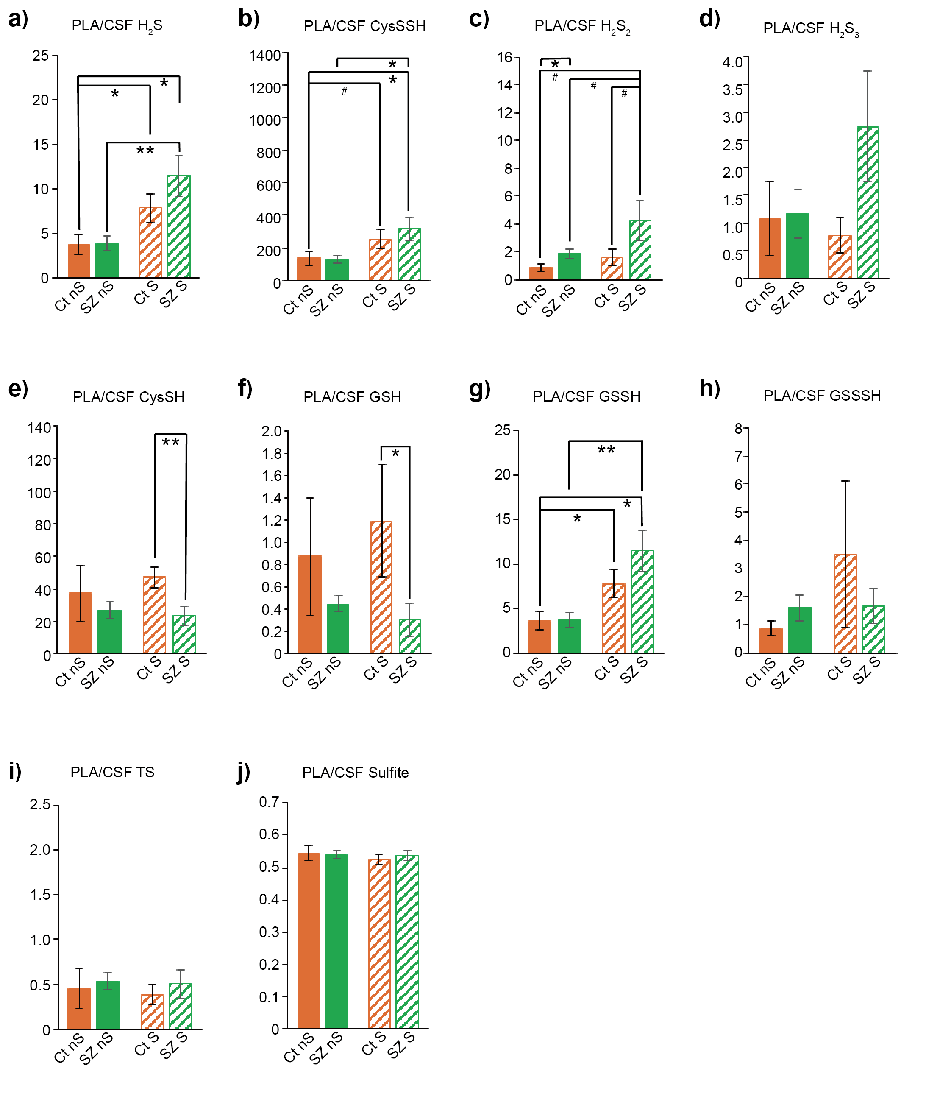
Supplementary Fig. S7 | PLA/CSF ratio of H₂S, polysulfides, and related molecules in SZ and control young smokers and non-smokers. a–j. PLA/CSF ratio of H₂S (a), CysSSH (b), H₂S₂ (c), H₂S₃ (d), CysSH (e), GSH (f), GSSH (g), GSSSH (h), thiosulfate (TS) (i), and sulfite (j) in patients with SZ (35–56 years old) (smokers (S): n = 10, non-smokers (nS): n = 10) compared with control (Ct) young individuals (37–56 years old) (smokers: n = 7, non-smokers: n = 5). Both CSF and PLA samples were obtained from the same individuals. *p<0.05, **p<0.01 indicate significantly different, and #p<0.1 indicate tendency, Student t-test. All data are presented as mean ± SEM.

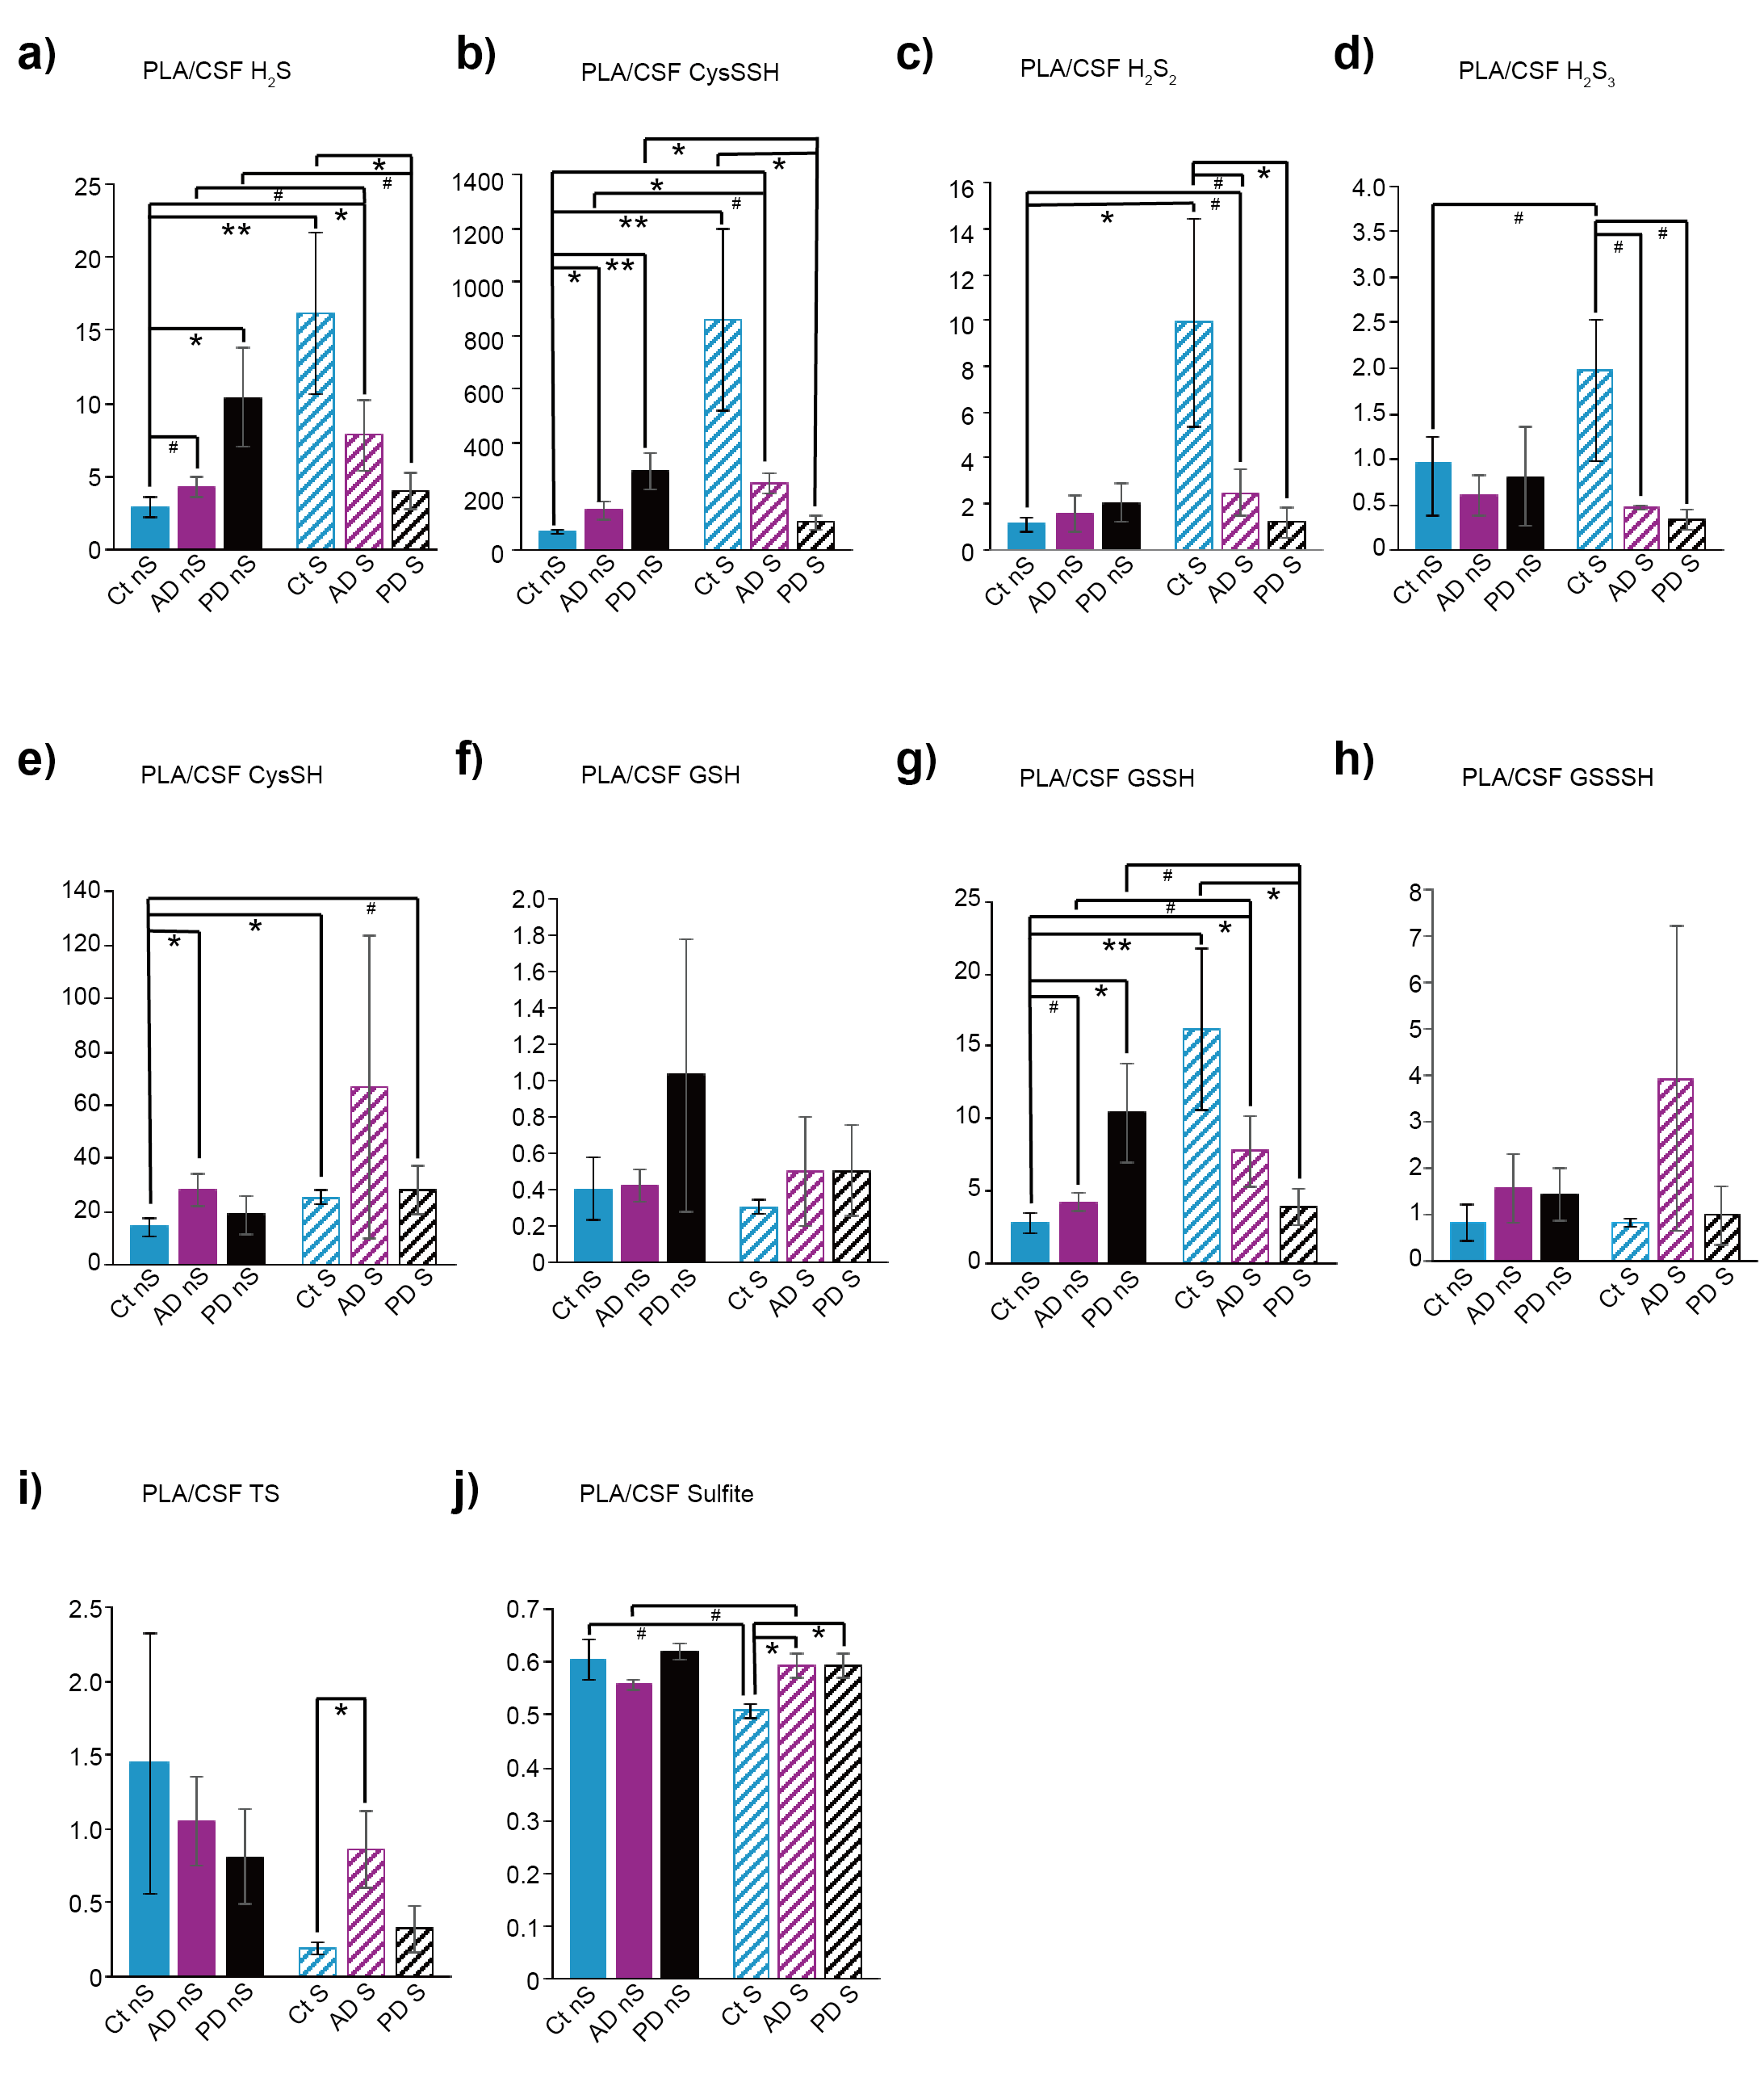
Supplementary Fig. S8 | PLA/CSF ratio of H₂S, polysulfides, and related molecules in AD, PD and control old smokers and non-smokers. a–j. PLA/CSF ratio of H₂S (a), CysSSH (b), H₂S₂ (c), H₂S₃ (d), CysSH (e), GSH (f), GSSH (g), GSSSH (h), thiosulfate (TS) (i), and sulfite (j) in patients with AD (57–81 years old) (smokers (S): n = 5, non-smokers (nS): n = 5) and PD (57–74 years old) (smokers: n = 6, non-smokers: n = 6) compared with control (Ct) old individuals (59–73 years old) (smokers: n = 3, non-smokers: n = 5). Both CSF and PLA samples were obtained from the same individuals. *p<0.05, **p<0.01 indicate significantly different, and #p<0.1 indicate tendency, Student t-test. All data are presented as mean ± SEM.

