Supplemental Material for
"Study of the ACT-R Model to Reproduce the Variation in Response Time for Addition Tasks derived from Experiments"
Preamble
This document provides supplementary figures for the main manuscript. The main text of the paper presents experimental results from a representative participant (Participant 1). For the model performance comparisons against experimental data, the results for Set 3 of Participant 1 are shown as the representative case. To demonstrate the robustness and consistency of our findings, this supplemental material contains the model comparison figures for the remaining sets of Participant 1 (Sets 4 and 5), in addition to the full set of experimental and model comparison figures for all other analyzed participants (Participants 2, 3, and 4).
Participant 1: Additional Results
A. Proposed Model Performance vs. Experimental Data (corresponding to Section 5.2)
- Figure S1. Comparison of proposed model simulations and experimental data for Participant 1 (Set 4).
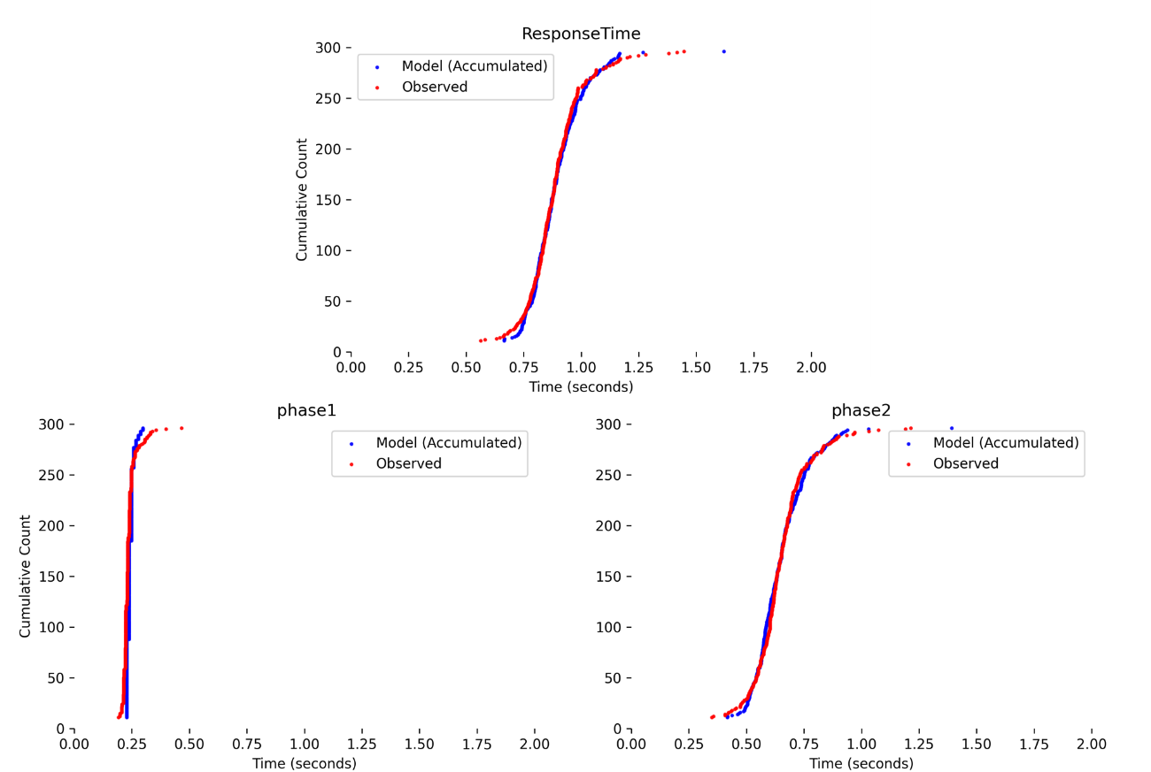
- Figure S2. Comparison of proposed model simulations and experimental data for Participant 1 (Set 5).
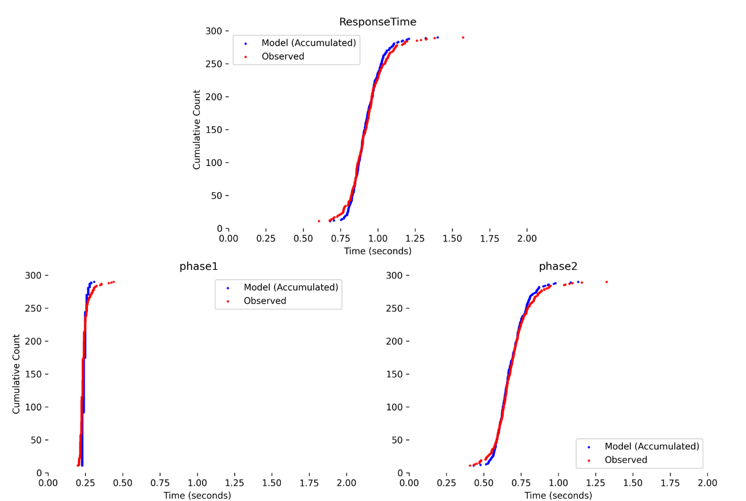
B. Previous Model Performance vs. Experimental Data (corresponding to Section 5.3)
- Figure S3. Comparison of previous model simulations and experimental data for Participant 1 (Set 4).
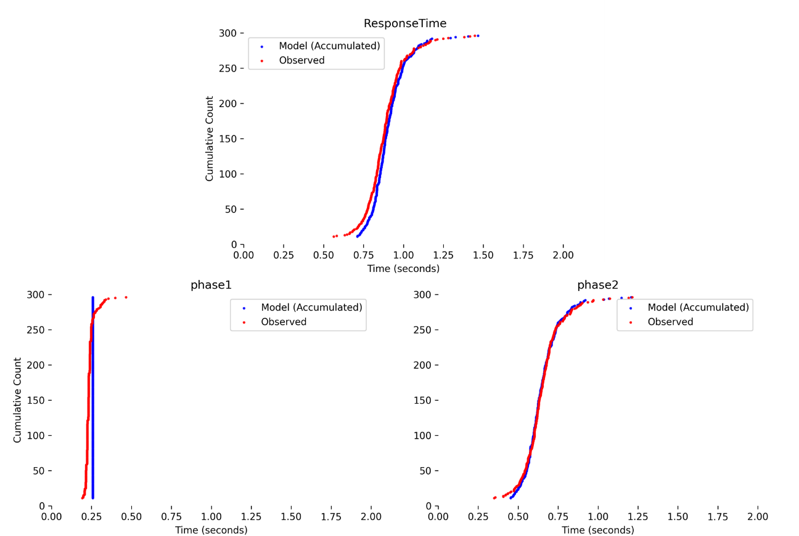
- Figure S4. Comparison of previous model simulations and experimental data for Participant 1 (Set 5).
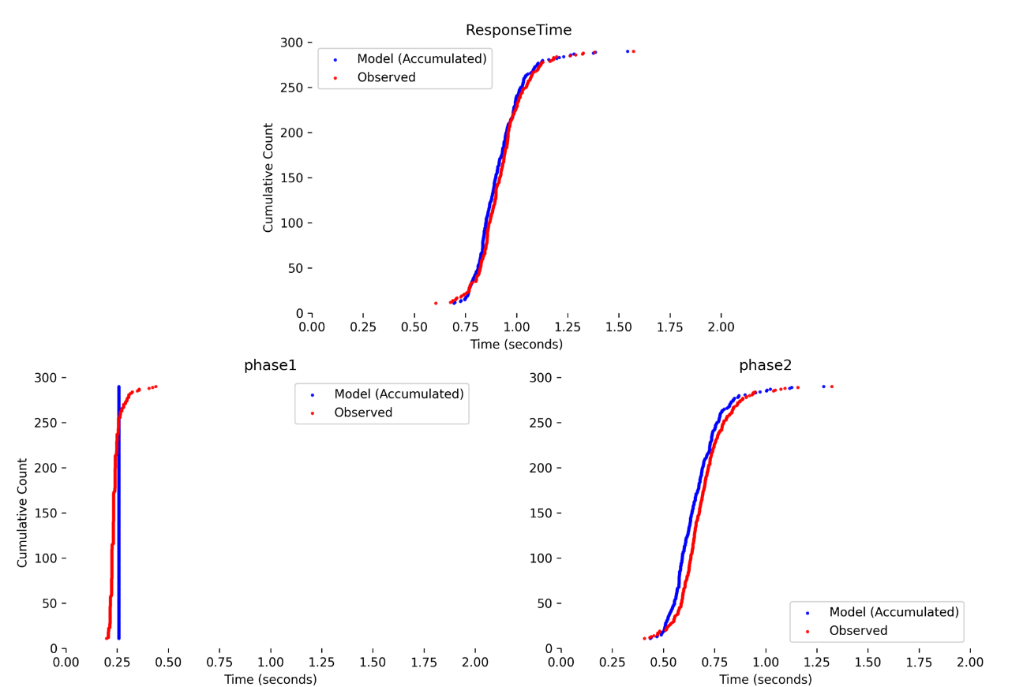
Participant 2: Results
A. Experimental Results (corresponding to Section 5.1)
- Figure S5. Cumulative response time distributions for Participant 2.
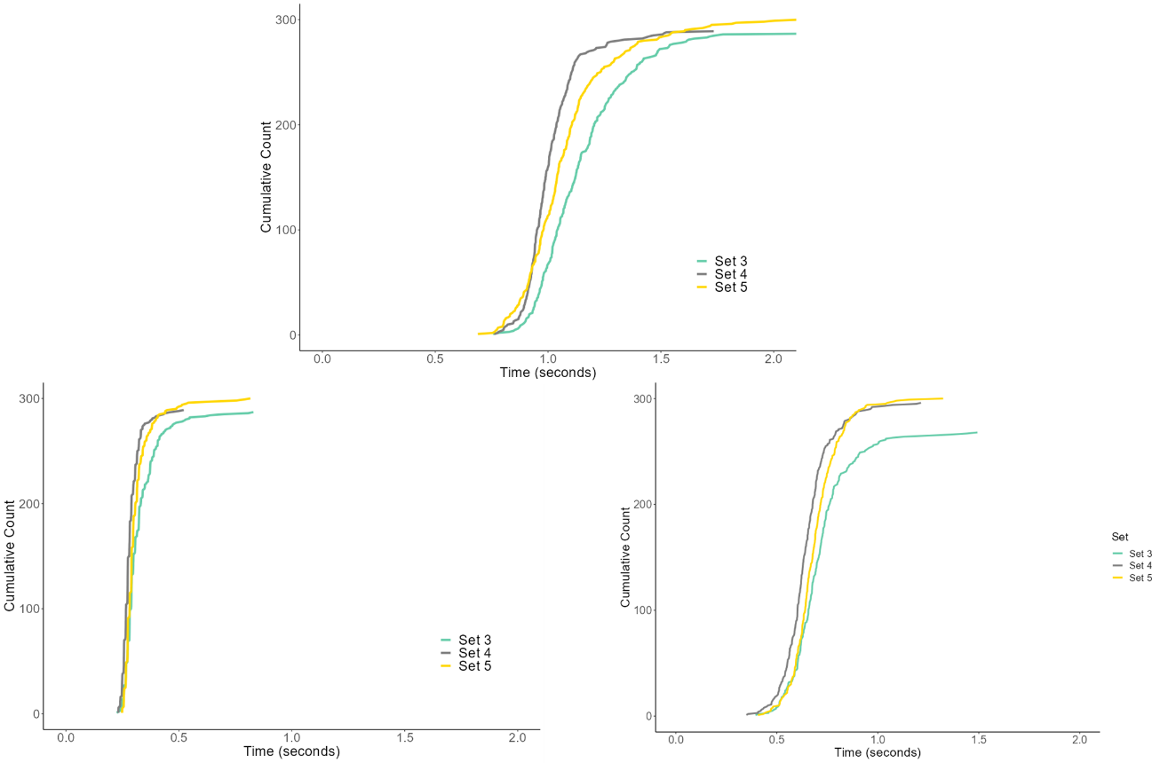
B. Proposed Model Performance vs. Experimental Data (corresponding to Section 5.2)
- Figure S6 Comparison of proposed model simulations and experimental data for Participant 2 (Set 3).
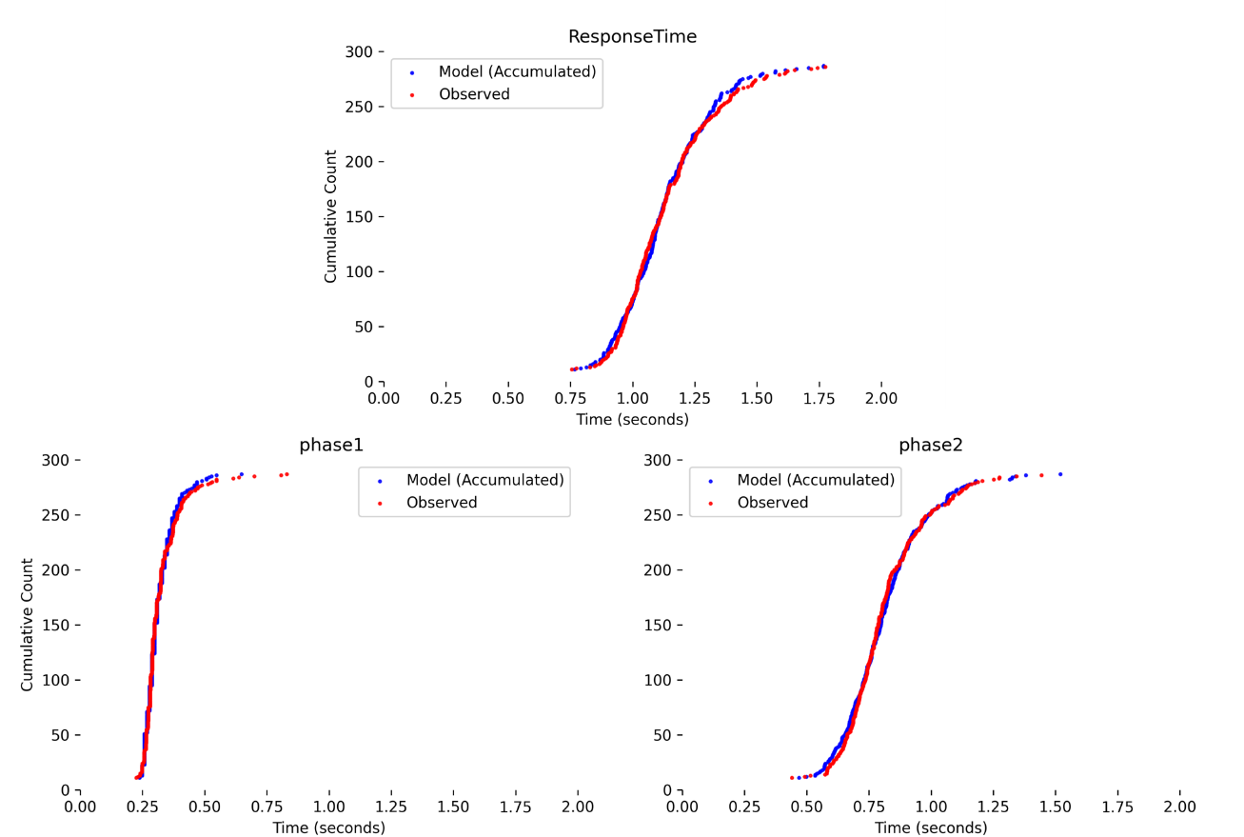
- Figure S7 Comparison of proposed model simulations and experimental data for Participant 2 (Set 4).
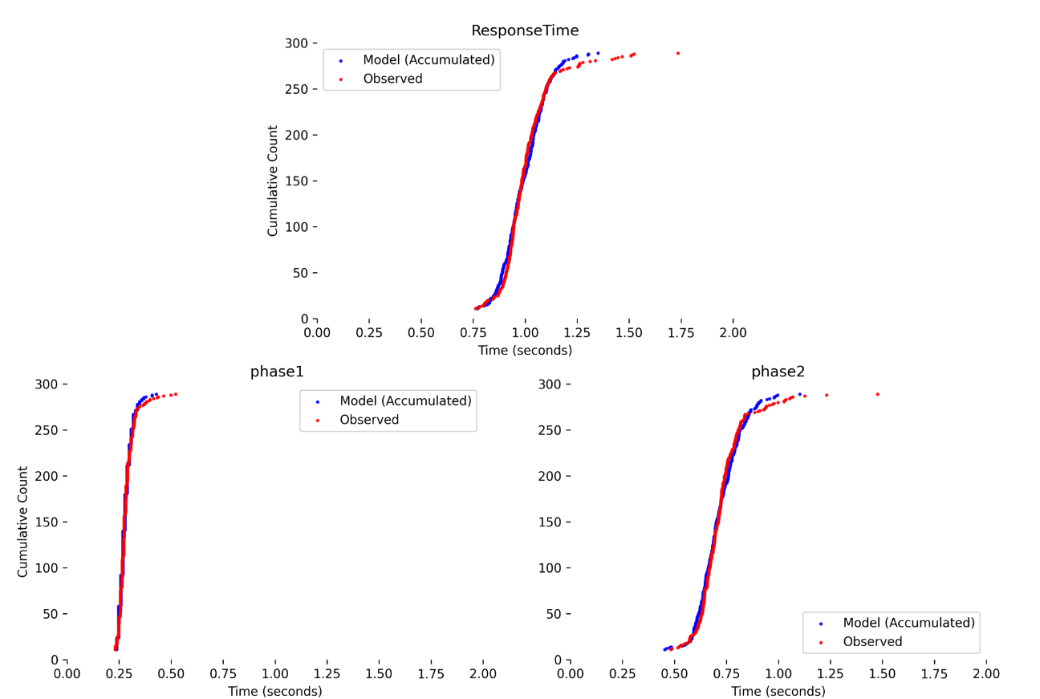
- Figure S8 Comparison of proposed model simulations and experimental data for Participant 2 (Set 5).
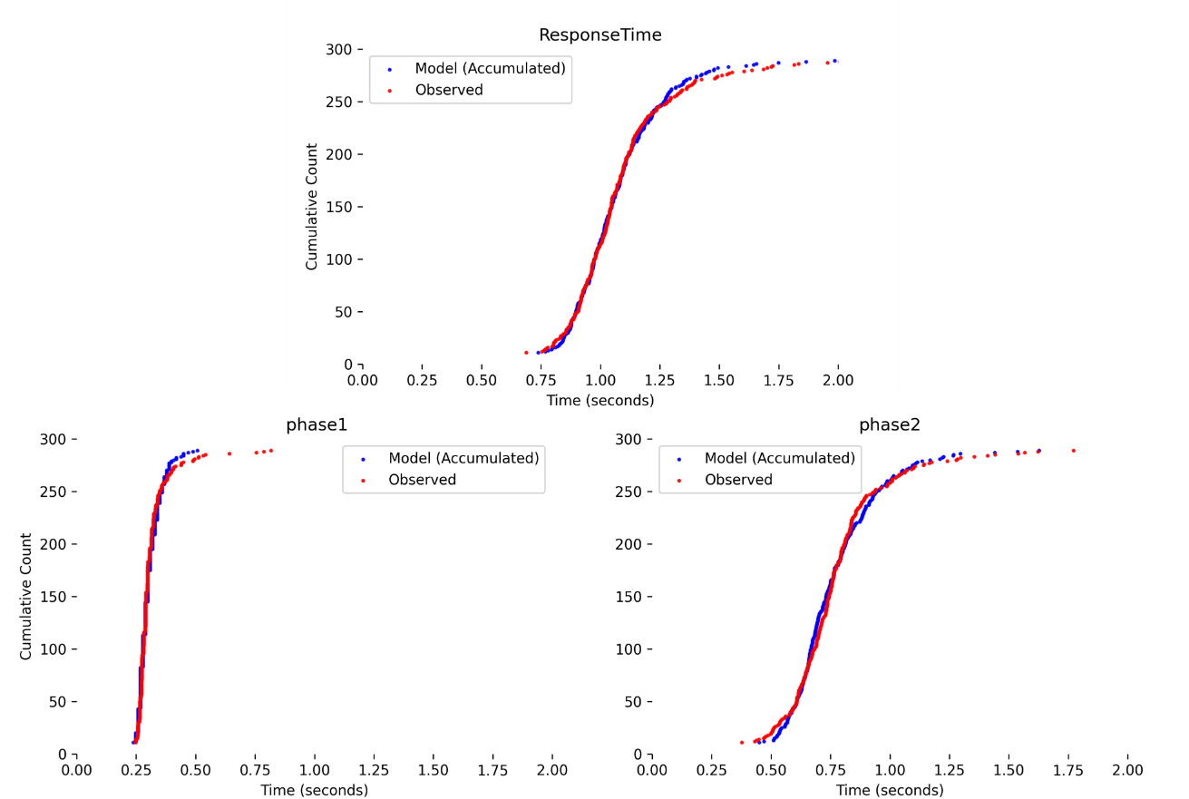
C. Previous Model Performance vs. Experimental Data (corresponding to Section 5.3)
- Figure S9 Comparison of previous model simulations and experimental data for Participant 2 (Set 3).
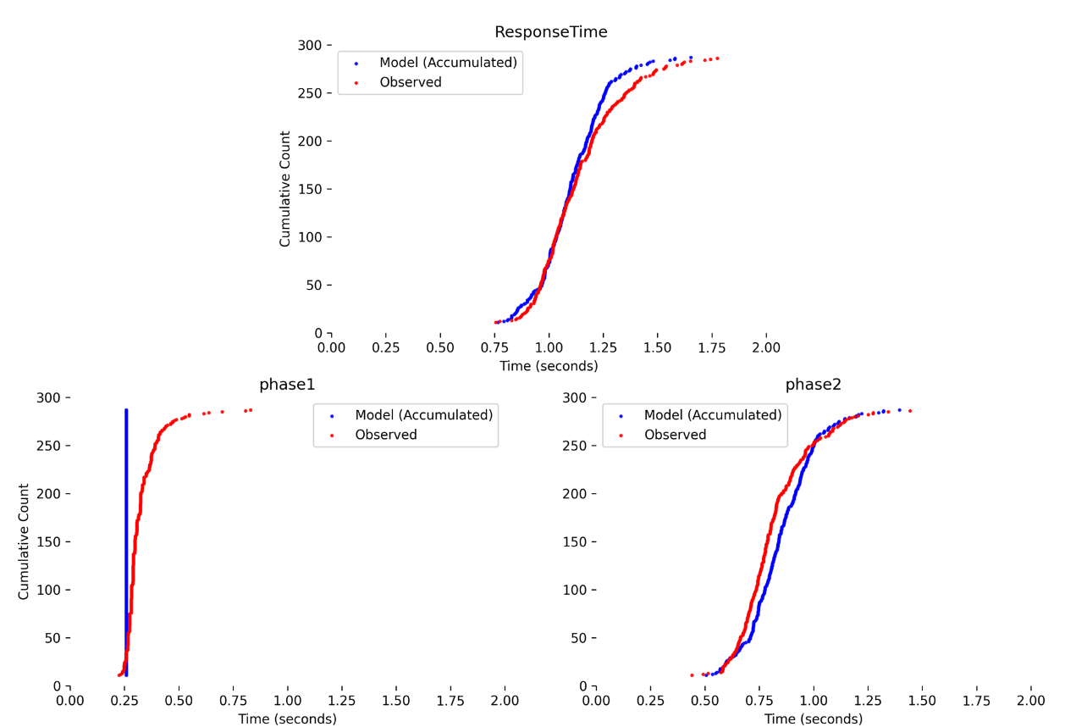
- Figure S10 Comparison of previous model simulations and experimental data for Participant 2 (Set 4).
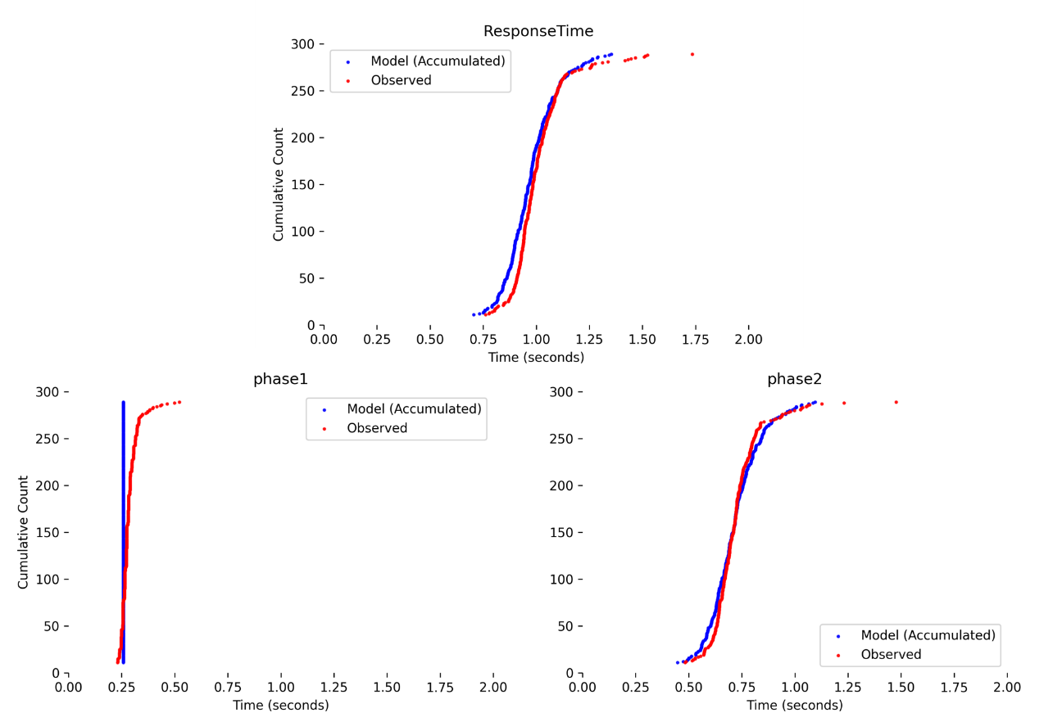
- Figure S11 Comparison of previous model simulations and experimental data for Participant 2 (Set 5).
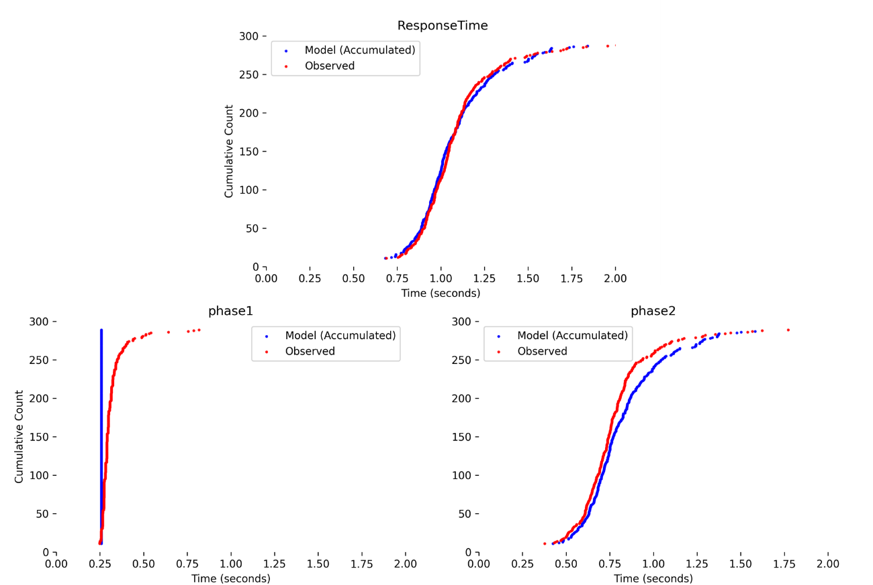
Participant 3: Results
A. Experimental Results (corresponding to Section 5.1)
- Figure S12. Cumulative response time distributions for Participant 2.
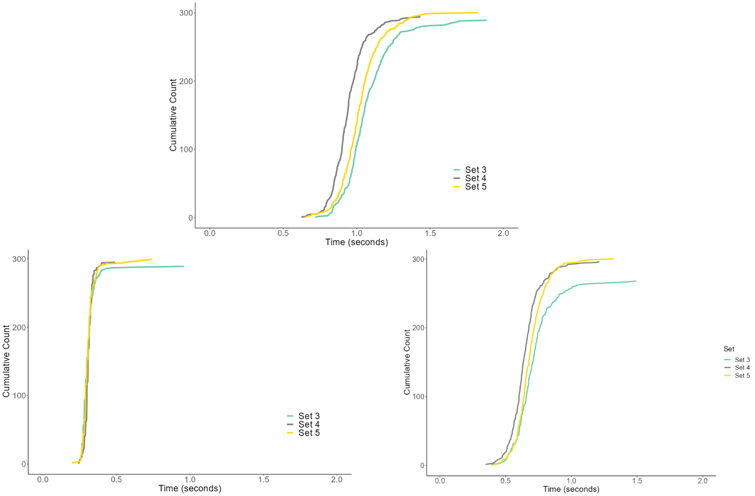
B. Proposed Model Performance vs. Experimental Data (corresponding to Section 5.2)
- Figure S13 Comparison of proposed model simulations and experimental data for Participant 2 (Set 3).
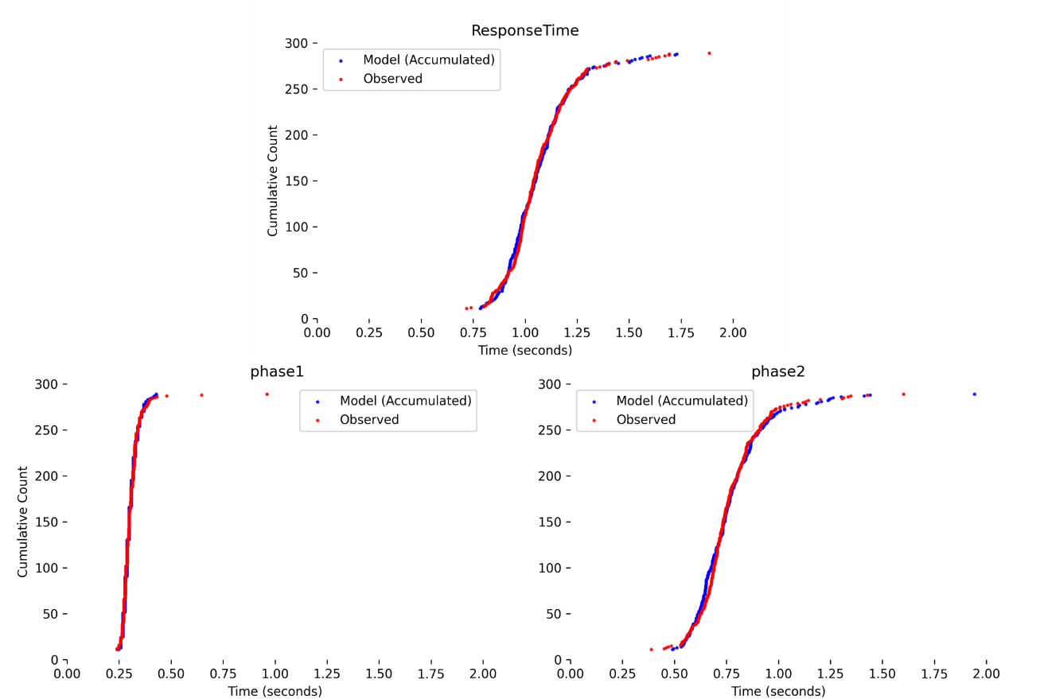
- Figure S14 Comparison of proposed model simulations and experimental data for Participant 2 (Set 4).
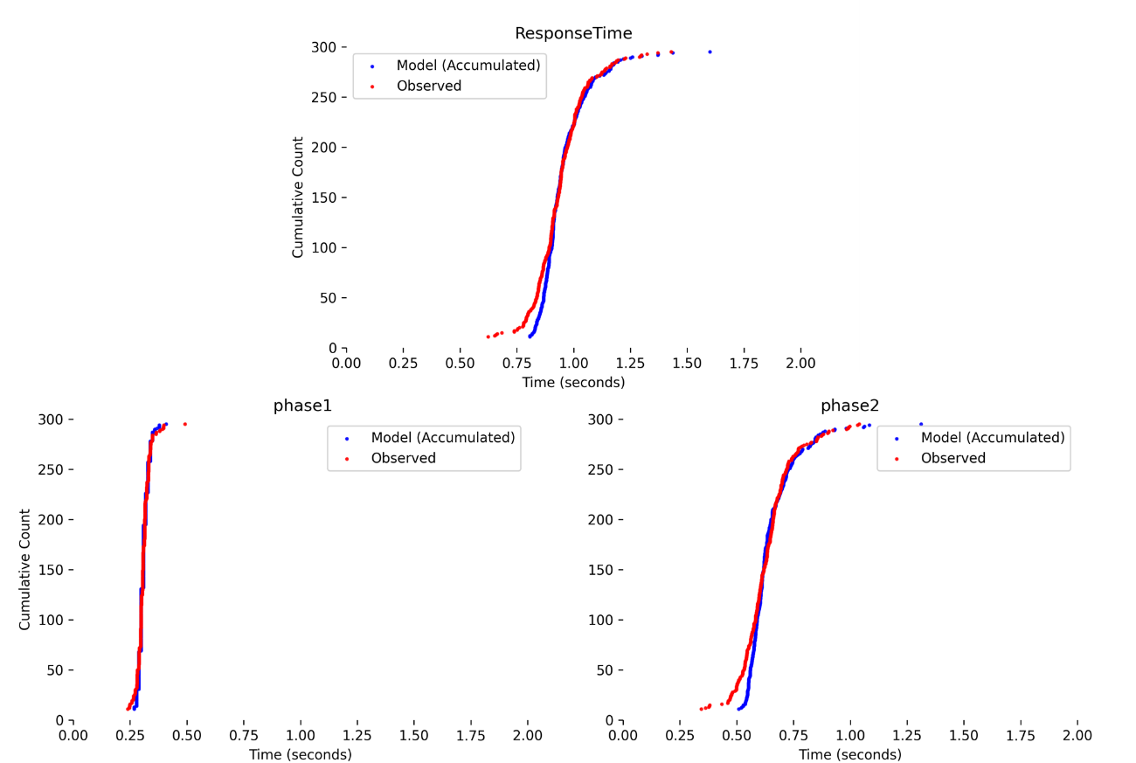
- Figure S15 Comparison of proposed model simulations and experimental data for Participant 2 (Set 5).
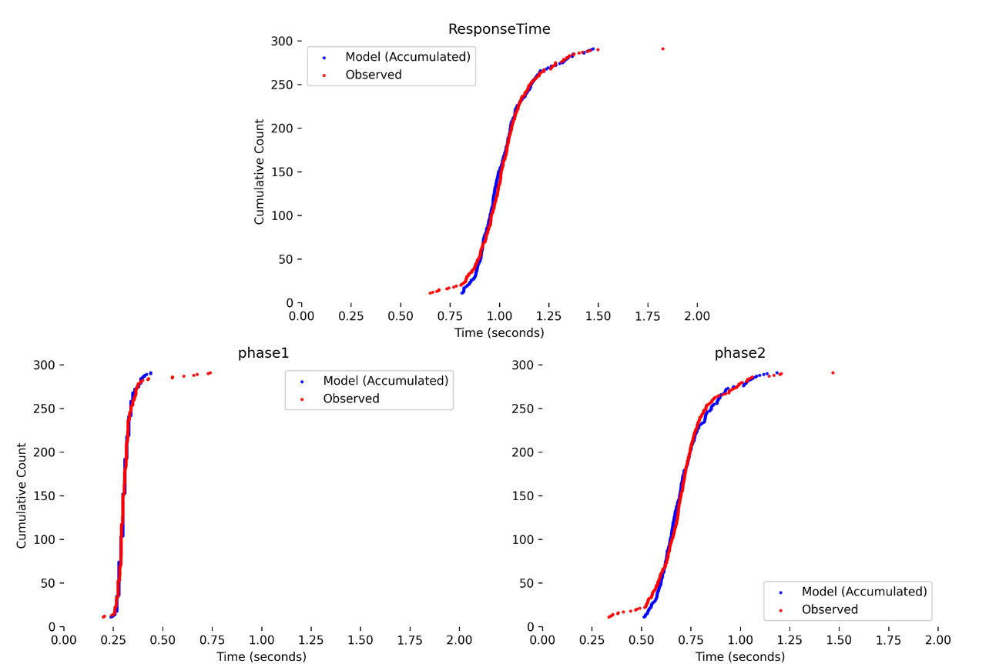
C. Previous Model Performance vs. Experimental Data (corresponding to Section 5.3)
- Figure S16 Comparison of previous model simulations and experimental data for Participant 2 (Set 3).
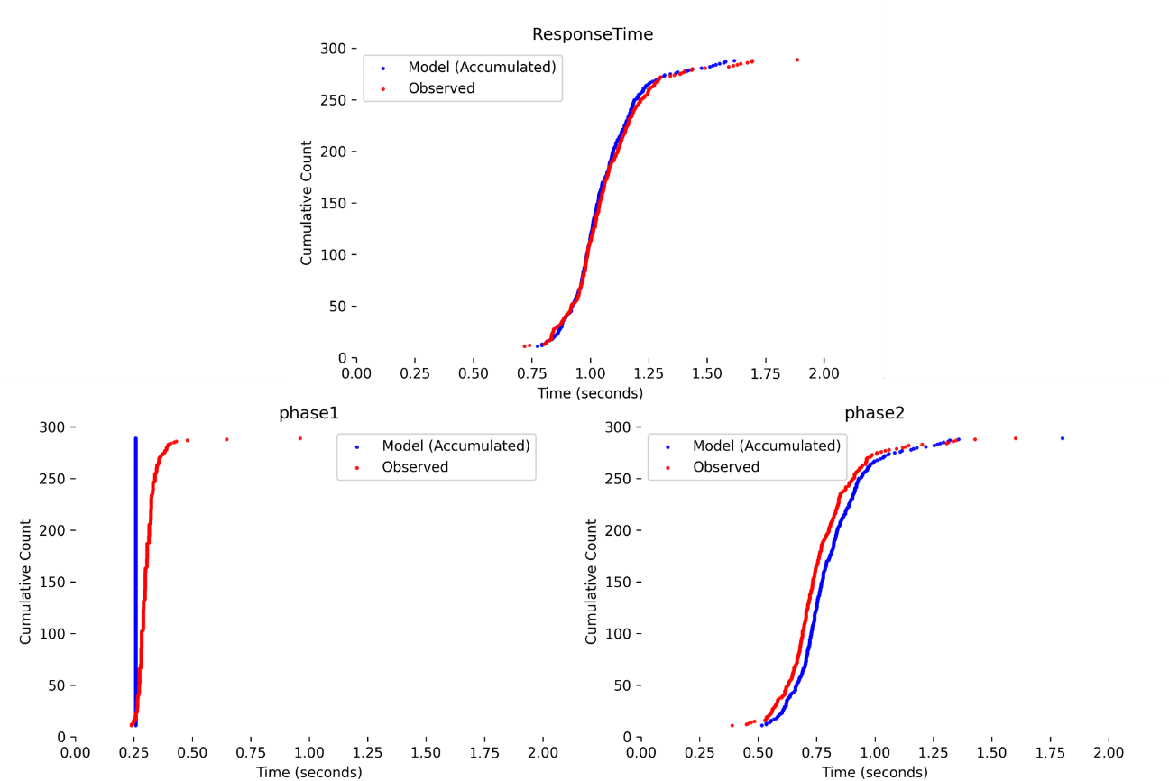
- Figure S17 Comparison of previous model simulations and experimental data for Participant 2 (Set 4).
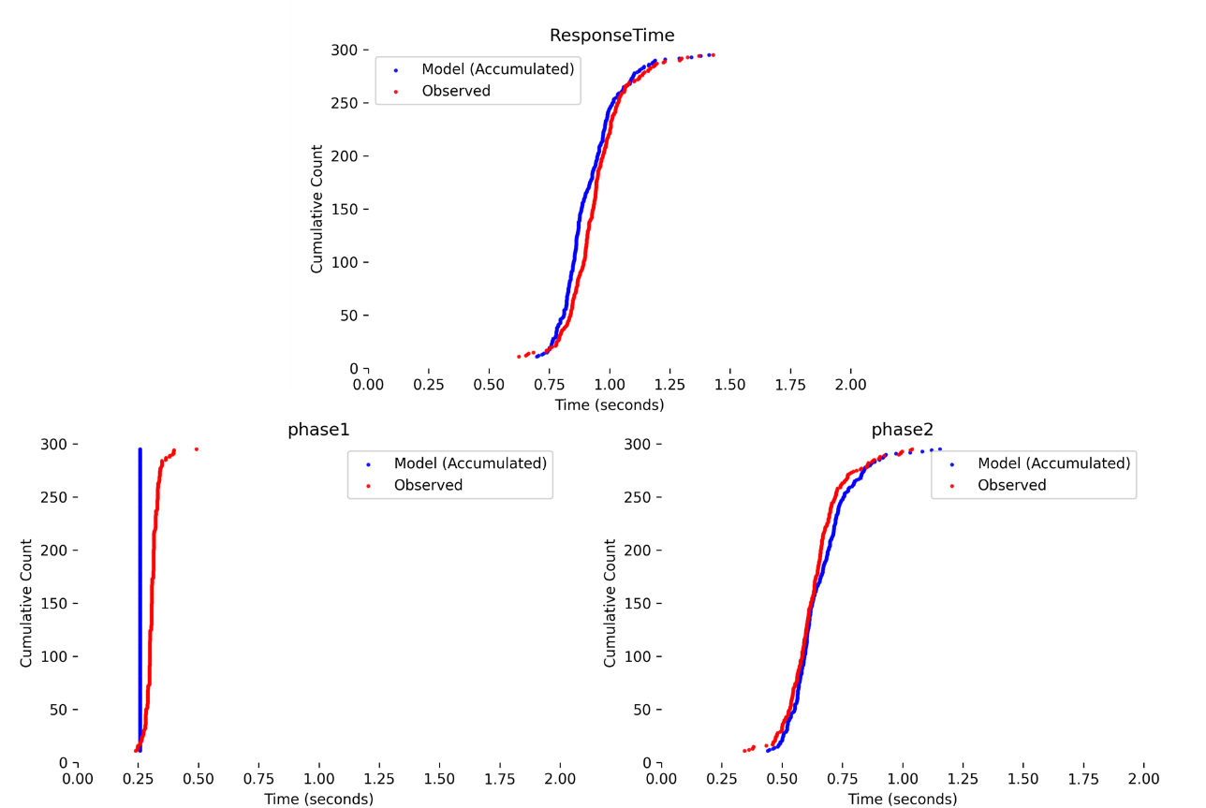
- Figure S18 Comparison of previous model simulations and experimental data for Participant 2 (Set 5).
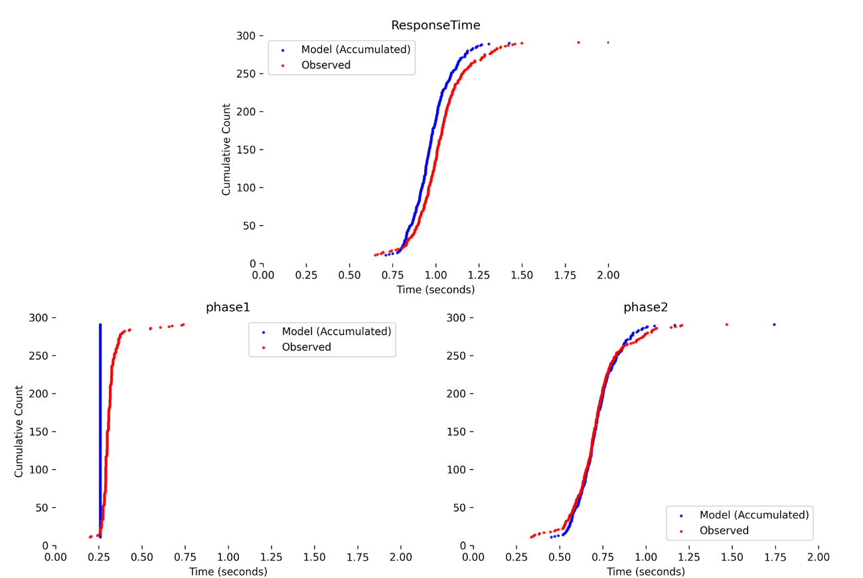
Participant 4: Results
A. Experimental Results (corresponding to Section 5.1)
- Figure S19. Cumulative response time distributions for Participant 2.
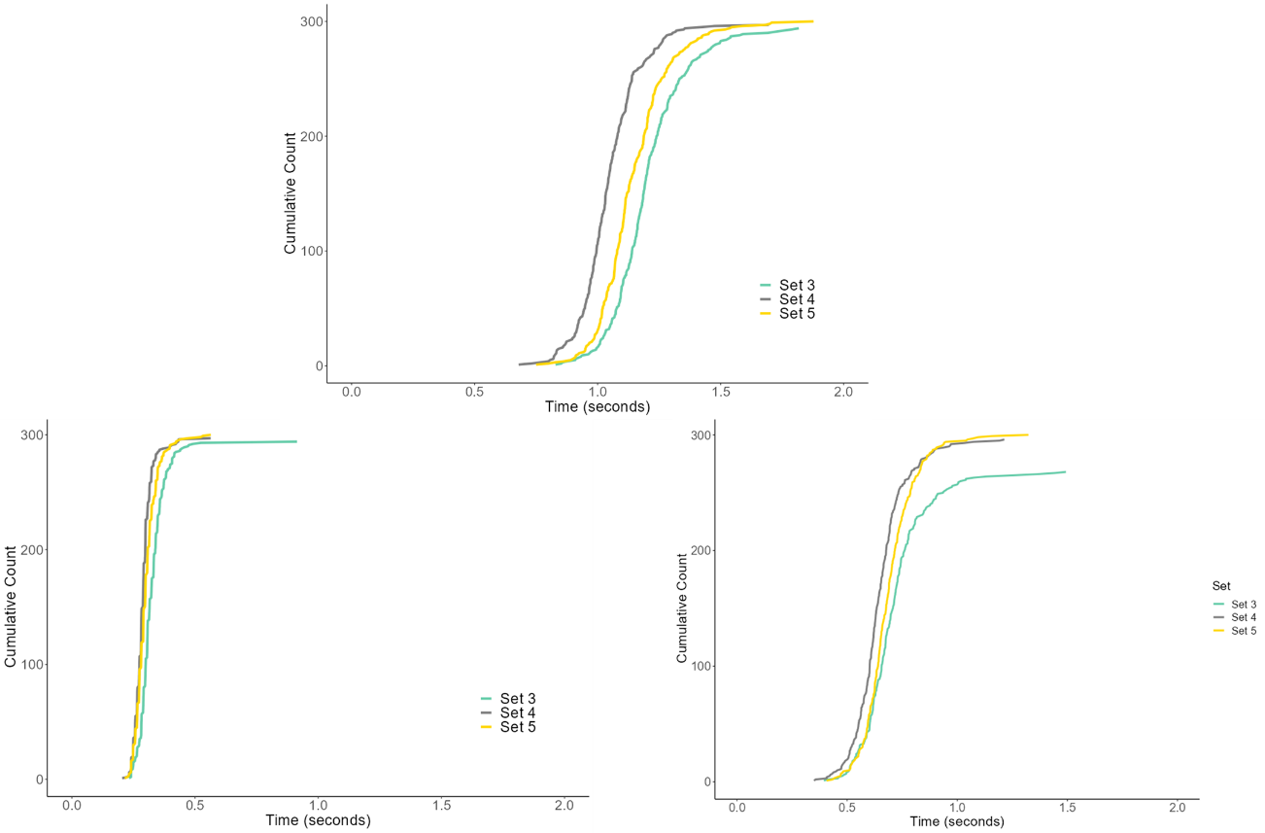
B. Proposed Model Performance vs. Experimental Data (corresponding to Section 5.2)
- Figure S20 Comparison of proposed model simulations and experimental data for Participant 2 (Set 3).
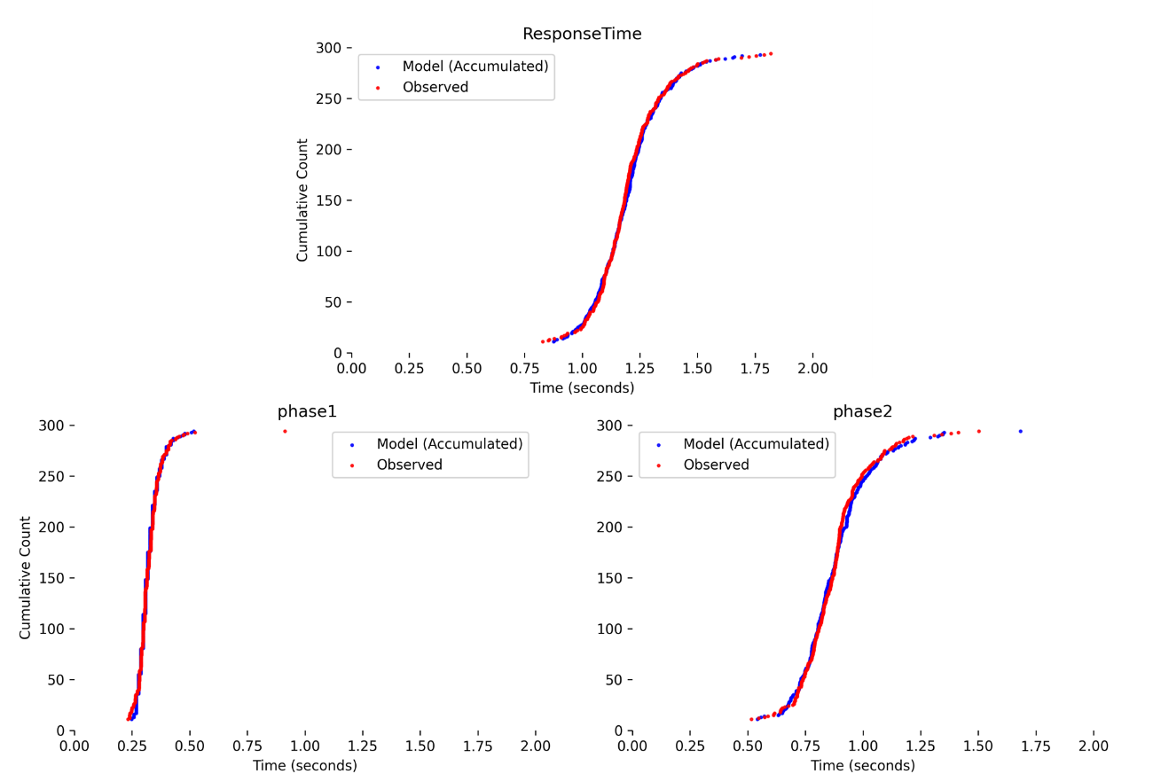
- Figure S21 Comparison of proposed model simulations and experimental data for Participant 2 (Set 4).
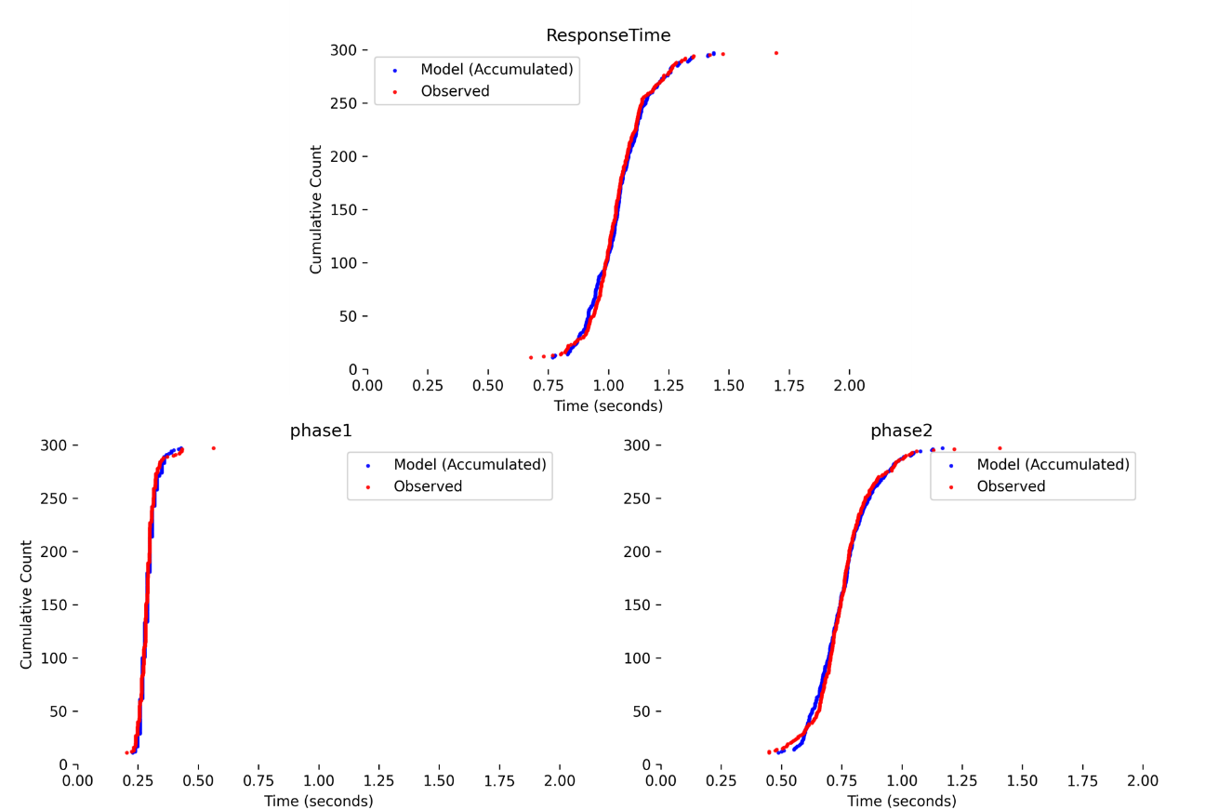
- Figure S22 Comparison of proposed model simulations and experimental data for Participant 2 (Set 5).
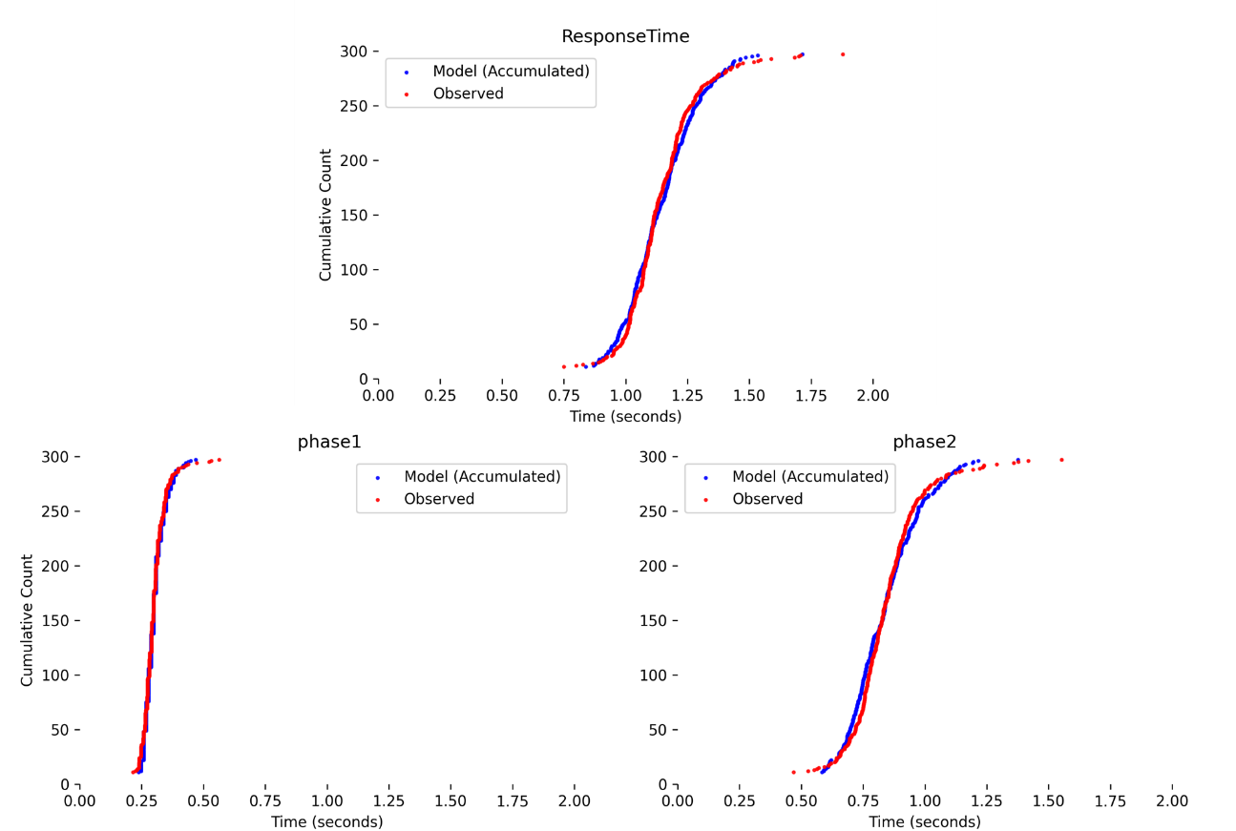
C. Previous Model Performance vs. Experimental Data (corresponding to Section 5.3)
- Figure S23 Comparison of previous model simulations and experimental data for Participant 2 (Set 3).
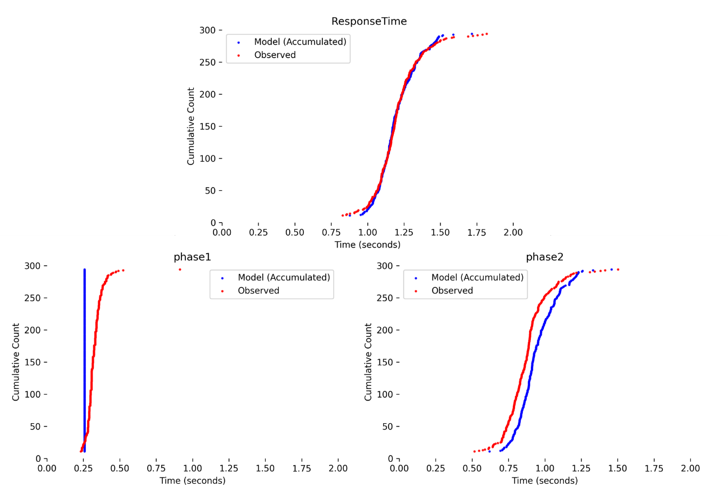
- Figure S24 Comparison of previous model simulations and experimental data for Participant 2 (Set 4).
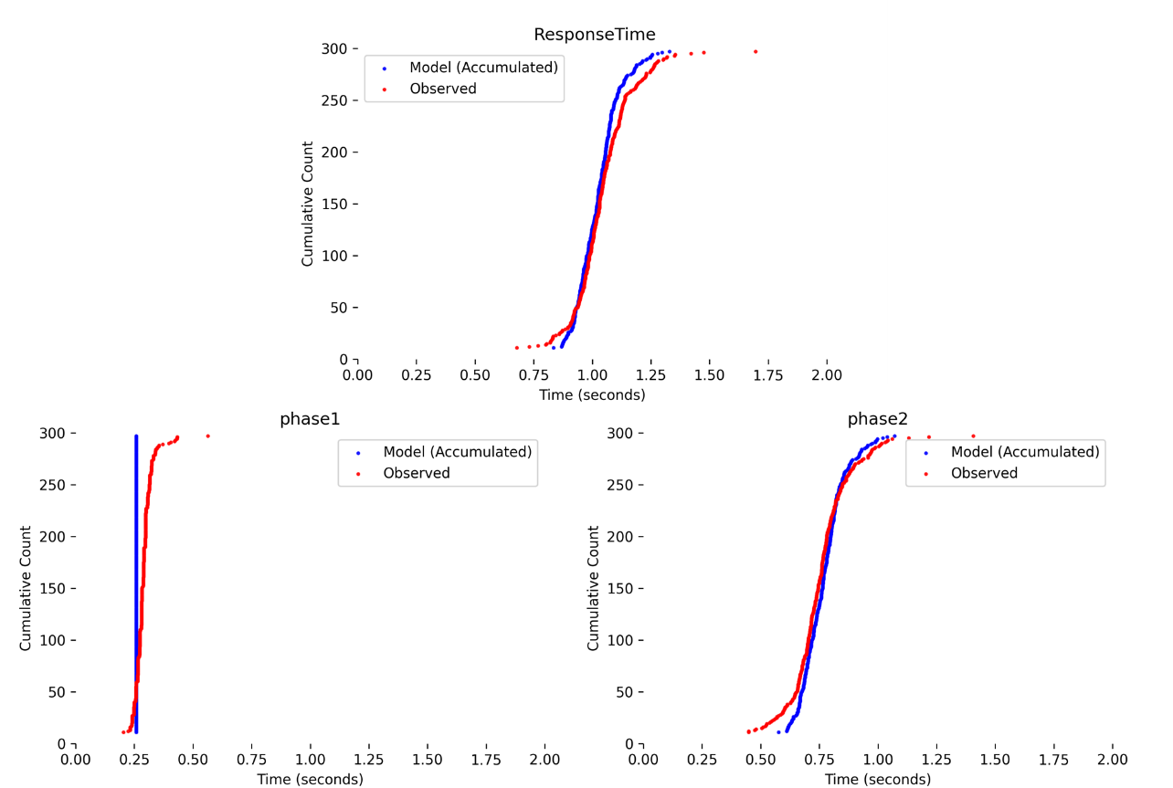
- Figure S25 Comparison of previous model simulations and experimental data for Participant 2 (Set 5).
