Differential responses of termite gut bacterial and fungal community to tropical forest conversion

Zhizhou Jia^{1,2}, Yuanyuan Meng¹*, Wenting Wang², Jocelyn Behm³, Feng M. Cai¹, Sandhya Mishra², Shangwen Xia², Shengjie Liu^{1,2}*, Xiaodong Yang²

Supplementary information

Termite species | Ancistrotermes dimorphus |  | Odontotermes angustignathus |  | Odontotermes gravelyi |  | Odontotermes yunnanensis
Forest type | Natural forest | Rubber plantation | Natural forest | Rubber plantation | Natural forest | Rubber plantation | Natural forest | Rubber plantation
Replicate | 8 | 10 | 5 | 3 | 4 | 5 | 7 | 16
Table S1 The replicate for each termite species in natural forests and rubber plantations.

Table S2 Effects of forest type, termite species and their interactions explain the gut microbiome variation of termite hosts using PERMANOVA with unweighted Uni-Frac.
 | Bacteria |  | Fungi
Factor | r² | p | r² | p
Forest type | 0.012 | 0.240 | 0.044 | <0.001
Termite species | 0.461 | <0.001 | 0.085 | <0.001
Forest type * Termite species | 0.038 | 0.180 | 0.060 | 0.072

Table S3 PERMANOVA using unweighted Uni-Frac on each termite species, testing if forest type explains the gut microbiome variation within each termite species.
 |  | Bacteria |  | Fungi
Termite species | Factor | r² | p-value | r² | p-value
Ancistrotermes dimorphus | Forest type | 0.062 | 0.433 | 0.089 | 0.023
Odontotermes angustignathus | Forest type | 0.224 | 0.033 | 0.195 | 0.18
Odontotermes gravelyi | Forest type | 0.166 | 0.079 | 0.205 | 0.009
Odontotermes yunnanensis | Forest type | 0.053 | 0.255 | 0.076 | 0.006

Table S4 PERMANOVA using Bray-Curtis on function prediction of all termite samples, testing if termite species, forest type, and their interaction explain the function variation of the gut bacterial of termite host.
KO Level | Factor | r² | p-value
Level 1 | Termite species | 0.74 | 0.001
Level 1 | Forest type | 0.0009 | 0.72
Level 1 | Termite species * Forest type | 0.007 | 0.68
Level 2 | Termite species | 0.74 | 0.001
Level 2 | Forest type | 0.0003 | 0.89
Level 2 | Termite species * Forest type | 0.01 | 0.60
Level 3 | Termite species | 0.70 | 0.001
Level 3 | Forest type | 0.001 | 0.84
Level 3 | Termite species * Forest type | 0.02 | 0.44

Table S5 PERMANOVA using Bray-Curtis on function prediction (KO Level 3) of each termite species, testing if forest type explains the function variation of the gut bactiria within each termite species.
Termite species | Factor | r² | p-value
Ancistrotermes dimorphus | Forest type | 0.019 | 0.656
Odontotermes angustignathus | Forest type | 0.161 | 0.312
Odontotermes gravelyi | Forest type | 0.307 | 0.085
Odontotermes yunnanensis | Forest type | 0.015 | 0.836

Table S6 PERMANOVA using Bray-Curtis on fungal guild prediction (excluding Undefined) of all termite samples, testing if termite species, forest type, and their interaction explain the function variation of the gut fungi of termite host.
Factor | r² | p-value
Termite species | 0.152 | 0.001
Forest type | 0.064 | 0.006
Termite species * Forest type | 0.041 | 0.560

Table S7 PERMANOVA using Bray-Curtis on fungal guild prediction (excluding Undefined Saprotroph) of each termite species, testing if forest type explains the function variation of the gut fungi within each termite species.
Termite Species | Factor | r² | p
Ancistrotermes dimorphus | Forest type | 0.123 | 0.059
Odontotermes angustignathus | Forest type | 0.149 | 0.518
Odontotermes gravelyi | Forest type | 0.350 | 0.012
Odontotermes yunnanensis | Forest type | 0.062 | 0.206

Table S8 The relative abundance of each predicted function of gut bacteria community in different termite species in natural forests and rubber plantations.
KO level 3 | Odontotermes yunnanensis |  | Ancistrotermes dimorphus |  | Odontotermes gravelyi |  | Odontotermes angustignathus
 | Natural  Forest | Rubber Plantation | Natural  Forest | Rubber Plantation | Natural  Forest | Rubber Plantation | Natural  Forest | Rubber Plantation
Transporters | 0.0411 | 0.0429 | 0.0497 | 0.048 | 0.0411 | 0.0386 | 0.0392 | 0.0388
General function prediction only | 0.0388 | 0.0388 | 0.0371 | 0.037 | 0.0389 | 0.0368 | 0.0374 | 0.0373
DNA repair and recombination proteins | 0.0306 | 0.0308 | 0.032 | 0.0323 | 0.0309 | 0.0308 | 0.0314 | 0.0317
Ribosome | 0.0293 | 0.0293 | 0.0293 | 0.03 | 0.0297 | 0.0298 | 0.0302 | 0.0307
Purine metabolism | 0.0239 | 0.024 | 0.0242 | 0.0245 | 0.0242 | 0.0238 | 0.0242 | 0.0246
Pyrimidine metabolism | 0.0218 | 0.0218 | 0.0217 | 0.0221 | 0.0217 | 0.0222 | 0.0221 | 0.0224
ABC transporters | 0.0177 | 0.0185 | 0.0258 | 0.0244 | 0.0176 | 0.0163 | 0.0177 | 0.0171
Peptidases | 0.0192 | 0.0192 | 0.0185 | 0.0188 | 0.0194 | 0.0188 | 0.019 | 0.0192
Chromosome | 0.0176 | 0.0177 | 0.0171 | 0.0172 | 0.0174 | 0.0175 | 0.0177 | 0.0176
Amino acid related enzymes | 0.0168 | 0.0168 | 0.017 | 0.0174 | 0.0171 | 0.0168 | 0.0172 | 0.0175
Ribosome Biogenesis | 0.0161 | 0.0163 | 0.0166 | 0.0168 | 0.016 | 0.0159 | 0.0161 | 0.0161
Amino sugar and nucleotide sugar metabolism | 0.0155 | 0.0151 | 0.013 | 0.0131 | 0.0154 | 0.0165 | 0.0153 | 0.0153
Oxidative phosphorylation | 0.0143 | 0.0142 | 0.0136 | 0.0138 | 0.0147 | 0.0135 | 0.014 | 0.0143
DNA replication proteins | 0.014 | 0.0141 | 0.0137 | 0.0138 | 0.014 | 0.014 | 0.0143 | 0.0144
Function unknown | 0.0136 | 0.0137 | 0.014 | 0.0135 | 0.0137 | 0.0125 | 0.013 | 0.0126
Aminoacyl-tRNA biosynthesis | 0.0126 | 0.0126 | 0.0134 | 0.0136 | 0.0128 | 0.0127 | 0.0131 | 0.0132
Carbon fixation pathways in prokaryotes | 0.0124 | 0.0123 | 0.0125 | 0.0127 | 0.0129 | 0.0124 | 0.0129 | 0.0129
Chaperones and folding catalysts | 0.0129 | 0.0127 | 0.0114 | 0.0115 | 0.0128 | 0.0134 | 0.0131 | 0.0131
Two-component system | 0.0117 | 0.0117 | 0.0152 | 0.0144 | 0.0111 | 0.0118 | 0.0116 | 0.0111
Arginine and proline metabolism | 0.0124 | 0.0122 | 0.0117 | 0.0121 | 0.0122 | 0.0125 | 0.0123 | 0.0125
Methane metabolism | 0.0119 | 0.0119 | 0.0121 | 0.0117 | 0.0114 | 0.0123 | 0.0122 | 0.0122
Secretion system | 0.011 | 0.0113 | 0.0131 | 0.013 | 0.0111 | 0.0105 | 0.0112 | 0.011
Alanine, aspartate and glutamate metabolism | 0.0118 | 0.0117 | 0.0109 | 0.0112 | 0.0119 | 0.0116 | 0.0117 | 0.0118
Other ion-coupled transporters | 0.0122 | 0.0123 | 0.0101 | 0.00978 | 0.0118 | 0.012 | 0.0115 | 0.0114
Transcription factors | 0.0116 | 0.012 | 0.0109 | 0.0107 | 0.0112 | 0.0112 | 0.0104 | 0.0102
Homologous recombination | 0.0108 | 0.0107 | 0.0113 | 0.0114 | 0.0108 | 0.0109 | 0.0111 | 0.0112
Starch and sucrose metabolism | 0.0121 | 0.0117 | 0.00827 | 0.00823 | 0.0119 | 0.0128 | 0.0114 | 0.0114
Energy metabolism | 0.0105 | 0.0104 | 0.011 | 0.0108 | 0.0101 | 0.011 | 0.0111 | 0.011
Transcription machinery | 0.0102 | 0.0102 | 0.01 | 0.0102 | 0.0101 | 0.0104 | 0.0103 | 0.0104
Translation proteins | 0.01 | 0.0101 | 0.0101 | 0.0102 | 0.0101 | 0.01 | 0.0101 | 0.0102
Glycine, serine and threonine metabolism | 0.00992 | 0.00986 | 0.00966 | 0.00982 | 0.00989 | 0.0101 | 0.00999 | 0.01
Glycolysis / Gluconeogenesis | 0.0102 | 0.0102 | 0.00893 | 0.009 | 0.0101 | 0.0107 | 0.01 | 0.01
Pyruvate metabolism | 0.00967 | 0.00968 | 0.0103 | 0.0102 | 0.00958 | 0.00989 | 0.0098 | 0.00979
Phenylalanine, tyrosine and tryptophan biosynthesis | 0.00971 | 0.00967 | 0.00938 | 0.00945 | 0.00994 | 0.00991 | 0.00995 | 0.0101
Mismatch repair | 0.0092 | 0.00924 | 0.00958 | 0.00967 | 0.00924 | 0.00926 | 0.00944 | 0.00951
Cysteine and methionine metabolism | 0.00908 | 0.00913 | 0.00902 | 0.00899 | 0.0091 | 0.00904 | 0.00898 | 0.00908
Galactose metabolism | 0.0101 | 0.00996 | 0.00636 | 0.0063 | 0.00975 | 0.0107 | 0.00947 | 0.00968
Bacterial motility proteins | 0.00619 | 0.00628 | 0.0157 | 0.0149 | 0.00575 | 0.00593 | 0.00713 | 0.00624
Peptidoglycan biosynthesis | 0.00851 | 0.0086 | 0.00884 | 0.00903 | 0.00868 | 0.00839 | 0.00859 | 0.00863
Citrate cycle (TCA cycle) | 0.00869 | 0.00855 | 0.00841 | 0.00851 | 0.00896 | 0.00872 | 0.00907 | 0.00906
Pentose phosphate pathway | 0.00848 | 0.00855 | 0.0083 | 0.00847 | 0.00857 | 0.00829 | 0.00834 | 0.00855
Fructose and mannose metabolism | 0.00848 | 0.00837 | 0.00708 | 0.00695 | 0.00858 | 0.00863 | 0.00795 | 0.00791
DNA replication | 0.00781 | 0.00779 | 0.00807 | 0.00815 | 0.00782 | 0.0079 | 0.00806 | 0.00812
Lipid biosynthesis proteins | 0.00767 | 0.00762 | 0.00808 | 0.00823 | 0.00784 | 0.00766 | 0.008 | 0.00811
Lysine biosynthesis | 0.00773 | 0.00779 | 0.0074 | 0.00755 | 0.0078 | 0.00783 | 0.00776 | 0.00789
Membrane and intracellular structural molecules | 0.0083 | 0.00817 | 0.0067 | 0.00662 | 0.00845 | 0.00755 | 0.00786 | 0.00775
Protein export | 0.00769 | 0.00764 | 0.00752 | 0.00767 | 0.00772 | 0.00769 | 0.00782 | 0.00791
Valine, leucine and isoleucine biosynthesis | 0.00727 | 0.00732 | 0.00748 | 0.00767 | 0.00736 | 0.00739 | 0.00753 | 0.00764
Nitrogen metabolism | 0.00748 | 0.00756 | 0.00723 | 0.00709 | 0.00754 | 0.00718 | 0.00719 | 0.00713
Replication, recombination and repair proteins | 0.00706 | 0.00697 | 0.00709 | 0.00694 | 0.00706 | 0.00699 | 0.00703 | 0.00693
Translation factors | 0.00695 | 0.00695 | 0.00681 | 0.00692 | 0.00701 | 0.00702 | 0.00711 | 0.00722
Porphyrin and chlorophyll metabolism | 0.00699 | 0.0071 | 0.00689 | 0.00685 | 0.00729 | 0.00675 | 0.00675 | 0.00679
Protein folding and associated processing | 0.0065 | 0.00651 | 0.00769 | 0.0078 | 0.00651 | 0.00636 | 0.00685 | 0.00673
Pantothenate and CoA biosynthesis | 0.00678 | 0.00686 | 0.00666 | 0.00677 | 0.00701 | 0.00682 | 0.00702 | 0.00708
Bacterial secretion system | 0.0068 | 0.00682 | 0.00667 | 0.00675 | 0.00688 | 0.00664 | 0.00689 | 0.00693
One carbon pool by folate | 0.00684 | 0.00679 | 0.00637 | 0.00645 | 0.00687 | 0.00699 | 0.00697 | 0.00701
Carbon fixation in photosynthetic organisms | 0.00664 | 0.00664 | 0.00657 | 0.00657 | 0.00676 | 0.00676 | 0.00676 | 0.00686
Others | 0.00734 | 0.00733 | 0.00543 | 0.00531 | 0.00722 | 0.00718 | 0.00656 | 0.00657
Histidine metabolism | 0.00663 | 0.00658 | 0.00616 | 0.00628 | 0.00636 | 0.00687 | 0.00663 | 0.00673
Terpenoid backbone biosynthesis | 0.0059 | 0.0059 | 0.00629 | 0.00641 | 0.006 | 0.00606 | 0.00619 | 0.00627
Cell cycle - Caulobacter | 0.00588 | 0.0059 | 0.00626 | 0.00636 | 0.00598 | 0.00594 | 0.00613 | 0.00612
Lipopolysaccharide biosynthesis proteins | 0.00591 | 0.0057 | 0.00531 | 0.00554 | 0.00621 | 0.00586 | 0.00637 | 0.00641
Pores ion channels | 0.00619 | 0.00604 | 0.00493 | 0.00501 | 0.00615 | 0.0059 | 0.00606 | 0.00599
Pentose and glucuronate interconversions | 0.0063 | 0.00599 | 0.00439 | 0.00439 | 0.00607 | 0.00688 | 0.00593 | 0.0059
Glycerophospholipid metabolism | 0.00602 | 0.00587 | 0.00492 | 0.00494 | 0.00585 | 0.00606 | 0.00579 | 0.00585
Streptomycin biosynthesis | 0.00561 | 0.00528 | 0.00419 | 0.00418 | 0.00535 | 0.00647 | 0.00561 | 0.00554
Propanoate metabolism | 0.00482 | 0.00486 | 0.0058 | 0.00593 | 0.00501 | 0.00471 | 0.00495 | 0.00497
Fatty acid biosynthesis | 0.00485 | 0.00491 | 0.00556 | 0.00574 | 0.00508 | 0.00473 | 0.00502 | 0.00519
Glyoxylate and dicarboxylate metabolism | 0.00518 | 0.0052 | 0.005 | 0.00498 | 0.00527 | 0.00505 | 0.00523 | 0.00516
RNA degradation | 0.00508 | 0.00506 | 0.00521 | 0.00528 | 0.00501 | 0.00506 | 0.00514 | 0.00516
Nicotinate and nicotinamide metabolism | 0.00509 | 0.00509 | 0.00482 | 0.00497 | 0.00519 | 0.00526 | 0.00527 | 0.00535
Other glycan degradation | 0.00587 | 0.00558 | 0.00296 | 0.00298 | 0.0056 | 0.00677 | 0.00582 | 0.00585
Butanoate metabolism | 0.00482 | 0.00493 | 0.00496 | 0.00501 | 0.00491 | 0.00485 | 0.00502 | 0.00492
Lipopolysaccharide biosynthesis | 0.00503 | 0.00487 | 0.00399 | 0.00423 | 0.00531 | 0.00503 | 0.00536 | 0.00541
Nucleotide excision repair | 0.00458 | 0.00459 | 0.00465 | 0.00474 | 0.00463 | 0.00462 | 0.0047 | 0.00477
Flagellar assembly | 0.00324 | 0.00329 | 0.00806 | 0.00775 | 0.00292 | 0.00302 | 0.00376 | 0.00323
Folate biosynthesis | 0.00458 | 0.00459 | 0.00413 | 0.00416 | 0.00472 | 0.00451 | 0.00478 | 0.00492
Base excision repair | 0.00432 | 0.00438 | 0.00418 | 0.00431 | 0.0044 | 0.00437 | 0.00435 | 0.00446
Sphingolipid metabolism | 0.00489 | 0.00461 | 0.00206 | 0.00204 | 0.00451 | 0.00575 | 0.0047 | 0.00474
Bacterial chemotaxis | 0.00275 | 0.00282 | 0.00732 | 0.00683 | 0.00246 | 0.00267 | 0.00305 | 0.00264
Drug metabolism - other enzymes | 0.00405 | 0.00397 | 0.0034 | 0.00352 | 0.00391 | 0.00453 | 0.00412 | 0.0042
Glycerolipid metabolism | 0.00413 | 0.0041 | 0.00292 | 0.0029 | 0.00391 | 0.00413 | 0.00369 | 0.00374
Valine, leucine and isoleucine degradation | 0.00359 | 0.00353 | 0.00389 | 0.00407 | 0.0037 | 0.00346 | 0.00367 | 0.0037
Glycosyltransferases | 0.00365 | 0.00362 | 0.00363 | 0.00373 | 0.00386 | 0.00351 | 0.00373 | 0.00375
Signal transduction mechanisms | 0.0034 | 0.00347 | 0.0042 | 0.00412 | 0.00333 | 0.00321 | 0.00334 | 0.00325
Cyanoamino acid metabolism | 0.00396 | 0.00383 | 0.00244 | 0.00258 | 0.00392 | 0.00415 | 0.00369 | 0.00372
Selenocompound metabolism | 0.00321 | 0.00321 | 0.00378 | 0.00379 | 0.00314 | 0.00319 | 0.00328 | 0.00325
Thiamine metabolism | 0.00333 | 0.00355 | 0.00315 | 0.00322 | 0.00341 | 0.00307 | 0.0032 | 0.00331
Cytoskeleton proteins | 0.00297 | 0.00299 | 0.00314 | 0.00313 | 0.00286 | 0.00309 | 0.00303 | 0.00299
Photosynthesis proteins | 0.00272 | 0.00268 | 0.00368 | 0.00366 | 0.00329 | 0.00242 | 0.00294 | 0.00295
Prenyltransferases | 0.00299 | 0.00299 | 0.00296 | 0.00301 | 0.00305 | 0.00297 | 0.00307 | 0.00315
Photosynthesis | 0.0027 | 0.00266 | 0.00365 | 0.00364 | 0.00327 | 0.0024 | 0.00293 | 0.00294
Sulfur metabolism | 0.00289 | 0.00283 | 0.00293 | 0.00285 | 0.00272 | 0.00305 | 0.00288 | 0.00281
Lysosome | 0.00348 | 0.00314 | 0.00134 | 0.00132 | 0.00305 | 0.00476 | 0.00352 | 0.00344
Polyketide sugar unit biosynthesis | 0.00295 | 0.00274 | 0.00241 | 0.00244 | 0.0028 | 0.00355 | 0.00303 | 0.00296
Vitamin B6 metabolism | 0.00274 | 0.0027 | 0.00255 | 0.00256 | 0.00276 | 0.00271 | 0.00272 | 0.00272
C5-Branched dibasic acid metabolism | 0.00255 | 0.00256 | 0.00288 | 0.00292 | 0.0026 | 0.00255 | 0.00263 | 0.00265
Ubiquinone and other terpenoid-quinone biosynthesis | 0.00281 | 0.00285 | 0.00226 | 0.00228 | 0.00286 | 0.00242 | 0.00271 | 0.00284
Sporulation | 0.00253 | 0.00293 | 0.00265 | 0.00261 | 0.00219 | 0.00249 | 0.0019 | 0.00194
Other transporters | 0.00255 | 0.00265 | 0.00254 | 0.00255 | 0.00259 | 0.00236 | 0.00241 | 0.0024
Glycosphingolipid biosynthesis - globo series | 0.00299 | 0.00278 | 0.00121 | 0.00116 | 0.00261 | 0.00371 | 0.00294 | 0.00292
Fatty acid metabolism | 0.00228 | 0.00224 | 0.00273 | 0.00275 | 0.00228 | 0.00232 | 0.00239 | 0.00232
Glutathione metabolism | 0.00238 | 0.00236 | 0.0025 | 0.00263 | 0.00256 | 0.00205 | 0.00231 | 0.00235
Cell motility and secretion | 0.00221 | 0.00216 | 0.00264 | 0.00264 | 0.00223 | 0.00221 | 0.00241 | 0.00233
Protein kinases | 0.00231 | 0.00239 | 0.00242 | 0.00239 | 0.00222 | 0.00212 | 0.00215 | 0.00214
Restriction enzyme | 0.00222 | 0.00225 | 0.00233 | 0.00222 | 0.00224 | 0.0024 | 0.00254 | 0.00257
beta-Alanine metabolism | 0.0022 | 0.00222 | 0.00183 | 0.00188 | 0.00225 | 0.00221 | 0.00217 | 0.00223
Phenylpropanoid biosynthesis | 0.00248 | 0.00234 | 0.00122 | 0.00127 | 0.00245 | 0.00266 | 0.00228 | 0.00231
Riboflavin metabolism | 0.00215 | 0.00215 | 0.00179 | 0.00184 | 0.00221 | 0.00226 | 0.00222 | 0.00229
Inorganic ion transport and metabolism | 0.00216 | 0.00215 | 0.00188 | 0.00173 | 0.00218 | 0.00215 | 0.00198 | 0.00198
Phenylalanine metabolism | 0.00183 | 0.00187 | 0.00223 | 0.00218 | 0.00194 | 0.00167 | 0.00185 | 0.00182
Glycosaminoglycan degradation | 0.00236 | 0.00212 | 0.000856 | 0.000815 | 0.00196 | 0.00337 | 0.00243 | 0.00236
Peroxisome | 0.00179 | 0.00174 | 0.00222 | 0.00225 | 0.00181 | 0.00183 | 0.00199 | 0.00194
PPAR signaling pathway | 0.00186 | 0.0018 | 0.0021 | 0.00213 | 0.0018 | 0.00191 | 0.00198 | 0.00195
D-Glutamine and D-glutamate metabolism | 0.00189 | 0.00188 | 0.00178 | 0.00179 | 0.00184 | 0.00196 | 0.00193 | 0.00195
Tyrosine metabolism | 0.00189 | 0.00189 | 0.00184 | 0.00187 | 0.00191 | 0.00185 | 0.00178 | 0.00176
RNA polymerase | 0.0018 | 0.00183 | 0.00192 | 0.00193 | 0.00185 | 0.00182 | 0.00187 | 0.00192
Sulfur relay system | 0.00161 | 0.00163 | 0.00242 | 0.00237 | 0.00166 | 0.00155 | 0.00176 | 0.0018
Novobiocin biosynthesis | 0.00174 | 0.00175 | 0.00164 | 0.00161 | 0.00177 | 0.00171 | 0.00175 | 0.00179
Phosphotransferase system (PTS) | 0.00182 | 0.00231 | 0.00142 | 0.00129 | 0.00229 | 0.00107 | 0.000856 | 0.000873
Tryptophan metabolism | 0.0015 | 0.00149 | 0.00165 | 0.00172 | 0.0015 | 0.00147 | 0.00151 | 0.00152
Adipocytokine signaling pathway | 0.00145 | 0.00139 | 0.00168 | 0.00171 | 0.00142 | 0.00151 | 0.0016 | 0.00156
Lysine degradation | 0.00139 | 0.00133 | 0.00153 | 0.00161 | 0.00139 | 0.00139 | 0.00148 | 0.00147
Glycosphingolipid biosynthesis - ganglio series | 0.00165 | 0.00154 | 0.000697 | 0.000671 | 0.00143 | 0.0022 | 0.00175 | 0.00173
Inositol phosphate metabolism | 0.00149 | 0.00143 | 0.00122 | 0.00116 | 0.00146 | 0.00153 | 0.00149 | 0.00148
Biotin metabolism | 0.00128 | 0.0013 | 0.00153 | 0.00152 | 0.00134 | 0.00121 | 0.00138 | 0.00135
Toluene degradation | 0.00142 | 0.00139 | 0.00114 | 0.0012 | 0.00147 | 0.00141 | 0.00147 | 0.00149
Tropane, piperidine and pyridine alkaloid biosynthesis | 0.00132 | 0.00132 | 0.0013 | 0.00132 | 0.00139 | 0.00126 | 0.00134 | 0.00136
Taurine and hypotaurine metabolism | 0.0013 | 0.0013 | 0.00131 | 0.00134 | 0.00133 | 0.00125 | 0.00127 | 0.00129
Biosynthesis of unsaturated fatty acids | 0.00119 | 0.00121 | 0.00142 | 0.00149 | 0.00122 | 0.00112 | 0.00123 | 0.00126
Bacterial toxins | 0.00132 | 0.00132 | 0.00104 | 0.00105 | 0.00131 | 0.00153 | 0.00134 | 0.00137
Plant-pathogen interaction | 0.00115 | 0.00115 | 0.00154 | 0.00154 | 0.00109 | 0.00114 | 0.00118 | 0.00114
Benzoate degradation | 0.0012 | 0.00125 | 0.00127 | 0.00119 | 0.0012 | 0.00107 | 0.00118 | 0.00111
Ascorbate and aldarate metabolism | 0.00136 | 0.00133 | 0.000906 | 0.000914 | 0.0014 | 0.0013 | 0.00107 | 0.00105
Carbohydrate metabolism | 0.00127 | 0.00131 | 0.000978 | 0.000914 | 0.00132 | 0.00124 | 0.00114 | 0.00108
D-Alanine metabolism | 0.00115 | 0.00115 | 0.00118 | 0.0012 | 0.00115 | 0.00115 | 0.00117 | 0.00117
Butirosin and neomycin biosynthesis | 0.00134 | 0.00126 | 0.00071 | 0.000722 | 0.00129 | 0.00161 | 0.00129 | 0.00131
Phosphatidylinositol signaling system | 0.0012 | 0.00119 | 0.00105 | 0.00108 | 0.00123 | 0.00114 | 0.00117 | 0.00119
Lipoic acid metabolism | 0.00115 | 0.00112 | 0.00114 | 0.00117 | 0.00119 | 0.00112 | 0.0012 | 0.00121
Cell division | 0.00107 | 0.00104 | 0.00114 | 0.00112 | 0.0011 | 0.00106 | 0.00114 | 0.00112
Metabolism of cofactors and vitamins | 0.00104 | 0.00101 | 0.00115 | 0.0011 | 0.00105 | 0.000887 | 0.00103 | 0.000984
Lipid metabolism | 0.000929 | 0.000946 | 0.00123 | 0.00125 | 0.000973 | 0.000919 | 0.000996 | 0.00098
Amino acid metabolism | 0.00108 | 0.00107 | 0.000865 | 0.000895 | 0.00109 | 0.000981 | 0.00102 | 0.00101
RNA transport | 0.000994 | 0.000994 | 0.000952 | 0.000944 | 0.000959 | 0.000992 | 0.000981 | 0.000976
Glutamatergic synapse | 0.000994 | 0.000987 | 0.000921 | 0.000914 | 0.000934 | 0.00107 | 0.00101 | 0.00102
Chloroalkane and chloroalkene degradation | 0.000892 | 0.000875 | 0.000938 | 0.000863 | 0.000842 | 0.0011 | 0.000792 | 0.000732
Biosynthesis of ansamycins | 0.000776 | 0.000798 | 0.00102 | 0.00101 | 0.000822 | 0.000747 | 0.000789 | 0.000812
Nucleotide metabolism | 0.000929 | 0.000963 | 0.000627 | 0.000619 | 0.000878 | 0.000891 | 0.000868 | 0.000875
Cellular antigens | 0.00089 | 0.000824 | 0.000665 | 0.000734 | 0.000906 | 0.000923 | 0.00094 | 0.000953
Aminobenzoate degradation | 0.0008 | 0.000764 | 0.000935 | 0.000876 | 0.000813 | 0.000833 | 0.000815 | 0.000844
Tetracycline biosynthesis | 0.000593 | 0.000641 | 0.00119 | 0.00126 | 0.000622 | 0.000569 | 0.000639 | 0.00066
Isoquinoline alkaloid biosynthesis | 0.000759 | 0.000751 | 0.000794 | 0.000816 | 0.00083 | 0.000716 | 0.000784 | 0.000807
Zeatin biosynthesis | 0.000739 | 0.000727 | 0.000742 | 0.000759 | 0.000792 | 0.000704 | 0.000754 | 0.000763
Insulin signaling pathway | 0.000726 | 0.000712 | 0.000797 | 0.000772 | 0.000783 | 0.000552 | 0.000608 | 0.000609
Biosynthesis of vancomycin group antibiotics | 0.000743 | 0.000697 | 0.000595 | 0.000623 | 0.0007 | 0.000882 | 0.00076 | 0.00074
Naphthalene degradation | 0.000689 | 0.000645 | 0.00068 | 0.000661 | 0.000618 | 0.000843 | 0.000705 | 0.000675
Glycan biosynthesis and metabolism | 0.000598 | 0.000579 | 0.000749 | 0.000756 | 0.000581 | 0.000562 | 0.00064 | 0.000571
Protein processing in endoplasmic reticulum | 0.000549 | 0.000526 | 0.000713 | 0.000707 | 0.000577 | 0.000563 | 0.000621 | 0.000612
Ribosome biogenesis in eukaryotes | 0.000561 | 0.000563 | 0.000573 | 0.000587 | 0.000571 | 0.000566 | 0.000581 | 0.000591
N-Glycan biosynthesis | 0.000616 | 0.000579 | 0.000458 | 0.000503 | 0.000679 | 0.000568 | 0.000615 | 0.000655
Biosynthesis and biodegradation of secondary metabolites | 0.000633 | 0.000627 | 0.000363 | 0.00034 | 0.00056 | 0.00065 | 0.000603 | 0.00058
Protein digestion and absorption | 0.000588 | 0.000556 | 0.000437 | 0.000454 | 0.000604 | 0.000556 | 0.000583 | 0.000581
MAPK signaling pathway - yeast | 0.000627 | 0.000644 | 0.00034 | 0.000355 | 0.000618 | 0.000549 | 0.000529 | 0.000537
Steroid hormone biosynthesis | 0.000568 | 0.000517 | 0.000185 | 0.000158 | 0.000426 | 0.000847 | 0.000621 | 0.000602
Geraniol degradation | 0.000399 | 0.00038 | 0.000549 | 0.000532 | 0.000376 | 0.00041 | 0.000448 | 0.000431
Nitrotoluene degradation | 0.000334 | 0.000379 | 0.000576 | 0.000476 | 0.000389 | 0.000266 | 0.000441 | 0.000346
Arachidonic acid metabolism | 0.000406 | 0.000407 | 0.000412 | 0.00043 | 0.000463 | 0.000307 | 0.000353 | 0.000345
Limonene and pinene degradation | 0.000399 | 0.000392 | 0.00038 | 0.000415 | 0.000368 | 0.000482 | 0.000361 | 0.000379
Phosphonate and phosphinate metabolism | 0.000433 | 0.000423 | 0.000431 | 0.000394 | 0.000416 | 0.000282 | 0.000352 | 0.000321
Primary bile acid biosynthesis | 0.000478 | 0.00048 | 0.000119 | 9.19E-05 | 0.000448 | 0.000433 | 0.000365 | 0.000378
Secondary bile acid biosynthesis | 0.000478 | 0.000479 | 0.000118 | 9.06E-05 | 0.000447 | 0.000432 | 0.000364 | 0.000377
alpha-Linolenic acid metabolism | 0.000499 | 0.000457 | 0.000156 | 0.000133 | 0.000488 | 0.000251 | 0.000311 | 0.000323
Proximal tubule bicarbonate reclamation | 0.000321 | 0.000296 | 0.000341 | 0.000317 | 0.000264 | 0.000368 | 0.000344 | 0.00035
Flavone and flavonol biosynthesis | 0.00039 | 0.000325 | 7.89E-05 | 7.43E-05 | 0.000296 | 0.00066 | 0.000401 | 0.000384
Synthesis and degradation of ketone bodies | 0.000228 | 0.000252 | 0.000414 | 0.000424 | 0.000263 | 0.000187 | 0.000279 | 0.000258
Biosynthesis of siderophore group nonribosomal peptides | 0.000361 | 0.000359 | 0.000201 | 0.000188 | 0.000392 | 0.000214 | 0.000262 | 0.000261
Ion channels | 0.00037 | 0.000365 | 0.000102 | 9.15E-05 | 0.000359 | 0.000322 | 0.000263 | 0.000274
Apoptosis | 0.000246 | 0.00024 | 0.000169 | 0.000122 | 0.000206 | 0.000335 | 0.000273 | 0.000268
Carbohydrate digestion and absorption | 0.000327 | 0.000283 | 7.68E-05 | 6.93E-05 | 0.000287 | 0.000263 | 0.000203 | 0.000181
Drug metabolism - cytochrome P450 | 0.000233 | 0.000202 | 0.000203 | 0.000181 | 0.000191 | 0.000255 | 0.000187 | 0.000161
Bisphenol degradation | 0.000228 | 0.000218 | 0.000162 | 0.000177 | 0.000205 | 0.000262 | 0.000184 | 0.00016
Metabolism of xenobiotics by cytochrome P450 | 0.000229 | 0.000201 | 0.000198 | 0.000176 | 0.00019 | 0.000249 | 0.000183 | 0.000158
Linoleic acid metabolism | 0.000215 | 0.00021 | 0.000156 | 0.000181 | 0.000193 | 0.00026 | 0.000177 | 0.000153
Germination | 0.000192 | 0.00022 | 0.000212 | 0.00022 | 0.00011 | 0.000184 | 0.000134 | 0.000126
Meiosis - yeast | 0.000144 | 0.000113 | 0.000321 | 0.000283 | 0.000121 | 9.19E-05 | 0.000147 | 0.000119
Electron transfer carriers | 0.000194 | 0.000182 | 0.000196 | 0.00017 | 0.000178 | 0.000116 | 0.000148 | 0.000103
Ethylbenzene degradation | 0.000161 | 0.000147 | 0.000155 | 0.000169 | 0.000132 | 0.000204 | 0.000161 | 0.000146
Chlorocyclohexane and chlorobenzene degradation | 0.000166 | 0.000152 | 0.000149 | 0.000125 | 0.000148 | 0.00022 | 0.000169 | 0.000161
Retinol metabolism | 0.000175 | 0.00015 | 0.000115 | 9.87E-05 | 0.000154 | 0.000242 | 0.000151 | 0.000133
Dioxin degradation | 0.000129 | 0.000168 | 0.000204 | 0.000146 | 0.000138 | 9.13E-05 | 9.15E-05 | 7.06E-05
Xylene degradation | 0.000113 | 0.000135 | 0.00023 | 0.000157 | 0.00012 | 7.98E-05 | 8.45E-05 | 5.79E-05
Ubiquitin system | 7.54E-05 | 5.82E-05 | 0.000223 | 0.000181 | 8.64E-05 | 9.01E-05 | 0.000105 | 0.00011
Styrene degradation | 6.83E-05 | 6.69E-05 | 0.000209 | 0.000189 | 7.79E-05 | 5.18E-05 | 7.19E-05 | 6.62E-05
Caprolactam degradation | 0.000138 | 0.000127 | 7.71E-05 | 6.89E-05 | 0.000134 | 6.03E-05 | 9.40E-05 | 8.80E-05
Basal transcription factors | 2.21E-05 | 1.70E-05 | 0.000143 | 0.00014 | 1.31E-05 | 2.78E-05 | 3.93E-05 | 3.21E-05
beta-Lactam resistance | 4.94E-05 | 6.71E-05 | 5.18E-05 | 4.37E-05 | 3.76E-05 | 4.90E-05 | 3.79E-05 | 4.08E-05
Non-homologous end-joining | 5.00E-05 | 5.67E-05 | 4.71E-05 | 5.01E-05 | 4.50E-05 | 4.85E-05 | 3.47E-05 | 4.21E-05
Fluorobenzoate degradation | 4.18E-05 | 2.72E-05 | 8.07E-05 | 8.99E-05 | 3.27E-05 | 2.33E-05 | 3.90E-05 | 3.85E-05
Carotenoid biosynthesis | 2.42E-05 | 2.26E-05 | 9.48E-05 | 8.54E-05 | 3.59E-05 | 3.15E-05 | 4.57E-05 | 4.82E-05
Penicillin and cephalosporin biosynthesis | 2.15E-05 | 2.29E-05 | 6.78E-05 | 8.47E-05 | 1.47E-05 | 2.16E-05 | 2.97E-05 | 2.46E-05
Mineral absorption | 2.84E-05 | 3.96E-05 | 4.24E-05 | 3.74E-05 | 4.02E-05 | 3.79E-05 | 2.97E-05 | 2.54E-05
D-Arginine and D-ornithine metabolism | 2.16E-05 | 2.80E-05 | 5.45E-05 | 5.98E-05 | 2.19E-05 | 1.82E-05 | 1.70E-05 | 1.36E-05
Atrazine degradation | 2.35E-05 | 1.93E-05 | 2.66E-05 | 2.03E-05 | 1.85E-05 | 1.68E-05 | 1.31E-05 | 1.29E-05
Proteasome | 7.58E-06 | 1.19E-05 | 5.55E-06 | 6.31E-06 | 2.42E-05 | 1.90E-05 | 2.30E-05 | 4.39E-05
Transcription related proteins | 2.36E-05 | 2.85E-05 | 1.11E-06 | 9.27E-07 | 1.85E-05 | 1.81E-06 | 6.20E-06 | 1.09E-06
Flavonoid biosynthesis | 6.44E-06 | 5.72E-06 | 3.61E-05 | 3.02E-05 | 6.92E-06 | 4.60E-06 | 8.70E-06 | 2.44E-06
Ether lipid metabolism | 6.94E-06 | 7.55E-06 | 1.44E-05 | 1.52E-05 | 1.52E-05 | 1.26E-05 | 1.10E-05 | 1.56E-05
RIG-I-like receptor signaling pathway | 1.17E-05 | 2.00E-05 | 1.82E-06 | 1.68E-06 | 1.96E-05 | 8.15E-06 | 6.19E-06 | 8.85E-06
Betalain biosynthesis | 3.43E-06 | 2.02E-06 | 2.13E-05 | 2.81E-05 | 1.26E-06 | 5.34E-06 | 5.28E-06 | 2.33E-06
Indole alkaloid biosynthesis | 3.43E-06 | 2.02E-06 | 2.04E-05 | 2.72E-05 | 1.26E-06 | 5.34E-06 | 5.28E-06 | 2.33E-06
Polycyclic aromatic hydrocarbon degradation | 1.36E-05 | 1.04E-05 | 7.93E-06 | 3.63E-06 | 1.21E-05 | 3.74E-06 | 8.40E-06 | 9.78E-06
NOD-like receptor signaling pathway | 2.19E-06 | 7.73E-06 | 3.10E-08 | 9.85E-08 | 1.55E-05 | 1.43E-05 | 1.11E-05 | 1.02E-05
Stilbenoid, diarylheptanoid and gingerol biosynthesis | 4.45E-06 | 5.69E-06 | 6.53E-06 | 2.77E-06 | 5.02E-06 | 3.61E-06 | 4.23E-06 | 7.79E-06
Steroid biosynthesis | 1.02E-06 | 1.61E-06 | 3.45E-06 | 1.45E-06 | 1.72E-05 | 2.37E-06 | 6.64E-06 | 1.63E-05
Fatty acid elongation in mitochondria | 5.96E-08 | 1.76E-08 | 1.08E-06 | 6.29E-06 | 3.45E-08 | 5.79E-07 | 5.75E-07 | 3.85E-07
Various types of N-glycan biosynthesis | 5.76E-07 | 6.36E-07 | 1.86E-06 | 9.24E-07 | 1.42E-06 | 2.59E-06 | 4.94E-07 | 3.97E-07
Melanogenesis | 0 | 0 | 8.78E-07 | 9.61E-07 | 0 | 0 | 0 | 0
Vasopressin-regulated water reabsorption | 1.49E-07 | 5.49E-08 | 3.10E-07 | 1.89E-07 | 8.63E-08 | 9.18E-08 | 1.55E-07 | 0
Aldosterone-regulated sodium reabsorption | 0 | 0 | 3.82E-07 | 2.13E-07 | 5.18E-08 | 0 | 5.90E-08 | 0
Bile secretion | 0 | 0 | 3.82E-07 | 2.13E-07 | 5.18E-08 | 0 | 5.90E-08 | 0
Cardiac muscle contraction | 0 | 0 | 3.82E-07 | 2.13E-07 | 5.18E-08 | 0 | 5.90E-08 | 0
Endocrine and other factor-regulated calcium reabsorption | 0 | 0 | 3.82E-07 | 2.13E-07 | 5.18E-08 | 0 | 5.90E-08 | 0
Gastric acid secretion | 0 | 0 | 3.82E-07 | 2.13E-07 | 5.18E-08 | 0 | 5.90E-08 | 0
Pancreatic secretion | 0 | 0 | 3.82E-07 | 2.13E-07 | 5.18E-08 | 0 | 5.90E-08 | 0
Salivary secretion | 0 | 0 | 3.82E-07 | 2.13E-07 | 5.18E-08 | 0 | 5.90E-08 | 0
Isoflavonoid biosynthesis | 4.96E-07 | 8.12E-08 | 0 | 8.21E-09 | 0 | 0 | 0 | 0
mRNA surveillance pathway | 0 | 1.76E-08 | 0 | 0 | 5.70E-09 | 0 | 1.96E-08 | 1.44E-07
Biosynthesis of type II polyketide products | 0 | 0 | 0 | 0 | 0 | 0 | 1.11E-08 | 0

Table S9 The relative abundance of each function of gut fungal community in different termite species in natural forests and rubber plantations.
Functional guild | Ancistrotermes dimorphus |  | Odontotermes angustignathus |  | Odontotermes gravelyi |  | Odontotermes yunnanensis
Functional guild | Natural forest | Rubber plantation | Natural forest | Rubber plantation | Natural forest | Rubber plantation | Natural forest | Rubber plantation
Animal Pathogen | 0.012240016 | 0.006159378 | 0.026991286 | 0 | 0.065790773 | 0.10086712 | 0.012514988 | 0.020076378
Animal Pathogen-Endophyte-Epiphyte-Fungal Parasite-Plant Pathogen-Wood Saprotroph | 0.057007129 | 0.213578059 | 0.052616337 | 0.146198328 | 0.093089359 | 0.25236957 | 0.034524602 | 0.216446553
Animal Pathogen-Epiphyte | 0 | 0 | 0.007268322 | 0 | 0 | 0 | 0 | 0.000125401
Bryophyte Parasite-Litter Saprotroph-Wood Saprotroph | 0 | 0 | 0 | 0 | 0.010957519 | 0.000847458 | 0 | 0.008712149
Dung Saprotroph-Plant Saprotroph | 0 | 0 | 0 | 0 | 0.005396527 | 0 | 0 | 0
Dung Saprotroph-Plant Saprotroph-Wood Saprotroph | 0.039782328 | 0 | 0.046634963 | 0 | 0.029039933 | 0 | 0.023440468 | 0.003009845
Dung Saprotroph-Soil Saprotroph | 0 | 0.000947867 | 0 | 0 | 0.000505732 | 0 | 4.1869E-05 | 0
Ectomycorrhizal | 0.00024975 | 0.006648199 | 0 | 0 | 0.000469263 | 0 | 0.001687136 | 0.003924987
Ectomycorrhizal-Fungal Parasite | 0 | 0 | 0 | 0.029049296 | 0 | 0 | 0 | 0.000451165
Endophyte | 0 | 0.003912659 | 0.008988764 | 0.028169014 | 0.022561756 | 0.05968276 | 0.00664267 | 0.000934065
Endophyte-Plant Pathogen | 0.003080706 | 0.003191489 | 0.008050121 | 0.048780488 | 0.024824585 | 0.000906618 | 0.050761296 | 0.001999147
Endophyte-Plant Pathogen-Wood Saprotroph | 0.003522834 | 0.002150538 | 0 | 0.023767606 | 0.022382338 | 0 | 0.004584374 | 0.036292681
Epiphyte | 0.000777605 | 0 | 0.002201835 | 0.04665493 | 0.007028685 | 0.001271186 | 0.001254543 | 0.005490424
Ericoid Mycorrhizal | 0.00184583 | 0.010571109 | 0.003573336 | 0.002640845 | 0.00271861 | 0 | 0.00487089 | 0.000677083
Fungal Parasite | 0 | 0 | 0 | 0.018292683 | 0.005731625 | 0.002185792 | 0.002151867 | 0.01027531
Fungal Parasite-Plant Pathogen-Plant Saprotroph | 0.000621891 | 0 | 0.001343195 | 0 | 0.002214062 | 0 | 0.001640718 | 0.000461914
Lichen Parasite-Lichenized | 0.012950938 | 0.002702703 | 0 | 0.002640845 | 0.000999001 | 0.002077922 | 9.91604E-05 | 0.007202669
Lichenized | 0 | 0 | 0.011353712 | 0.064260563 | 0 | 0.003921569 | 0.000305 | 0.000341297
Lichenized-Wood Saprotroph | 0 | 0.013597862 | 0.003420185 | 0 | 0 | 0 | 0.000165267 | 0.025420235
Litter Saprotroph-Soil Saprotroph-Wood Saprotroph | 0 | 0.006524793 | 0.004770642 | 0 | 0.003540121 | 0.000423729 | 0.015726274 | 0.004328056
Plant Pathogen | 0.368973078 | 0.330555172 | 0.353237835 | 0.325246193 | 0.417342207 | 0.204015247 | 0.455097556 | 0.341270789
Plant Pathogen-Plant Saprotroph | 0.000899281 | 0 | 0 | 0 | 0.013486513 | 0 | 0 | 0
Plant Pathogen-Wood Saprotroph | 0.002525253 | 0.023912299 | 0.018762156 | 0 | 0.019608274 | 0.015686275 | 0.007096811 | 0.007142136
Plant Saprotroph-Wood Saprotroph | 0.001166407 | 0.041535284 | 0.002422774 | 0 | 0.005691634 | 0.007238346 | 0.004397294 | 0.028856225
Plant pathogen | 0 | 0 | 0 | 0 | 0 | 0 | 0 | 0.015185201
Soil Saprotroph | 0 | 0.016590653 | 0 | 0 | 0 | 0.017647059 | 0 | 0.000825577
Wood Saprotroph | 0.494356954 | 0.317421937 | 0.448364538 | 0.26429921 | 0.246621483 | 0.330859349 | 0.372997217 | 0.260550713

Fig. S1 ﻿Map showing the location of four typical natural forests (NF) and two rubber plantations (RP) located in Xishuangbanna, Southwest China. Photos on the right panel show the appearance of NF and RP, and on the bottom show four most abundant termite species.

Fig. S2 Effects of forest types and termite species on diversity of termite bacteria (a, c) and fungi (b, d). NF = natural forest, RP = rubber plantation. *p < 0.05, **p < 0.01, ***p < 0.001, ns = not significant

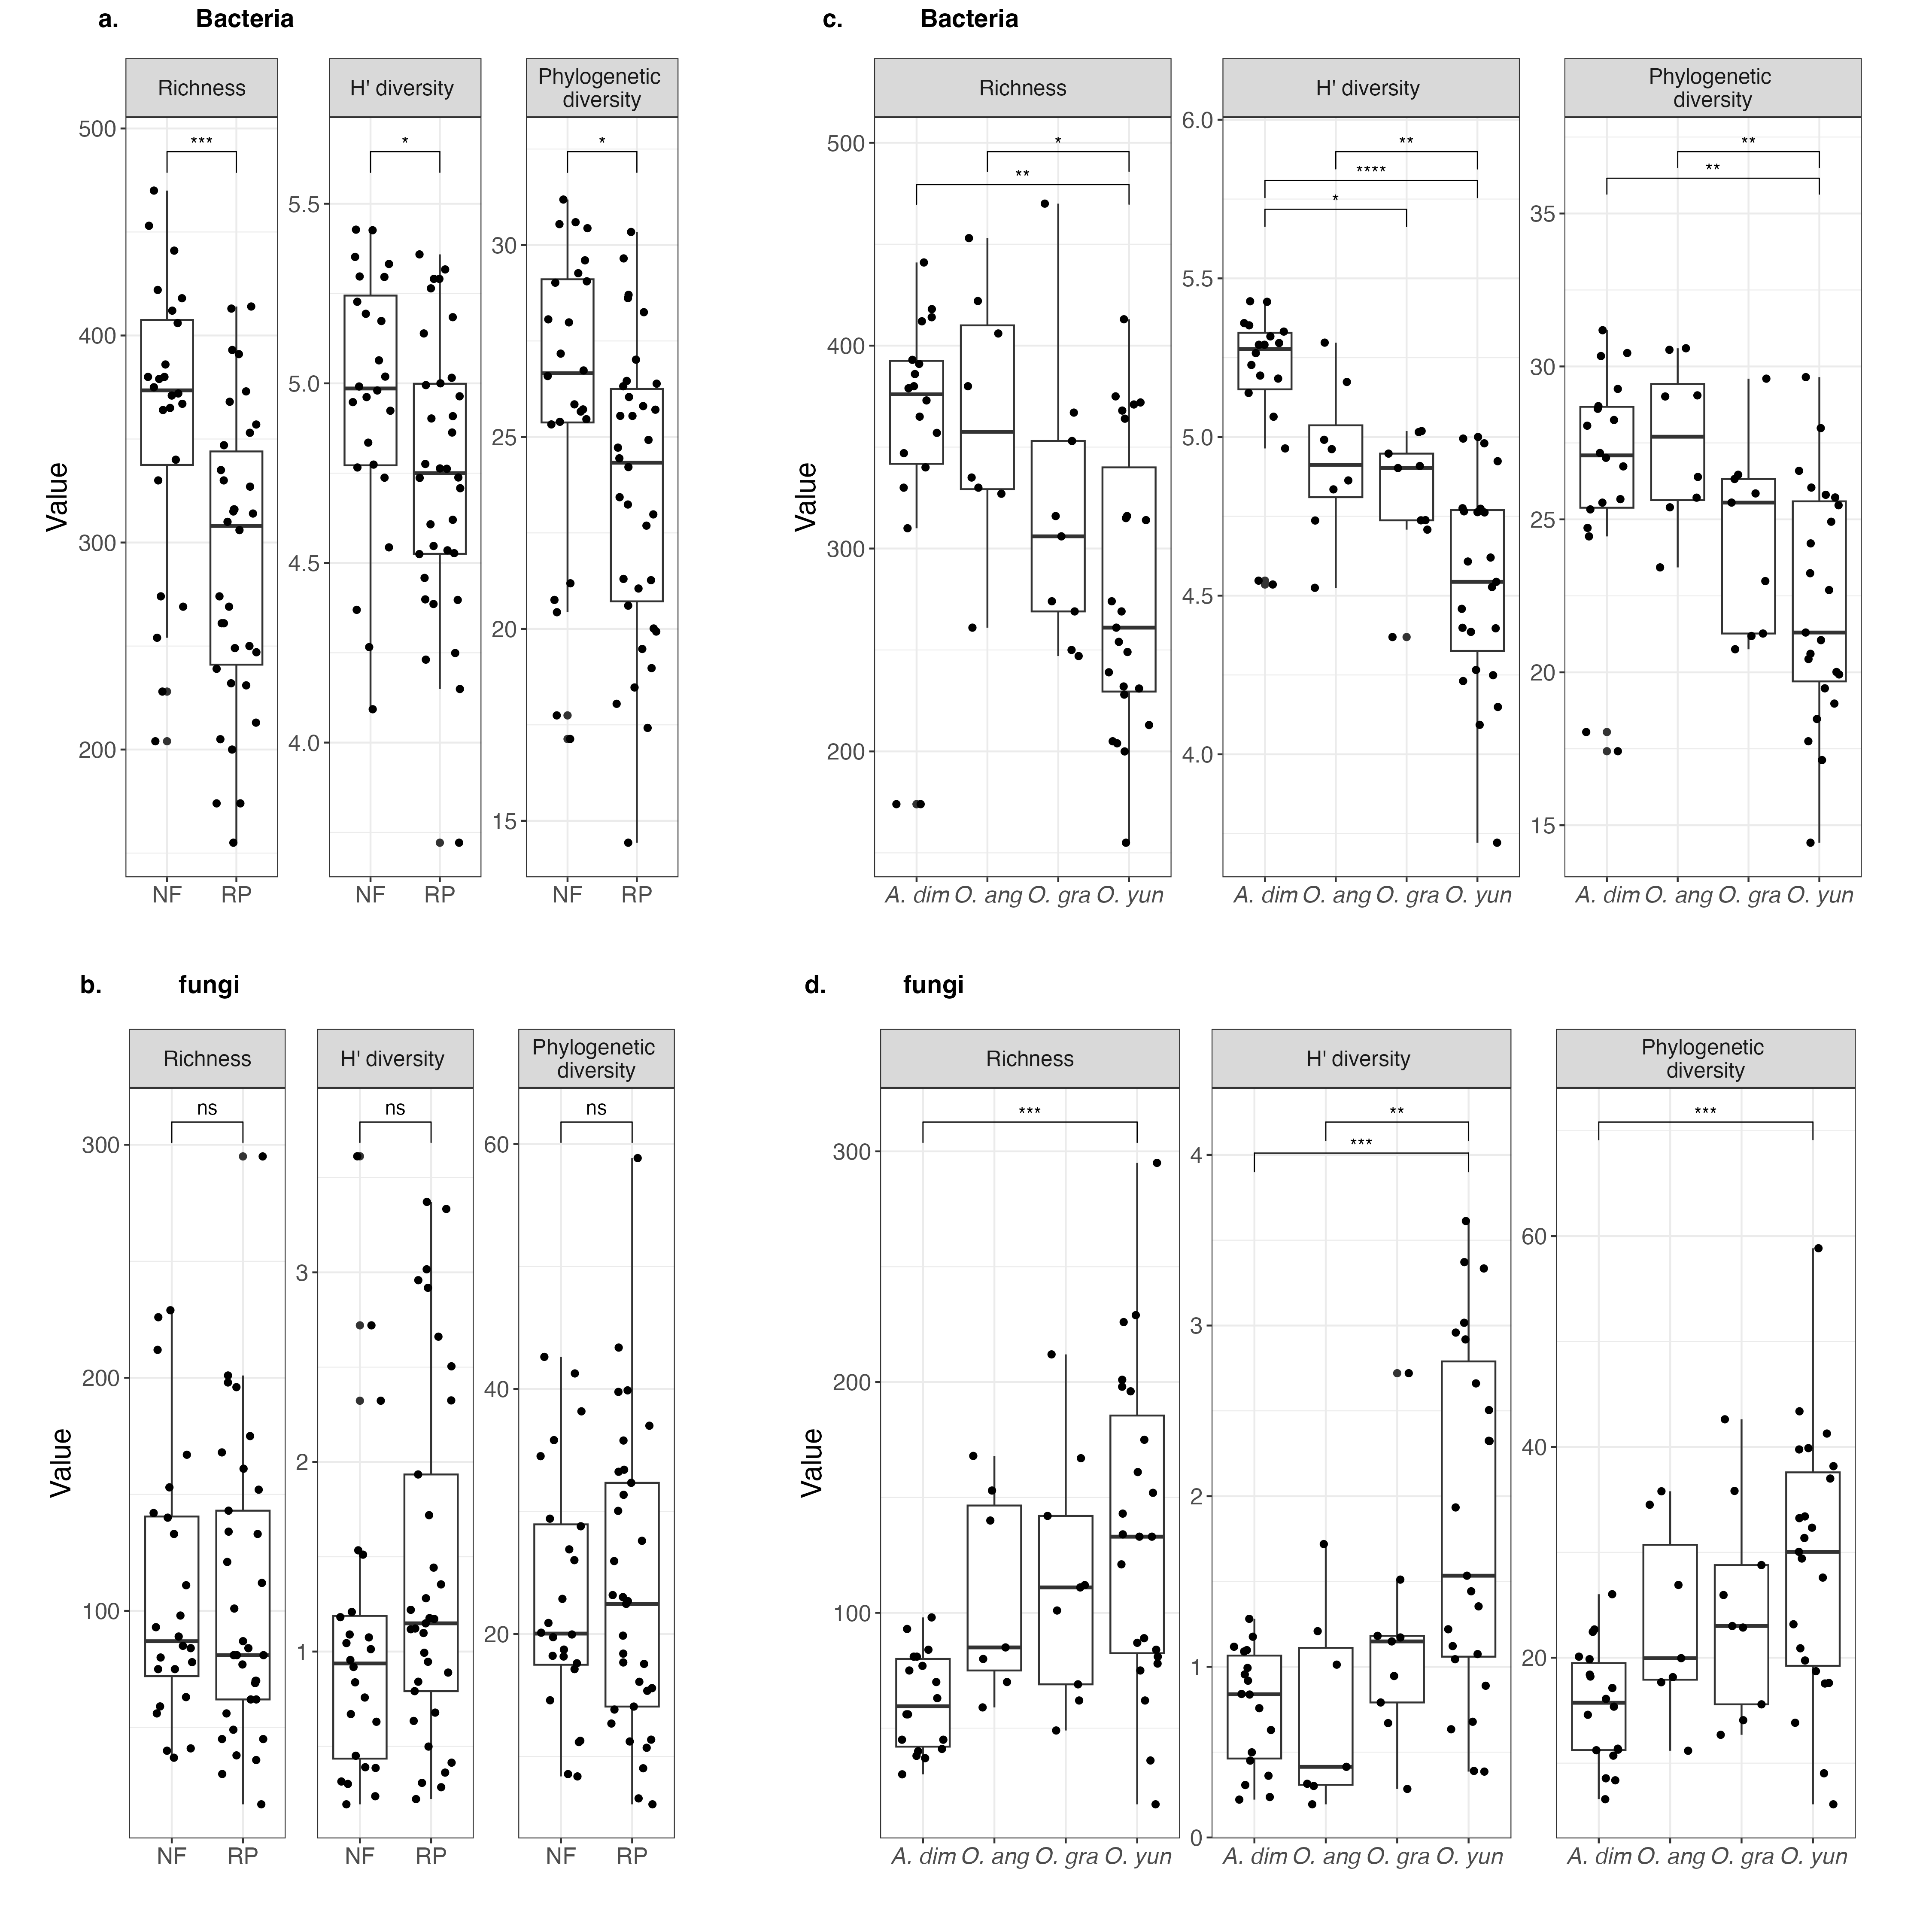

Fig. S3 The alpha diversity of bacteria (a, c, e) and fungi (b, d, f) in four termite species in natural forest (NF) and rubber plantation (RP). *p < 0.05, ns = not significant 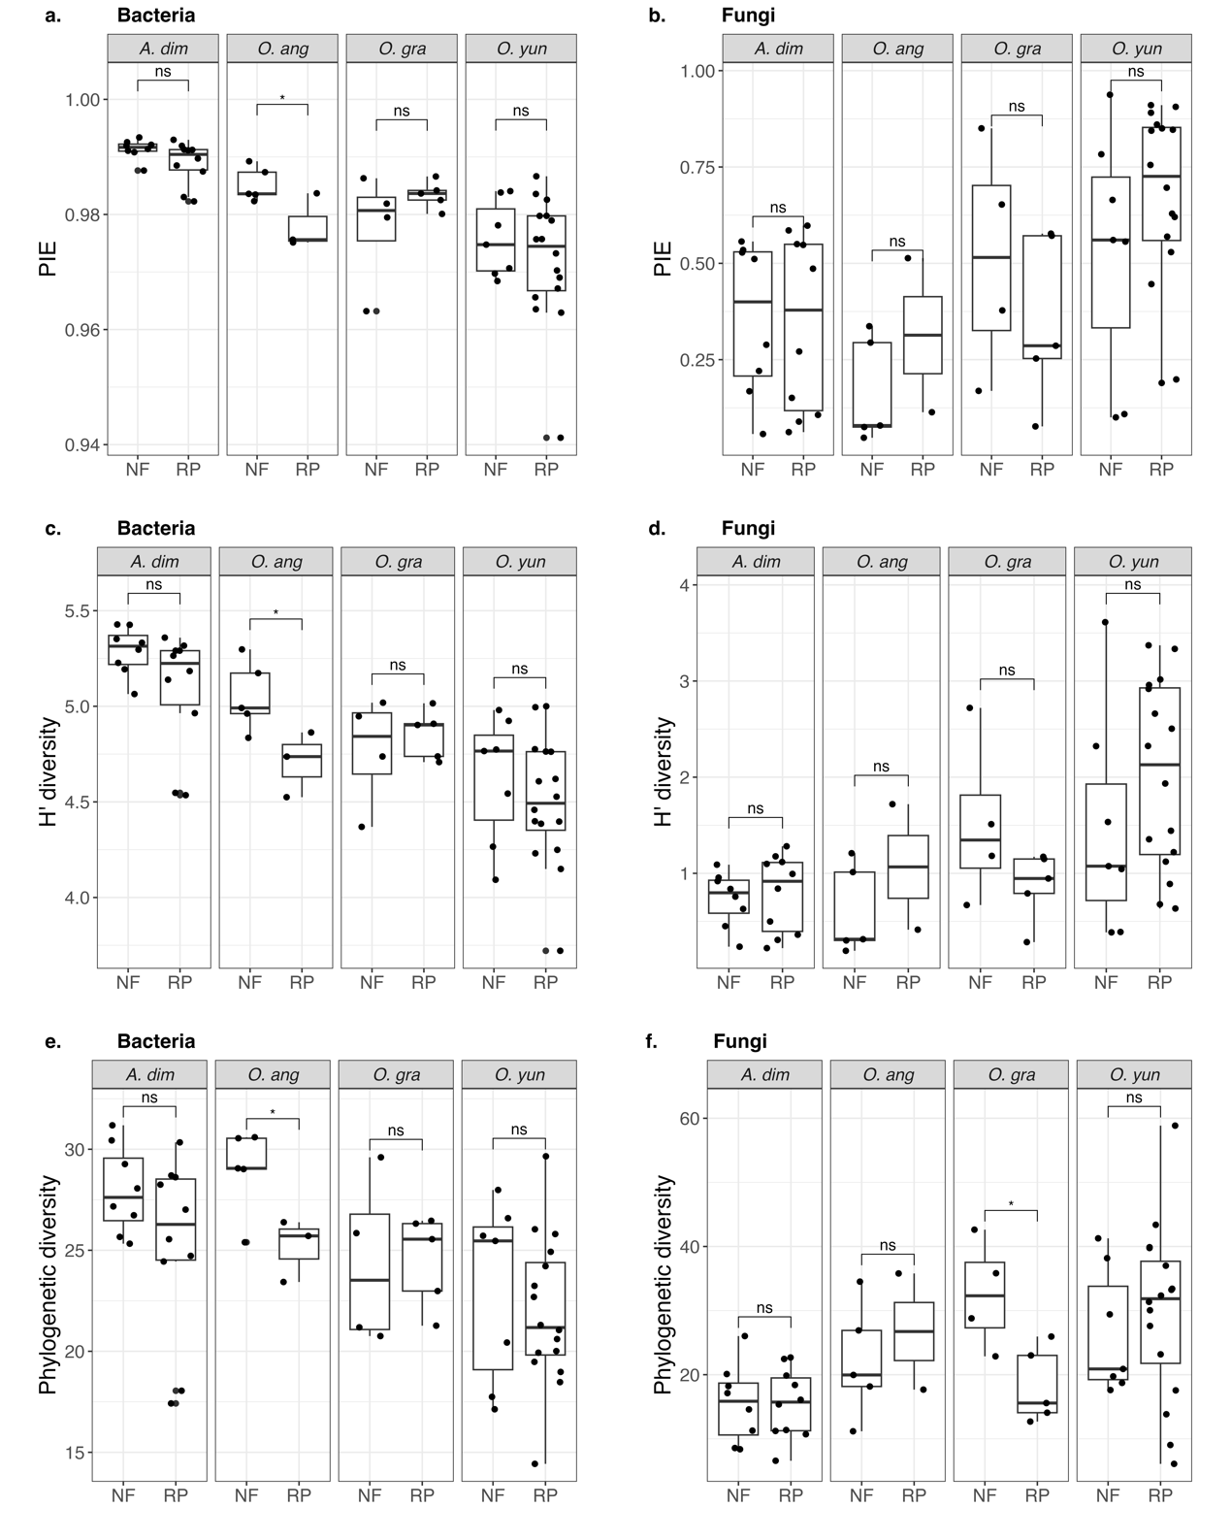

Fig. S4 Family-level gut bacterial composition of different termite species in natural forest and rubber plantation.
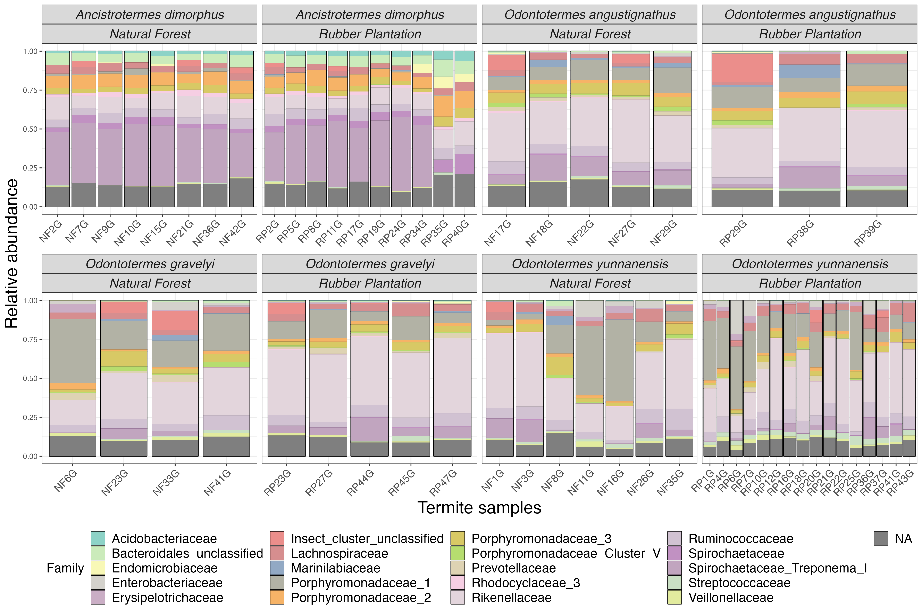

Fig. S5 Family-level gut fungal composition of different termite species in natural forest and rubber plantation.