A deep learning classification pipeline for identifying economically important tephritid fruit flies

Darren F Ward^{1,2}, Diana Pérez-Staples³, Christopher W. Weldon⁴, Vijendra Samy^{2,5}, Daniel Bentall⁶, Brent Martin⁷, Katarina Taskova⁸, Aaron M. T. Harmer¹

¹Bioeconomy Science Institute, Private Bag 92170 Auckland 1142, New Zealand
²School of Biological Sciences, University of Auckland, Private Bag 92019, Auckland, New Zealand
³Institute of Biotechnology and Applied Ecology (INBIOTECA), Universidad Veracruzana, Xalapa, Veracruz, Mexico
⁴Department of Zoology and Entomology, University of Pretoria, Private Bag X20, Hatfield 0028, Pretoria, South Africa
⁵Ministry of Agriculture and Waterways, PO Box 351, Suva, Fiji
⁶Bioeconomy Science Institute, Private Bag 4704, Christchurch 8140, New Zealand
⁷Bioeconomy Science Institute, PO Box 69040 Lincoln 7640, New Zealand
⁸School of Computer Sciences, University of Auckland, Private Bag 92019, Auckland, New Zealand

Corresponding author. Darren Ward wardda@landcareresearch.co.nz
ORCID 0000-0002-4509-8553

Abstract

Computer vision approaches utilising deep learning offer significant potential benefits for entomological applications, particularly for image-based taxonomic identification. Fruit flies (Tephritidae) represent economically damaging pests where species-level identification is critical for effective pest control, management, surveillance, and eradication programs. We assessed the capability of a deep learning convolutional neural network (CNN) pipeline to identify tephritid species from wing images, which serve as key diagnostic features. Our dataset comprised 1380 tephritid wing images spanning 34 tephritid species and 12 genera, with additional images from two 'other' classes (other Diptera and Hymenoptera). We employed a two-stage approach: (1) object detection using an Ultralytics YOLOv11n model to detect wing objects in images, treating all wings as a single class, followed by (2) species classification using an Ultralytics YOLOv11-cls model applied to cropped and augmented wing images generated from the object detection stage. The models demonstrated high accuracy in both wing detection (mAP50-95 value of 0.99 on a novel test set) and species classification (overall accuracy of 0.98 on a novel test set). Class-wise accuracy for different species varied (0.67-1) but showed general correlation with the number of original images available per class (10-285). Our results provide a potentially valuable tool for detecting pest tephritid species in biosecurity contexts. While deep learning technology remains in early development stages for entomological applications, such approaches hold promise to transform diagnostic and surveillance capabilities for biosecurity and pest management.

Key Words: Biosecurity, Computer vision, Insects, Pest management, Surveillance, Tephritidae

Key Message
Please include 3 to 5 bullet points of maximum 100 characters, including spaces, per each bullet point.

Supplementary
- Please include in each file the following information: article title, journal name, author names; affiliation and e-mail address of the corresponding author.

Introduction

Tephritidae, commonly known as fruit flies, are a diverse family of Diptera that are widely distributed around the world. Several species of Tephritidae cause severe economic damage to horticulture industries in a wide range of countries through costs associated with losses to fruit and vegetable crops, the loss of market access, and the costs associated with control (Suckling et al. 2014; Dias et al. 2018). Such losses can be substantial, for example, He et al. (2023) estimated the economic losses in China from Zeugodacus cucurbitae at many hundreds of millions of dollars per year. Kibira et al. (2010) noted that in eastern and southern Africa, several species of Ceratitis contribute to mango yield losses of between 30% to 70% depending on the locality, variety and season, and that an exotic species, Bactrocera dorsalis (reported as B. invadens) causes damage to over 80% of mango crops. In Australia, costs associated with maintaining exclusion zones and periodic outbreaks of B. dorsalis (reported as B. papayae) can also be as high as hundreds of millions of dollars (Jessup et al. 2007; Suckling et al. 2014).
Considerable effort and expenditure are associated with different types of control and management (Dias et al. 2018; He et al. 2023), such as the use of lures (Stringer et al. 2019), area wide suppression (Lloyd et al. 2010), natural enemies (Dias et al. 2022), and the sterile insect technique (Shelly and McInnis 2016). However, there is also significant effort and investment in keeping countries and areas free of these pests, particularly as many species can be easily transported around the globe via human trade networks. Such investment includes quarantine and fruit destruction, surveillance networks via large scale trapping, and eradication programmes (Quilici and Donner 2012; Suckling et al. 2014; Kean et al. 2024).
Correct species identification is critical, whether it is for the control and management of pests, or for keeping areas pest-free through surveillance and eradication. However, the morphological identification of tephritid species can be difficult and requires practical experience and professional skills (White 2006; Plant Health Australia 2011; Drew and Romig 2013; He et al. 2023). Molecular techniques are increasingly being used to resolve species limits and distinguish species, but this is also not without problems (Dhami et al., 2016; Doorenweerd et al. 2023; Starkie et al., 2024).
Imaged-based identification offers an additional, and likely complementary, approach to morphological and molecular identification. Computer vision approaches based on machine learning and deep learning have significantly influenced a wide range of scientific disciplines, though these have only relatively recently been applied to entomology (Boer and Vos 2018; Marques et al. 2018; Hansen et al. 2019). Recent studies on image-based insect identification are showing that deep learning models can extract features from images and learn to differentiate species to an accuracy approaching, or exceeding, human expertise (Valan et al. 2019; Hoye et al. 2020, Ward and Martin 2023, da Cunha et al. 2024) and is being applied to a growing range of insect taxa. For example, over half of British ground beetles (Carabidae) can be identified to species, and 74% to genus using convolutional neural networks (Hansen et al. 2019). Boer and Vos (2018) used over 10,000 images from AntWeb (www.antweb.org) to classify ants at species level based on dorsal, head, and profile images, obtaining accuracy between 62–92% for species and 79–95% for genus, depending on different configurations of the models.
Previous work on the automated identification of fruit flies is limited, however Wang et al. (2016) used custom built software (based on C# language on Microsoft’s Net Framework) to classify 74 species belonging to six genera, and despite having only a few images per species was able to obtain good identification rates depending on the morphological character, 71% (wing), 69% (thorax), 39% (abdomen). More recent work includes Tariq et al. (2022) who were testing the development of identification systems for farmers and growers through mobile applications and examined the image capture of two species using smartphone and Raspberry Pi cameras in both the laboratory and fruit orchards.
In this paper, we test the ability of a deep learning convolutional neural network pipeline to classify genera and species of Tephritidae using images of the wing for a range of species that are relevant around the world for pest control and management, and for border biosecurity and surveillance.

Methods

Taxonomic species and specimens
We captured 1,380 wing images representing 34 species across 12 genera of Tephritidae, along with 1,151 images of other Diptera and 3,368 images of Hymenoptera, totalling 5,899 images. An additional 10 tephritid species were excluded from the dataset as each had fewer than 10 images available. The dataset included economically important species from the genera Bactrocera, Ceratitis, and Zeugodacus, native New Zealand species from Austrotephritis, Sphenella, and Trupanea, and biocontrol agents from Procecidochares and Urophora that have been introduced to New Zealand for invasive weed control.
Specimens were primarily obtained from the New Zealand Arthropod Collection, including species from New Zealand and Pacific Island nations, using dry pinned material. Additional specimens were obtained from laboratory colonies kept at the USDA Daniel K. Inouye U.S. Pacific Basin Agricultural Research Center in Hilo, Hawaii (B. dorsalis, Bactrocera latifrons, and Z. cucurbitae), the Indian Institute of Horticultural Research in Bangalore, India (Bactrocera tau) and South Africa (B. dorsalis and Ceratitis cosyra). The median number of images per tephritid species was 19 (range: 10–285). A complete species list is provided in Supplementary Table 1.

Specimen preparation and imaging
For pinned specimens, wings were carefully removed from the body prior to imaging. Specimens were placed in a specimen manipulator, and a micropin or number 5 forceps was used to gently manipulate the tegula until the wing detached naturally. Wings were not forcibly pulled to avoid membrane damage. Wings were positioned on a microscope stage with a white background, imaged, and subsequently stored in gelatin capsules for preservation. For specimens from Hawaiian, Indian and South African laboratory colonies, wings were secured in position using double-sided tape during imaging. All wing images were captured using a Leica EZ4 W microscope (Leica Microsystems) with an integrated camera. The wings provided from South Africa were prepared as reported in Roets et al. (2018) and Makumbe et al. (2020). Wings were positioned flat, eliminating the need for image stacking techniques (Figure 1).

Model training and validation
Wing images were uploaded to Roboflow (https://roboflow.com/), an online platform for image annotation and deep learning. A project was established in Roboflow (publicly available at: https://universe.roboflow.com/bugider/tephritidae), where polygons were drawn around each wing using the Smart Polygon tool powered by Meta AI's Segment Anything Model (SAM2). Each polygon was annotated with the corresponding taxonomic species designation.
Images were exported to a local workstation (HP Z2 SFF G9 with 128GB RAM and NVIDIA RTX A4000 GPU, Windows 10) for processing. Annotations were converted to bounding box format compatible with YOLO object detection models. Images underwent preprocessing including resizing to 640 × 640 pixels, grayscale conversion (due to limited colour information in tephritid wings), and exposure correction using contrast stretching to create the object detection training dataset.
We trained a two-stage model, with a detection stage (finding the wing in the image) and then a classification stage (identification to species). Both datasets (detection and classification) were partitioned into training (85%), validation (15%), and test (5%) splits using stratified sampling to maintain proportional class representation across splits. For the classification dataset (i.e. stage two cropped wings generated from the detection stage), images were further processed by resizing the crops to 640 × 640 pixels, and augmenting through random flipping, blurring, and noise addition. The two 'other' classes (Hymenoptera and Diptera) were randomly subsampled to match the size of the largest tephritid class, preventing training bias. The final classification dataset comprised 7,800 images.
We trained two-stage YOLOv11 models using the Ultralytics Python library (Jocher et al., 2023). A single object detection model was trained treating all wings as a single class. Multiple classification models were trained with varying dropout rates (0.2–0.5) and learning rates (0.0001–0.01) to optimize performance. Complete training parameters are detailed in Supplementary Table 2. Model performance was evaluated on the test splits in each image set (unseen during training or validation) using mean Average Precision (mAP) for object detection and accuracy, precision, recall, and F1 score for species classification. We also assessed performance by comparing the confidence scores of correct versus incorrect predictions on the test set.

Results and Discussion
Both the detection and classification models converged well after 30 training epochs. Training and validation loss curves were similar for both models (Supplementary Figure 1).

Object detection performance
The model (YOLOv11n) demonstrated excellent performance in detecting wing objects within images, achieving precision and recall of 1.00 for both metrics on the test dataset. The mean Average Precision at IoU threshold 0.5 (mAP50) was 1.00 and at mAP50-95 was 0.99. These results indicate that the model was highly effective at locating and delineating wing boundaries across all images, successfully distinguishing wing objects from the background. While these results may appear unrealistically high, it should be noted that wings were always displayed on a plain background, there was a single wing per image, and all classes were lumped for the object detection task, so precision and recall were expected to be very high. Further, we would expect that in any model deployed for identification queries would have images captured in very similar conditions (see Methods) to the training images to ensure similarly high detection rates. Images based on specimens photographed in filed situations would be expected to perform xxx because preparation is different.

Species classification performance
The classification model (YOLOv11n-cls) showed strong overall performance across the 34 tephritid species and two other taxonomic groups. Overall (across classes) classification accuracy was 0.98, with precision of 0.98, recall of 0.97, and F1 score of 0.97, demonstrating robust species-level identification.
Classification performance varied considerably among species, revealing patterns related to dataset composition and morphological distinctiveness (Table 1). Twenty-six species (76%) achieved perfect classification metrics (accuracy, precision, recall, and F1 scores of 1.00), including economically important pest species such as B. dorsalis, B. tryoni, C. capitata, and Z. cucurbitae. Several species showed slight reductions in precision while maintaining perfect recall and accuracy. Bactrocera passiflorae achieved 0.91 precision, B. facialis recorded 0.95 precision, and Sphenella ruficeps showed 0.80 precision. These lower precision values suggest occasional misclassification of other species (Figure 3=2, Supplementary Figure 2).
The most challenging classifications involved species with smaller training datasets and that were visually like other species in the same genus. Bactrocera minuta (83 training images) achieved 67% accuracy with precision of 1.00 but recall of 0.67, indicating that while wings predicted as B. minuta were accurately classified, some individuals within this class were misassigned to the visually similar B. passiflorae (e.g. Figure 3a). Similarly, B. latifrons (96 training images) showed 67% accuracy with 0.80 precision and 0.67 recall (misclassified as B. dorsalis, e.g. Figure 3b), B. tau (57 training images) achieved 80% accuracy with precision of 1.0 and 0.8 recall (misclassified as B. latifrons), and Sphenella fascigera (44 training images) achieved 75% accuracy with precision of 1.0 and 0.75 recall (misclassified as S. ruificeps, e.g. Figure 3c). Bactrocera kirki, despite having a larger training set (345 images), showed slightly reduced performance (96% accuracy, 1.00 precision, 0.96 recall, misclassified as B. fascialis), suggesting morphological similarity to closely related species rather than sample size limitations. All misclassified images were assigned to other species within the same genus as the source species. Wing morphology is also much more conserved within genera than across genera.
The high performance across diverse genera, including functionally distinct groups such as agricultural pests (e.g. Bactrocera, Ceratitis), biocontrol agents (Procecidochares, Urophora) and native New Zealand species (Austrotephritis, Trupanea), demonstrates the classification model's ability to generalise across varied wing morphologies to accurately identify species of economic importance. Further, there was generally good separation in confidence scores between correct and incorrect predictions, with correct predictions skewed towards 1.0 and incorrect predictions typically below 0.8 (Figure 4=3).

Conclusions
In this study we demonstrated the successful application of deep learning methods for automated species-level identification of Tephritidae, achieving excellent accuracy (98%) in distinguishing among 34 fruit fly species using wing morphology. The two-stage YOLOv11 pipeline showed perfect object detection performance and robust classification across economically critical pest species including B. dorsalis, B. tryoni, C. capitata, and Z. cucurbitae, which achieved near-perfect identification rates. Our results represent a significant advancement for biosecurity and pest management applications, where rapid and accurate species identification is essential for effective quarantine decisions, surveillance programs, and targeted control strategies. The classification model's ability to reliably distinguish between pest species, beneficial biocontrol agents, and native taxa addresses a critical bottleneck in entomological diagnostics, particularly in resource-limited settings where taxonomic expertise may be unavailable. By providing an accessible, automated identification tool that maintains high accuracy across diverse geographic specimens, this technology has the potential to transform frontline biosecurity operations. The further development of desktop or mobile applications will also enable real-time pest detection at ports of entry and support management decisions that protect agricultural systems and native ecosystems from invasive species.

Acknowledgements
Part of the material was made possible thanks to the Cooperative Agreements (23-8130-1011-IA, 25-8130-1011-CA) from the United States Department of Agriculture’s Animal and Plant Health Inspection Service (APHIS) awarded to DPS. It may not necessarily express APHIS’ views. DPS thanks Abraham Moreno Mejía and Kamala Jayanthi.

References
Ärje J, Melvad C, Jeppesen MR, Madsen SA, Raitoharju J, Rasmussen MS, Iosifidis A, Tirronen V, Gabbouj M, Meissner K, Høye TT (2020). Automatic image-based identification and biomass estimation of invertebrates. Methods in Ecology and Evolution 11:922–931.

Bjerge K, Nielsen JB, Sepstrup MV, Helsing-Nielsen F, Høye TT (2021). An automated light trap to monitor moths (Lepidoptera) using computer vision-based tracking and deep learning. Sensors, 21:343.

Boer MJ, Vos RA (2018). Taxonomic classification of ants (Formicidae) from images using deep learning. bioRxiv, 407452.

da Cunha VAG, Pullock DA, Ali M, Neto AdOC, Ampatzidis Y, Weldon CW, Kruger K, Manrakhan A, Qureshi, J (2024). Psyllid Detector: A web-based application to automate insect detection utilizing image processing and deep learning. Applied Engineering in Agriculture 40:427–438.

Dhami MK, Gunawardana DN, Voice D, Kumarasinghe L (2016). A real-time PCR toolbox for accurate identification of invasive fruit fly species. Journal of Applied Entomology 140:536–552. https://doi.org/10.1111/jen.12286

Dias NP, Montoya P, Nava DE (2022). A 30-year systematic review reveals success in tephritid fruit fly biological control research. Entomologia Experimentalis et Applicata 170:370–384. https://doi.org/10.1111/eea.13157

Dias NP, Zotti MJ, Montoya P, Carvalho IR, Nava DE (2018). Crop protection, fruit fly management research: a systematic review of monitoring and control tactics in the world. Crop Protection 112:187–200.

Doorenweerd C, Leblanc L, Norrbom AL, Jose MS, Rubinoff D (2018). A global checklist of the 932 fruit fly species in the tribe Dacini (Diptera, Tephritidae). Zookeys 730:19–56.

Drew RAI, Romig M (2013). Tropical Fruit Flies of South-East Asia (Tephritidae: Dacinae): Indomalaya to North-West Australasia. CABI, Wallingford. https://doi.org/10.1079/9781780640358.0000

Greeff M, Caspers M, Kalkman V, Willemse L, Sunderland BD, Bánki O, Hogeweg L (2022). Sharing taxonomic expertise between natural history collections using image recognition. Research Ideas and Outcomes 8, e79187.

Hansen OL, Svenning JC, Olsen K, Dupont S, Garner BH, Iosifidis A, Price BW, Høye TT (2020). Species‐level image classification with convolutional neural network enables insect identification from habitus images. Ecology and Evolution, 10:737–747.

He Y, Xu Y, Chen X (2023). Biology, ecology and management of tephritid fruit flies in China: a review. Insects 14:196. https://doi.org/10.3390/insects14020196

Høye TT, Ärje J, Bjerge K, Hansen OLP, Iosifidis A, Leese F, Mann HMR, Meissner K, Melvad C, Raitoharju J (2021). Deep learning and computer vision will transform entomology. Proceedings of the National Academy of Sciences 118(2), e2002545117.

Jessup AJ, Dominiak B, Woods B, De Lima CPF, Tomkins A, Smallridge CJ (2007). Area-Wide Management of Fruit Flies in Australia. In: Vreysen, M.J.B., Robinson, A.S., Hendrichs, J. (eds) Area-Wide Control of Insect Pests. Springer, Dordrecht. https://doi.org/10.1007/978-1-4020-6059-5_63

Jocher G, Qiu J, Chaurasia, A (2023). Ultralytics YOLO (Version 8.0.0) [Computer software]. https://github.com/ultralytics/ultralytics

Kean JM, Manoukis NC, Dominiak BC (2024). Review of surveillance systems for tephritid fruit fly threats in Australia, New Zealand, and the United States. Journal of Economic Entomology 117:8–23. https://doi.org/10.1093/jee/toad228

Kibira M, Affognon H, Njehia B, Muriithi B, Mohamed S, Ekesi S (2010). Economic evaluation of integrated management of fruit fly in mango production in Embu County, Kenya. African Journal of Agricultural and Resource Economics 10:343–353.

Makumbe LDM, Moropa TP, Manrakhan A, Weldon CW (2020). Effect of sex, age and morphological traits on tethered flight of Bactrocera dorsalis (Hendel) (Diptera: Tephritidae) at different temperatures. Physiological Entomology 45:110-119.

Plant Health Australia (2011). The Australian Handbook for the Identification of Fruit Flies. Version 1.0. Plant Health Australia. Canberra, ACT.
Roets PD, Bosua H, Ruth Archer C, Weldon CW (2018). Life-history and demographic traits of the marula fruit fly Ceratitis cosyra: potential consequences of host specialization. Physiological Entomology 43:259-267.

Shelly T, McInnis D (2016). Sterile insect technique and control of tephritid fruit flies: do species with complex courtship require higher overflooding ratios? Annals of the Entomological Society of America 109:1–11. https://doi.org/10.1093/aesa/sav101

Tariq S, Hakim A, Siddiqi AA, Owais M (2022). An image dataset of fruitfly species (Bactrocera zonata and Bactrocera dorsalis) and automated species classification through object detection. Data Brief 43:108366. https://doi.org/10.1016/j.dib.2022.108366

Wang J, Chen X, Hou X, Zhou L, Zhua C, Jia L (2017). Construction, implementation and testing of an image identification system using computer vision methods for fruit flies with economic importance (Diptera: Tephritidae). Pest Management Science 73:1511–1528. https://doi.org/10.1002/ps.4487

Ward DF, Martin B (2023). Trialling a convolution neural network for the identification of Braconidae in New Zealand. Journal of Hymenoptera Research 95:95–101.

White IM (2006). Taxonomy of the Dacina (Diptera: Tephritidae) of Africa and the Middle East. African Entomology, Memoir No. 2, 156 pp.

Valan M, Makonyi K, Maki A, Vondrácek D, Ronquist F (2019). Automated taxonomic identification of insects with expert-level accuracy using effective feature transfer from convolutional networks. Systematic Biology 68:876–895.

Statements and Declarations
Funding
This work was supported by SSIF Infrastructure funding for Nationally Significant Collections and Databases at Manaaki Whenua-Landcare Research; the B3 (Better Border Biosecurity) project D22.15 on ‘Using images and deep learning for the identification of high-risk insect species’; and the University of Auckland Summer Research program for Tomas Blokker, Angie Zhu, and Hope Ryu.

Competing Interests
The authors have no relevant financial or non-financial interests to disclose.

Author Contribution Statement
DW and AH conceived and designed research. DW, AH, CW, VS, and DPS provided images. DB, KW and BM provided computer science support. DW and AH wrote the manuscript. All authors read and approved the manuscript.

Data Availability
Specimen records are accessible through GBIF (https://www.gbif.org) or Symbiota's Ecdysis portal (https://ecdysis.org). Wing images are available via Roboflow (https://universe.roboflow.com/bugider/tephritidae), and Python scripts are provided on GitHub (https://github.com/aharmer/tephritIDhttps://github.com/aharmer/tephritID).

Table 1: Classification performance by species.
Species | Training Images | Validation Images | Test Images | Accuracy | Precision | Recall | F1 Score
Austrotephritis cassiniae | 32 | 6 | 2 | 1.00 | 1.00 | 1.00 | 1.00
Austrotephritis plebeia | 44 | 8 | 4 | 1.00 | 1.00 | 1.00 | 1.00
Bactrocera caliginosa | 38 | 7 | 3 | 1.00 | 1.00 | 1.00 | 1.00
Bactrocera correcta | 57 | 10 | 5 | 1.00 | 1.00 | 1.00 | 1.00
Bactrocera curvipennis | 38 | 7 | 3 | 1.00 | 1.00 | 1.00 | 1.00
Bactrocera distincta | 176 | 33 | 11 | 1.00 | 1.00 | 1.00 | 1.00
Bactrocera dorsalis | 912 | 171 | 57 | 1.00 | 0.97 | 1.00 | 0.98
Bactrocera facialis | 313 | 58 | 21 | 1.00 | 0.95 | 1.00 | 0.98
Bactrocera frauenfeldi | 48 | 9 | 3 | 1.00 | 1.00 | 1.00 | 1.00
Bactrocera kirki | 345 | 64 | 23 | 0.96 | 1.00 | 0.96 | 0.98
Bactrocera latifrons | 96 | 18 | 6 | 0.67 | 0.80 | 0.67 | 0.73
Bactrocera melanotus | 124 | 23 | 9 | 1.00 | 1.00 | 1.00 | 1.00
Bactrocera minuta | 83 | 15 | 6 | 0.67 | 1.00 | 0.67 | 0.80
Bactrocera obscura | 89 | 16 | 7 | 1.00 | 1.00 | 1.00 | 1.00
Bactrocera passiflorae | 320 | 60 | 20 | 1.00 | 0.91 | 1.00 | 0.95
Bactrocera tau | 57 | 10 | 5 | 0.80 | 1.00 | 0.80 | 0.89
Bactrocera tryoni | 57 | 10 | 5 | 1.00 | 1.00 | 1.00 | 1.00
Bactrocera umbrosus | 131 | 24 | 9 | 1.00 | 1.00 | 1.00 | 1.00
Bactrocera xanthodes | 211 | 39 | 14 | 1.00 | 1.00 | 1.00 | 1.00
Ceratitis capitata | 64 | 12 | 4 | 1.00 | 1.00 | 1.00 | 1.00
Ceratitis cosyra | 249 | 46 | 17 | 1.00 | 1.00 | 1.00 | 1.00
Coelotrypes punctilabris | 70 | 13 | 5 | 1.00 | 1.00 | 1.00 | 1.00
Dacus solomonensis | 44 | 8 | 4 | 1.00 | 1.00 | 1.00 | 1.00
Dacus vertebratus | 185 | 34 | 13 | 1.00 | 1.00 | 1.00 | 1.00
Diptera | 912 | 171 | 57 | 1.00 | 1.00 | 1.00 | 1.00
Dirioxa pornia | 76 | 14 | 6 | 1.00 | 1.00 | 1.00 | 1.00
Hymenoptera | 912 | 171 | 57 | 1.00 | 1.00 | 1.00 | 1.00
Procecidochares alani | 32 | 6 | 2 | 1.00 | 1.00 | 1.00 | 1.00
Procecidochares utilis | 41 | 7 | 4 | 1.00 | 1.00 | 1.00 | 1.00
Sphenella fascigera | 44 | 8 | 4 | 0.75 | 1.00 | 0.75 | 0.86
Sphenella ruficeps | 51 | 9 | 4 | 1.00 | 0.80 | 1.00 | 0.89
Trupanea fenwicki | 41 | 7 | 4 | 1.00 | 1.00 | 1.00 | 1.00
Trupanea longipennis | 38 | 7 | 3 | 1.00 | 1.00 | 1.00 | 1.00
Urophora cardui | 32 | 6 | 2 | 1.00 | 1.00 | 1.00 | 1.00
Urophora stylata | 32 | 6 | 2 | 1.00 | 1.00 | 1.00 | 1.00
Zeugodacus cucurbitae | 233 | 43 | 16 | 1.00 | 1.00 | 1.00 | 1.00

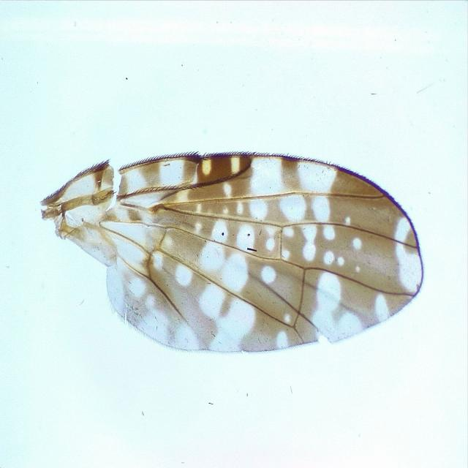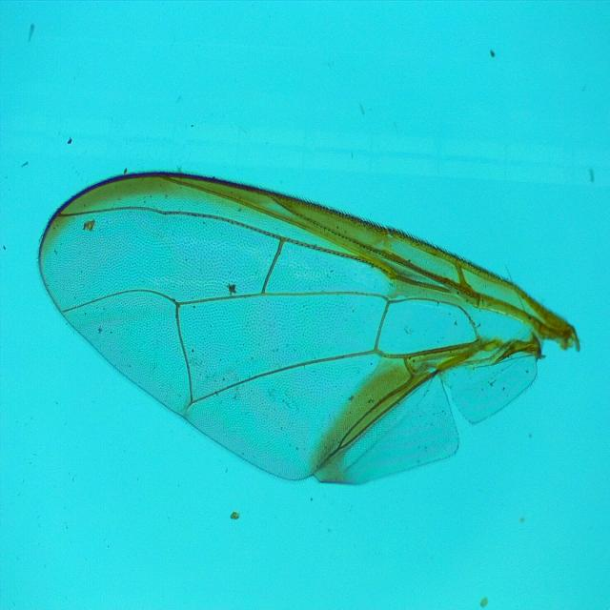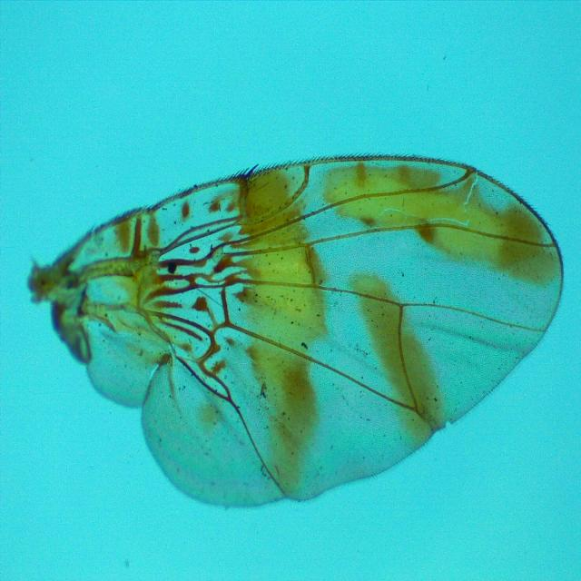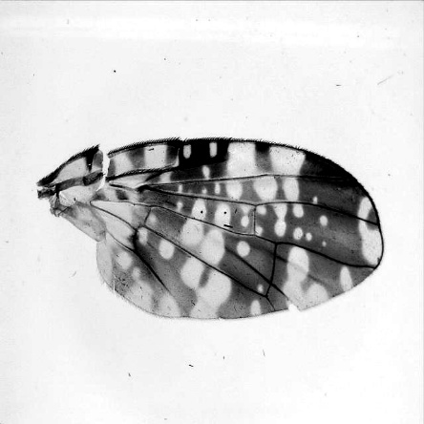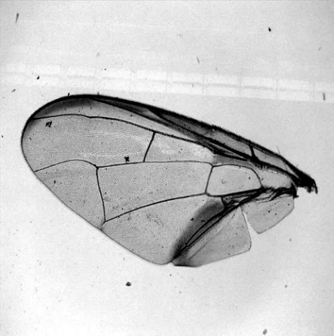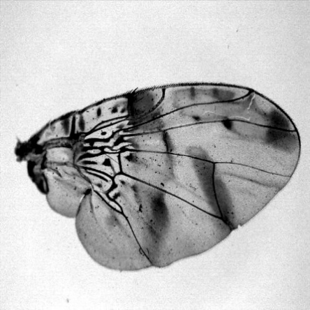
Figure 1. Examples of pre- processed (top) and post-processed (bottom) wing images used in training; from left to right: Austrotephritis plebeia, Bactrocera tryoni, and Ceratitis capitata.

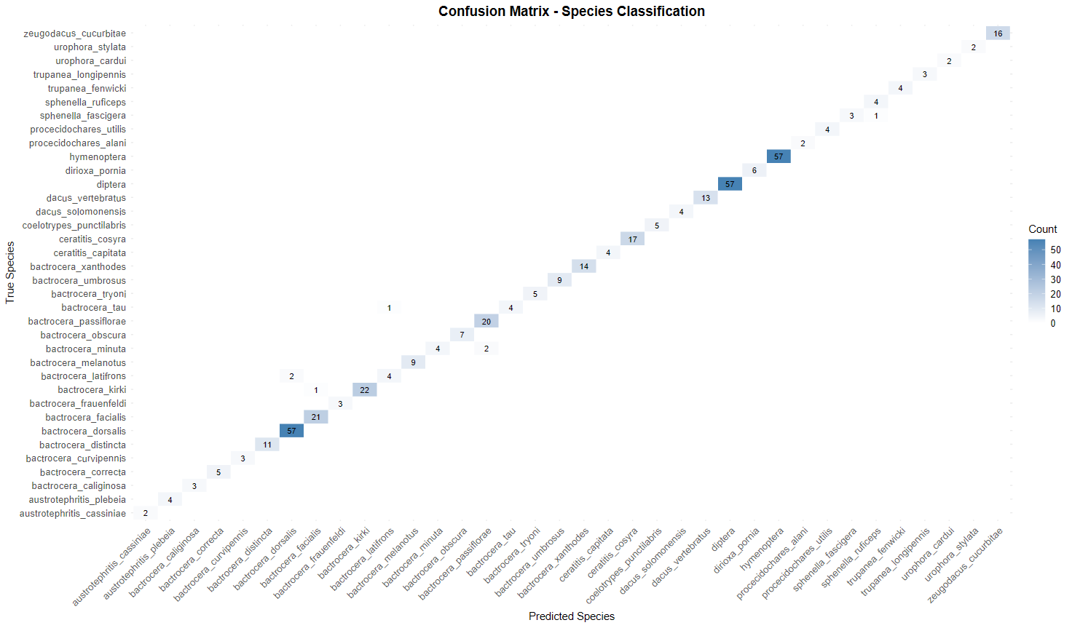
Figure 2. Confusion matrix of predicted species vs actual species for the classification task.

a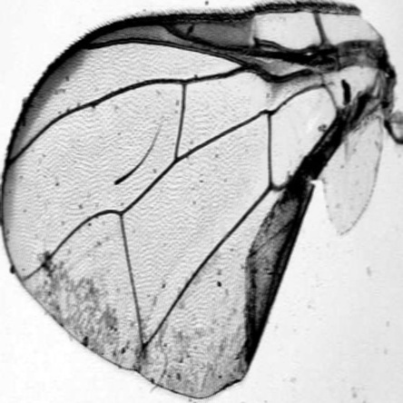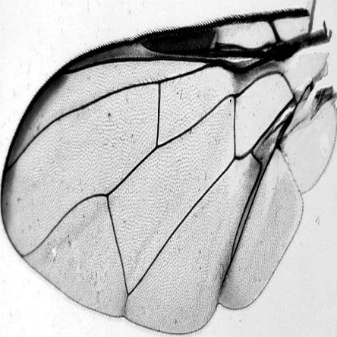
b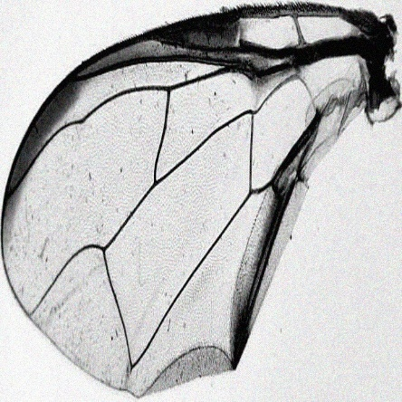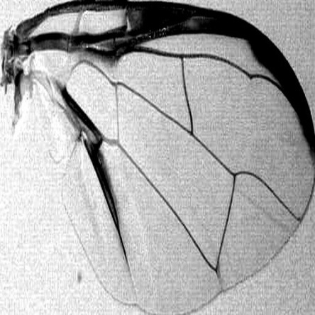
c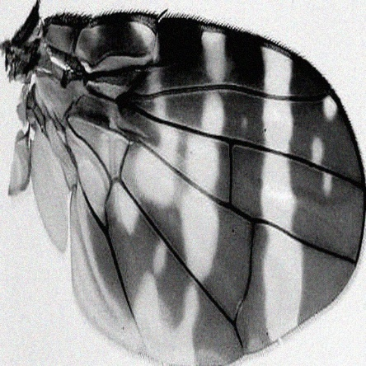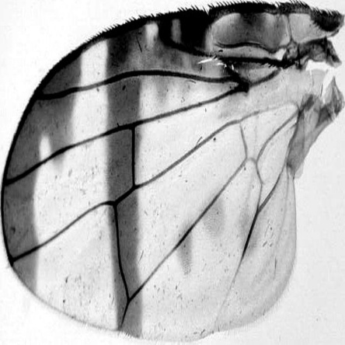
Figure 3. Examples of misclassified images (left) from the test split compared to the predicted species (right). (a) Actual species B. minuta, predicted species B. passiflorae. (b) Actual species B. latifrons predicted species B. dorsalis. (c) Actual species S. fascigera, predicted species S. ruificeps.

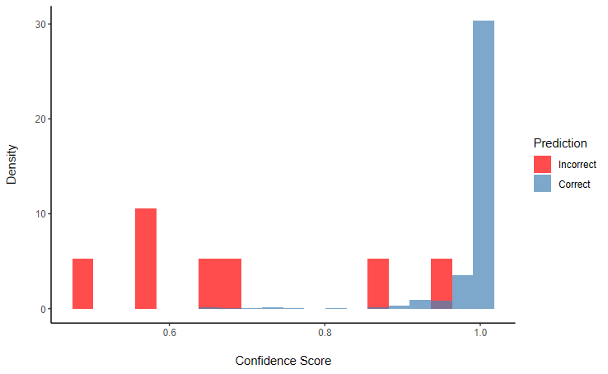
Figure 4. Confidence distribution by prediction correctness; Incorrect (red), Correct (blue).

Supplementary material

A deep learning classification pipeline for identifying economically important tephritid fruit flies.

Journal of Pest Science

Darren F Ward^{1,2}, Diana Pérez-Staples³, Christopher W. Weldon⁴, Vijendra Samy^{2,5}, Daniel Bentall⁶, Brent Martin⁷, Katarina Taskova⁸, Aaron M. T. Harmer¹

¹Bioeconomy Science Institute, Private Bag 92170 Auckland 1142, New Zealand
²School of Biological Sciences, University of Auckland, Private Bag 92019, Auckland, New Zealand
³Institute of Biotechnology and Applied Ecology (INBIOTECA), Universidad Veracruzana, Xalapa, Veracruz, Mexico
⁴Department of Zoology and Entomology, University of Pretoria, Private Bag X20, Hatfield 0028, Pretoria, South Africa
⁵Ministry of Agriculture and Waterways, PO Box 351, Suva, Fiji
⁶Bioeconomy Science Institute, Private Bag 4704, Christchurch 8140, New Zealand
⁷Bioeconomy Science Institute, PO Box 69040 Lincoln 7640, New Zealand
⁸School of Computer Sciences, University of Auckland, Private Bag 92019, Auckland, New Zealand

Corresponding author. Darren Ward wardda@landcareresearch.co.nz

Supplementary Table 1: Training configuration for each model stage.
Stage | Model | Epochs | Batch size | Image size | Optimizer | Dropout | Single class | Learning rate
Detection | YOLOv11n | 30 | 64 | 640x640 | AdamW | NA | Yes | 0.002
Classification | YOLOv11n-cls | 30 | 92 | 640x640 | AdamW | 0.2 | No | 0.001

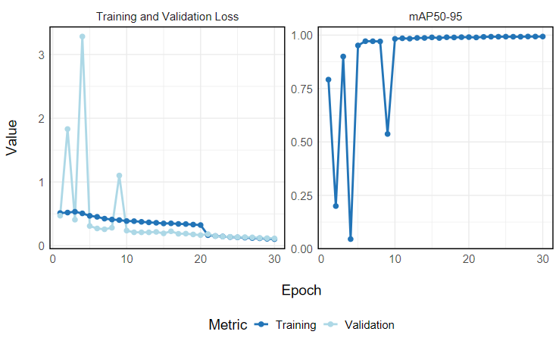
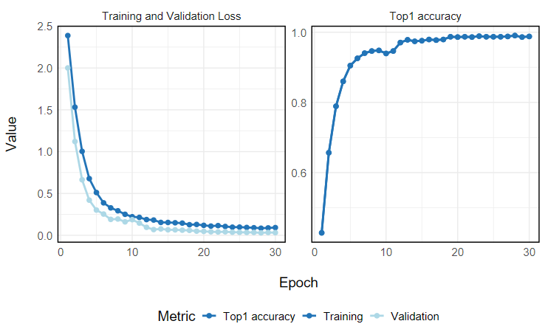
Supplementary Figure 1. Training and validation curves for the detection model (top) and the classification model (bottom).

Supplementary Figure 2. Confusion matrix of predicted species vs actual species for the classification task.

