SUPPLEMENTARY FIGURES

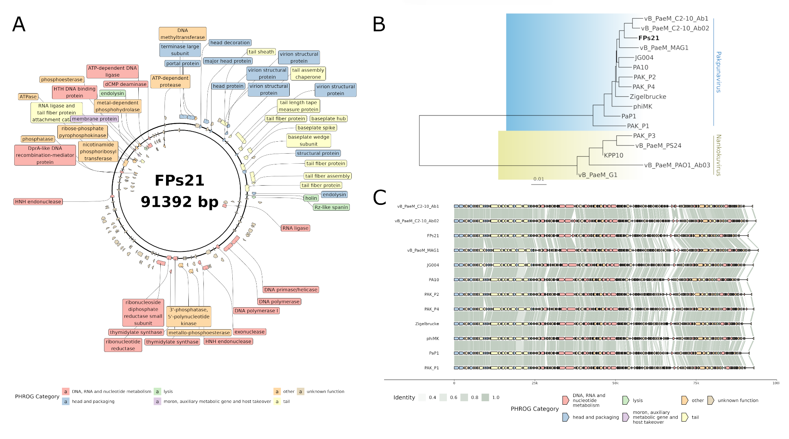

Supplementary Figure 1. Genomic analysis of phage FPs21. A) Genomic map of the complete genomic sequence of FPs21 phage. Functional annotation of genes is indicated according to PHROG gene families. B) Whole-genome phylogeny including FPs21 and related members of the Pakpunavirus and Nankokuvirus genera available in public databases. C) Genomic synteny conservation of FPs21 compared to other members of the Pakpunavirus genus.

