Author Information
Corresponding Authors
Stephan B. Bach - Department of Chemistry, The University of Texas at San Antonio, San Antonio, Texas 78249, United States. Email: stephen.bach@utsa.edu
Thomas G. Forsthuber - Department of Molecular Microbiology and Immunology, The University of Texas at San Antonio, San Antonio, Texas 78249, United States. Email: Thomas.forsthuber@utsa.edu
Authors
Krista A. Berlin - Department of Chemistry, the University of Texas at San Antonio, San Antonio, Texas 78249, United States.
Carol Chase Huizar - Department of Molecular Microbiology and Immunology, The University of Texas at San Antonio, San Antonio, Texas 78249, United States.
Celeste Garza – Department of Allergy Research, The University of California San Francisco, California 94143, United States.
Author Contributions
K.A.B.: Conducted all MSI analysis, data processing, figure generation, and manuscript writing and editing. C.C.H. performed all murine immunizations, cell culturing, disease scoring, and tissue acquisition. C.G. carried out immunofluorescent staining. T.G.F. reviewed and edited all manuscript drafts. S.B.H.B. Contributed his mass spectrometry expertise, manuscript editing, and final manuscript review.

Supporting Information

Table of Contents | Description | Page Number
Supplemental Figure S1 | General molecular structure and various identifiable ion attributes of the sulfatide lipid species | 2
Supplemental Figure S2 | Overlaid spectrum of matrices | 3
Supplemental Figure S3 | Zoomed-in spectra of naïve sample 1 displaying peak baseline resolution with ion | 4
Supplemental Figure S4 | Conformational timsTOF MS/MS spectra of each lipid ion species | 5-14
Supplemental Figure S5 | Ion distribution of all WM by disease phase | 15
Supplemental Figure S6 | Ion distribution of all GM by disease phase | 16

Supplemental Figure S1 provides the molecular structure of the negative C24:1 Sulfatide ion (top) and its general product ions.

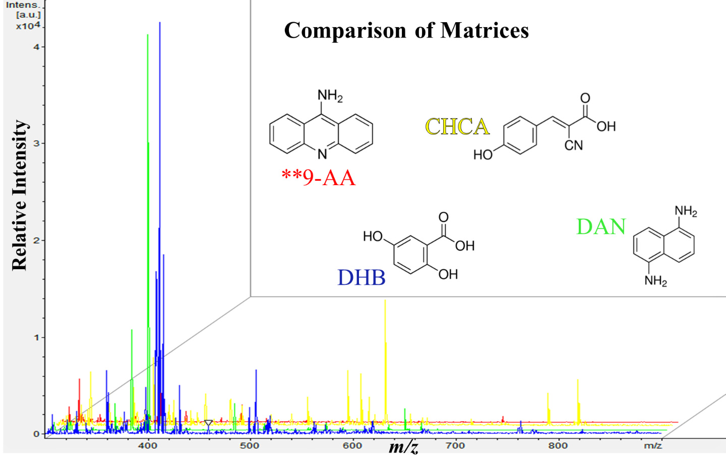
Supplemental Figure S2 provides an overlaid spectrum of the four matrices evaluated for optimal signal intensity during negative ionization mode MSI of sulfatide lipids.

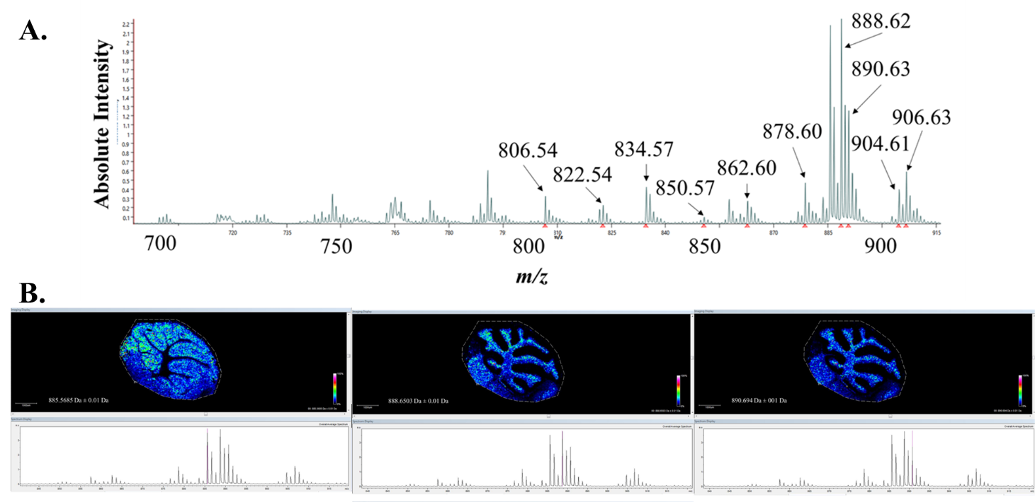

Supplemental Figure S3A provides the naïve spectra zoomed in to the mass range of ~700-915 Da, encompassing all the identified mass peaks within the study. Supplemental Figure S3B shows three mass distributions with their associated zoomed spectra displaying clean, mass-resolved baselines.

Supplemental Figure S4(A-J) provides the MALDI-TOF MS/MS conformational identification spectrum of the identified neuronal lipids within this study.

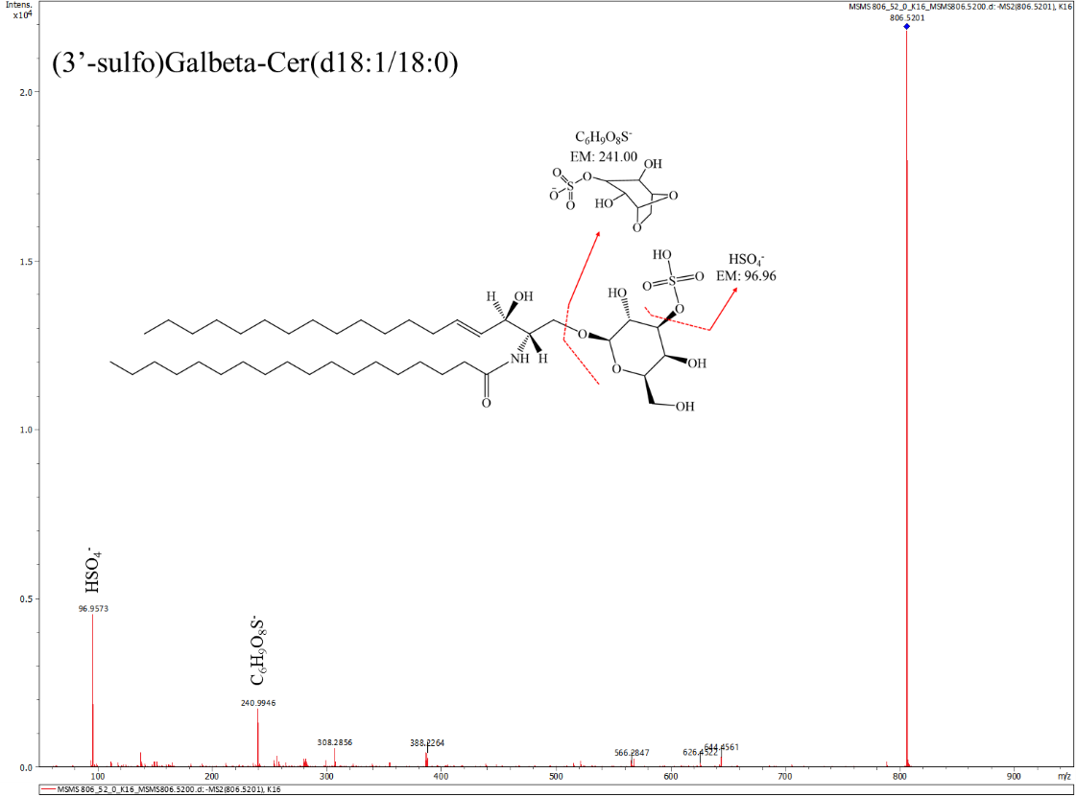
A.
Figure S4A MALDI-TOF MS/MS at m/z 806.52 displaying the identifying product ion attributes of SHexCer 36:1;O2.

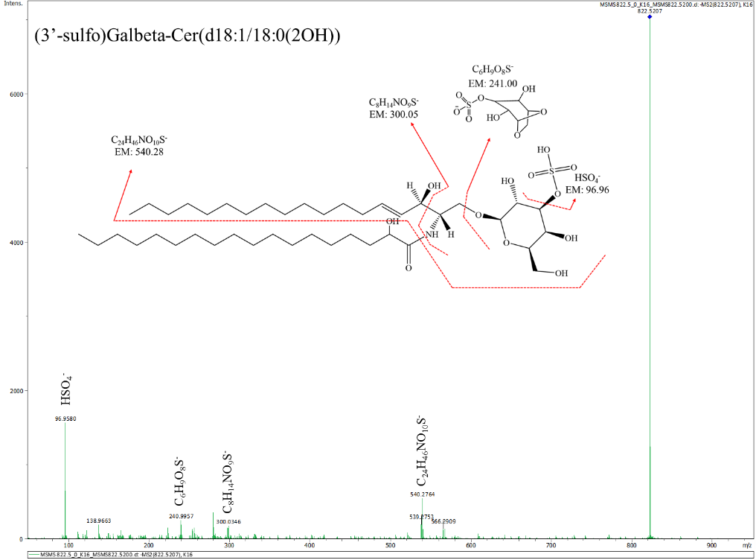
B.

Figure S4B MALDI-TOF MS/MS at m/z 822.50 displaying the identifying product ion attributes of SHexCer 36:1;O3.

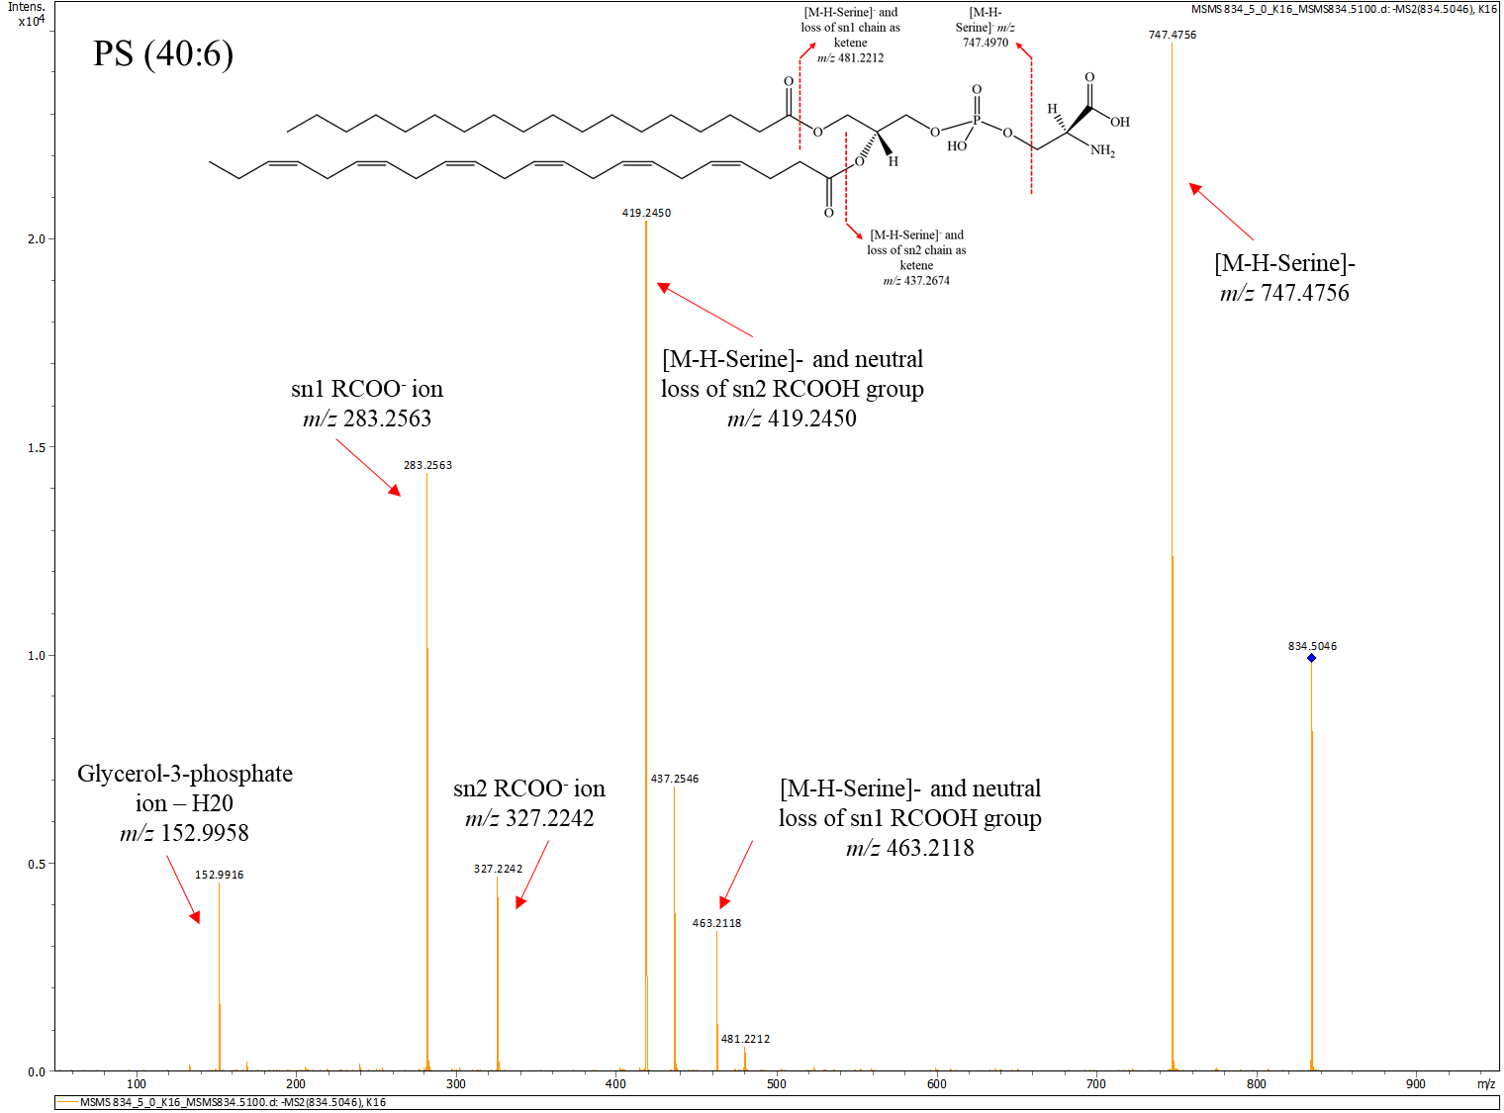
C.

Figure S4C MALDI-TOF MS/MS at m/z 834.50 displaying the identifying product ion attributes of PS (40:6).

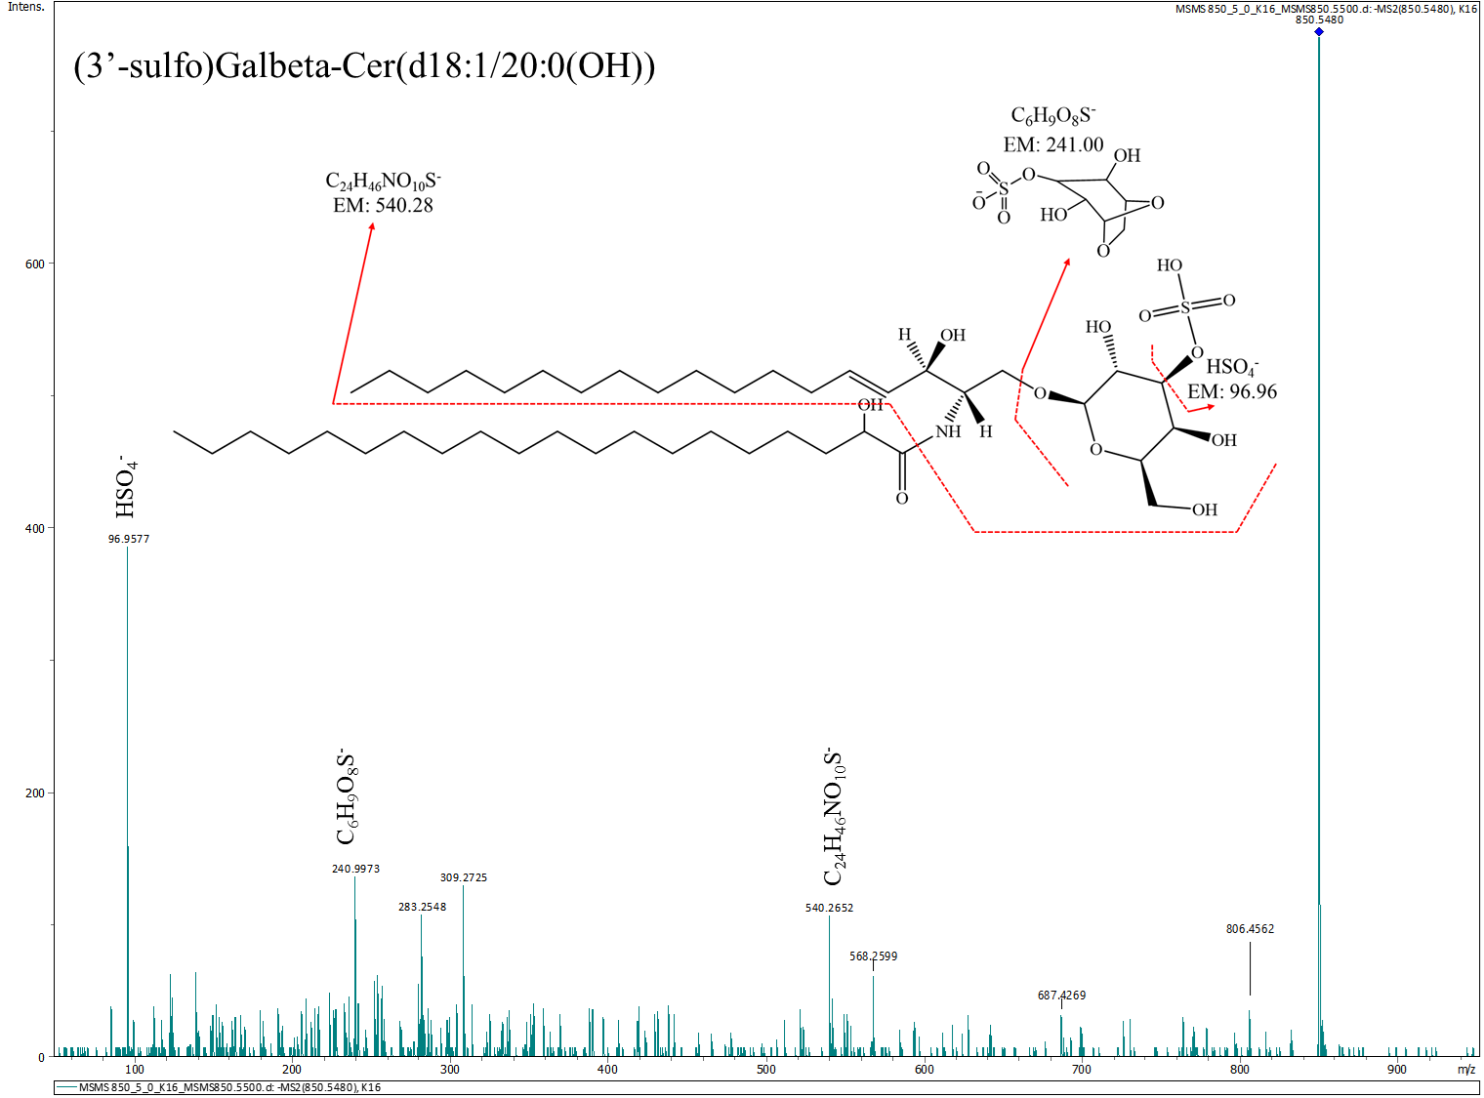
D.

Figure S4D timsTOF MS/MS at m/z 850.50 displaying the identifying product ion attributes of SHexCer 38:1;O3.

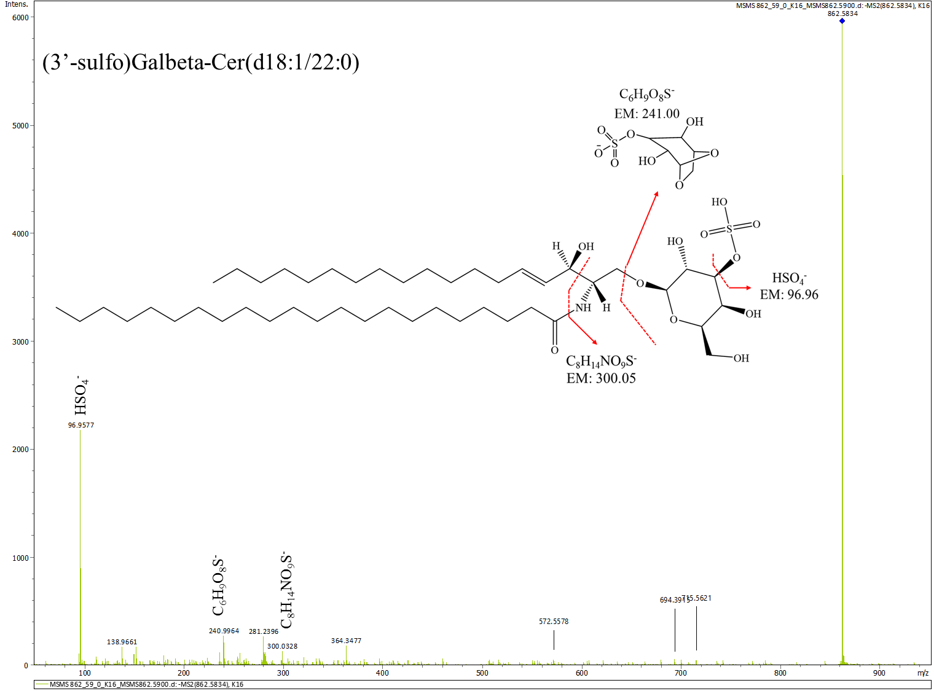
E.

Figure S4E MALDI-TOF MS/MS at m/z 862.59 displaying the identifying product ion attributes of SHexCer 40:1;O2.
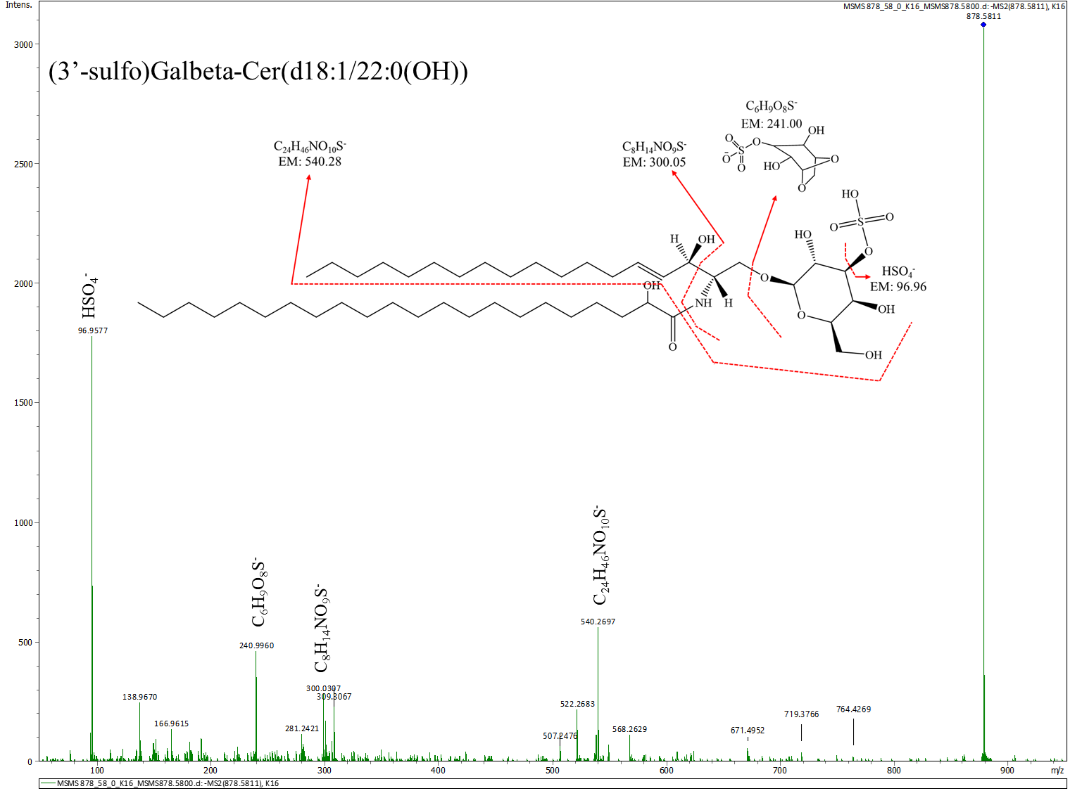
F.

Figure S4F MALDI-TOF MS/MS at m/z 878.58 displaying the identifying product ion attributes of SHexCer 40:1;O3.

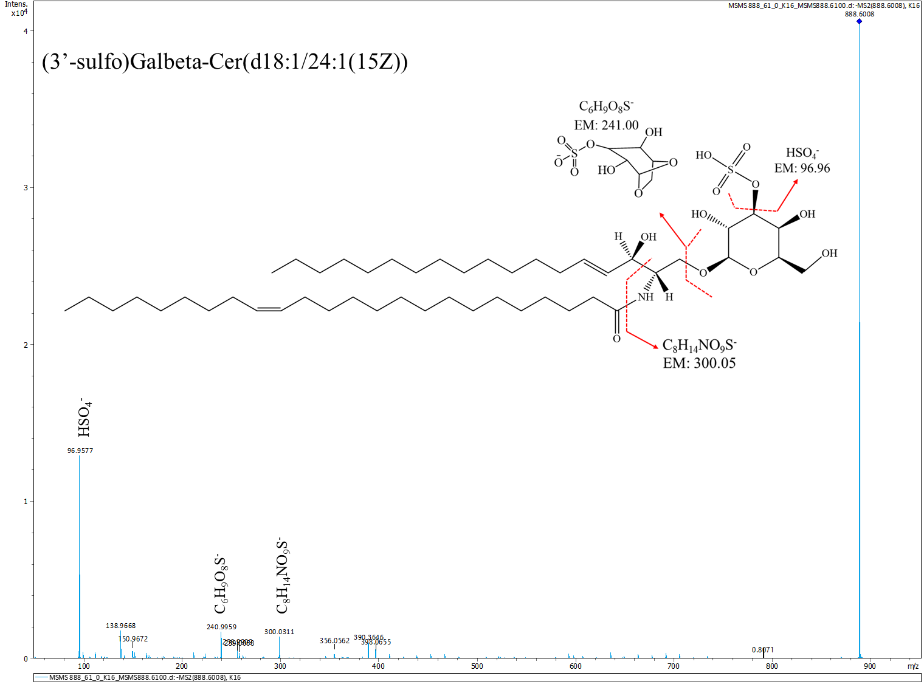
G.

Figure S4G MALDI-TOF MS/MS at m/z 888.61 displays the identifying product ion attributes of SHexCer 42:2;O2.

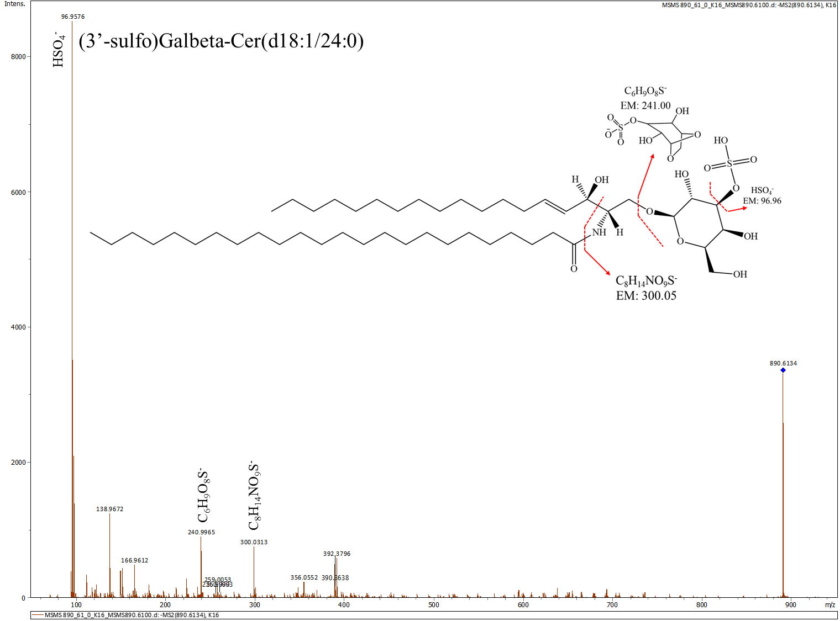
H.

Figure S4H MALDI-TOF MS/MS at m/z 890.61 displaying the identifying product ion attributes of SHexCer 42:1;O2.

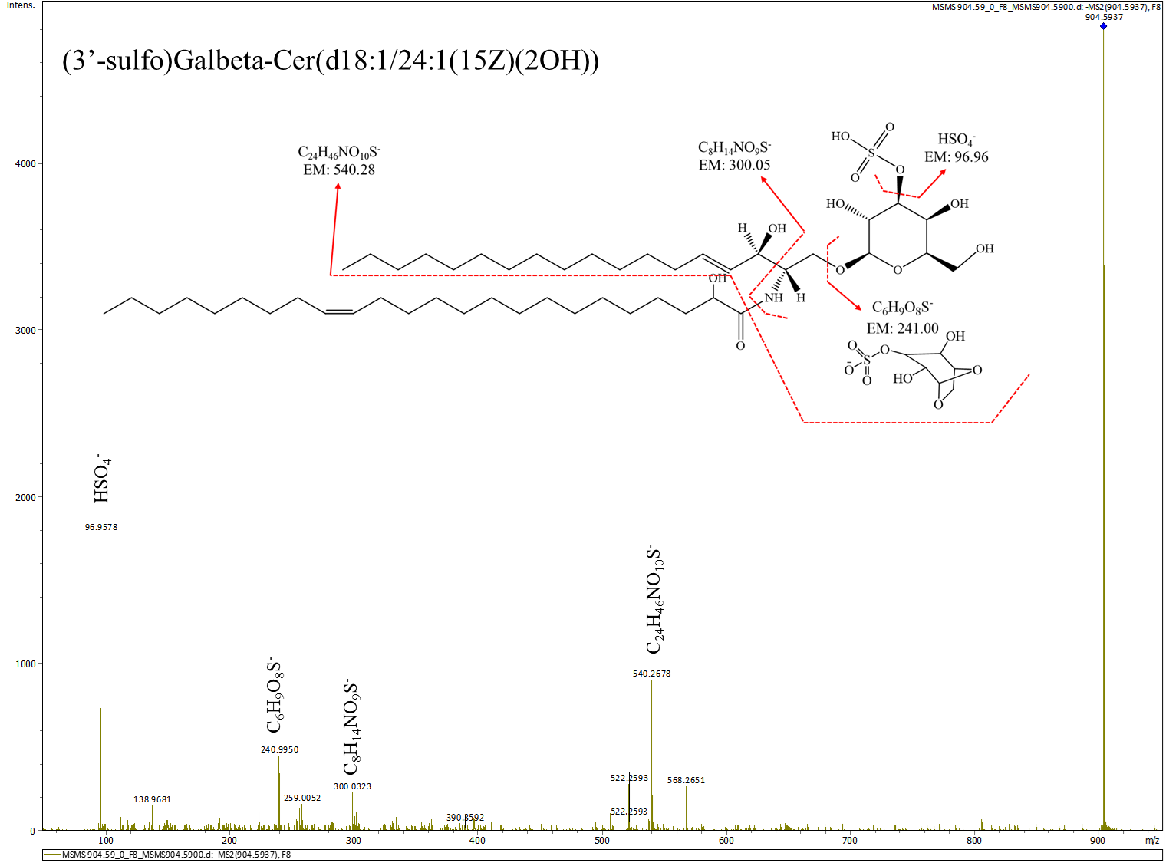
I.

Figure S4I MALDI-TOF MS/MS at m/z 904.59 displaying the identifying product ion attributes of SHexCer 42:2;O3.

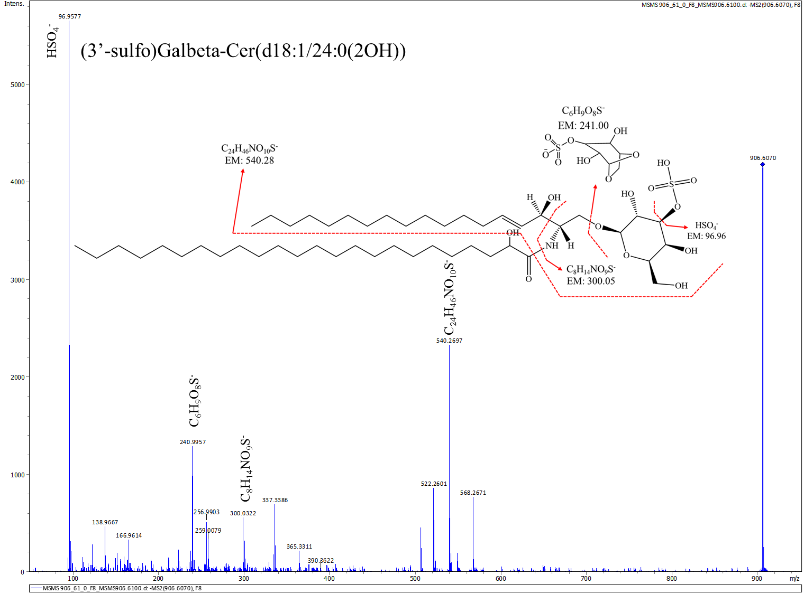
J.

Figure S4J MALDI-TOF MS/MS at m/z 906.61 displaying the identifying product ion attributes of SHexCer 42:1;O3.

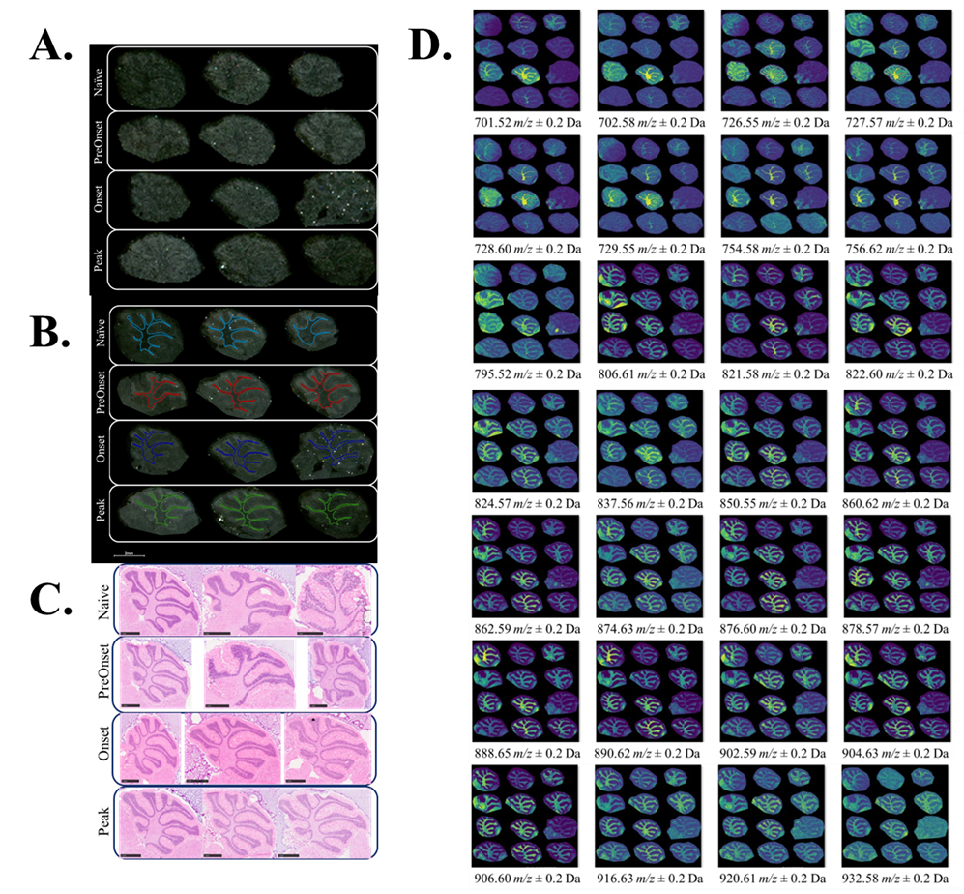

Supplemental Figure S5 displays the MSI of all the WM lipids detected in negative ionization mode within this study. S5A shows the raw scanned tissue sections with the different tissue samples labeled and encircled by group. S5B is the defined M region of interest, color-coded and encircled by the tissue sample group. S5C is the same set of tissue samples as S5A and S5B, post-MSI, with the 9-AA matrix washed off, and H&E staining performed. Figures S5A-S5C provide the sample layout that applies to all the MSI ion distributions seen in Figure S5D.

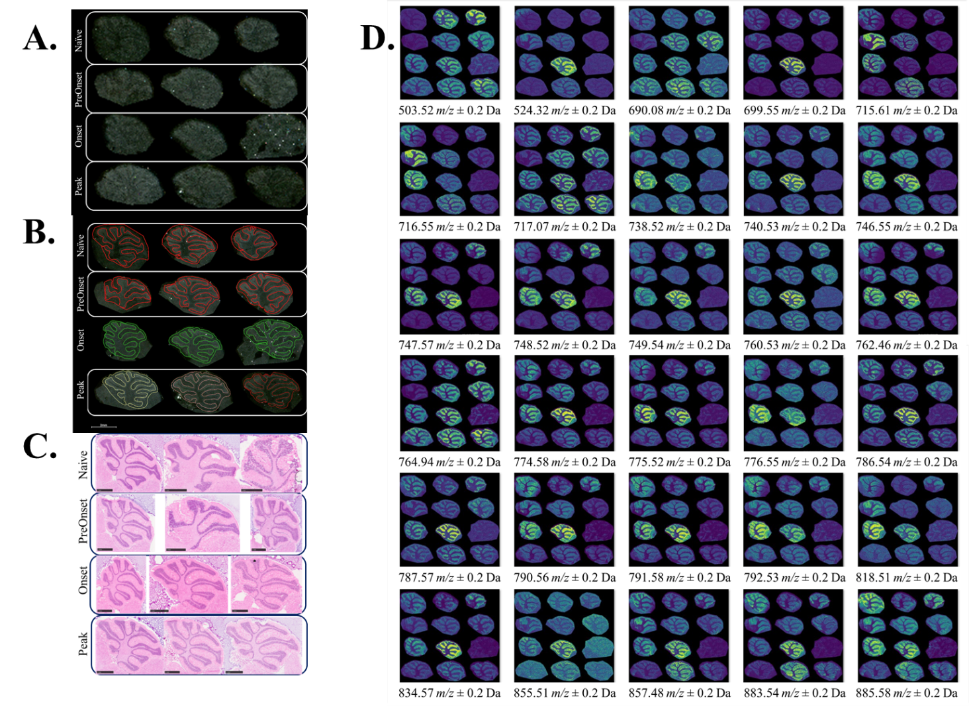

Supplemental Figure S6 displays the MSI of all GM lipids detected in negative ionization mode within this study. S6A shows the raw scanned tissue sections with the different tissue samples labeled and encircled by group. S6B is the defined GM region of interest, color-coded and encircled by the tissue sample group. S6C is the same set of tissue samples as S6A and S6B, post-MSI, with the 9-AA matrix washed off, and H&E staining performed. Figures S6A-S6C provide the sample layout that applies to all the MSI ion distributions seen in Figure S6D.

