Synthesis and evaluation of mycophenolic acid derivatives as potential anti-Toxoplasma gondii agents

Fan-Fan Shang^{a#}, Mei-Yuan Wang^{a#}, Jiang-Ping Aiª, Qing-Kun Shenª, Hong-Yan Guoª, Chun-Mei Jinª, Fen-Er Chen^{a,b}, Zhe-Shan Quanª, Lili Jinª*, Changhao Zhangª*

ªKey Laboratory of Natural Medicines of the Changbai Mountain, Ministry of Education, Yanbian University, Yanji 133002, China
^{b}Engineering Center of Catalysis and Synthesis for Chiral Molecules, Department of Chemistry, Fudan University, Shanghai 200433, China

*Corresponding author: Tel: + 86 433 243-6020; Fax: + 86 433 243-6020.
E-mail: zhangch@ybu.edu.cn (C. H. Zhang).

*Corresponding author: Tel: + 86 433 243-6020; Fax: + 86 433 243-6020.
E-mail: jinlili@ybu.edu.cn (L. L. Jin).

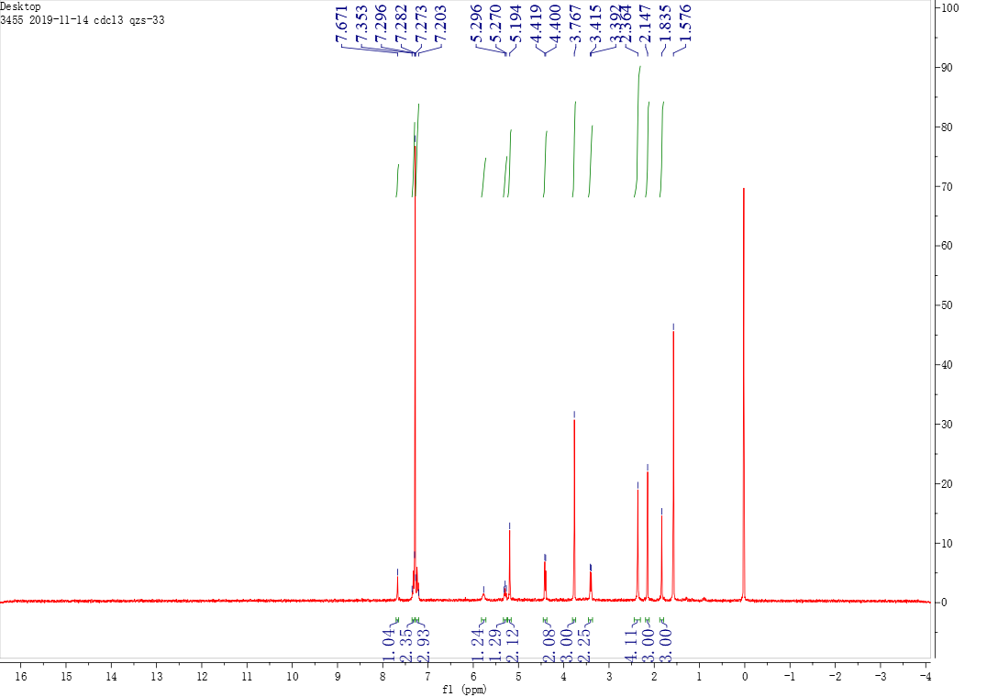

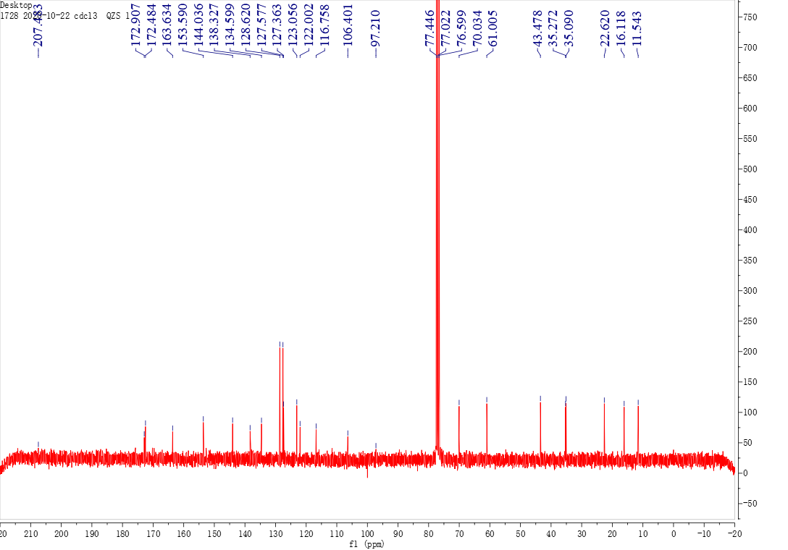

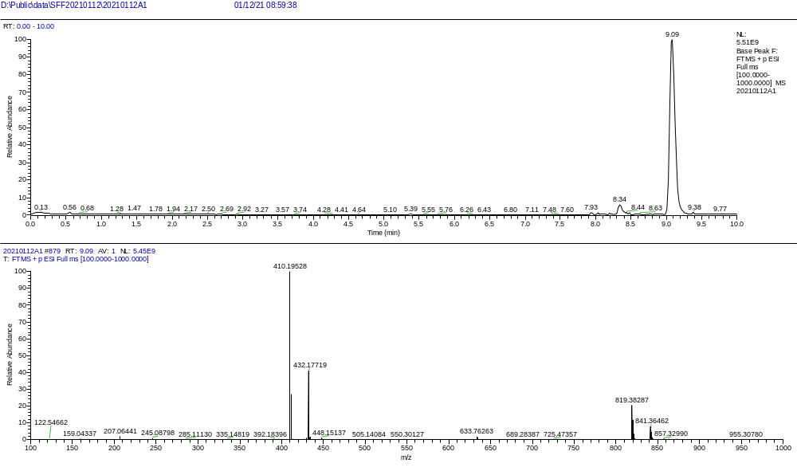

The ¹H NMR, ¹³C NMR, and HRMS of compound A1

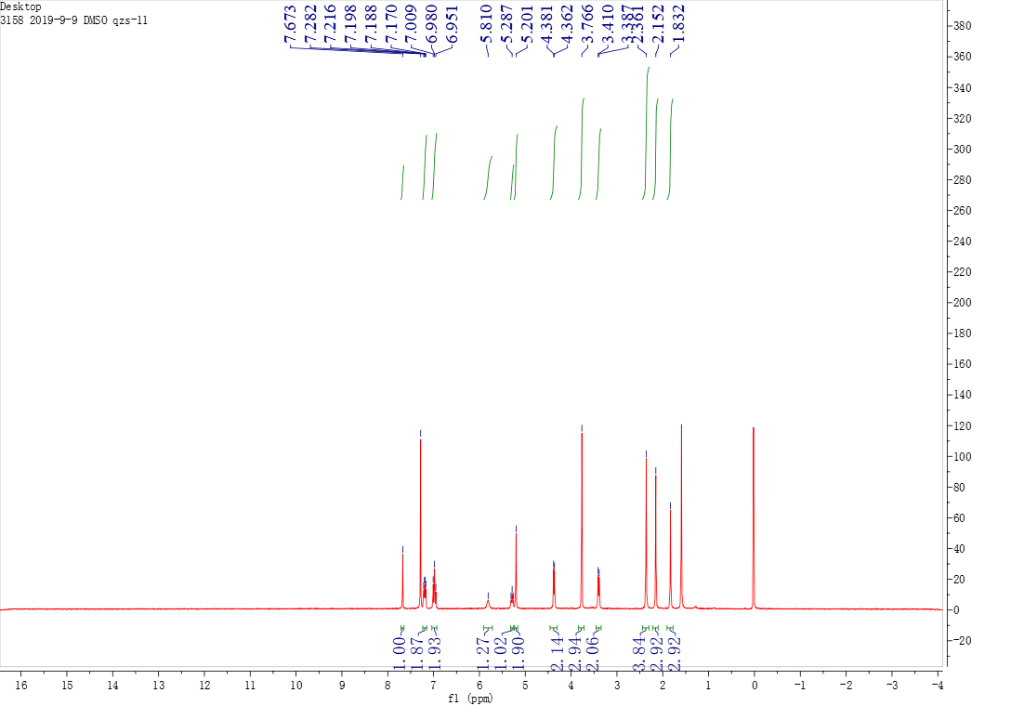

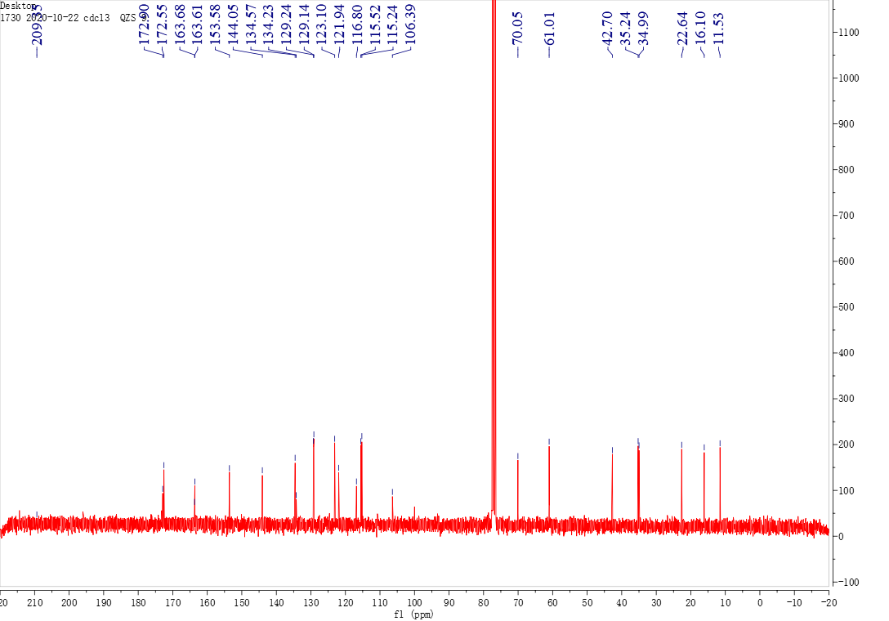

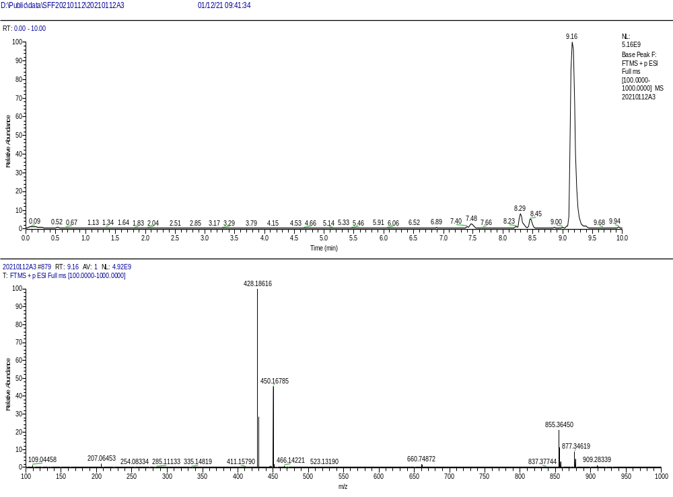

The ¹H NMR, ¹³C NMR, and HRMS of compound A2

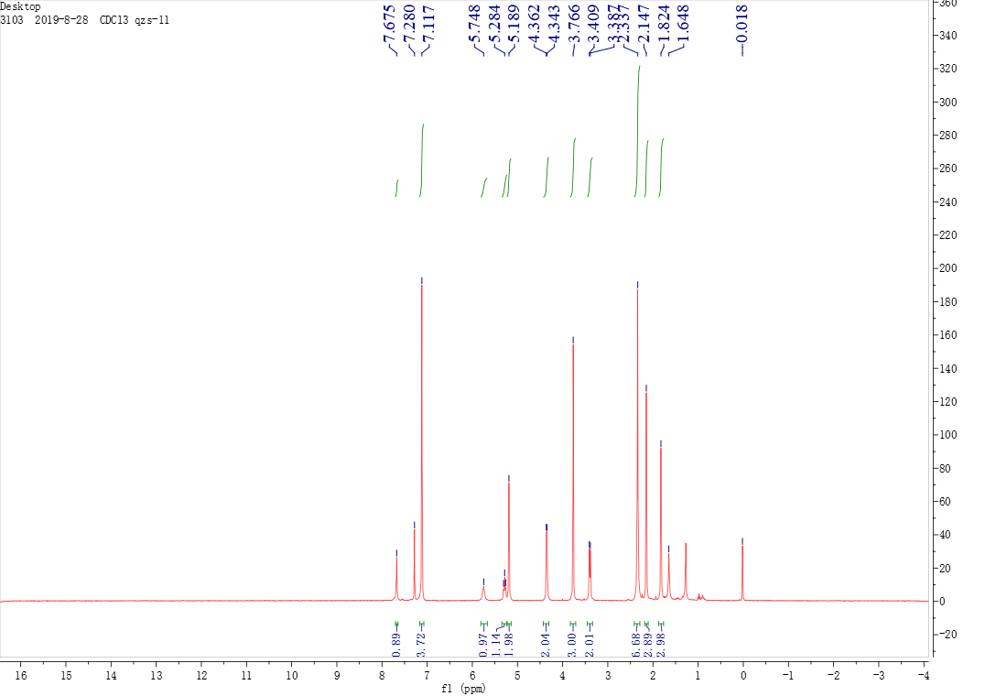

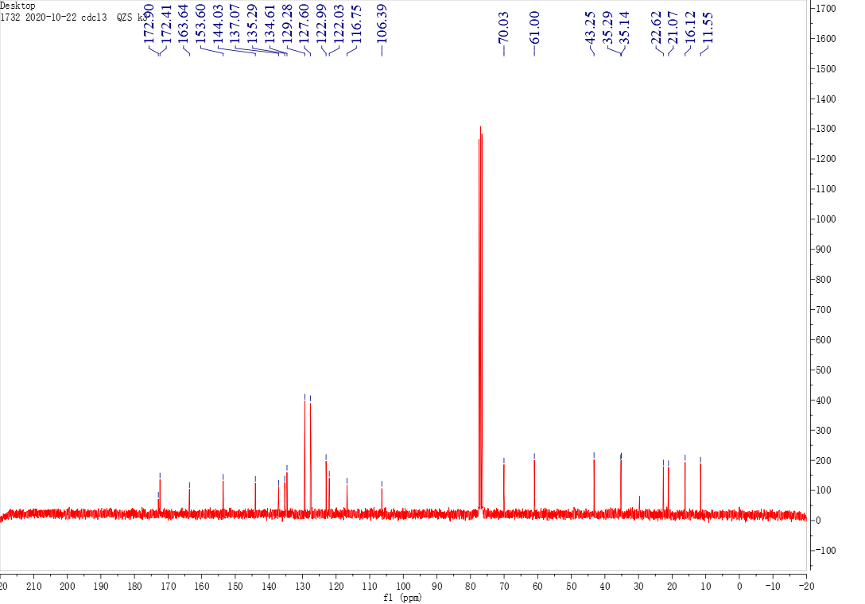

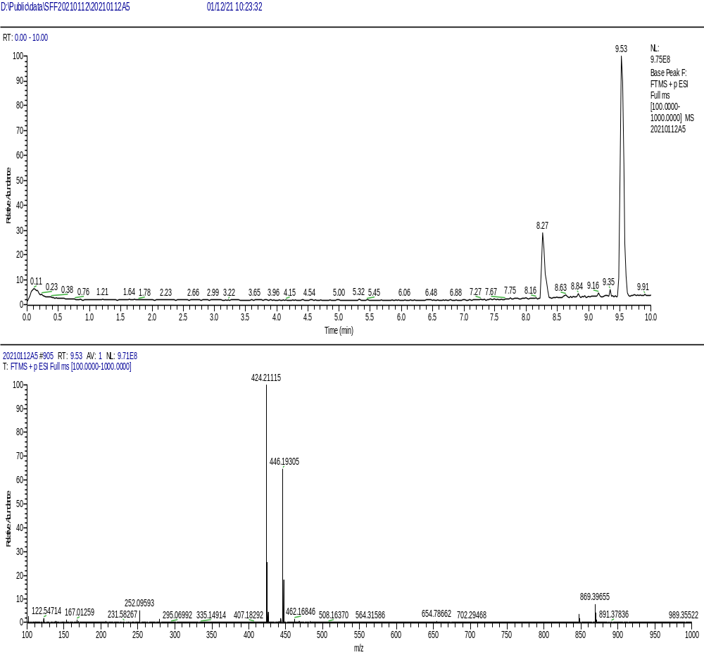
The ¹H NMR, ¹³C NMR, and HRMS of compound A3

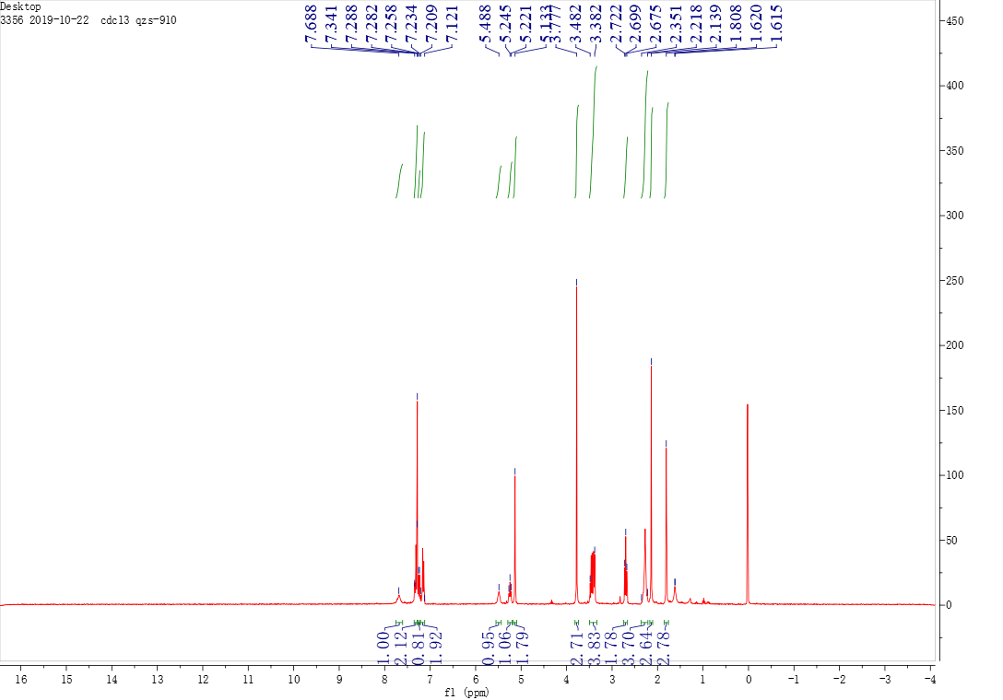

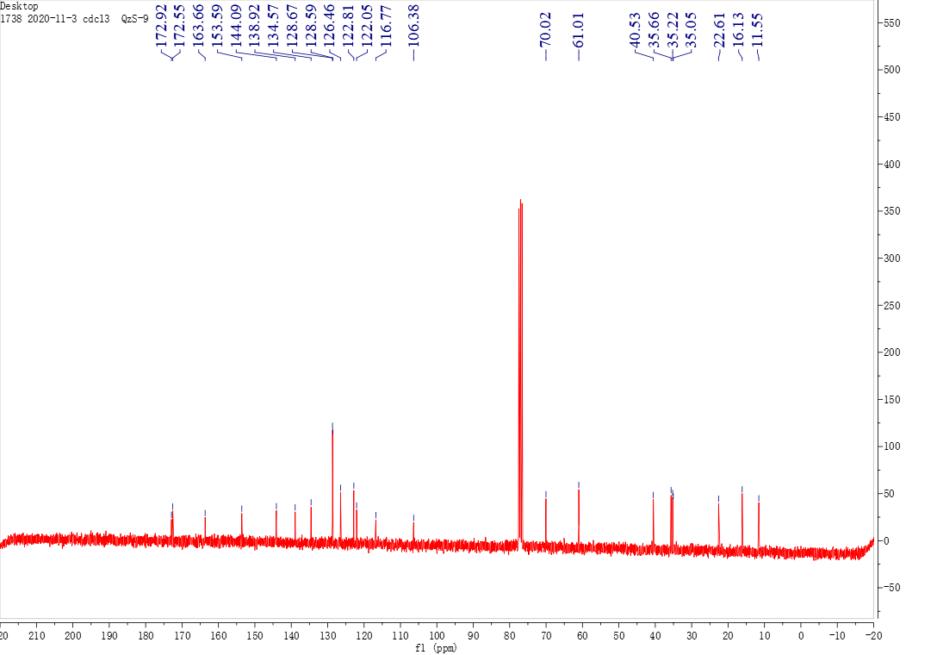

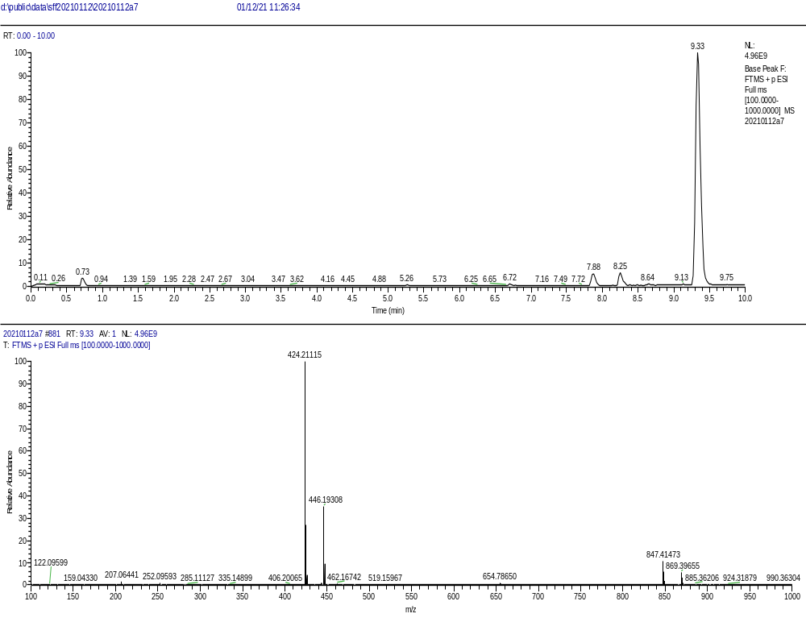

The ¹H NMR, ¹³C NMR, and HRMS of compound A4

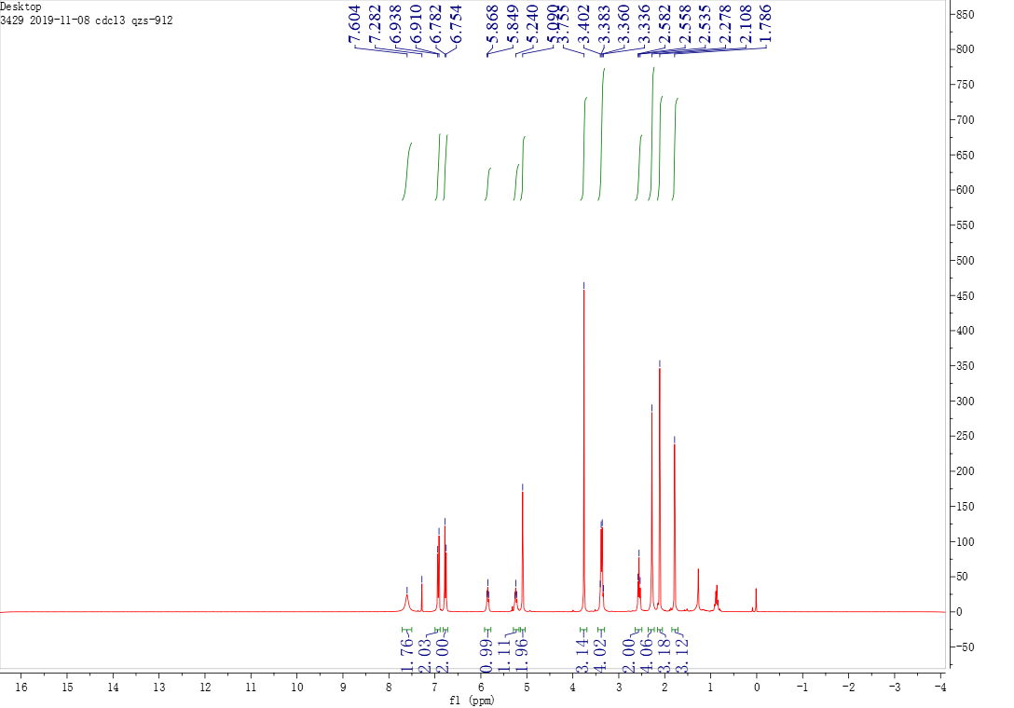

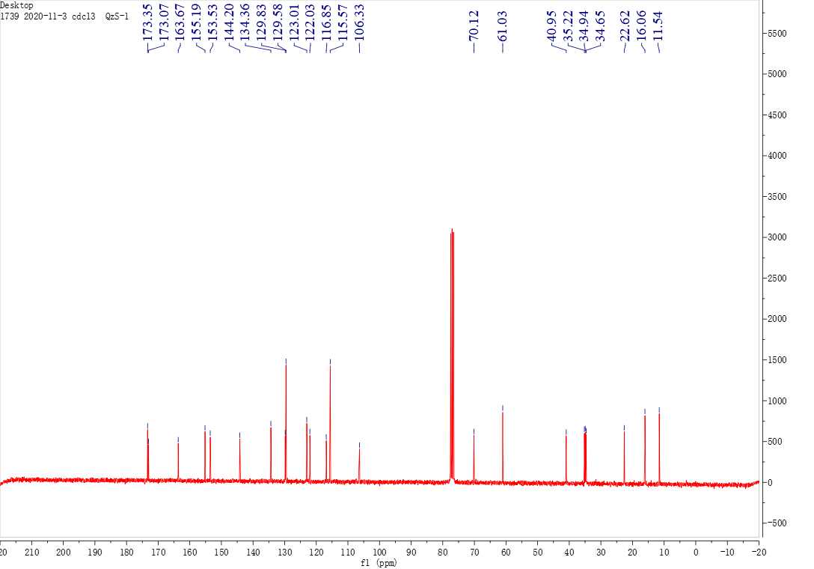

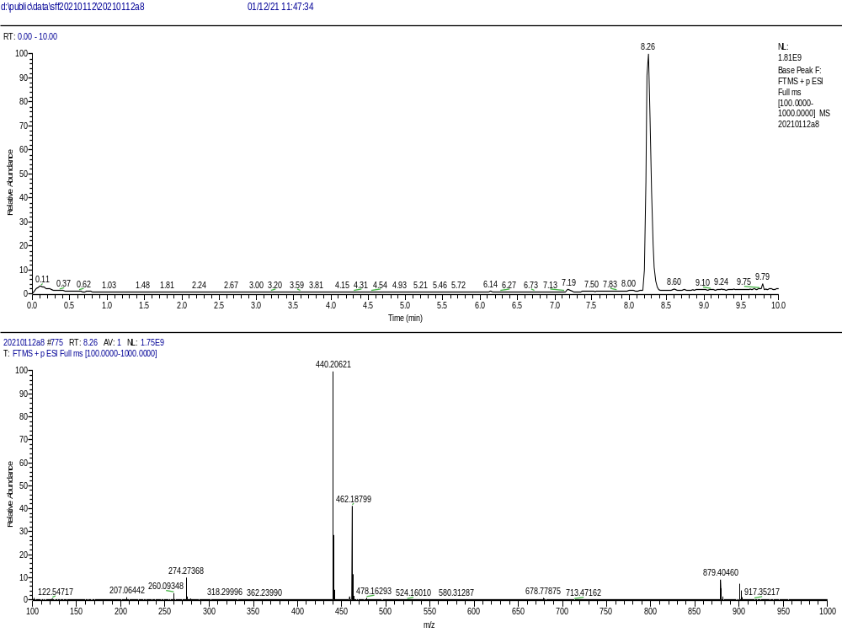

The ¹H NMR, ¹³C NMR, and HRMS of compound A5

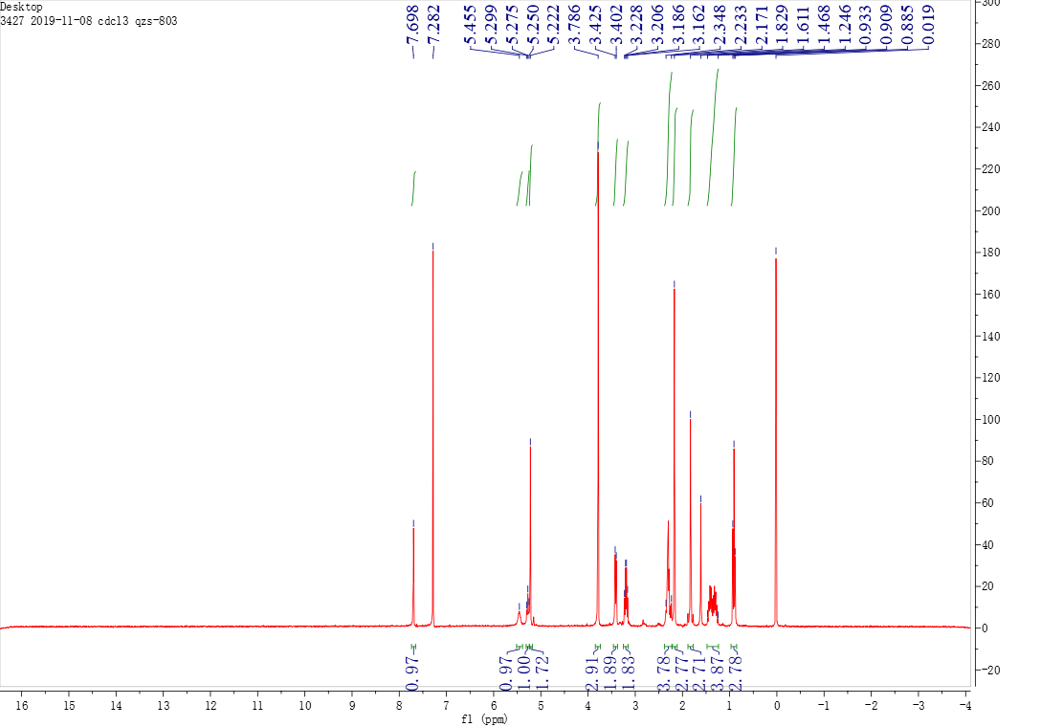

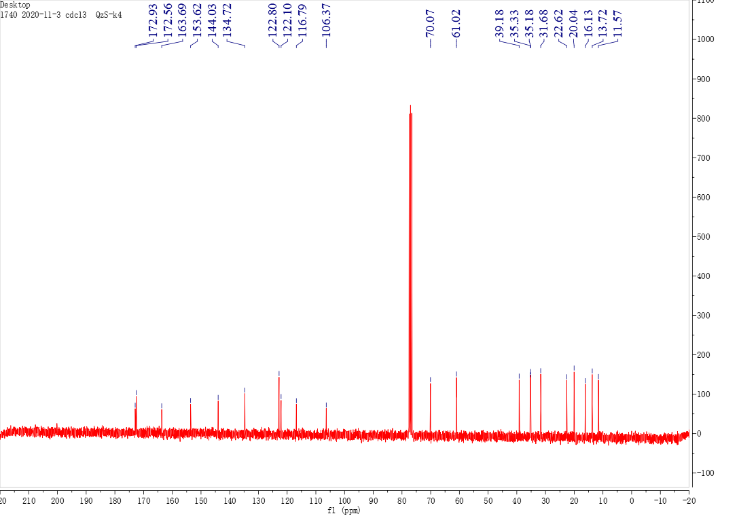

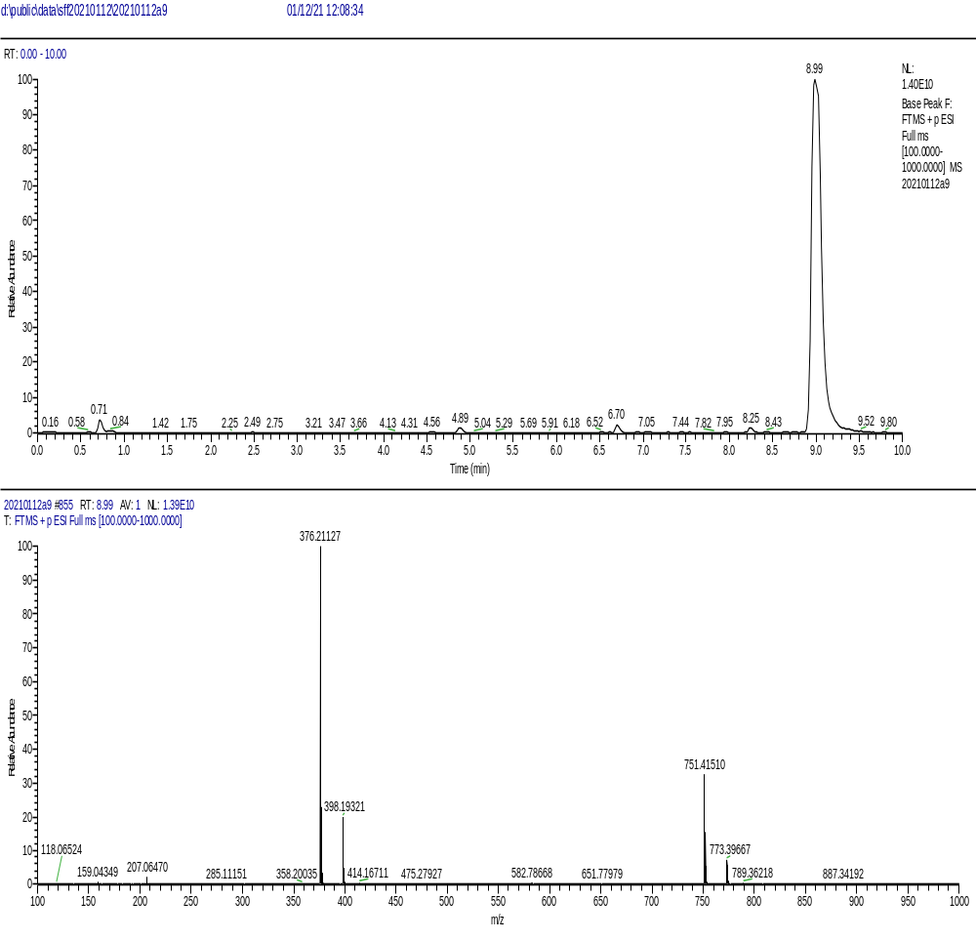

The ¹H NMR, ¹³C NMR, and HRMS of compound B1

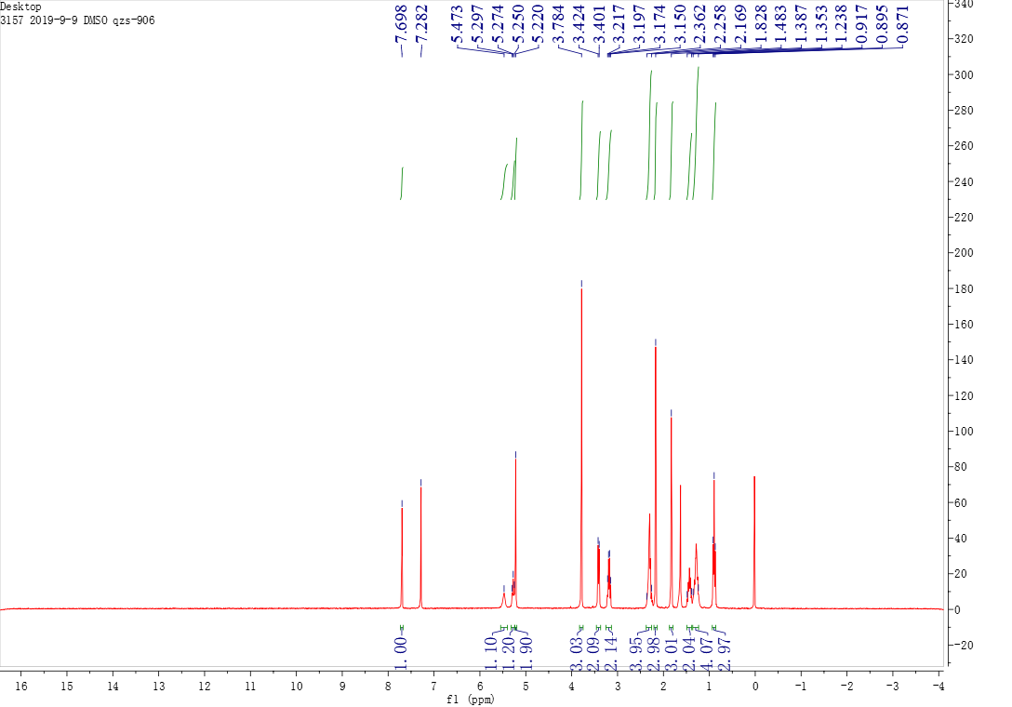

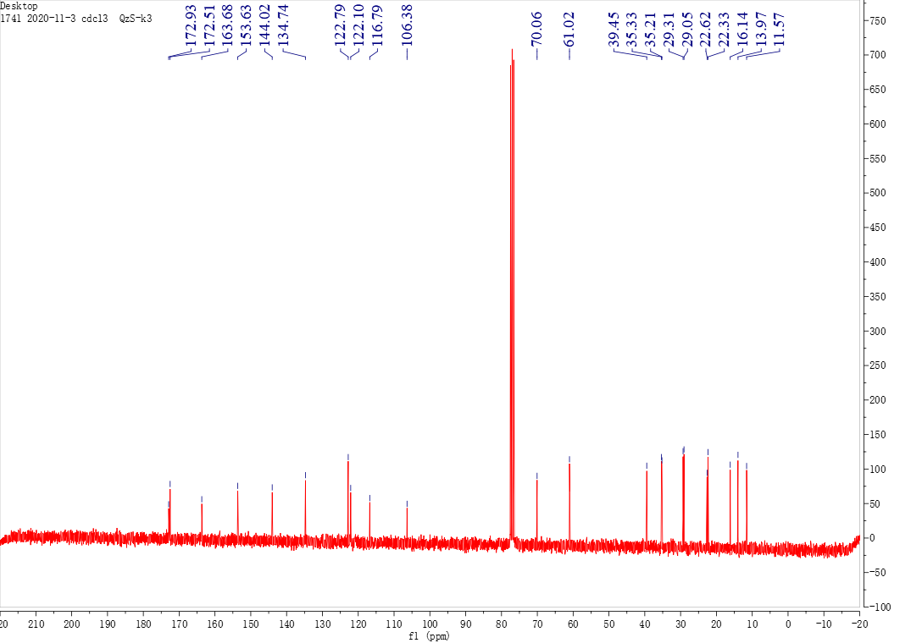

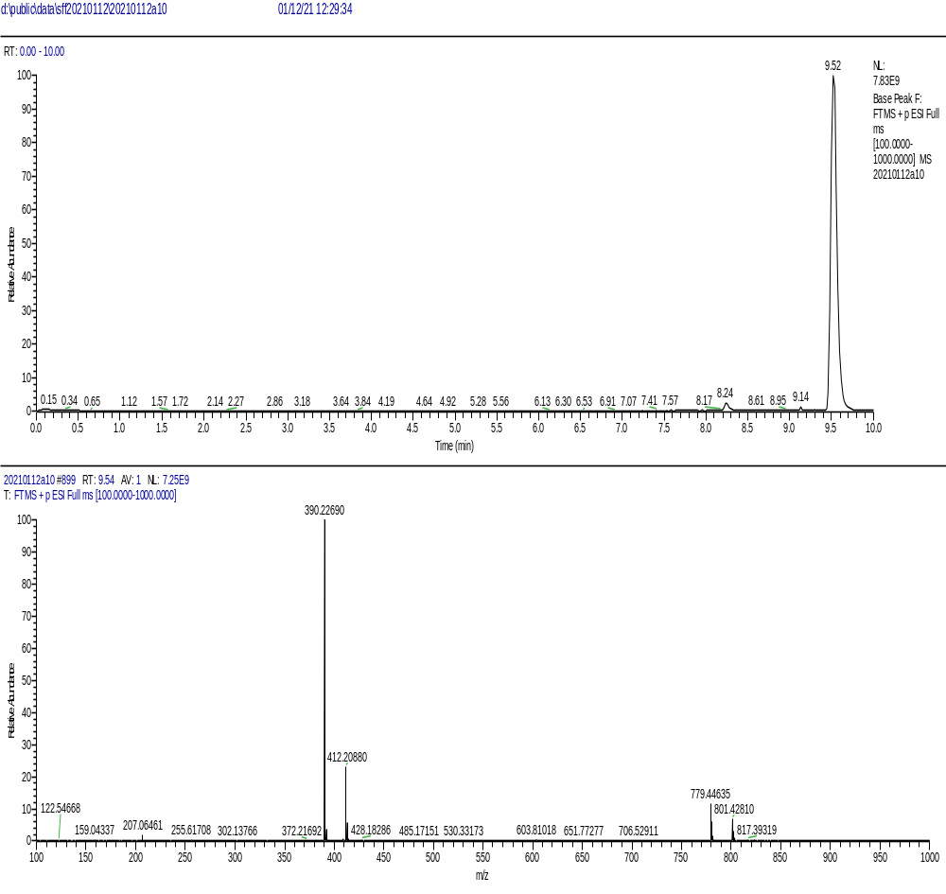

The ¹H NMR, ¹³C NMR, and HRMS of compound B2

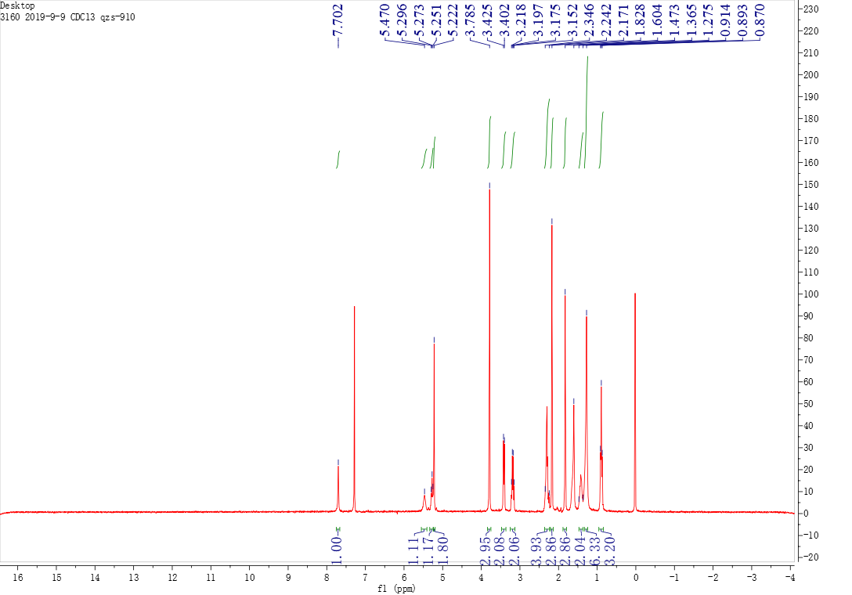

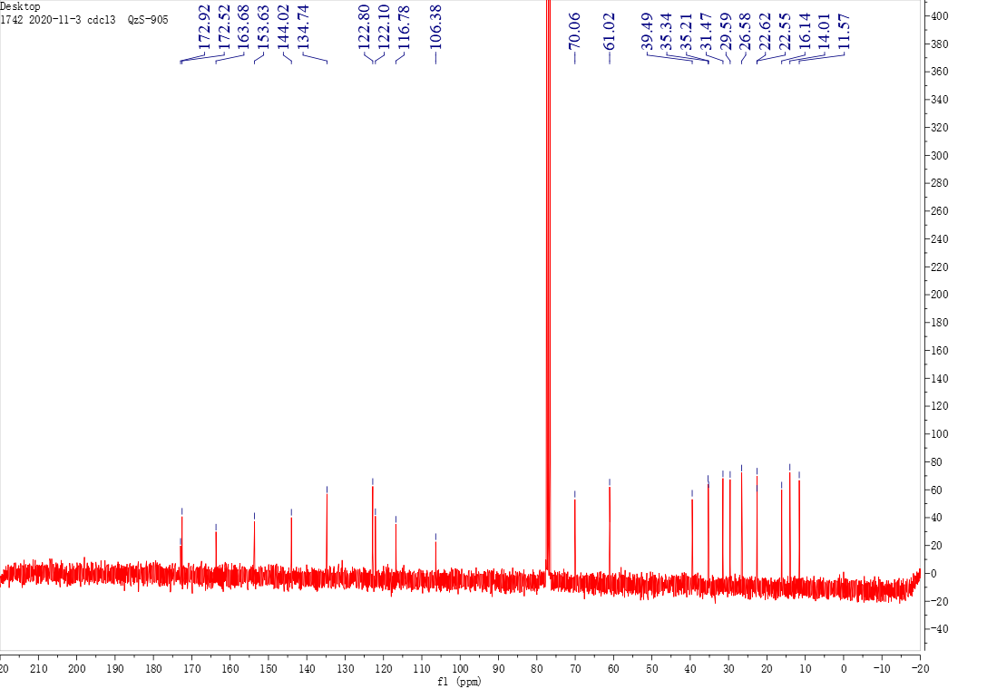

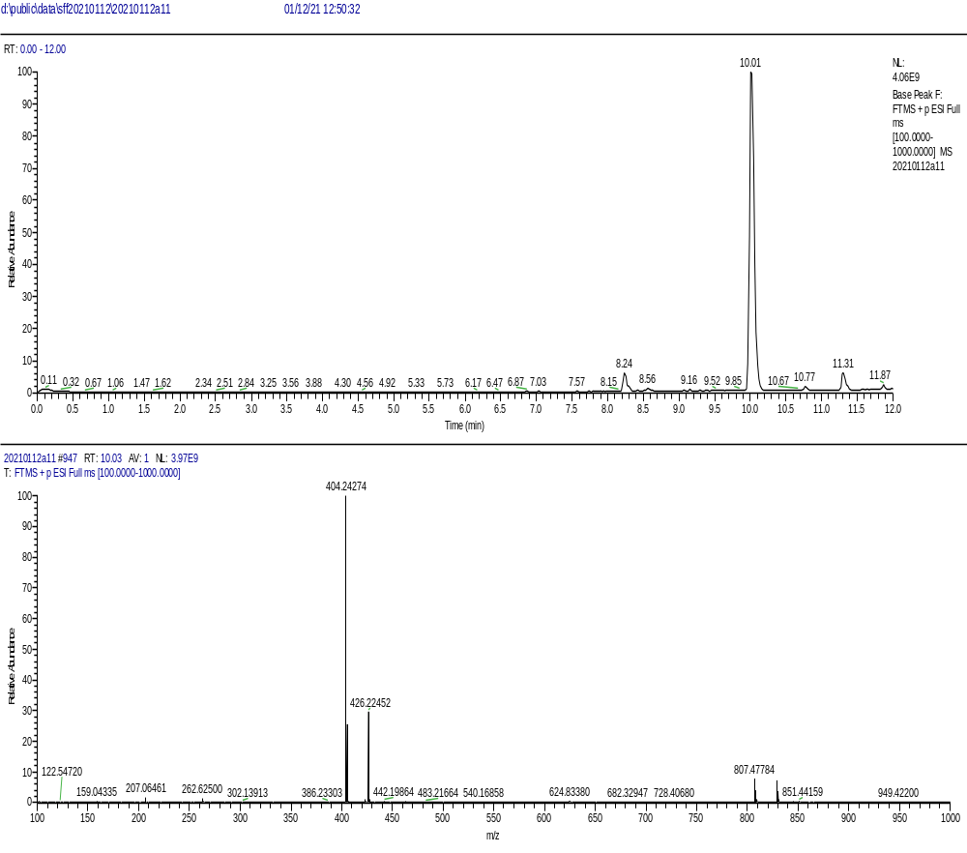

The ¹H NMR, ¹³C NMR, and HRMS of compound B3

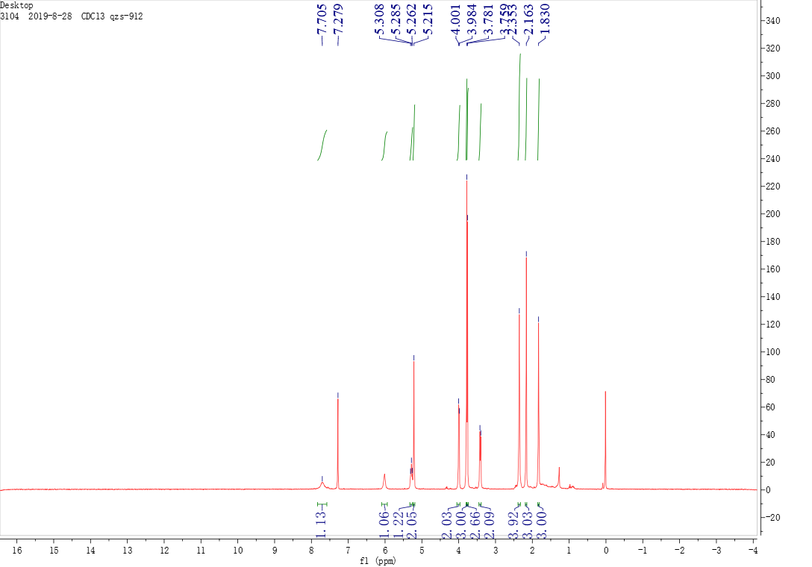

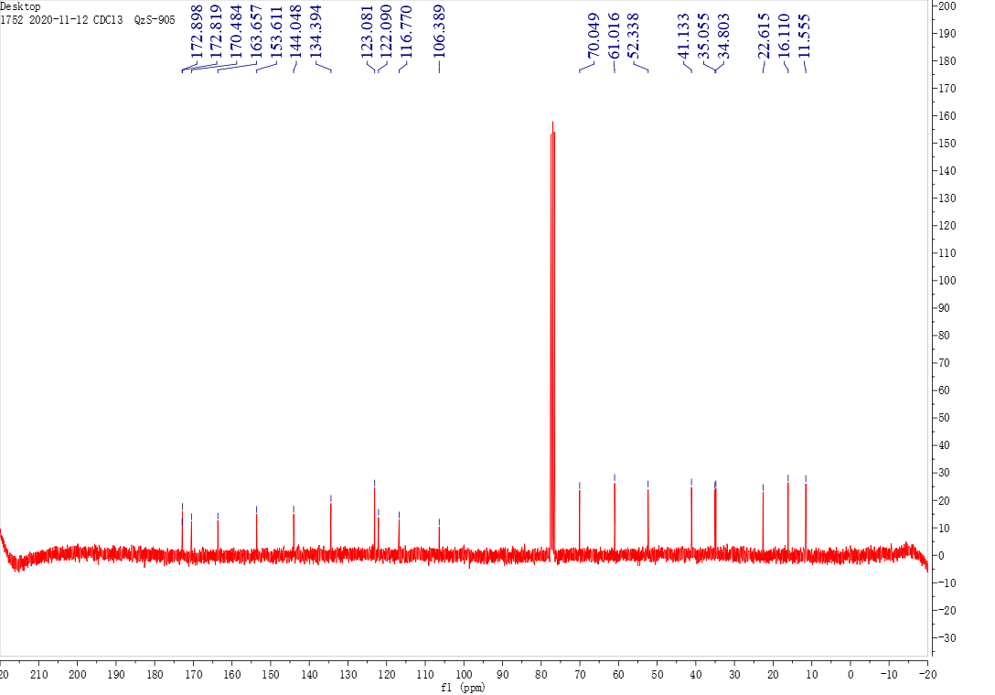

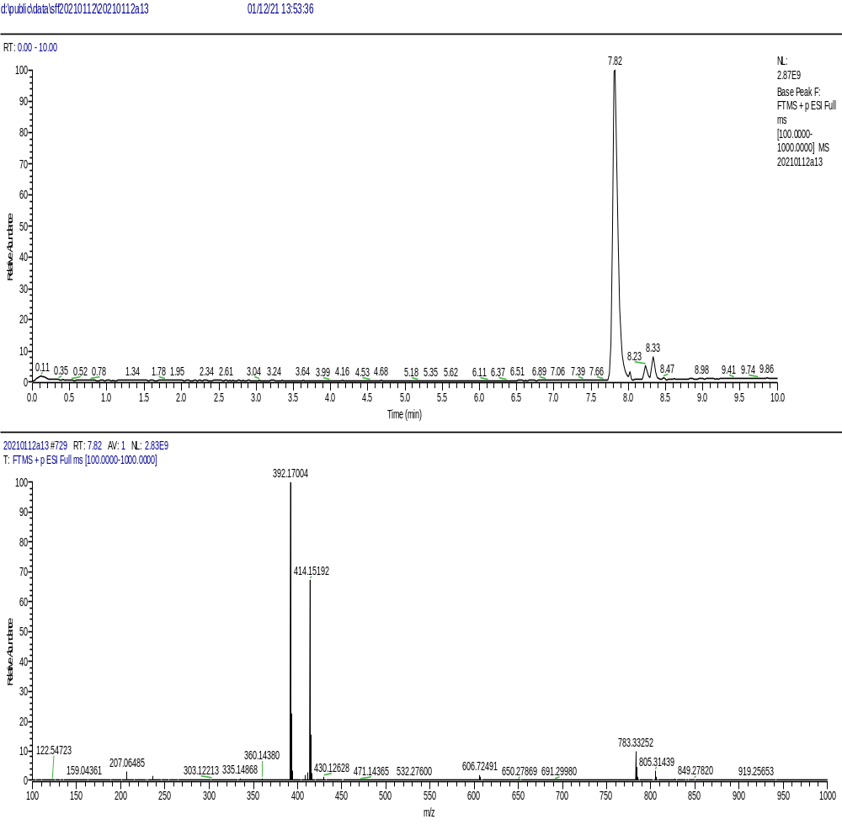

The ¹H NMR, ¹³C NMR, and HRMS of compound C1

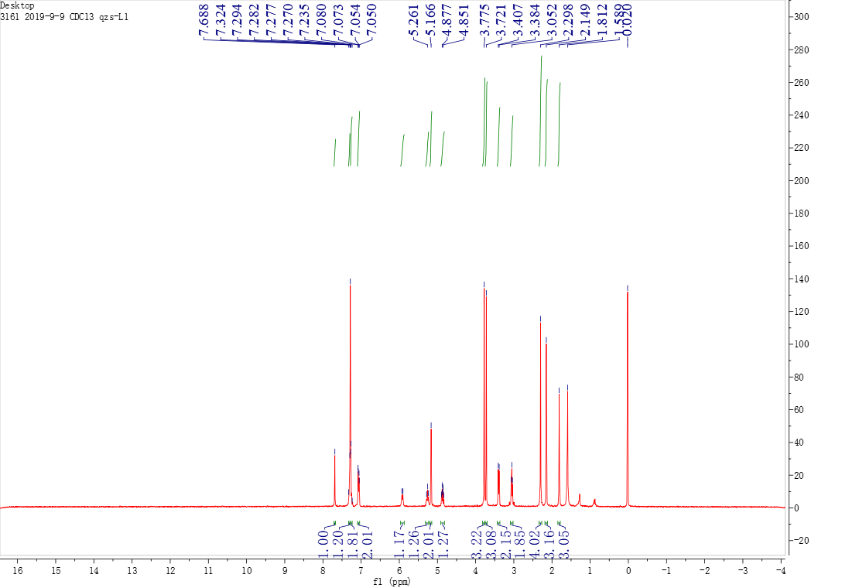

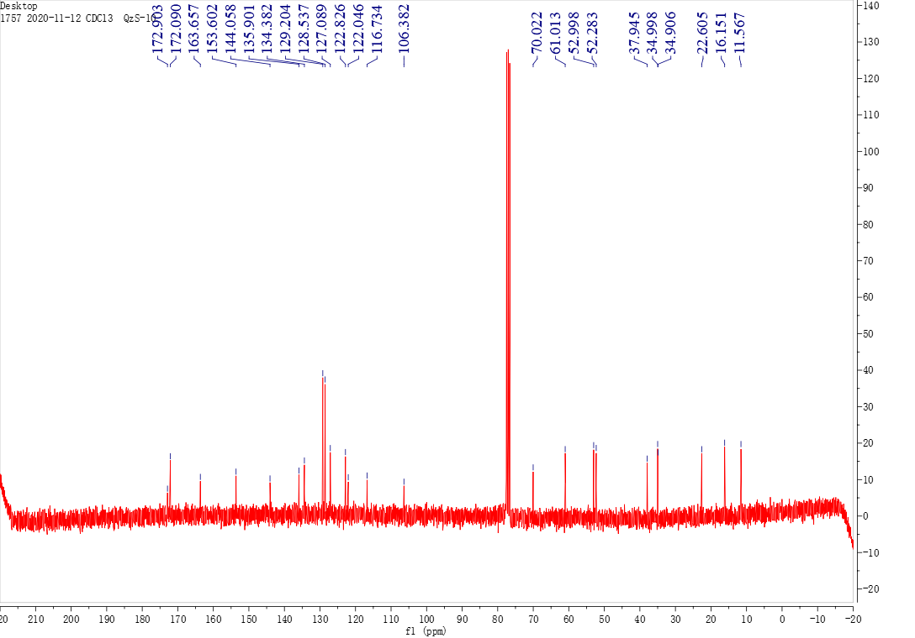

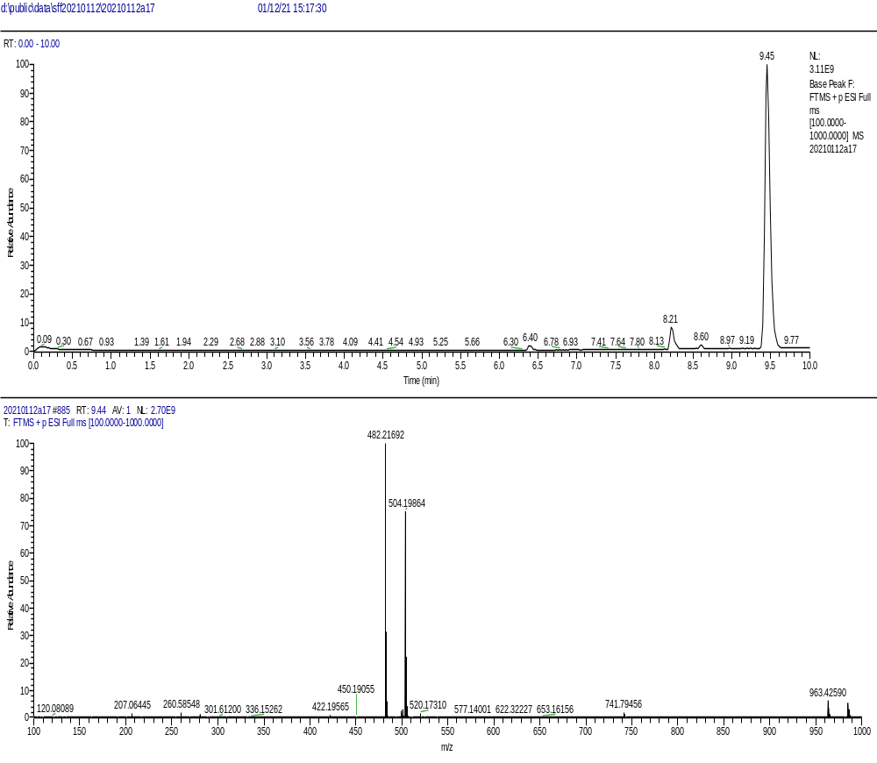

The ¹H NMR, ¹³C NMR, and HRMS of compound C2

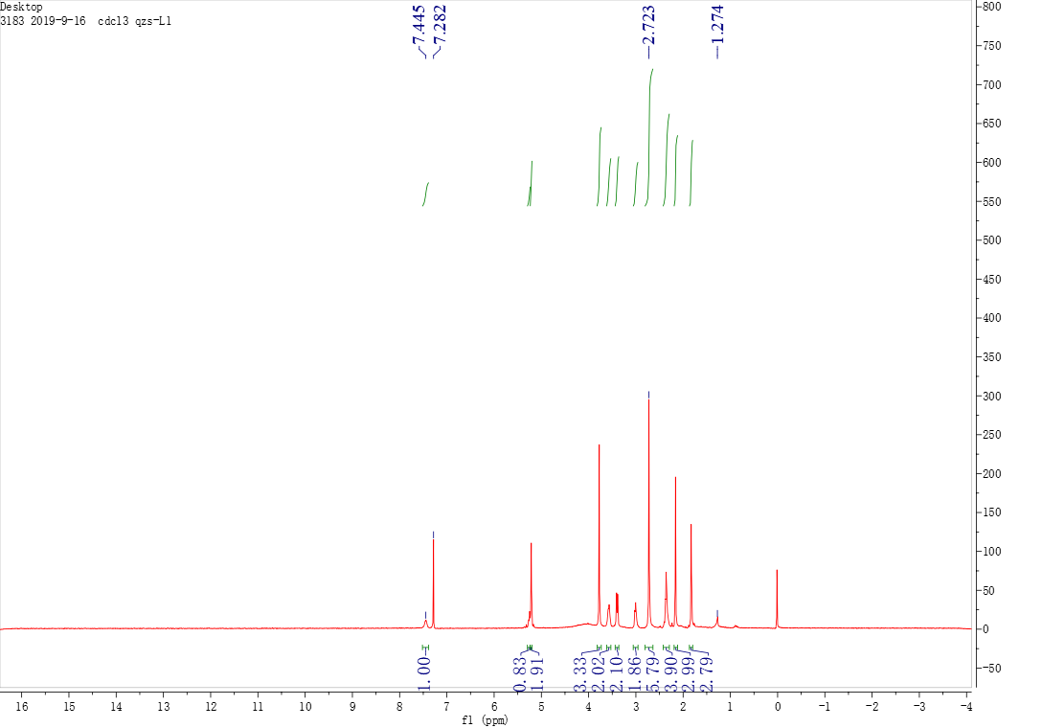

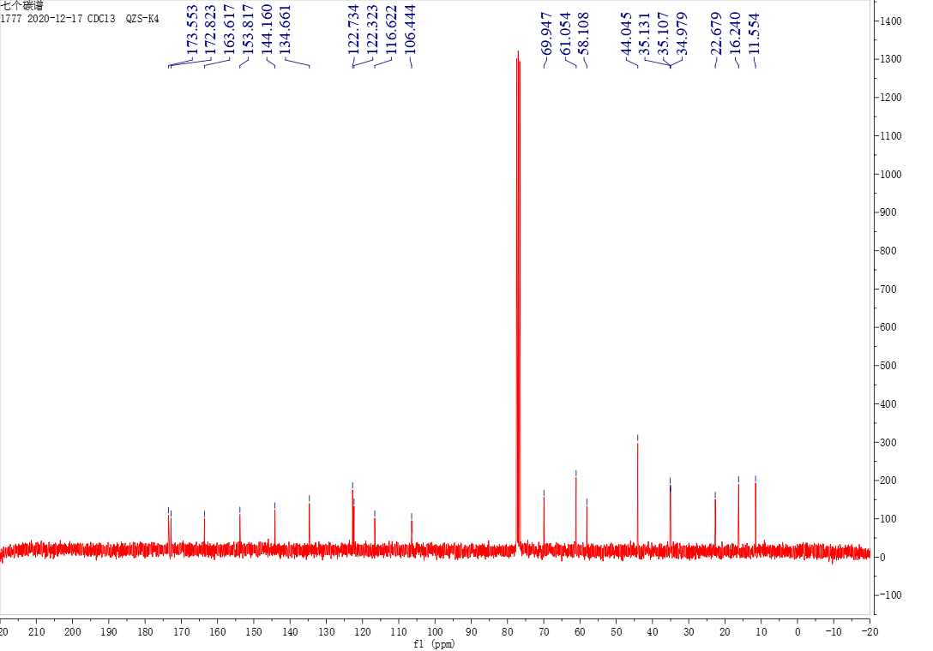

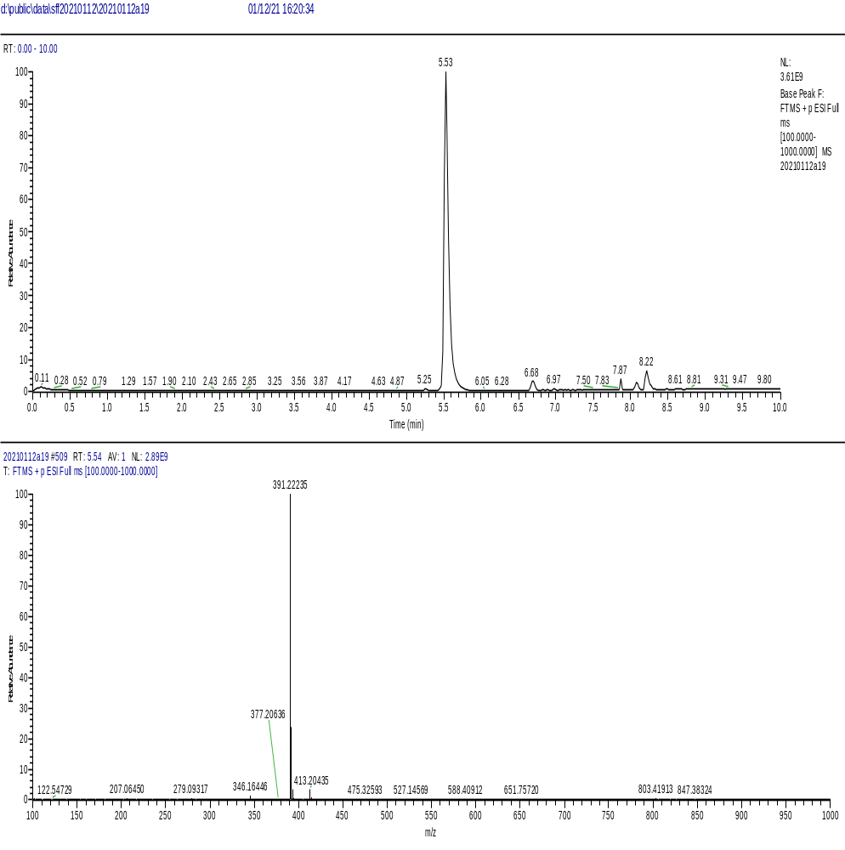

The ¹H NMR, ¹³C NMR, and HRMS of compound D1

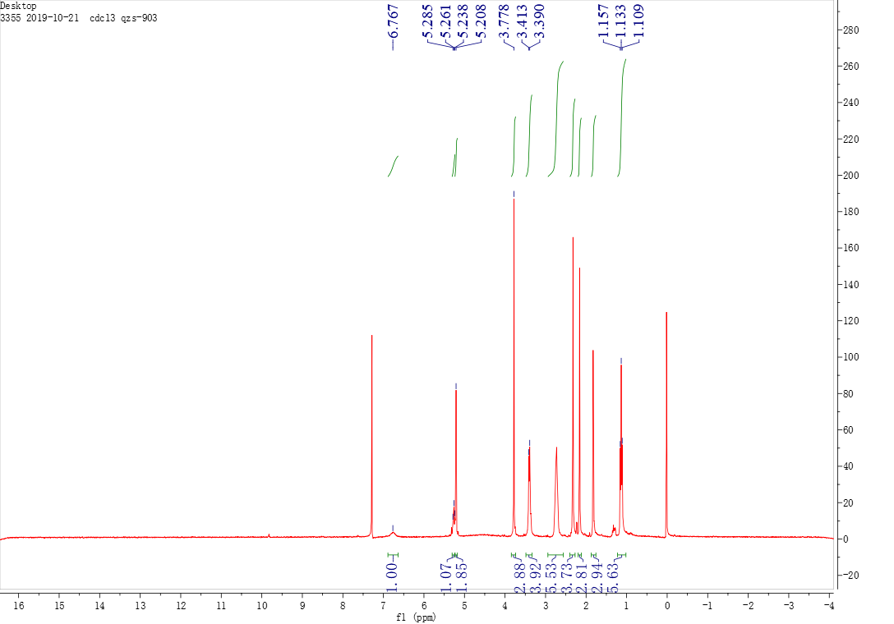

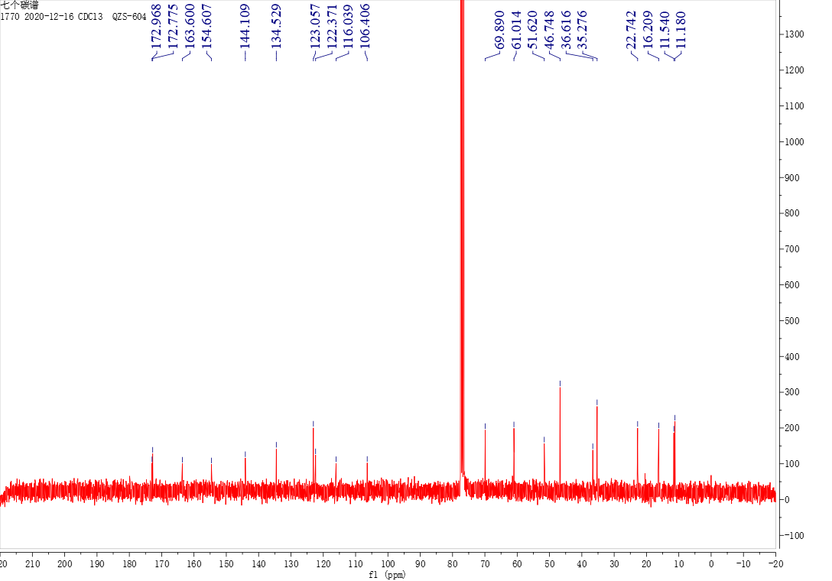

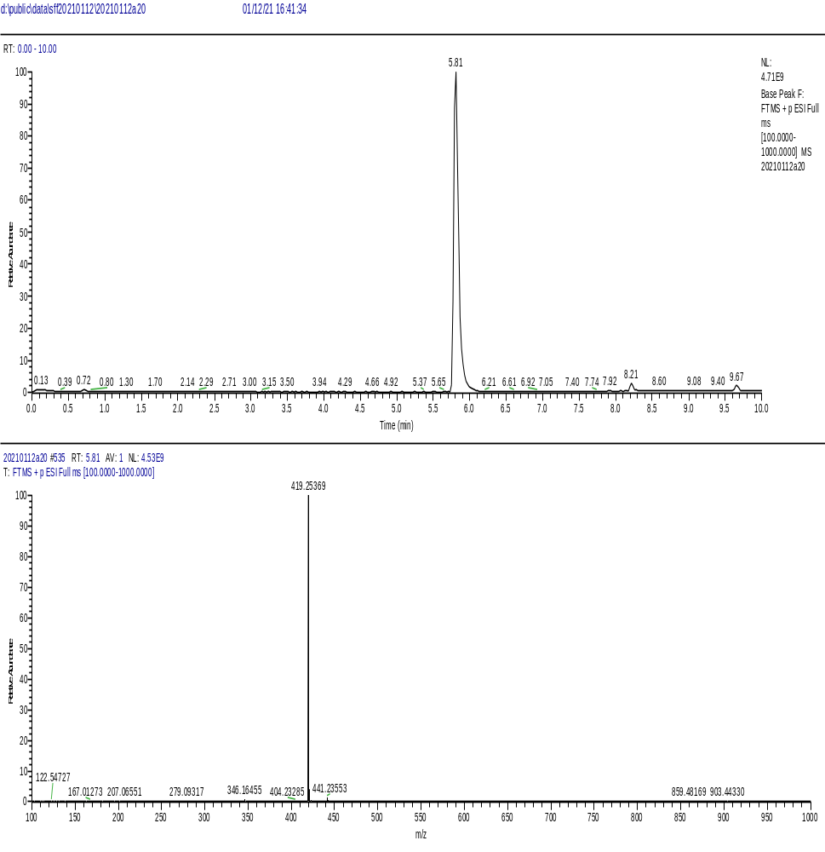

The ¹H NMR, ¹³C NMR, and HRMS of compound D2

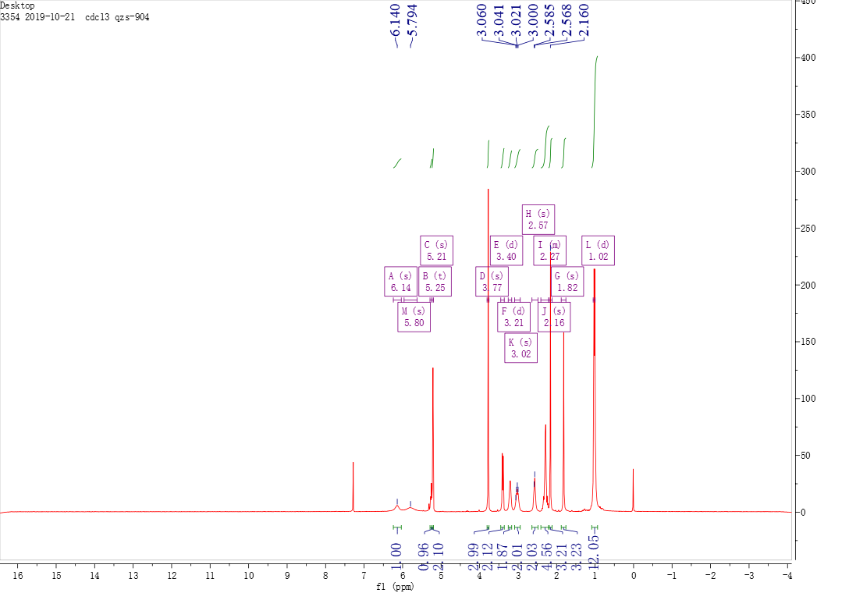

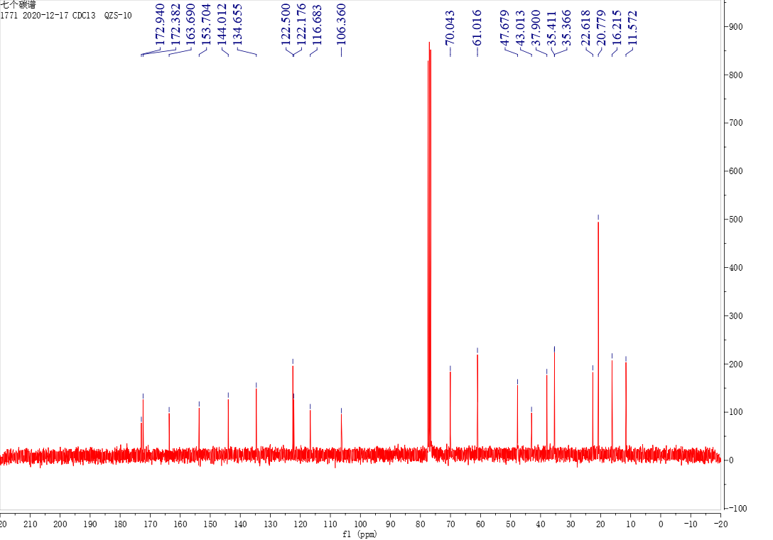

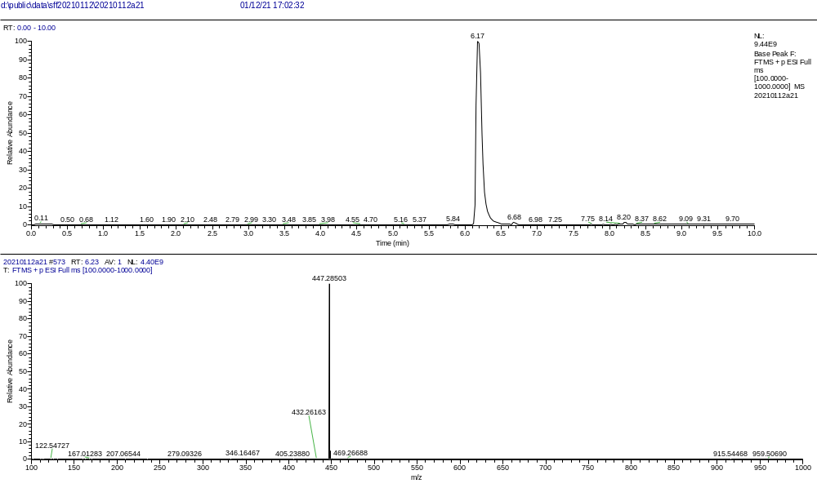

The ¹H NMR, ¹³C NMR, and HRMS of compound D3

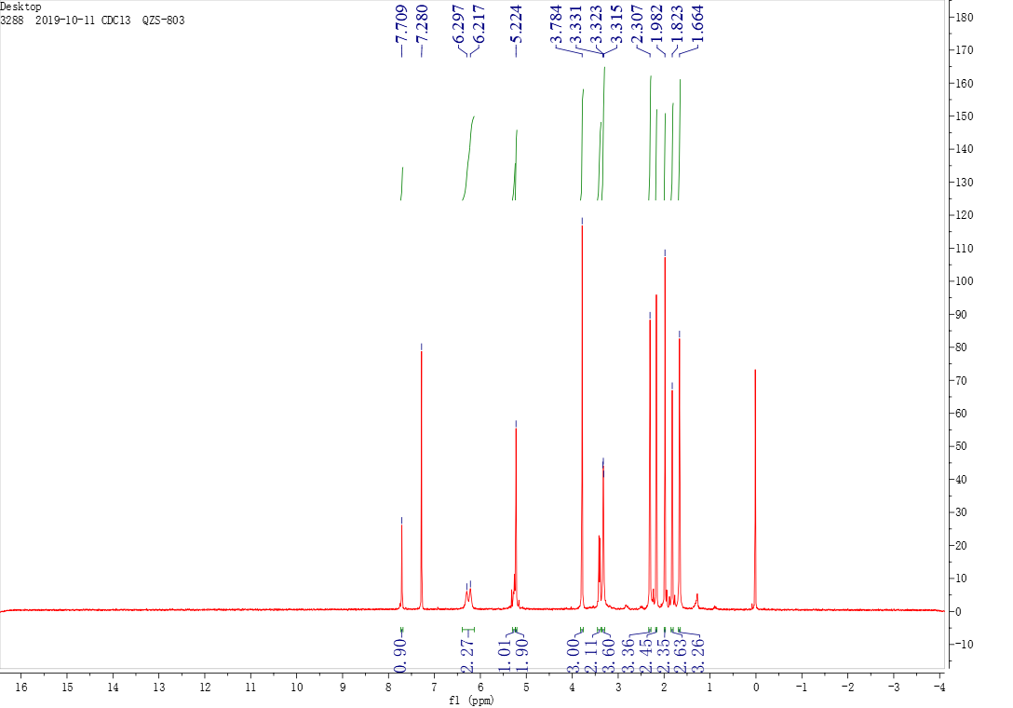

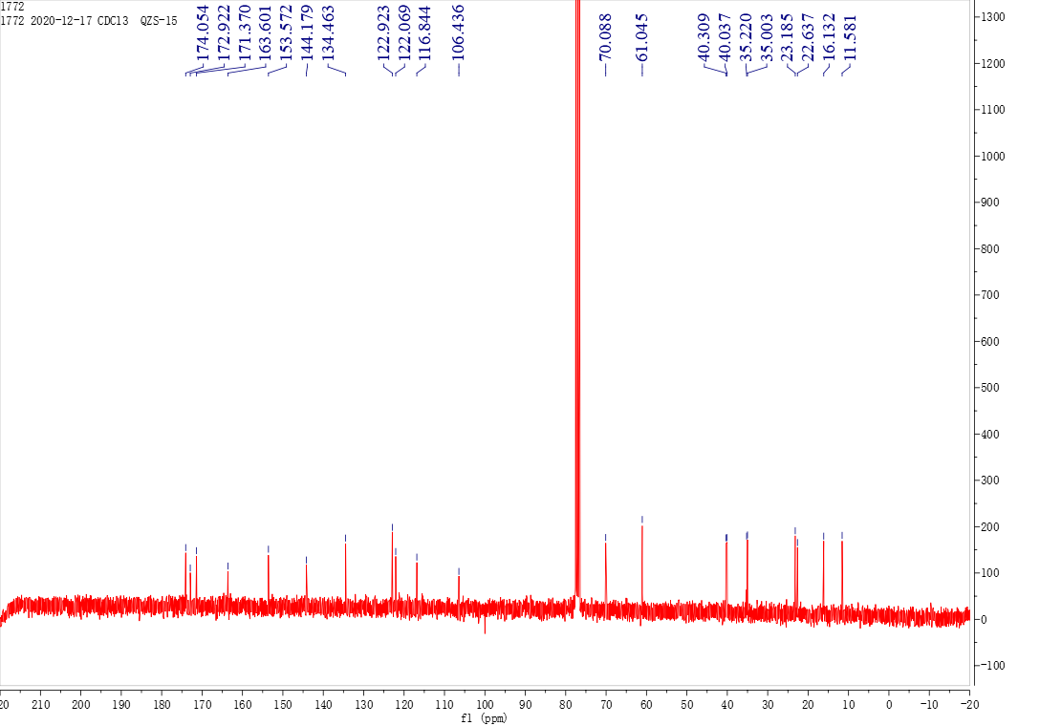

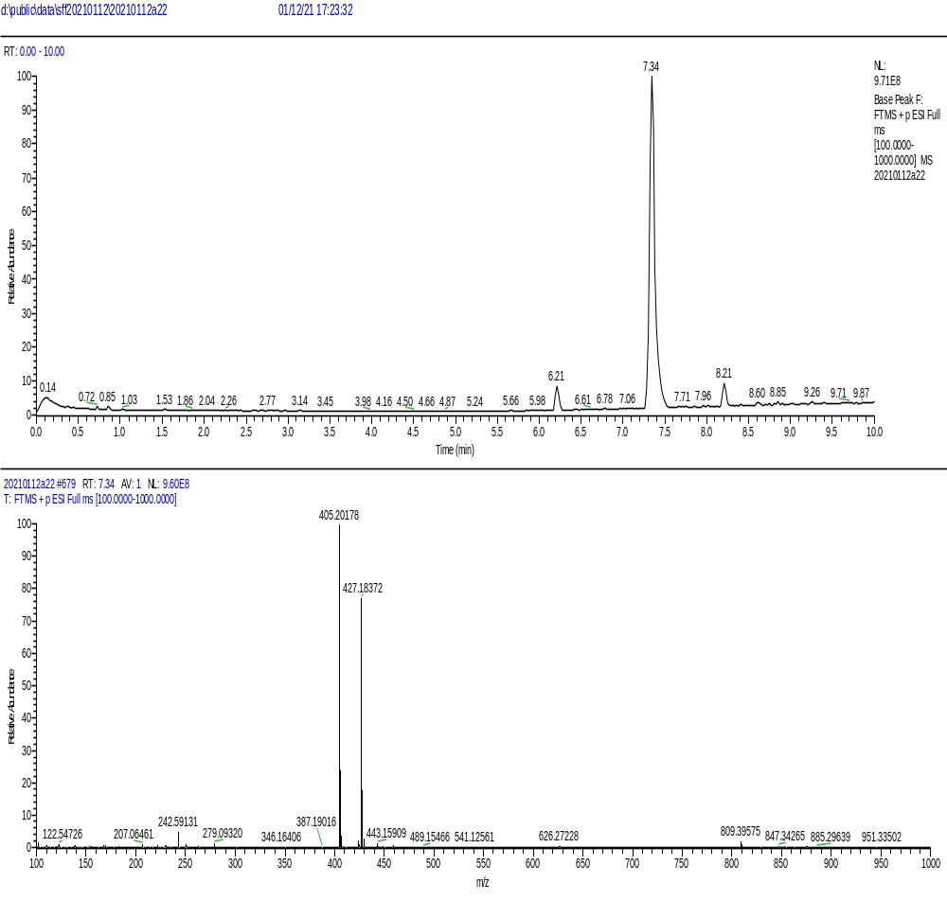

The ¹H NMR, ¹³C NMR, and HRMS of compound D4

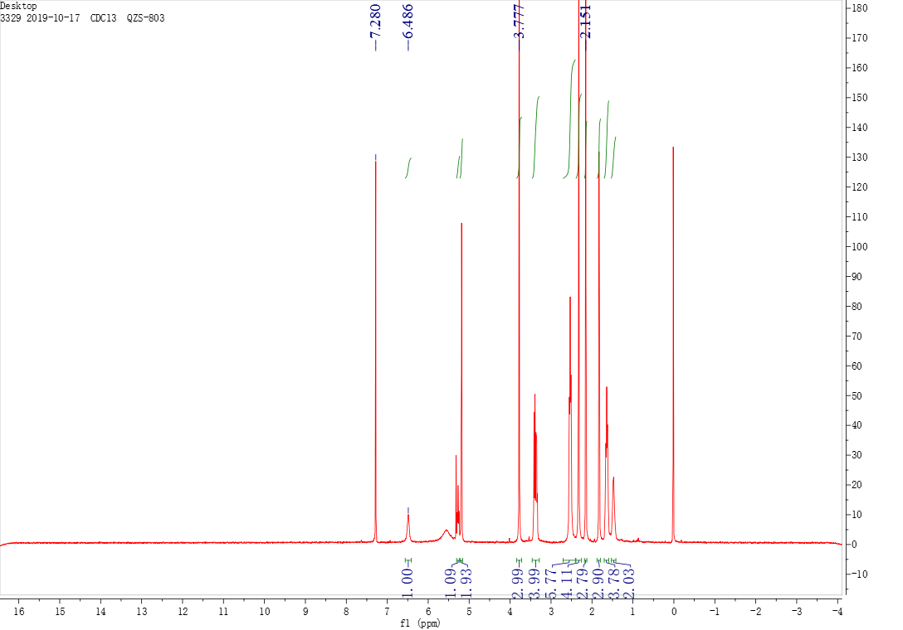

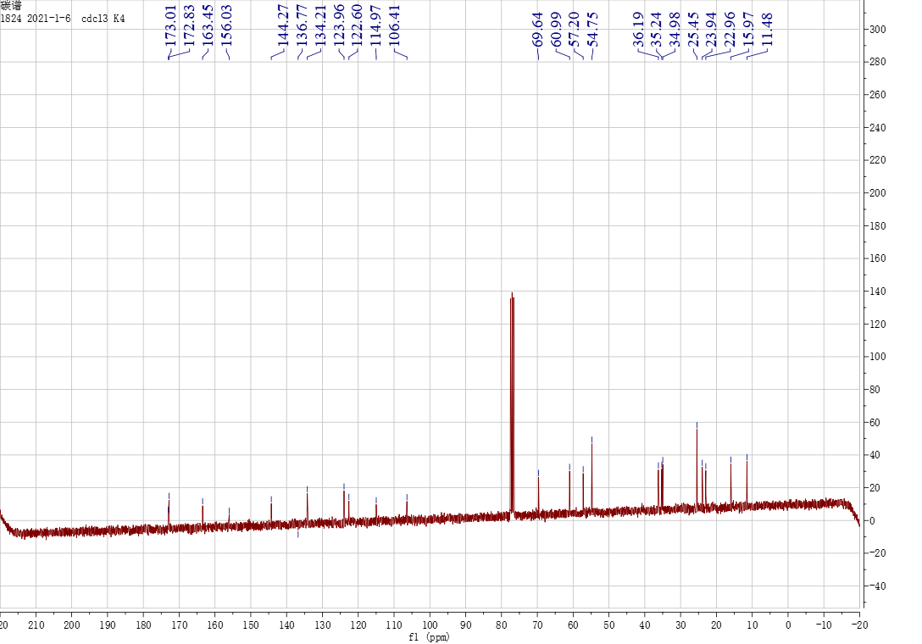

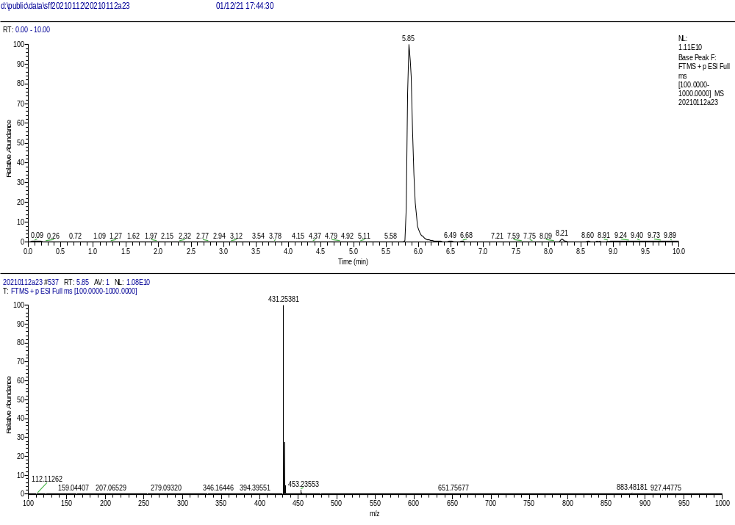

The ¹H NMR, ¹³C NMR, and HRMS of compound E1

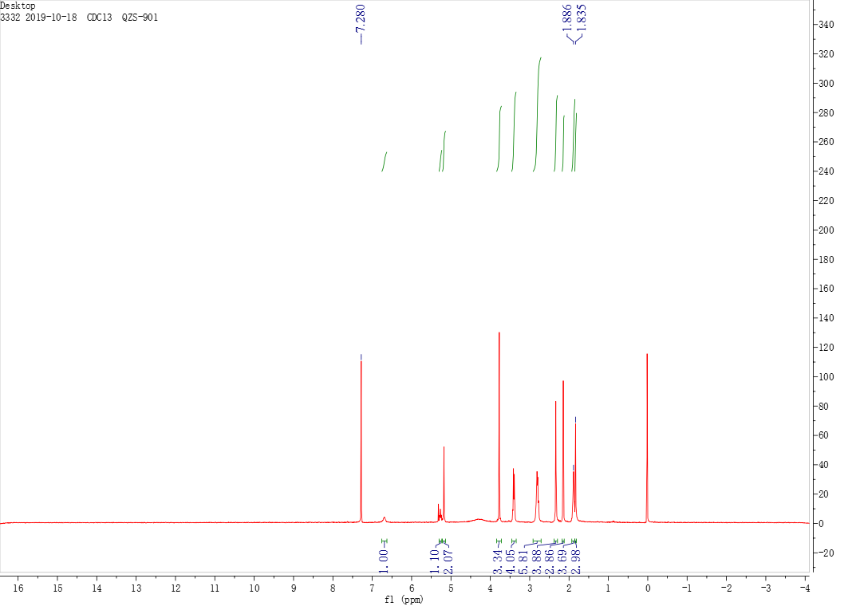

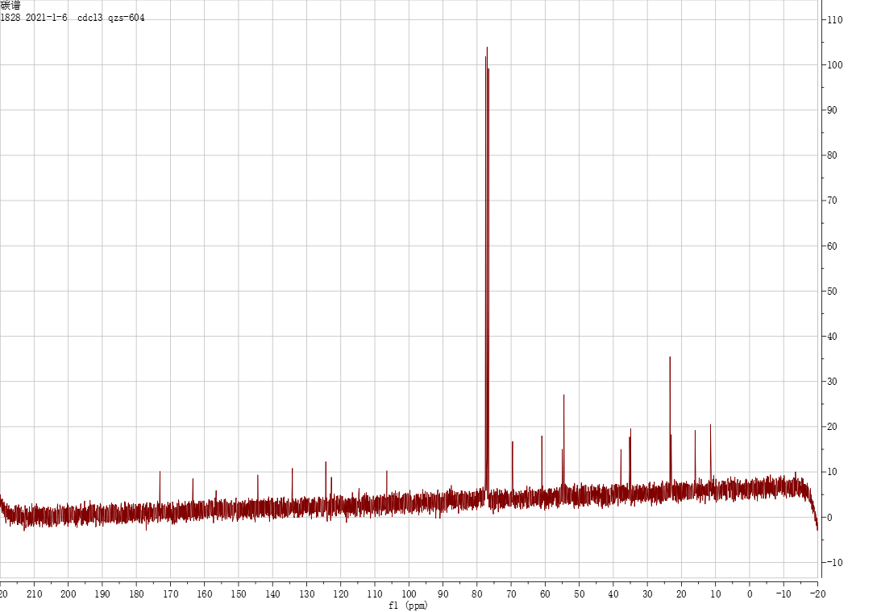

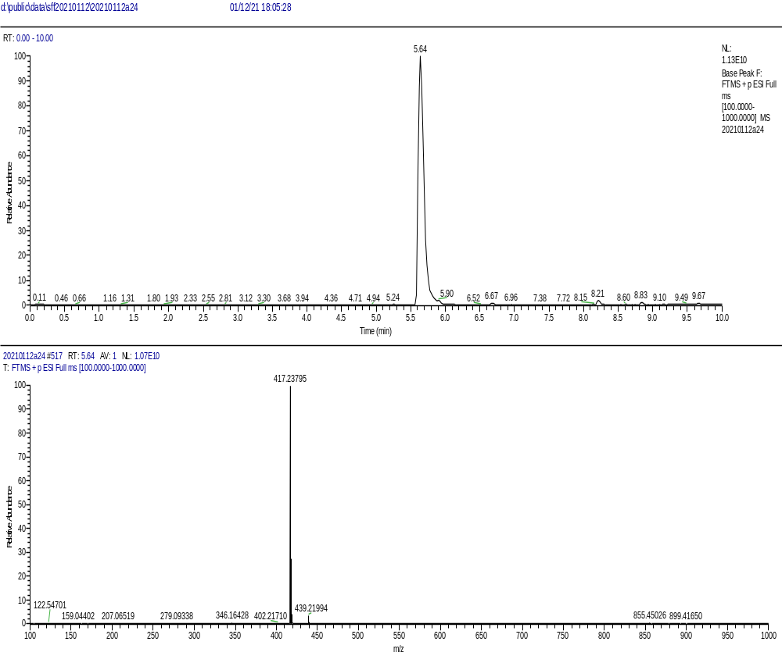

The ¹H NMR, ¹³C NMR, and HRMS of compound E2

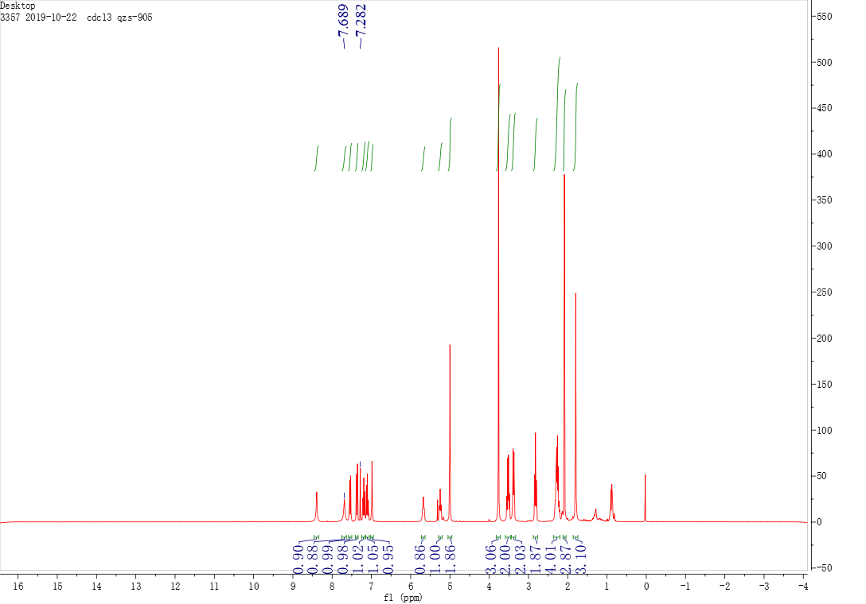

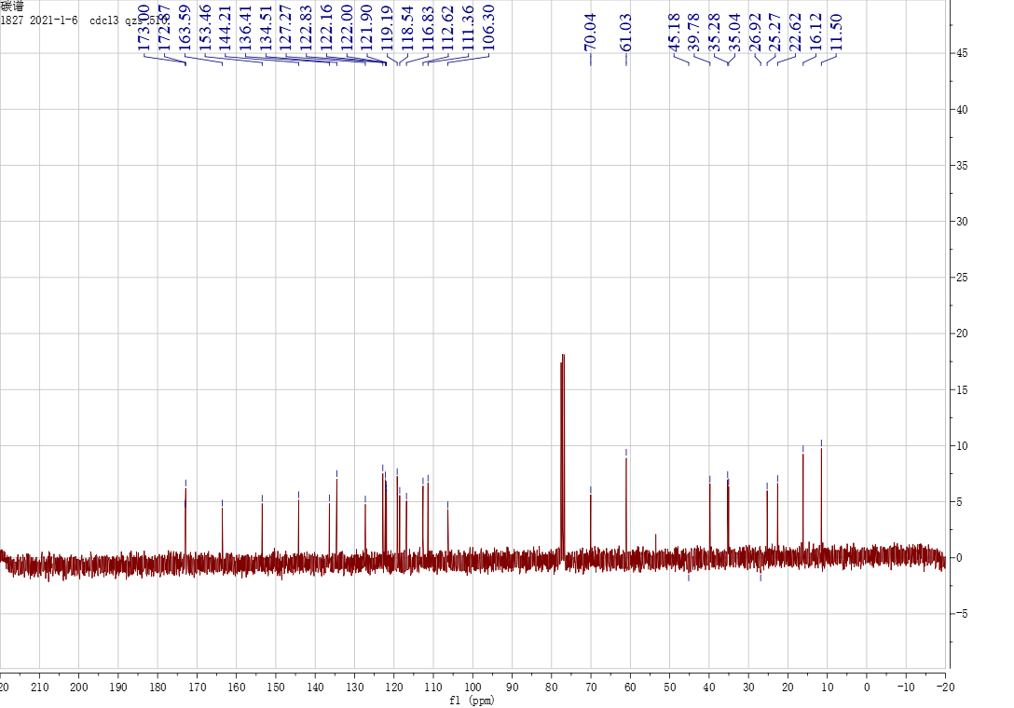

The ¹H NMR, ¹³C NMR, and HRMS of compound E3

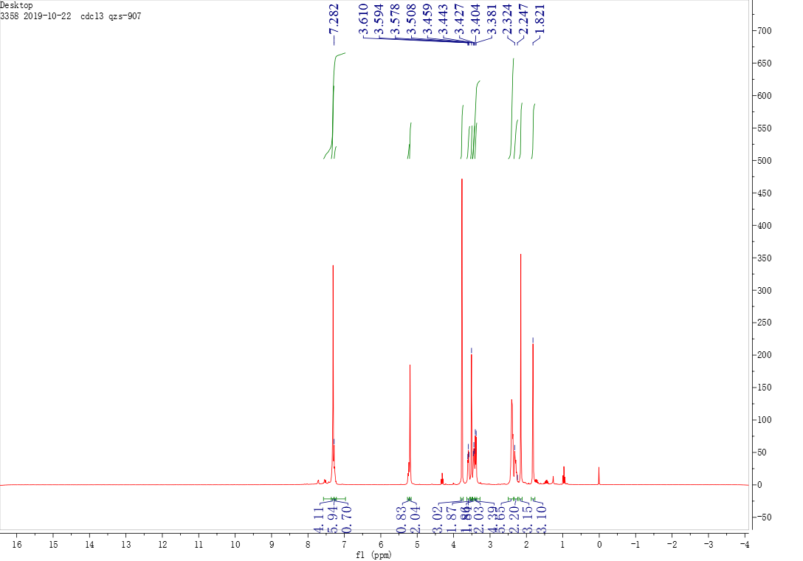

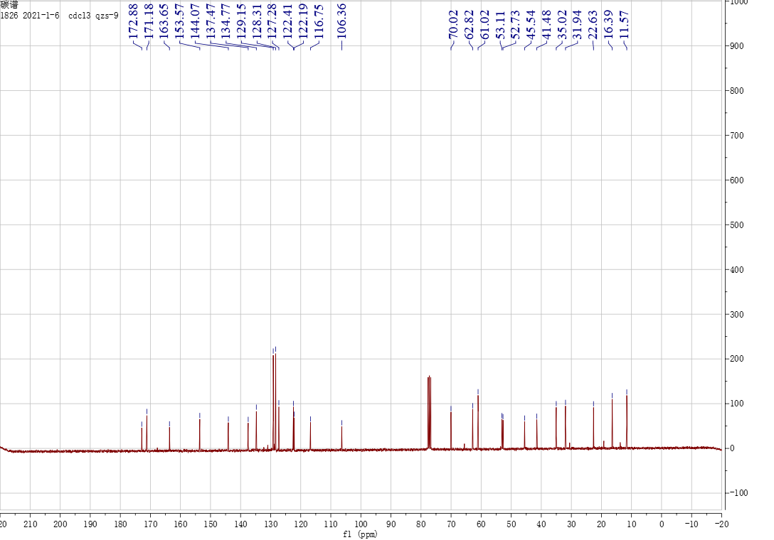

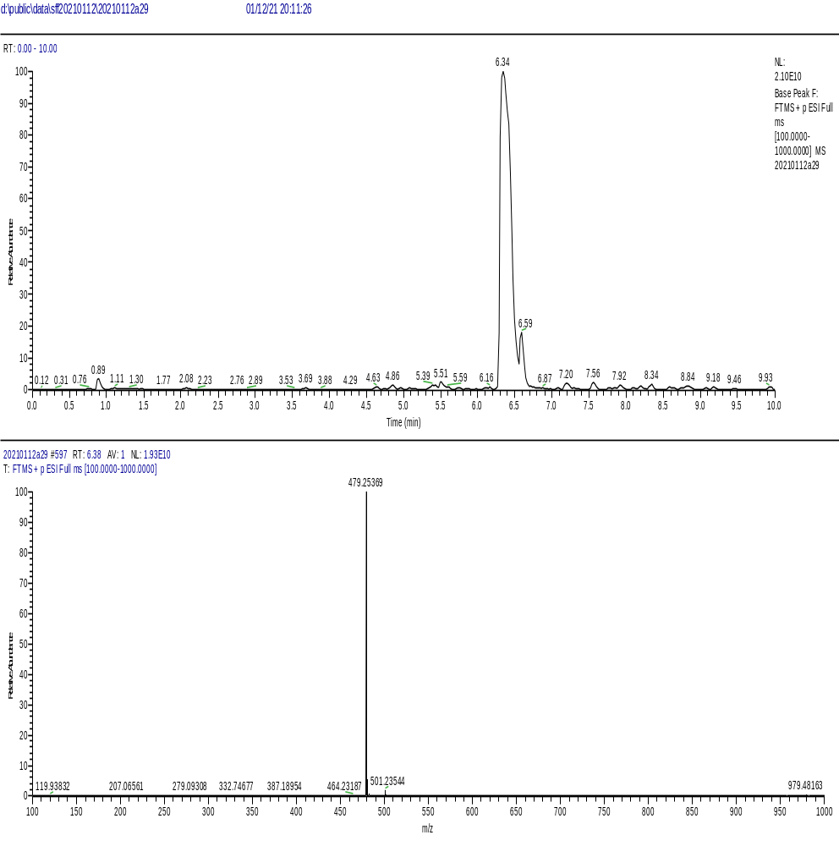

The ¹H NMR, ¹³C NMR, and HRMS of compound E4

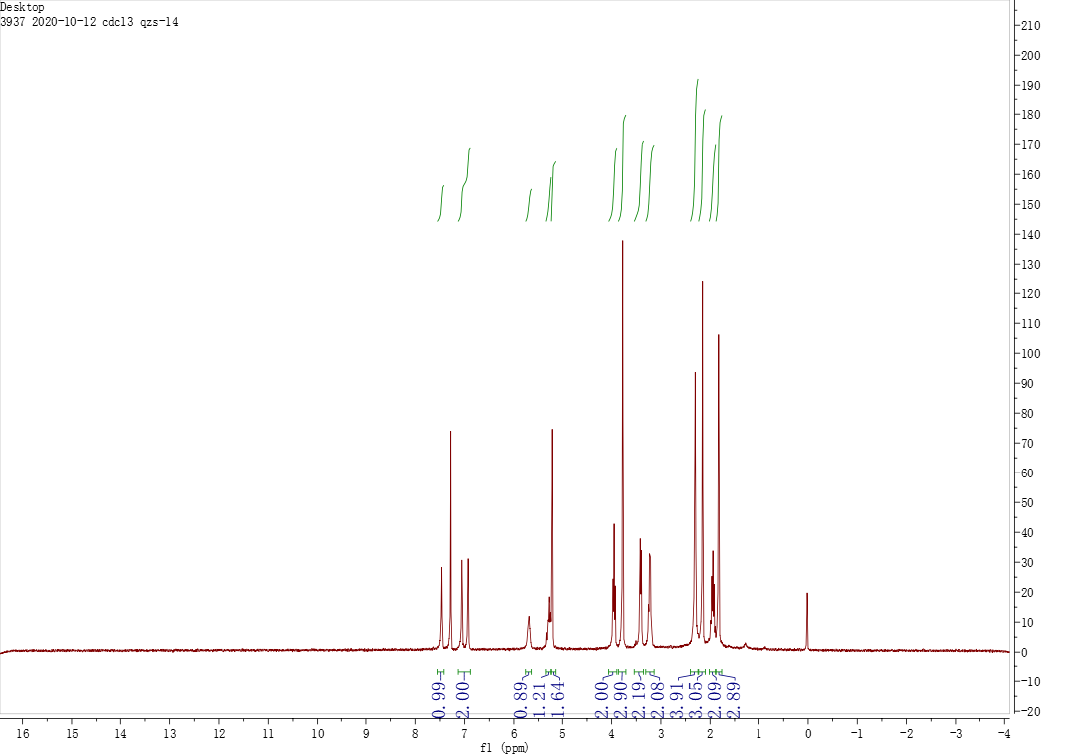

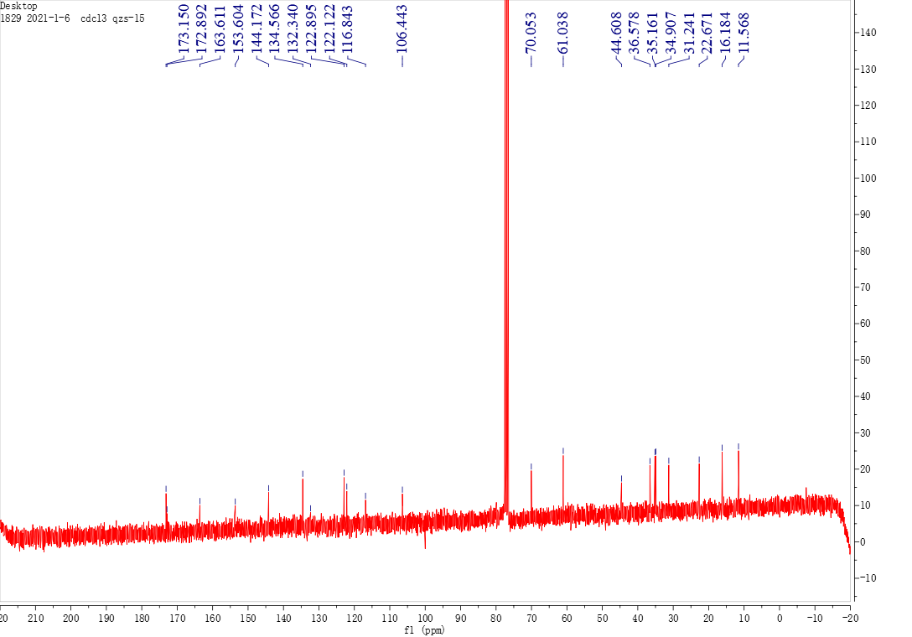

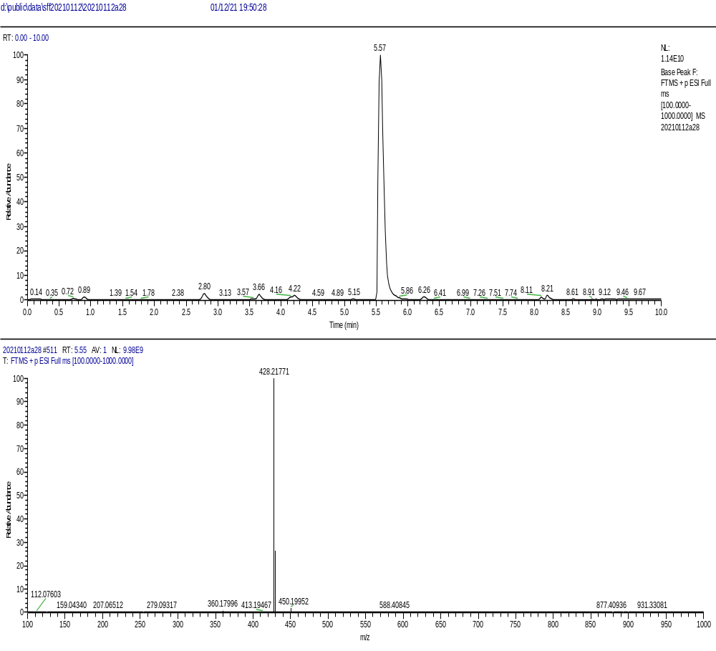

The ¹H NMR, ¹³C NMR, and HRMS of compound E5

