Supplementary Material

16S Long-Read Metabarcoding in Field Conditions Uncovers Compost-Driven Modulation of Rhizosphere Bacterial Communities During Red Bell Pepper Development

Mateo Córdoba-Agudelo¹, Maximilian Schmidt², Maria Serwetnicka³, Carolyn-Monika Görres⁴, Jana Zinkernagel³, Davide Francioli^{1#}

¹Department of Soil Science and Plant Nutrition, Hochschule Geisenheim University, Geisenheim, Germany

²Department of Plant Breeding, Hochschule Geisenheim University, Geisenheim, Germany

³Department of Vegetable Crops, Hochschule Geisenheim University, Geisenheim, Germany

⁴Department of Applied Ecology, Hochschule Geisenheim University, Geisenheim, Germany

#Corresponding author: Davide Francioli davide.francioli@hs-gm.de

Keywords: Compost placement, Rhizosphere microbiome, Nanopore long-read sequencing, Nitrogen cycling, Capsicum annuum

Figure S1. Accumulation curve of Consensus Cluster Sequences (CSCs) across samples. The curve shows the cumulative richness as the sample size increases, with plateauing indicating sufficient coverage of the bacterial community.
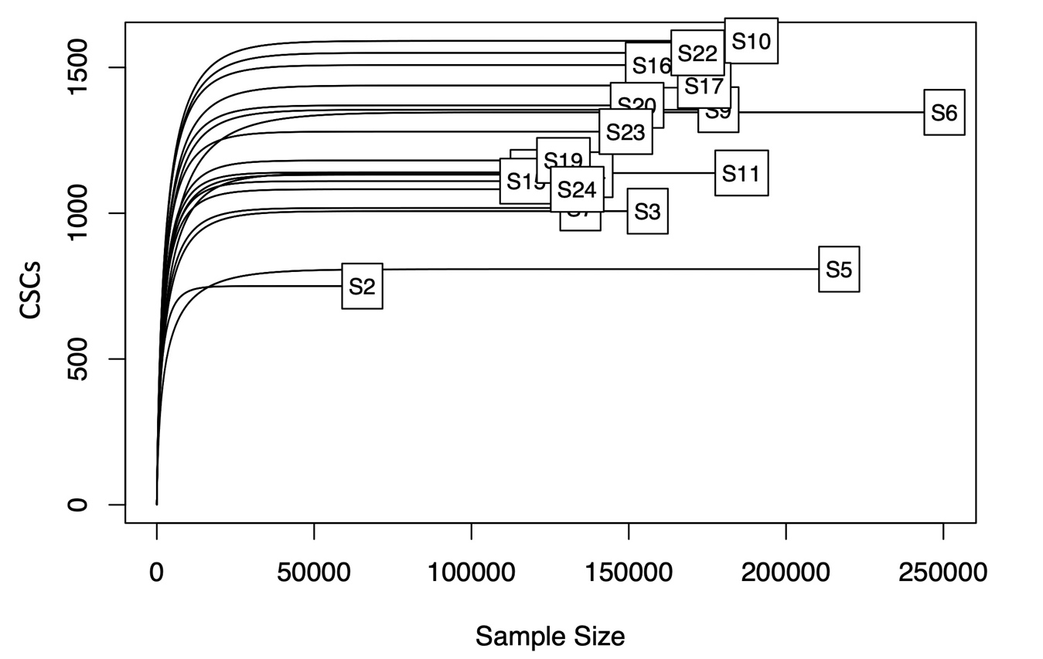

Table S1. Chemical properties of the green compost used in the study. The compost was analyzed by PLANCO-TEC GmbH, 37249 Neu-Eichenberg, Germany.
Fresh mass properties | Value
Total nitrogen | 8.8 kg/t
Soluble nitrogen in CaCl₂ | 0.74 kg/t
Organic Nitrogen | 8.06 kg/t
Total phosphate (P₂O₅) | 4.43 kg/t
Total potassium oxide (K₂0) | 9.8 kg/t
Saturaded magnesium oxide (MgO) | 5.55 kg/t
Alkaline substances (CaO) | 37.25 kg/t
pH | 8.8 kg/t
Salinity | 4.03 g/l
C/N ratio | 15
Organic matter | 223 kg/t
Humus-C | 56 kg/t
Dry mass properties
Organic matter (GV 450ºC) | 35.80 %
Basic active components (CaO) | 5.97 %
Physical parameters
Bulk density | 550 g/l
water content (dry mass) | 37.60 %
Salt content (Extr. 1:5, dry mass) | 4.03 g/l
Plant nutrients
Total nitrogen (N) | 1.41 % dry mass
Total phosphate (P₂O₅) | 0.71 % dry mass
Total potassium oxide (K₂O) | 1.57 % dry mass
Total magnesium oxide (MgO) | 0.89 % dry mass
Soluble ammonium CaCl2 (NH₄-N) | 407 mg/l dry mass
Heavy metals
Pb | 19 mg/kg dry mass
Cd | 0.26 mg/kg dry mass
Cr | 22.5 mg/kg dry mass
Cu | 29.4 mg/kg dry mass
Ni | 13.7 mg/kg dry mass
Hg | 0.06 mg/kg dry mass
Zn | 147 mg/kg dry mass

Table S2. Summary of high-quality bacterial 16S rRNA reads obtained per sample before and after quality filtering and denoising. Samples are grouped by treatment (Control, Broadcast, Deep-banding) and plant developmental stage (Maturation, Ripening).

Treatment | PGS | Sample ID | 16S rRNA reads | 16S rRNA reads after filtering
Control | Maturation | S10 | 203,283 | 188,988
Control | Maturation | S9 | 195,127 | 178,504
Control | Maturation | S11 | 204,816 | 185,902
Broadcast | Maturation | S3 | 179,257 | 156,023
Broadcast | Maturation | S2 | 81,568 | 65,312
Broadcast | Maturation | S4 | 160,033 | 138,467
Deep-banding | Maturation | S5 | 228,106 | 216,889
Deep-banding | Maturation | S6 | 265,719 | 250,360
Deep-banding | Maturation | S7 | 151,958 | 134,640
Broadcast | Ripening | S15 | 134,298 | 117,522
Broadcast | Ripening | S14 | 135,593 | 120,829
Broadcast | Ripening | S16 | 170,559 | 157,424
Deep-banding | Ripening | S17 | 190,723 | 173,983
Deep-banding | Ripening | S19 | 149,526 | 129,242
Deep-banding | Ripening | S20 | 165,824 | 152,653
Control | Ripening | S22 | 184,843 | 171,922
Control | Ripening | S23 | 159,362 | 149,078
Control | Ripening | S24 | 156,439 | 133,616

