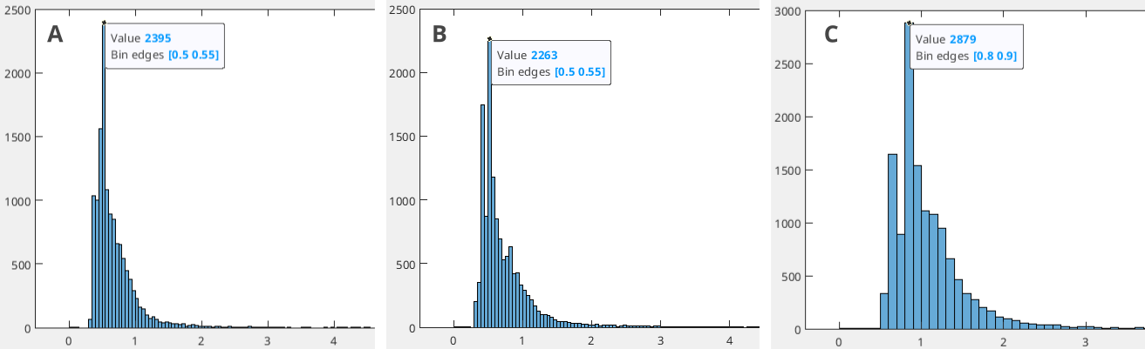Figure S1: Histograms of standard deviations in X (A), Y (B), and Z (C) directions for absolute locations of events in the 2014, 2017, and 2018 swarm periods. These represent input uncertainties prior to relative relocation.
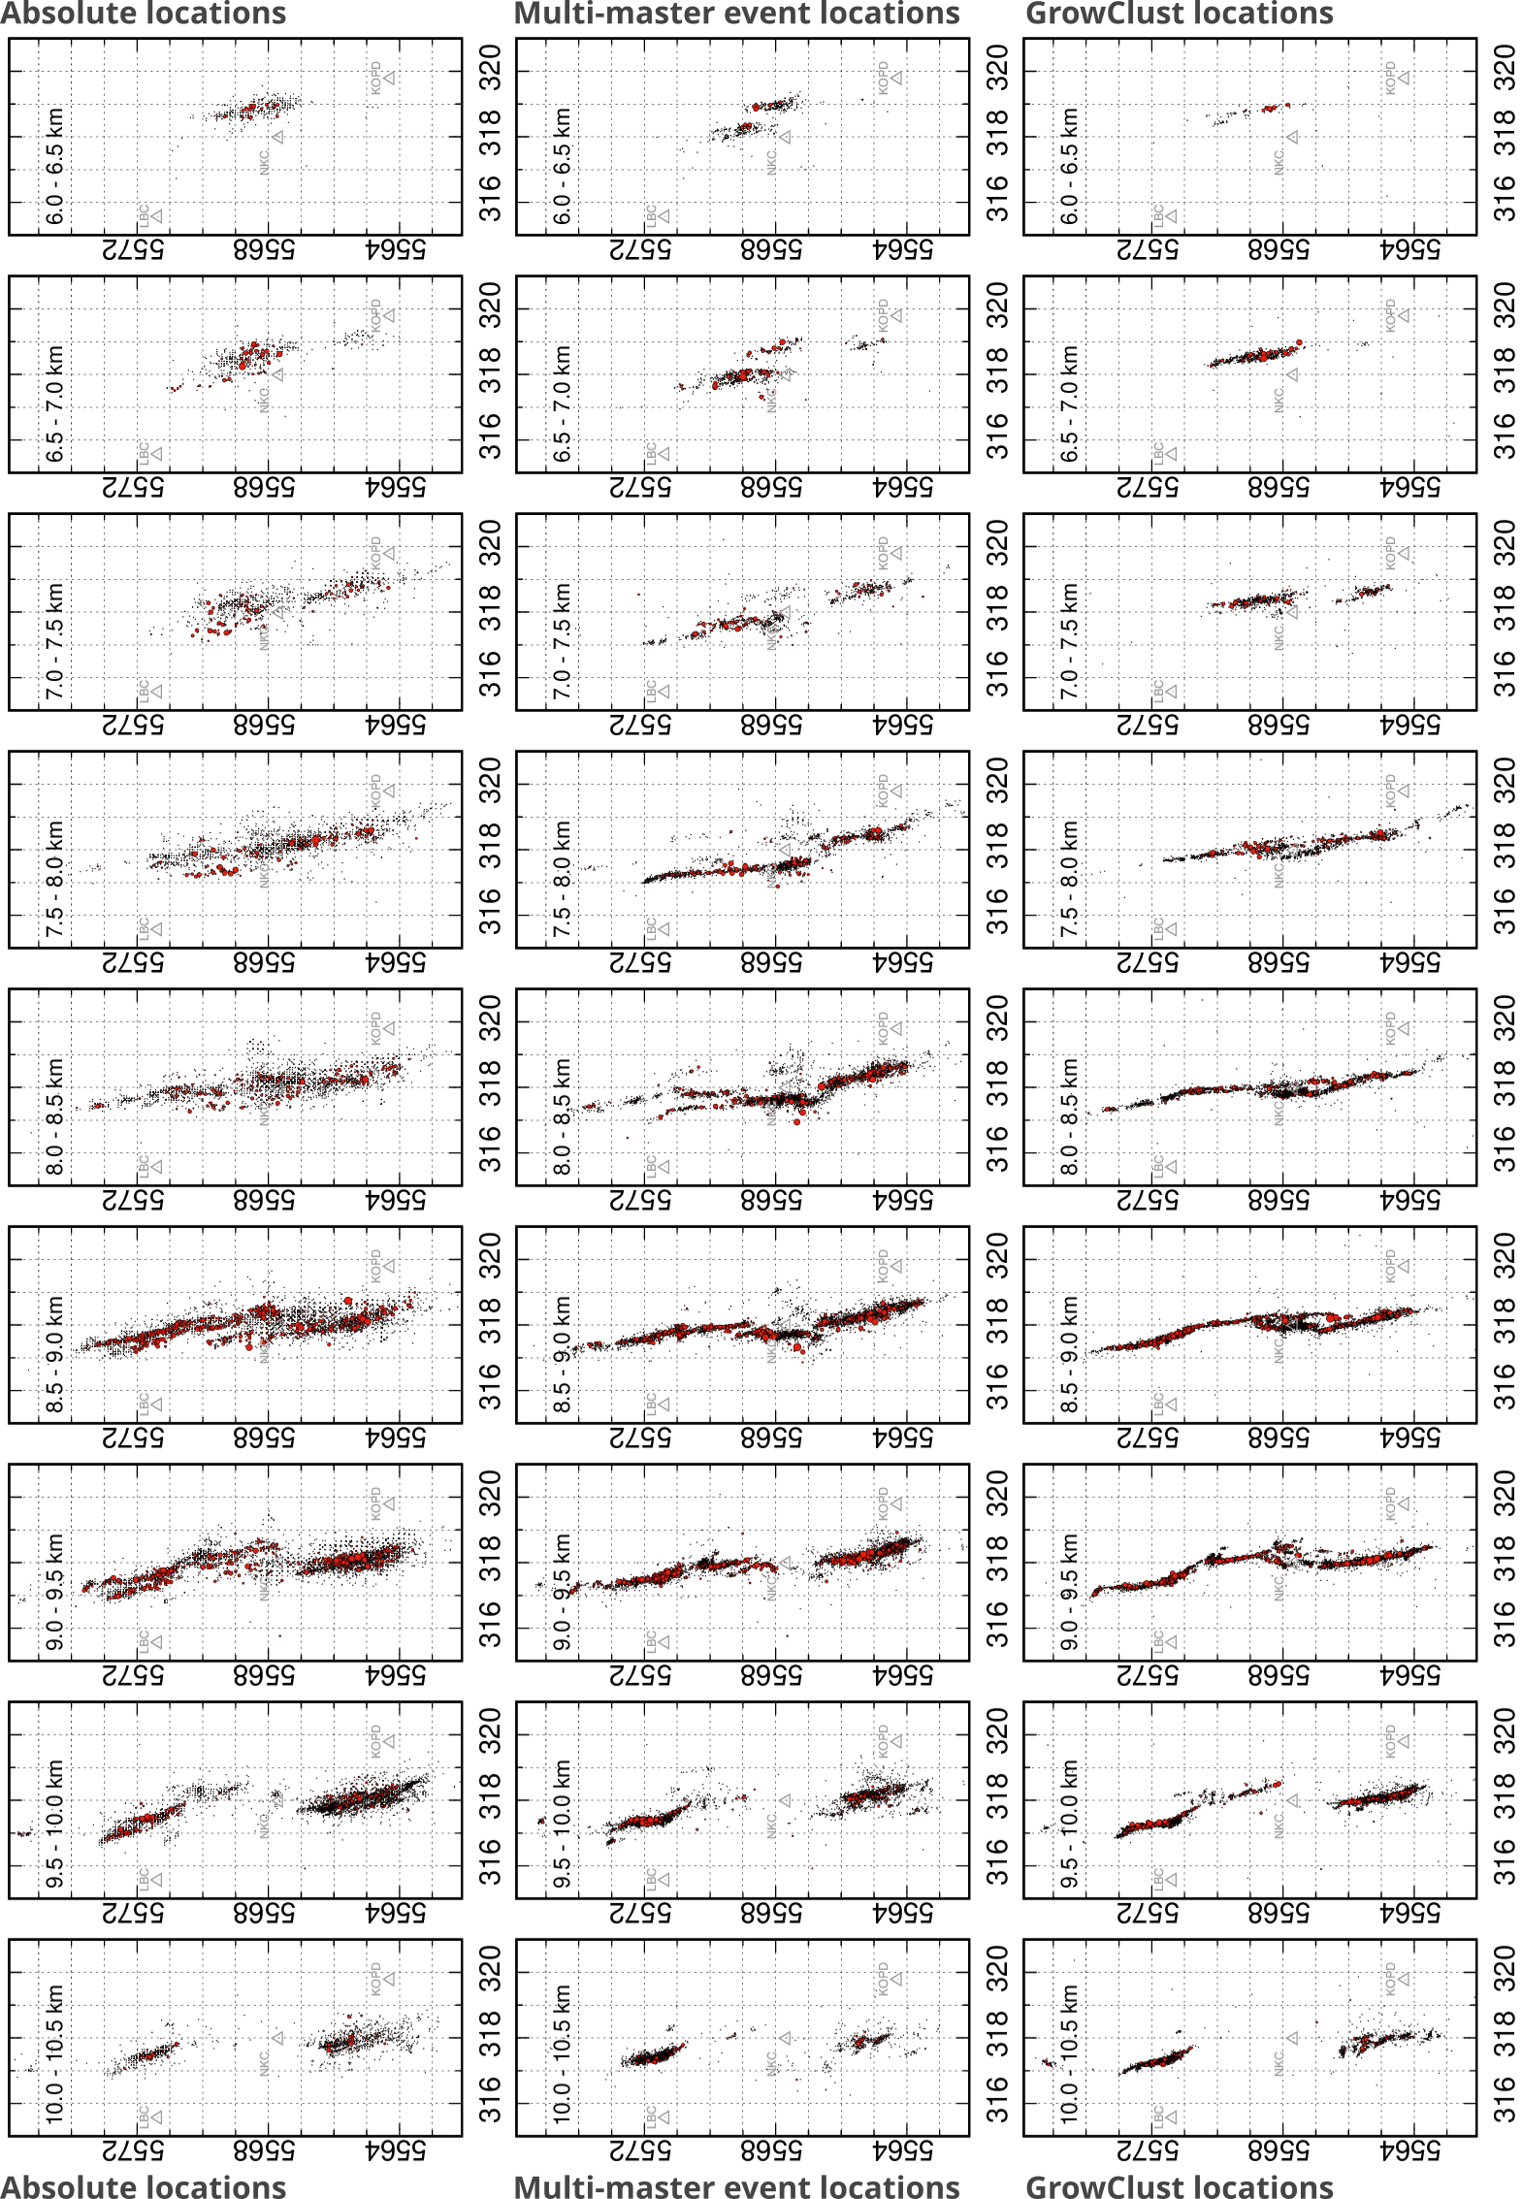Figure S2: Depth-sliced map views of the Nový Kostel seismic zone between 6.0 and 10.5 km depth (0.5 km intervals). Columns show (from left to right) the absolute locations, the relative locations obtained with the MME method, and the relative locations from GC. Black dots represent all events, while red dots mark earthquakes with magnitudes ≥ 1.5. The comparison illustrates the progressive sharpening of the seismicity pattern by the relative relocation methods, particularly in the central depth range (7–9.5 km).

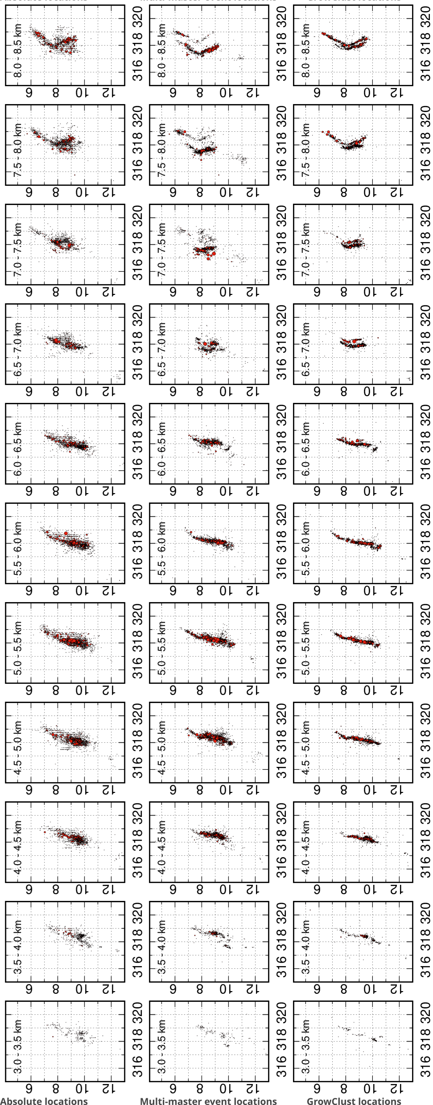Figure S3a: Depth cross-sections E–W of the Nový Kostel seismic zone between 3.0 and 8.5 km depth (0.5 km intervals). Columns show (from left to right) the absolute locations, the relative locations obtained with the MME method, and the relative locations from GC. Black dots represent all events, while red dots mark earthquakes with magnitudes ≥ 1.5.

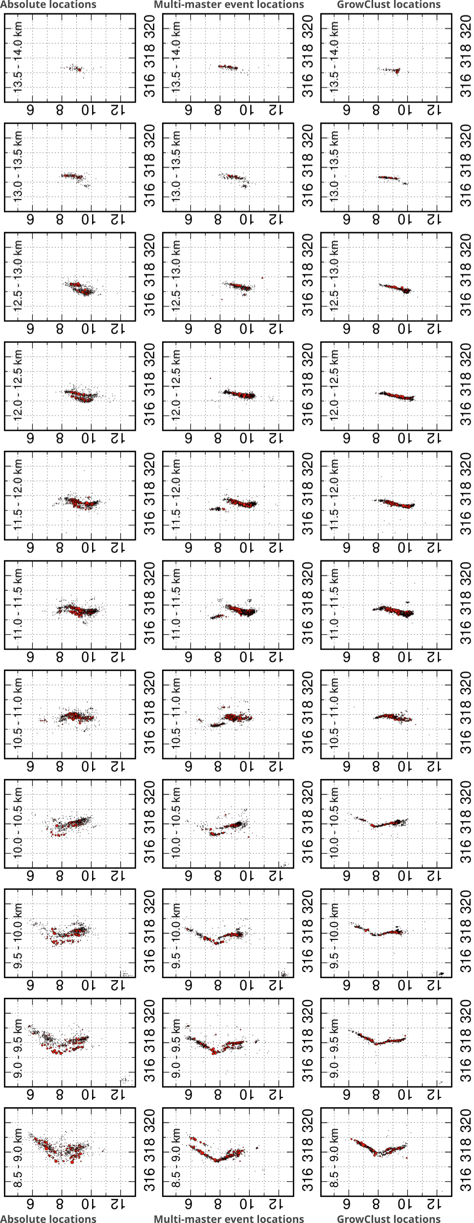Figure S3b: Depth cross-sections E–W of the Nový Kostel seismic zone between 8.5 and 14 km depth.
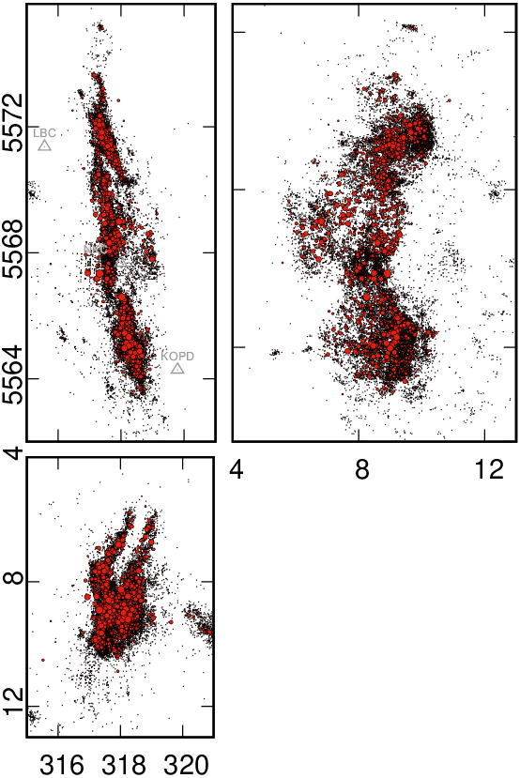Figure S4: : Multi-master event relative locations of seismicity from processed catalog in reverse order from the newest to the oldest, in the Nový Kostel zone. Map view (A), depth versus latitude section (B), and depth versus longitude section (C)

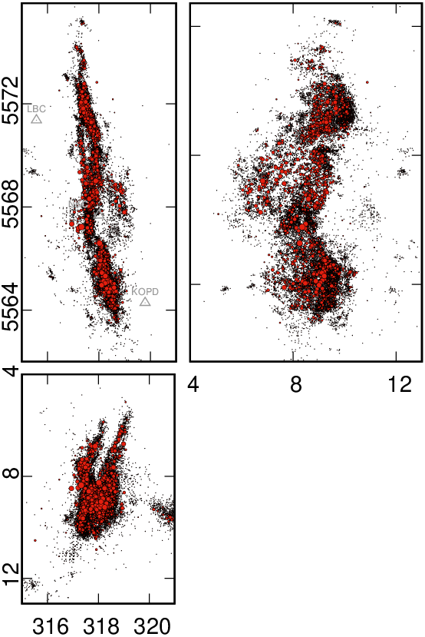Figure S5: Multi-master event relative locations of seismicity from processed catalog with randomly shuffled events, in the Nový Kostel zone. Map view (A), depth versus latitude section (B), and depth versus longitude section (C)

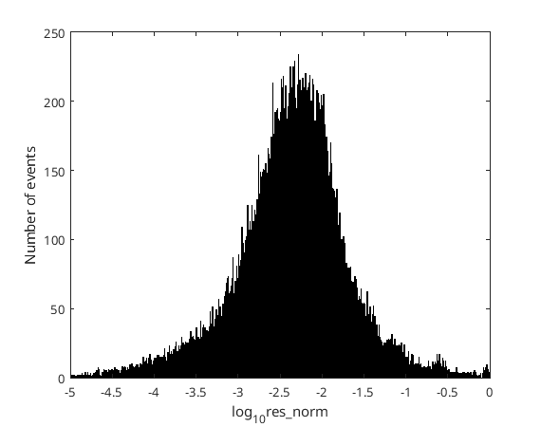Figure S6: Histogram of normalized residuals (res_norm) for the multi-master relocations. Most events exhibit residuals below 0.05 (median 0.0047), indicating a stable fit across the dataset.

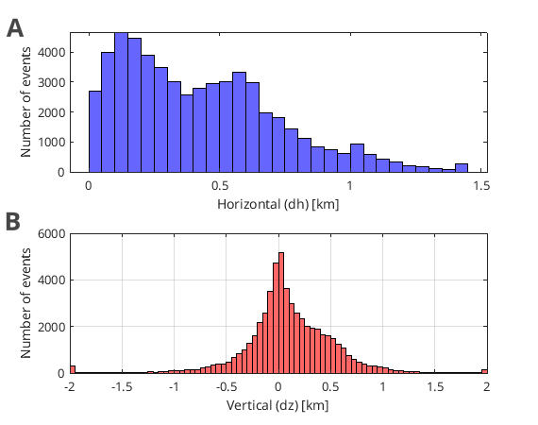Figure S7: Histograms of (A) horizontal (dh) and (B) vertical (dz) shifts of the multi-master relative locations with respect to the original catalog. Horizontal shifts are typically less than 1 km (median 0.38 km), while vertical shifts are symmetrically distributed around zero with most events within ±0.75 km.
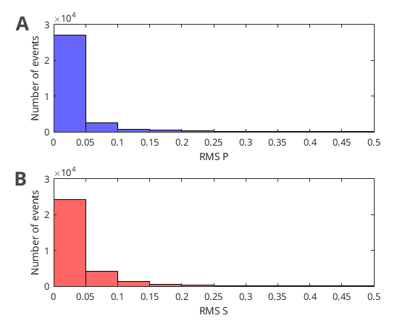Figure S8: Histograms of RMS residuals for (A) P-wave and (B) S-wave arrivals in the GrowClust catalog. Most events exhibit RMS values below 0.1 s.

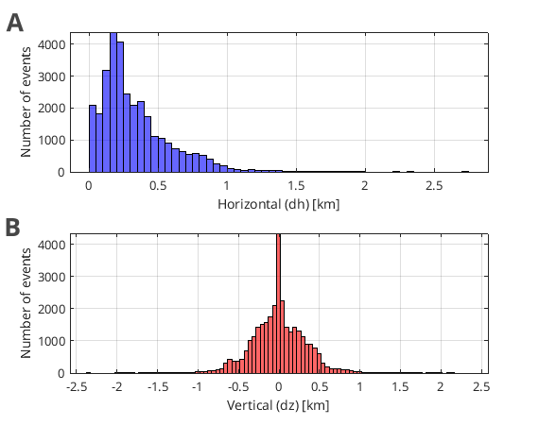Figure S9: Histograms of (A) horizontal (dh) and (B) vertical (dz) shifts of GrowClust relocations with respect to the original catalog. Horizontal shifts are typically <0.5 km, while vertical shifts are symmetrically distributed around zero within ±0.5 km.

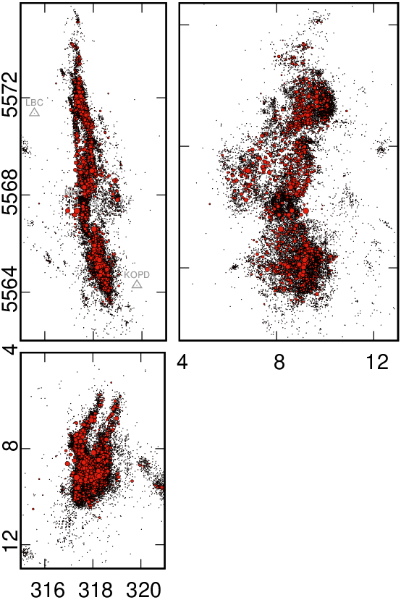Figure S10: Multi-master event relative locations of seismicity, without NKC station, in the Nový Kostel zone. Map view (A), depth versus latitude section (B), and depth versus longitude section (C)

