Additional File 1 – Figure descriptions are in bottom of respective figures.

Figure S I. Precipitation (mm) and average daily temperature (ºC) measured between the 1st of january and the 30th of june of 2022 and 2023 in Reguengos de Monsaraz. Data provided by the Instituto Português do Mar e da Atmosfera (IPMA) for the Reguengos de Monsaraz station (0840).
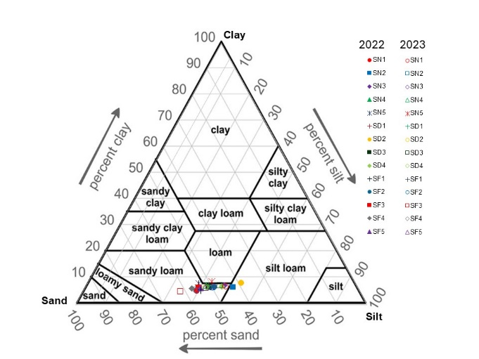
Figure S II. Triangular diagram of soil grain size distribution and placement of the soil samples studied. SN: Syrah No irrigation (corresponding to Rainfed irrigation), SD: Syrah Deficit irrigation, and SF: Syrah Full irrigation.
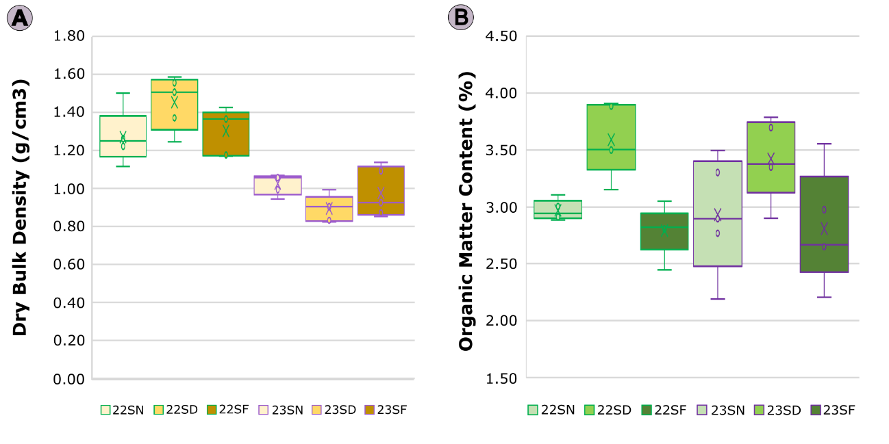
Figure S III.Dry Bulk Density (A) and Organic Matter Content (B) measured from the soils sampled in 2022 and 2023. ANOVA showed no statistically significant differences in the soils in function of the irrigation strategy adopted for the dry bulk density (2022: p = 0.11; 2023: p = 0.12). On the other hand, significant differences were found in the organic matter content of 2022, but not on the 2023 soils (2022: p < 0.01; 2023: p = 0.12). 22SN: 2022 Syrah No irrigation (corresponding to Rainfed irrigation), 22SD: 2022 Syrah Deficit irrigation, 22SF: 2022 Syrah Full irrigation, 23SN: 2023 Syrah No irrigation (corresponding to Rainfed irrigation), 23SD: 2023 Syrah Deficit irrigation, 23SF: 2023 Syrah Full irrigation.
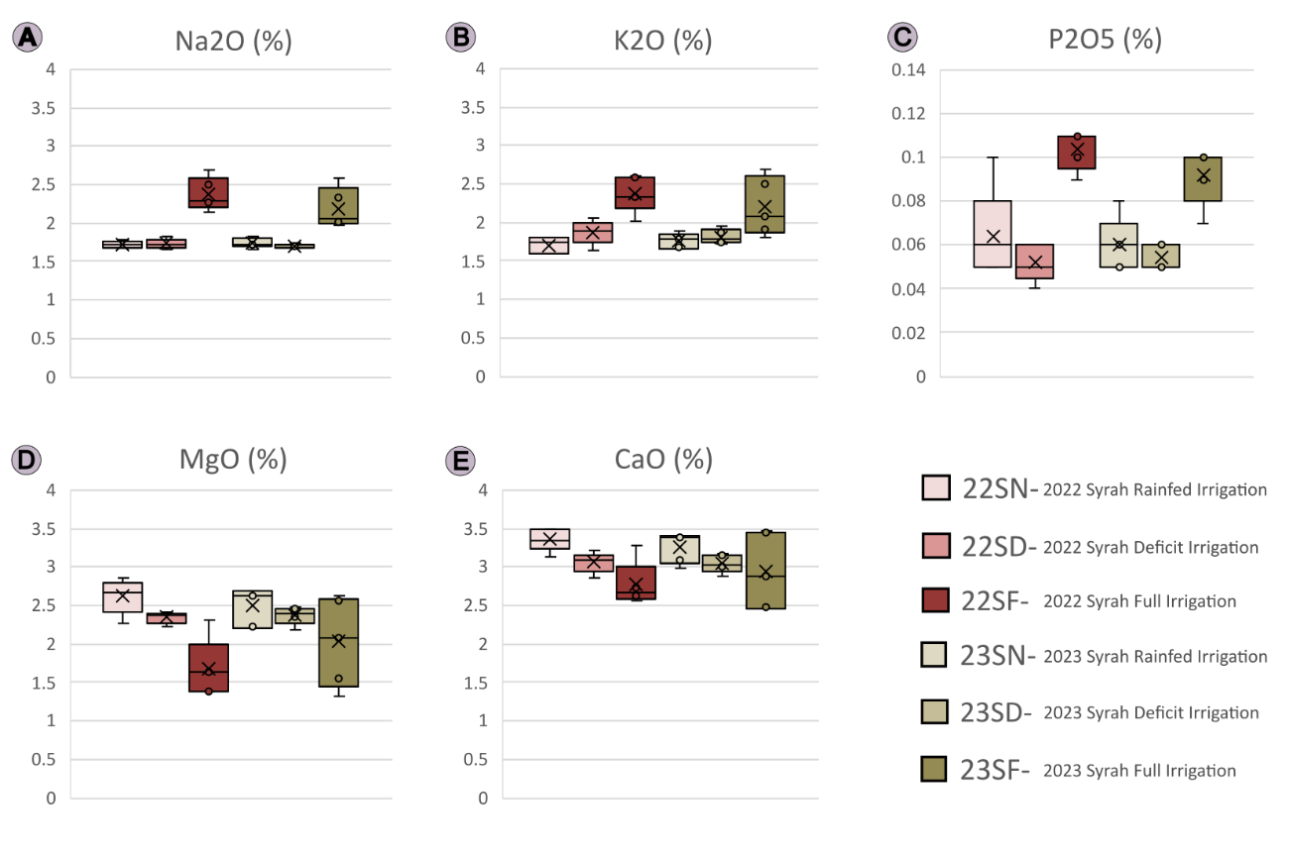
Figure S IV. Soil relative content of (A) sodium oxide, (B) potassium oxide, (C) phosphorus pentoxide, (D) magnesium oxide, and (E) calcium oxide as determined by ICP-OES. 22SN: 2022 Syrah No irrigation (corresponding to Rainfed irrigation), 22SD: 2022 Syrah Deficit irrigation, 22SF: 2022 Syrah Full irrigation, 23SN: 2023 Syrah No irrigation (corresponding to Rainfed irrigation), 23SD: 2023 Syrah Deficit irrigation, 23SF: 2023 Syrah Full irrigation.
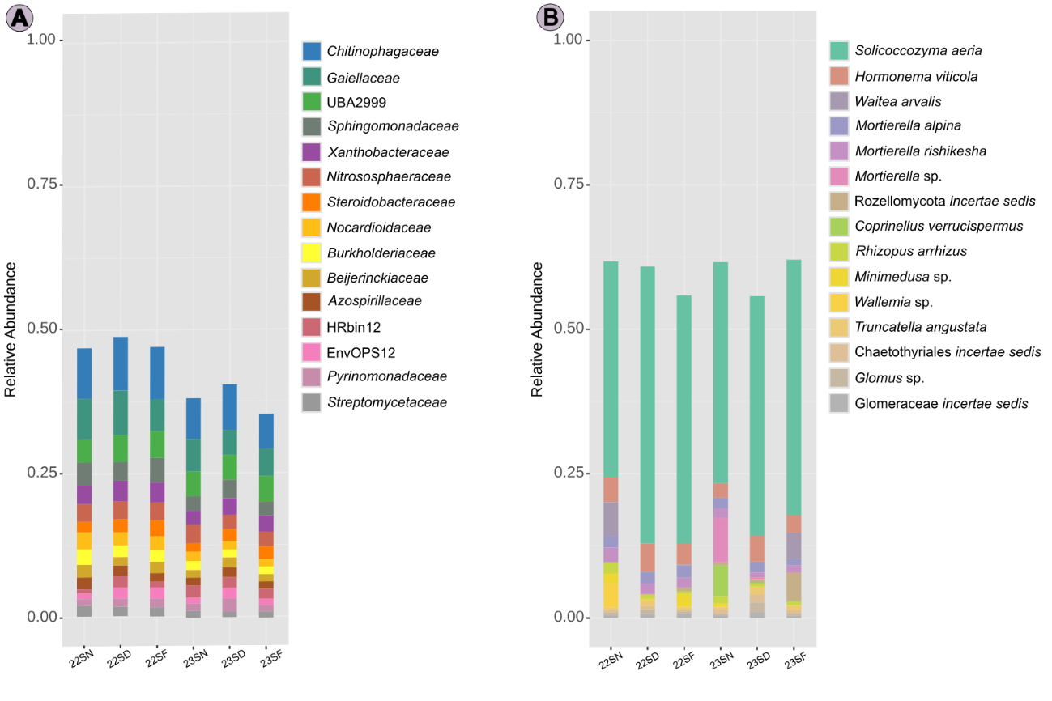
Figure S V. Taxonomic partition of the top 15 most abundant A) prokaryotic families and B) fungi species found in the soils of the grapevine cv. Syrah put through three different water regimes for two seasons. 22SN: 2022 Syrah No irrigation (corresponding to Rainfed irrigation), 22SD: 2022 Syrah Deficit irrigation, 22SF: 2022 Syrah Full irrigation, 23SN: 2023 Syrah No irrigation (corresponding to Rainfed irrigation), 23SD: 2023 Syrah Deficit irrigation, 23SF: 2023 Syrah Full irrigation.

Figure S VI. Microbiome correlation to soil water content calculated with Pearson coefficient. On the left it is displayed the prokaryotes resulting from the calculation from A) 2022 and C) 2023; on the right side it is displayed the fungi resulting from the calculations in B) 2022 and D) 2023. 22SN: 2022 Syrah No irrigation (corresponding to Rainfed irrigation), 22SD: 2022 Syrah Deficit irrigation, 22SF: 2022 Syrah Full irrigation, 23SN: 2023 Syrah No irrigation (corresponding to Rainfed irrigation), 23SD: 2023 Syrah Deficit irrigation, 23SF: 2023 Syrah Full irrigation.
