Metal-Organic Frameworks for Single-Dose Engineered Enzyme-Based Prophylaxis and Treatment of Organophosphate Poisoning

Orikeda Trashi*#ª, Ikeda Trashi*#ª, Fanrui Sha^{b}, Nithish Agamendranª, Ziqi Wangª, Yalini Wijesundaraª, Neelima Kotiª, Laurel Haggeª, Neha Satishª, Thomas Howlettª, Alyssa C. Chievª, Connie Huª, Harshini Bapanapalliª, Amy Do Leª, Julian Magdalenski^{b}, Xiaoliang Wang^{b}, Shailendra Koiralaª, Khayden S. Dongª, Michael D. Burton^{c}, Steven Harvey^{d}, Omar Farha^{b,e}*, Jeremiah J. Gassensmith^{a,f}*
ªDepartment of Chemistry and Biochemistry, The University of Texas at Dallas, 800 West Campbell Rd. Richardson, TX 75080, United States
^{b}Department of Chemical and Biological Engineering, Northwestern University, Evanston, Illinois 60208, United States
^{c}Neuroimmunology and Behavior Laboratory, Department of Neuroscience, School of Behavioral and Brain Sciences, Center for Advanced Pain Studies, University of Texas at Dallas, 800 W. Campbell Road, Richardson, TX 75080, USA
^{d}U.S. Army Chemical Biological Center, Aberdeen Proving Ground, MD 21010–5424.
^{e}Department of Chemistry and International Institute for Nanotechnology, Northwestern University, 2145 Sheridan Road, Evanston, IL 60208, USA
^{f}Department of Biomedical Engineering, The University of Texas at Dallas, 800 West Campbell Rd. Richardson, TX 75080, United States

Supplementary Information

Table of Contents
Materials and Characterization 2
Chemicals 2
Instrumentation and Sample Preparation 2
Methods for Behavioral Studies and Animal Ethics 2
Mouse Grimace Scale (MGS) Assessment 3
Grip Strength Study 3
Incapacitance test 3
ICP-MS Analysis of Tissues 3
Tissue Residency Study 4
Hematoxylin and Eosin (H&E) Staining Protocol 4
Tissue degradation study 5
Chemical and Biochemical Methods 5
Expression and Purification of OPAA-Y212F 5
Enzyme activity using a fluoride ion-selective electrode 5
Enzyme activity using 31P NMR 6
ZIF-8 synthesis 6
NU-1003 synthesis 6
OPAA@ZIF-8 synthesis 6
OPAA@NU-1003 synthesis 7
OPAA-Cy7 synthesis 7
Cytotoxicity Assay 7
In Vitro Cytotoxicity 7
Immunofluorescence: 8
Supplemental Figures 9
Reference 19

Materials and Characterization

Chemicals
Zinc acetate (ZnOAc), 2-methyl imidazole, sodium chloride, phosphate buffer saline (PBS) pH 7.4, Dulbecco's Modified Eagle Medium (DMEM), l-glutamine, BSA, Ethylenediaminetetraacetic acid (EDTA), sodium bicarbonate (NaCO₃), dimethyl sulfoxide (DMSO), paraformaldehyde (PFA), potassium phosphate dibasic, potassium phosphate monobasic, hydrochloric acid, and sodium hydroxide were purchased from Sigma Aldrich (St. Louis, MO, USA) or Thermofisher Scientific (Waltham, MA, USA) and used without further modification. FB essence (FBS) was purchased from VWR (Radnor, PA, USA). Pierce Bradford protein assay was purchased from ThermoFisher Scientific. Sulfo-Cyanine 7-NHS (sulfo-Cy7-NHS) was purchased from Lumiprobe (Cockeysville, MD, USA) and synthesized in previous literature.¹

Instrumentation and Sample Preparation
SEM micrographs were taken on Zeiss Supra 40. Absorbance and fluorescence spectra were obtained on Biotek Synergy H4 Hybrid microplate reader.
Centrifuges used included the Thermofisher Scientific Sorvall Legend Micro17, Eppendorf 5418R, and Beckman Coulter Allegra X-22R centrifuges, which were used for obtaining MOF composites, cell pellets, and plasma.
CLSM images were taken on Olympus FLUOVIEW FV4000 microscope.
PXRD samples were dried under high vacuum and gently ground to a fine powder. The powder was then loaded into a sample holder and lightly pressed with a glass slide to create a smooth, even surface. Powder X-ray diffraction (PXRD) patterns were collected using a Rigaku SmartLab X-ray Diffractometer equipped with Cu Kα radiation (λ = 1.5406 Å). Data were acquired over a 2θ range of 0° to 40° with a step size of 0.01°.
ICPMS
The concentration of Zn in the extracted organs was quantified using Agilent 7900 ICP-MS. Cell counting was performed using a Thermo Countess II.
Live animal imaging was performed on an IVIS Lumina III Revvity.
Paraffin embedding was done on Histo-Core ARCADIA.
Tissue processing was with a Leica RM22335 microtome.
H&E imaging was performed on OLYMPUS SLIDEVIEW VS200.

Methods for Behavioral Studies and Animal Ethics

All procedures were in accordance with the National Institutes of Health Guidelines for the Care and Use of Laboratory Animals and approved by the University of Texas at Dallas Institutional Animal Care and Use Committee (IACUC) (Protocol number 22-07). For behavioral studies, we used female BALB/c mice (6–8 weeks old) purchased from Charles River Laboratories and allowed them two weeks to acclimate to their new environment. Animals were group housed in polypropylene ventilated cages with 4 mice per cage with ad-libitum access to water and regular chow diet. Room temperature was maintained at 21 ±2°C and the facility maintained a 12-h light/dark cycle (lights on 0700h/lights off 1900h).

Power analyses were conducted using GraphPad Prism software. For behavioral testing, an n=4 per group was sufficient to detect an effect size of 0.75 using alpha=0.05 and two-tailed hypothesis testing.
The order of all behavioral experiments was 1. Grimace, grip strength, incapacitance to remain consistent.
To minimize bias, behavioral assessments were performed in a blinded manner. Two undergraduate evaluators, who were not informed of the treatment groups or study design, observed the animals during each behavioral assay. Based solely on the animals’ performance, they scored behavioral differences between groups without knowledge of group assignments.
All behavioral assays were performed in a fixed order: grimace (observational), followed by grip strength, and then incapacitance. To minimize carryover from the exertional task, animals were acclimated to the testing room for 30 minutes and given a 3–5-minute rest between assays.

Mouse Grimace Scale (MGS) Assessment
Spontaneous pain was evaluated using the Mouse Grimace Scale (MGS), a validated tool based on facial expression analysis. Five facial action units were assessed: orbital tightening, ear position, cheek bulge, nose bulge, and whisker position. Each parameter was scored on a scale of 0 to 2, where 0 indicated the feature was not present, 1 indicated moderate presence, and 2 indicated the feature was obviously present. Scores from all five components were averaged to calculate a mean grimace score (MGS) for each animal. All assessments were performed in a blinded manner by trained observers.

Grip Strength Study
Muscle strength in the forelimbs of 8-10-week-old female BALB/c mice was evaluated using a grip strength test meter (IITC, California, USA). Animals were acclimated to the behavioral testing room for 30 minutes prior to the start of each assay and habituated for 5 minutes to reduce stress from environmental changes. All the measurements were taken in the early afternoon. Each mouse was first weighed, then gently lifted by the tail and positioned to grasp the pull bar assembly of the device. The mouse was steadily pulled backward in a straight line until it released its grip, and the peak force generated was recorded in newtons (N). All measurements were performed in a blind manner across the experimental group. Grip strength for each mouse was normalized by its body weight, and data were analyzed using GraphPad Prism software using Paired T test and One-way analysis of variance (ANOVA) for the delta values.

Incapacitance test
Female BALB/c mice (6–8 weeks old) were weighed prior to testing. Animals were acclimated in a dual-platform incapacitance chamber (IITC Series 8) and positioned such that each hind paw rested on separate force plates. After ~30 s stabilization, 5-s trials were recorded per mouse, with ~10 s rest between trials. The weight distribution for each hind limb was calculated as the percentage of total hind-limb weight borne by each paw. A higher ΔW (difference in weight distribution) indicated greater asymmetry, suggesting increased discomfort or pain. Testing was conducted in a blinded manner before and after intoxication to assess any changes in weight-bearing behavior.

ICP-MS Analysis of Tissues
Following euthanasia, mouse organs were collected, weighed, and digested in 70% nitric acid. The digested samples were then diluted to a final concentration of 35% nitric acid and heated at 70 °C for an hour. After complete digestion, the solutions were filtered through a 0.22 µm syringe filter to remove particulates. The filtered samples were subsequently diluted to 2% nitric acid using ultrapure water. Zirconium (Zr) content was quantified using a commercially available Zr standard curve. Samples were analyzed using inductively coupled plasma mass spectrometry (ICP-MS) on a Agilent 7900 ICP-MS.

Tissue Residency Study

Female BALB/c mice (6–8 weeks old) were shaved on the flank area (injection site) one day prior to injection. Baseline fluorescence imaging was performed the day before administration to ensure that no background signal was present. On the day of injection, mice were anesthetized using isoflurane and subcutaneously injected with 100 µL of the respective formulations, delivering 20 µg of OPAA per mouse. Experimental groups included saline, free OPAA, OPAA@ZIF-8, and OPAA@NU-1003. Mice were imaged at various time points using an IVIS Lumina III Revvity imaging system. Fluorescence intensity data were normalized and analyzed using GraphPad Prism, as shown in the corresponding graphs and images.

Hematoxylin and Eosin (H&E) Staining Protocol
After mice were euthanized, tissues were collected and rinsed in PBS to remove excess blood. Samples were then fixed in 4% paraformaldehyde (PFA) for 24 hours at room temperature. Following fixation, tissues were dehydrated using a Leica tissue processor for 12 hours. The dehydrated tissues were then embedded in paraffin and stored at 4°C overnight. The next day, paraffin-embedded tissues were sectioned at a thickness of 5 µm and mounted onto glass microscope slides.
Tissue sections were first deparaffinized and rehydrated by sequential immersion in xylene (3 × 10 min), followed by 100%, 95%, 70%, and 50% ethanol (2 × 5 min each), and finally rinsed in deionized water for 5 minutes. Sections were then stained with hematoxylin for 1.5 to 2 minutes to visualize nuclei, with timing adjusted based on desired intensity. After staining, slides were rinsed in tap water (10 dunks, 3 times) and then differentiated in Accumate (0.25% acid alcohol) by dunking 4 times to remove excess hematoxylin and sharpen nuclear definition. Slides were rinsed again in tap water (10 dunks) and then placed in Scott’s tap water for 1 minute to enhance the hematoxylin stain. Following this, slides were immersed in 95% reagent alcohol for 30 seconds and stained with 1% eosin in acetic acid for 1 minute to visualize cytoplasm and extracellular matrix components. Dehydration was completed through 95% ethanol (2 × 10 dunks), 100% ethanol (2 × 1 min), and xylene (3 × 5 min). Slides were stored in xylene before mounting. Scott’s tap water was prepared using 2 g sodium bicarbonate and 20 g magnesium sulfate dissolved in 1 L of deionized water.
IgG Titers
To assess the total IgG levels in serum, a high-binding ELISA plate (NEST, Cat# 514201) was coated with 100 μL/well of OPAA (10 μg/mL in 0.1 M sodium bicarbonate buffer, pH 9.5). The plate was allowed to incubate overnight at 4 °C. The following day, the plates were washed five times with phosphate-buffered saline containing 0.05% Tween-20 (PBST), then tapped on absorbent paper, and subsequently blocked with 200 μL of blocking buffer (1% BSA in 0.1 M Tris buffer, pH 8.0) for 1 hour at room temperature. After discarding the blocking solution, the plates underwent five additional washes with PBST. Serum samples were then serially diluted in a sample buffer (PBS with 1% BSA), with 100 μL /well added in triplicate. The plates were incubated for 1h at 37 °C, followed by five washes with PBST. Goat anti-mouse IgG (Biolegend, Cat# 405301) was diluted to 1:500 in assay diluent, and 100 μL/well was added, and the plate was incubated for 1 h at 37 °C. HRP-Avidin (Cat# 405103) was then diluted to 1:1000 and incubated for 1 h at 37 °C. The washing process was repeated five times with the wash buffer. Subsequently, 100 μL of TMB substrate solution (Biolegend, Cat# 421101) was added and allowed to develop color in the dark for 15 min at room temperature. The reaction was stopped with 100 μL of 0.2 M sulfuric acid, and absorbance was measured at 450 nm (reference at 570 nm) using a microplate reader (BioTek Synergy H4 Hybrid Reader). The endpoint titers were calculated by plotting absorbance values against the dilution factor, fitting the data to a logarithmic curve, and determining the dilution at which the curve intersected the average baseline absorbance from the saline control. To achieve the logarithmic fit and ascertain endpoint titers, the absorbance values from the ELISA were plotted in GraphPad against the corresponding sample dilution factors, using the average absorbance value from saline-treated control wells as the baseline threshold.
Ex Vivo Degradation Study
NU-1003 was incubated at room temperature on a rotisserie under various buffer conditions, including 0.1 M potassium phosphate (KP, pH 7.4), 0.1 M phosphate-buffered saline (PBS, pH 7.4), and 0.1 M sodium bicarbonate buffer at pH 7.4 and pH 9.5. At predetermined time points (1, 4, 18, and 24 hours), 200 µL aliquots were collected, centrifuged, and washed three times with milliQ water. The resulting pellets were resuspended in water, and 5 µL of each suspension was deposited onto silicon wafers for sSEM analysis.

Tissue degradation study

Female BALB/c mice (6–8 weeks old) received treatments with OPAA@AIF or OPAA@NU-1003. Mice were euthanized at specified time points (day 3 or day 24) using cervical dislocation. Skin was excised from the injection site, and the subcutaneous depot was carefully dissected using water and forceps. The extracted depot was washed three times with deionized water, pelleted by gentle centrifugation, and resuspended in water. A 5 µL sample was then applied to an SEM and imaged.

Chemical and Biochemical Methods

Expression and Purification of OPAA-Y212F

The OPAA-Y212F plasmid was transformed into E. coli BL21(DE3) cells and expressed in LB medium supplemented with 0.1 mM MnCl₂. A single colony from an agar plate was used to inoculate a starter culture, which was then used to seed 1 L LB cultures.
Cells were grown at 37°C until reaching an OD₆₀₀ of 0.4–0.8, at which point protein expression was induced with 0.1 mM IPTG. Cultures were incubated overnight at 37°C. The next day, cells were harvested by centrifugation and lysed using sonication (2 min total, 50% amplitude). The lysate was clarified by centrifugation, and the resulting supernatant containing soluble protein was subjected to ammonium sulfate precipitation (30% saturation) overnight at 4°C.
The resulting pellet was collected by centrifugation, resuspended in 0.1 M Bis-Tris buffer pH 7.5, and purified by sequential chromatography steps. First, the sample was applied to a desalting column (EconoFit Bio-Gel P-6) followed by anion exchange column chromatography (HiTrap Q HP). The purified protein was concentrated using a 10 kDa molecular weight cut-off spin filter and was characterized using native gel (Fig. S1A).

Enzyme activity using a fluoride ion-selective electrode
Enzyme activity was measured using a fluoride ion-selective electrode (Accumet XL250 ion-selective meter). Reactions were performed by first adding approximately 2.5 mL of 0.05 M Bis-Tris propane buffer to a temperature-controlled vessel. MnCl₂ was then added to a final concentration of 0.1 mM, followed by the addition of OPAA-Y212F at a final concentration of 5 µg/mL. The reaction was initiated by adding DFP to a final concentration of 3 mM. All measurements were conducted at 25 °C, and fluoride release was monitored every 10 seconds (Fig. S1B).

Enzyme activity using 31P NMR
Hydrolysis Activity for DFP followed the previously published literature.² Hydrolysis profiles of DFP using free OPAA or immobilized OPAA@NU-1003 were recorded on an Agilent 600 FT-NMR spectrometer (600 MHz) based on the 31P NMR spectrum. The 31P NMR spectrum for DFP consists of a doublet (−7.62 and −13.69 ppm) due to the phosphorus−fluorine coupling. After the phosphorus−fluorine bond is hydrolyzed by OPAA, the spectrum consists entirely of a downfield singlet from the diisopropylphosphate (−0.95 ppm).
For a typical reaction, 100 μL of solution was loaded into a 1.5 dram vial. Then 796 μL of BTP buffer (pH 7.2, 50 mM) and 100 μL of deuterated water were added, and the reaction mixture was stirred for 1 min to disperse the MOF crystals homogeneously. 4 μL (23 μmol) of DFP was then added, and the reaction mixture was swirled for 10 s. The reaction mixture was then transferred to an NMR tube, and the 31P NMR spectrum was immediately measured; the first data point was collected 120 s after the start of the reaction. The progress of the reaction was monitored with 1 min increments for 30 min (number of scans = 16, delay time = 0 s). The degree of completion was assessed by calculating the ratio between integration of the product and the reactant peaks in the 31P NMR spectra (percent conversion = product peak integral/(substrate + product peak integral) × 100) (Fig. S2B, S2G).

ZIF-8 synthesis

1 M ZnOAc and 3 M mIM stocks were made in sterile water (filtered and autoclaved). The final stock solutions were filtered through a 0.22 μM syringe filter. All microscale reactions took place at a final volume of 1 mL. Sterile water, OPAA (250 μg mL⁻¹ in 0.1 M Bis-Tris buffer pH 7.5), 1000 mM mIM, and 48 mM ZnOAc were added sequentially, vortexing after each addition. The reaction vial was left for 1 h at RT. The resulting crystals were washed with sterile water 3× by centrifuging at 17,000 × g for 5 min. The supernatant was removed, and the pellet was resuspended in 1 mL of sterile water.

NU-1003 synthesis
Stock solution A was prepared by dissolving 200 mg of zirconyl chloride octahydrate (ZrOCl2 * 8H2O) in 50 mL of DMF and 0.8 mL of TFA. Stock solution B was made with 30 mg H4TNAPy 1,3,6,8-tetra(6-methoxycarbonylnaphthalen-2-yl)pyrene dissolved in 50 mL DMF. 10 mL A and 10 mL B were combined in a 10-20 mL Biotage microwave vial charged with a stir bar. The solution was immediately subjected to microwave heating at 150 °C for 20 minutes, resulting in a yellow, cloudy suspension. Each batch of reaction yields about 10 mg of NU-1003. The suspension was then centrifuged at 8000 rpm for 20 minutes to isolate the MOF particles, which were subsequently washed three times with 20 mL of DMF, with a 1-minute waiting time in between each wash. The MOF particles were then incubated with 0.5 mL 8 M HCl and 12 mL DMF at 100 °C for 18 hours, and subsequently washed with 20 mL DMF 3 times and 20 mL acetone 3 times. NU-1003 was kept in acetone for long-term storage and was solvent exchanged to an aqueous solution before encapsulation. The synthesis was followed as previous literature.²

OPAA@ZIF-8 synthesis
Sterile stock solutions of 1 M zinc acetate (Zn(OAc)₂) and 3 M 2-methyl-imidazole (mIM) were prepared in autoclaved, 0.22 µm–filtered water. For each microscale encapsulation, reagents were combined sequentially in a 1 mL reaction tube: sterile water, OPAA (2.5 mg mL⁻¹ in Bis-Tris buffer), mIM to 1000 mM, and Zn(OAc)₂ to 48 mM, vortexing after every addition. The mixture was left at room temperature for 1 h to allow crystal growth. Crystals were collected by centrifugation at 17,000 × g for 5 min, washed three times with sterile water (resuspended in 1 mL each time), and then resuspended in 1 mL of sterile saline. The Bradford analysis of the supernatants confirmed complete OPAA encapsulation (100 % efficiency). A single 1 mL reaction yields sufficient OPAA@NU-1003 material for ten animal doses.

OPAA@NU-1003 synthesis
NU-1003 particles (5 mg, stored in acetone) were pelleted by centrifugation at 17,000 × g for 5 min, the solvent decanted, and the solids resuspended in 1 mL sterile water. The slurry was vortexed, allowed to settle for 10 min, and sonicated for 10 min; this wash-rest-sonicate cycle was repeated two additional times to ensure complete exchange from acetone to water. The hydrated NU-1003 pellet (still 5 mg) was then combined with 2.5 mg OPAA in 1mL 0.1 M Bis-Tris buffer, pH 7.5, and incubated at room temperature for four days. Next, the solution was centrifuged, and the supernatant was collected. The Bradford analysis of the supernatants confirmed an encapsulation efficiency of 50% w/w (OPAA per mass of MOF). The final pellet, after being washed three times with water, was then resuspended in 1mL of sterile saline. To have enough 10 animal doses of OPAA@NU-1003 one single 1 mL reaction yields sufficient.

OPAA-Cy7 synthesis
OPAA (10 mg) was dissolved in 0.1 M NaHCO₃ buffer at pH 8.5. A 5 mg mL⁻¹ stock of sulfo-Cyanine7 NHS ester (Cat# 15320, Lumiprobe) in anhydrous DMSO was prepared, and 200 µL of this dye solution was added to the protein. The mixture was gently mixed and incubated overnight at 4 °C on a rotisserie to complete the conjugation. Unreacted dye was removed by repeatedly washing the solution with water in a 10 kDa MWCO spin column, yielding purified OPAA-Cy7 conjugate. The final protein concentration was determined using the Bradford assay.

Cytotoxicity Assay
HEK293 cells were seeded the night before at a density of 3 × 10⁴ cells per well in a 96-well plate using DMEM supplemented with 10% fetal bovine serum (FBS). The following day, after confirming cell adherence, wells were washed once with PBS and treated with the respective groups: media alone, ZIF-8, NU-1003, OPAA@ZIF-8, and OPAA@NU-1003. Treatments were applied for either 4 hours or 24 hours and incubated at 37 °C in a humidified incubator with 5% CO₂.
Cell viability was assessed using the Alamar Blue assay (Deep Blue Cell Viability Kit, Cat# 424702, BioLegend), a resazurin-based dye that fluoresces upon reduction in metabolically active cells. Fluorescence was measured at the appropriate excitation/emission wavelengths (typically ~560 nm excitation and ~590 nm emission). As a negative control, cells were lysed 30 minutes prior to assay by adding 10 µL of lysis buffer per well. As a positive control, cells were treated with media alone. To ensure that the metal-organic frameworks (MOFs) did not interfere with dye signal, lysed cells were incubated with MOFs, and no fluorescence interference was observed.

Immunofluorescence
HEK293 cells were cultured in T75 flasks using DMEM supplemented with 10% fetal bovine serum (FBS). Upon reaching ~80% confluency, cells were seeded onto sterile glass coverslips in a 6-well plate at a density of 3 × 10⁵ cells per well and incubated overnight. The following day, cells were treated with 100 µg of either OPAA-Cy7@ZIF-8 or OPAA-Cy7@NU-1003 for 4 hours. After incubation, cells were washed three times with PBS and fixed with 4% paraformaldehyde (PFA) for 20 minutes at room temperature. Following fixation, cells were permeabilized with 0.1% Triton X-100 in PBS for 10 minutes, washed three times with PBS, and blocked with 5% bovine serum albumin (BSA) for 1 hour at room temperature. Cells were then incubated overnight at 4°C with rabbit anti-RAB7A polyclonal antibody (Cat# PA5-78238, Invitrogen) diluted in blocking buffer. The next day, cells were washed three times with PBS and incubated with Cy5-conjugated goat anti-rabbit IgG (H+L) secondary antibody (Cat# A10523, Invitrogen) for 1 hour at room temperature.
Subsequently, cells were incubated with DAPI (1:1000 dilution from 300 µM stock) and Phalloidin-546 for 30 minutes, followed by three PBS washes. Coverslips were then mounted using antifade mounting medium and imaged using a fluorescence microscope.
As a negative control, one group of cells were processed without the primary antibody but incubated with the secondary antibody alone to assess background signal and rule out non-specific fluorescence.

Supplemental Figures

Figure S1. (A) SDS-PAGE of purified OPAA-Y212F protein reveals two distinct bands corresponding to the expected monomer (~50 kDa) and dimer (~100 kDa) forms, indicating partial dimerization under native conditions. (B) Fluoride-specific enzymatic activity was assessed by measuring fluoride (F⁻) release over time. OPAA-Y212F showed robust catalytic activity, while no spontaneous hydrolysis was observed in the absence of enzyme.

Figure S2. (A) SDS-PAGE of OPAA-Y212F, exfoliated OPAA@ZIF-8, and OPAA@NU-1003. (B) Enzyme activity confirms that OPAA remains catalytically active after exfoliation from both MOFs, with fluoride-specific activity similar to native OPAA. (C, D) Scanning electron microscopy (SEM) images of OPAA@ZIF-8 (C) and OPAA@NU-1003 (D) after 90 days indicate retained morphology and no significant particle degradation. (E) PXRD patterns of OPAA@ZIF-8 and OPAA@NU-1003 after 90 days show strong agreement with simulated patterns, confirming long-term structural integrity. (F) SDS-PAGE of exfoliated protein samples shows no evidence of degradation after 90 days, with protein bands consistent with native OPAA-Y212F. (G) Enzymatic activity of OPAA after exfoliation from ZIF-8 and NU-1003 at day 90 remains comparable to freshly prepared protein, indicating preserved functionality post-storage.

Figure S3. (A) Encapsulation efficiency of OPAACy7@NU-1003 and OPAACy7@ZIF-8 as measured by Cy7 fluorescence in the supernatants (λ_{ex}=750 nm and λ_{em}=773 nm). (B) PXRD diffractogram of OPAACy7@MOF composites. (C) UV-Vis absorbance of OPAACy7 and OPAA. D) SEM images of NU-1003, OPAACy7@NU-1003, ZIF-8, OPAACy7@ZIF-8.

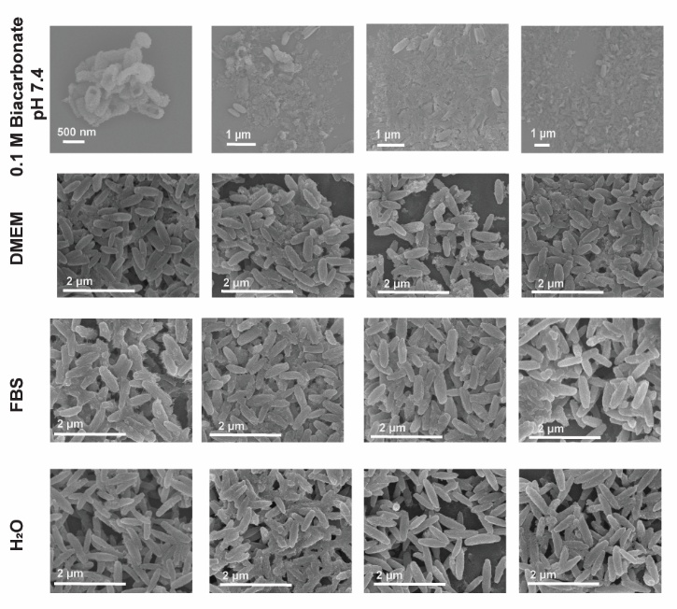

Figure S4. SEM micrographs showing the morphological stability of NU-1003 particles incubated in various biologically relevant media. NU-1003 particles were suspended in 0.1 M bicarbonate buffer (pH 7.4), Dulbecco’s Modified Eagle Medium (DMEM), fetal bovine serum (FBS), or deionized water (H₂O), and imaged at multiple time points to assess morphological integrity. Samples were collected at 1, 4, 18, and 24 h, washed with water three times and imaged by SEM. Severe morphological degradation was observed in 0.1 M bicarbonate buffer, while particles retained their shape and integrity in DMEM, FBS, and water throughout the 24-h period.

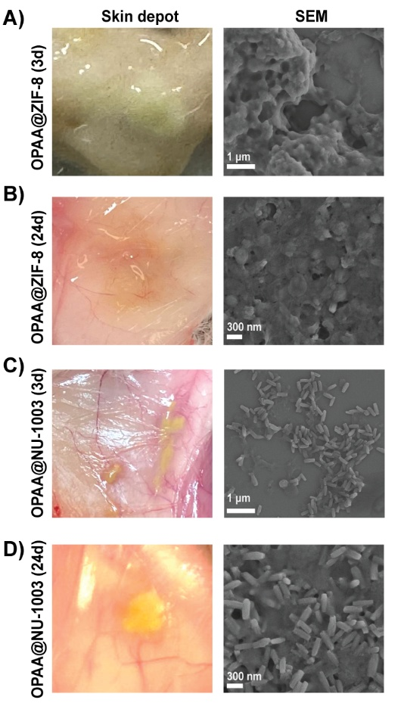

Figure S5. Images (left) show visible subcutaneous depots at the injection site in mice treated with OPAA@ZIF-8 (A, B) or OPAA@NU-1003 (C, D) at 3 d (A, C) and 24 d (B, D) post-injection. SEM micrographs (right) show the morphology of particles recovered from the depots after extensive washing with water (5×). OPAA@ZIF-8 showed visible depot formation at day 3 but was largely degraded by day 24, as indicated by the lack of defined particulate structure in the SEM images. In contrast, OPAA@NU-1003 depots remained visible and retained distinct crystalline morphology even at day 24, demonstrating greater stability and persistence at the injection site. Scale bars are indicated in each panel.

Figure S6. Biodistribution of zirconium (Zr) in major organs 72 hours post-injection.
ICP-MS was used to quantify zirconium levels in the (A) heart, (B) kidney, (C) liver, (D) lung, (E) lymph node, and (F) spleen following subcutaneous injection of OPAA@NU-1003. Zirconium was primarily detected in the kidney and liver, where the highest levels accumulated. In all other organs, including lymph nodes, Zr levels were minimal or below the limit of detection.

Figure S7. Comparison of Delta grip strength between groups showing significance change of MOF groups compared to saline and OPAA after immediate treatment. A one-way analysis of variance (ANOVA) was used for statistical analysis.

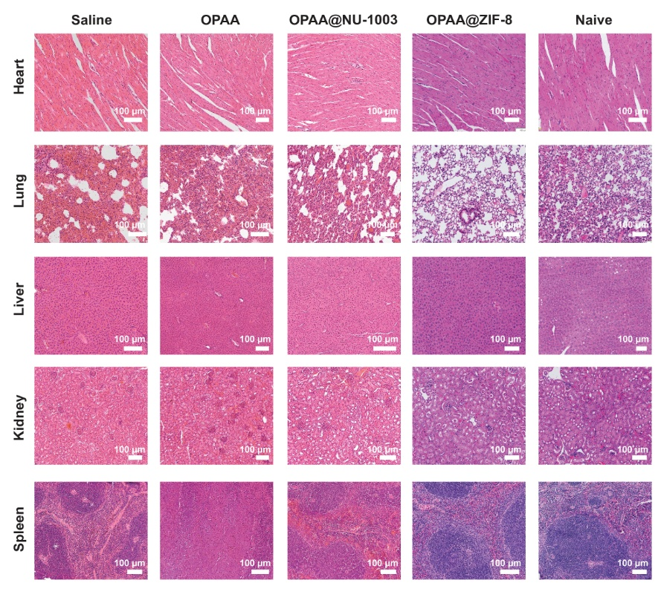
Figure S8. Histological analysis of major organs following therapeutic treatment.
H&E-stained sections of heart, lung, liver, kidney, and spleen from mice treated with saline, OPAA, OPAA@NU-1003, OPAA@ZIF-8, or untreated (naïve) were examined for toxicity. OPAA@NU-1003 showed preserved tissue morphology similar to naïve controls.

Figure S9. Comparison between groups in the delta grip strength after prophylactic treatment and observing that enzyme@MOF had significantly lower change in grip strength after treatment compared to saline and OPAA alone. A one-way analysis of variance (ANOVA) was used for statistical analysis.

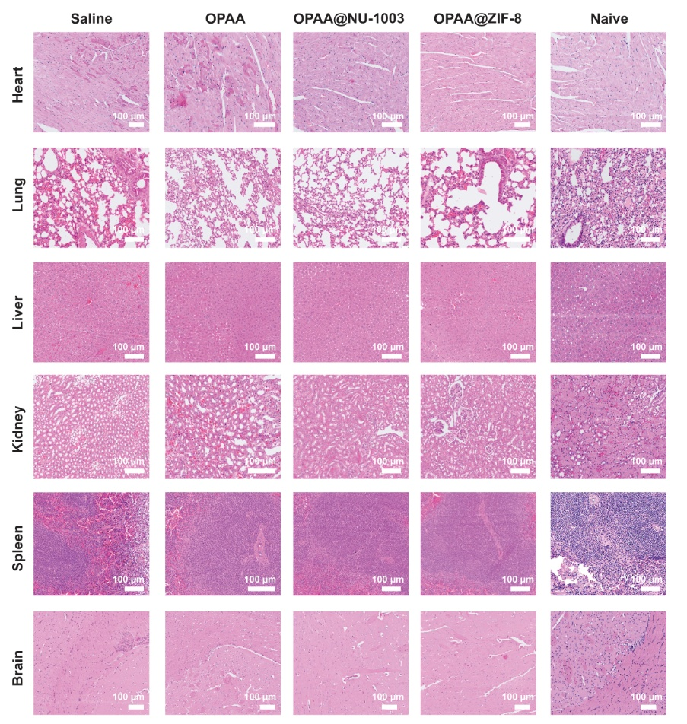
Figure S10. Histological analysis of major organs after prophylactic treatment.
H&E-stained sections of heart, lung, liver, kidney, spleen, and brain were collected following prophylactic administration of saline, OPAA, OPAA@NU-1003, OPAA@ZIF-8, or from naïve mice. OPAA@NU-1003 showed minimal tissue changes and closely resembled naïve controls.

Reference

1 Koirala, S. et al. Fluorescent molecular probe for in vivo and in vitro targeting and imaging of an intracellular bacterial infection. Chemical Science 16, 7902-7911 (2025).
2 Li, P. et al. Nanosizing a metal–organic framework enzyme carrier for accelerating nerve agent hydrolysis. ACS nano 10, 9174-9182 (2016).

