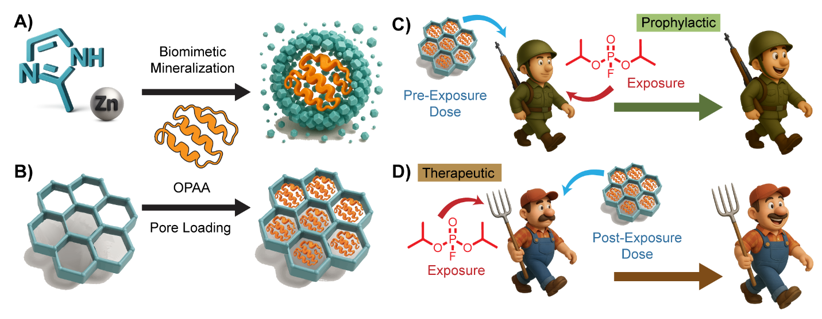
Scheme 1. (A) Schematic representation of biomimetic mineralization of the OPAA enzyme within ZIF-8. Zinc ions and 2-methylimidazole self-assemble around the enzyme, forming a protective ZIF-8 shell. (B) OPAA enzyme loading into the large pores of the metal-organic framework NU-1003 via passive diffusion. (C) Illustration of a prophylactic approach where enzyme-loaded MOF particles are administered before exposure to an OP nerve agent, offering protective effects to soldiers. (D) A therapeutic approach involves administering enzyme-loaded MOF particles after OP exposure to treat affected individuals, enabling recovery by breaking down the toxic compound.

