Supporting Information

Activating Free Volume of Polymeric Aggregates toward Advanced Hard Carbon for Sodium Storage

Jianhao Lin¹, Zhishan Liao¹, Yike Liu², Bote Zhao¹, Jiexi Wang³ and Xunhui Xiong^{1,} *

¹ School of Environment and Energy, Guangdong Provincial Key Laboratory of Advanced Energy Storage Mater., South China University of Technology, Guangzhou 510006, China
² School of Materials and Energy Engineering, Guizhou Institute of Technology, Guiyang 550003, China
³ Engineering Research Center of the Ministry of Education for Advanced Battery Materials, Hunan Provincial Key Laboratory of Nonferrous Value-Added Metallurgy, School of Metallurgy and Environment, Central South University, Changsha 410083, China
E-mail: esxxiong@scut.edu.cn

1. Correlated Calculations
Swelling ratio (ΔS/S₀): the change in the upper area (ΔS) with the respect to the original upper area (S₀).
ΔS/S₀ (%) = (S₁- S₀)/S₀ Equation S1
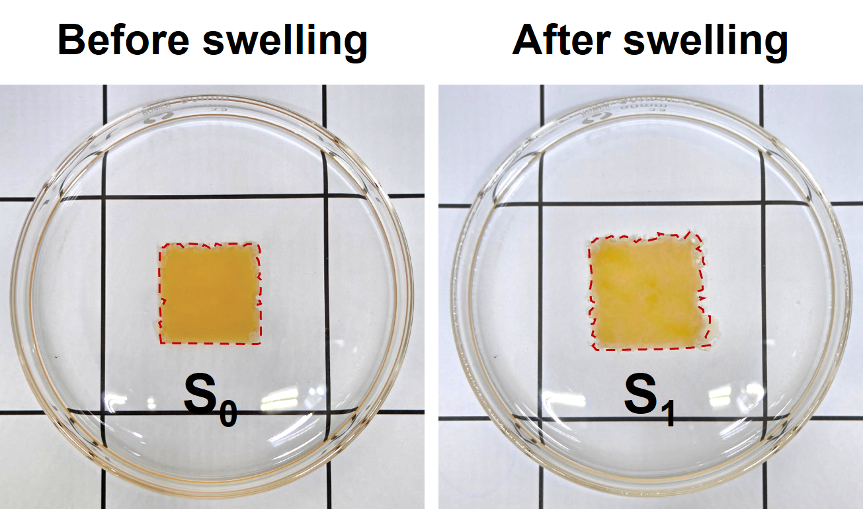
in which S₀ is upper area before swelling and S₁ is upper area after swelling calculated by Photoshop software.

Interlayer spacing (d₀₀₂): d₀₀₂ is calculated using Bragg’s equation:
$d= \frac{nλ}{2sin (θ)}$ Equation S2
in which n=1(order of diffraction)
λ is the XRD wavelength (Cu Kα radiation,1.54056 Å)
θ is the scattering angle (002) peak

Tensile stress (σ, Pa), Tensile strain (ɛ, %) and Tensile Modulus (E, Pa) was calculated using the following equation:
σ = F/S Equation S3
ɛ=Δl/l₀ Equation S4
E=σ/ɛ Equation S5
where S is the cross-sectional area of PPR or PR samples (m²), F is load (N), Δl is the change in the length (m) and l₀ is the gauge length of PPR or PR samples (m).

Shrinkage ratio (Δl/l₀) of PPR and PR during the carbonization process:
Δl/l₀ (%) = (l₁-l₀)/ l₀ Equation S6
where l₁ is the side length after carbonization and l₀ is the original side length.

Closed pore volume (V_{closed pore}, cm³ g⁻¹) was calculated from true density (ρ_{true}) according to the following equation:
V_{closed pore} = 1/ρ_{true}-1/2.26 Equation S7

Na⁺ diffusion coefficients were calculated using Fick’s second law:
$D=\frac{4}{πτ}{\left(\frac{m_{B}V_{M}}{M_{B}S}\right)}^{2}{\left(\frac{∆E_{s}}{∆E_{τ}}\right)}^{2}$ Equation S8
where τ (s) is the pulse duration
m_{B} (g) is active mass of the electrode
V_{M} (cm³ mol⁻¹) is molar volume
MB (g mol⁻¹) is active mass of the el molecular weight
S (m² g⁻¹) is active surface area of the electrode
∆E_{s} and ∆E_{τ} are obtained from the GITT curves.

The average distance between adjacent crystalline domains was calculated by Bragg equation:
d=2π/q_{max} Equation S9
in which q_{max} is the scattering vector at the peak position in SAXS curve.

Falling steel ball test: the PPR-S or PPR-W pieces was covered on a glass substrate, and the impact process was mimicked by dropping a 50 g steel ball above the samples from the same height of about 1 m.

2. Additional Figures and Tables
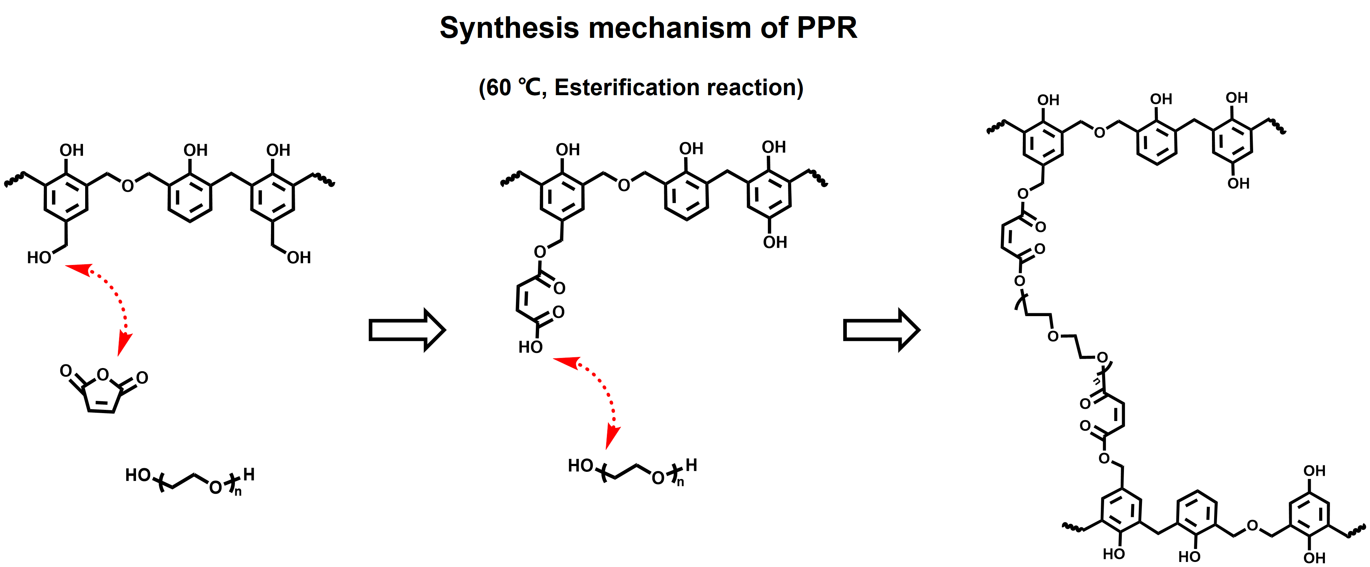
Supplementary Fig. 1 Scheme of reaction mechanism of PPR aggregates.

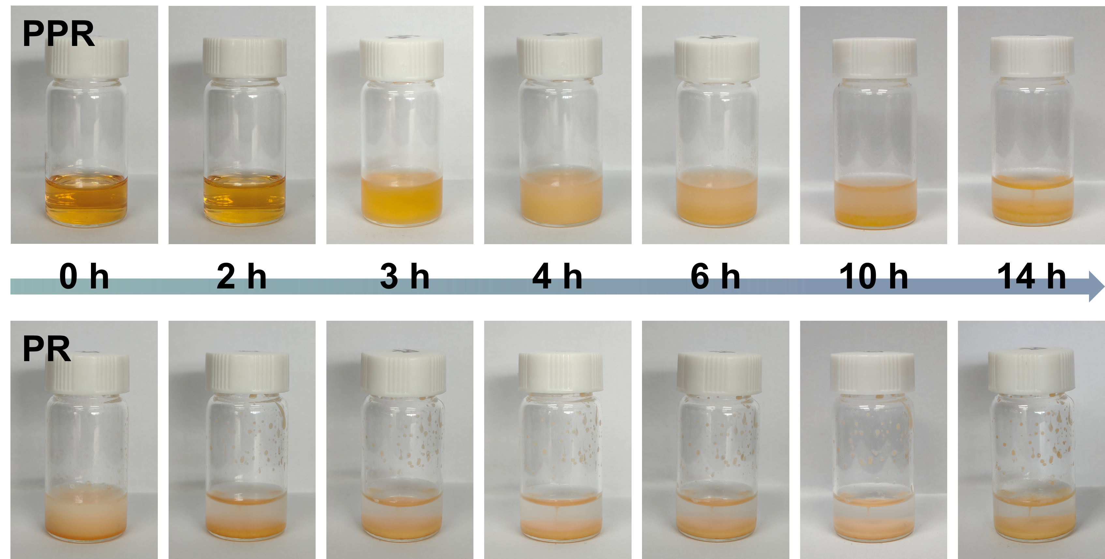
Supplementary Fig. 2 The digital photographs of synthesis process of PPR and PR aggregates with different reaction time.

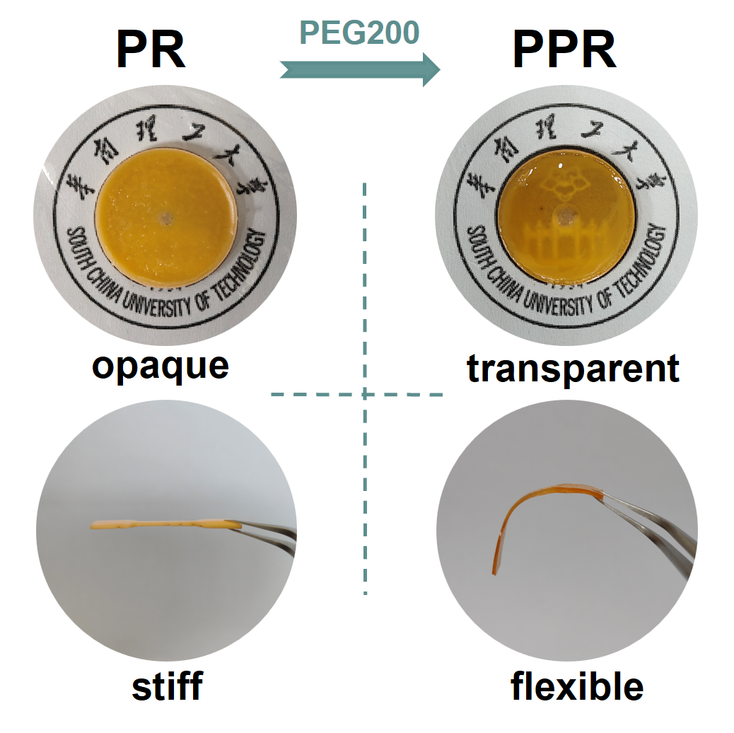
Supplementary Fig. 3 The photographs of the transparency and flexibility of PPR and PR aggregates.

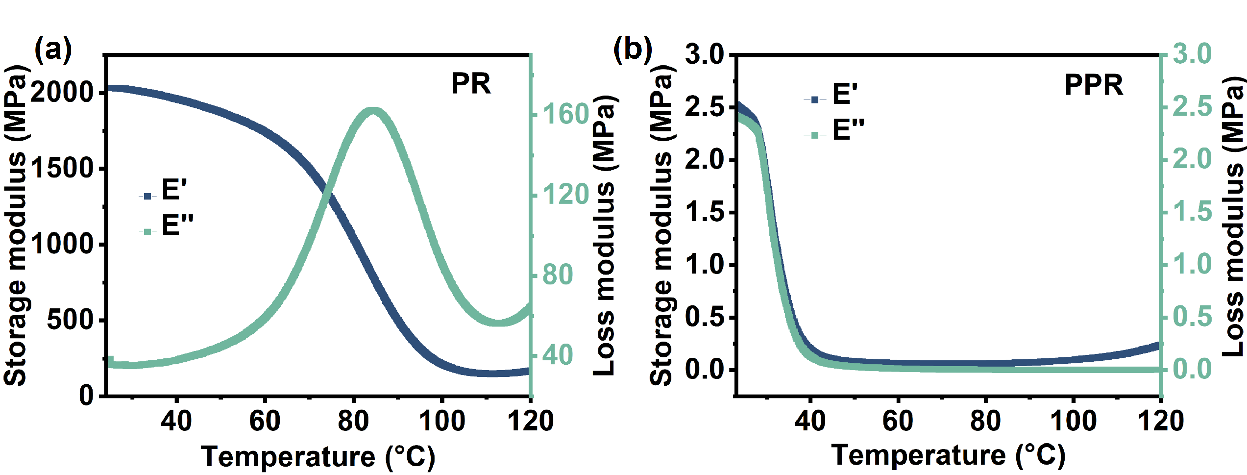
Supplementary Fig. 4 The storage modulus (E’), loss modulus (E”) for PR and PPR aggregates at 25~120 °C by DMA in compression mode (frequency:1 Hz).

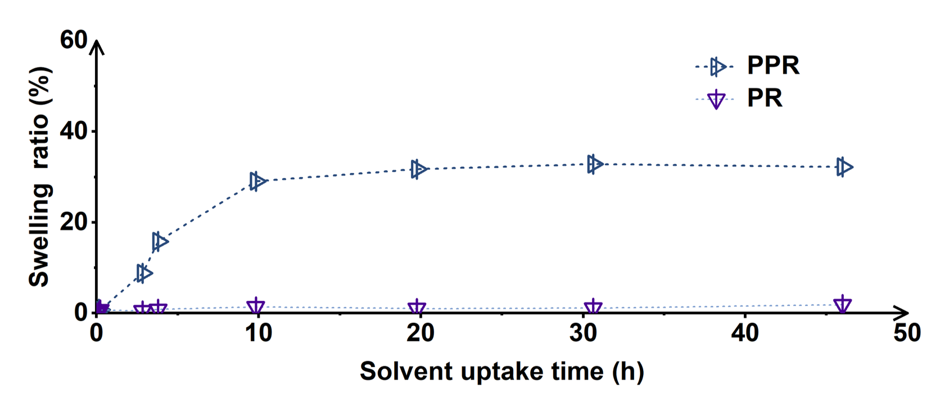
Supplementary Fig. 5 Swelling ratio of PPR and PR aggregates in ethanol solvent.

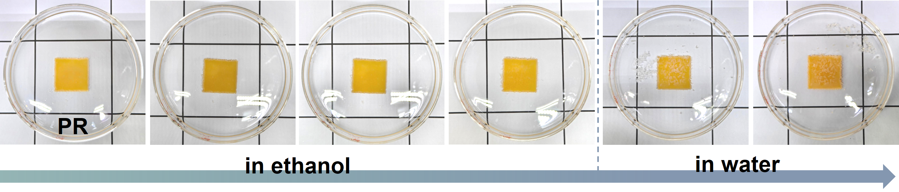
Supplementary Fig. 6 Photos of the immersion process of PR aggregates in ethanol and water solvents.

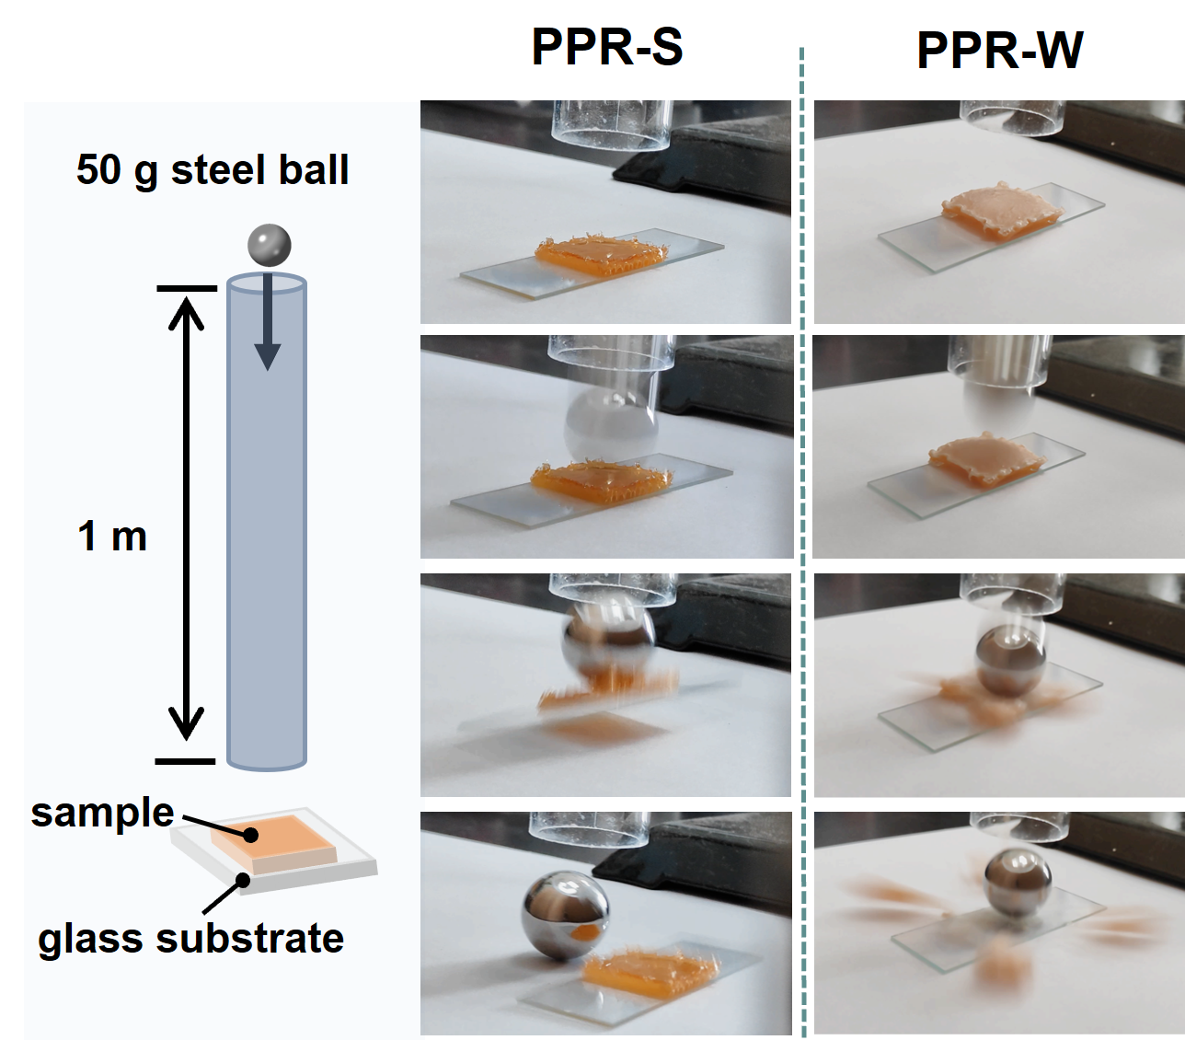
Supplementary Fig. 7 Photographs of the PPR and PPR-A aggregates during falling-ball test.

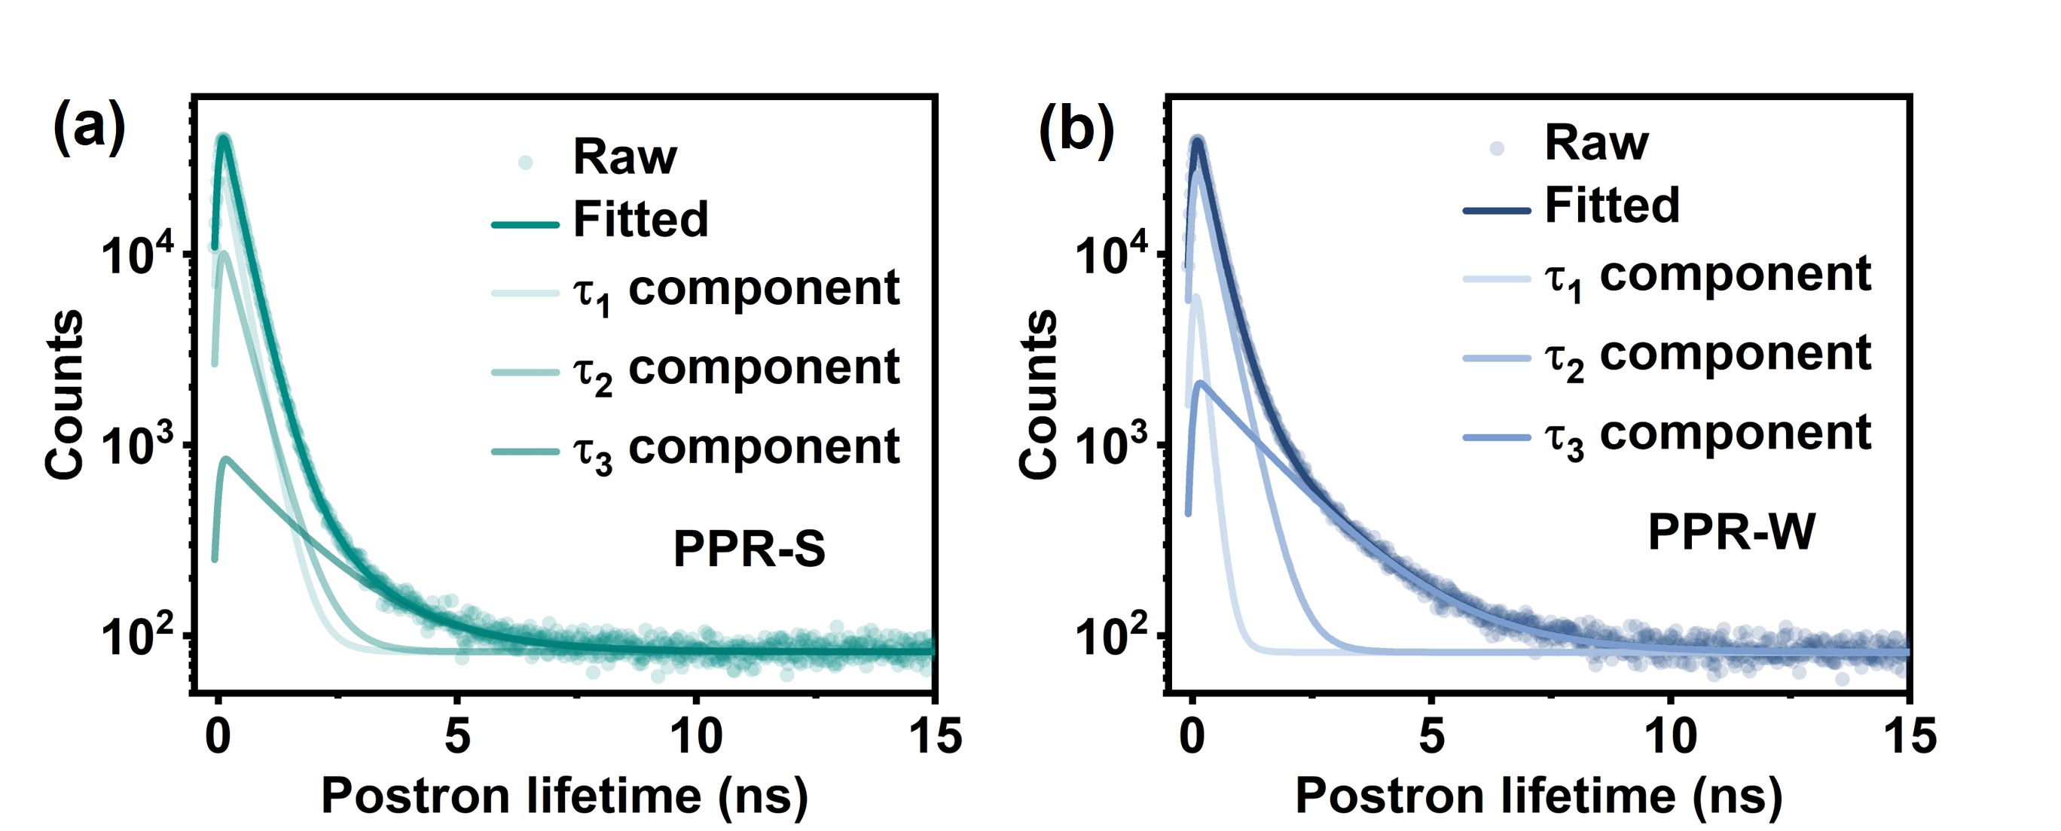
Supplementary Fig. 8 Fitted PALS spectra of (a) PPR-S and (b) PPR-W aggregates.

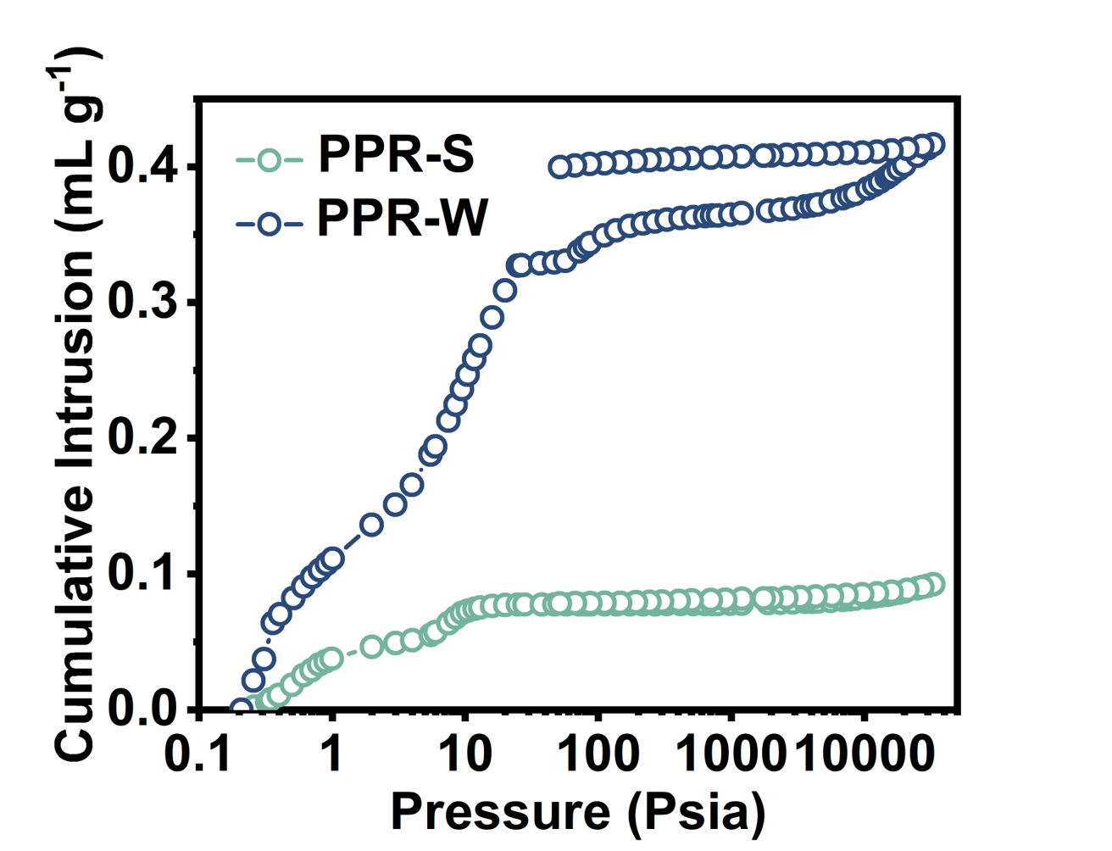
Supplementary Fig. 9 The mercury porosimetry intrusion and retraction curves of PPR-S and PPR-W aggregates.

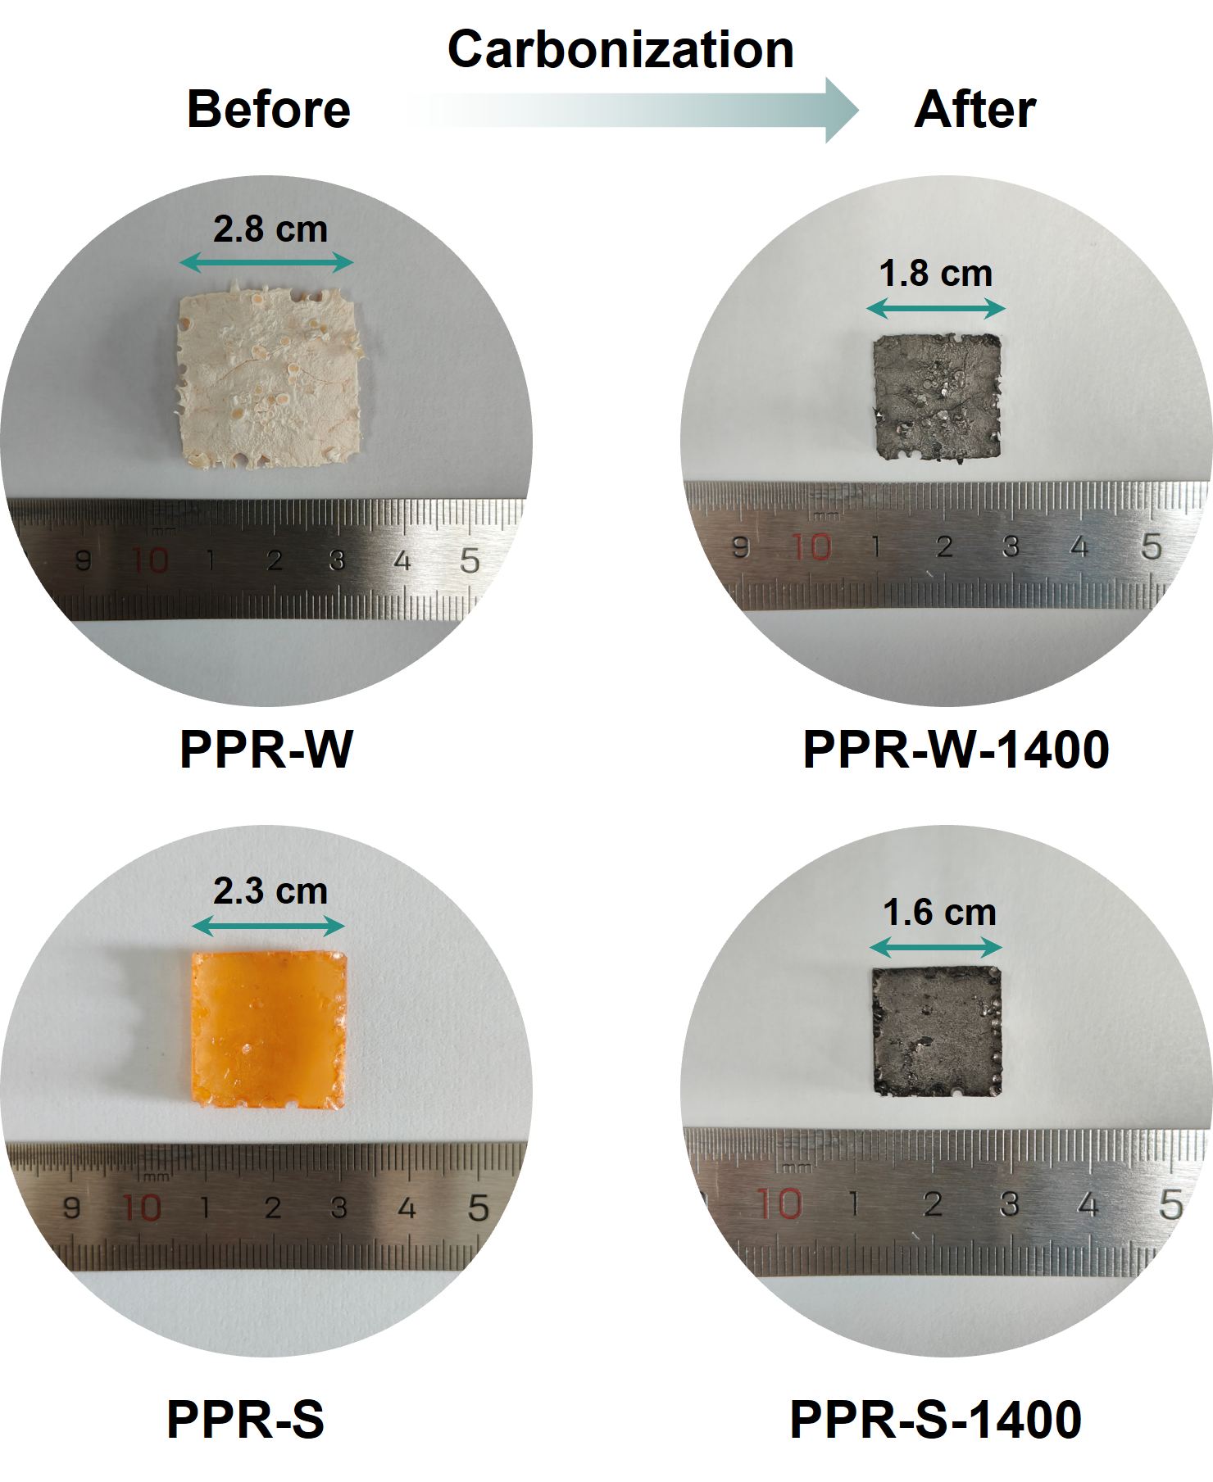
Supplementary Fig. 10 Photographs of the PPR-S and PPR-W aggregates before and after carbonization process.

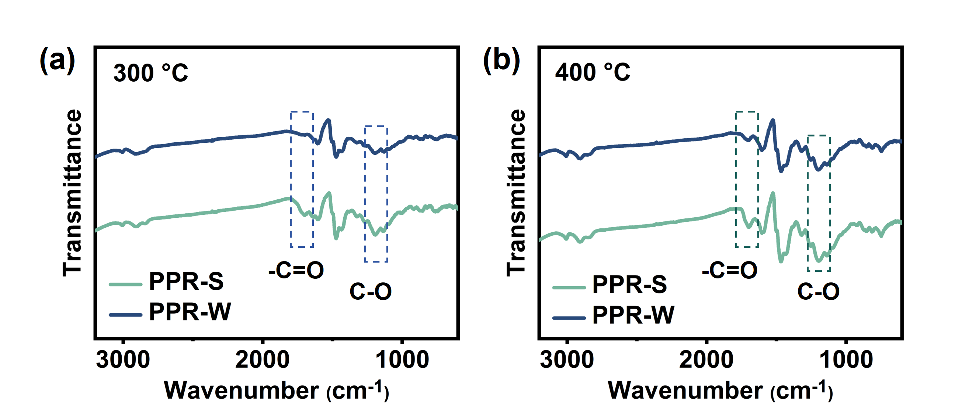
Supplementary Fig. 11 FTIR spectrums of PPR-S and PPR-W aggregates at (a) 300 °C and (b) 400 °C.

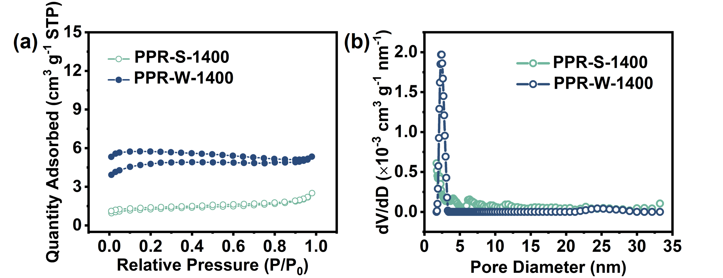
Supplementary Fig. 12 (a) N₂ adsorption/desorption isotherms and (b) pore size distribution of PPR-S-1400 and PPR-W-1400 anodes.
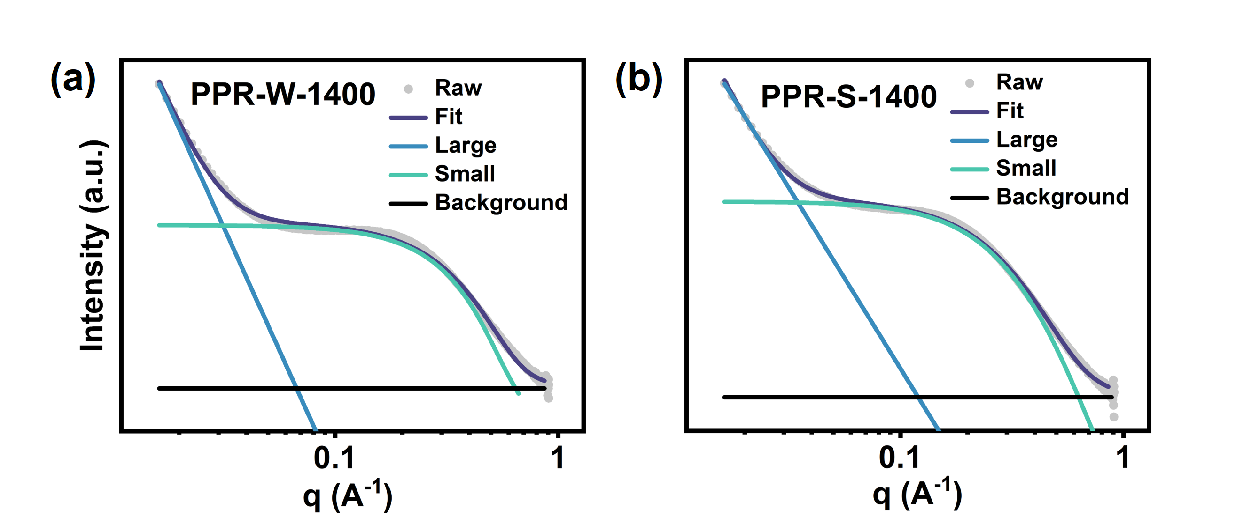
Supplementary Fig. 13 Fitted SAXS curves of (a) PPR-W-1400 and (b) PPR-S-1400 anodes.
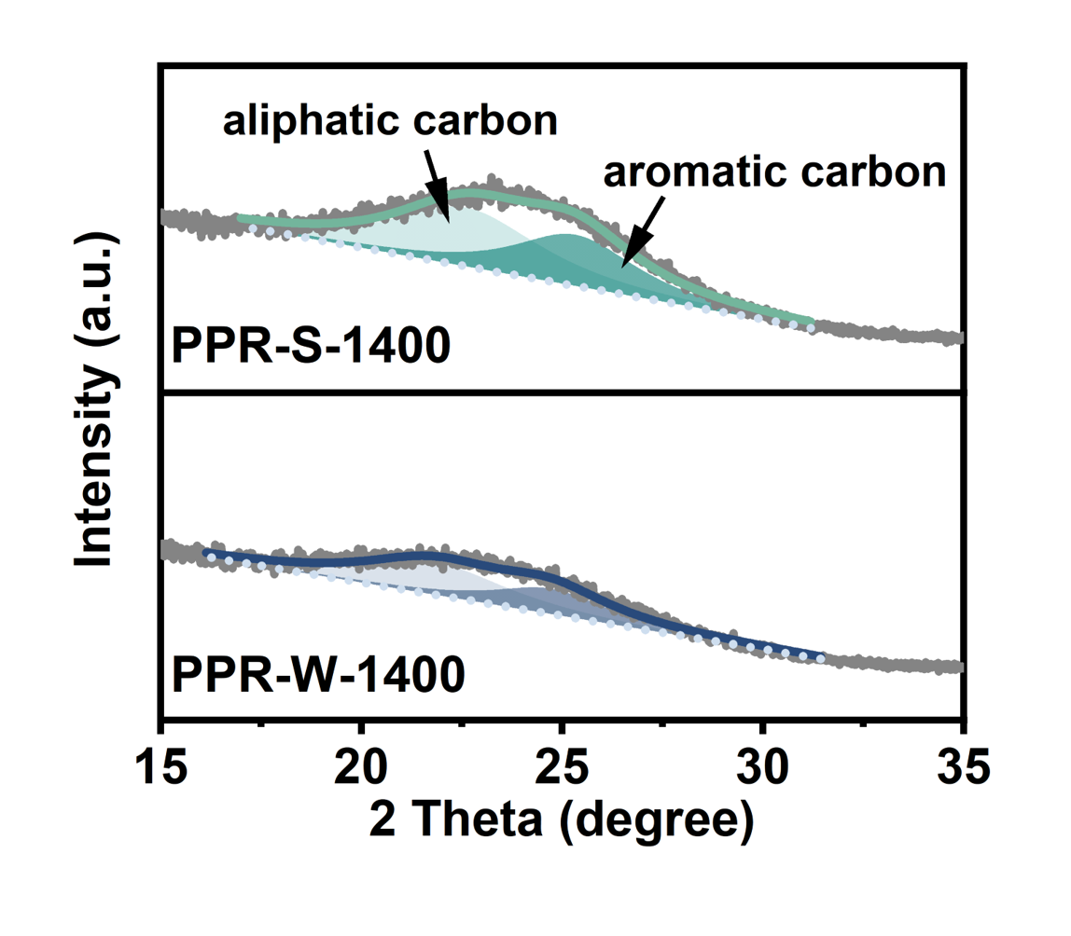
Supplementary Fig. 14 Fitted XRD curves of PPR-W-1400 and PPR-S-1400 anodes.

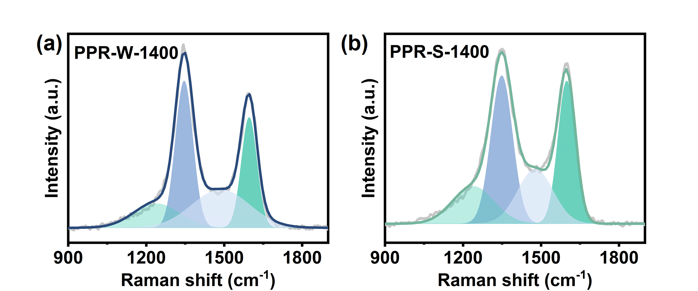
Supplementary Fig. 15 Fitted Raman curves of (a) PPR-W-1400 and (b) PPR-S-1400 anodes.

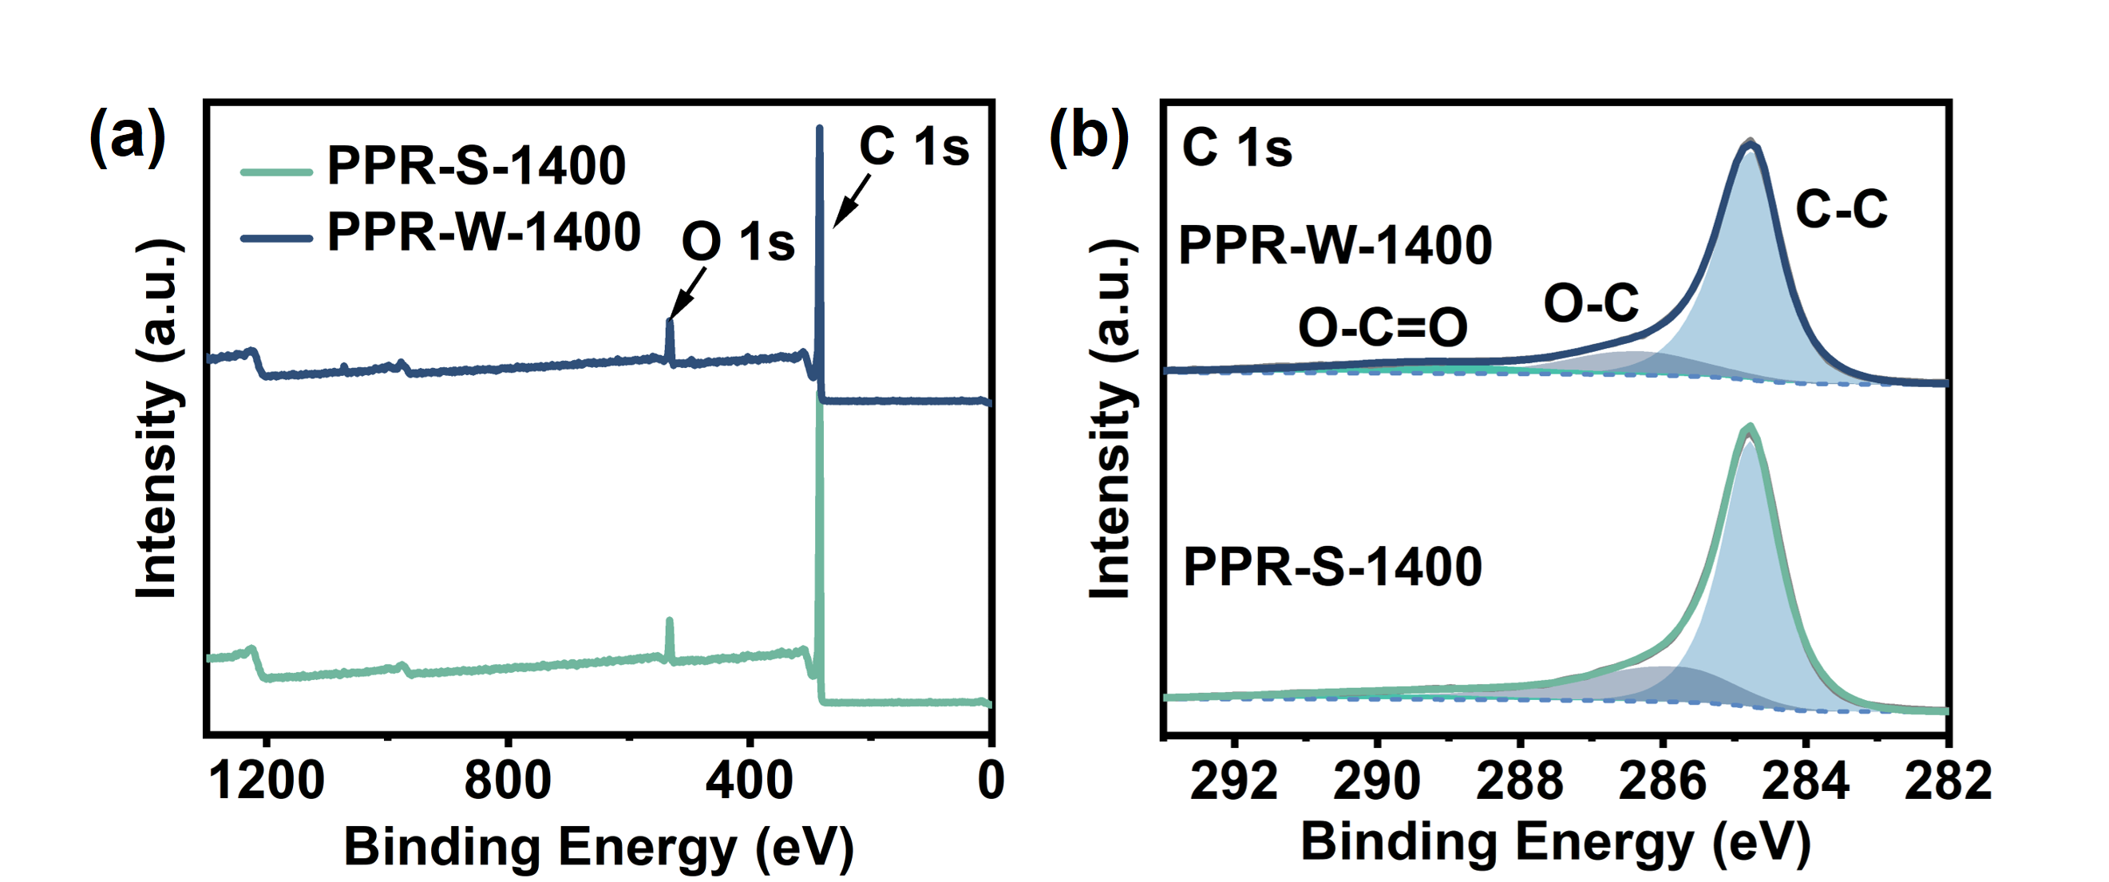
Supplementary Fig. 16 (a) XPS full spectra and (b) High-resolution C 1s XPS spectra of PPR-W-1400 and PPR-S-1400 anodes.

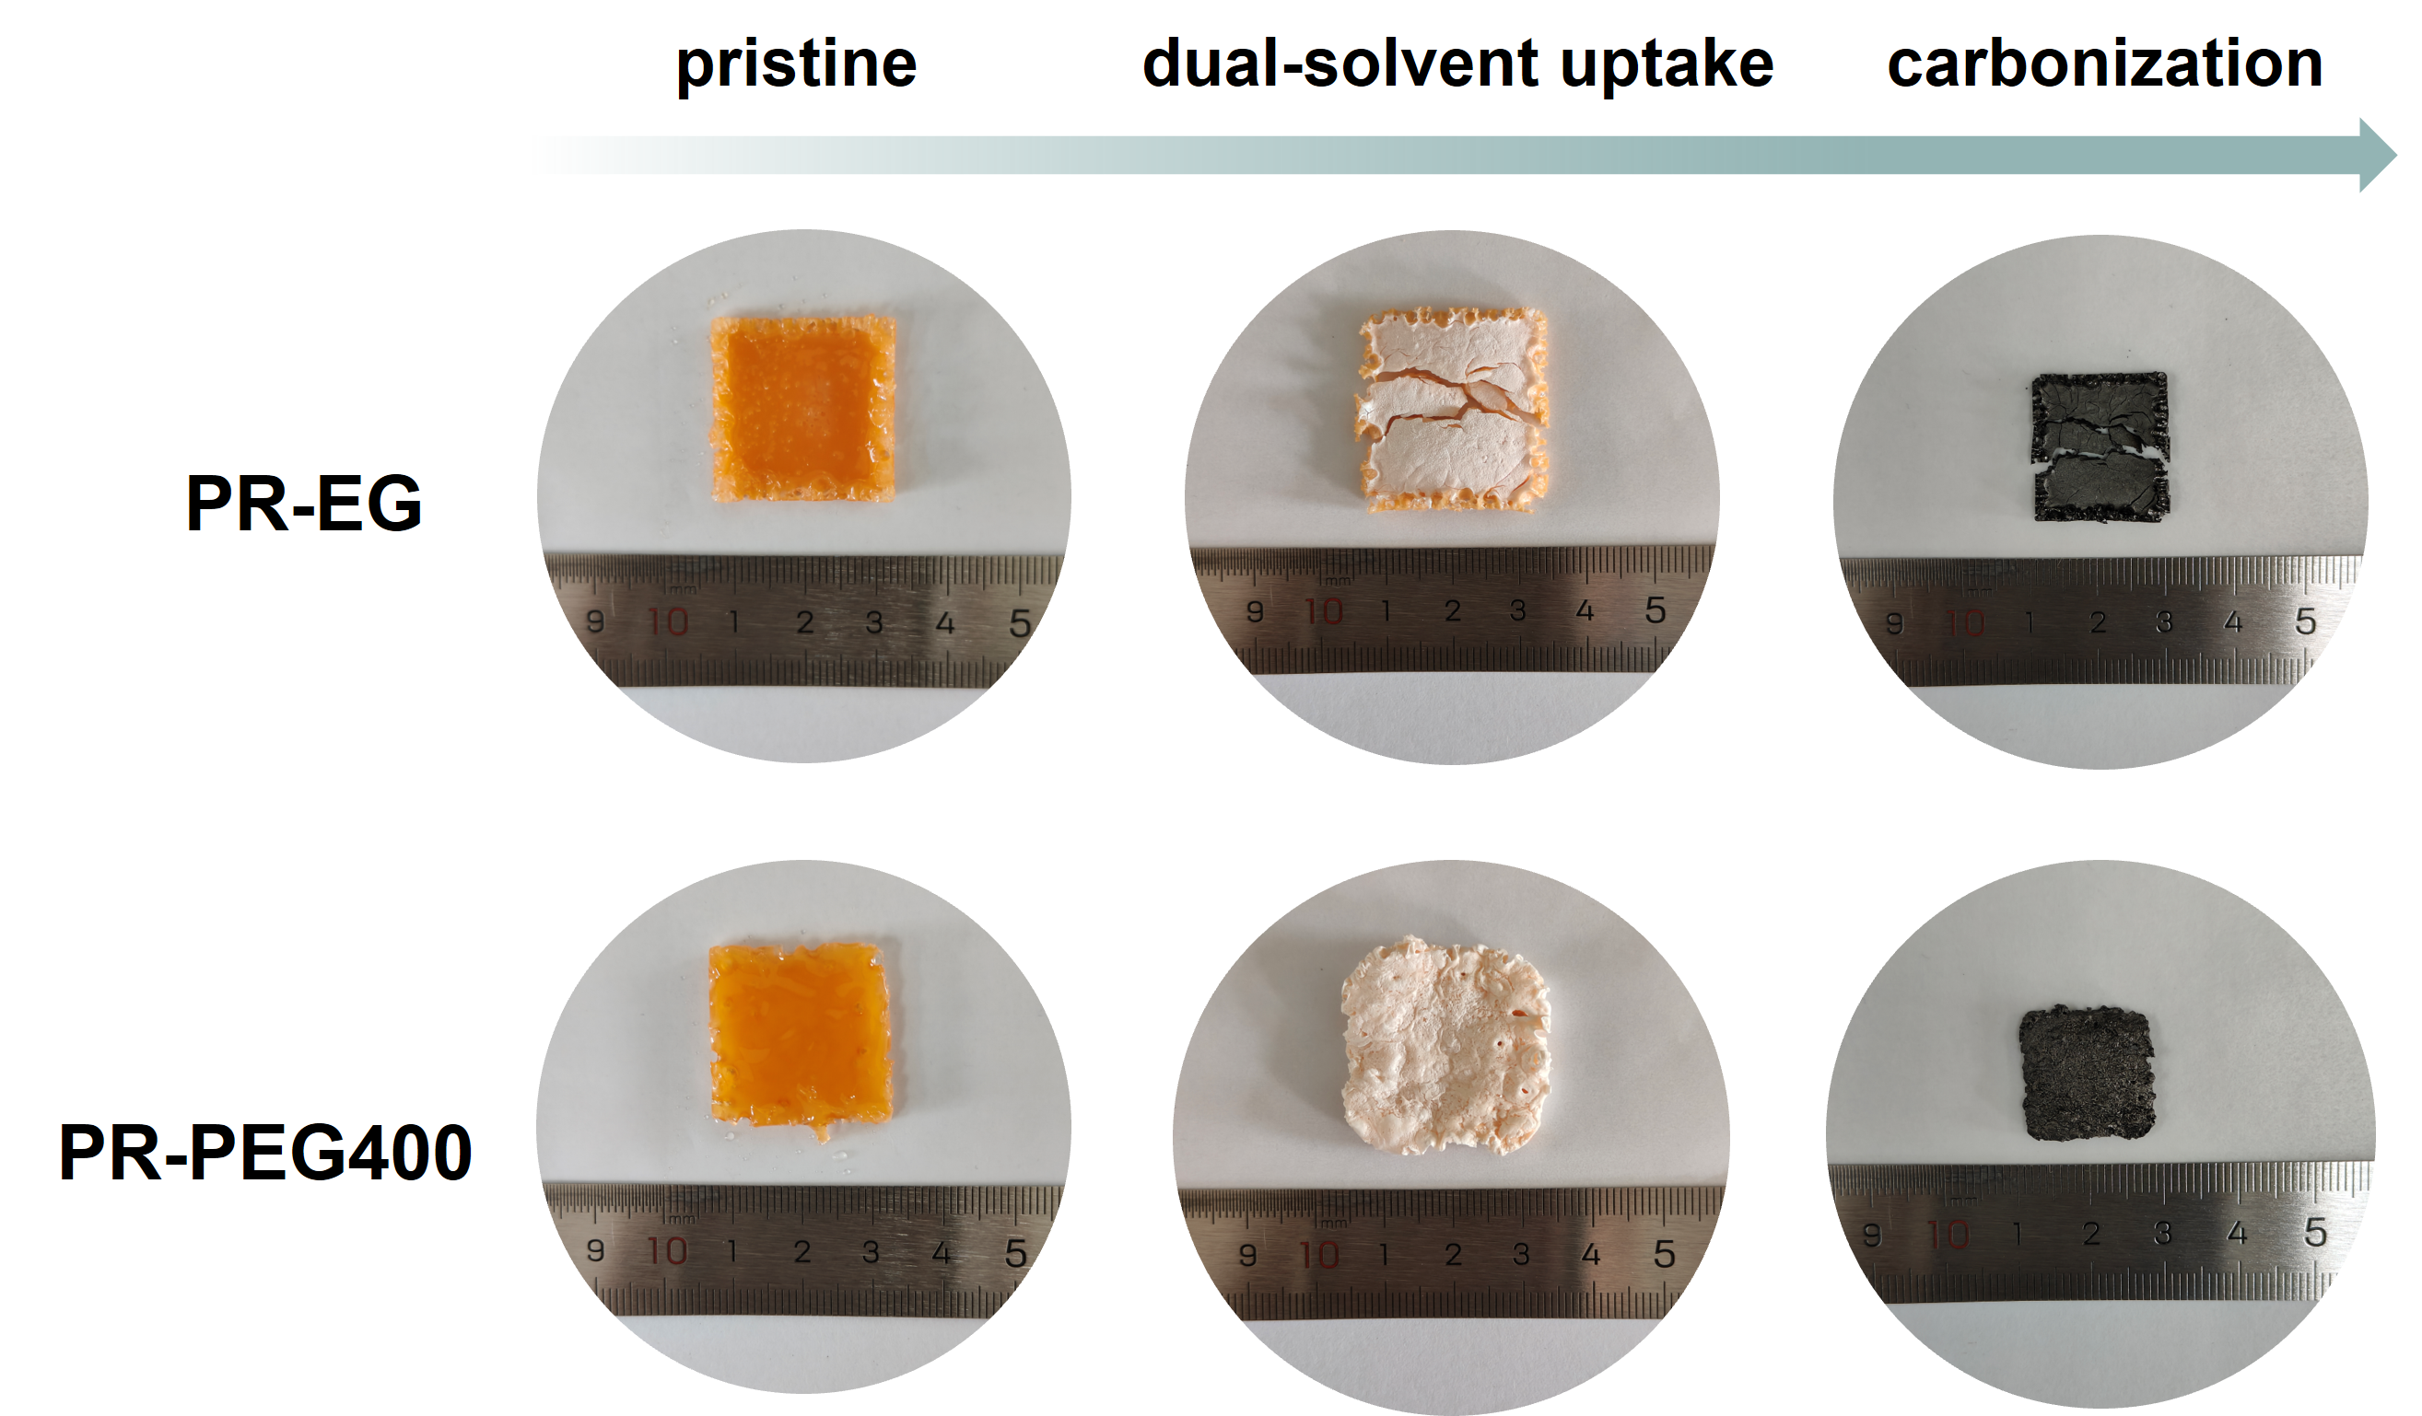
Supplementary Fig. 17 Photographs of the PR-EG and PR-PEG400 aggregates with the dual-solvent uptake and carbonization process.

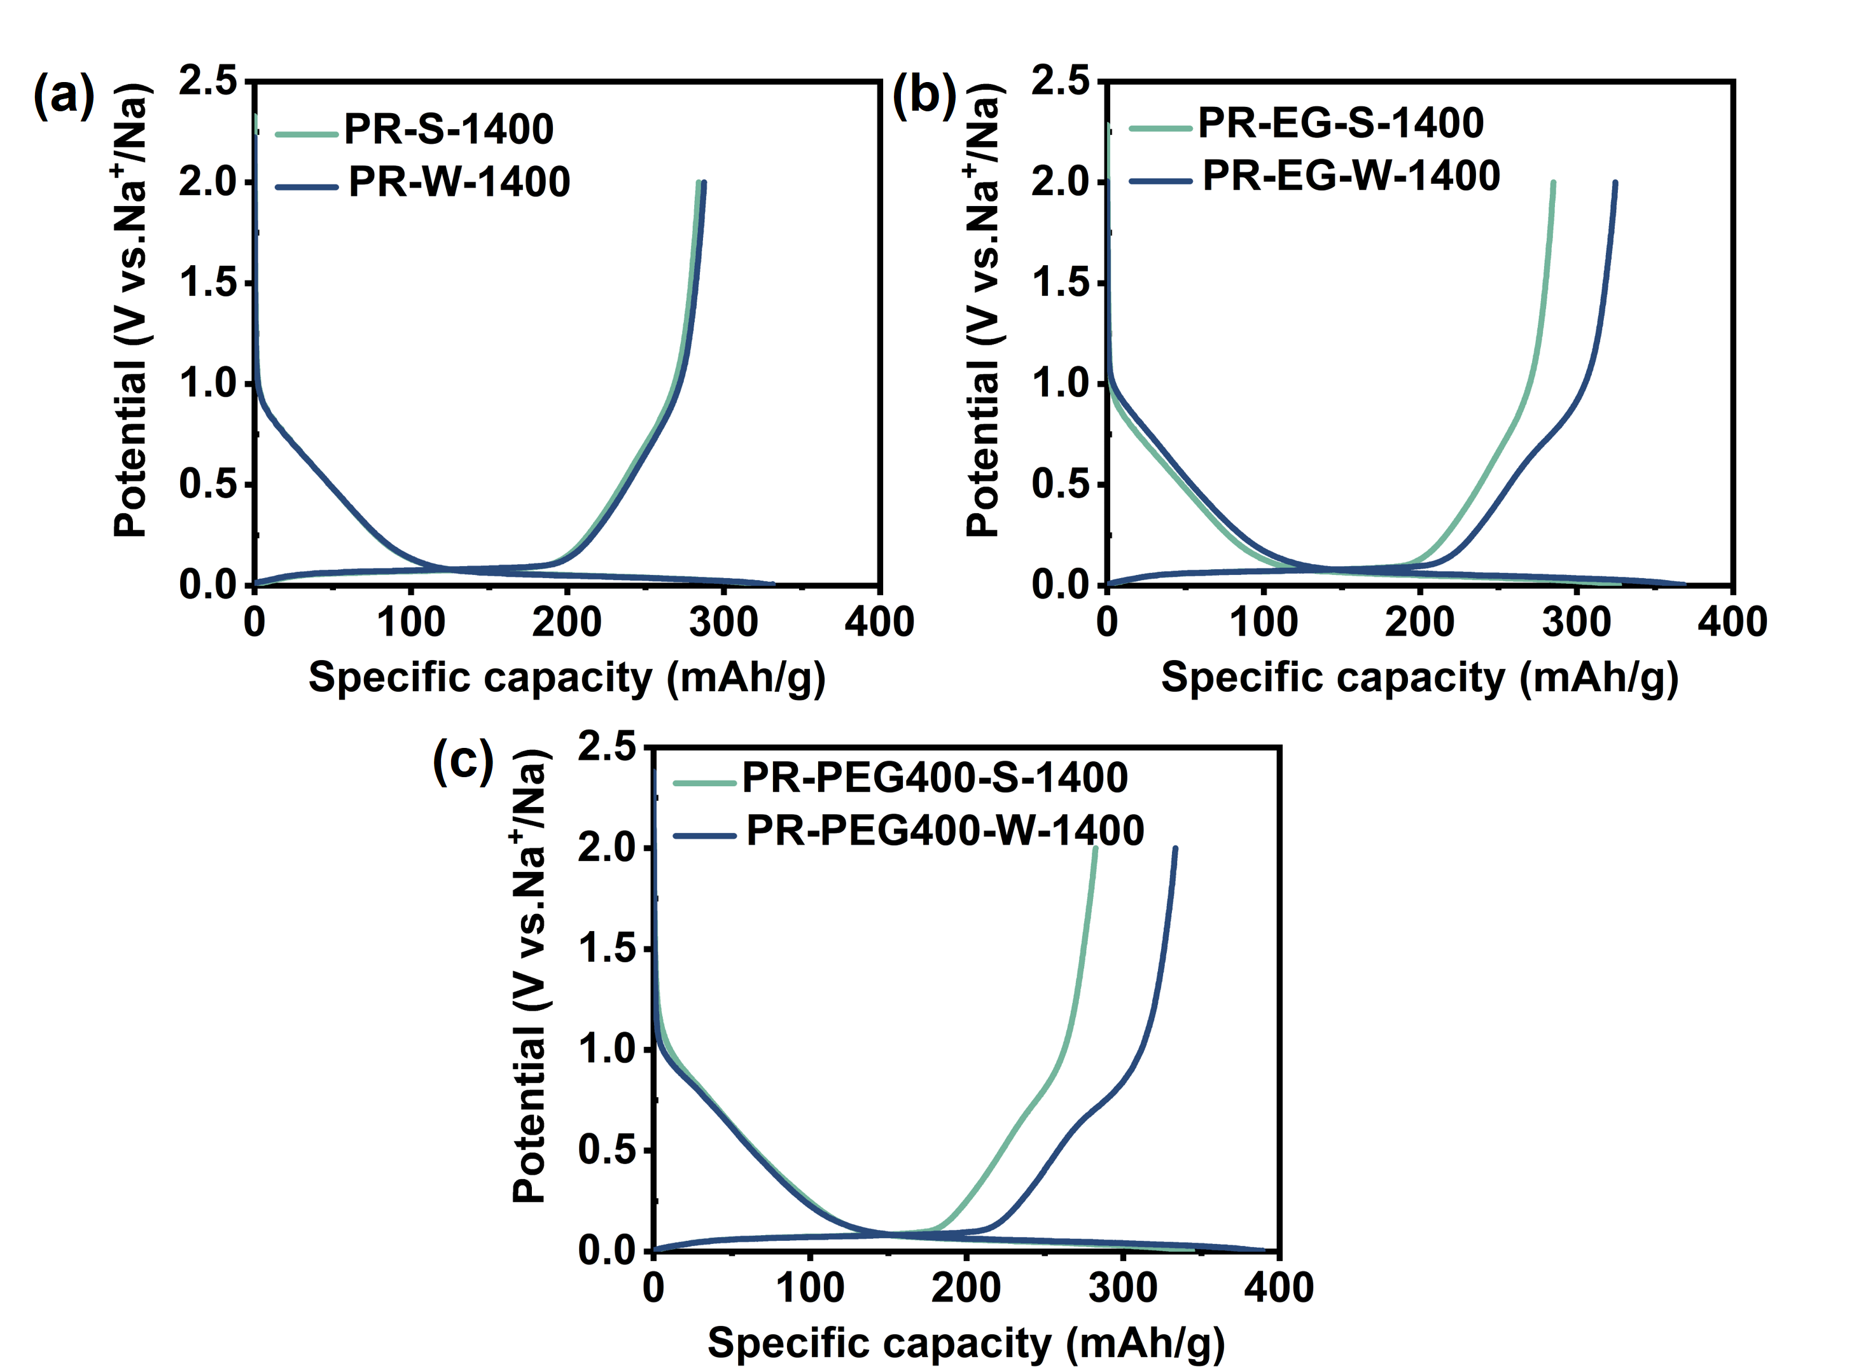
Supplementary Fig. 18 The initial discharge/charge curves of HC samples derived from strongly and weakly aggregated state in PR, PR-EG and PR-PEG400 systems.

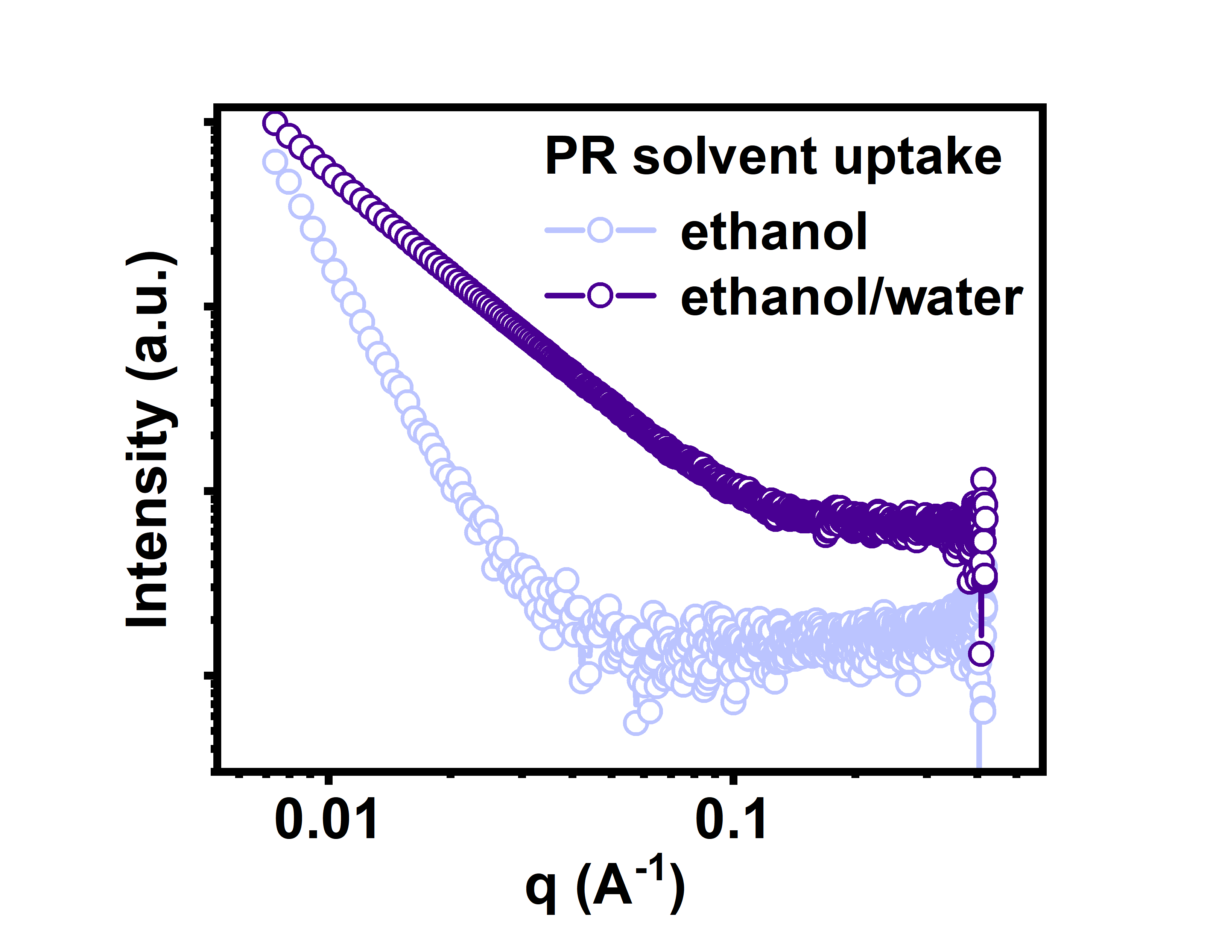
Supplementary Fig. 19 SAXS patterns of PR aggregates after only ethanol or ethanol/water dual-solvent immersion.

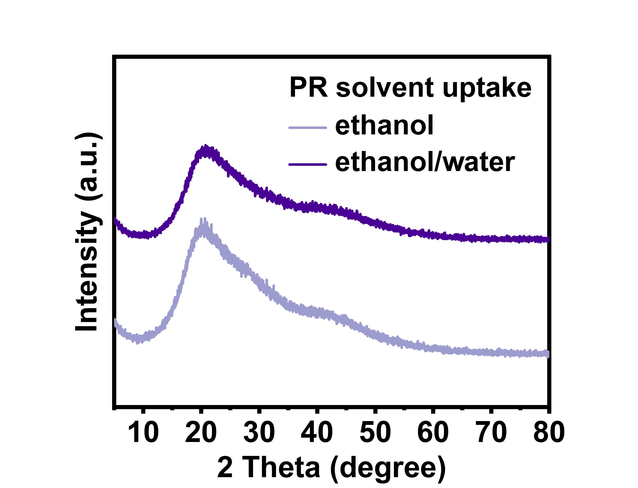
Supplementary Fig. 20 XRD patterns of PR aggregates after only ethanol or ethanol/water dual-solvent immersion.

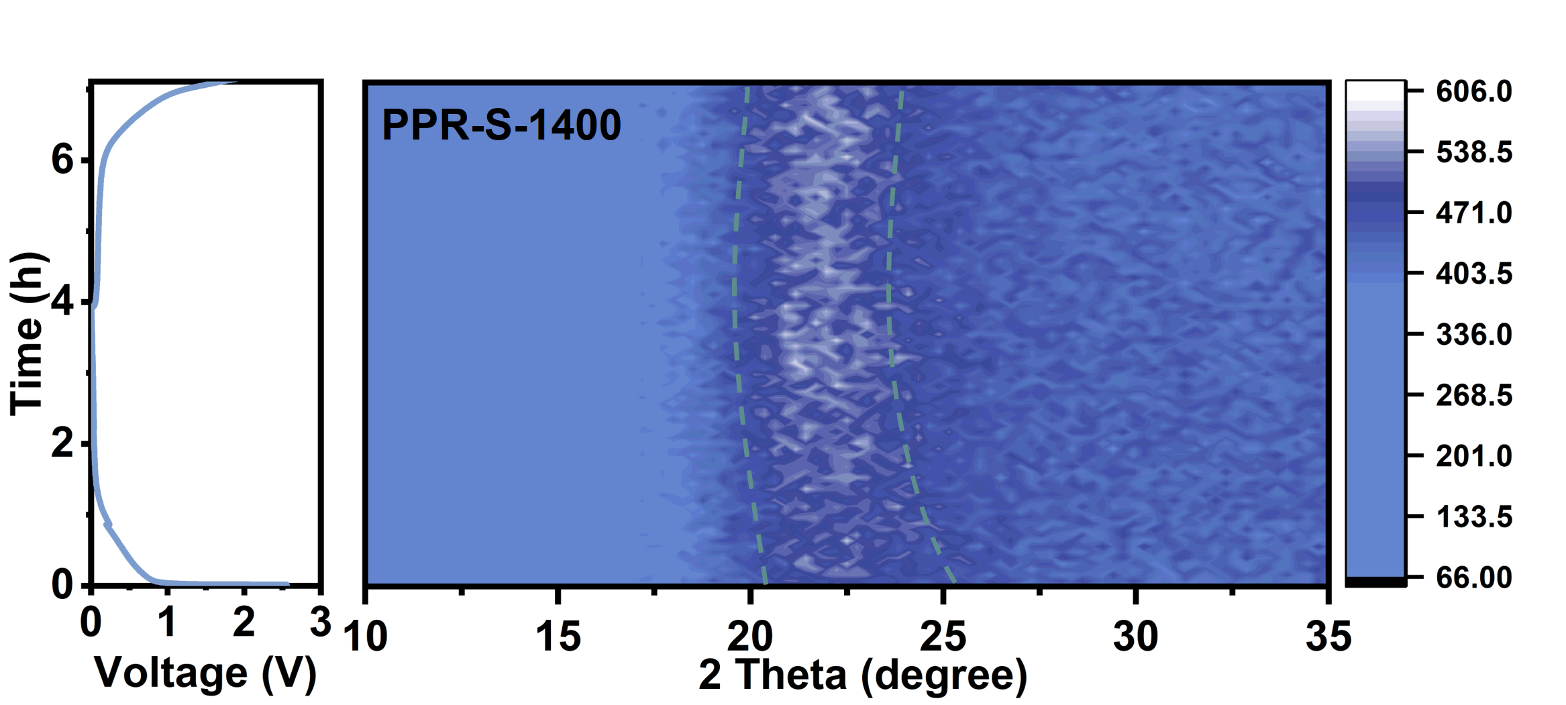
Supplementary Fig. 21 In-situ XRD spectra of PPR-S-1400 anode.

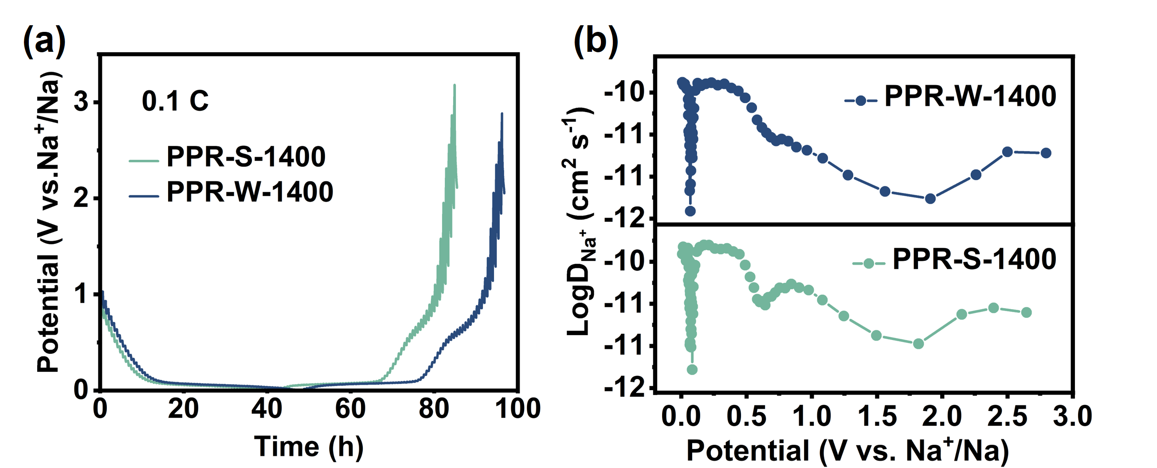
Supplementary Fig. 22 (a) GITT curves and (b) Na⁺ diffusion coefficients at de-sodiation process estimated from GITT curves of PPR-W-1400 and PPR-S-1400 anodes.

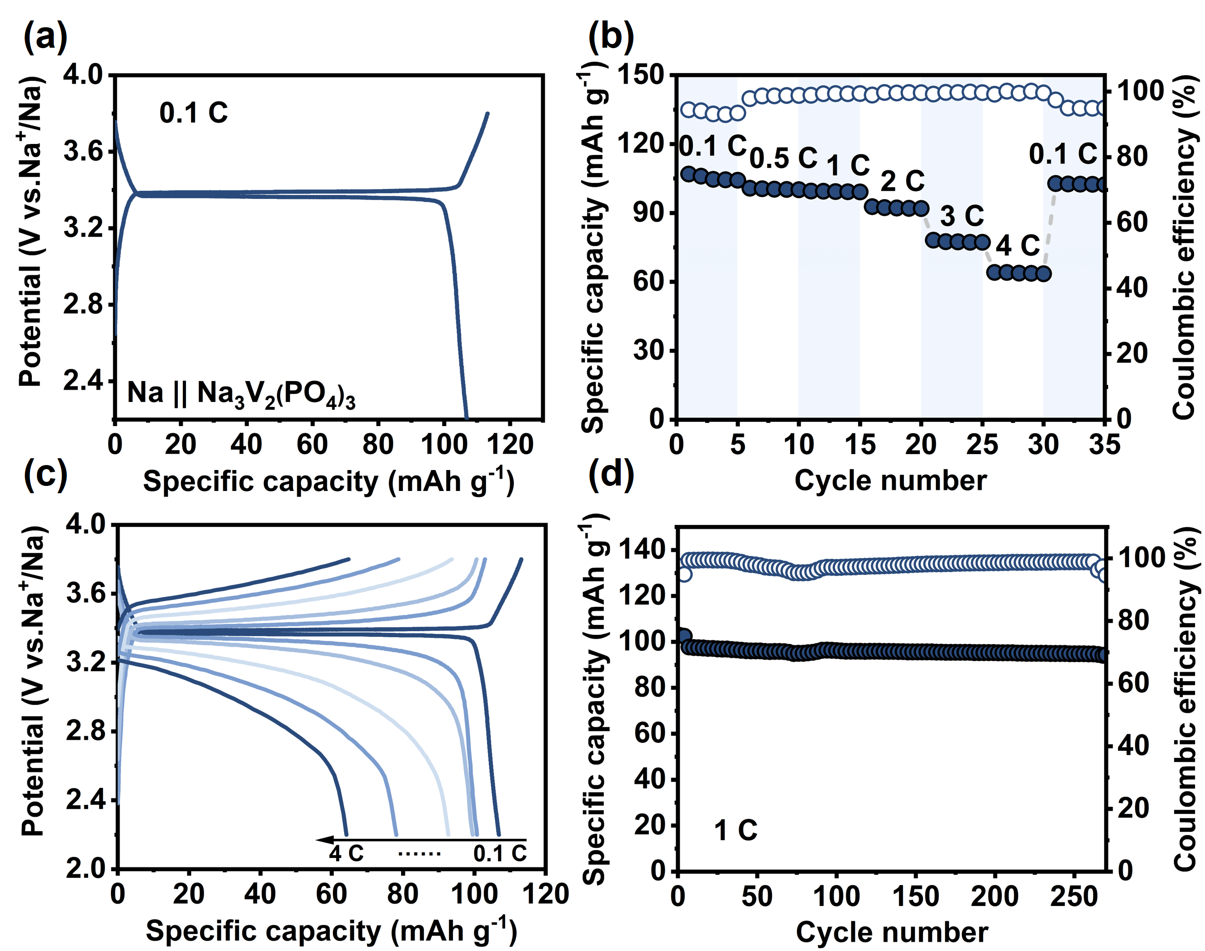
Supplementary Fig. 23 Electrochemical performance of NVP cathode. (a) Initial charge/discharge curve at 0.1 C; (b) Rate performance; (c) Charge/discharge curves at different rate; (d) Cycling performance at 1 C.

Supplementary Table S1. Positron lifetime distributions in PPR-S and PPR-W precursor
Samples | Lifetimes (ns) |  |  | Intensities (%) |  |  | Free volume radius (Å) | Free volume size (Å³) | Fractional free volume
Samples | τ₁ | τ₂ | τ₃ | I₁ | I₂ | I₃ | Free volume radius (Å) | Free volume size (Å³) | Fractional free volume
PPR-W | 0.17 | 0.36 | 1.48 | 10.2 | 72.0 | 19.6 | 2.311 | 51.698 | 0.015
PPR-S | 0.32 | 0.45 | 1.29 | 61.7 | 31.9 | 8.5 | 2.091 | 38.295 | 0.005

