Supplementary materials

Table S1. The characterization of the plant communities feature on the different slopes.
 | Species richness | Coverage (%) | Shannon-Wiener index | Dominant species
SHS | 42.8±3.70a | 76.2±4.32a | 2.06±0.17a | Myrsine africana Linn.  Debregeasia orientalis C. J. Chen  Ternstroemia gymnanthera (Wight et Arn.) Beddome
SUS | 29.8±5.06b | 60.0±5.94b | 1.77±0.12a | Quercus guyavifolia  Quercus variabilis Bl.

Table S2. The gene number of CAZy class on the different slopes.
CAZy Class | CAZy Abbr | SHS | SUS | P value
Auxiliary Activities | AA5 | 0.1396 | 0.1849 | 0.018
Carbohydrate-Binding Modules | CBM12 | 0.0745 | 0.0980 | 0
 | CBM38 | 0.0265 | 0.0186 | 0.028
 | CBM40 | 0.0223 | 0.0279 | 0.011
 | CBM41 | 0.0240 | 0.0337 | 0.05
 | CBM51 | 0.0182 | 0.0137 | 0.02
 | CBM61 | 0.0195 | 0.0145 | 0.015
Carbohydrate Esterases | CE1 | 0.0147 | 0.0074 | 0.001
 | CE15 | 0.0111 | 0.0139 | 0.005
 | CE16 | 0.0108 | 0.0195 | 0.006
 | CE2 | 0.0157 | 0.0104 | 0.016
 | CE3 | 0.0117 | 0.0077 | 0
Glycoside Hydrolases | GH100 | 0.0109 | 0.0074 | 0.027
 | GH104 | 0.0063 | 0.0036 | 0.017
 | GH119 | 0.0083 | 0.0040 | 0.011
 | GH12 | 0.0071 | 0.0047 | 0.042
 | GH13 | 0.0041 | 0.0024 | 0.012
 | GH17 | 0.0030 | 0.0013 | 0.005
 | GH19 | 0.0025 | 0.0052 | 0.014
 | GH2 | 0.0031 | 0.0020 | 0.04
 | GH25 | 0.0054 | 0.0017 | 0.002
 | GH29 | 0.0021 | 0.0013 | 0.046
 | GH30 | 0.0048 | 0.0020 | 0.018
 | GH4 | 0.0025 | 0.0010 | 0.012
 | GH46 | 0.0030 | 0.0017 | 0.043
 | GH49 | 0.0023 | 0.0008 | 0.02
 | GH50 | 0.0023 | 0.0005 | 0.001
 | GH53 | 0.0016 | 0.0006 | 0.005
 | GH54 | 0.0016 | 0.0011 | 0.038
 | GH55 | 0.0016 | 0.0006 | 0
 | GH57 | 0.0016 | 0.0010 | 0.021
 | GH68 | 0.0014 | 0.0008 | 0.039
 | GH7 | 0.0019 | 0.0004 | 0.009
 | GH70 | 0.0011 | 0.0003 | 0.001
 | GH75 | 0.0008 | 0.0004 | 0.028
 | GH76 | 0.0008 | 0.0004 | 0.039
 | GH78 | 0.0010 | 0.0006 | 0.022
 | GH94 | 0.0010 | 0.0002 | 0.006
Glycosyl Transferases | GT12 | 0.0007 | 0.0002 | 0.029
 | GT14 | 0.0003 | 0.0000 | 0.002
 | GT2 | 0.0005 | 0.0002 | 0.015
 | GT21 | 0.0003 | 0.0001 | 0.01
 | GT26 | 0.0010 | 0.0002 | 0.043
 | GT30 | 0.0002 | 0.0007 | 0.014
 | GT39 | 0.0003 | 0.0001 | 0.008
 | GT40 | 0.0001 | 0.0000 | 0.003
 | GT47 | 0.0005 | 0.0001 | 0.044
 | GT58 | 0.0002 | 0.0000 | 0.018

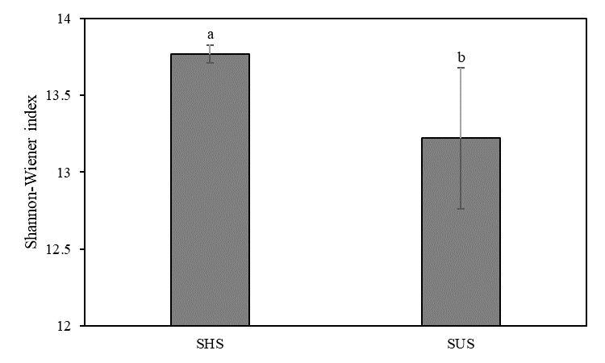
Figure S1. The Shannon-Wiener index of microbial community on the different slopes.

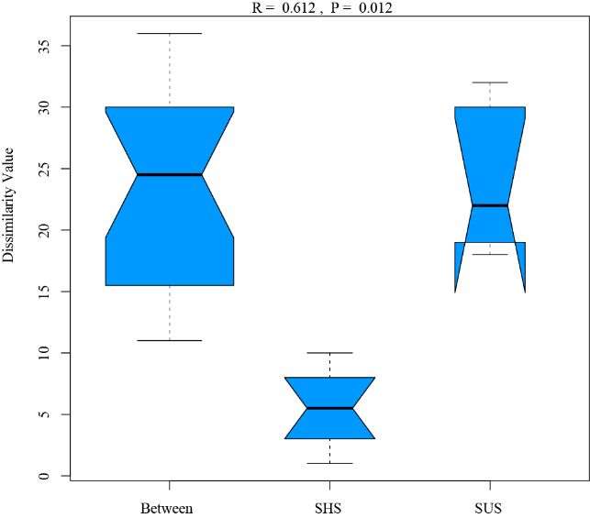

Figure S2. The analysis of similarities (AMOSIM) of microbial community on the different slopes.
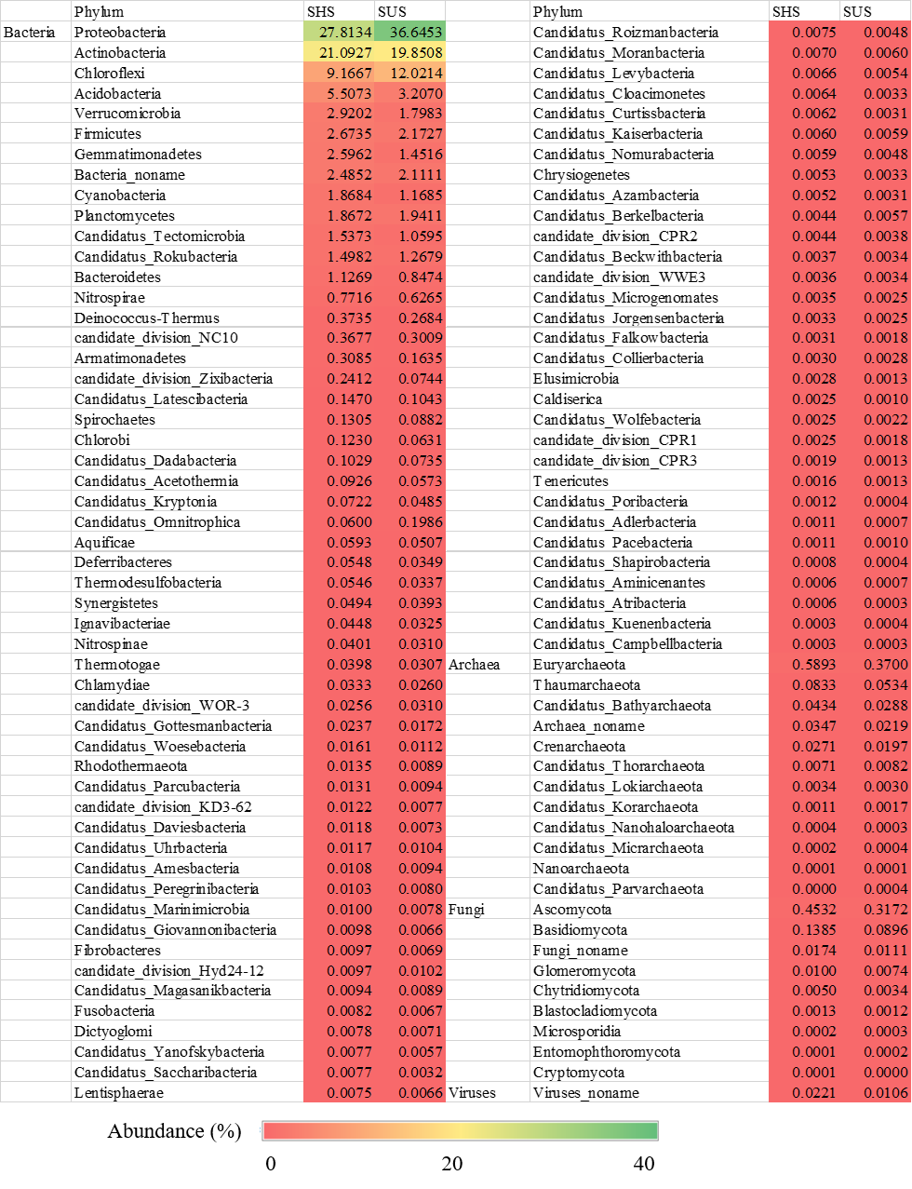
Figure S3. The abundance of microbial community composition on the different slopes.

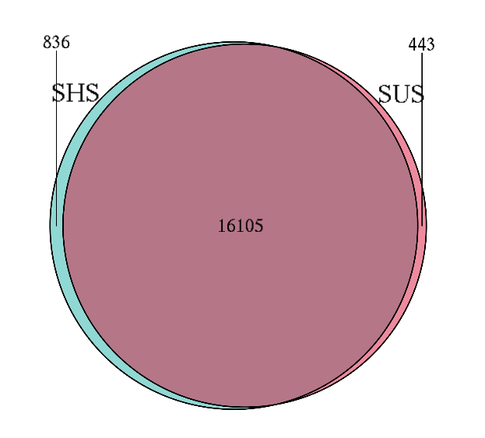
Figure S4. The veen diagrams of microbial composition on the different slopes.

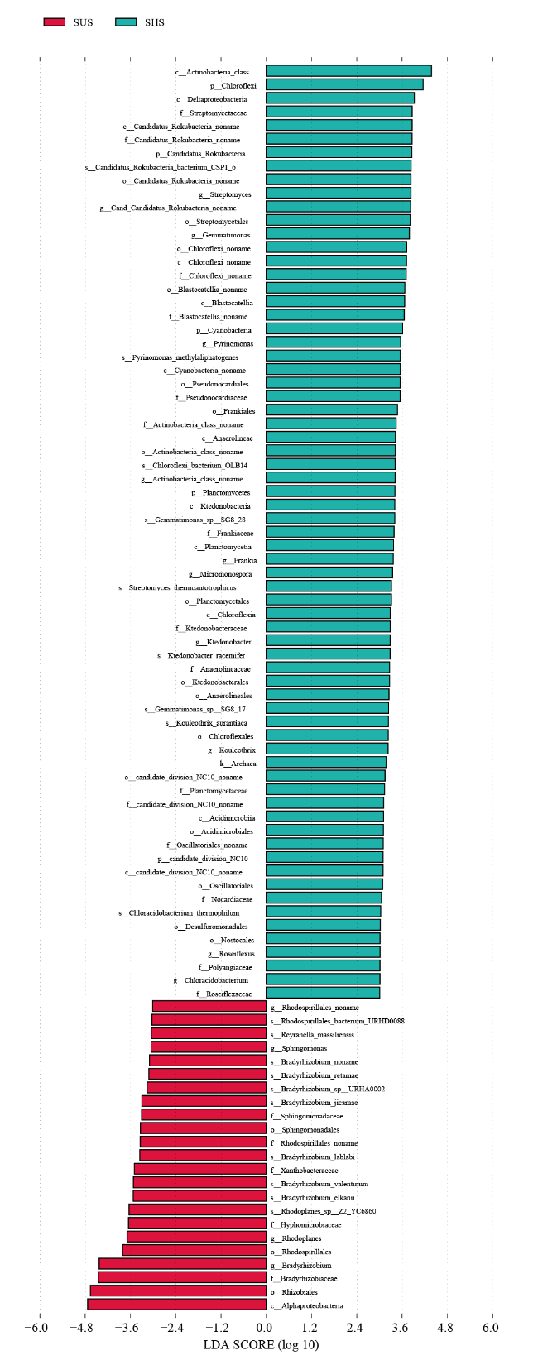
Figure S5. The LEfSe analysis of microbial community composition on the different slopes (LDA > 3).
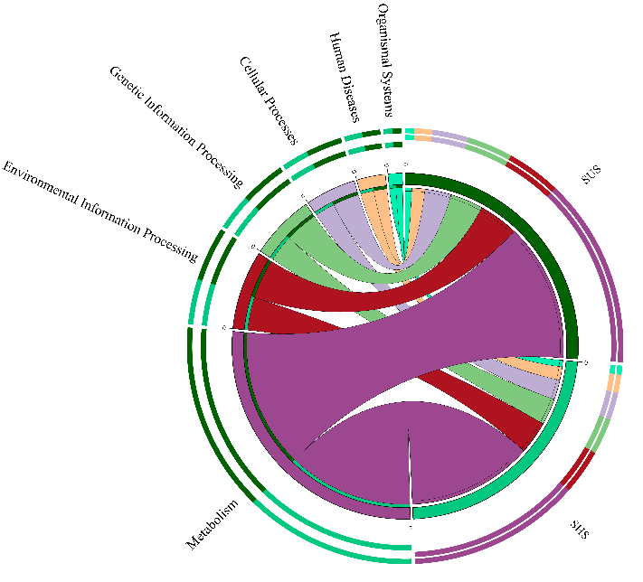
Figure S6. The microbial community function pathways on the different slopes.

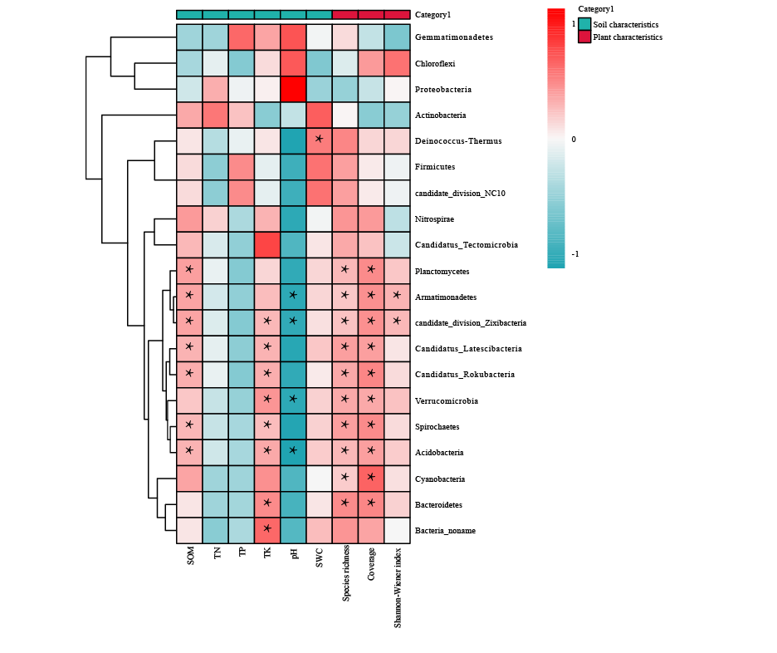
Figure S7. The correlation between the microbial community (at phylum level) and environmental variables. * correlation significant at the 0.05 level. SWC, soil water content; SOM, soil organic matter; TN, total nitrogen; TP, total phosphorus; TK, total potassium.
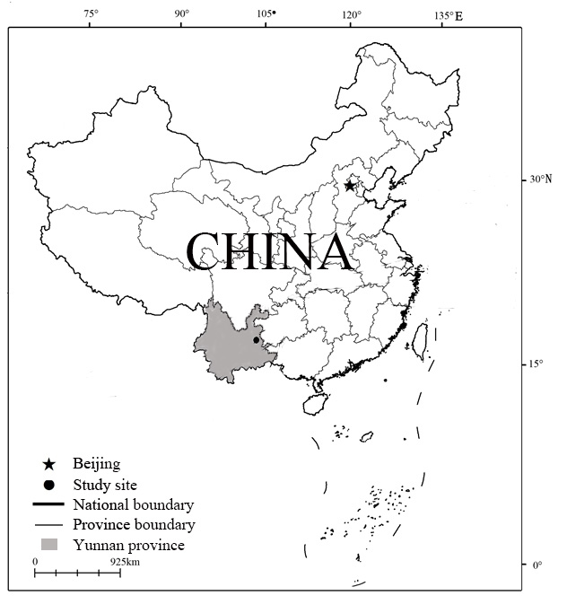
Figure S8. Location of the study site in Yunnan Province, China.

