Supplementary information

Generative Model of Protein Dynamic Trajectory Based on Latent Diffusion with DynaFold
Zirui Fan, Junjie Zhu, Hai-Feng Chen*
State Key Laboratory of Microbial Metabolism, Department of Bioinformatics and Biostatistics, SJTU-Yale Joint Center for Biostatistics, National Experimental Teaching Center for Life Sciences and Biotechnology, School of Life Sciences and Biotechnology, Shanghai Jiao Tong University, 200240, Shanghai, China.

*Corresponding Author
Email: haifengchen@sjtu.edu.cn

Notes
The authors declare that there is no conflict of interest.

Supplementary algorithms
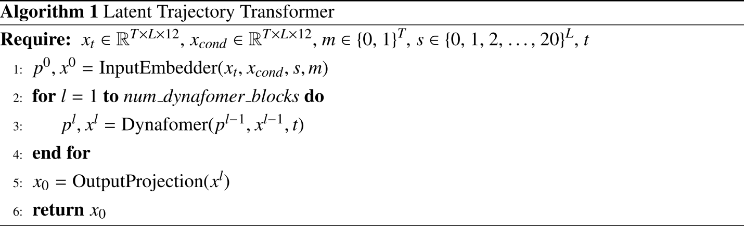
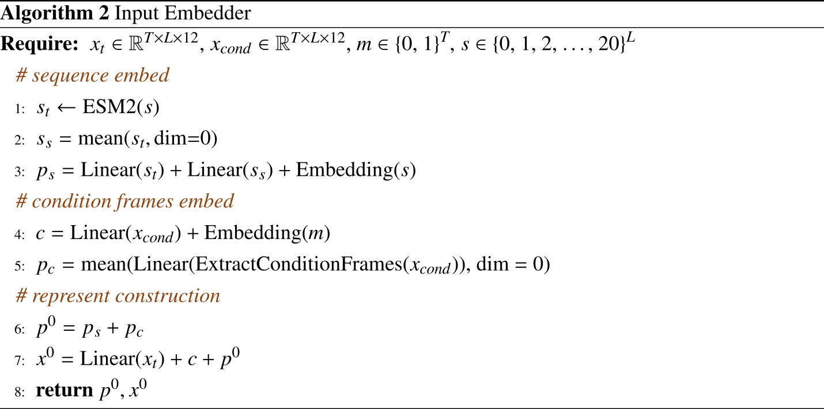
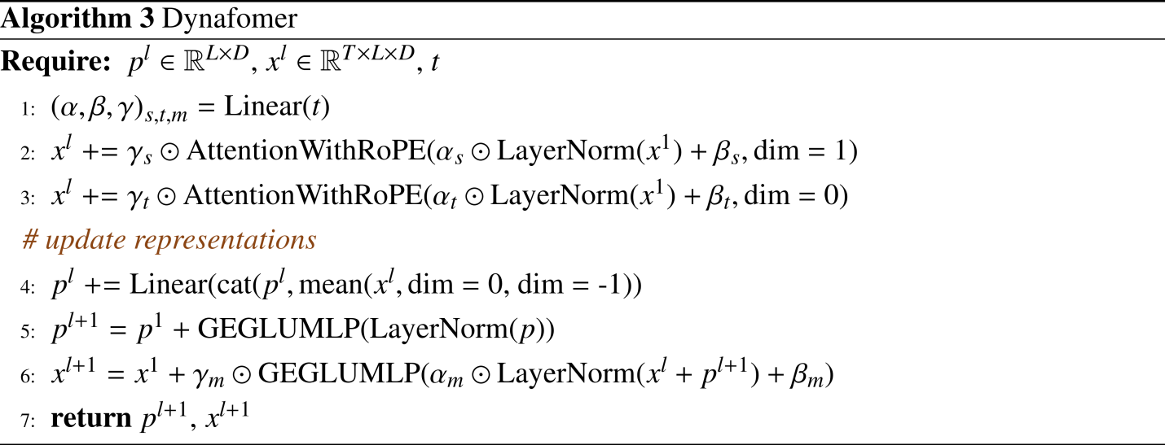

Supplementary figures
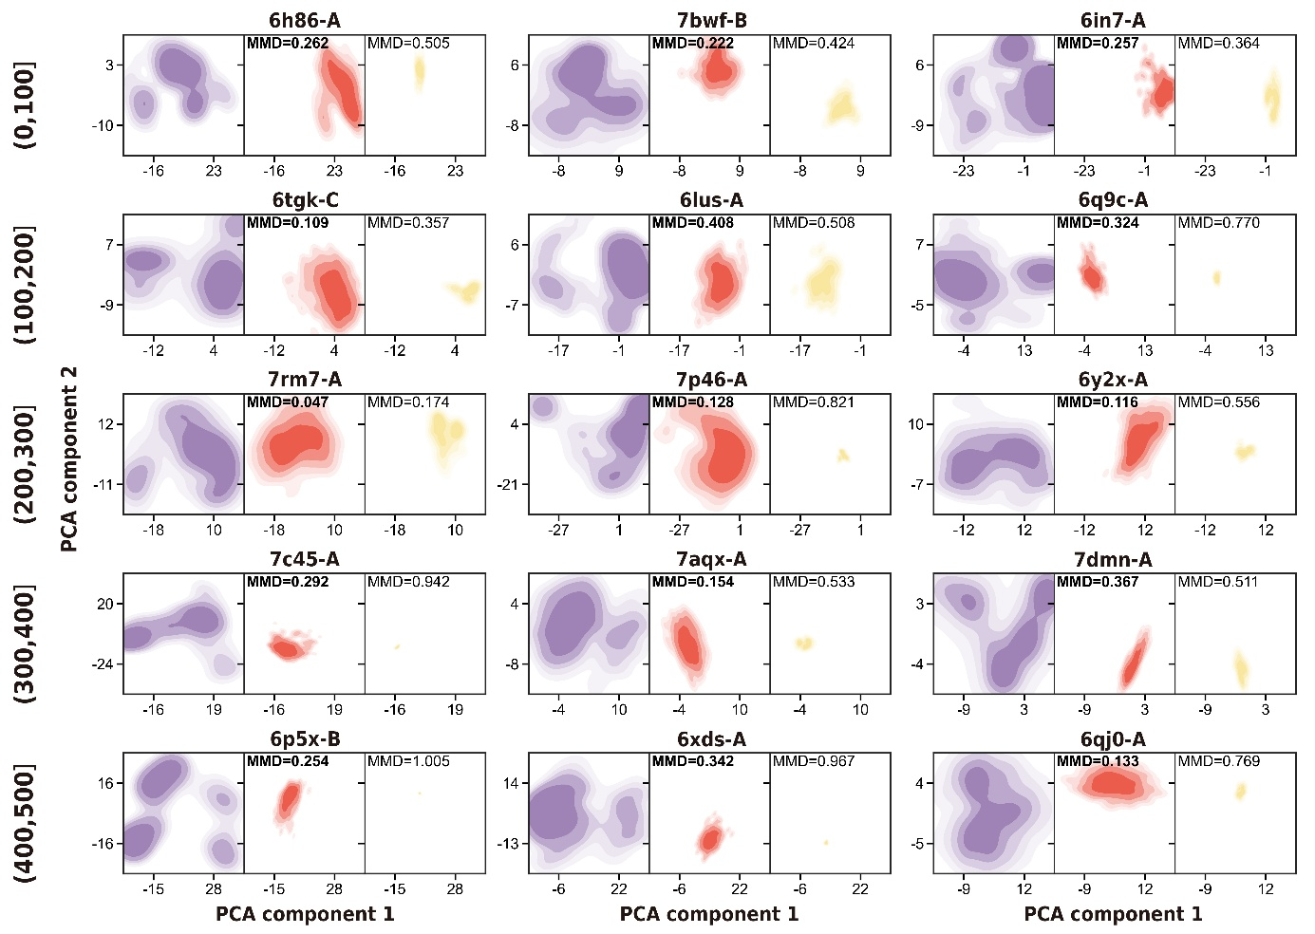
Figure S1. Distribution of MD predicted ensembles and different model predicted ensembles in PCA space.

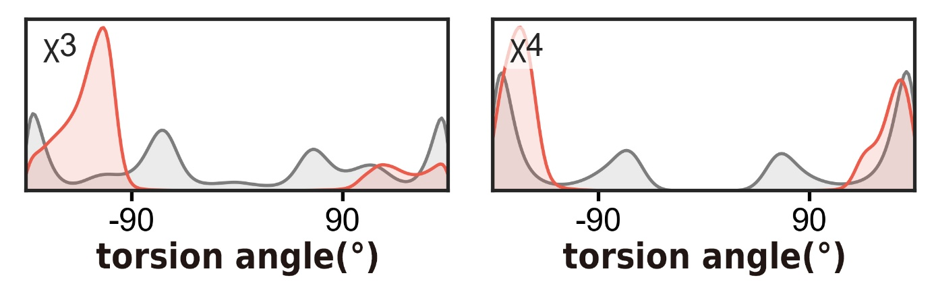
Figure S2. χ3-χ4 distributions of MD predicted ensembles and DynaFold predicted ensembles. DynaFold: red, MD: grey.

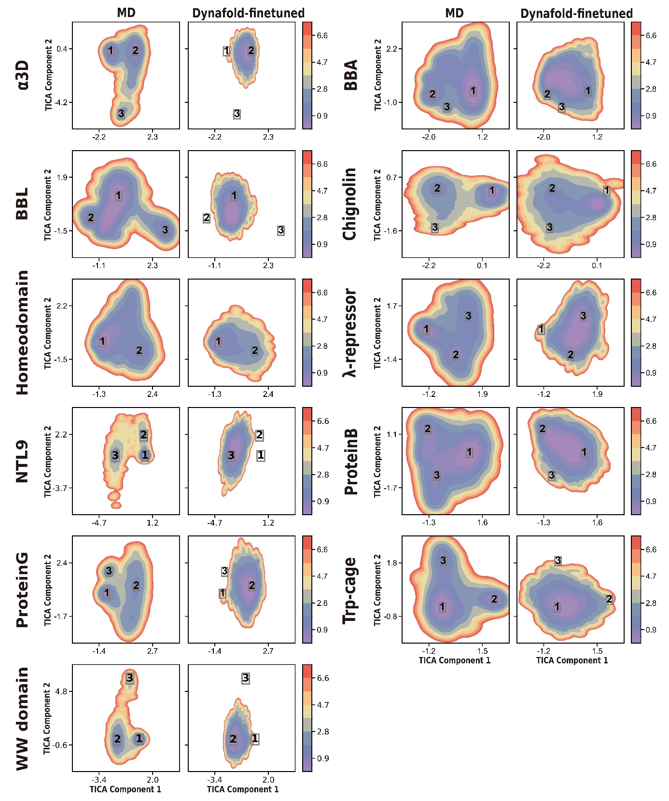
Figure S3. Free energy surface of MD ground truth and DynaFold's prediction in MD-fitted TICA space.
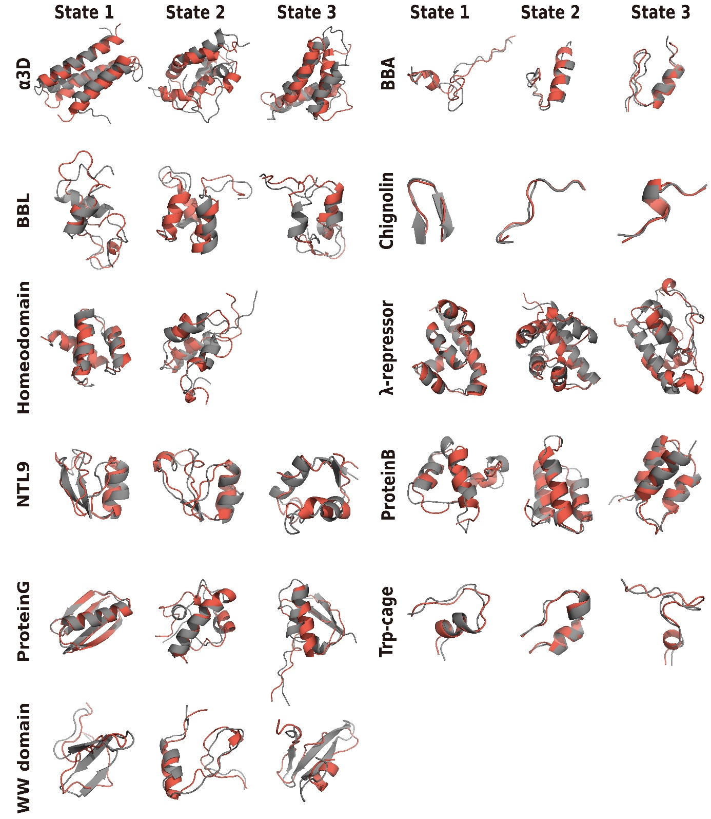
Figure S4. Low-free-energy conformations of MD ground truth and DynaFold's prediction.

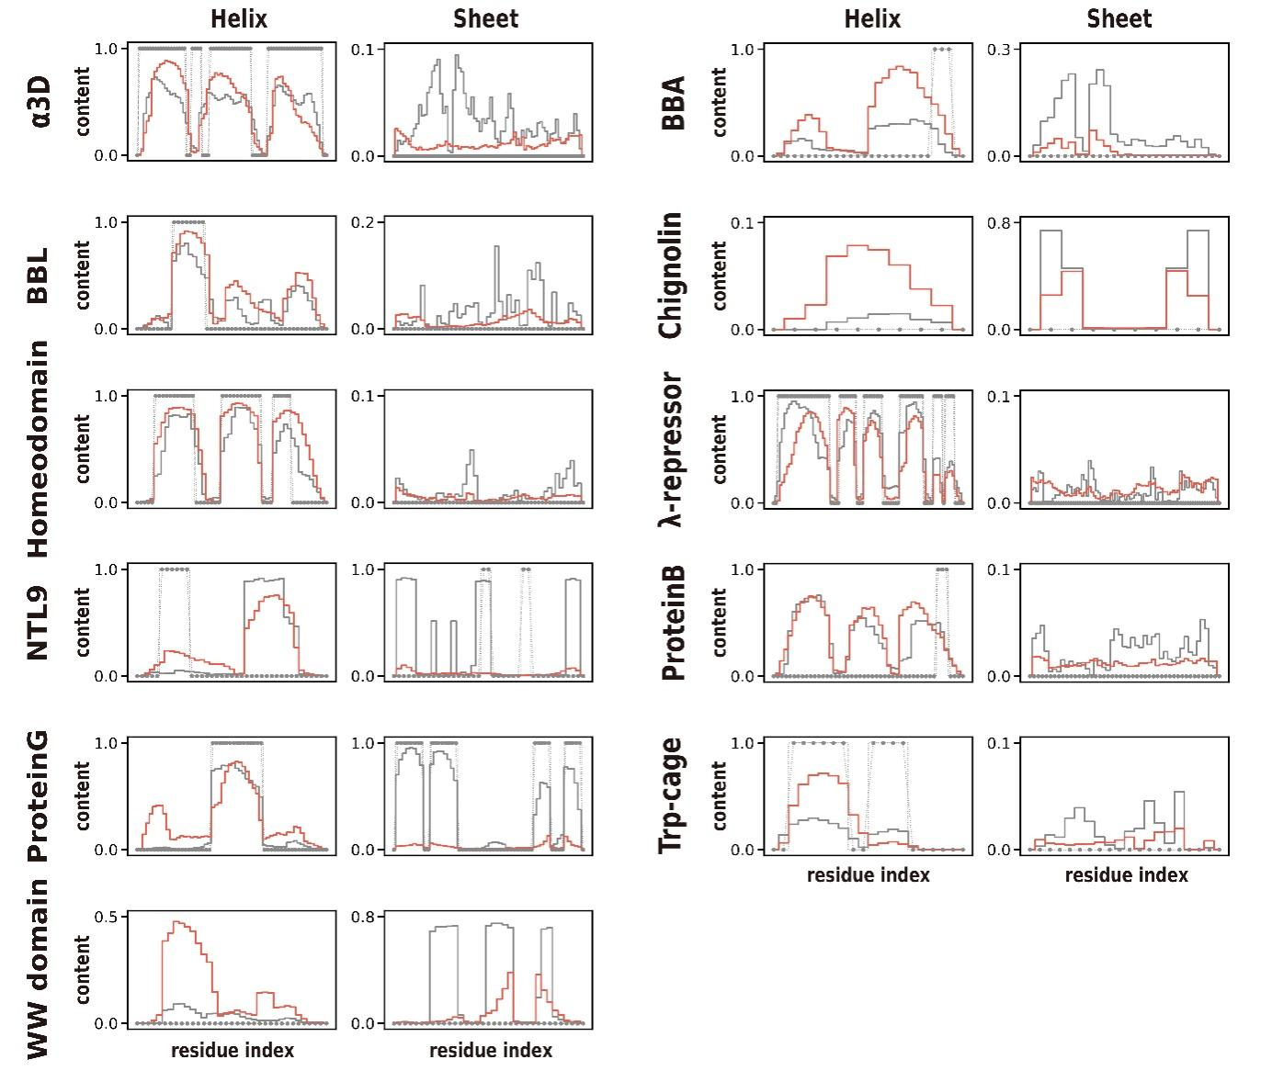
Figure S5. Secondary structure frequency of MD ground truth and DynaFold's prediction.

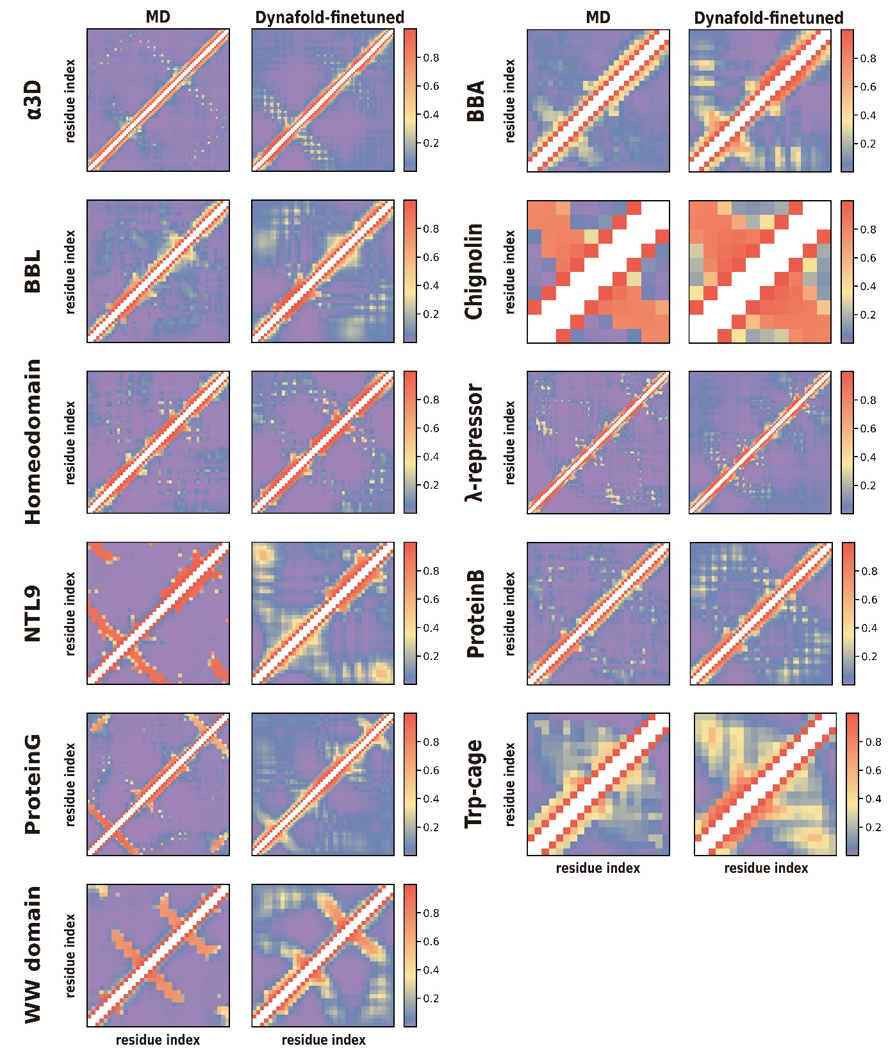
Figure S6. Residue contact frequency of MD ground truth and DynaFold's prediction.

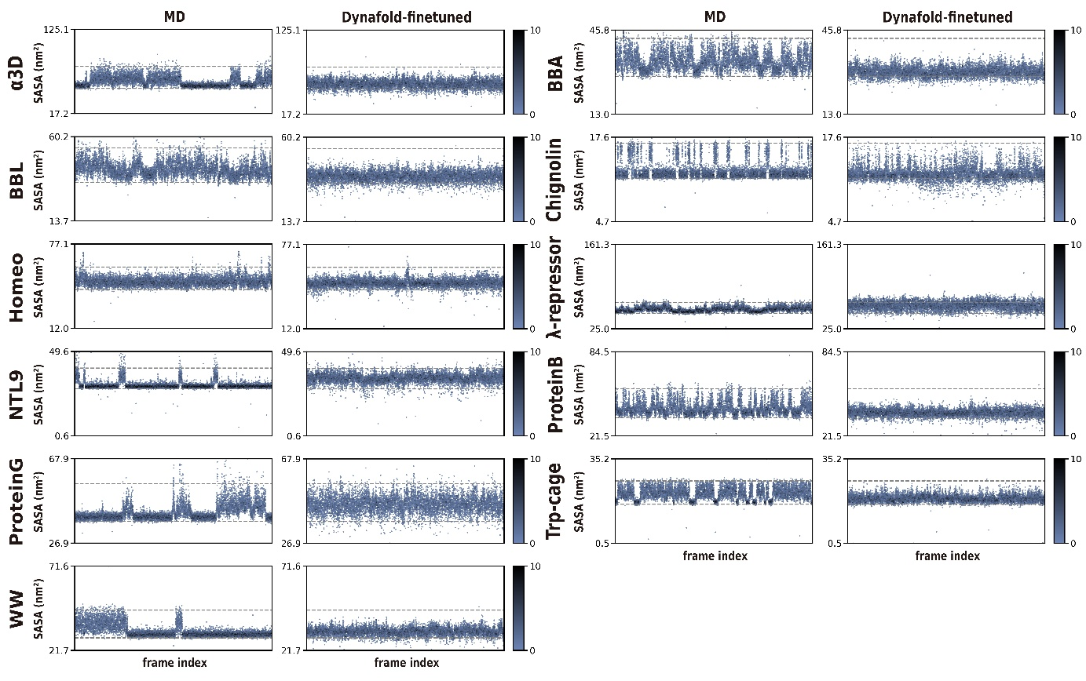Figure S7. Solvent accessible surface areas (SASA) of MD ground truth and DynaFold's prediction in MD-fitted TICA space.

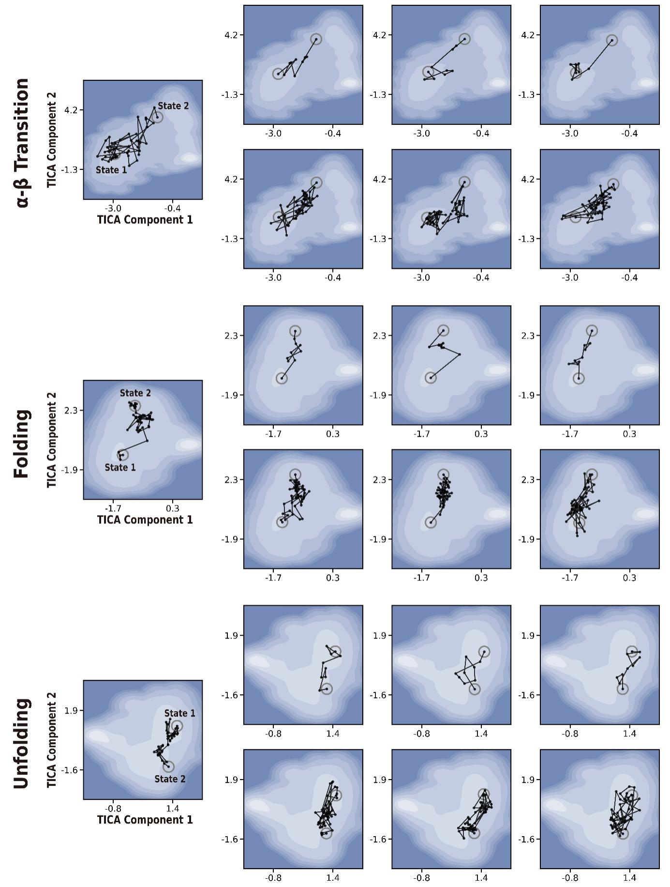Figure S8. Various conformational transition pathways predicted by DynaFold.
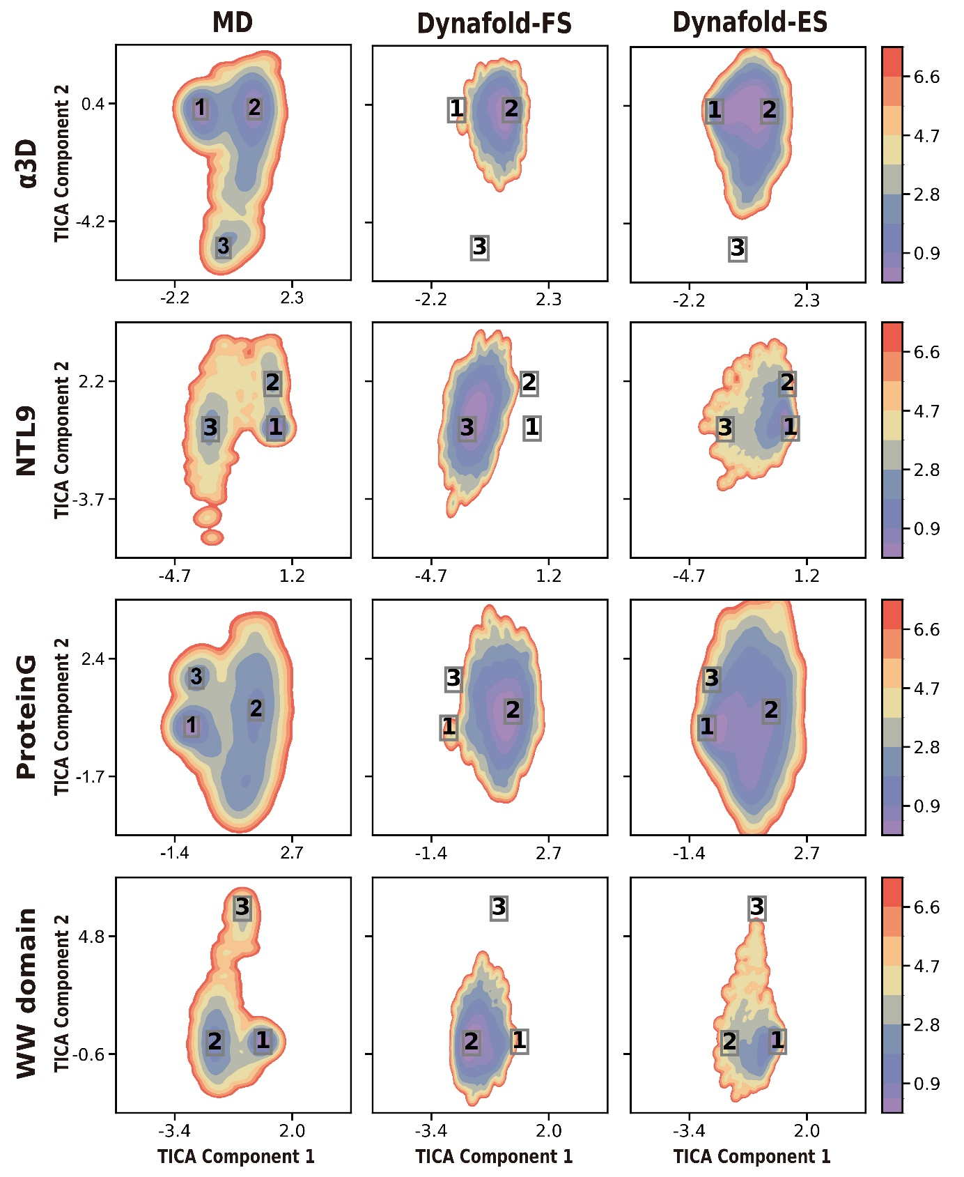
Figure S9. Free energy surface of MD ground truth, DynaFold-FS and DynaFold-ES prediction in MD-fitted TICA space.

Supplementary tables
Table S1. Top three ATLAS test set proteins with the highest average RMSF (Å) within five length intervals.
Bin | Protein ID | Length | Avg RMSF
(0,100] | 6h86-A | 88 | 0.579
(0,100] | 7bwf-B | 92 | 0.566
(0,100] | 6in7-A | 81 | 0.446
(100,200] | 6tgk-C | 105 | 0.441
(100,200] | 6lus-A | 133 | 0.277
(100,200] | 6q9c-A | 155 | 0.242
(200,300] | 7rm7-A | 228 | 0.381
(200,300] | 7p46-A | 282 | 0.331
(200,300] | 6y2x-A | 235 | 0.317
(300,400] | 7c45-A | 302 | 0.363
(300,400] | 7aqx-A | 364 | 0.205
(300,400] | 7dmn-A | 377 | 0.122
(400,500] | 6p5x-B | 457 | 0.445
(400,500] | 6xds-A | 492 | 0.311
(400,500] | 6qj0-A | 412 | 0.210

Table S2. Maximum Mean Discrepancy between MD predicted ensembles and different model predicted ensembles in PCA space and Rg-RMSD space.
Protein ID | DynaFold | MDGen
6h86-A | 0.262 | 0.505
7bwf-B | 0.257 | 0.364
6in7-A | 0.408 | 0.508
6tgk-C | 0.254 | 1.006
6lus-A | 0.324 | 0.77
6q9c-A | 0.133 | 0.769
7rm7-A | 0.109 | 0.357
7p46-A | 0.342 | 0.967
6y2x-A | 0.116 | 0.556
7c45-A | 0.154 | 0.533
7aqx-A | 0.222 | 0.424
7dmn-A | 0.292 | 0.942
6p5x-B | 0.367 | 0.511
6xds-A | 0.128 | 0.822
6qj0-A | 0.047 | 0.174
Mean | 0.228 | 0.614
Minimum count | 15 | 0
Table S3. Backbone RMSD (Å) between MD low-free-energy conformations and the most similar conformations predicted by DynaFold.
Protein | 1 | 2 | 3 | Mean
Alpha3D370K | 4.27 | 5.07 | 6.07 | 5.13
BBA325K | 2.76 | 1.62 | 1.33 | 1.90
BBL298K | 3.84 | 3.35 | 3.78 | 3.65
Chignolin340K | 0.50 | 0.93 | 0.89 | 0.77
Homedomain360K | 1.66 | 3.37 | — | 2.52
Lambdarepressor350K | 1.12 | 3.82 | 4.47 | 3.14
NTL9355K | 2.53 | 2.35 | 2.92 | 2.60
ProteinB340K | 3.45 | 1.71 | 1.99 | 2.38
ProteinG350K | 0.76 | 3.65 | 4.04 | 2.81
Trpcage290K | 1.65 | 0.67 | 2.09 | 1.47
WW360K | 2.85 | 2.80 | 3.50 | 3.05
Mean | — | — | — | 2.68

Table S4. Secondary structure RMSD (Å) between MD low-free-energy conformations and the most similar conformations predicted by DynaFold. Calculated only on structures with a secondary structure content exceeding 40%.
Protein | 1 | 2 | 3 | Mean
Alpha3D370K | 1.55 | 3.08 | 4.09 | 2.90
BBA325K | — | 0.95 | 0.55 | 0.75
BBL298K | — | 2.08 | — | 2.08
Chignolin340K | 0.43 | — | 0.30 | 0.36
Homedomain360K | 1.24 | 1.89 | — | 1.57
Lambdarepressor350K | 0.96 | 3.01 | 2.31 | 2.09
NTL9355K | 1.31 | 1.49 | 2.45 | 1.75
ProteinB340K | 3.15 | 1.21 | 1.50 | 1.95
ProteinG350K | 0.71 | 1.22 | 2.90 | 1.61
Trpcage290K | — | 0.32 | — | 0.32
WW360K | — | — | — | —
Mean | — | — | — | 1.68
Table S5. Maximum Mean Discrepancy between MD predicted ensembles and DynaFold predicted ensembles in 100000-frame MD-fitted TICA space.
Protein | DynaFold-ES
Alpha3D370K | 0.037
NTL9355K | 0.237
ProteinG350K | 0.083
WW360K | 0.110
Mean | 0.117
Table S6. Maximum Mean Discrepancy between MD predicted ensembles and DynaFold predicted ensembles in 10000-frame MD-fitted TICA space.
Protein | DynaFold-FS | DynaFold-ES
Alpha3D370K | 0.217 | 0.127
NTL9355K | 1.077 | 0.333
ProteinG350K | 0.553 | 0.155
WW360K | 0.626 | 0.142
Mean | 0.618 | 0.189

