Supplementary Material

Genomic differentiation of endangered polyploid Braya (Brassicaceae) populations in the limestone barrens ecosystem at risk support separate management units

Author Information
Nathan MacNeil*¹, Maria Esther Nieto-Blazquez*²†, Lourdes Peña-Castillo^{1,3}, Luise Hermanutz¹, Julissa Roncal¹
¹Memorial University of Newfoundland, Department of Biology, St. John’s, Newfoundland and Labrador, Canada
²Senckenberg Biodiversity and Climate Research Centre, Department of Molecular Ecology, Frankfurt am Main, Germany
³Memorial University of Newfoundland, Department of Computer Science, St. John’s, Newfoundland and Labrador, Canada

Supplementary Methods

Table S1. GBS-SNP-CROP parameter values.

Parameter definition | Parameter | Value
Minimum depth when secondary allele count is zero | mnHoDepth0 | 5
Minimum depth when secondary allele count is one | mnHoDepth1 | 20
Minimum allele depth for calling heterozygotes | mnHetDepth | 3
Alternative allele strength | altStrength | 0.962
Minimum ratio of more frequent allele depth to less frequent allele depth | mnAlleleRatio | 0.25
Minimum percentage of individuals genotyped to keep a variant | mnCall | 0.75
Minimum average depth | mnAvgDepth | 3
Maximum average depth | mxAvgDepth | 200

Figure S1. Schematic diagram showing the eight demographic models compared in fastsimcoal2. Population acronym as follows. For B. longii SC/ShCD= Sandy Cove and Shoal Cove Disturbed, YP= Yankee Point. For B. fernaldii CN/AP= Cape Norman and Anchor Point, and GIB/WB/BB= Green Island Brook, Wild Bight and Bellburns. NANC refers to the MRCA effective population size of Braya species in Newfoundland and AN refers to the ancestral effective population size of each population. TIME refers to the different divergence times (specified as historical events) in the analysis. Arrows indicate gene flow between populations.

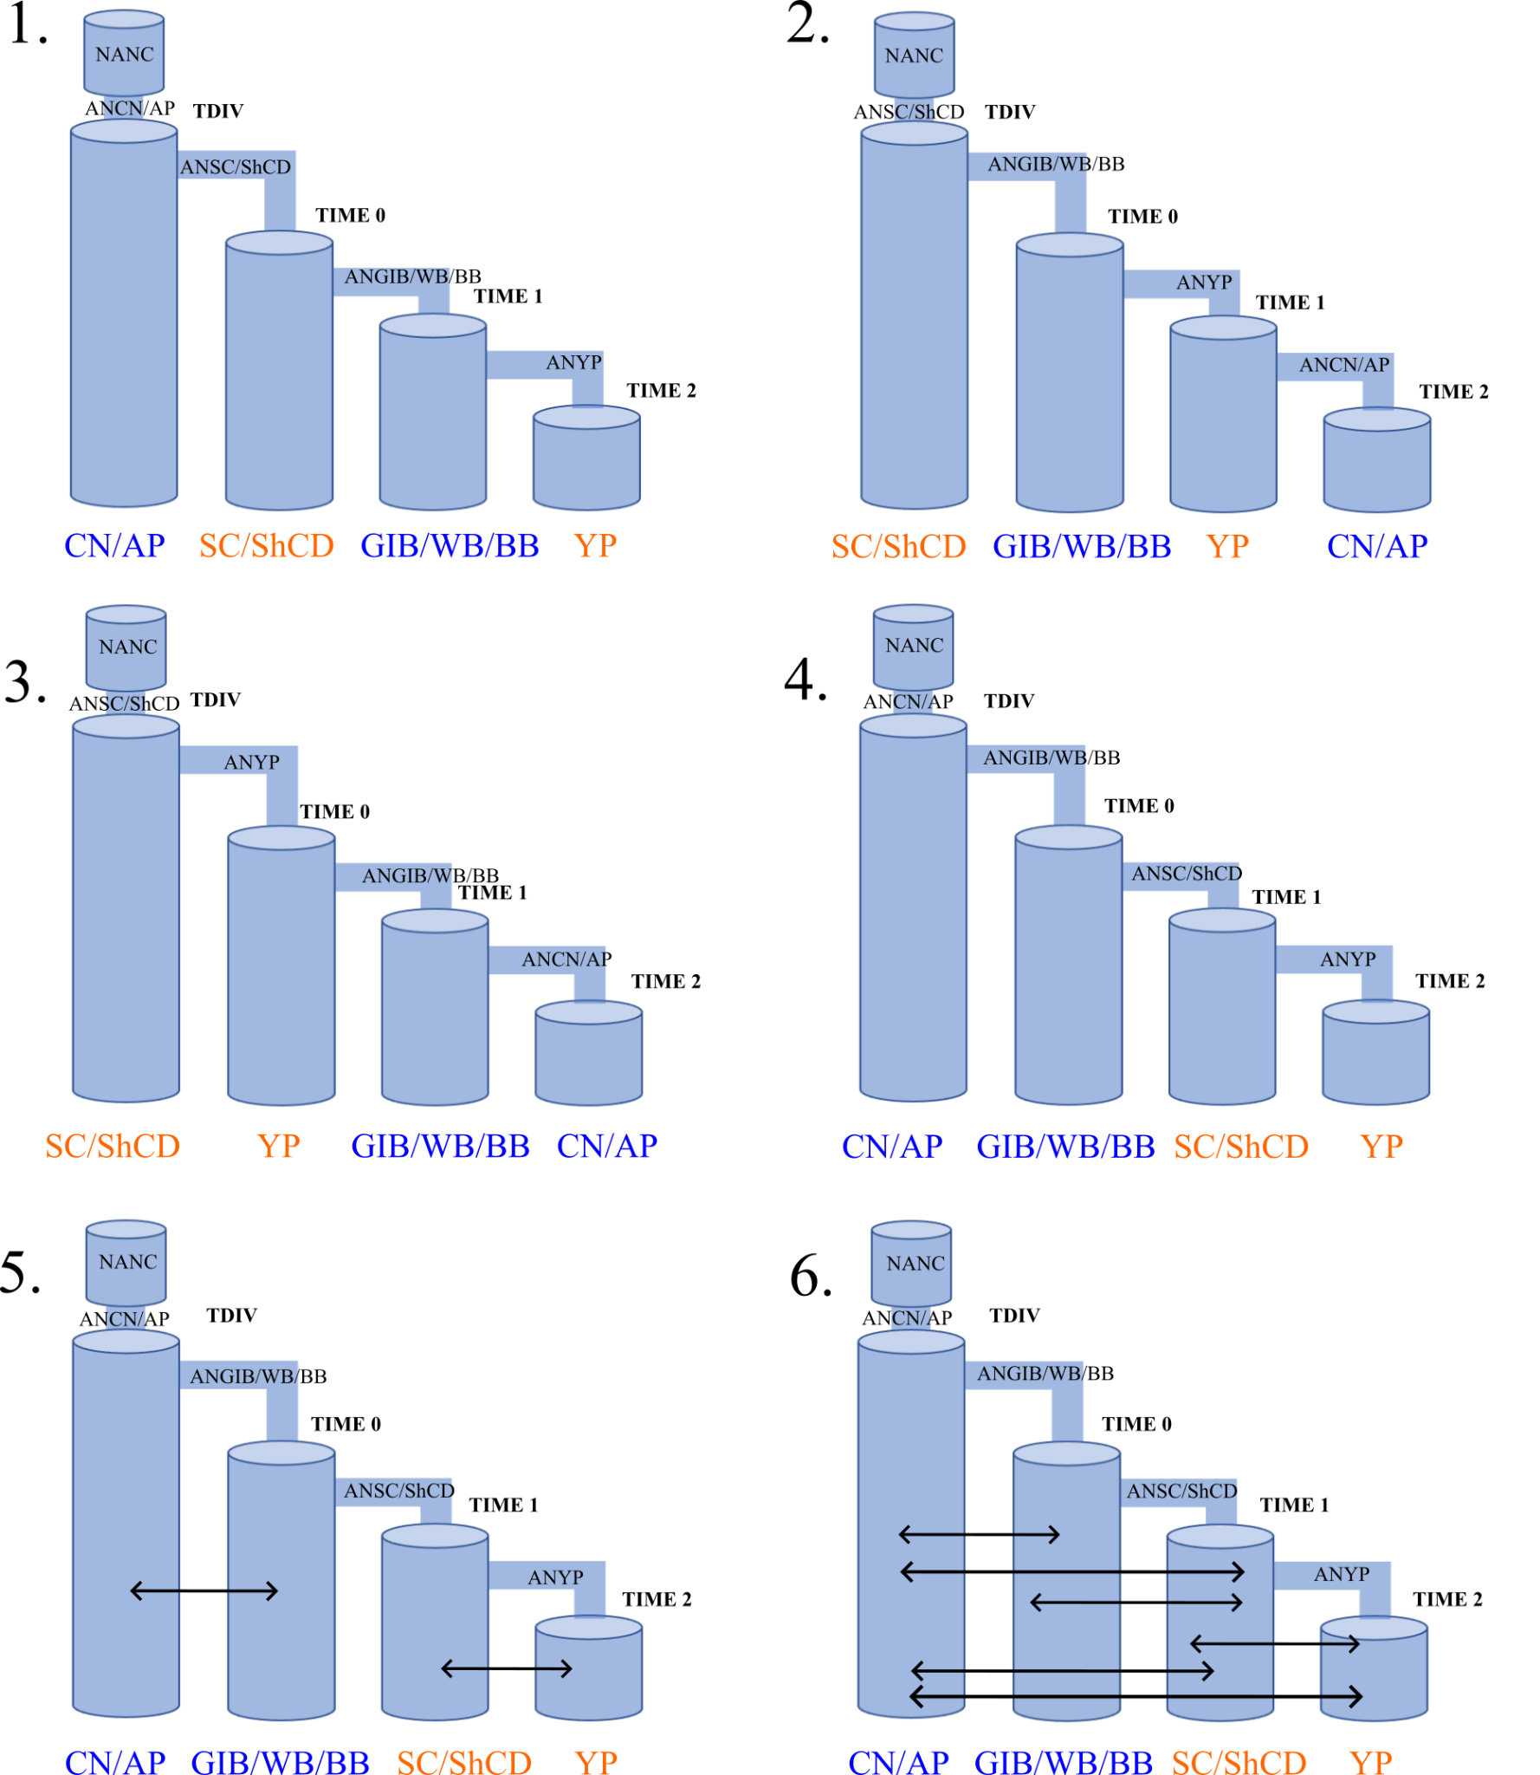
Supplementary Results

Table S2. MaxEstLhood, MaxObsLhood, Bayesian Information Criterion (BIC) and parameters estimates obtained for the six demographic models tested in using fastsimcoal2. Estimates in bold indicate the best-fitting demographic model. NANC refers to the MRCA effective population size of Braya species in Newfoundland. TDIV represents the divergence time between the Newfoundland ancestor and the first Newfoundland population, while TIME refers to the various historical divergence events shown in Figure S1. All times are given in generations. NPOP* and NPOPA* refers to the effective population size and ancestral effective population size of each population, respectively. Mig* refers to migration events between populations.
 | Model 1 | Model 2 | Model 3 | Model 4 | Model 5 | Model 6
MaxEstLhood | -36538.697 | -36456.24 | -36493.134 | -36700.221 | -34326.798 | -34513.146
MaxObsLhood | -10903.547 | -10903.547 | -10903.547 | -10903.547 | -10903.547 | -10903.547
BIC | 73091.9513 | 72927.0373 | 73000.8253 | 73414.9993 | 68668.1533 | 69040.8493
NANC | 86513 | 83636 | 83157 | 76888 | 83374 | 83567
TDIV | 987 | 1017 | 945 | 974 | 937 | 972
TIME0 | 762 | 793 | 723 | 611 | 692 | 782
TIME1 | 455 | 463 | 395 | 432 | 430 | 452
TIME2 | 170 | 111 | 161 | 148 | 117 | 137
NPOPA0 | 64029 | 66286 | 47956 | 69767 | 74134 | 63545
NPOPA1 | 48237 | 69216 | 58440 | 80382 | 64160 | 55222
NPOPA2 | 72132 | 56010 | 48250 | 49377 | 74101 | 48835
NPOPA3 | 73771 | 56653 | 79941 | 57432 | 65291 | 76412
NPOP0 | 53240 | 42353 | 51872 | 68926 | 58224 | 82962
NPOP1 | 68877 | 86379 | 45521 | 79187 | 65417 | 47622
NPOP2 | 67536 | 40259 | 74140 | 53285 | 45863 | 55390
NPOP3 | 83122 | 57667 | 57409 | 68963 | 69811 | 53746
Mig03 | - | - | - | - | 8.47E-10 | 1.25E-07
Mig30 | - | - | - | - | 7.11E-05 | -
Mig12 | - | - | - | - | 1.91E-06 | -
Mig21 | - | - | - | - | 1.53E-07 | 6.02E-06
Mig02 | - | - | - | - | - | 2.50E-04
Mig20 | - | - | - | - | - | 8.40E-09
Mig01 | - | - | - | - | - | 4.09E-07
Mig10 | - | - | - | - | - | -
Mig32 | - | - | - | - | - | -
Mig13 | - | - | - | - | - | 4.69E-07
Mig23 | - | - | - | - | - | 5.85E-07
Mig31 | - | - | - | - | - | 1.02E-09

