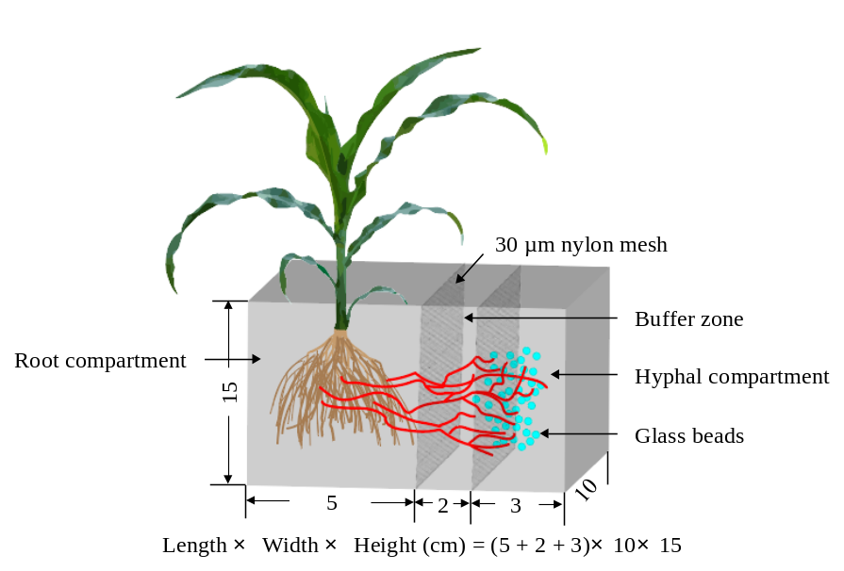
Fig. S1 Schematic drawing of the two-compartment cultivation system (microcosm) used in this study. The microcosms were divided into a root compartment and a hyphal compartment separated by a 30-μm nylon mesh and a buffer zone. Overall dimensions were 10 × 10 × 15 cm

